City of Spartanburg
Procurement and Property Division
Post Office Drawer 1749, SC 29304-1749
Phone (864) 596-2049 - Fax (864) 596-2365

RFP Legal Notice

Request for Proposals to Demolish Structure, Clear lot and remove trees

NOTICE IS HEREBY GIVEN – The City of Spartanburg is requesting proposals to demolish a structure in the City of Spartanburg located at 300 Marion Ave.

Proposal No:

The City of Spartanburg, hereby, notifies all proposers that it will affirmatively ensure that all disadvantaged and women’s business enterprises will be afforded full opportunity to submit proposals in response to this invitation and will not be discriminated against on the grounds of gender, race, color, or national origin in consideration for an award.

The City of Spartanburg reserves the right to reject any or all proposals or to waive any informality in the qualifications process. Proposals may be held by the City of Spartanburg for a period not to exceed sixty (60) days from the date of the opening of Proposals for the purpose of reviewing the Proposals and investigating the qualifications of prospective parties, prior to awarding of the Contract. The vendor that is awarded the proposal will be required to obtain a City of Spartanburg Business License and have all related State or Federal License to complete the work.

Pre-Bid: Tuesday, January 5, 2020 at 9AM at the site, starting at 300 Marion Ave.

Please summit two (2) copies of your sealed proposals:

Sealed Bids Due Tuesday, January 12, 2020 no later than 3 PM. Proposals must be submitted to Carl Wright, Procurement and Property Manager, City Hall 145 W. Broad Street, at which time they will be publicly opened and read aloud in the Training Room.

Technical question regarding the scope of services should be directed to Lynn Coggins, Construction Project Administrator, and City of Spartanburg at 864-596-2914.

Proposals can be hand delivered or mailed to the following address:

City of Spartanburg
P.O. Box 5107
145 W. Broad Street
Spartanburg, SC. 29304

Attn: Procurement and Property Division

For further information and complete Proposal Package, please contact the Procurement and Property office at (864) 596-2049. Complete proposal package also available at www.cityofspartanburg.org by following the links for Invitations for bids.

_____________________

Company Bidding
Bidding Requirements for Contractors

This entire bid package consisting of all pages and one copy must be submitted back to City, or your bid will be considered incomplete and will be eliminated.

- PRESENT ONE PRICE for all work ON THE RESIDENTIAL DEMOLITION AND SEWER ABANDOMENTS PER CITY AND STATE AND SSSD AND DHEC REQUIREMENTS
- Contractor and all sub-contractors must have a current City License and SC State License.
- Contractors and all subcontractors must be fully insured per City’s insurance requirements.
- Must have three years of experience demolishing Residential and Light Commercial Buildings and know the regulations and protocol.
- Must submit six references for work completed in the last twelve months on table D.
- Management Companies (jobbers) (shoppers) who subcontract other companies to perform their work do not qualify as a
- Return entire RFP bound, all pages, signed or initialized, and One copy.
- All sewer abandonments: the Contractor must use someone on the City’s approved street cut list from the building officials office. They must be bonded/permitted to cut City and County and State streets.
- The actual demolition of the structures cannot be subcontracted, the bidder must own a sufficient amount of dependable equipment and have enough personnel to complete the work in the 30 day time period required by the City.
- The contractor must notify the Project Manager five working days prior to the start date before starting work with the exact dates they plan to complete the demolition.
- Work Time Schedule: Acceptable working time is 7AM to 7PM
- Pre Bid Conference: The pre-bid conference is not mandatory however, if you do not attend the pre-bid conference and miss important information you are still responsible for information you missed.
- Contract: The most responsive contractor will be asked to sign a contract with the City. This entire bid package will be part of the contract.
- Liquidated Damages: Liquidated damages for non-compliance of a late or incomplete contract will be deducted at $100.00 per day and will be deducted from the original contract amount.

Scope of Work

Remove asbestos if present
Camera sewer line have inspected if its not useable cap and cover per SSSD
Save water tap and meter to be reconnected to a new line
Demolish house
Demolish garage
Remove oil tank in basement
Fill basement red clay 98% compaction rate
Remove all trees and above ground roots grind stumps below 12 inches
Remove retaining wall
Clear rear of lot beyond retaining wall to street
Remove topsoil and store on site
Grade lot to level
Seed and straw lot
Install silt fence before grading

Measure all dimensions and number of stories including all basements out buildings and garages.
Use Safe Work Practices to tear down, demolish, raze, remove, and cart away all materials to appropriate dumping facility comprising of said building(s) components, to ground level or basement level, if said building(s) has a basement, including all concrete slabs, floors, basement walls, foundations, footings, and sidewalks, steps, patios and driveways etc. to leave only ground and soil on the site.

MOST RETAINING WALLS WILL REMAIN UNLESS OTHERWISE SPECIFIED AT THE PREBID OR IN THE SCOPE OF WORK

Remove all debris of whatever charter arising from the demolition of the building(s) including all contents demolition debris, debris in the yard, out buildings and cart away to leave the entire premises cleaned to ground level and seed and straw.

The contractor is required to clear the entire lot of all undergrowth, small trees, damaged trees, and dead trees. Standing healthy trees will not be removed unless specified.
Clear fence lines, poles, or hedgerows that joins property line.

All tree stumps must be removed or ground below 12 inches

The Contractor must furnish everything to complete the work including but not limited to, all equipment, trucks, tractors and related equipment and materials, labor, Insurance and Workers Compensation and all DHEC Permits and City and State Permits and State and License to complete the work.

Fill all crawl spaces or basements or septic tanks holes with compactable red clay. Existing dirt on a lot may be used to level the lot if it does not cause erosion, depressions, or other drainage problems.

Asbestos
If applicable, there should be no asbestos in the building, it will be tested and removed before it’s assigned for demolition unless it’s too dangerous to enter and work safely.

Lead Based Paint
It is very likely this house has lead based paint. The contractor must properly handle and dispose of debris containing Lead based Paint at a Subtitle D Landfill.

Typical Demolition
The typical demolished is 1000SF to 2000SF framed house with a two to four foot foundation, and 4/12 pitched roof a walkway and driveway underbrush and shrubbery removal

Field Verification
Field measure all structures and items present for the complete demolition
The City will use Spartanburg County Assessors information as a guideline.

Red Clay Compactable Fill
Include red clay compactable fill dirt to level the lot, include it in your total cost.

Topsoil
Include topsoil in your bid for each demolition to cover the entire disturbed area, if topsoil is not on the disturbed areas you will not be paid until its completed reseed and strawed.

Tree Removal
When removing trees the Contractor is required to remove tree stumps and fill-in depression with dirt or grind the stump below grade 12 inches.

Dust Control

It is the responsibility of the contractor to use good judgment to control dust during demolition and keep complaints to a minimum. Use wet demolition practices if needed. If there is a problem with dust accumulating on other exterior property, the contractor will clean the exterior of property real or personal.

Safety Fence
Will be provided if needed.

Silt Fencing

The contractor will provide silt fencing if needed for erosion control or required by DHEC or City Staff.

GRADING

Harley rake must be used to remove all debris before planting grass and applying straw.

Grass Seed and Straw
The contractor is required to fine grade all areas so that there will be no depressions that would cause water to stand. The area must be clear so that grass can be mowed with a standard lawn mower.
Once cleared and level, the contractor is required to meet the following planting schedule.
DURING THE SUMMER- PLANT BERMUDA OR CENTIPEDE PER MANUFACTORS RECOMMENDATIONS AND STRAW. NO RYE GRASS.
DURING THE WINTER – PLANT TERF TYPE FESCUE SEED AND STRAW, PER MANUFACTORS RECOMMENDATIONS NO RYE GRASS. Hydro seeding is allowed.

Call Backs
If the final grading leaves depressions that cause water to stand or too much debris remain or grass can’t be cut with a lawnmower, the contractor will return and clean and reseed the lot at your expense.
If grass does not grow within three months, the contractor at his own expense will return light till and reseed and straw the lots. Drought conditions will extend this by three months

Permanent Sewer Abandonments
Contractor must include the sewer abandonment in bid.
Contractor must Follow SSSD and City sewer abandonment policy and procedures.
The Demolition Contractor is required to complete permanent abandonments if the sewer line is on the property where the demolition is located or in the street.
The contractor is required to follow the policy of SSSD and acquire a sewer permit from SSSD.

Septic Tanks
The Contractor will arrange for the septic tank to be pumped out, and will remove the tank and fill the hole with compacted red clay seed and straw area.
Extra time and material will be allowed with a change order request.

Wells
The contractor is required to fill any abandon or open wells to comply with state law.
Extra time and material will be allowed.

Gas Tanks
The contractor must have them removed properly.

Oil Tanks
Contractor must have the tank pumped out and removed from the property and meet all Environmental
Regulations regarding the removal.
Extra time and material will be allowed with a change order request if not in the RFP specfications.

Utilities
The City will request that all Utility services be removed and confirmations sent to the Build Inspection,
Permit Clerks. The contractor will coordinate with the Permits Clerks to obtain a Demolition Permit.
The contractor will field verify all utilities are removed before beginning work.

Locations of Utilities
The contractor is responsible for calling a utility locater before starting work.

Recycling Building Materials
The City of Spartanburg encourages contractors to recycle as much demolition debris as possible

Asbestos covered material or materials containing asbestos cannot be recycled. It must be handled per DHEC Regulations.

Pre-Mature Stripping or Removal of Contents
The Public Safety Department, Code Enforcement, and Neighborhood Services Department monitor all houses. Premature stripping or removal of any contents or structural parts is a violation of the law and will be treated as such.

Original Waste Manifest Receipts
The original waste manifest receipts must be presented with the final Invoice for all materials disposed.

Improper Disposal
Improper disposal will be reported to SCDHEC. The City of Spartanburg will not pay a contractor any portion of the contract if improper disposal occurs. Legal action may also be taken against the contractor.

Preparation of Bid
Each bid must be submitted on the prescribed forms (contained herein). All blank spaces for bid prices must be completed in ink or typewritten, in words and/or figures, and all required Certifications must be fully completed and executed when submitted.
The lowest total BID will carry the most weight not the unit prices along with the contractor’s ability to meet the City's needs.

Awarding Contracts
The City of Spartanburg shall be the sole judge of the bid and the resulting agreement that is in its best interest and its decision shall be final. All bidding and award procedures undertaken by the City in regard to this project shall be consistent with the City’s adopted procurement procedures. Bid prices shall remain in effect for 90 days after bid opening.
Lowest Bid
The lowest bid does not automatically guarantee a contractor will get the work they bid on. Bids will be reviewed and scored for experience, pricing, quality of recent service, previous work history, references, State Licenses, State Registration, Insurances, Bonds, Subcontractors, Equipment Owned, Equipment Rented, Operators Experience, and Financial Stability. The City at its sole discretion will decide after a review which contractor, if any is responsive to the RFP.

Bid Submittal
INCOMPLETE BID INFORMATION OR UNSIGNED BIDS WILL BE REJECTED IMMEDIATELY WITHOUT RECOURSE.

Please submit BOUND this entire RFP one (1) original and one (1) copy of your bid in a sealed envelope reflecting on the outside thereof the bidder’s name and "Sealed Bid for Building Demolition Services”
Table A Complete table A. Demolition Fee Schedule

Table B List the sub-contractors you plan to use. If none, indicate none.

Table C Complete Table C, Equipment

Table D Complete Table D, References

Immigration Reform Act: Read and Sign

Insurance Requirements: Read and Sign

TABLE A

DEMOLITIOM FEE SCHEDULE

MY PRICE FOR TOTAL DEMOLITION AND REMOVAL OF ALL DEBRIES AND SEWER ABANDOMENT ON THE PROPERTY IS. PRICE INCLUDES REMOVAL OF All MATERIALS AND THE SEWER ABANDOMENT ON THE PROPERTY AND EVERYTHING LISTED IN THE SCOPE OF WORK.

Demolition House………………….………...$__________________

Demolition Garage……………………………$__________________

Fill foundation with red clay and pack at 98% compaction $______________

Grading, Seeding and Straw ……………........$__________________

Tree removal……………………………………$__________________

Oil tank Removal……………………………….$__________________

Mandatory Sewer Abandoment……………………………$_________________

Install sewer line per SSSD specificatons to street_________________

Total Cost ………………..……………………..$__________________

_____________________________________________________________________

BIDDERS INFORMATION

_____________________________________________________________________
Company Name

______________________________________________________________________

Owner or Company Representative Signature

_____________________________________________________________________

Company Address

___________________________________________________________________________
Cell Phone Office Phone

___________________________________________________________________________
Email

__________________________________________________________________________
Federal Tax ID # or Social Security #

MANDATORY SEWER ABANDOMENTS

PRICE TO COMPLETE THE MANDATORY SEWER ABANDOMENT IN THE STREET

ONLY COMPANIES ON THE APPROVED CITY STREET CUT LIST MAY COMPLETE THIS PORTION OF WORK

Who will perform the work?
Company Name: |  | Federal ID or SS #:
Street Address: |  | Telephone #:
City, State, Zip: |  | Fax #:

SEWERS ABANDOMENTS, STREET CUT PATCH FAILURE
If the street patch fails, drops or shrinks or collapse and does not hold, the contractor must return remove the failed patch and repair the problem and pass City inspection at you companies expense.

TABLE C
EQUIPMENT

I certify that I own sufficient equipment to complete the work according to the specifications and will not subcontract any part of this contract without written approval from the City of Spartanburg.

______________________________________________________________________________
Company Name Contractor/Owner Signature Date

Table D
References

List only references you have completed work for in the last twelve months.

Company Name: |  | Federal ID or SS #:
Street Address: |  | Telephone #:
City, State, Zip: |  | Fax #:

Company Name: |  | Federal ID or SS #:
Street Address: |  | Telephone #:
City, State, Zip: |  | Fax #:

Company Name: |  | Federal ID or SS #:
Street Address: |  | Telephone #:
City, State, Zip: |  | Fax #:

Company Name: |  | Federal ID or SS #:
Street Address: |  | Telephone #:
City, State, Zip: |  | Fax #:

Company Name: |  | Federal ID or SS #:
Street Address: |  | Telephone #:
City, State, Zip: |  | Fax #:

Company Name: |  | Federal ID or SS #:
Street Address: |  | Telephone #:
City, State, Zip: |  | Fax #:

____________________________________________________________________________________
Company Name Contractor/Owner Signature Date

Immigration Reform Act

Each Contractor and Sub-Contractor must complete one of these forms.

Contractor agrees to verify the hiring eligibility of its employees as required under South Carolina’s Eligible Immigration Reform Act, S.C. Code Ann., § 41-8-10, et seq. by either registering and participating in the Federal Work Authorization Program (E-Verify) pursuant to the Statute or employ only workers who at the time of their employment possess a valid South Carolina Driver’s License or Identification Card or are eligible to obtain same or possess a valid Driver’s License or Identification Card from another state deemed by the Director of the Department of Motor Vehicles to have requirements at least as strict as those in South Carolina. Contractor certifies that it will comply with the Statute in its entirety and agrees to provide the Owner with documentation to establish applicability of the Statute to the Contractor and compliance by same.

Furthermore, The City of Spartanburg will have the right to request and receive legal status verification within five working days of any person working under Contract with Contractor or Sub Contractor. Failure to comply can result in the immediate cancellation of the contract.

_________________________________________________________
Contractor Name

________________________________________________________
Subcontractor
Certifies that it is compliant with the South Carolina Eligible Immigration Reform Act by either registering and participating in the Federal Work Authorization Program (E-Verify) pursuant to the Statute or employing only workers who at the time of their employment possess a valid South Carolina Driver’s License or Identification Card or are eligible to obtain same or possess a valid Driver’s License or Identification Card from another state which has been deemed by the Director of the Department of Motor Vehicles to have requirements at least as strict as South Carolina. By the signature below, the Contractor (Subcontractor, etc.) agrees to provide the City with documentation to establish the applicability of the Statute to the Contractor and by the signature below, certifies that it is compliant with the Statute with all regards. This certification and the requirements of this Statute require that the Contractor verify the hiring eligibility of its employees before and during the Project.

____________________________________
Name of Contractor or (Subcontractor, etc.)

_________________________________
By

________________________________
Date

CITY OF SPARTANBURG
INSURANCE REQUIREMENTS FOR CONTRACTORS AND SUB CONTRACTORS
AND ALL VENDORS
September 30, 2010

NOTE: DO NOT BID ON THIS PROJECT IF YOU CAN NOT MEET THE FOLLOWING INSURANCE REQUIREMENTS!

Each sub-contractor must also complete this form and furnish a Certificate of Coverage.

CONTRACTOR'S LIABILITY AND OTHER INSURANCE: The Contractor shall purchase and maintain with a company acceptable to the City and authorized to do business in the State of South Carolina, such insurance as will protect him from claims under workers' compensation laws, disability benefit laws or other similar employee benefit laws; from claims for damages because of bodily injury, occupational sickness or disease, or death of his employees, and claims insured by usual personal injury liability coverage; from claims for damages because of bodily injury, sickness or disease, or death of any person other than his employees, including claims insured by usual bodily injury liability coverage; and from claims for injury to or destruction of tangible property, including loss of use resulting there from - any or all of which may arise out of or result from the Contractor's operation under the contract documents, whether such operations be by himself or any subcontractor or anyone directly or indirectly employed by any of them or for whose acts any of them may be legally liable. This insurance shall be written for not less than the limits of liability specified below, or required by law.

Automobile - Bodily injury and property damage liability covering all owned, non-owned and hired automobiles for limits of not less than $1,000,000 minimum for bodily injury each person/each accident and $1,000,000 property damage, or $1,000,000 combined single limit - Bodily injury and property damage combined.

Comprehensive general liability – This coverage shall be on an “Occurrence” basis. Coverage shall include Premises and Operations; Products and Completed Operations; Medical Expense in reference to General Liability, and Contractual Liability. Bodily injury and property damage liability shall protect the Contractor and any subcontractor performing work under this contract from claims of bodily injury, Personal & Advertising injury, and property damage which could arise from operations of this contract whether such operations are performed by the Contractor, any subcontractor or anyone directly or indirectly employed by either. The amounts of such insurance shall not be less than $1,000,000 per occurrence / personal & advertising injury, $2,000,000 general aggregate / Products completed operations aggregate, $100,000 damages to rented premises, and $10,000.00 medical expense (any one person) in reference to General Liability.

This insurance shall include coverage for products/completed operations, personal injury liability and contractual liability assumed under the indemnity provision of this contract and broad form property damage, explosion, collapse and underground utility damage stating if policy is written on an occurrence basis. Any policy written on a claim made basis must be approved by the City of Spartanburg in advance.

Property Insurance including Builders Risks-Property coverage will name the City of Spartanburg as loss payee in instances where the City has an interest in the property unless otherwise requested.

Workers' Compensation and Employer’s Liability – This coverage shall meet the statutory requirement of the State of South Carolina. Employers Liability shall be in the amount of $1,000,000 each accident and disease - each employee and $1,000,000 disease - policy limit. Sole Proprietors, Partners, Members of LLC and Corporate officers will not be excluded from coverage.

The Contractor shall provide the City with insurance certificates certifying that the foregoing insurance is in force; and such insurance certificates shall include provisions that the insurance shall not be canceled, allowed to expire or be materially changed without giving the City thirty (30) days advance notice by registered mail.

The City of Spartanburg, its employees, and agents shall be named as additional insured under the Contractor's general liability policies.

The Contractor is advised that if any part of the work under the contract is sublet, he shall require the subcontractor(s) to carry insurance as required above. However, this will in no way relieve the Contractor from providing full insurance coverage on all phases of the projects, including any that are sublet.

When certain work is to be performed inside right-of-way owned by railroads, South Carolina Department of Transportation or other Agencies, both the Contractor and any subcontractor may be required to furnish individual insurance certificates made in favor by the controlling agency, with limits as established by that agency.

Cancellation and Re-issuance of Insurance: If any insurance required to be provided by the Contractor should be canceled or changed by the insurance company or should any such insurance expire during the period of this contract, the Contractor shall be responsible for securing other acceptable insurance to provide continuous coverage during the life of this contract.

Failure of the Contractor to maintain continuous coverage as specified herein will result in this project being shut down and any payments due, or to become due, withheld until such time as adequate, acceptable insurance is restored. This would be in addition to any legal recourse open to the City under breach of contract.

All coverage’s and provisions shall be in place, and documentation of such coverage shall be provided to the City of Spartanburg, before any work can began.

I can and will maintain the insurance requirements during all related work.

______________________________________________________________________________
Company Name

______________________________________________________________________________
Contractor or Owner or Sub Contractor Signature Date

FINAL INSPECTIONS

THE FOLLOWING MUST BE COMPLETED BEFORE YOU SUBMITT AN INVOICE FOR PAYMENT

THIS IS YOUR RESPONSIBILITY!!!!

THE BUILDING OFFICIALS OFFICE MUST BE CONTACTED REQUESTING A FINAL INSPECTION AND THE WORK MUST BE APPROVED.

THE ENGINEERING DEPARTMENT MUST BE SATISFIED WITH ANY STREET CUT REPAIRS AND EROSION ISSUES.

THE NEIGHBORHOOD SERVICES DEPARTMENT MUST BE SATISFIED THAT CONTRACTORS HAVE MET THE REQUIREMENTS OF THE CONTRACT AND BID SPECIFICATIONS.

THE SPARTANBURG SANITARY SEWER DISTRICT MUST BE SATISFIED WITH THE FINAL SEWER ABANDOMENT.

AT ALL TIMES!! YOU MUST COMPLY WITH ALL CITY AND STATE AND FEDERAL REGULATIONS WHETHER YOU KNOW THEM OR NOT YOU ARE RESPONSIBLE.

NIP DEMOLITIONS MUST MEET THE STATE REQUIREMENTS.

I UNDERSTAND AND WILL COMPLY WITH THE REQUIREMENTS FOR THE NIP PROGRAM FOR PAYMENT

_________________________________________________________________________________
COMPANY NAME CONTRACTOR SIGNATURE DATE

Exhibit D
CITY OF SPARTANBURG, SC
Bidder Conflict of Interest Disclosure Form

The information called for in this questionnaire is for use by the City of Spartanburg in connection with its risk assessment procedures and related activities

Does your organization have any officers, managers, employees, or officials that are related to
any employees, officials, board members, committee members or City Council Members of the
City of Spartanburg, SC?

____ No (Please sign the certification below and promptly return this page with the W‐9)

____ Yes (Please sign and provide the name(s) of the individual(s)

CERTIFICATION
I certify that the information herein supplied in response to this questionnaire is complete and
correct to the best of my knowledge and belief and understand that the information
submitted is subject to audit and verification by the City of Spartanburg.

___________________________ ______________________ ________________
Name of Authorized Official Title of Authorized Official Date

____________________________________________ ________________________________ __________________________________
Signature Phone Email Address

__
______

Exhibit E
EXPERIENCE/ REFERENCES
List five jobs, similar in size, completed by Proposer. List dollar amount, brief description reference name and phone number for each job.
- Name of Project: _____________________________________________
Owner/Engineer: _____________________________________________
Telephone No._____________________________________________
Address: _____________________________________________
Date Started: ______________
Date Completed: ________________
Value of Contract: ___________________________________________
Project Description: __________________________________________

B. Name of Project: _____________________________________________
Owner/Engineer: _____________________________________________
Telephone No.: _____________________________________________
Address: _____________________________________________
Date Started: ______________ Date Completed: ________________
Value of Contract: ________________________________________
Project Description: __________________________________________

- Name of Project: _____________________________________________
Owner/Engineer: _____________________________________________
Telephone No.: _____________________________________________
Address: _____________________________________________
Date Started: ______________ Date Completed: ________________
Value of Contract: ___________________________________________
Project Description: __________________________________________

- Name of Project: _____________________________________________ Owner/Engineer: _____________________________________________
Telephone No.: _____________________________________________
Address: _____________________________________________
Date Started: ______________ Date Completed: ________________
Value of Contract: ___________________________________________
Project Description: __________________________________________

- Name of Project: _____________________________________________ Owner/Engineer: _____________________________________________
Telephone No.: _____________________________________________
Address: _____________________________________________
Date Started: ______________ Date Completed: ________________
Value of Contract: ___________________________________________
Project Description: __________________________________________

Exhibits H
AFFIDAVIT OF NON-COLLUSION

I state that I am _____________________________ (title) of __________________________________ (name of firm) and that I am authorized to make this affidavit on behalf of my firm, and its owners, directors, and officers. I am the person responsible in my firm for the price(s) and the amount of this Offer.
I state that:
(1) The price(s) and amount of this Offer have been arrived at independently and without consultation, communication or agreement with any other Proposer or potential Proposer.
(2) That neither the price(s) nor the amount of this Offer, and neither the approximate price(s) nor approximate amount of this Offer, have been disclosed to any other firm or person who is a Proposer or potential Proposer, and they will not be disclosed before Solicitation opening.
(3) No attempt has been made or will be made to induce any firm or person to refrain from bidding on this contract, or to submit an Offer higher than this Offer, or to submit any intentionally high or noncompetitive Offer or other form of complementary Offer.
(4) The Offer of my firm is made in good faith and not pursuant to any agreement or discussion with, or inducement from, any firm or person to submit a complementary or other noncompetitive Offer.
(5) ________________________________________ (name of firm), its affiliates, subsidiaries, officers, directors and employees are not currently under investigation by any governmental agency and have not in the last four years been convicted of or found liable for any act prohibited by State or Federal law in any jurisdiction, involving conspiracy or collusion with respect to bidding on any public contract, except as described in the attached appendix.
I state that________________________________________ (name of firm) understands and acknowledges that the above representations are material and important, and will be relied on by the City of Spartanburg in awarding the contract(s) for which this Offer is submitted. I understand and my firm understands that any misstatement in this affidavit is and shall be treated as fraudulent concealment from the City of Spartanburg of the true facts relating to the submission of Offers for this contract.
_________________________________________________
(Authorized Signature)
_________________________________________________
(Name of Company/Position)

Sworn to and subscribed before me this _______ day of __________________, 20___.

_________________________________________________
Notary

My Commission Expires: __________________________

Exhibit G
GOOD FAITH DOCCUMENTATION MUST ACCOMPANY THE BID DOCUMENT

City of Spartanburg, hereby, notifies all proposers that it will affirmatively ensure that all disadvantaged and women’s business enterprises will be afforded full opportunity to submit bids in response to this invitation and will not be discriminated against on the grounds of gender, race, color, or national origin in consideration for an award. Each proposer shall attest that they engaged in good faith efforts in an endeavor to achieve the City’s M/WBE goal of 10%.

Any questions or any assistance please contact Mrs. Natasha Pitts.
Contact Information
Phone 864-596-3449
Email npitts@cityofspartanburg.org

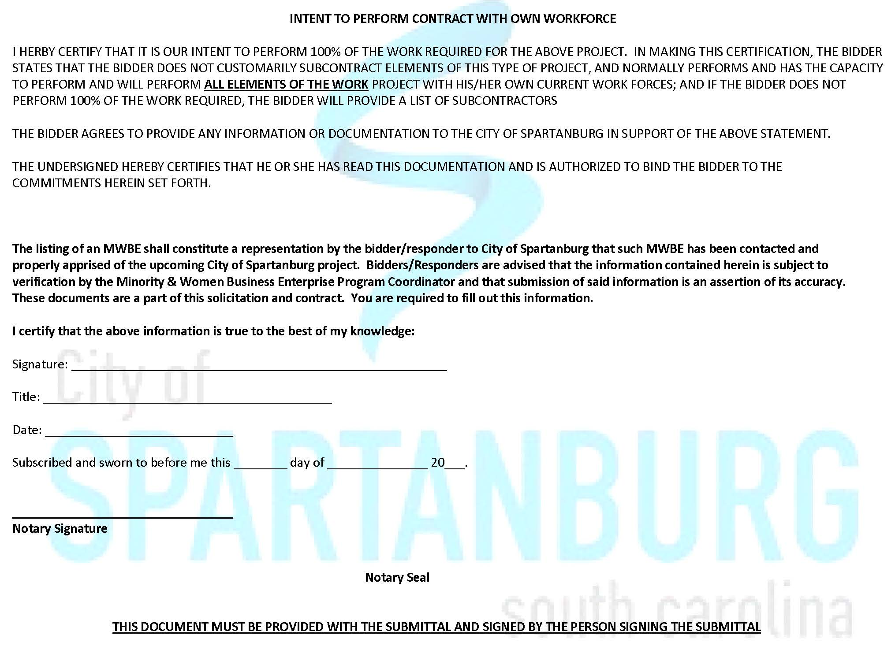
Page 7
Exhibit G
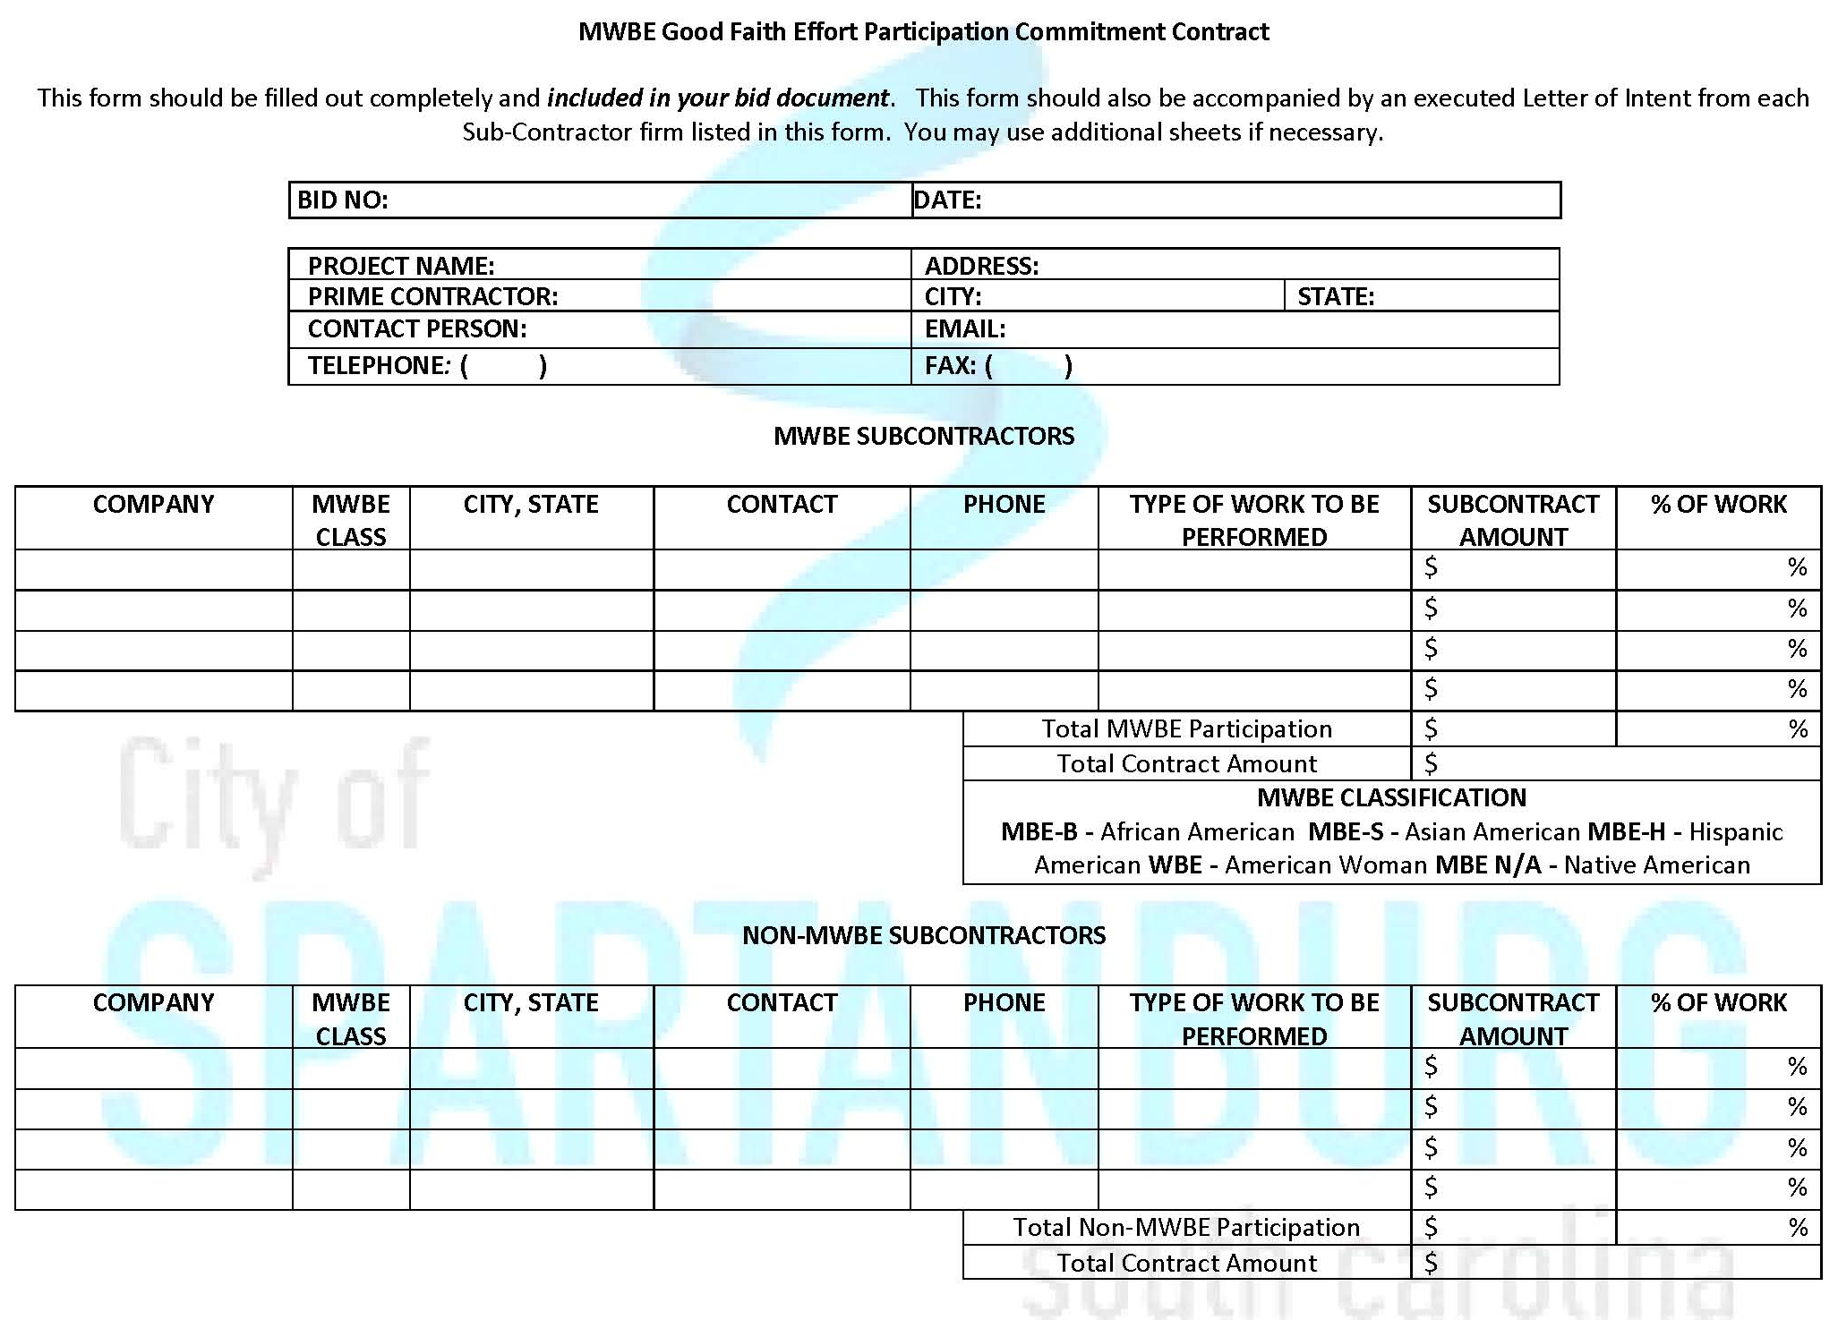
Page 7
Exhibit G

