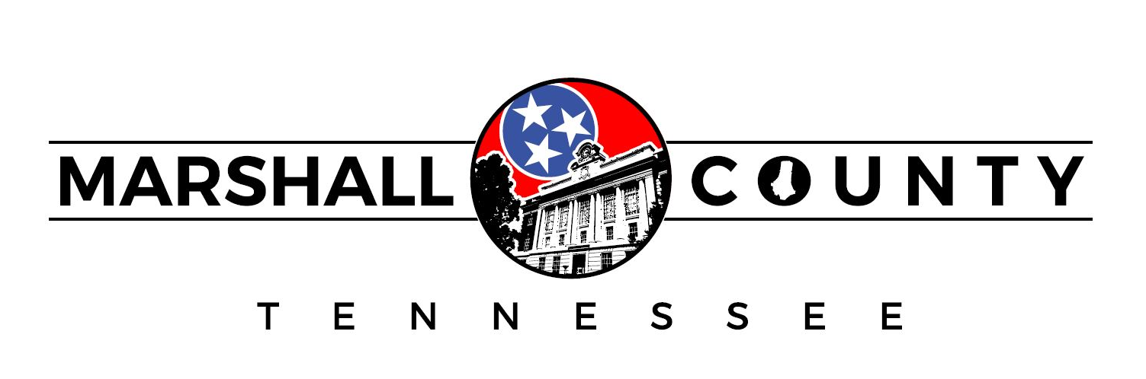
Request for Qualifications:
RETAIL RECRUITMENT PLAN

Marshall County Government
2205 Courthouse Annex, Lewisburg, TN 37091
Phone: (931) 359-2300 Fax: (931) 359-0551
Email: dwilliams@marshallcountytn.com

Request for Qualifications
Marshall County, TN in conjunction with the Marshall County Joint Economic and Community Development Board is seeking retail recruitment education services for the County in connection with its competitive grant application to the Tennessee Department of Economic and Community Development (TNECD) for Three-Star grant funds which have been allocated to the County for a retail recruitment plan with education component.
Description of Scope of Services
These services include the following items.

• Research necessary for retail recruitment including gap analysis and mobile data collection

• Community demographic research related to retail including actual and projected data, as well as consumer spending and behavior reporting

• Retail prospect list curated to community’s demographics according to data provided

• Real estate analysis to aid in identification of possible retail sites for development, traffic counts and existing targeted sites, including a retail property catalog

• Development of marking materials including customized retail recruitment plan

• Retail recruitment workshop for up to 12 community stakeholders with scheduled follow-up over the next year

Evaluation Criteria
Administrators will be rated on the following criteria:
- Past work performance including quality of work, timeliness, and program knowledge
- Capacity of firm to perform the work within the time limitations and grant requirements
- Familiarity of the firm with the objectives of the grant program
- Specialized experience or technical expertise of the firm with grant projects

Submittal of Qualifications
Firms should submit qualifications by Thursday, 2:00 p.m. CST on January 18, 2024, to Debbie Williams at the Marshall County Budget Office, 2205 Courthouse Annex, Lewisburg, TN 37091 or via email to dwilliams@marshallcountytn.com . Marshall County’s evaluation proceedings will be conducted within the established guidelines regarding equal employment opportunity and nondiscriminatory action based upon the grounds of race, color, religion, national origin, sex, creed, age, and disability. All firms submitting qualifications must be willing and capable to enter into a contract with the County.

