Request for Qualifications

Solicitation Name and Number | Master Planning Services for the Western Heights Site C21005
Responses Must Arrive No Later Than | 11:00 a.m. on August 12, 2020 (as KCDC’s clocks indicate)
Deliver Responses to: | procurementinfo@kcdc.org
Electronic Copies | Suppliers are to use the MS Word version posted on KCDC’s website to provide a typed response.
Solicitation Meeting | ☒ Yes ☐ No
Solicitation Meeting is Mandatory | ☐ Yes ☒ No ☐ Not Applicable
Solicitation Meeting Date and Time | August 5, 2020 at 9:00 a.m.
Solicitation Meeting Connection | KCDC will host an on-line meeting. Email procurementinfo@kcdc.org for the web link.
Questions About This Solicitation | Submit questions to procurementinfo@kcdc.org by the end of August 7, 2020.  KCDC will not accept questions via telephone.
Award Results | KCDC posts the award decision to its web page at: https://www.kcdc.org/procurement/
Open Records/Public Access to Documents | All document provided to KCDC are subject to the Tennessee Open Meetings Act (TCA 8-44-101) and open records requirements.
Check KCDC’s webpage (https://www.kcdc.org/procurement/) for addenda and changes before submitting your response

General Information

1. Background and Intent
a. Knoxville's Community Development Corporation (KCDC) is the public housing and redevelopment agency for the City of Knoxville and for Knox County in Tennessee. KCDC’s affordable housing portfolio includes 20 sites with approximately 3,525 dwelling units. KCDC also oversees approximately 3,958 Section 8 Vouchers, 82 Moderate Rehabilitation units and 20 Redevelopment areas.

Several of KCDC’s largest properties are undergoing substantial rehabilitation or total redevelopment through HUD’s Rental Assistance Demonstration (RAD). Notable projects include the Five Points and Austin redevelopment efforts. KCDC will complete the redevelopment of the former Walter P. Taylor and Lee Williams properties in September 2020. This multiyear process started with master planning and moved to a four stage demolition and rebuilding of 336 energy efficient, affordable units. KCDC more recently completed master planning for its Austin Homes community. The master planning, completed in 2018 and 2019, suggested approximately 425 affordable and workforce units to replace the 129 existing units. The demolition was completed in the winter and construction on the first phase started in July 2020. The first phase is 105 units, comprised of 43 PBRA units, 36 60% AMI units, and 26 market rate units. Both master plans also emphasized the replacement of aging infrastructure, reconnection of streets to the existing neighborhood grid; improved connectivity through construction of sidewalks, greenways, playgrounds and open space.

KCDC’s next master planning and redevelopment effort is Western Heights and that process will begin upon selection of a master planning team. The project should be completed within the following year. Unlike past projects, KCDC intends to apply for a Choice Neighborhood Planning Grant on September 14, 2020.

b. KCDC is soliciting qualifications statements from highly qualified firms to provide master planning, architectural design and engineering support services for the Western Heights master planning and redevelopment process. Services required may include but are not limited to:

- Help KCDC in its process of applying for a Choice Neighborhoods Planning Grant
- Evaluation of existing conditions (both the Western Heights housing development as well as the surrounding neighborhood)
- Architectural and Engineering design
- Charrette Facilitation and Public Engagement Process
- Environmental Reviews
- Feasibility Study and Analysis of Existing Conditions for site planning
  - Civil evaluation of housing feasibility
  - Geotechnical Evaluation
- Green/Energy Efficient Design
- Landscape Architecture/Open Space Planning
- Market Study
- Preparation of Preliminary Development Budget (Sources/Uses)
- Surveying
- Transportation Planning/Traffic Study
- Other related services
c. In addition to development of the master plan, KCDC intends for the selected firm to provide design services for the first phase of rehab/construction, the specific scope of which will be determined as part of the master plan. If the overall project is implemented in multiple phases, KCDC may at its sole discretion elect to use the awarded firm for any and all phases of the project. It is imperative that the selected firm consider the unique topographical issues of the neighborhood in the master planning and ultimate architectural design.

d. Western Heights, located just off Keith and Western Avenues in northwest Knoxville, is KCDC’s largest affordable housing property with 440 units. It features ample acreage (the entire site, including roadways is approximately 70 acres), and sweeping views of downtown and the Smoky Mountains. This property has access to churches, public schools, public transit and other resources. Some specific community amenities are a Boys and Girls Club, a walkable elementary school, Beaumont Magnet Academy (which is highly regarded in the community) and a future Head Start facility, currently in predevelopment. The area does not, however, have easy pedestrian access to jobs or the urban core. Much of the surrounding area is composed of small single family residences, some of which are in a state of disrepair. Also adjacent to the site is the location of the former Rule High School, which is now mostly boarded up and only partially utilized for school system maintenance.

Western Heights has a mix of 1, 2, 3, 4 and 5 bedroom units. A section of the property (244 units) built in 1939 underwent a moderate renovation in 2019, and there are limited upgrades remaining for this portion of the site. The other section of the property, built in the 1950s was not rehabbed. The City vastly improved vehicular connectivity to the site with the expansion of Western Avenue in 2019. Although the units have been well maintained, aspects of the physical design are obsolete, particularly the newer units that did not undergo the rehab. Aging infrastructure may be in need of replacement; site access and connectivity could be improved; and off street parking is inadequate. The topography of the site is challenging and is an important consideration of the ultimate master plan.

e. KCDC has an existing environmental review of the site. KCDC does want the firm to conduct a geotechnical evaluation of the site.

f. KCDC has an old site survey and a boundary survey is being conducted.

g. Western Heights and the surrounding neighborhood is undergoing some revitalization. As mentioned above, the City of Knoxville significantly improved the nearby vehicular connections with the improvement of Western Avenue. Additionally, in the nearby Lonsdale community, the Emerald Youth Foundation just added an eight million dollar 30,000 square foot family and youth complex which includes community space, soccer fields, a full size gym and a Cherokee Health Clinic. The complex is a five minute drive, or a 1.7 mile walk from Western Heights. Finally, KCDC and CAC have signed a letter of intent to construct a new Head Start Facility on the Western Heights campus. While these three items, as well as the Beaumont Magnet Academy and The Boys and Girls Club are positive forces in the community, there are a number of areas in the community that require additional investment. Effective growth here requires proper planning. While redevelopment is a product of a strong local economy, there are issues related to affordability, traffic and infrastructure that will need to be considered as part of this planning process.
It is critical that the master planning process improve connections between Western Heights and community assets (both planned and existing). Planning for this revitalization must consider the needs and desires of current and future tenants – both residential and commercial.

The planning will focus on three core areas: People, Neighborhood and Housing. The culmination of this planning process will be a Master Plan that serves as a blueprint and catalyst for the community’s shared vision of what this area can become.

2. Changes after Award
It is possible that after award KCDC will need to revise the service needs or requirements specified in this document. KCDC reserves the right to make such changes after consultation with the supplier. Should additional costs arise, the supplier must document increased costs. KCDC reserves the right to accept or reject and negotiate these charges.

3. Codes and Ordinances
All work covered is to be done in full accord with national, state and local codes and ordinances and orders that are in effect at the time the work is performed.

4. Contact Policy
Only contact KCDC’s Procurement Division about this solicitation from the issuance of this RFP until its award. Information obtained from any other person will not affect the risks or obligations assumed by the supplier or relieve the supplier from fulfilling any of the conditions of the resulting award. Such contact can disqualify the supplier from the solicitation process.

5. Evaluation
All responses are subject to a determination of “responsive” and “responsible” prior to award. KCDC is the sole judge as to the supplier’s “responsiveness” and “responsibility.” KCDC reserves the right to request additional information to assist in the evaluation process. This includes references and business capacity information.

a. KCDC will review all proposals and reserves the right to request necessary modifications, waive minor technicalities, reject all proposals, reject any proposal that does not meet mandatory requirement(s) or cancel this RFP, according to KCDC’s best interests. KCDC further reserves the right to make adjustments to its evaluation scenario if the changes are in KCDC’s best interest and consistent with good business practices.

b. KCDC’s Evaluation Team may elect to interview one or more suppliers before making an award.

c. KCDC’s Evaluation Team may elect to first rank proposals with a simple numeric score and then detail score only the top tier of proposals.

d. KCDC evaluates responses on a weighted evaluation system. The categories and points assigned for each category are below. Details of each factor are provided later in this document.

CRITERIA | POINTS
Master Planning Team Experience and Vision | 40
Architectural/Design Team Experience and Vision | 30
Project Approach | 20
References/comparable projects | 10
TOTAL | 100

6. General Instructions
a. KCDC does not insert “General Instructions to Suppliers” in solicitation documents. These instructions are at www.kcdc.org. Click on “Procurement” and then follow the link to the instructions. The supplier’s submittal means acceptance of the terms and conditions set forth in KCDC’s “General Instructions to Suppliers.”

b. Paragraphs in the “General Instructions” document that do not apply to this solicitation: 16, 33a, 33b, 33e, 53, 65, 69.

7. Insurance
a. The Master Developer (“Firm”) agrees to obtain and maintain at its sole expense during the term of this agreement insurance coverages and limits in accordance with the Firm’s standard business practices and acceptable to KCDC. Such insurance shall contain or be endorsed to contain a provision that includes KCDC, its officials, officers, employees and volunteers as additional insureds with respect to liability arising out of work or operations performed by or on behalf of the Firm including materials, parts, or equipment furnished in connection with such work or operations. The coverage shall contain no special limitations on the scope of its protection afforded to the above-listed insureds.

b. The supplier will submit a copy of their Certificate of Insurance with their proposal package.

8. Invoicing
a. Suppliers are required to submit invoices within 90 days following the delivery of the goods or services. KCDC may deny invoices submitted after the 90-day threshold.

b. KCDC normally pays by electronic transfer (ACH) only.

c. KCDC requires that invoices be submitted via email.

9. Licensure
Suppliers must possess and maintain proper licensure from the State of Tennessee and all other authorities having jurisdiction throughout the term of this award.

10. Ownership
Any reports, specifications, blueprints, negatives or other documents prepared by the supplier in the performance of its obligations under the resulting contract shall be KCDC’s exclusive property and all such materials shall be returned to the owner upon completion, termination, or cancellation of this contract. The suppliers shall not use, willingly allow, or cause such materials to be used for any purpose other than performance of all supplier’s obligations under the resulting contract without KCDC’s prior written consent.

Documents and materials developed by the supplier under the resulting award shall be KCDC’s property. However, the supplier may retain file copies, which cannot be used without KCDC’s prior written consent.

11. Qualifications
The successful firm will have the following qualifications:

a. At least one architect licensed by the State of Tennessee.

b. Previous experience with similar planning and design of related site plans.

c. Demonstrated understanding of the planning process, including managing the requirements of community stakeholders, regulatory authorities, utility providers and KCDC’s future needs.

12. Scope of Work
The selected firm will assist with the (expected) tasks shown below. This list is not necessarily all inclusive.

a. Review of Existing Conditions

  - Research and analyze site conditions including the location of services, utilities, topography, drainage, vehicular and pedestrian circulation and access to neighborhood amenities and services.

  - Research and analyze applicable development and zoning regulations affecting redevelopment options.

  - Research and analyze pertinent public and KCDC records, topography surveys, as-built surveys, et cetera, relating to the site.

  - Research and analyze nearby existing development patterns including housing, commercial, public facilities and parks.

  - Research and analyze other private and public development occurring in the immediately surrounding that may impact the development of the site.

  - Develop comprehensive base map and narrative reflecting all current conditions including adjoining neighborhoods.

  - Engage market study consultant to prepare market feasibility study to inform the master planning process.

b. Land Use Analysis

  - Review the demographic, behavioral and economic characteristics of the surrounding neighborhood as they relate to neighborhood design, organization, density, amenities and housing preferences.

  - Address the impact of the contiguous properties on the proposed development of the site and propose solutions to any negative impacts.

  - Perform a market analysis with recommendations as to the nature, number and type of residential units proposed for the site; the nature and scale of commercial development; and any recommended surrounding community development.

  - Review plans for existing and proposed area developments (including those referenced in Section 1), sidewalks, greenways, parks, and other public spaces, and propose solutions to better connect and incorporate these assets into the development.

c. Preliminary Conceptual Plan

  - Meet with KCDC representatives to outline initial goals/objectives, create a framework and timeline to reach those goals. After the KCDC meeting schedule approximately 10 one on one or small group meetings with key stakeholders.

  - Meet with Western Heights residents, community stakeholders, regulatory authorities (including, but not limited to, utility providers, Knoxville-Knox County Metropolitan Planning Commission, the City of Knoxville and Knox County) and the public at large to present and discuss conceptual plan alternatives. This must include a minimum of four resident meetings, four public meetings, and four stakeholder group meetings. At least two of the meetings with each group must focus on engaging community members in the planning process via a charrette or other collaborative approach to solicit thoughts and ideas from the community.

  - Based on public input, existing conditions, land use analysis, and initial goals, develop not less than three distinct and different conceptual plan alternatives identifying land uses and infrastructure.

  - Modify, refine, and finalize the conceptual plan with input from Western Heights residents, community stakeholders, regulatory authorities, and the public. The conceptual plan will be used as the basis for development of the final master plan.

d. Master Plan Alternatives

  - Meet with KCDC staff and Commissioners to discuss master plan direction and alternatives. Bi-weekly project review/update meetings with KCDC staff are contemplated. Some meeting may be done by video conference or teleconference.

  - Develop a minimum of three master plan alternatives by overlaying the conceptual plan with building types and locations.

  - Develop preliminary cost estimates for each alternative in current year dollars.

  - Meet with residents, community stakeholders and regulatory authorities to present and discuss master plan alternatives.

  - Refine master plan alternatives based upon input received during presentations to various participants in the redevelopment process.

e. Final Master Plan

  - Meet with KCDC to finalize the master site plans.

  - Develop detailed master plan and architectural concepts for the proposed buildings and proposed infrastructure improvements.

  - Develop preliminary cost estimates based upon unit quantities, types and prices.

  - Develop a plan for phasing the implementation of the master plan, taking into consideration such factors as the estimated development costs, the need to relocate current residents, the HUD approval process required for further demolition on the site, the probable availability and timing of financing resources, the sequencing of phases that would be least disruptive to the implementation of later phases of redevelopment and most conducive to the efficient installation of infrastructure improvements.

  - Meet with residents, community stakeholders and regulatory authorities to present and discuss the master plan design.

  - Prepare a final master plan including presentation scale drawings of the site, representative drawings of the buildings, site plans, cost estimates, a minimum of three perspective drawings of the plan including one bird’s eye perspective of the entire site, recommended phasing of the revitalization and bound copies of the final report. Provide all documents in electronic form such that KCDC may utilize them.

  - Final submission is KCDC’s sole property and shall include a hard copy and electronic submissions of maps, plans, PowerPoint presentations and other related documents.

f. Additional Services

  - The successful firm may be engaged to assist KCDC in the procurement of other services needed to fully develop the master plan, including such services as market studies, engineering analysis and design, transportation and infrastructure studies, and financial feasibility studies. All such procurements shall be performed in accordance with KCDC’s procurement policies.

  - At KCDC’s sole discretion, the successful firm may be engaged to perform similar services related to execution of the master plan.

g. Other Notes

1. The successful firm will develop a master plan and strategies for implementing it, recognizing such challenges as the relocation and appropriate assistance to current residents, physical configuration, potential for market absorption, funding resources and other factors.

2. While this RFQ is soliciting proposals for the development of the master plan and strategies for its implementation, the successful firm may be engaged to provide services to KCDC throughout any actual implementation of the plan.

13. Smoke Free Policy
a. KCDC’s Smoke Free policy is applicable to you, your employees and subcontractors. The policy mandates:
- No smoking on owner’s property
- No e-vape or similar usage on owner’s property
- The Smoke Free policy applies in personal or corporate vehicles on owner’s property

b. Applicable definitions include:
- “Smoking” means inhaling, exhaling, burning or carrying any lighted or heated cigar, cigarette or pipe, or any other lighted or heated tobacco or plant product intended for inhalation, including hookahs and marijuana, whether natural or synthetic, in any manner or in any form. “Smoking” also includes the use of an electronic smoking device which creates an aerosol or vapor, in any manner or in any form.

- “Electronic Smoking Device” means any product containing or delivering nicotine or any other
substance intended for human consumption that can be used by a person in any manner for the purpose of inhaling vapor or aerosol from the product. The term includes any such device, whether manufactured, distributed, marketed or sold as an e-cigarette, e-cigar, e-pipe, e-hookah or vape pen or under any other product name or descriptor.

- Property means all buildings, parking lots, streets, structures and land owned by owners. Should your staff be observed violating these requirements, KCDC’s Procurement Division will notify your firm about the problem. Should there be recurrences, KCDC may ask your firm to not send the employee to KCDC’s property. Repeated offenses may result in forfeiture of your awarded “contract.”

14. Solicitation Requirements
Caution: Requirements in the solicitation are not optional. If you have concerns or issues with any of the stated requirements, raise them before the due date. Examples of past issues where suppliers made faulty assumptions include Insurance requirements and payment expectations.

15. Submittal Instructions
Submit your information in the order indicated below:

Document | Title
Solicitation Document A | General Response Section
Solicitation Document B | Affidavits
Solicitation Document C | HUD Form 5369A
Solicitation Document D | Firm’s Executive Coversheet
Solicitation Document E | Master Planning Team and Experience
Solicitation Document F | Architectural/Design Team and Experience
Solicitation Document G | Project Approach
Solicitation Document H | References

a. Place your company’s name on each page and number all pages consecutively

b. The use of tables in presenting information facilitates the evaluation team’s review.

c. Do not use phrases such as “See the attached” or “Will be provided upon award.”

d. Proposals are limited to 30 pages’ total. A page is the front and reverse of one 8.5 x 11 sheet of paper.

This and the previous pages do not need to be returned

Master Planning Services for the Western Heights Site C19006

Solicitation Document A General Information

General Information about the Supplier
Sign Your Name to the Right of the Arrow
Your signatures means you agree to “KCDC’s General Instructions to Suppliers” on www.kcdc.org.
Printed Name and Title
Company Name
Street Address
City/State/Zip
Contact Person (Please Print Clearly)
Telephone Number
Cell Number
Supplier’s E-Mail Address (Please Print Clearly)
Addenda
Addenda are at www.kcdc.org. Click on “Procurement” and then on “Open Solicitations” to find addenda. Please check for addenda prior to submitting a proposal.
Acknowledge addenda have been issued by checking below as appropriate:
None ☐ | Addendum 1 ☐ |  |  | Addendum 2 ☐ |  | Addendum 3 ☐ |  |  | Addendum 4 ☐ | Addendum 5 ☐
Statistical Information (Check all the apply)
This business is at least 51% owned and operated by a woman |  |  |  |  |  |  |  |  |  |  | Yes ☐ No ☐
This business qualifies as a small business by the State of Tennessee  (Gross receipts of $10,000,000 or less and employing less than 100 full time persons ) |  |  |  |  |  |  |  |  |  |  | Yes ☐ No ☐
This business qualifies as Section 3 business (as defined by HUD):  It is at least 51% owned by a Section 3 resident (lives in Public Housing) or it employs Section 3 residents for at least 30% of its employee base; or it commits to sub contract at least 25% of the project’s dollars to a Section 3 business. |  |  |  |  |  |  |  |  |  |  | Yes ☐ No ☐
This business is owned & operated by persons at least 51% of the following ethnic background:
Asian/Pacific ☐ |  | Black ☐ | Hasidic Jew ☐ |  | Hispanic ☐ |  |  | Native Americans ☐ |  |  | White ☐
Prompt Payment Discount
A prompt payment discount of ________% is offered for payment within ____ days of submission of an
accurate and proper invoice.
Mastercard is accepted for payment without additional fees. Yes ☐ No ☐

Solicitation Document B Affidavits

Supplier: _____________________________________________________________________________

Conflict of Interest:
1. No commissioner or officer of KCDC or other person whose duty it is to vote for, let out, overlook or in any manner superintend any of the work for KCDC has a direct interest in the award or the supplier providing goods or services.

2. No employee, officer or agent of the grantee or sub-grantee will participate in selection, or in the award or administration of an award supported by Federal funds if a conflict of interest, real or apparent, would be involved. Such a conflict would arise when the employee, officer or agent, any member of his immediate family, his or her partner, or an organization, which employs, or is about to employ, any of the above, has a financial or other interest in the supplier selected for award.

3. The grantee's or sub-grantee's officers, employees or agents will neither solicit nor accept gratuities, favors or anything of monetary value from suppliers, potential supplier s, or parties to sub-agreements.

4. By submission of this form, the supplier is certifying that no conflicts of interest exist.

Drug Free Workplace Requirements:
5. Private employers with five or more employees desiring to contract for construction services attest that they have a drug free workplace program in effect in accordance with TCA 50-9-112.

Eligibility:
6. The supplier is eligible for employment on public contracts because no convictions or guilty pleas or pleas of nolo contender to violations of the Sherman Anti-Trust Act, mail fraud or state criminal violations with an award from the State of Tennessee or any political subdivision thereof have occurred.
General:
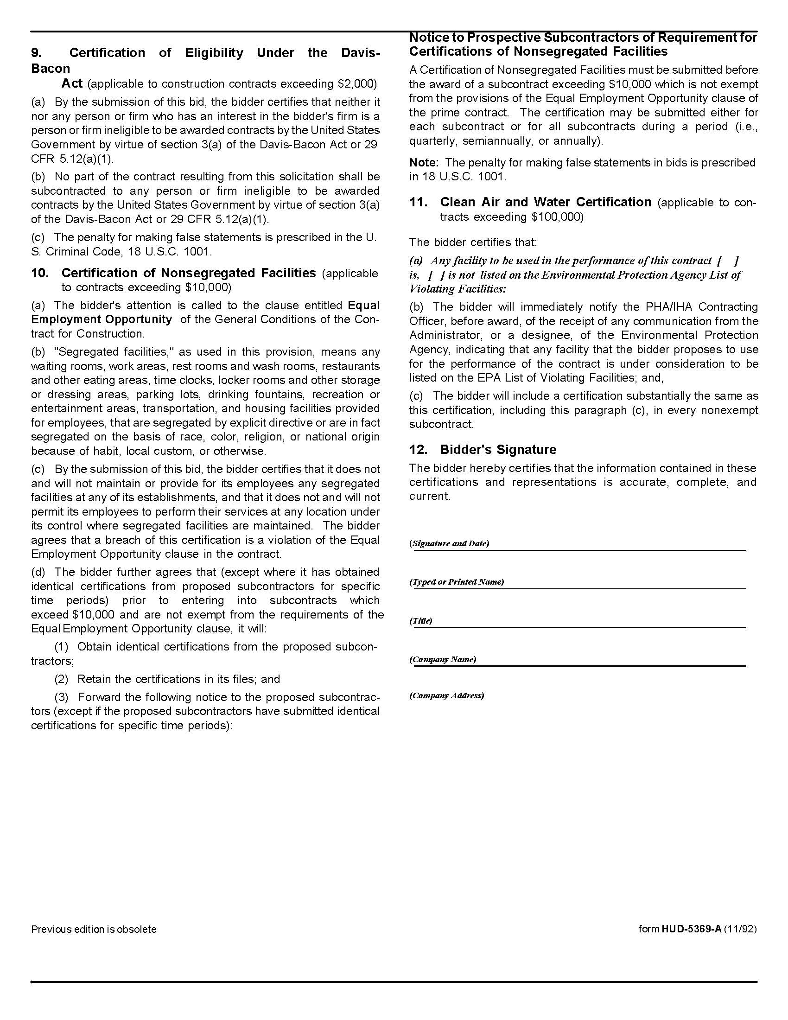
7. Supplier fully understands the preparation and contents of the attached offer and of all pertinent circumstances respecting such offer.

8. Such offer is genuine and is not a sham offer.

Iran Divestment Act:
9. Concerning the Iran Divestment Act (TCA 12-12-101 et seq.), by submission of this bid/quote/quotes, each supplier and each person signing on behalf of any supplier certifies, and in the case of a joint bid/quote/quotes, each party thereto certifies as to its own organization, under penalty of perjury, that to the best of its knowledge and belief that each supplier is not on the list created pursuant to § 12-12-106.

Solicitation Document B Affidavits-continued

Non-Collusion:
10. Neither the said supplier nor any of its officers, partners, owners, agents, representatives, employees or parties interest, including this affiant, has in any way colluded conspired, connived or agreed, directly or indirectly, with any other responder, supplier, or person to submit a collusive or sham offer in connection with the award or agreement for which the attached offer has been submitted or to refrain from making an offer in connection with such award or agreement, or collusion or communication or conference with any other supplier, or, to fix any overhead, profit, or cost element of the offer price or the offer price of any other supplier, or to secure through any collusion, conspiracy, connivance, or unlawful agreement any advantage against KCDC or any person interested in the proposed award or agreement.

11. The price or prices quoted in the attached offer are fair, proper and not tainted by any collusion, conspiracy, connivance, or unlawful agreement on the part of the supplier or any of its agents, representatives, owners, employees, or parties in interest, including this affiant.

Accuracy of Electronic Copies:
12. If the supplier provides electronic copies of the bid/proposal/quote to KCDC, the supplier certifies that the information provided on paper and in the electronic format is identical unless specifically noted otherwise.

The undersigned hereby acknowledges receipt of these affidavits and certifies that the submittal in response to this solicitation is in full compliance with the listed requirements.

Signed by
Printed Name
Title
Subscribed and sworn to before me this date
By (Notary Public)
My Commission Expires on
Notary Stamp

Solicitation Document C HUD Form 5369A

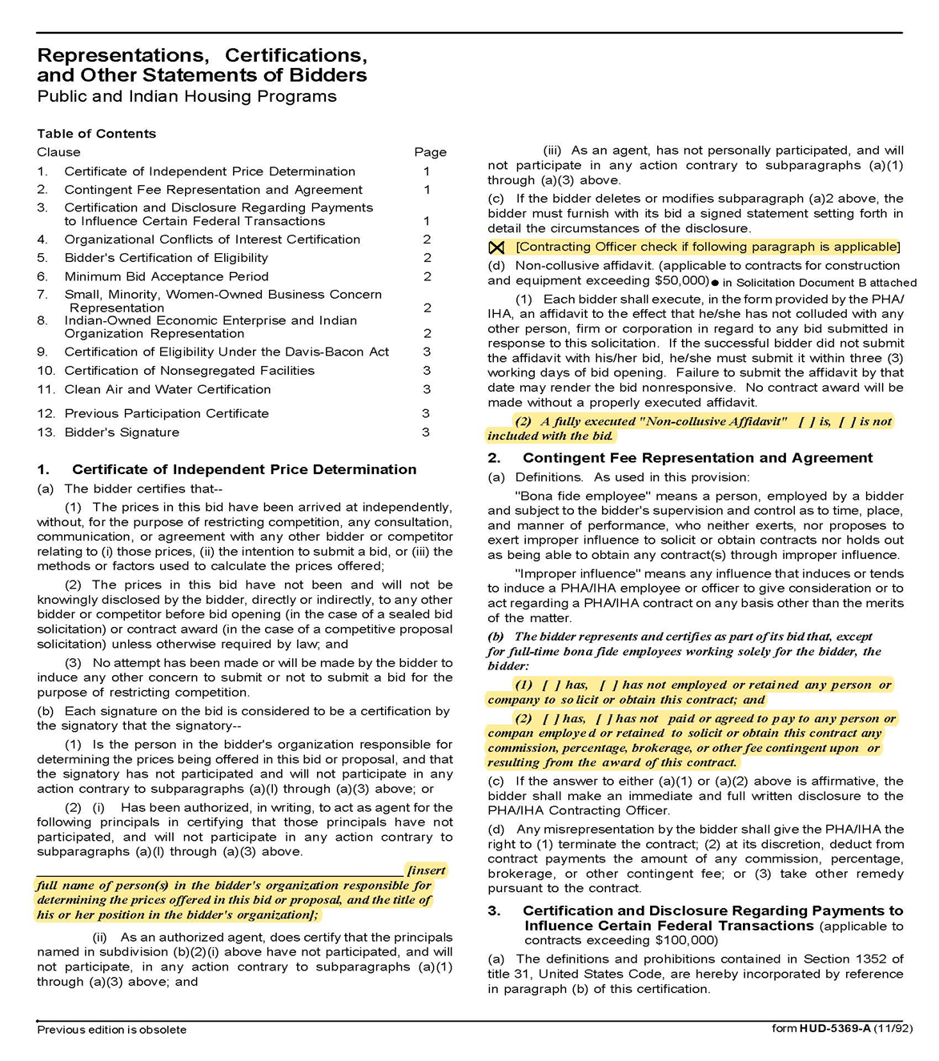

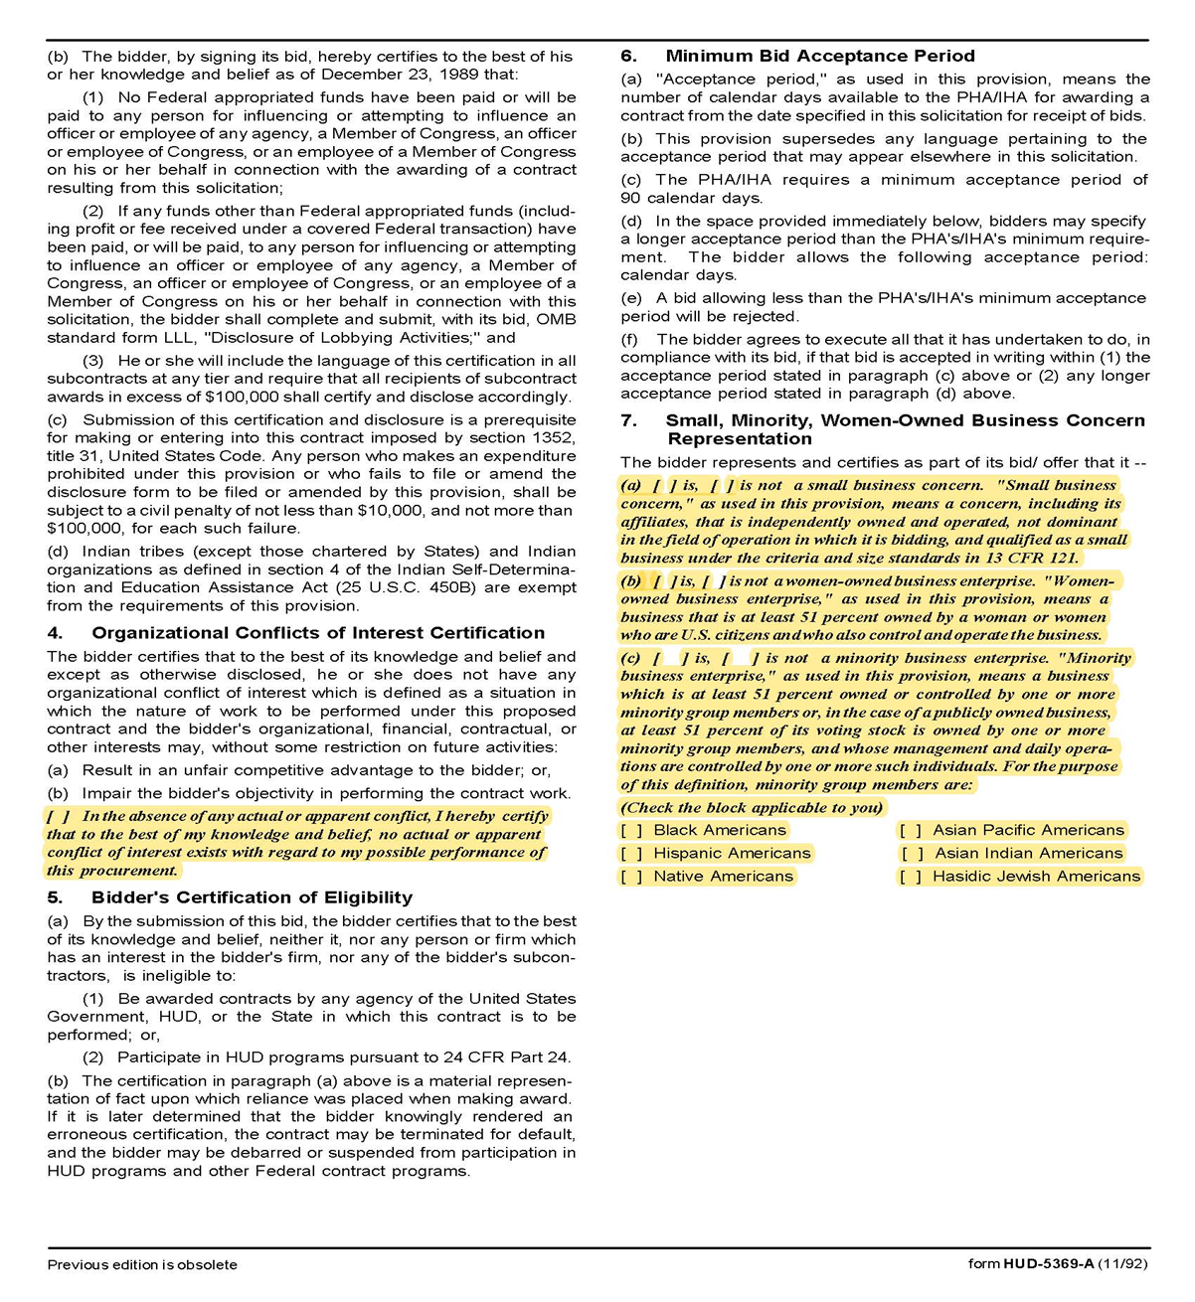
Solicitation Document C HUD Form 5369A-continued

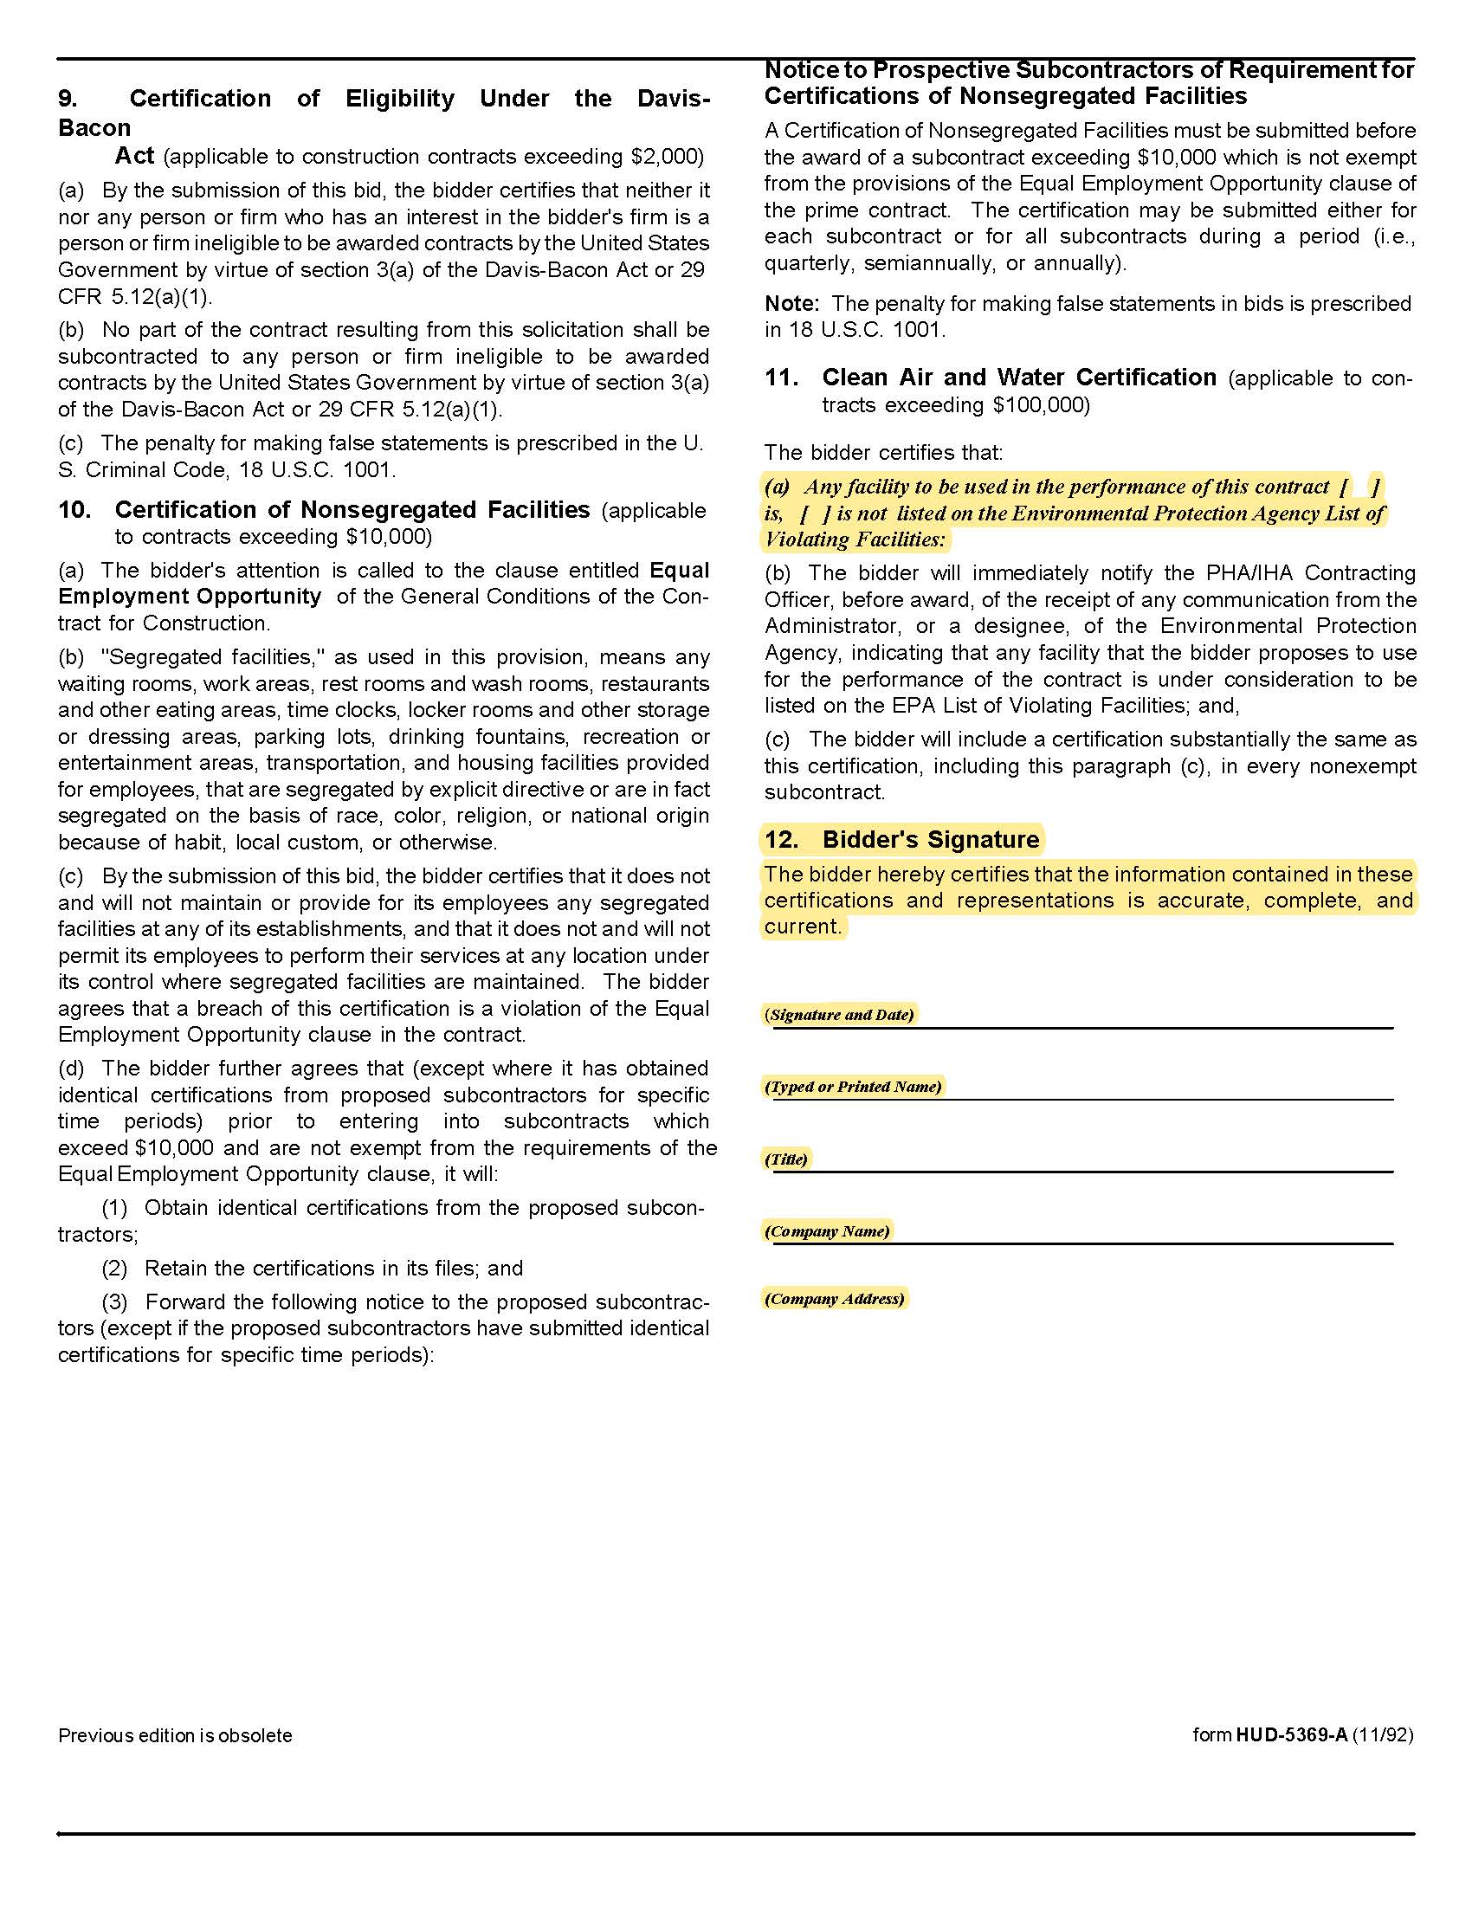
Solicitation Document C HUD Form 5369A-continued

\

Solicitation Document D Executive Summary Cover Letter

Provide an Executive Summary Cover Letter (two pages or less) that includes:

1. A statement explaining your interest in the project.

2. An overview of the proposed project team.

3. An explanation of why the team is best qualified for the work.

4. A statement that the firm agrees to and accepts the terms and conditions of the RFQ.

5. The name and contact points for the firm’s authorized negotiator.

6. Other information as desired.

Solicitation Document E Master Planning Team and Experience

1. Provide an organizational structure of the proposed team identifying key team members, associated roles and responsibilities along with the availability of key team members to complete the scope of work in a timely manner.

2. Identify the person/firm(s) that will lead the community outreach efforts.

3. Provide a list of recently completed projects of a similar nature and scope. For each identify:

- The initial project timeframe
- The actual project timeframe (provide any necessary explanations)
- The initial project budget
- The actual project budget (provide any necessary explanations)
- Drawings/photographs from recent projects

4. A narrative description of the company’s experience with Master Planning.

- Multifamily Housing Projects
- Affordable projects
- Public Housing or other Neighborhood Revitalization

5. Provide examples of the work product that KCDC may expect you to deliver during the master planning process. Include examples of residential and mixed use projects within an urban neighborhood setting. In this response, address any concerns, issues, or discussion topics that should be addressed during contract negotiations to ensure successful, timely, and cost effective completion of the project.

Solicitation Document F Architectural/Design Team and Experience

1. Identify key professionals on the project team.

2. For at least one and preferably two, licensed/registered professionals for each major discipline (including partners and subcontractors) list relevant qualifications and experience with similar projects.

4. Indicate plans to partner with small, minority, or woman owned firms to complete this work. If work is to be subcontracted, KCDC is highly interested in firms partnering or using small, minority and women owned firms.

5. Indicate the relevant project experience of the architects.

6. Indicate the relevant project experience of any proposed subcontractors and their experience with past similar projects.

7. Identify comparable projects employing best practice green and/or sustainable design, construction and operation principles.

8. Provide illustrative examples of urban planning and design conducted by your firm, that is of a similar scale to the Western Heights site, and which included intentional consideration and planning for the factors that create a high-quality and enduring neighborhood: transportation, walkability, bikeability, connectivity, open spaces, public art, neighborhood amenities, community services, a sense of place and outstanding residential and commercial design.

Solicitation Document G Project Approach

1. Provide an explanation of how the project team will successfully accomplish the stated scope of work in a timely manner and within the established budget. Provide a detailed outline and description of the community engagement process, from initial goal setting all the way through finalization of the master plan. Keep in mind the master planning effort will be highly visible and will attract significant interest from the community. Highlight any specific timing constraints or limitations relative to the scope of work that might delay completion of any of the requirements of this RFQ.

2. Indicate the proposed process for finalizing the building program and the methodologies to be employed to identify, evaluate and determine sustainable goals for design techniques, building technologies and construction projects and aesthetic best suited for the project.

Solicitation Document H References

1. Provide information about experience with public entities to show proven and demonstrated ability to execute the work requirements. The proposal must include five specific references of similar accounts. Note that while your firm may have performed multiple jobs for a company, a company can only be one reference.

2. Present information in this format:

- Name of the business serviced
- Contact name
- Address
- Phone number
- Email address
- Amount of the contract (or use the description bullet to enable KCDC to understand its magnitude)
- Description of the work perform
- Date the contract began
- Date the contract ended (if applicable)

3. KCDC may use SurveyMonkey to collect reference information so please make sure that your contacts know to respond to emails from KCDC and/or SurveyMonkey.

Appendix 1 Map of Western Heights

