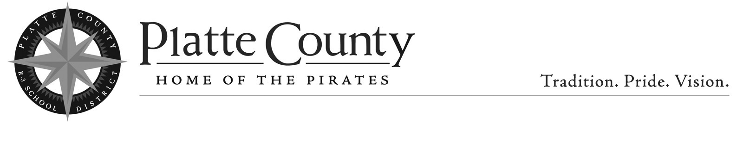

April 2, 2020

To Whom It May Concern:

Please be advised that the Platte County R-3 School District will receive sealed bids for the purchase of four (4) new 2021 model 77-passenger school buses. There will be the trade-in of three (3) current fleet 77-passenger buses. In addition, each bidder is invited to submit a bid for four (4) used buses (not to exceed 25,000 miles) with the same specifications as noted for the new buses.

Bids are to be submitted according to the enclosed Bid Specifications for 2021 Type C 77-Passenger Diesel School Buses specification sheets and Instructions to Bidders notice. All buses bid must meet or exceed the standards set forth in the 2017 Missouri Minimum Standards for School Buses, as adopted by the Missouri Department of Education.

Bids must be submitted on the enclosed Bid Sheet form, and are to be marked with the bidder’s name and the words “Bus Bid” clearly marked on the outside of the envelope.

Bids are to be received on or before Tuesday May 12, 2020 at 10:00am.

Summary sheets and purchase recommendations will be made to the Board of Education at the regularly-scheduled board meeting on May 21, 2020. Prices are to remain firm for a period of thirty (30) days after the board meeting date.

It is the intent of the District to purchase four (4) new school buses (or used buses) and to sell/trade three (3) used buses as a part of the bid package. However, the Platte County R-3 Board of Education reserves the right to accept or reject any and all bids, or to reduce the number of buses purchased if budget conditions warrant such a reduction.

Bids are to be submitted to: JT Thomas, Director of Transportation, Platte County R-3 School District, 998 Platte Falls Rd., Platte City, MO 64079.

Sincerely,

JT Thomas
Director of Transportation

Attachments

