

City of Adams, Tennessee

Roof Project – Omer Gene Brooksher Pavilion
Bid # 2025-20 Packet

Tuesday November 25, 2025
The City of Adams, TN is requesting sealed bids for the Omer Gene Brooksher Pavilion. The City of Adams desires to obtain pricing for roofing tasks. All offerings made under this invitation shall meet or exceed the detailed requirements as set forth in the attached minimum specifications, drawings and plans, if any.

INSTRUCTION TO BIDDERS
Bid Submittal:
The bidder must submit their proposal on the “Bid Forms” provided by the City of Adams. The bid pricing must be typed or written in blue or black ink. The bids will be received by the City Recorder by the 7th of January 2026 at 3:00 pm (central time). The bid due date and time will be strictly observed. It is the responsibility of the bidder to ensure that their bid is delivered via mail, carrier, by hand or other method prior to the scheduled bid opening day, date and time.
Before submitting a bid or proposal each bidder shall carefully examine the project site and the specifications, drawings and plans and inform themselves fully concerning the existing conditions, and shall make their bid or proposal to provide the items covered at the lowest cost while offering the best service and quality.
Bids shall be identified on the exterior of the sealed envelope with all the information required by law, including the name of the project and the bidder's name, address and license number, expiration date and classification.

Bid Opening:
A bid opening will occur at the time and on the date as scheduled at 7:00 p.m. during the City Meeting on January 8th, 2026. The City of Adams reserves the right to reject any or all bids submitted.
Alternate bids and specifications are not acceptable unless specifically asked for and/or authorized in the “Advertisement for Bids”.

Bids submitted may be immediately rejected when:
• The bidder fails to use the provided bid form,
• Bid form is not signed by an authorized representative of the bidding company,
• Conditions are placed upon the bid by the bidder,
• Unauthorized additions to the bid by the bidder,
• Lack of appropriate documents as required or requested in the bid packet,

Bid Inspection:
A record shall be kept, listing each bidder by name and address and indicating their bid amounts. These records are to be open to public inspection after review and after the award to the successful bidder.
Evaluation Period:
1.The review period is following the bid opening, during which time the bids are closed to public inspection and lasts until the Adams Board of Commissioners award the project to an “Successful Bidder”.
2. During the period when evaluation is being made, all bid analysis is confidential, thereby maintaining the integrity of the bidding system.
3. None of the City of Adams personnel in any office should discuss information pertinent to any bid during this period, other than at scheduled meetings of the City of Adams personnel specifically intended for review with regard to the bid and/or project.
4. Violation of the confidentiality of bids pending award seriously compromises the City of Adams’ position in establishing contractual agreements.

During the bid review period, certain issues may be discussed with the potential “Successful” Bidder. Any failure to come to an agreement on the discussed issues may result in the rejection of that bidder’s bid and force the City of Adams to move to the next bidder in line, when deemed by the City of Adams as being in the best interest of the City of Adams.

Award of Business:
A bid shall be considered an offer subject to acceptance by the City of Adams. The City of Adams may reject any and all bids or delay or cancel the project for any reason.

Indemnity and Insurance Requirements:
The Contractor agrees to protect, defend and save harmless the City, its elected and appointed officials, agents, employees and volunteers, while working in the scope of their duties as such, from and against all claims, demands, and causes of action of any kind or character, including the cost of their defense arising from the Contractor's employees or third parties on account of bodily or personal injuries, death or damage to property arising out of services performed or omissions of service or in any way resulting from the acts or omissions of the Contractor and/or its agents, employees, subcontractors, representative or the City under this agreement.

The Contractor shall procure and maintain for the duration of the contract, at his/her own cost and expense, insurance against claims for injuries to persons or damages to property including contractual liability that may arise in connection with the performance of the work by the Contractor, his agents, representative, employees, or subcontractors under this agreement. The insurance carrier(s) must be licensed to conduct business in the State of Tennessee. The insurance will be evidenced by certificates of insurance. The certificate shall include wording that the City will be notified thirty (30) days prior to cancellation of the coverage or a major change in the coverage provided. The Contractor will either verify the listed coverage(s) for all subcontractors hired by the contractor to assist with the project, or the Contractor will assume total financial responsibility for uninsured claims of the subcontractor. The City shall be held harmless for any injuries, claims or judgments against the subcontractor. Certificates for liability coverage shall name the City as an additional insured. The following coverage will be required:
- Worker’s Compensation Insurance: A certificate shall be provided that indicates the contractor provides workman’s compensation coverage in compliance with the State Laws of Tennessee and including Employer’s Liability (Coverage B).
- General Liability Insurance with a minimum limit of $100,000 per occurrence. This insurance shall indicate on the certificate of insurance the following coverage:
- Broad Form Contractual
- Independent Contractor and Subcontractors
- Premises Operations

Project Description:
The work consists of removing old roof and placing a new roof on the City of Adams property. The work described in these specifications consists of furnishing all labor, materials, tools, equipment, appurtenances, incidentals, services and performing all work required. A general description of the work to be performed includes, but is not limited to, the following items.
(1) General
(2) Materials & Requirements
(3) Detailed Information on Roofs

The quantities of work identified above are estimated and may vary with actual field applications. The quantities are not guaranteed to be the final scope of work. The unit prices will not be adjusted should the quantities be reduced or increased.
In the event that the bids exceed the City’s available funds, the successful bidder and the City may negotiate reducing the scope of work based on the unit prices provided. The City also has the alternative to re-bid the project.

ALL WORK ON ROOF TO BE COMPLETED BY JUNE 30TH 2026.
NO WORK CAN BE DONE DURING THE MONTH OF ARPIL 2026.

(1) General:
The roof that the city will consider inclusion in the Bid #2025-20 Omer Gene Brooksher Pavilion roof project includes the following information:
A) Removal of existing roof system down to the substrate and inspect condition.
B) Replace any non-suitable roof substrate with OSB 7/16 Application as 4ft. X 8 ft. Sheathing Panel Board
C) Install a moisture barrier between roof and the substrate.
D) Install new metal roof on Pavilion & Kitchen Area - approximately 6,408 square feet.
E) Place metal where there are cedar boards on the east end of pavilion’s gable (where the Omer Gene Broosher sign is)
F) Dispose of removed roof materials off site and clean any debris on the ground from demolition.
G) Remove and Install new WHITE gutters on the pavilion
(2) Materials and Requirements:
29GA Tuff Rib WXL Panel (4/12 – 8/12)
4/12 to 8/12 roof pitch
Double Bubble
NN-Felt Staple 21Guage 3/8”
Staples used to secure synthetic underlayment to roof substrate
2GA Drip Edge (10’2”) installed on all eaves
29GA Ridge Cap 16IN (10’ 6”) installed on all hips and ridges
29GA Sidewall Flashing (10’ 2”) installed on all side walls
29GA W Valley w/ Hems (10’ 2”) installed in all valleys
29GA Small Corner (10’ 6”) installed on all rakes
Metal Roof Electric Pipe Boot
#3 Pipe Flange 1/4" – 5” installed on all plumbing pipes through roof system
29 GA outside closure
Metal roof Screws (1.5”) used for metal panel installation (250 ct. give or take)
Roof Repair- remove and replace 120-150 linear foot of 2x4 slats that are damaged or showing issues
Remove and Install NEW WHITE GUTTERS to the new roof
5 Year Workmanship Warranty
Additional Requirements for Contractor when submitting bids:
Bidder must be licensed contractors to perform the type of construction herein described and as required by Tennessee Code Annotated.
Bidder must also have a business license and provide a copy of their license.
Bidder must have liability insurance, workers comp insurance, and provide a copy of their certificate for each policy listing City of Adams as an additional insurer.
Bidder must fill out a W-9 and provide it to the City of Adams.
Bidder agrees with the submission of his bid to complete all work and provide invoices prior to June 15th, 2026. After inspection by the City of Adams all work to be repaired must be completed by June 30th, 2026.
By the submission of bid, the bidder agrees to complete all work with the requirements listed on the bid packet.
(3) Detail Information about Roof:
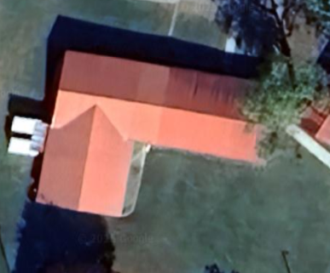
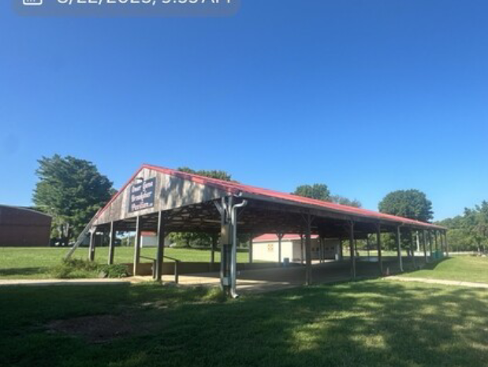
REFERENCE IMAGES

Omer Gene Brooksher Pavilion located at 7617 Hwy 41 North Adams TN 37010
Approximately 4,640 square feet pavilion area.
Removal of old roofing system, inspect substrates, replace any damaged areas of substrate, place new roof with moisture barrier, clean up and remove any materials removed, magnetize the area after completion.
5-year warranty workmanship should be included
*** City of Adams recommends each bidder measure square footage before placing bid. Please write square footage on bid form ****

City of Adams encourages all bidders to come to inspect roof before placing bids.
BID FORM: Bid #2025-20 Omer Gene Brooksher Pavilion Roof Project

Company/Bidder: _________________________________________________________
Contact Name: ___________________________________________________________
E-mail Address: __________________________________________________________
Address: _______________________________________________________________
_______________________________________________________________
Phone: __________________________ Fax: ________________________
Federal Tax Identification # (Please send a W-9 with Bid Form): ______________________
Item – Roof  Per Materials listed on Page 5 | Square Footage or Number of Materials | ***Measured by Bidder Square Footage*** | Unit Price  Per Item Listed | Bid Amount
1. Pavilion Removal of Existing Roof | Approximately 6,408 square feet |  |  | $
2. Materials – New Metal (Color match to existing) and Installation Costs
3. Substrate - OSB 7/16 Application as 4ft. X 8 ft. Sheathing Panel Board
4. Moisture Barrier -Double Bubble
5. New White Gutters
6. Labor & Warranty
Total of Project |  |  |  | $
Bid Prices

The above quantities are listed for calculation and comparison purposes only. Quantities may vary based on the City of Adams priorities and budgetary considerations.
It is further understood and agreed by the undersigned in submitting this proposal that the City of Adams reserves the following rights and privileges:
1. To accept or reject any or all bids.
CHECKLIST FOR BIDDERS FOR ALL FORMS SUBMITTED WITH BID FORM
_____Bidders shall not add any conditions or qualifying statements to this bid or the bid may be declared irregular and not being responsive to the Advertisement for Bids.
_____Bidder must be licensed contractors to perform the type of construction herein described and as required by Tennessee Code Annotated.
_____Bidder must also have a business license and provide a copy of their license.
_____ Bidder must have liability insurance, workers comp insurance, and provide a copy of their certificate for each policy listing City of Adams as an additional insurer.
_____Bidder must fill out a W-9 and provide it to the City of Adams.

Bidder agrees with the submission of his bid to complete all work and provide invoices prior to June 15th, 2026. After inspection by the City of Adams all work to be repaired must be completed by June 30th, 2026.
By the submission of bid, the bidder agrees to complete all work with the requirements listed on the bid packet.
The undersigned BIDDER proposes and agrees, if this bid is accepted and successful, to enter into an agreement with the City of Adams, Tennessee to perform and/or furnish the goods and/or services at the prices indicated below in accordance with the terms, conditions, time frame, specifications and contract stipulations.

Bid Submitted by: ______________________________________

______________________________ _______________________________
Authorized Signature Name (Printed)

_____________________________ _______________________________
Title Date

