Request for Proposals

FSA & COBRA Administration Services

Solicitation Number | Q1919
Due Date | November 30, 2018
Due Time | 11:00 a.m. EST
Deliver Responses to: | Knoxville’s Community Development Corporation    Procurement Division  901 N. Broadway  Knoxville, TN 37917  Procurement is in a building behind the main office building.
Electronic Copies | Electronic copies are available on KCDC’s webpage or by email at purchasinginfo@kcdc.org.
Responses may be Emailed to KCDC | ☒ Yes ☐ No
Printed Responses Required | ☐ Yes ☒ No
Solicitation Meeting | ☐ Yes ☒ No
Solicitation Meeting is Mandatory | ☐ Yes ☐ No ☒ Not Applicable
Solicitation Meeting Date | Not applicable
Solicitation Meeting Time | Not applicable
Solicitation Meeting Location | Not applicable
Questions About This Solicitation | Submit questions to purchasinginfo@kcdc.org  KCDC will not accept questions via telephone.
Award Results | KCDC posts both a summary of the quotes received and the award decision to its web page at: http://www.kcdc.org/procurement/
Open Records/Public Access to Documents | All document provided to KCDC are subject to the Tennessee Open Meetings Act (TCA 8-44-101) and open records requirements.

Check KCDC’s webpage for addenda and changes before submitting your response

General Information

1. Background and Intent

a. Knoxville's Community Development Corporation (KCDC) is the public housing and redevelopment agency for the City of Knoxville and for Knox County in Tennessee. KCDC’s affordable housing property portfolio includes 20 sites with approximately 3,525 dwelling units. KCDC also oversees approximately 3958 Section 8 Vouchers, 82 Moderate Rehabilitation units and 20 Redevelopment areas. Several of the properties have transformed to the Project Based Rental Assistance program (PBRA) and KCDC is the management company for those sites. The properties for which KCDC is the management company include Five Points 1, LP; Lonsdale Homes, LP; Northridge Crossing, LP and The Vista at Summit Hill, LP.

b. The intent of this solicitation is to obtain quotes from qualified suppliers for providing administrative services for KCDC’s Flexible Spending Account (FSA) and Consolidated Omnibus Budget Reconciliation Act (COBRA).

c. KCDC offers health care and dependent care flexible spending accounts for active employees. KCDC’s current supplier for these services is BenefitsAssist in Knoxville, Tennessee. The current administration fee is $5.00 per employee per month for any employee who has a FSA account. There is an additional fee of $1.20 for a debit card available for healthcare use only.

d. Employee may contribute to a health care FSA or a dependent care FSA. The health care FSAs for active employees allows for reimbursement of all Section 213(d) expenses. The dependent care FSA for active employees allows for reimbursement of all IRS eligible expenses.

e. Employees currently have the following options for accessing their FSA funds:

1. Use their healthcare FSA debit card (provided by the FSA supplier), or
2. Email, mail or fax a paper claim with the receipts to the FSA supplier
3. Submit claims on-line via the supplier’s website

f. KCDC currently outsources its COBRA administration. The current administration fee is $1.25 per active employee per month. Employees who elect COBRA pay the full plan premium plus 2% for administrative costs monthly. For qualified beneficiaries receiving the 11 month disability extension of coverage, the premium for those additional months may be increased to 150% of the plan’s total cost of coverage.

g. At the time of retirement, the employee must choose to elect COBRA or to continue medical coverage as a retiree. Retiree medical coverage terminates when the retiree is eligible for Medicare coverage due to age or disability.

h. The tables below include summary information for the current FSA and COBRA programs for 2018.

 | HEALTH CARE FSA | DEPENDENT CARE FSA
Eligibility | All active employees. New employees are eligible on the first day after 6 months of employment. | All active employees. New employees are eligible on the first day after 30 days of employment.
Number of Eligible Employees | 133 | 133
Number of 2018 Participating Employees | 67 | 2
Funding | Employee salary reduction | Employee salary reduction
Claims Filing Deadline | The earlier of 90 days after termination or 90 days after the end of the plan year. | The earlier of 90 days after termination or 90 days after the end of the plan year.
Minimum Contribution Amount | $240/year | $240/year
Maximum Contribution Amount | As set by IRS regulations | As set by IRS regulations
Frequency of Claim Payment | Bi-weekly for checks and direct deposit | Bi-weekly for checks and direct deposit
Reimbursement Method | Check and Direct deposit | Check and Direct deposit
Plan Year | 01/01 – 12/31 | 01/01 – 12/31
Eligible Expenses | All IRS Section 213(d) expenses | All IRS authorized expenses

COBRA Administration
Number of Eligible Employees | 133
Number Current COBRA Continuants | 13
Annual Turnover Rate | Under 5%
Total Number Insurance Carriers | 4-State of TN, Delta Dental, EyeMed, and Magellan EAP
Total Number Benefit Plans | 4
Frequency that eligibility is sent to suppliers | Carriers are notified upon COBRA enrollment, coverage change, and termination.
Supplier Collects Premiums from Participants | Monthly
Supplier sends 1 premium payment to KCDC | Monthly
Benefits termination Date | End of the month

i. The effective date for administrative services implemented as a result of this RFQ will be January 1, 2019.

j. The primary objective is to acquire Third Party Administrator(s) with full knowledge, capability and resourcefulness to effectively administer KCDC’s FSA and COBRA administration including eligible claims reimbursement, record keeping, enrollment services, participant education and communications in accordance with IRS guidelines.

k. The selected supplier is expected to:
- Provide proactive support and flexible program alternatives to help KCDC meet its objectives to
provide ongoing education to employees on the advantages of FSAs and communicate available FSA benefits with the goal of maximizing program enrollment.

- Provide industry-leading performance in COBRA administration and in compliance with all
regulatory requirements. Provide top-notch customer service, demonstrated by professional, courteous and highly competent member services.

2. Changes after Award
It is possible that after award KCDC will need to revise the service needs or requirements specified in this document. KCDC reserves the right to make such changes after consultation with the supplier. Should additional costs arise, the supplier must document increased costs. KCDC reserves the right to accept and negotiate these charges.

3. Codes and Ordinances
All work covered is to be done in full accord with national, state and local codes and ordinances
and orders that are in effect at the time the work is performed.

4. Contact Personnel
The supplier will assign no more than two contacts to handle billing inquiries and service related issues. In the event one or both contacts leave the KCDC account, the supplier will introduce the new contacts to KCDC personnel. These contacts must be knowledgeable of KCDC’s account to avoid any interruption of service.

5. Contact Policy
The supplier may not contact an officer, agent or employee of KCDC other than the KCDC’s Procurement Division about matters pertaining to this solicitation, from the issuance of this solicitation until its award. Information obtained from an unauthorized officer, agent or employee of KCDC will not affect the risks or obligations assumed by the supplier or relieve the supplier from fulfilling any of the conditions of the project. Such contact can disqualify the supplier from participation in the solicitation process.

6. Evaluation

a. KCDC alone determines (using NIGP’s definition and other relevant sources as appropriate) the supplier’s “responsive” and “responsible” status prior to award. Responsible means a business with the financial and technical capacity to perform the requirements of the solicitation and subsequent contract. A responsive bid/proposal is one that fully conforms in all material respects to the solicitation document and all of its requirements, including all form and substance.

b. KCDC reserves the right to request additional information to assist in the evaluation process. This includes references and business capacity information.

c. KCDC will review all proposals and reserves the right to request necessary modifications, waive minor technicalities, reject all proposals, reject any proposal that does not meet mandatory requirement(s) or cancel this RFP, according to KCDC’s best interests.
d. KCDC’s Evaluation Team may elect to interview one or more suppliers before making an award.
Interviews may include an in-person examination of the proposed product. KCDC shall not reimburse the supplier for the costs associated with the interview process.

e. KCDC evaluates responses on a weighted evaluation system. The categories and points assigned for each category are below.

Factors | Maximum Points
Cost | 35 points
Technology and processes | 35 points
Staff Qualifications | 15 points
References | 15 points
Total | 100

7. General Instructions
KCDC does not insert “General Instructions to Suppliers” in solicitation documents. These instructions are at www.kcdc.org. Click on “Procurement” and the link to the instructions. The supplier’s submittal means acceptance of the terms and conditions set forth in KCDC’s “General
Instructions to Suppliers.”.

8. Insurance
The supplier agrees to maintain at its sole expense during the term of this agreement insurance coverages and limits in accordance with the supplier’s standard business practices and acceptable to KCDC. Upon request, supplier shall provide KCDC with Certificate(s) of Insurance evidencing such insurance.

The supplier agrees that KCDC’s review or acknowledgement of insurance coverages, is not intended to and shall not in any manner limit or qualify the liabilities and obligations assumed by the supplier/contractor under this agreement/contract.

9. Invoicing/Ordering

a. Until a purchase order is in place, work is not to be performed nor are goods to be delivered. KCDC does not have a legal obligation to pay for the work performed prior to the issuance of a purchase order.

b. Suppliers must submit invoices within 90 days of the delivery of goods or services. KCDC may deny invoices submitted after the 90 day threshold. KCDC prefers invoices arrive within 10 days following the end of the month in which goods or services were supplied.

c. KCDC’s purchases of goods are exempt from Tennessee sales and use tax pursuant to Tennessee Code Annotated 67-6-329(a) (4) and KCDC is generally exempt from the Federal Excise tax. Suppliers are subject to Tennessee sales and use tax on all materials and supplies used in the performance of a contract, whether such materials and supplies are purchased by the supplier, produced by the supplier, or provided to the supplier by KCDC, pursuant to Tennessee Code Annotated 67-6-209. The supplier will pay all taxes incurred in the performance of an awarded contract.
Upon the placement of a purchase order or the award of a contract, KCDC will provide a State of Tennessee Sales Tax Exemption form to the supplier. KCDC will not pay taxes on invoices.

d. KCDC pays by electronic transfer (ACH) only.

e. Invoices must show:

1. Invoice Numbers
2. Include a service date
3. The purchase order number

10. Length of Award
The length of the contract will be twelve months with four optional annual renewals that KCDC may exercise at its discretion. KCDC will determine the need to exercise the option prior to the end of the executed award year.

11. Price Structure

- At the end of each twelve month period, the awarded supplier may request a change to the
percentage and/or specific item charged to KCDC. The supplier must provide proof of increased Producer Price Index (Knoxville) to the Procurement Division. Suppliers may lower prices at any time with or without notice. KCDC will decide whether to accept a price increase. If the price increase is accepted, the solicitation file will be so noted. If the price increase is not accepted, the supplier may:

1. Continue with the existing pricing.
2. Suggest an alternative price increase.
3. End the award.

b. Suppliers may decrease prices at any time without notice.

12. Questions
Direct questions to purchasinginfo@KCDC.org with “FSA and COBRA Administration Services” in the subject line, at least five business days prior to the due date.

13. Section 3 of the HUD Act of 1968
Section 3 is a provision of the Housing and Urban Development Act of 1968 which requires that programs of direct financial assistance administered by the U.S. Department of Housing and Urban Development (HUD) provide, to the greatest extent feasible, opportunities for job training and employment to lower income residents in connection with projects in their neighborhoods. Further, to the greatest extent feasible, contracts in connection with these projects are to be awarded to local businesses. Section 3 is a tool for fostering local economic development, neighborhood economic improvement and individual self-sufficiency.

a. Recipients and suppliers must make a good faith effort to utilize Section 3 area residents as trainees and employees in connection with the project. Targeted recruitment and the selection of Section 3 area residents for available positions are two examples of good faith efforts to meet this requirement.
b. Recipients and suppliers must make a good faith effort to award contracts to Section 3 business concerns for work in connection with the project. An example of a good faith effort to meet this requirement is the implementation of an affirmative action plan, which includes targets for the number and dollar value for awarding contracts to Section 3 business concerns.

c. Recipients and suppliers must keep records and submit reports to HUD documenting the good faith efforts taken and the results of these actions. Examples of such documentation include letters to community organizations, employment development and business development centers, copies of solicitations for bids or proposals; and copies of affirmative action plans.

d. How can businesses find Section 3 residents to work for them? This can be accomplished by recruiting in the neighborhood and public housing developments to tell about available training and job opportunities. Distributing flyers, posting signs, placing ads, and contacting resident organizations and local community development and employment agencies to find potential workers are a few effective ways of getting jobs and people together.

e. All contracts awarded are subject to Section 3 requirements. Supplier shall seek to fill any and all position that are needed and unfilled with residents of KCDC communities. For additional information, please go to http://www.hud.gov/offices/fheo/section3/Section3.pdf. The successful supplier will supply KCDC with job announcements for any position that must be filled as a result of the award of KCDC work. Additionally the successful supplier will supply the same job announcement to the Knoxville-Knox County Committee Action Committee’s Workforce Connections group. These can be faxed to 865-544-5269.

f. A Section 3 resident is one who lives within a public housing authority’s site. It is also people who live in an area with a HUD assisted program and whose income is below HUD’s low income requirements.

g. A Section 3 business is one that:

1. Is at least 51% owned by a Section 3 resident; or
2. Employs Section 3 residents for at least 30% of its employee base; or
3. Makes a commitment to sub contract at least 25% of the project’s dollars to a Section 3 business.

h. Upon award, the successful supplier will supply two documents to KCDC:

1. A Section 3 Business determination (forms supplied by KCDC) if not already on file.
2. A Section 3 Business plan for this work.

14. Submittal Instructions
Submit your information in the order indicated below:

Document Number | Title | Form Provided by
Solicitation Document A | General Response Section | KCDC
Solicitation Document B | HUD Form 5369A | KCDC
Solicitation Document C | Affidavits | KCDC
Solicitation Document D | Proposal Requirements & Cost | KCDC
Solicitation Document E | Completed Questionnaire | KCDC
Solicitation Document F | References | KCDC

a. Place your company’s name on each page and number all pages consecutively.

b. The use of tables in presenting information facilitates the evaluation team’s review.

c. Do not use phrases such as “See the attached” or “Will be provided upon award.”

d. Bind proposals simply since KCDC ultimately scans documents into electronic format. Acceptable binding methods include paper clips, staples and three ring binders.

15. Use of Solicitation Forms
Suppliers are to complete the solicitation forms contained in the solicitation package. Failure to complete these forms may result in rejection of your response. Do not alter the solicitation forms without KCDC’s approval. Suppliers are asked to use the MS Word version of the pricing pages to eliminate difficulties in reading handwritten text.

THIS AND THE PREVIOUS PAGES DO NOT NEED TO BE RETURNED

FSA & COBRA Administration Services Q1919

Solicitation Document A General Response Section

General Information about the Supplier
Sign Your Name to the Right of the Arrow
By signing, you indicate you read and agree to “KCDC’s General Instructions to Suppliers” on www.kcdc.org.
Printed Name and Title
Company Name
Street Address
City/State/Zip
Contact Person (Please Print Clearly)
Telephone Number
Cell Number
Supplier’s E-Mail Address (Please Print Clearly)
Addenda
Addenda are at www.kcdc.org. Click on “Procurement” and then on “Open Solicitations” to find addenda. Please check for addenda prior to submitting a proposal.
Acknowledge addenda have been issued by checking below as appropriate:
None ☐ | Addendum 1 ☐ |  |  | Addendum 2 ☐ |  | Addendum 3 ☐ |  |  | Addendum 4 ☐ | Addendum 5 ☐
Statistical Information (Check all the apply)
This business is at least 51% owned and operated by a woman |  |  |  |  |  |  |  |  |  |  | Yes ☐ No ☐
This business qualifies as a small business by the State of Tennessee  (Gross receipts of $10,000,000 or less and employing less than 100 full time persons ) |  |  |  |  |  |  |  |  |  |  | Yes ☐ No ☐
This business qualifies as Section 3 business (as defined by HUD):  It is at least 51% owned by a Section 3 resident (lives in Public Housing) or it employs Section 3 residents for at least 30% of its employee base; or it commits to sub contract at least 25% of the project’s dollars to a Section 3 business. |  |  |  |  |  |  |  |  |  |  | Yes ☐ No ☐
This business is owned & operated by persons at least 51% of the following ethnic background:
Asian/Pacific ☐ |  | Black ☐ | Hasidic Jew ☐ |  | Hispanic ☐ |  |  | Native Americans ☐ |  |  | White ☐
Cooperative Procurement
Subject to additional location/delivery charges, the supplier agrees to extend the offered costs to other governments if the government so desires. Yes ☐ No ☐
Prompt Payment Discount
A prompt payment discount of ________% is offered for payment within ____ days of submission of an accurate and proper invoice.
MasterCard Acceptance
Mastercard is accepted for payment without additional fees. Yes ☐ No ☐
Mastercard is accepted for payment with a fee of _______. Yes ☐ No ☐

FSA & COBRA Administration Services Q1919
Solicitation Document B HUD Form 5369A

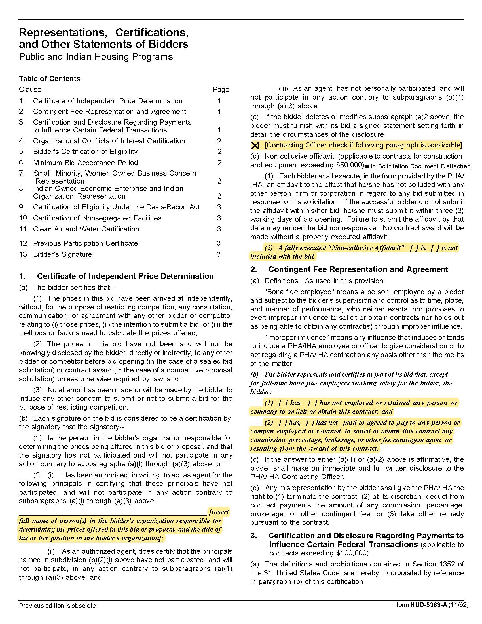

FSA & COBRA Administration Services Q1919
Solicitation Document B HUD Form 5369A - Continued

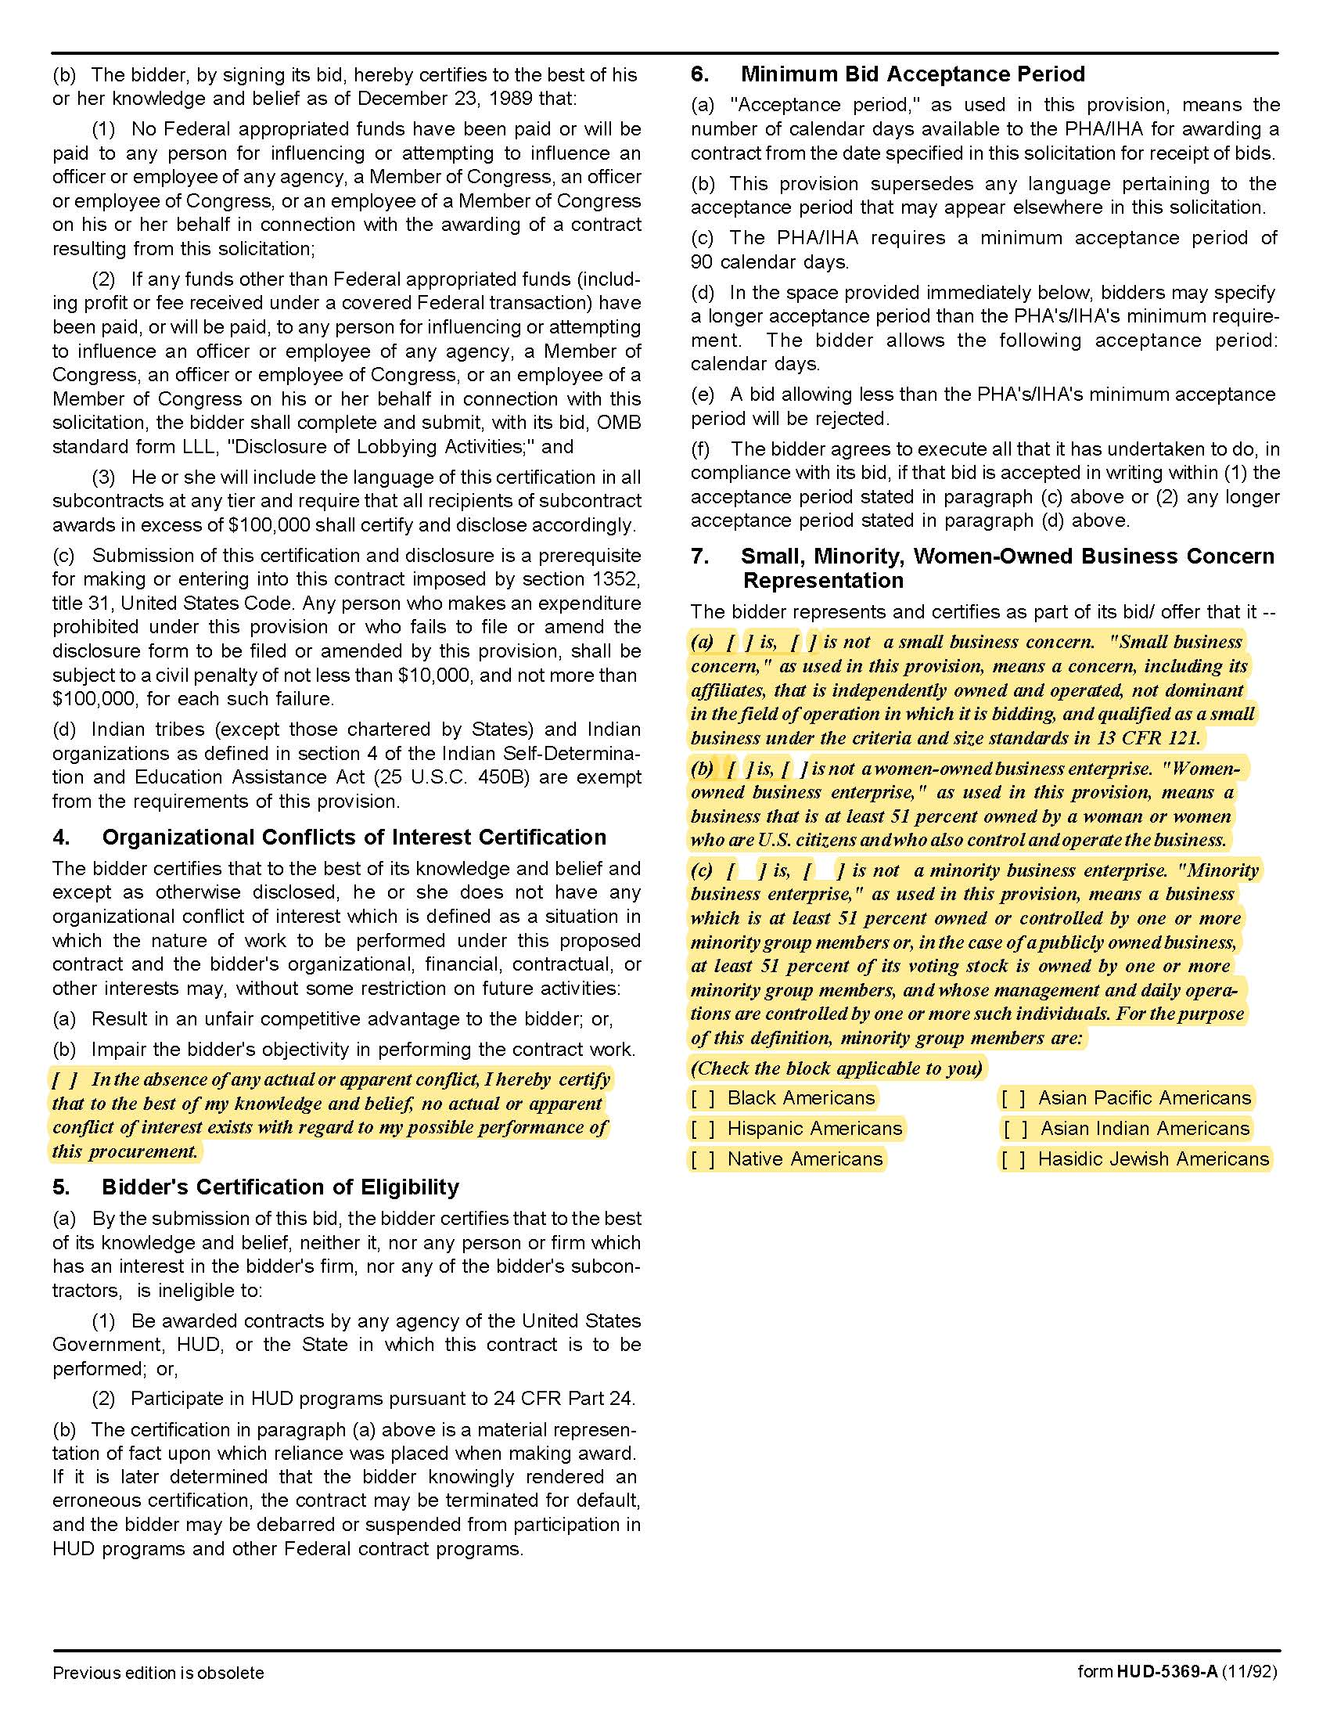

FSA & COBRA Administration Services Q1919
Solicitation Document B HUD Form 5369A - Continued
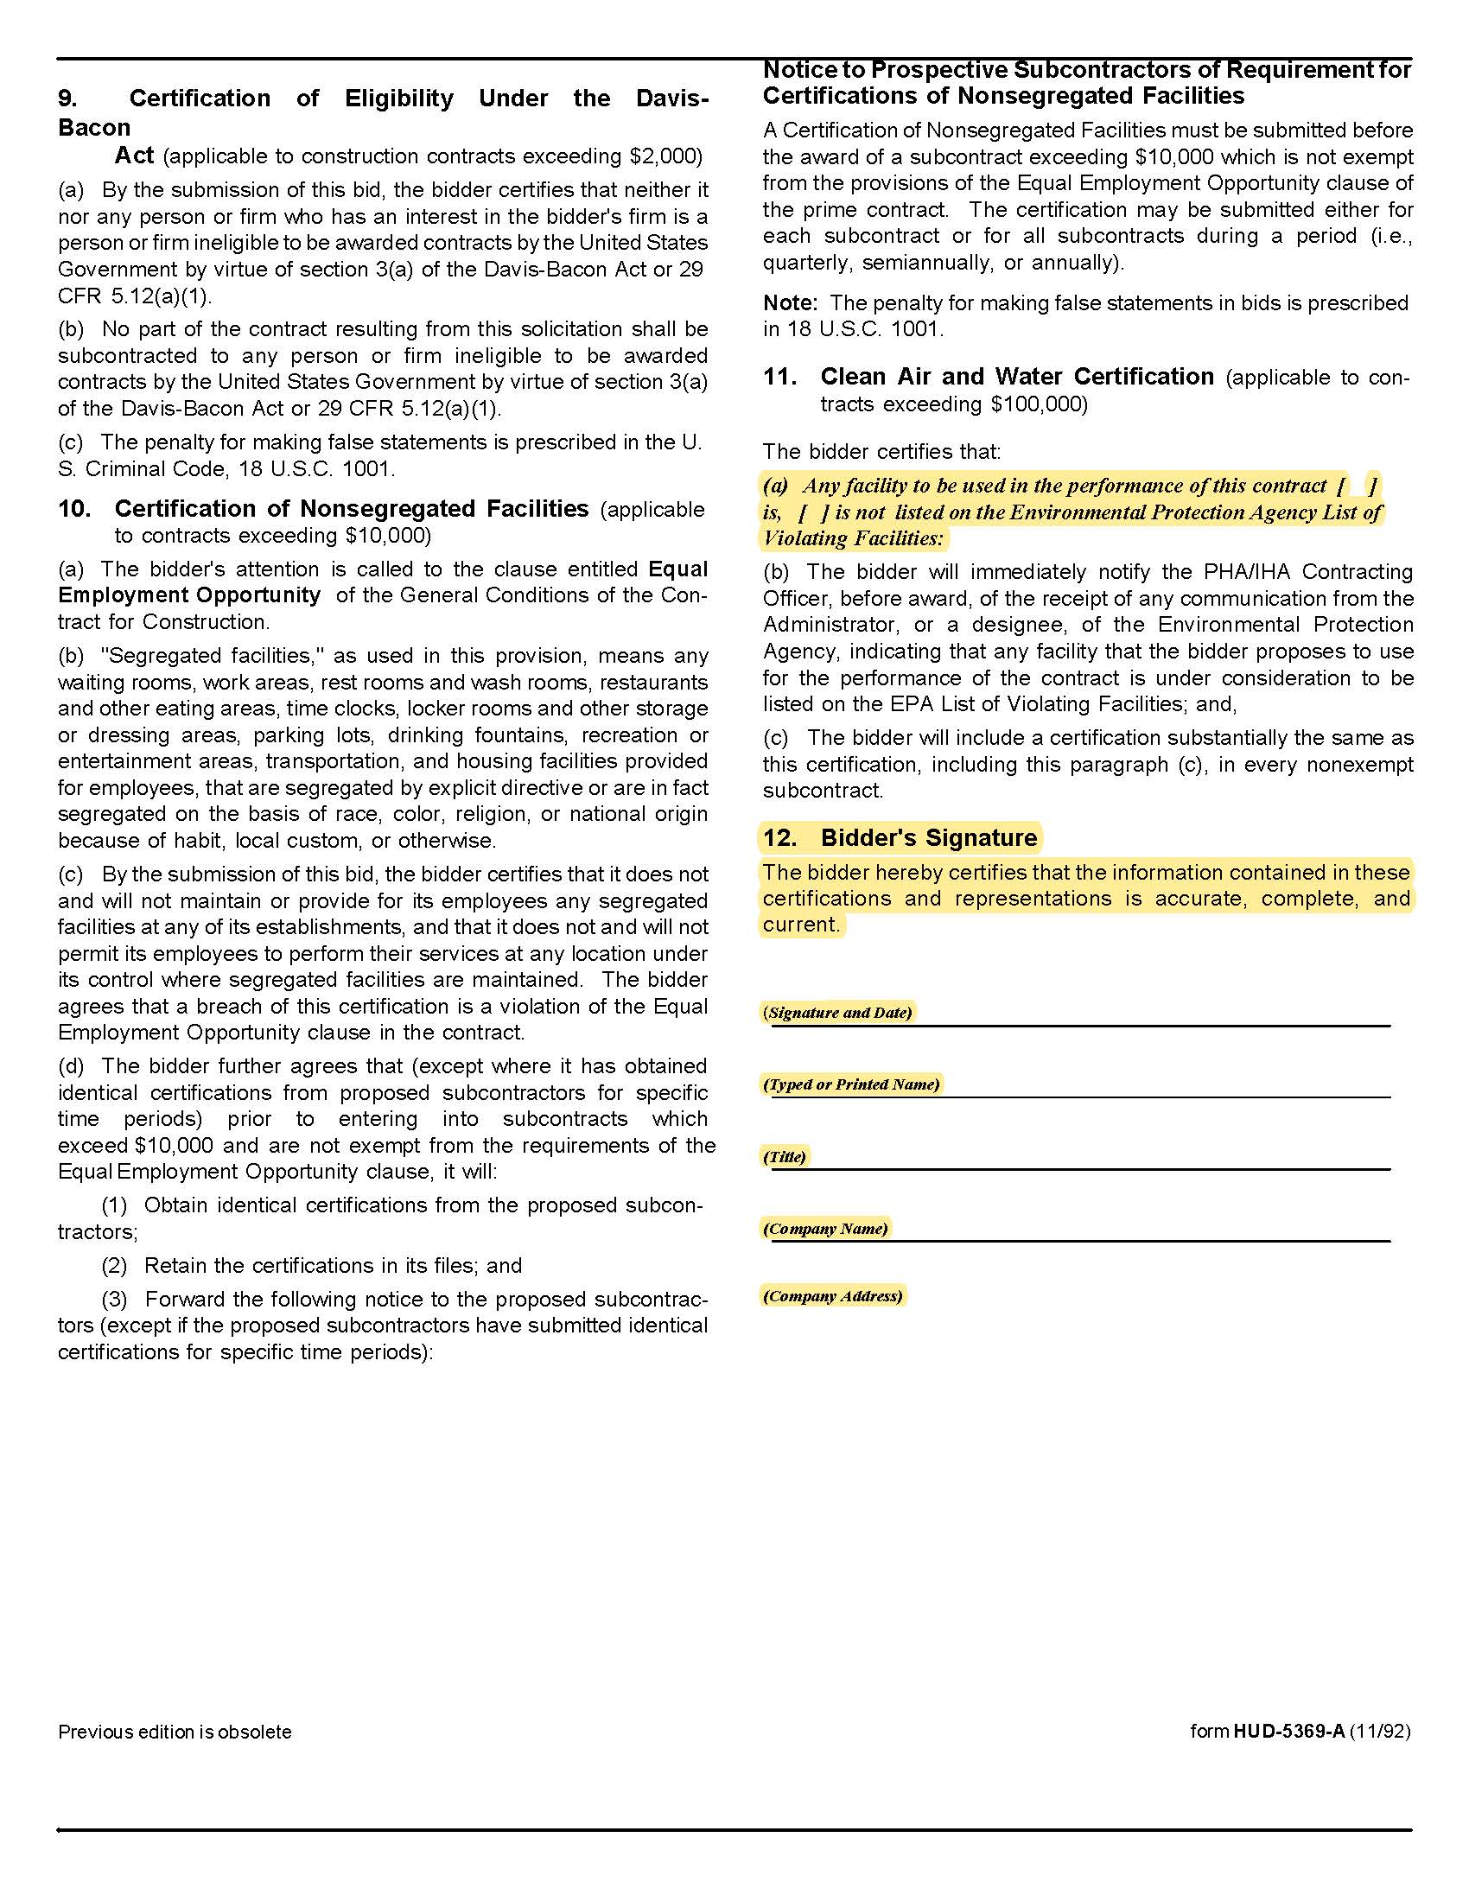

FSA & COBRA Administration Services Q1919

Solicitation Document C Affidavits

Supplier: _____________________________________________________________________________

Conflict of Interest:
1. No commissioner or officer of KCDC or other person whose duty it is to vote for, let out, overlook or in any manner superintend any of the work for KCDC has a direct interest in the award or the supplier providing goods or services.

2. No employee, officer or agent of the grantee or sub-grantee will participate in selection, or in the award or administration of an award supported by Federal funds if a conflict of interest, real or apparent, would be involved. Such a conflict would arise when the employee, officer or agent, any member of his immediate family, his or her partner, or an organization, which employs, or is about to employ, any of the above, has a financial or other interest in the supplier selected for award.

3. The grantee's or sub-grantee's officers, employees or agents will neither solicit nor accept gratuities, favors or anything of monetary value from suppliers, potential supplier s, or parties to sub-agreements.

4. By submission of this form, the supplier is certifying that no conflicts of interest exist.

Drug Free Workplace Requirements:
5. Private employers with five or more employees desiring to contract for construction services attest that they have a drug free workplace program in effect in accordance with TCA 50-9-112.

Eligibility:
6. The supplier is eligible for employment on public contracts because no convictions or guilty pleas or pleas of nolo contender to violations of the Sherman Anti-Trust Act, mail fraud or state criminal violations with an award from the State of Tennessee or any political subdivision thereof have occurred.

General:
7. Supplier fully understands the preparation and contents of the attached offer and of all pertinent circumstances respecting such offer.

8. Such offer is genuine and is not a sham offer.

Iran Divestment Act:
9. Concerning the Iran Divestment Act (TCA 12-12-101 et seq.), by submission of this bid/quote/proposal, each supplier and each person signing on behalf of any supplier certifies, and in the case of a joint bid/quote/proposal, each party thereto certifies as to its own organization, under penalty of perjury, that to the best of its knowledge and belief that each supplier is not on the list created pursuant to § 12-12-106.

FSA & COBRA Administration Services Q1919

Solicitation Document C Affidavits - continued

Non-Collusion:
10. Neither the said supplier nor any of its officers, partners, owners, agents, representatives, employees or parties interest, including this affiant, has in any way colluded conspired, connived or agreed, directly or indirectly, with any other responder, supplier, or person to submit a collusive or sham offer in connection with the award or agreement for which the attached offer has been submitted or to refrain from making an offer in connection with such award or agreement, or collusion or communication or conference with any other supplier, or, to fix any overhead, profit, or cost element of the offer price or the offer price of any other supplier, or to secure through any collusion, conspiracy, connivance, or unlawful agreement any advantage against KCDC or any person interested in the proposed award or agreement.

11. The price or prices quoted in the attached offer are fair, proper and not tainted by any collusion, conspiracy, connivance, or unlawful agreement on the part of the supplier or any of its agents, representatives, owners, employees, or parties in interest, including this affiant.

Accuracy of Electronic Copies:
12. If the supplier provides electronic copies of the bid/proposal/quote to KCDC, the supplier certifies that the information provided on paper and in the electronic format is identical unless specifically noted otherwise.

The undersigned hereby acknowledges receipt of these affidavits and certifies that the submittal in response to this solicitation is in full compliance with the listed requirements.

Signed by
Printed Name
Title
Subscribed and sworn to before me this date
By (Notary Public)
My Commission Expires on
Notary Stamp

FSA & COBRA Administration Services Q1919

Solicitation Document D Proposal Requirements & Cost

Proposal Requirements
Suppliers must agree to the following requirements:

FSA Administration
1. Provide support for plan, plan document development, maintenance plan document and summary plan description for KCDC’s Section 125 plan including healthcare and dependent care FSA.

2. Maintain records of deposits and withdrawals for each employee’s FSA account

3. FSA funds are auto drafted from a KCDC account. Daily reports of debit card drafts and credits and bi-weekly reports of manual claims paid are required. Reports must include a break down by employee and type of FSA account. Additional reporting on a monthly and quarterly basis may be requested.

4. Provide FSA debit card(s) to participant and dependents as requested

5. Update FSA balances as claims are processed, based upon KCDC’s plan design

6. Provide appropriate access to online report generation for Human Resources and Accounting use.

7. Set up FSA for new hires on an as needed basis

8. Provide for direct claims submissions by US mail, fax, email, and online

9. Provide online claims inquiry for employee claims submissions and inquiries

10. Completion of annual Non-discrimination Testing for applicable plans

11. Provide guidance for FSA/Section 125 plan as requested

COBRA Administration

1. Send COBRA Initial Notice to new hires and as requested

2. Send COBRA Qualifying Event Notice to qualified beneficiary(ies)

3. Provide guidance on COBRA coverage as requested

4. Receive COBRA premium payments through convenient methods for participants

5. Send total amount received for COBRA premium payments in the form of an ACH payment or
supplier check to KCDC at least monthly with a report reflecting the breakdown of payments applied by participant and plan(s).

FSA & COBRA Administration Services Q1919

Solicitation Document D Proposal Requirements & Cost

6. Provide additional monthly reporting to reflect participant paid through balance per plan to allow
for accounting of payments made in advance or pending termination for lack of payment.

7. Complete annual Non-discrimination Testing for applicable plans

A. Health Care FSA Fee Proposal Form | Year 1 | Year 2 | Year 3 | Year 4 | Year 5
1 Per employee per month
2 Initial set-up charges (indicate if no charges)
3 Annual Flat Fee (if applicable)
4 Debit card fee per employee per month
5 List and describe any/all other fees/charges for
any/all services being proposed

B. Dependent Care FSA Fee Proposal Form | Year 1 | Year 2 | Year 3 | Year 4 | Year 5
1 Per employee per month
2 Initial set-up charges (indicate if no charges)
3 Annual Flat Fee (if applicable)
4 If the employee has both a health care and
dependent care FSA, will there be a charge for
each account?
5 List and describe any/all other fees/charges for
any/all services being proposed
C. COBRA Fee Proposal Form | Year 1 | Year 2 | Year 3 | Year 4 | Year 5
1 Per employee per month
2 Initial set-up charges (indicate if no charges)
3 Annual Flat Fee (if applicable)
4 List and describe any/all other fees/charges for
any/all services being proposed

FSA & COBRA Administration Services Q1919
Solicitation Document E Questionnaire

Flexible Spending

- Please provide the name, location, contact information and a brief resume of the individual(s) who will service the KCDC account. Include information on the experience of these individuals with the management of accounts and knowledge of regulations related to administration of FSAs.

- Please provide sample communication materials available to promote the understanding of the FSAs, the reimbursement process, et cetera.

3. List any participation requirements or other minimum requirements for any services being offered.

4. Provide the link to your employer website and a demo ID and PW, if possible, so that we can view the following online service capabilities:

a. Employer information and daily/monthly administration capabilities
b. Employee information and capabilities
c. Billing
d. Claims submission and status
e. Forms access
f. Planning worksheets
g. Eligible expenses
h. Savings calculators

5. In what form(s) will you accept eligibility data from KCDC?

6. How long after the close of the plan year is the annual accounting performed?

7. What is your claims turnaround time? Please indicate if this time varies by method of claim
submission and provide timing of each.

8. Is there a minimum amount for which reimbursements may be issued?

9. Will your company accept responsibility for all regulatory compliance and filings for spending accounts?

10. Will your company maintain and update the summary plan document(s) and provide support for developing/maintaining the plan documents? Will your company send the required documents to participants each year? If so, is there an additional fee for this?

11. Do you provide account statements to individual employees indicating the balance of their health care FSA benefits? If yes, how frequently and what is the method of delivery?

12. Do you provide any additional notices prior to the plan year end or during the three (3) months after the close of the plan year to employees who may be at risk of forfeiting deferrals? If yes, please describe. Is this included in the plan fee? If no, what is the additional cost for these services?

FSA & COBRA Administration Services Q1919
Solicitation Document E Questionnaire

13. Describe your process for the annual $500 rollover of healthcare FSA funds. What is the effective date of the availability of those funds? How are employees notified of the rollover amount?

14. Explain your process for handling claims that require additional documentation. Give a summary of the timeline, types of communication(s) to employees, options for resolutions, and impact to employee’s account if adequate documentation is not provided.

COBRA Questionnaire

- Please provide the name, location, contact information and a brief resume of the individuals(s) who will
service the KCDC account. Include information on the experience of the individuals who will administer the COBRA process.

- When a COBRA Notice needed, how does that information need to be communicated? Please provide a
sample or description of data needed and methods to submit.

- Please provide a sample of the Initial COBRA Notice provided for new hires. Also note the methods available
to send this information.

- Please provide a sample of the COBRA Notice provided to persons newly eligible for COBRA benefits. Also
note the method(s) available to send this information.

- How do you communicate changes in premiums to COBRA participants?

- What is the process for cancellation; include timing triggers, notices sent to the participant, KCDC, and
insurance coverage providers?

- What forms of payment do you accept from COBRA participants? Do you offer electronic draft for
payment?

FSA & COBRA Administration Services Q1919
Solicitation Document F Supplier References

Supplier: ________________________________________________________________________________

Provide three references as similar in nature and scope to this project as possible. A firm may only be listed as a reference once - even if you have completed multiple projects/jobs for them.

Name of Business
Contact Person
Contact Person Title
Contact Person Telephone Number
Description of Service Provided
Date Contract Began
Date Contract Ended
Approximate Dollar Value of the Contract | $

Name of Business
Contact Person
Contact Person Title
Contact Person Telephone Number
Description of Service Provided
Date Contract Began
Date Contract Ended
Approximate Dollar Value of the Contract | $

Name of Business
Contact Person
Contact Person Title
Contact Person Telephone Number
Description of Service Provided
Date Contract Began
Date Contract Ended
Approximate Dollar Value of the Contract | $

