Request for Proposals

Solicitation Name and Number | Apartment Preparation Services Q2200
Responses Must Arrive No Later Than | 2:00 p.m. on November 18, 2021 (as KCDC’s clocks indicate)
Upload your responses to | https://vrapp.vendorregistry.com/Account/LogOn  (Can also be accessed via KCDC’s webpage)
Printed Responses Required | ☐ Yes ☒ No
Questions About This Solicitation | KCDC will not accept questions via telephone.  Submit questions to procurementinfo@kcdc.org by 12:00 p.m. on November 14, 2021.
Solicitation Opening | This bid will be “opened” electronically and interested parties may attend via Zoom only. To obtain the Zoom link, email procurementinfo@kcdc.org.  Note however that the bid tabulation is normally posted to KCDC’s webpage within four hours of the bid opening time.
Award Results | KCDC posts the award decision to its web page at: http://www.kcdc.org/procurement/.
Open Records/Public Access to Documents | All document provided to KCDC are subject to the Tennessee Open Meetings Act (TCA 8-44-101) and open records requirements.
Check KCDC’s webpage for addenda and changes before submitting your response

General Information

1. Background and Intent
a. Knoxville's Community Development Corporation (KCDC) is the public housing and redevelopment agency for the City of Knoxville and for Knox County in Tennessee. KCDC’s affordable housing property portfolio includes 20 sites with approximately 3,525 dwelling units. Several of the properties include Low Income Housing Tax Credits units and KCDC is both the General Partner and the management company for those sites. Those properties include Eastport LP, Five Points 1, LP; Five Points 2, LP; Five Points 3, LP; Five Points 4, LP; Lonsdale Homes, LP; Northridge Crossing, LP and The Vista at Summit Hill, LP. KCDC also oversees approximately 3,958 Section 8 Vouchers, 82 Moderate Rehabilitation units and 20 Redevelopment areas. KCDC has issued this solicitation for itself and on the behalf of the various properties that it now provides “management services” as detailed above. Any resulting awards are either for KCDC itself or are on behalf of those properties which KCDC provides “management services.”

b. KCDC desires the services of a supplier to provide apartment preparation services for its locations in Knoxville and Knox County Tennessee when vacancies or other needs arise. This will be on an “as needed” basis thus the intent of this specification is to arrive at an agreed to price for such services so that the successful supplier can be easily and quickly engaged to perform the services as needed. Since KCDC’s funding is partially contingent upon prompt turnaround of vacant units, the ability of the supplier to respond rapidly is of critical importance.

c. KCDC reserves the right to initially award a limited scope of work to ascertain the feasibility of the project. If this option is exercised, upon the successful completion of the test period, the full award will be made.

2. Bonding
The proposer’s employees must be bonded as they will be alone in the resident’s apartments. Proof of the bond must be supplied to KCDC prior to the commencement of work.

3. Changes after Award
It is possible that after award KCDC will need to revise the service needs or requirements specified in this document. KCDC reserves the right to make such changes after consultation with the supplier. Should additional costs arise, the supplier must document increased costs. KCDC reserves the right to accept and negotiate these charges.

4. Codes and Ordinances
All work covered by these award documents is to be done in full accord with national, state and local codes, ordinances and orders that are in effect at the time the work is performed.

5. Contact Policy
Only contact KCDC’s Procurement Division about this solicitation from the issuance of this RFP until its award. Information obtained any other person will not affect the risks or obligations assumed by the proposer or relieve the proposer from fulfilling any of the conditions of the resulting award. Such contact can disqualify the proposer from the solicitation process.

6. Contract Length
The length of the contract will be for twelve months. The contract will have four one-year optional renewals that can be exercised upon KCDC's request.

7. Damage
The awarded supplier is responsible for any and all damage to buildings, equipment, grounds, premises and all other types of potential resulting from the provision of the services requested herein.

8. Employees
Supplier(s) will:

a. Allow only personnel thoroughly trained and skilled to work on the job. Employees are not to be accompanied in their work area by acquaintances, family members, assistants or any person unless said person is an authorized employee of the supplier.

b. Have sufficient personnel to complete the work in a timely manner.

c. Provide adequate supervision and adequate discipline among his/her employees.

d. Provide at least one employee on every job assignment with the ability to speak, read, write and understand English so KCDC’s staff can communicate effectively with them.

e. Employ the quantity and quality of supervision necessary for both effective and efficient management at all times.

f. Ensure that employees have proper identification displayed while on the job site. Employees must wear a company uniform or have photo identification badges at all times.

g. Employees parking vehicles (whether corporately or privately owned) must ensure that company identification is on the vehicles. This may be by placards on the vehicle’s side, laminated paper with the company name placed on the dashboard or other identifying means.

h. Any and all successful proposers, proposer’s employees, proposer’s sub-contractors and the employees of any sub-contractors must submit to a criminal history records check at the proposer’s expense, conducted by the Tennessee Bureau of Investigation and the Federal Bureau of Investigation. The proposer must provide proof of satisfactory results from background checks for each employee who will work on KCDC’s property.

9. Entrance to KCDC Sites
Only those supplier employees working on a KCDC project are allowed on KCDC’s premises. Supplier employees are not to be accompanied in their work area by acquaintances, family members, assistants or any person unless said person is an authorized employee of the supplier.

10. Equipment
Supplier shall provide all necessary cleaning equipment, materials, supplies, et cetera needed for the performance of the work. KCDC will provide electricity (if available in the area that the work is to be performed in) and water (if available in the area that the work is to be performed in).

11. Evaluation
a. KCDC alone determines (using NIGP’s definition and other relevant sources as appropriate) the supplier’s “responsive” and “responsible” status prior to award. Responsible means a business with the financial and technical capacity to perform the requirements of the solicitation and subsequent contract. A responsive bid/proposal is one that fully conforms in all material respects to the solicitation document and all of its requirements, including all form and substance.

b. KCDC reserves the right to request additional information to assist in the evaluation process. This includes references and business capacity information.

c. KCDC will review all proposals and reserves the right to request necessary modifications, waive minor technicalities, reject all proposals, reject any proposal that does not meet mandatory requirement(s) or cancel this RFP, according to KCDC’s best interests.

d. KCDC’s Evaluation Team may elect to interview one or more suppliers before making an award.
Interviews may include an in-person examination of the proposed product. KCDC shall not reimburse the supplier for the costs associated with the interview process.

e. All materials submitted pursuant to this RFP become KCDC’s property. Information about proposals which are submitted will not be released to anyone until the process is complete and a recommendation is ready for the KCDC Board. Members of the evaluation team will not release information to anyone except the Procurement Director.

f. KCDC plans to award to the best overall proposal on the following evaluation scale:

Factors | Maximum Points
Cost | 60
Supplier Experience/Resources/Staff | 30
Supplier References | 10
Total Points Possible | 100

12. General Instructions to Suppliers
KCDC does not insert “General Instructions to Suppliers” in solicitation documents. These instructions are at www.kcdc.org. Click on “Procurement” and the link to the instructions. The supplier’s submittal means acceptance of the terms and conditions set forth in KCDC’s “General Instructions to Suppliers.”

These paragraphs in the “General Instructions” document do not apply to this solicitation: 15, 16, 43, 44a., 44b., 44d. and 67.

13. Identification
The supplier’s employees shall have proper identification displayed, at all times, while on KCDC property. All employees must wear a company uniform or have picture identification badges or other company identification at all times.

14. Insurance
The Supplier shall maintain, at Supplier’s sole expense, on a primary and non‐contributory basis, at all times during the life of the contract insurance coverages, limits, and endorsements described herein. All insurance must be underwritten by insurers with an A.M. Best rating of A- :VI or better. Upon award, the Supplier shall provide Certificate(s) of Insurance and amendatory endorsements to KCDC evidencing said insurance coverages. See paragraph “e” for exact naming of certificate holder and additional insureds (Owner Entities).

The Supplier agrees the insurance requirements herein as well as KCDC’s review or acknowledgement, is not intended to and shall not in any manner limit or qualify the liabilities and obligations assumed by the Supplier under this contract. KCDC’s failure to require a certificate of insurance, acceptance of a non-conforming certificate, or allowing the Supplier to commence work shall not operate as a waiver of these minimum insurance requirements or the liabilities and obligations assumed by the Supplier under this contract.

a. Commercial General Liability Insurance: occurrence version general liability insurance with a minimum combined single limit of $1,000,000 per occurrence with $2,000,000 in the aggregate covering the following perils: bodily injury, personal injury, and broad form property damage including products/completed operations for one year after completion of the Project(s). Limits must apply separately to the work/location in this contract.

Such insurance shall contain or be endorsed to contain a provision that includes the Owner Entities as additional insureds with respect to the Supplier’s ongoing and completed operations, providing coverage at least as broad as CG 20 10 07 04 and 20 37 07 04 endorsements. The coverage shall contain no special limitations on the scope of its protection afforded to the listed insureds.

b. Commercial Automobile Liability Insurance: in an amount not less than $1,000,000 (combined single limit) for all owned, hired, and non-owned vehicles utilized by Supplier in connection with the Project. Coverage is to include coverage for loading and unloading hazards. Such insurance shall contain or be endorsed to contain a provision that includes the Owner Entities as additional insureds.

c. Workers’ Compensation Insurance and Employers Liability Insurance: Workers’ Compensation Insurance with statutory limits as required by the State of Tennessee or other applicable laws.

d. Other Insurance Requirements:
1. Upon award, Supplier shall furnish KCDC with original Certificate(s) of Insurance and amendatory endorsements effecting coverage required by this section.

2. Provide a waiver of subrogation for each required policy herein. When required by the insurer, or should a policy condition not permit Supplier to enter into a pre‐loss agreement to waive subrogation without an endorsement, the policy should be endorsed with a Waiver of Transfer of Rights of Recovery Against Others, or its equivalent. This waiver of subrogation requirement shall not apply to any policy which includes a condition specifically prohibiting such an endorsement, or voids coverage should supplier enter into such an agreement on a pre‐loss basis.

3. A minimum 30‐day cancellation notice for all insurances (by endorsement if necessary) is required.

4. Replace certificates, policies, and endorsements for any such insurance expiring prior to completion of services.

5. Maintain such insurance from the time services commence until services are completed or through such extended discovery/reporting/tail period as required. Failure to maintain or renew coverage or to provide evidence of renewal may be treated by KCDC as a material breach of contract.

6. Any deductibles and/or self‐insured retentions greater than $50,000 must be disclosed to and approved by KCDC prior to the commencement of services. Use of large deductibles and/or self‐insured retentions will require proof of financial ability as determined by KCDC.

7. All policies must be written on an occurrence basis with the exception of Errors and Omissions Liability (E & O) / Professional Liability and Pollution Liability which may be claims made coverage.

8. Require all subcontractors to maintain during the term of the resulting contract commercial general liability insurance, automobile liability insurance, and workers’ compensation/employer’s liability insurance (unless subcontractor’s employees are covered by contractor’s insurance) in the same manor and limits as specified for the Supplier.

e. Certificate Holder and Owner Entities:
The Certificate Holder shall be:
KCDC
901 N Broadway
Knoxville, TN 37917

Owner Entities are defined as those entities listed below and shall be provided all insurance coverages, limits, and endorsements included herein including additional insured status. Provided Supplier’s insurer(s) permits, the entities listed below can be identified collectively as “Owner Entities”:

KCDC, its officials, officers, employees, and volunteers

Eastport Development, LP
Five Points 1 LP
Five Points 2 LP
Five Points 3 LP
Five Points 4 LP
Bell Street LP
Lonsdale, LP
North Ridge Crossing, LP
Vista at Summit Hill, LP
Montgomery Village Corporation
Cagle Terrace Corporation

(Note: Only one (1) certificate needs to be provided. Certificate must reflect KCDC as the Certificate Holder and specify all coverages and terms apply to all Owner Entities.)

f. Right to Revise or Reject: KCDC reserves the right to revise any insurance requirement, including
but not limited to, limits, coverages, and endorsements based on changes in scope of work/specifications, insurance market conditions affecting the availability or affordability of coverage.

g. No Representation of Coverage Adequacy: The coverages, limits or endorsements required herein
protect the primary interests of the Owner Entities, and the Supplier agrees in no way should these coverages, limits or endorsements required be relied upon when assessing the extent or determining appropriate types and limits of coverage to protect the Supplier against any loss exposures, whether as a result of the project or otherwise.

Term Sheet - Insurance Requirements

Certificate Holder
KCDC
901 N Broadway
Knoxville, TN 37917

Additional Insureds (Owner Entities)
(can be identified collectively as Owner Entities)
KCDC, its officials, officers, employees, and volunteers
Knoxville’s Housing Development Corporation (KHDC)
Eastport Development, LP
Five Points 1 LP
Five Points 2 LP
Five Points 3 LP
Five Points 4 LP
Bell Street LP
Lonsdale, LP
North Ridge Crossing, LP
Vista at Summit Hill, LP
Montgomery Village Corporation
Cagle Terrace Corporation
GL (Supplier & Subcontractors) $1M / $2M
Auto (Supplier & Subcontractors) $1M (owned, hired, & non-owned)
WC & Employers Liability (Supplier & Subcontractors) statutory limits
30-day cancellation (Supplier & Subcontractors) Required– must indicate on COI
Primary non-contributory (Supplier & Subcontractors) Required – must indicate on COI
Waiver of Subrogation (Supplier & Subcontractors) Required – must indicate on COI

15. Invoicing
a. Until a purchase order is in place, work is not to be performed nor are goods to be delivered. KCDC has no legal obligation to pay for work performed prior to the issuance of a purchase order.

b. Suppliers are asked to email invoices with 10 days following work completion and are required to submit invoices within 90 days following the delivery of the goods or services. KCDC may deny invoices submitted after the 90-day threshold.

c. KCDC pays by electronic transfer (ACH). Supplier’s accounts receivable staff must use KCDC’s Supplier Portal to ascertain payments made and to which invoices they apply. Suppliers will set up an account in KCDC’s Supplier Portal so that they receive an email with each payment detailing the invoice number and the amount paid. KCDC is not able to routinely offer payment history assistance and so if the supplier is unable or unwilling to use KCDC’s Supplier Portal to track payments, consider whether or not to submit a response to this solicitation.

d. Invoices must:
- Be numbered
- List a date on them that is after the work is completed or goods delivered
- List the purchase order number
- Breakdown pricing according to the award structure
- Show the supplier’s name and address

16. Material Safety Data Sheets (MSDS)
Suppliers are advised that MSDS must be provided for each product intended for use within the KCDC system. As work is performed, submit the MSDS to the property managers at each site.

17. Price Structure at Renewals
a. At the end of each twelve-month period, the awarded supplier(s) may request a change to the agreed to price. The supplier(s) must provide proof of increased Producer Price Index (Knoxville) to the Procurement Division.

b. KCDC will decide whether to accept a price increase. If the price increase is accepted, the solicitation file will be so noted. If the price increase is not accepted, the supplier may:

1. Continue with the existing pricing.
2. Suggest an alternative price increase.
3. End the award.

c. KCDC does not pay fuel surcharges.

d. KCDC will consider price increases due to tariffs and embargos upon submitted documentation. KCDC reserves the right to deny such requests. Further if a price increase is granted due to a tariff or embargo, prices must return to their previous rates once the issue is resolved.

e. Suppliers may lower prices at any time with or without notice

18. Representations
By submitting a response, the supplier represents and warrants:

a. That the supplier is financially solvent and that it is experienced in and competent to perform the type of work, and/or to furnish the personnel, plans, materials, supplies or equipment to be performed or furnished by it; and

b. That the supplier is familiar with all federal, state, municipal and county laws, ordinances and regulations, which may in any way affect the work of those employed therein, including but not limited to any special acts relating to the work or to the project of which it is a part; and

19. Responsibilities
At no expense to KCDC, the supplier(s) will:

a. Provide quality control for all services provided.

b. Provide competent supervision.

c. Provide competent workers.

d. Take precautions necessary to protect persons or property against injury or damage and be responsible for any such damage or injury that occurs as a result of their fault or negligence.

e. Perform work without unnecessarily interfering with the activities of KCDC, residents or other suppliers.

20. Safety/OSHA Guideline Compliance
a. Staff and public safety are of prime concern to KCDC. All costs are the supplier’s responsibility.

b. Supplier(s) shall comply with all applicable OSHA and TOSHA rules.

c. The supplier(s) shall ensure that its employees exercise all necessary caution and discretion to avoid injury to persons or damage to property.

d. Supplier(s) shall use caution signs as required by OSHA Regulation 1910.144 and 1910.145.

e. Markings or labeling of materials containing hazardous or toxic substance or wastes shall be in accordance with all Federal, State and County laws, ordinances, rules and regulations.

f. The successful supplier(s) will provide SDS’s for each product used at KCDC. Upon award, submit the SDS to the property managers at each complex. Whenever the chemicals used change, the supplier(s) will supply the new information to the apartment managers.

21. Section 3 of the HUD Act of 1968
Section 3 is a provision of the Housing and Urban Development Act of 1968 which requires that programs of direct financial assistance administered by the U.S. Department of Housing and Urban Development (HUD) provide, to the greatest extent feasible, opportunities for job training and employment to lower income residents in connection with projects in their neighborhoods. Further, to the greatest extent feasible, contracts in connection with these projects are to be awarded to local businesses. Section 3 is a tool for fostering local economic development, neighborhood economic improvement and individual self-sufficiency.

a. Recipients and suppliers must make a good faith effort to utilize Section 3 area residents as trainees and employees in connection with the project. Targeted recruitment and the selection of Section 3 area residents for available positions are two examples of good faith efforts to meet this requirement.

b. Recipients and suppliers must make a good faith effort to award contracts to Section 3 business concerns for work in connection with the project. An example of a good faith effort to meet this requirement is the implementation of an affirmative action plan, which includes targets for the number and dollar value for awarding contracts to Section 3 business concerns.

c. Recipients and suppliers must keep records and submit reports to HUD documenting the good faith efforts taken and the results of these actions. Examples of such documentation include letters to community organizations, employment development and business development centers, copies of solicitations for bids or proposals, and copies of affirmative action plans.

d. How can businesses find Section 3 residents to work for them? This can be accomplished by recruiting in the neighborhood and public housing developments to tell about available training and job opportunities. Distributing flyers, posting signs, placing ads, and contacting resident organizations and local community development and employment agencies to find potential workers are a few effective ways of getting jobs and people together.

e. All contracts awarded are subject to Section 3 requirements. Supplier shall seek to fill all positions that are unfilled with KCDC residents. For additional information, go to http://www.hud.gov/offices/fheo/section3/Section3.pdf. The successful supplier will give KCDC job announcements for any position that must be filled as a result of the award of KCDC work. Additionally the successful supplier will supply the same job announcement to the Knoxville-Knox County Committee Action Committee’s Workforce Connections group. These can be faxed to 544-5269.

f. A Section 3 resident is one who lives within a public housing authority’s site. It is also people who live in an area with a HUD assisted program and whose income is below HUD’s low income requirements.

g. A Section 3 business is one that:

1. Is at least 51% owned by a Section 3 resident; or
2. Employs Section 3 residents for at least 30% of its employee base; or
3. Makes a commitment to sub contract at least 25% of the project’s dollars to a Section 3 business.

h. Upon award, the successful supplier will supply two documents to KCDC:

1. A Section 3 Business determination provided one is not already on file.
2. A Section 3 Business plan for this work.

22. Security
The successful supplier is responsible for providing (if necessary) all security to equipment, materials, personnel and tools that are required for this work. KCDC is not responsible for damage or losses to equipment, materials, personnel, tools or the apartment.

23. Smoke Free Policy
a. KCDC’s Smoke Free policy is applicable to you, your employees and subcontractors. The policy mandates:
• No smoking on KCDC’s property
• No e-vape or similar usage on owner’s property
• The Smoke Free policy applies in personal or corporate vehicles on KCDC’s property

b. Applicable definitions include:
• “Smoking” means inhaling, exhaling, burning or carrying any lighted or heated cigar, cigarette or pipe, or any other lighted or heated tobacco or plant product intended for inhalation, including hookahs and marijuana, whether natural or synthetic, in any manner or in any form. “Smoking” also includes the use of an electronic smoking device which creates an aerosol or vapor, in any manner or in any form.

• “Electronic Smoking Device” means any product containing or delivering nicotine or any other
substance intended for human consumption that can be used by a person in any manner for the purpose of inhaling vapor or aerosol from the product. The term includes any such device, whether manufactured, distributed, marketed or sold as an e-cigarette, e-cigar, e-pipe, e-hookah or vape pen or under any other product name or descriptor.

• Property means all buildings, parking lots, streets, structures and land owned by owners. Should Your staff be observed violating these requirements, KCDC’s Procurement Division will notify you about the problem. Should there be recurrences, KCDC may ask you to not send the employee to KCDC’s property. Repeated offenses may result in forfeiture of your award.

24. Solicitation Requirements
Caution: Requirements in the solicitation are not optional. If you have concerns or issues with any of the stated requirements, raise them before the solicitation due date. Examples of past issues where suppliers made faulty assumptions include bonds, insurance requirements and payment expectations.

25. Subcontractors
Subcontractors must:

a. Be approved by KCDC prior to beginning work. Any changes must be approved by KCDC.

b. Not be on HUD’s nor the State of Tennessee’s debarment lists.

c. Carry the insurance coverages as outlined herein.

26. Submittal Instructions
Submit your information in the order indicated below:

Document Number | Title
Solicitation Document A | General Response Section
Solicitation Document B | Affidavits
Solicitation Document C | HUD Form 5369A
Solicitation Document D | References
Solicitation Document E | Supplier Qualifications

a. Place your company’s name on each page and number all pages consecutively

b. Do not use phrases such as “See the attached” or “Will be provided upon award.”

c. Submit one written original (with all pages marked “original”), five printed copies and one electronic copy (email or flash drive) of your submittal.

Scope of Work

1. General Requirements
This work includes the cleaning of vacant units so that they are ready for showing to and rental by prospective tenants. It includes walls, ceilings, closets, doors (interior & exterior), door frames, stairs, stairwell railings, pipes, et cetera within the floor print of the unit. Supplier’s unit price for cleaning of vacant units will include the cost for all items within the floor space of the unit.

a. Clean HVAC closets

b. Clean range hoods and filters

c. Complete cleaning of the entire interior space including but not limited to:

  - Cabinets/ Vanities
  - Dusting
  - Light globes
  - Shower surrounds/ Tubs/ Sinks
  - Thresholds
  - Toilets
  - Tubs
  - Windows/Sills/ Screens
  - Clean and vacuum all air registers and filter grills

d. Sweep VCT, LVT & LVP tile floors

e. Strip VCT, LVT & LVP tile floors, use only manufacturer’s recommended products.

f. Wax VCT, LVT & LVP tile floors- 2 coats of wax, use only manufacturer’s recommended products.

g. Refrigerators: Clean the drip pan(s), vacuum dust from rear and coils, clean the exterior and clean
all interior parts.

h. Ranges: Clean the top surface, side surfaces and oven area. Vacuum the rear section of stove unit.

2. Clean-up and Precautions
a. All rubbish accumulated from a job shall be removed from KCDC's premises by the supplier at the supplier’s expense. Trash nor other debris shall not be placed in KCDC dumpsters or other trash facilities belonging to KCDC.
b. All clean-up requirements will be completed before payment is made for a job.
c. All work is to be completed at the convenience and safety of the nearby occupants (if any). If there are complaints from occupants about fumes, smells, et cetera, the supplier shall be required to immediately cease work and ventilate the area until the problem is corrected. The supplier will be required to reschedule the work at a time suitable to the occupants or devise a ventilation method that eliminates the problem. Any remedy used by the supplier will be done at no additional cost to KCDC.
3. Employees
The successful supplier will take care to employ qualified, dependable and trustworthy persons for this work. Suppliers will employ bonded employees for this work.

4. Inspection
Upon completion of the cleaning of a unit(s), the supplier is responsible for having the Maintenance Supervisor or Property Manager approve the work completed. The Property Manager and Maintenance Supervisor are the only two individuals who can approve payment for work and sign the invoice. The invoice will show the address of the unit cleaned, the name of the property, the bedroom size of the unit and any other relevant information.

5. Turnaround Time
a. The supplier shall respond within thirty-six hours of the official notification to supplier.

b. Work shall be completed within forty-eight hours of official notification to the supplier.

c. If the supplier does not complete the work within the specified time frame, the supplier will be assessed damages of twenty-five dollars ($25) a day for each day the supplier fails to meet the established deadline, unless there are delays caused by KCDC or circumstances beyond the supplier’s control. Any delay that is beyond the supplier’s control, regardless of time or costs, must be promptly documented and the circumstances clearly stated with an estimate of the amount of time or costs the project will be impacted.

This and the Previous Pages Do Not Need to be Returned

Solicitation Document A: General Information about the Supplier
Note: Complete all cells even if the answer if “Does not apply”
Sign Your Name to the Right of the Arrow
If completing this document in Adobe, an electronic signature is acceptable to KCDC.
Your signature indicates you read and agree to “KCDC’s General Instructions to Suppliers” (www.kcdc.org) and that you are authorized to bind the supplier or are submitting the response on behalf of and at the direction of the suppliers’ representative authorized to contractually bind the supplier. I represent that the supplier or its applicable representative(s) has reviewed the information contained in this Solicitation Package and that the information submitted is accurate.
Printed Name and Title
Legal Corporate Name
Street Address
City/State/Zip
Contact Person (Please Print Clearly)
Telephone Number
Cell Number
Supplier’s E-Mail Address (Please Print Clearly)
Addenda
Addenda are at www.kcdc.org. Click on “Procurement” and then on “Open Solicitations” to find addenda. Please check for addenda prior to submitting a proposal.
Acknowledge addenda have been issued by checking below as appropriate:
None ☐ | Addendum 1 ☐ |  |  | Addendum 2 ☐ |  | Addendum 3 ☐ |  |  | Addendum 4 ☐ |  | Addendum 5 ☐
Statistical Information (Check all the apply)
This business is at least 51% owned and operated by a woman |  |  |  |  |  |  |  |  |  |  | Yes ☐ No ☐
This business qualifies as a small business by the State of Tennessee  Total gross receipts of not more than $10,000,000 average over a three-year period OR employs no more than 99 persons on a full-time basis |  |  |  |  |  |  |  |  |  |  | Yes ☐ No ☐
This business is owned & operated by persons at least 51% of the following ethnic background:
Asian/Pacific ☐ |  | Black ☐ | Hasidic Jew ☐ |  | Hispanic ☐ |  | Native American ☐ |  |  | White ☐ | Publicly Owned ☐
Prompt Payment Discount
A ____% prompt payment discount applies when KCDC makes payment in ____ days of accurate invoicing.
Insurance Statement
I have reviewed the insurance requirements and will comply with them without exception. Yes ☐ No ☐
Supplier Corporate Information
Years in this Business
Total Number of Employees
Number of Employees to Service KCDC
Number of Similar Clients on the Proposed Product

Solicitation Document B: Affidavits

Conflict of Interest
1. No commissioner or officer of KCDC or other person whose duty it is to vote for, let out, overlook or in any manner superintend any of the work for KCDC has a direct interest in the award or the supplier providing goods or services.

2. No employee, officer or agent of the grantee or sub-grantee will participate in selection, or in the award or administration of an award supported by Federal funds if a conflict of interest, real or apparent, would be involved. Such a conflict would arise when the employee, officer or agent, any member of his immediate family, his or her partner, or an organization, which employs, or is about to employ, any of the above, has a financial or other interest in the supplier selected for award.

3. The grantee's or sub-grantee's officers, employees or agents will neither solicit nor accept gratuities, favors or anything of monetary value from suppliers, potential suppliers or parties to sub-agreements.

4. By submission of this form, the supplier is certifying that no conflicts of interest exist.

Drug Free Workplace Requirements:
5. Private employers with five or more employees desiring to contract for construction services attest that they have a drug free workplace program in effect in accordance with TCA 50-9-112.

Eligibility
6. The supplier is eligible for employment on public contracts because no convictions or guilty pleas or pleas of nolo contender to violations of the Sherman Anti-Trust Act, mail fraud or state criminal violations with an award from the State of Tennessee or any political subdivision thereof have occurred.

General
7. Supplier fully understands the preparation and contents of the attached offer and of all pertinent circumstances respecting such offer.

8. Such offer is genuine and is not a sham offer.

Iran Divestment Act
9. Concerning the Iran Divestment Act (TCA 12-12-101 et seq.), by submission of this bid/quote/proposal, each supplier and each person signing on behalf of any supplier certifies, and in the case of a joint bid/quote/proposal, each party thereto certifies as to its own organization, under penalty of perjury, that to the best of its knowledge and belief that each supplier is not on the list created pursuant to § 12-12-106.

Accuracy of Electronic Copies
10. If the supplier provides electronic copies of the bid/proposal/quote to KCDC, the supplier certifies that the information provided on paper and in the electronic format is identical unless specifically noted otherwise.

Non-Collusion
11. Neither the said supplier nor any of its officers, partners, owners, agents, representatives, employees or parties interest, including this affiant, has in any way colluded conspired, connived or agreed, directly or indirectly, with any other responder, supplier, or person to submit a collusive or sham offer in connection with the award or agreement for which the attached offer has been submitted or to refrain from making an offer in connection with such award or agreement, or collusion or communication or conference with any other supplier, or, to fix any overhead, profit, or cost element of the offer price or the offer price of any other supplier, or to secure through any collusion, conspiracy, connivance, or unlawful agreement any advantage against KCDC or any person interested in the proposed award or agreement.

12. The price or prices quoted in the attached offer are fair, proper and not tainted by any collusion, conspiracy, connivance, or unlawful agreement on the part of the supplier or any of its agents, representatives, owners, employees, or parties in interest, including this affiant.

No Contact/No Advocacy Affidavit
13. After this solicitation is issued, any contact initiated by any supplier with any KCDC representative concerning this proposal is strictly prohibited-except for communication with the Procurement Division. My signature signifies that no unauthorized contact occurred.

14. To ensure the integrity of the review and evaluation process, respondents to this solicitation nor any firm representing them, may not lobby or advocate to KCDC staff or Board members. My signature signifies that no unauthorized advocacy occurred.

The undersigned hereby acknowledges receipt of these affidavits and certifies that the submittal in response to this solicitation is in full compliance with the listed requirements.

Signed by
Printed Name
Title
Subscribed and sworn to before me this date
By (Notary Public)
My Commission Expires on
Notary Stamp
Solicitation Document C: HUD Form 5359A

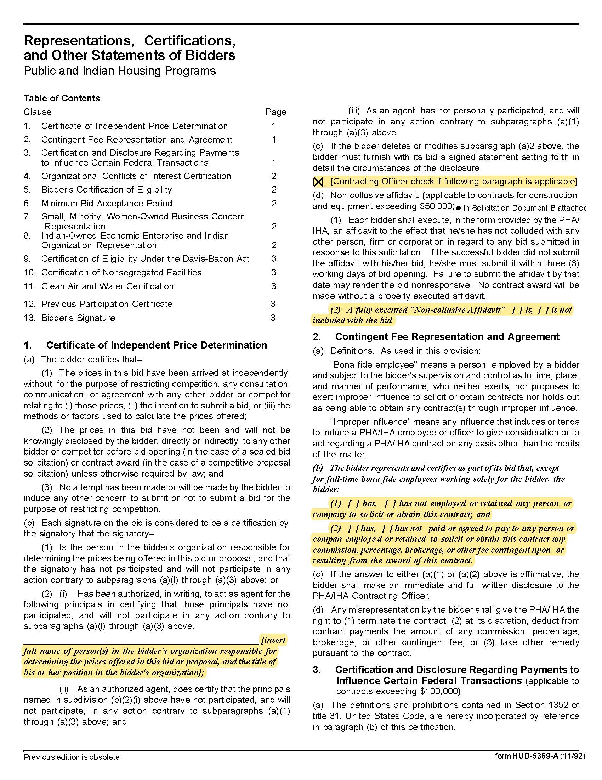

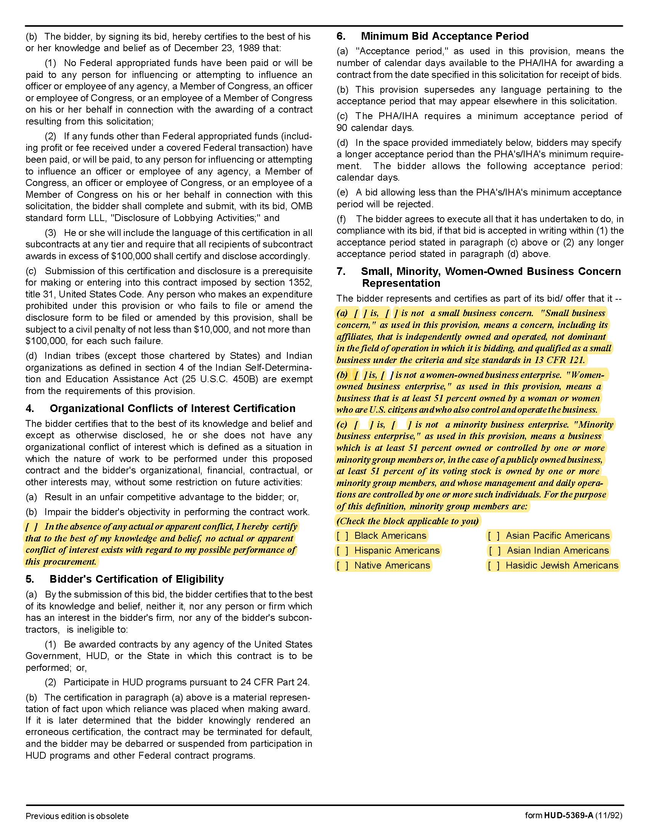

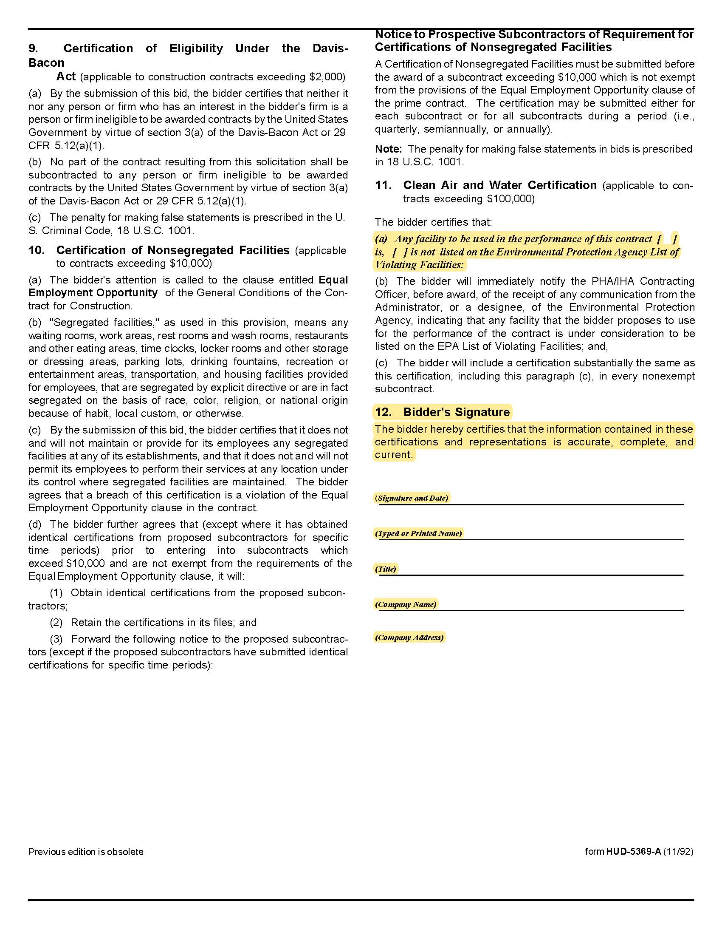

Solicitation Document D: Supplier References
D Form 5359A
Supplier: ________________________________________________________________________________

The proposal must include at least three specific references of similar accounts. While you may have had numerous separate contracts with a particular company, a company can only be one reference.
Name of Business
Contact Person
Contact Person Email Address
Contact Person Telephone Number
Description of Service Provided
Date Contract Began
Date Contract Ended
Type of positions placed for this client
Identify any contract issues and describe how they were resolved
Approximate number of placements within an average 12 month period

Name of Business
Contact Person
Contact Person Email Address
Contact Person Telephone Number
Description of Service Provided
Date Contract Began
Date Contract Ended
Type of positions placed for this client
Identify any contract issues and describe how they were resolved
Approximate number of placements within an average 12 month period
Solicitation Document E: Supplier Qualifications

Supplier: ________________________________________________________________________________

Use this section of your response to detail your company’s qualifications. Include:
1. An overview of your company’s history
2. The names of key personnel who will be involved in this project and indicate titles and roles.
3. A list of subcontractors-if applicable
4. General business information

Years in business
Years in business under this name
Years performing this type of work
Value of work now under award
Value of work in place last year
Number of Clients
What company do you use for pre-employment criminal background checks?
Has your company:
Failed to complete an award? | Yes ☐ No ☐
Been involved in bankruptcy or reorganization? | Yes ☐ No ☐
Pending judgment claims or suits against supplier? | Yes ☐ No ☐

5. Safety:
Have you had any OSHA fines within the last three (3) years? | Yes ☐ No ☐
Have you had any job related fatalities within the last five (5) years? | Yes ☐ No ☐
If you have answered YES to either of the above questions, you MUST submit, on a separate sheet, the details describing the circumstances surrounding each incident.

6. Personnel:
Area | Fulltime | Part Time
Clerical
Management
Plumbers

Total Employees working for your company
s
Solicitation Document F: Cost

Site | Autumn Landing
Address | 6331 Pleasant Ridge Road Knoxville, TN 37921
Manager | James Pruitt
Cell | 865-755-5964
Email | jpruitt@kcdc.org
 | Efficiency | 1 Bedroom | 2 Bedroom | 3 Bedroom | 4 Bedroom | 5 Bedroom
Number of Units | 0 | 30 | 46 | 18 | 8 | 0
Base Cost per Unit | NA | $ | $ | $ | $ | NA

Site | Cagle Terrace
Address | 515 Renford Drive Knoxville TN 37919
Manager | Rhonda Harris
Cell | 865-755-5959
Email | rharris@kcdc.org
 | Efficiency | 1 Bedroom | 2 Bedroom | 3 Bedroom | 4 Bedroom | 5 Bedroom
Number of Units | 250 | 24 | 0 | 0 | 0 | 0
Base Cost per Unit | $ | $ | NA | NA | NA | NA

Site | First Creek
Address | 1250 Burge Avenue, Knoxville, TN 37915
Manager | Kayla Clabough
Cell | 865-910-7142
Email | kclabough@kcdc.org
 | Efficiency | 1 Bedroom | 2 Bedroom | 3 Bedroom | 4 Bedroom | 5 Bedroom
Number of Units | 0 | 46 | 38 | 17 | 4 | 0
Base Cost per Unit | NA | $ | $ | $ | $ | NA

Site | Five Points Properties
Address | 381 McConnell Street Knoxville, TN 37915
Manager | Tanji Damewood
Cell | 865-978-2656
Email | tdamewood@kcdc.org
 | Efficiency | 1 Bedroom | 2 Bedroom | 3 Bedroom | 4 Bedroom | 5 Bedroom
Number of Units | 68 | 93 | 12 | 0 | 0 | 0
Base Cost per Unit | $ | $ | $ | NA | NA | NA

Site | Guy B. Love Towers
Address | 1171 Armstrong Avenue Knoxville, TN 37917
Manager | Steve Ellis
Cell | 865-755-5988
Email | sellis@kcdc.org
 | Efficiency | 1 Bedroom | 2 Bedroom | 3 Bedroom | 4 Bedroom | 5 Bedroom
Number of Units | 104 | 116 | 28 | 1 | 0 | 0
Base Cost per Unit | $ | $ | $ | $ | NA | NA

Site | Isabella Towers
Address | 1515 Isabella Circle Knoxville TN 37915
Manager | Tiara Webb
Cell | 865-755-5991
Email | twebb@kcdc.org
 | Efficiency | 1 Bedroom | 2 Bedroom | 3 Bedroom | 4 Bedroom | 5 Bedroom
Number of Units | 215 | 21 | 0 | 0 | 0 | 0
Base Cost per Unit | $ | $ | NA | NA | NA | NA

Site | Lonsdale Homes
Address | 2020 Minnesota Avenue Knoxville, TN 37921
Manager | Darlene Farmer
Cell | 865-755-5961
Email | dfarmer@kcdc.org
 | Efficiency | 1 Bedroom | 2 Bedroom | 3 Bedroom | 4 Bedroom | 5 Bedroom
Number of Units | 0 | 13 | 169 | 70 | 8 | 0
Base Cost per Unit | NA | $ | $ | $ | $ | NA

Site | Mechanicsville
Address | 2020 Minnesota Avenue Knoxville, TN 37921
Manager | Darlene Farmer
Cell | 865-755-5961
Email | dfarmer@kcdc.org
 | Efficiency | 1 Bedroom | 2 Bedroom | 3 Bedroom | 4 Bedroom | 5 Bedroom
Number of Units | 0 | 0 | 14 | 8 | 0 | 0
Base Cost per Unit | NA | NA | $ | $ | NA | NA

Site | Montgomery Village
Address | 4530 Joe Lewis Road Knoxville, TN 37920
Manager | Darrell Lindsey
Cell | 865-755-6763
Email | dlindsey@kcdc.org
 | Efficiency | 1 Bedroom | 2 Bedroom | 3 Bedroom | 4 Bedroom | 5 Bedroom
Number of Units | 0 | 108 | 86 | 112 | 42 | 36
Base Cost per Unit | NA | $ | $ | $ | $ | $

Site | Nature’s Cove
Address | 6331 Pleasant Ridge Road Knoxville, TN 37921
Manager | James Pruitt
Cell | 865-755-5964
Email | jpruitt@kcdc.org
 | Efficiency | 1 Bedroom | 2 Bedroom | 3 Bedroom | 4 Bedroom | 5 Bedroom
Number of Units | 0 | 28 | 49 | 16 | 2 | 0
Base Cost per Unit | NA | $ | $ | $ | $ | $

Site | North Ridge Crossing
Address | 712 Breda Drive Knoxville, TN 37918
Manager | Adronicus Thomas
Cell | 865-755-5990
Email | athomas@kcdc.org
 | Efficiency | 1 Bedroom | 2 Bedroom | 3 Bedroom | 4 Bedroom | 5 Bedroom
Number of Units | 0 | 20 | 92 | 141 | 10 | 5
Base Cost per Unit | NA | $ | $ | $ | $ | $

Site | Northgate Terrace
Address | 4301 Whittle Springs Road Knoxville, TN 37917
Manager | Terri Evans
Cell | 865-755-5994
Email | tevans@kcdc.org
 | Efficiency | 1 Bedroom | 2 Bedroom | 3 Bedroom | 4 Bedroom | 5 Bedroom
Number of Units | 250 | 26 | 1 | 0 | 0 | 0
Base Cost per Unit | $ | $ | $ | NA | NA | NA

Site | Passport Homes
Address | 381 McConnell Street Knoxville, TN 37915
Manager | Tanji Damewood
Cell | 865-978-2656
Email | tdamewood@kcdc.org
 | Efficiency | 1 Bedroom | 2 Bedroom | 3 Bedroom | 4 Bedroom | 5 Bedroom
Number of Units | 0 | 0 | 12 | 20 | 1 | 0
Base Cost per Unit | NA | NA | $ | $ | $ | NA

Site | Passport Residences
Address | 381 McConnell Street Knoxville, TN 37915
Manager | Tanji Damewood
Cell | 865-978-2656
Email | tdamewood@kcdc.org
 | Efficiency | 1 Bedroom | 2 Bedroom | 3 Bedroom | 4 Bedroom | 5 Bedroom
Number of Units | 0 | 0 | 42 | 8 | 0 | 0
Base Cost per Unit | NA | NA | $ | $ | NA | NA

Site | The Residences at Eastport
Address | 381 McConnell Street Knoxville, TN 37915
Manager | Tanji Damewood
Cell | 865-978-2656
Email | tdamewood@kcdc.org
 | Efficiency | 1 Bedroom | 2 Bedroom | 3 Bedroom | 4 Bedroom | 5 Bedroom
Number of Units | 0 | 85 | 0 | 0 | 0 | 0
Base Cost per Unit | NA | $ | NA | NA | NA | NA

Site | Valley Oaks Apartments
Address | 712 Breda Drive Knoxville, TN 37918
Manager | Adronicus Thomas
Cell | 865-755-5990
Email | athomas@kcdc.org
 | Efficiency | 1 Bedroom | 2 Bedroom | 3 Bedroom | 4 Bedroom | 5 Bedroom
Number of Units | 0 | 0 | 48 | 0 | 0 | 0
Base Cost per Unit | NA | NA | $ | NA | NA | NA

Site | The Verandas
Address | 4530 Joe Lewis Road Knoxville, TN 37920
Manager | Darrell Lindsey
Cell | 865-755-6763
Email | dlindsey@kcdc.org
 | Efficiency | 1 Bedroom | 2 Bedroom | 3 Bedroom | 4 Bedroom | 5 Bedroom
Number of Units | 0 | 34 | 8 | 0 | 0 | 0
Base Cost per Unit | NA | $ | $ | NA | NA | NA

Site | The Vista at Summit Hill
Address | 957 East Hill Avenue Knoxville, TN 37915
Manager | Linda Jeter
Cell | 865-755-5965
Email | ljeter@kcdc.org
 | Efficiency | 1 Bedroom | 2 Bedroom | 3 Bedroom | 4 Bedroom | 5 Bedroom
Number of Units | 0 | 38 | 101 | 36 | 0 | 0
Base Cost per Unit | NA | $ | $ | $ | NA | NA

Site | Western Heights
Address | 1621 Jourolman Avenue Knoxville, TN 37921
Manager | Terri Stanley
Cell | 865-409-7959
Phone | tstanley@kcdc.org
 | Efficiency | 1 Bedroom | 2 Bedroom | 3 Bedroom | 4 Bedroom | 5 Bedroom
Number of Units | 0 | 124 | 186 | 100 | 20 | 10
Base Cost per Unit | NA | $ | $ | $ | $ | $

