

CITY OF ADAMS
REQUEST FOR BIDS
FOR
RESTROOM RE-MODEL (MOSS’S)

July 12th, 2023

BID 2023-014

7617 Highway 41N, Suite 101
Adams, Tennessee 37010

CITY OF ADAMS, TENNESSEE
REQUEST FOR SEALED BIDS

- INTRODUCTION
  - General Information
The City of Adams is requesting bids from qualified companies to provide bid for restroom re-model.

There is no expressed or implied obligation for the City of Adams to reimburse responding firms for any expenses incurred in preparing bids in response to this request.

To be considered, please submit one (1) copy of the bid sealed in an envelope. The bid must be received by Ms. Anna Luke City Manager at 7617 Highway 41N, Suite 101, Adams, Tennessee, 37010 before 4:00 PM on Thursday, September 14th, 2023. Bids will be opened and read aloud, at the regularly scheduled City Meeting on Thursday, September 14th, 2023 at 7:00 PM.

The City of Adams reserves the right to reject any or all bids submitted.

During the evaluation process, the City reserves the right to request additional information or clarifications from proposers, or to allow corrections of errors or omissions.

The City of Adams reserves the right to retain all bids submitted and to use any ideas in a bid regardless of whether that bid is selected. Submission of a bid indicates acceptance by the company of the conditions contained in this request for sealed bids, unless clearly and specifically noted in the bid submitted and confirmed in the contract between the City of Adams and the firm selected.

It is anticipated the selection of a company will be completed by December 31st, 2023. Following the notification of the selected firm it is expected a contract will be executed between both parties following the September 14th, 2023 meeting of the City of Adams Board of Commissioners.

  - Term of Engagement
A contract is contemplated, subject to the annual review and recommendation of the City, the satisfactory negotiation of terms and the concurrence of the Board of Commissioners of the City of Adams.

- NATURE OF SERVICES REQUIED
The selected company will be required to provide services including, but not limited to, the following:

- Combine two small restrooms into ONE ADA complaint restroom at Moss’s Restaurant.
- Tear out existing doors and frame out for one door.
- Replace wood under floor.
- Install new waterproof flooring.
- Install new wallcoverings.
- Install new ceilings.
- Install new commode, new vanity with sink, and handicapped rails.
- Paint
- Re-work plumbing where needed.

- AWARDED BID REQUIREMENTS
- Must submit at least three (2) references on similar projects.
- Must have a business license with the City of Adams or obtain one within 30 days of being awarded the contract.
- Any equipment that is essential to the company’s operation must be provided by the company.
- Insurance Requirement-The Contractor shall provide Commercial Liability insurance naming the City of Adams as an Additional Insured. Proof of Workers Compensation insurance (if applicable) will be required as evidenced by a certificate.

- SUBMITAL REQUIREMENTS
One (1) copy of the company’s bid shall be submitted to the City of Adams no later than 4:00 PM on Thursday, September 14th, 2023. Please have company information on the outside of the bid envelope.

City of Adams---Bid#2023-014 Restroom Re-model
Attention: City Manager
7617 Highway 41N, Suite 101
Adams, TN 37010

- SCHEDULE
Advertisement publication date………………………………..July 25th, 2023
RFB Deadline (4:00 PM CST) ………………………………….. September 14th, 2023
Award Contract by this date, if applicable…………………September 15th, 2023
Start Date for Contractor, if applicable…………………….. September 18th, 2023

- BID OPENING
Competitive bids shall be opened no later than September 14th, 2023 at 7:00 PM.

- NEGOTIATIONS
The City retains the right to make an award based on initial bids without negotiations.

- CHANGES IN BID DOCUMENTS
Any communication from the City to a Company will be transmitted simultaneously to all Companies along with written questions submitted. Any Company who fails to recognize or utilize this process of communication will be notified of its violation of the process and may be disqualified. All agenda will be numbered in sequence, dated as of the date of issue, and sent via email, fax, or mail to all Proposers.

- VERBAL AGREEMENTS
No verbal agreement or conversation with any officer, agent or employee of the City, either before or after execution of the Contract, shall affect or modify any of the terms or obligations contained in the Contract. Any such verbal agreement or conversation shall be considered unofficial information and in no way binding upon the City or the Contractor.

- RESERVATION OF RIGHTS
The City reserves and holds at its discretion the following rights and options:
- Issue addenda to the Request for Bids, including extending or otherwise revising the timeline for submittals;
- Withdraw the Request for Bids;
- Request clarification and/or additional information from the Company at any point in the procurement process;
- Execute a Contract with a Company, on the sole basis of the original bid;
- Reject any or all Bids, waive irregularities in any Bid, accept or reject all or any part of any Bid, waive any requirements of the Request, as may be deemed to be in the best interest of the City; and
- Reissue or modify the Request for Bids.

In order to be considered for selection, responses must be received on or before the date and time specified. Firms mailing responses should allow normal mail delivery time to ensure timely receipt by the City. Bids received after the stated time shall not be considered. No fax or email transmittals will be accepted.

- DISPOSITION OF BIDS
All materials submitted in response to this Bid will become the property of the City of Adams. One (1) copy of each bid shall be retained for official files. It is understood that the bid will become part of the official file on this matter without obligation on the part of the City of Adams. All Bids become the property of the City upon submission and will not be returned to the applicant.

- DISCLOSURE
Any trade secrets or proprietary information submitted by a vendor in connection with this procurement shall not be subject to public disclosure. However, the vendor must invoke the protection of this section prior to or upon submission of the data or other materials by identifying the specific area or scope of data or other materials to be protected and state the reasons protection is necessary. An all-inclusive statement that the entire bid is proprietary is not acceptable. A statement that cost bids are to be protected is not acceptable. There is no expressed or implied obligation for the City of Adams to reimburse responding firms for any expenses incurred in preparing bids in response to this request.

Before submitting a bid or proposal each bidder shall carefully examine the project site and the specifications, drawings and plans and inform themselves fully concerning the existing conditions, and shall make their bid or proposal to provide the items covered at the lowest cost while offering the best service and quality.

CURRENT BATHROOM #1
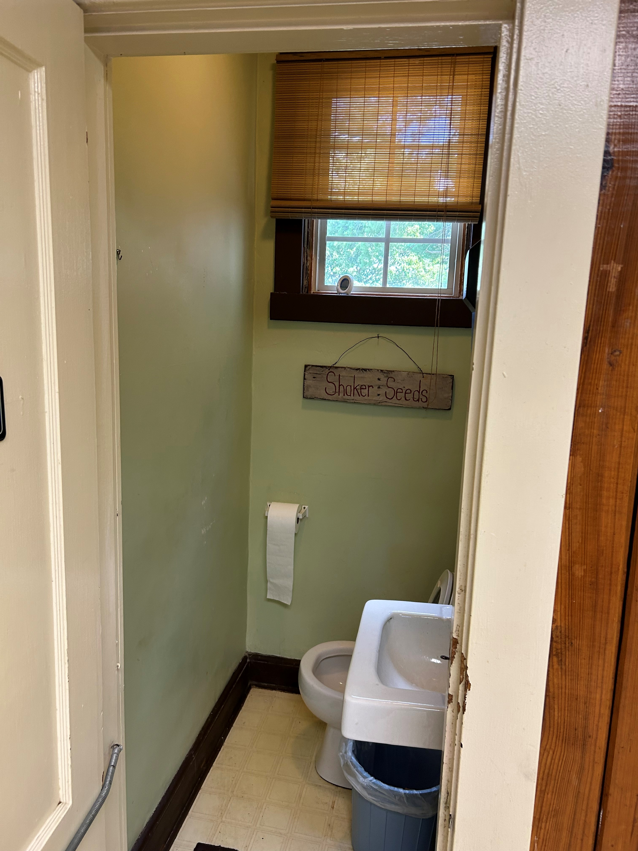

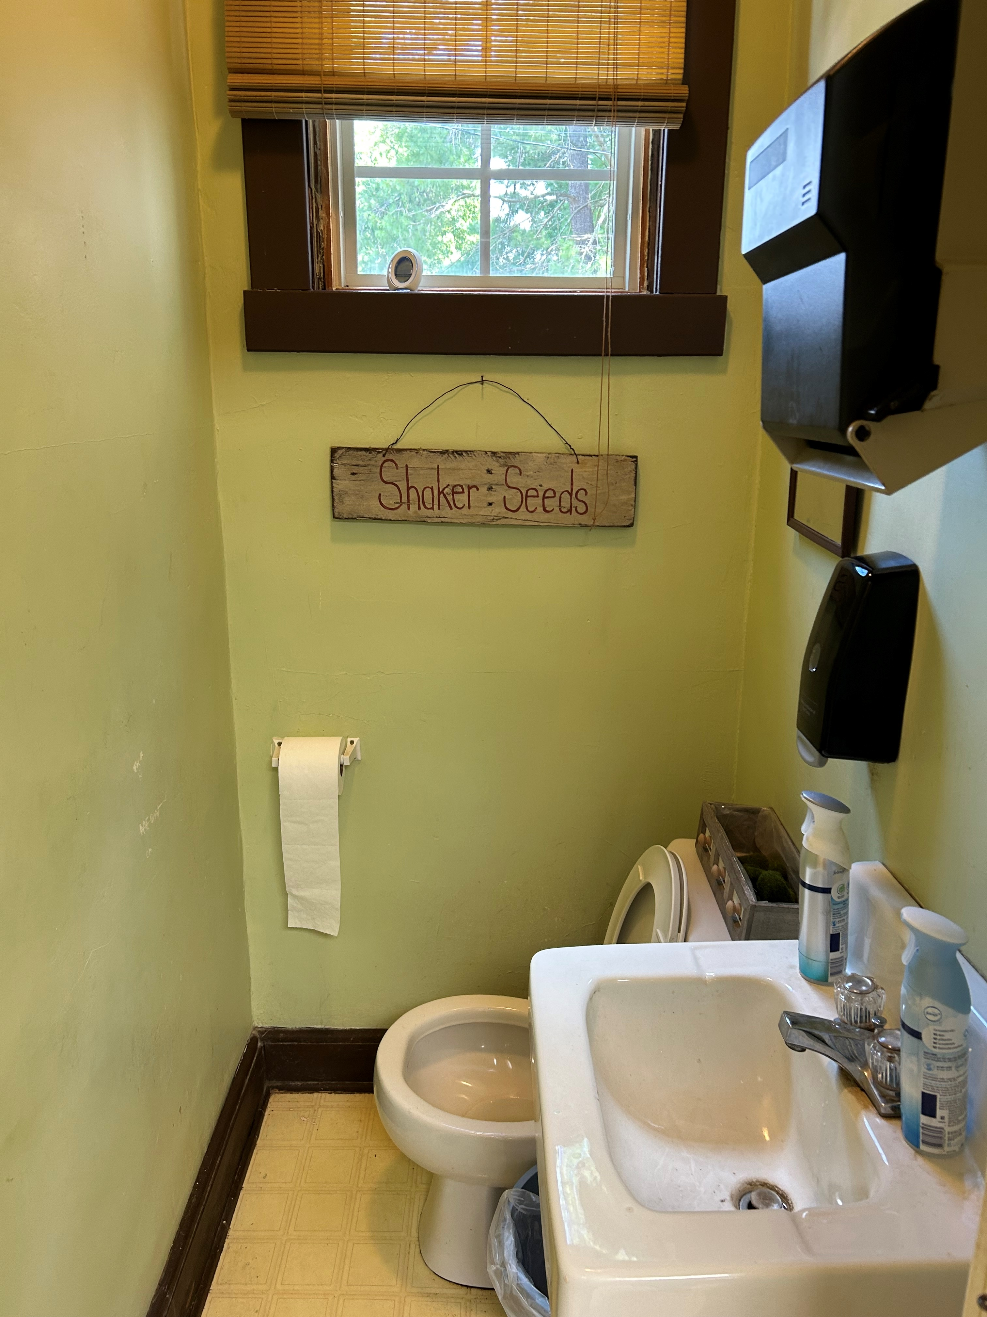
CURRENT BATHROOM #2

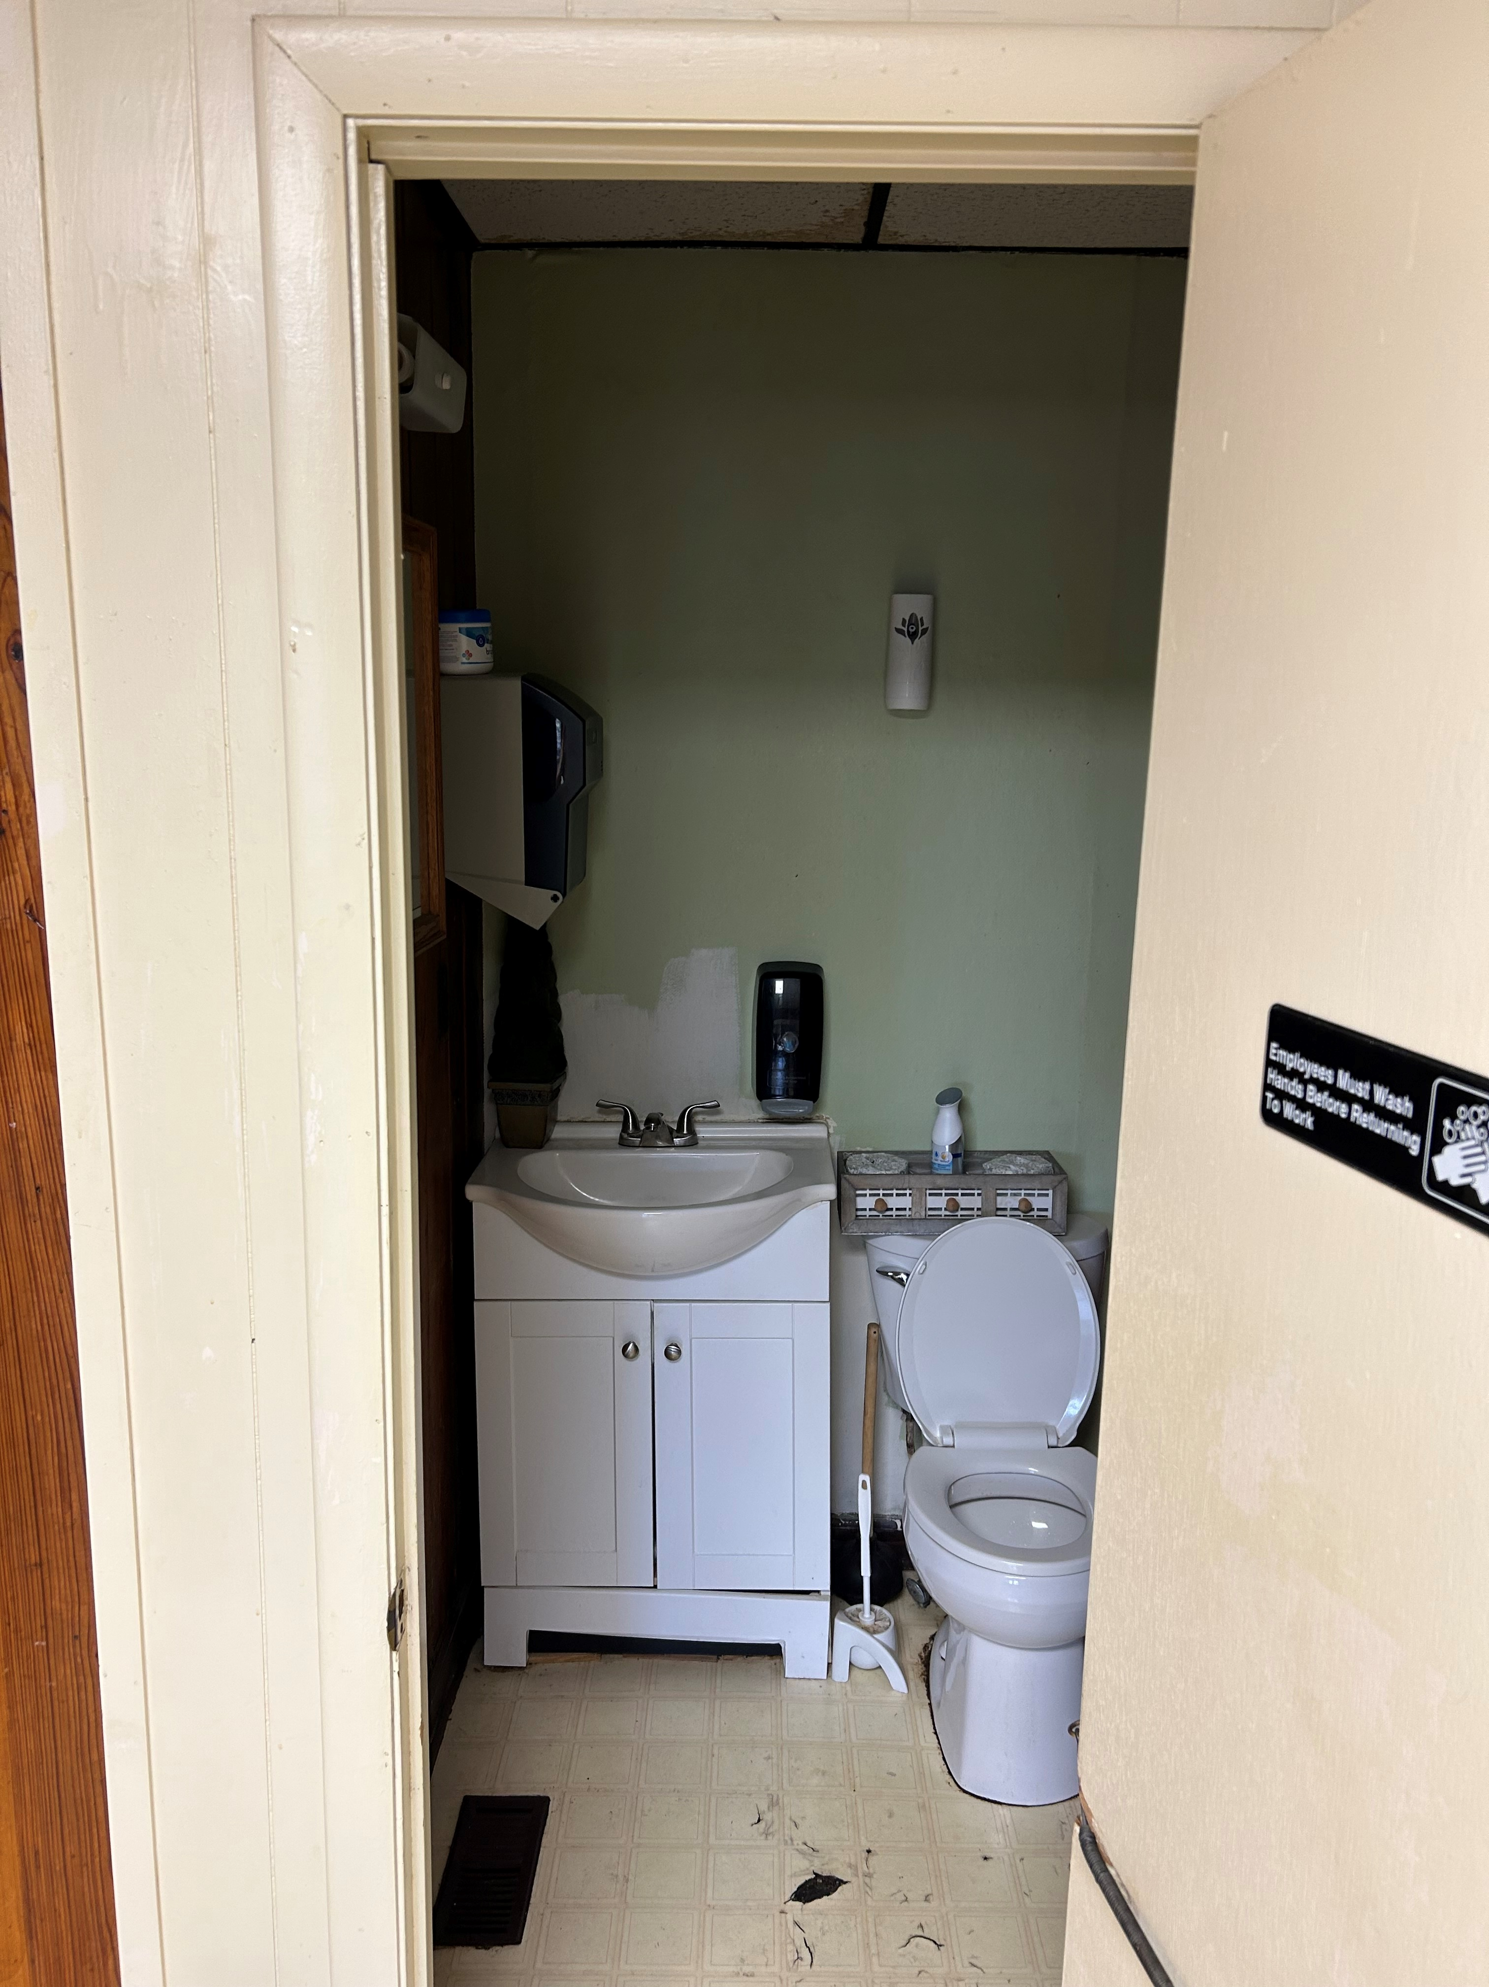

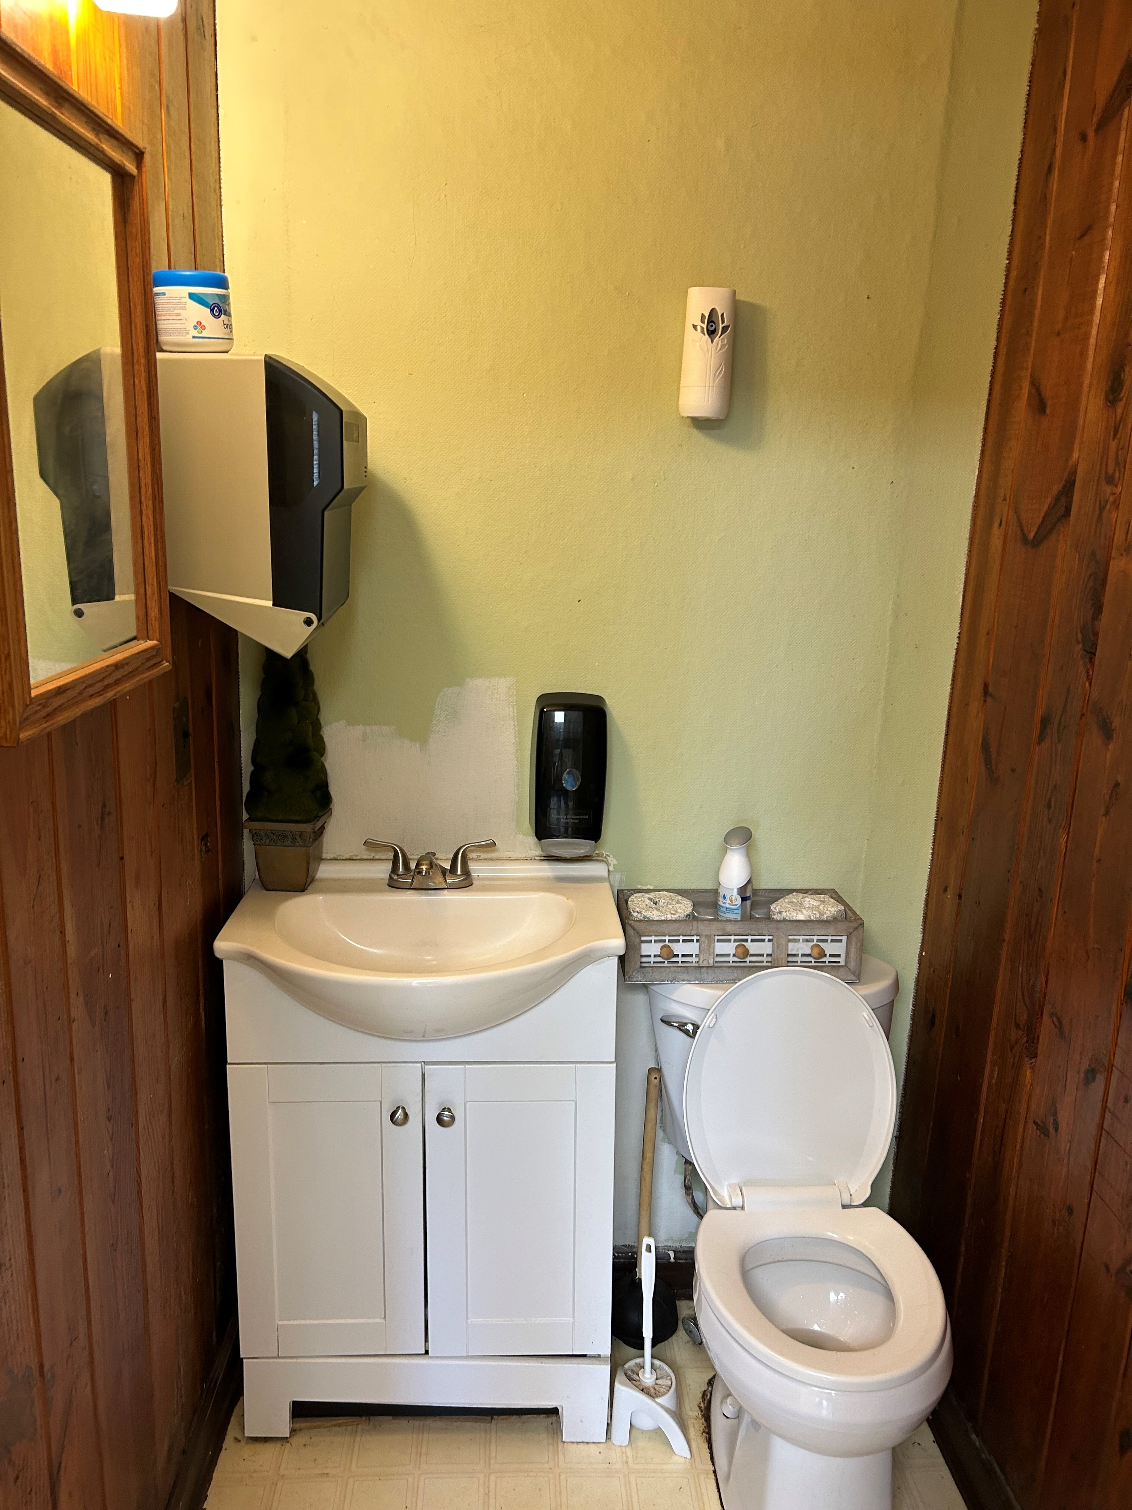

BID FORM: Bid #2023-014

Company/Bidder: _________________________________________________________
Contact Name: ___________________________________________________________
E-mail Address: __________________________________________________________
Address: _______________________________________________________________
_______________________________________________________________
Phone: __________________________ Fax: ________________________
Federal Tax Identification # (Please send a W-9 with Bid Form): ______________________

Bid for Bathroom Re-Model | Total

The above quantities are listed for calculation and comparison purposes only. Quantities may vary based on the City of Adams priorities and budgetary considerations.

PLEASE SUBMIT THIS BID FORM WHEN YOU SUBMIT YOUR BIDS FOR THIS PROJECT. ALSO SUBMIT A W-9 AND PROVIDE YOUR CERTIFICATE OF INSURANCE.

