Request for Proposals
Solicitation name and number | Provision of In Fill Housing Units in KCDC’s Five Points Community C23004
Upload responses by | 11:00 a.m. on 11/08/22
Upload your responses  (As one document) to | https://vrapp.vendorregistry.com/Account/LogOn  (Can also be accessed via KCDC’s webpage)
Questions about this solicitation | KCDC will not accept questions via telephone  Submit questions to procurementinfo@kcdc.org by 6:00 p.m. on 11/01/22
Solicitation Meeting is Mandatory | ☐ Yes ☒ No
Solicitation Meeting Date and Time | October 26, 2022, at 11:00 a.m.
Solicitation Meeting Location | The meeting is accessible through Zoom.
Solicitation Meeting Connection | Email procurementinfo@kcdc.org for the Zoom link.
Opening | There is no public opening since this is a request for proposals solicitation. However, the scoring tabulation is posted to KCDC’s webpage shortly after an award decision is made.
Award results | KCDC posts the award decision to its web page at: http://www.kcdc.org/procurement/.
Open Records/Public Access to Documents | All document provided to KCDC are subject to the Tennessee Open Meetings Act (TCA 8-44-101) and open records requirements.
Check KCDC’s webpage for addenda and changes before submitting your response

General Information

1. Background and Intent

a. Knoxville's Community Development Corporation (KCDC) is the public housing and redevelopment agency for the City of Knoxville and for Knox County in Tennessee. KCDC’s affordable housing property portfolio includes 20 sites with approximately 3,525 dwelling units.

b. KCDC uses “supplier” as inclusive of various words describing interested parties often called “supplier,” “bidders,” “contractors” and “proposers.”

c. This solicitation is for the provision/construction of infill housing at KCDC’s Five Points property (office located at 381 McConnell Street, 37915). The general description of the work is a turnkey solution for the design build services of affordable single-family housing on vacant lots located on Ben Hur Avenue, Selma Avenue and South Chestnut Street in the Knoxville area. The construction schedule and the project generally are dependent on finalizing sources of financing, such as grant funds and a bank loan.

d. The current need is for six 4-bedroom single family homes and five 5-bedroom single family homes. However, KCDC reserves the right, upon the agreement of the supplier, to purchase additional units (including units with different configurations) under the similar terms and conditions as detailed herein. KCDC will still evaluate proposals that exclude certain turnkey items as described below.

e. It is important that these units match the appearance of the better aspects of the traditional
neighborhoods in the heart of Knoxville.

f. See the Scope of Work section for additional technical details.

2. Bonds
Proposal, payment and performance bonds are required if the proposal exceeds $100,000 in value. The supplier will include all bonding costs in the base cost. Bonding requirements include:
a. A proposal bond from each supplier equivalent to 5% of the proposal price. Such proposal bond must accompany the proposal. Proposal bonds will not be returned until a contract is signed.

b. Performance and payment bonds for 100% of the contract price.

c. All bonding companies must be listed in the “Federal Register, Department of the Treasury Fiscal Service, Companies Holding Certificates of Authority as Acceptable Sureties on Federal Bonds and as Acceptable Reinsuring Companies; Notice.” Companies licensed to do business in the State of Tennessee must issue all required bonds.
3. Changes after Award
It is possible that after award KCDC will need to revise the requirements specified herein. KCDC reserves the right to make such changes after consultation with the supplier.
Should additional costs arise, the supplier must document increased costs. KCDC reserves the right to accept or reject and negotiate these charges. Such changes will not be of a “cardinal” nature.

4. Codes and Ordinances
All work covered is to be done in full accord with national, state and local codes, ordinances and orders that are in effect at the time the work is performed.

5. Contact Policy
Only contact KCDC’s Procurement Division about this solicitation from the issuance of this solicitation until award. Information obtained from an unauthorized officer, agent, or employee will not affect the risks or obligations assumed by the supplier or relieve the supplier from fulfilling any of the conditions of the resulting award for the purpose of this project. Such contact can disqualify the supplier from the solicitation process.

6. Contract Approval
The resulting contract is subject to KCDC’s Board’s approval.

7. Contract Documents
KCDC has posted a prototype of the standard contract and rider that will be used to its webpage. Please review these documents before submitting a proposal.

8. Damage
The supplier is responsible for all damage to buildings, equipment, grounds, premises and all other types of potential damage resulting from the provision of the services requested herein.

9. Employees
Supplier will:

a. Allow only personnel thoroughly trained and skilled to work on the job. Employees are not to be accompanied in their work area by acquaintances, family members, assistants or any person unless said person is an authorized employee of the supplier.

b. Have sufficient personnel to complete the work in a timely manner.

c. Provide adequate supervision and adequate discipline among his/her employees.

d. Provide at least one employee on every job assignment with the ability to speak, read, write and understand English so owner’s staff can communicate effectively with them.

e. Ensure that employees have proper identification displayed while on the job site. Employees, while on site, must wear a company uniform or have photo identification displayed.

f. Employees parking vehicles (whether corporately or privately owned) must ensure that company identification is on the vehicles. This may be by placards on the vehicle’s side, laminated paper with the company name placed on the dashboard or other means.

10. Equipment
Supplier shall provide all necessary equipment, materials, supplies, et cetera needed for the work. Include the cost for such equipment, materials and supplies in the price quoted.

11. Evaluation
KCDC will evaluate this solicitation as detailed below. KCDC alone determines (using NIGP’s definition and other relevant sources as appropriate) the supplier’s “responsive” and “responsible” status prior to award. Responsible means a business with the financial and technical capacity to perform the requirements of the solicitation and subsequent contract. A responsive proposal is one that fully conforms in all material respects to the solicitation document and all its requirements, including all form and substance. KCDC reserves the right to request additional information to assist in the evaluation process; this includes references and business capacity information.

a. KCDC will review all proposals and reserves the right to request necessary modifications, waive minor technicalities, reject all proposals, reject any proposal that does not meet mandatory requirement(s) or cancel this RFP, according to KCDC’s best interests.

b. KCDC’s Evaluation Team may elect to interview one or more suppliers before making an award. Interviews may include an in‐person examination of the proposed product. KCDC shall not reimburse the supplier for the costs associated with the interview process.

c. KCDC’s Evaluation Team may elect to first rank proposals with a simple numeric score and then detail score only the top tier of proposals.

d. KCDC evaluates responses on a weighted evaluation system. The categories and points assigned for each category are below.

Item | Weight
Cost  Purchase, set up, delivery, options, et cetera | 40
Experience and References  Positive or negative past experiences and references will be evaluated. | 15
Design/Build Capability  Experience of project team. | 10
Product Quality  How well the proposal meets the turnkey approach and the overall features of the home. | 35
Total Points Possible | 100

12. General Instructions to Suppliers
KCDC’s General Instructions to Suppliers are at www.kcdc.org . Click on “Procurement” and the link to the instructions. The supplier’s submittal means acceptance of the terms and conditions found in KCDC’s “General Instructions to Suppliers.” The following paragraphs in the General Instructions to Suppliers do not apply: 16, 42, 44a, 44b, 44d, 52, 63, 65, 69,

13. Insurance

a. See Appendix 1. These insurances and levels are required and not optional. If you or your insurance agent have concerns or believe that some coverages are not necessary, email procurementinfo@kcdc.org detailing any requested changes before this solicitation’s due date. The supplier will include all insurance costs in the base proposal.

b. Note that KCDC’s Insurance Appendix has changed and now requires your signature as well as that of your insurance agent(s).

c. Upon notice of intent to award, your insurance agent will email questions and the proposed Certificate of Insurance (COI) to dmartin@kcdc.org for review.

14. Licenses

a. Suppliers must possess and maintain proper licensure from the State of Tennessee and all other authorities having jurisdiction throughout the term of this award.

b. Suppliers must meet the requirements of the State Licensing Board for the set-up portion of this project.

15. Liquidated Damages
Liquidated damages of $300.00 per calendar day for each day beyond the scheduled completion date apply and are included in the award. This applies to the scheduled completion date for each phase of the approved project schedule.
16. Pandemic Special Requirements
If COVID or other pandemic requirements are in effect, all workers assigned to work on this project must follow the same health and safety standards that KCDC employees do and must follow any federal, state or local guidance that applies.

17. Permits
The supplier (and/or any subcontractors) shall obtain and pay for all permits required to complete authorized work.

18. Safety/OSHA Guideline Compliance

a. The supplier is responsible for providing and placing barricades, tarps, plastic, flag tape and other safety/traffic control equipment to protect the public, surrounding areas, equipment and vehicles.

b. The supplier shall ensure that its employees exercise all necessary caution and discretion to avoid injury to persons or damage to property.

c. Supplier shall use caution signs as required by OSHA Regulation 1910.144 and 1910.145 at no cost to KCDC. Caution signs shall be on-site at commencement of contract.

d. Supplier shall comply with all other OSHA and TOSHA safety standards that apply.

19. Schedule of Values
After KCDC issues a notice of award, the successful supplier will provide a standard Schedule of Values within 10 calendar days.

20. Section 3 of the HUD Act of 1968
Section 3 is a provision of the Housing and Urban Development Act of 1968 which requires that programs of direct financial assistance administered by the U.S. Department of Housing and Urban Development (HUD) provide, to the greatest extent feasible, opportunities for job training and employment to lower income residents in connection with projects in their neighborhoods. Further, to the greatest extent feasible, contracts in connection with these projects are to be awarded to local businesses. Section 3 is a tool for fostering local economic development, neighborhood economic improvement and individual self-sufficiency.

a. Recipients and suppliers must make a good faith effort to utilize Section 3 area residents as trainees and employees in connection with the project. Targeted recruitment and the selection of Section 3 area residents for available positions are two examples of good faith efforts to meet this requirement.

b. Recipients and suppliers must make a good faith effort to award contracts to Section 3
business concerns for work in connection with the project.
An example of a good faith effort to meet this requirement is the implementation of an affirmative action plan, which includes targets for the number and dollar value for awarding contracts to Section 3 business concerns.

c. Recipients and suppliers must keep records and submit reports to HUD documenting the good faith efforts taken and the results of these actions. Examples of such documentation include letters to community organizations, employment development and business development centers, copies of solicitations for bids or proposals; and copies of affirmative action plans.

d. How can businesses find Section 3 residents to work for them? This can be accomplished by
recruiting in the neighborhood and public housing developments to tell about available training and job opportunities. Distributing flyers, posting signs, placing ads, and contacting resident organizations and local community development and employment agencies to find potential workers are a few effective ways of getting jobs and people together.

e. All contracts awarded are subject to Section 3 requirements. Supplier shall seek to fill any and all position that are needed and unfilled with residents of KCDC communities. For additional information, go to http://www.hud.gov/offices/fheo/section3/Section3.pdf. The successful supplier will supply KCDC with job announcements for any positions that must be filled as a result of the award of KCDC work. Additionally the successful supplier will supply the same job announcement to the Knoxville-Knox County Committee Action Committee’s Workforce Connections group. These can be faxed to 544-5269.

f. A Section 3 resident is one who lives within a public housing authority’s site. It is also people who live in an area with a HUD assisted program and whose income is below HUD’s low income requirements.

g. A Section 3 business is one that:

1. Is at least 51% owned by a Section 3 resident; or
2. Employs Section 3 residents for at least 30% of its employee base; or
3. Makes a commitment to sub contract at least 25% of the project’s dollars to a Section 3 business.

h. Upon award, the successful supplier will supply two documents to KCDC:

1. A Section 3 Business determination (forms supplied by KCDC) provided one is not already on file.
2. A Section 3 Business plan for this work.

The successful supplier is responsible for providing any necessary security to equipment, materials, personnel, tools and the site that are required for this job. KCDC is not responsible for damage or losses to equipment, materials, personnel, tools or the site.
21. Security
The successful supplier is responsible for providing all security for equipment, materials, personnel and tools required for this work. KCDC is not responsible for damage or losses to equipment, materials, personnel or tools.

22. Small Business Outreach
KCDC requires the successful supplier to reach out to small businesses, minority owned businesses and woman owned businesses for goods and subcontracted services to fulfill this award. In addition to the successful supplier reporting on dollars spent with such businesses each January, KCDC expects outreach that results in actual subcontracting arrangements with such suppliers.

23. Smoke Free Policy

a. KCDC’s Smoke Free policy is applicable to you, your employees and subcontractors. The policy mandates:

- No smoking on owner’s property
- No e-vape or similar usage on owner’s property
- The Smoke Free policy applies in personal or corporate vehicles on owner’s property

b. Applicable definitions include:

- “Smoking” means inhaling, exhaling, burning or carrying any lighted or heated cigar, cigarette or pipe, or any other lighted or heated tobacco or plant product intended for inhalation, including hookahs and marijuana, whether natural or synthetic, in any manner or in any form.

- “Smoking” also includes the use of an electronic smoking device which creates an aerosol or vapor, in any manner or in any form.

- “Electronic Smoking Device” means any product containing or delivering nicotine or any other substance intended for human consumption that can be used by a person in any manner for the purpose of inhaling vapor or aerosol from the product. The term includes any such device, whether manufactured, distributed, marketed or sold as an e-cigarette, e-cigar, e-pipe, e-hookah or vape pen or under any other product name or descriptor.

- Property means all buildings, parking lots, streets, structures and land owned by KCDC. Should Supplier’s staff be observed violating these requirements, KCDC’s Procurement Division will notify the supplier about the problem. Should there be recurrences, KCDC may ask the CMAR to not send the employee to KCDC’s property. Repeated offenses may result in forfeiture of your awarded “contract.”

24. Solicitation Requirements
Caution: Requirements in the solicitation are not optional. If you have concerns or issues with any of the stated requirements, raise them before the solicitation due date. Examples of past issues where suppliers made faulty assumptions include bonds, insurance requirements and payment expectations.

25. Storm Water and Street Ordinances
The City of Knoxville’s Storm Water and Street Ordinances apply to this solicitation. The successful supplier will comply with the City’s ordinances. Compliance includes but is not limited to:

a. Retaining all sediments on the project site using structural drainage controls. Drainage control costs are incidental to the work.

b. Not discharging any construction or demolition related materials, wastes, spills, or residues from the project site to streets, drainage facilities, or adjacent properties by wind or runoff.

c. Containing non-storm water runoff from equipment and vehicle washing and any other activity at the project site.

d. Additional information about NPDES, BMPs and the Land Development Manual at http://www.cityofknoxville.org/engineering/stormwater/npdes.asp.

e. The successful supplier is responsible for all work, remediation, repair and monetary penalties or fines arising out of a Notice of Violation of the City of Knoxville’s Storm Water and Street Ordinances. The supplier will be charged costs KCDC incurs to install structural drainage controls or remedy a Notice of Violation. KCDC shall also charge a $50 fee per violation for related administrative costs.

f. KCDC will prepare, submit and pay the permitting fees. Upon award, the successful supplier will be required to sign onto the permit and be responsible for implementing and maintaining all erosion control measures as required on the SWPPP.

26. Subcontractors
Subcontractors must:

a. Be approved by KCDC prior to beginning work.

b. Carry the insurance coverages as outlined herein.

c. Not be on the general federal government, HUD’s nor the State of Tennessee’s debarment lists.

d. Not be changed without owner’s permission.
27. Time for Completion
Supplier will achieve substantial completion of the entire project by a schedule approved by the owner.

28. Weather
KCDC provides allowances for excessive inclement weather since this solicitation calls for liquidated damages-provided the supplier exceeds the guaranteed number of days for completion.

a. Extensions of Contract Time
If the basis exists for an extension of time in accordance with this solicitation, then an extension of time based on weather may be granted only for the number of weather delay days more than the number of weather days listed as the Standard Baseline for that month.

b. Standard Baseline for Average Climatic Range
The Standard Baseline is the normal and anticipated number of calendar days for each month during which adverse weather will prevent activity.

Suspension of activity for the number of days each month as listed in the Standard Baseline is to be included in the work and not eligible for an extension of the contract time. The baseline is:

Jan | Feb | Mar | Apr | May | Jun | July | Aug | Sep | Oct | Nov | Dec
12 | 11 | 8 | 7 | 7 | 6 | 7 | 5 | 4 | 5 | 6 | 11

c. Adverse Weather and Weather Delay Days

1) Adverse weather is the occurrence of one or more of the following conditions which prevents only exterior activity or access to the site within a twenty-four-hour period:

a) Precipitation (rain, snow or ice) more than one-tenth inch (0.10”) liquid measure.

b) Temperatures which do not rise above 32 degrees Fahrenheit by 10:00 a.m.

c) Standing snow more than one inch (1.00”).

2) Adverse weather may include, if appropriate, “dry-out” or “mud” days when all the following are met:

a) For rain above the Standard Baseline.

b) Only if there is a hindrance to site access or site work or excavation and supplier has taken all reasonable accommodations to avoid such hindrance.

c) At a rate, no greater than one make-up day for each day or consecutive days of rain beyond the Standard Baseline that total 1.0 inch or more, liquid measure, unless specifically recommended otherwise by the KCDC.

3) A weather delay day occurs only if adverse weather prevents work on the project for 50 percent or more of the supplier’s scheduled workday, including a weekend day or holiday if the supplier has scheduled construction activity that day.

d. Documentation and Submittals

1) Submit Daily Jobsite Work Log showing which and to what extent activities were affected by weather monthly.

2) Submit actual weather data to support a claim for the time extension obtained from nearest NOAA weather station or other independently verified source approved by the KCDC at the beginning of the project.

3) Maintain a rain gauge, thermometer and clock at the jobsite. Keep daily records of precipitation, temperature and the time of each occurrence throughout the project.

4) Use the Standard Baseline data provided in this section when documenting actual delays due to weather more than the average.

5) Organize claim documentation on calendar month periods and submit in accordance with the procedures for claims established by the KCDC.

e. Approval by KCDC

1) If the extension of the contract time is appropriate, it will occur in accordance with the provisions of this solicitation.

2) KCDC shall not incur extra costs for any extra time increase to the contract.

Scope of Work

29. General Information

a. KCDC wants proposals for the design and build services of homes as noted below (in addition see concept floor plans and conceptual site plans included with this solicitation document). Proposers must provide a description of any excluded portions of the work.

KCDC wants 6 single-family homes with each of the units configured with:
Bedroom | 4
Open Concept Kitchen/Living area | 1
Laundry area | 1
Porch | 1
Bathroom | 2

KCDC wants 5 single-family homes with each of the units configured with:
Bedroom | 5
Open Concept Kitchen/Living area | 1
Laundry area | 1
Porch | 1
Bathroom | 2

b. All houses must comply fully with the City of Knoxville’s Infill Design Guidelines. These can
be found at http://archive.knoxmpc.org/plans/dguides/infill_guide.pdf

30. Property and Design Standards

a. All housing constructed must meet all Tennessee Housing Development Agency (THDA) minimum design standards for new construction of single-family units, applicable local, county and state codes, Uniform Property Condition Standards (UPCS) and zoning ordinances at the time of project completion. These can be found on KCDC’s webpage with this solicitation.

b. In the absence of a local code, new construction of single‐family units for rental must meet the current, state‐adopted edition of the International Residential Code for One‐ and Two‐ Family Dwellings. The newly constructed units must also meet accessibility requirements and mitigate disaster impact as applicable per state and local codes, ordinances, et cetera.

c. Additional design standards include:

1. Energy Conservation. In addition to meeting the City of Knoxville code Requirements and International Energy Conservation Code, new construction projects must be Energy Star qualified as certified by an independent Home Energy Rating System (HERS) rater supplier should include the cost of rater in its proposal or specifically state that the cost is excluded.

2. Broadband Infrastructure. THDA requires that newly constructed rental units must be wired for broadband internet access.

3. Modular Housing (if applicable) must meet all applicable code requirements (i.e. manufactured housing is not acceptable), modular is acceptable.

4. Each home must have at least one level entrance.

5. Titles II and III of the Americans with Disabilities Act (42 U.S.C. 12131–12189) implemented at 28 CFR parts 35 and 36, as applicable.

This and the previous pages do not need to be returned.

Solicitation Document A |  |  |  | General Information about the Supplier
Note: Complete all cells even if the answer is “Does not apply”
Sign Your Name to the Right of the Arrow
If completing this document in Adobe, an electronic signature is acceptable to KCDC.
Your signature indicates you read and agree to “KCDC’s General Instructions to Suppliers” (www.kcdc.org) and that you are authorized to bind the supplier or are submitting the response on behalf of and at the direction of the suppliers’ representative authorized to contractually bind the supplier. I represent that the supplier or its applicable representatives has reviewed the information contained in this Solicitation Package and that the information submitted is accurate.
Item |  |  |  |  |  |  | Response
Printed Name and Title
Legal Corporate Name
Street Address
City/State/Zip
Contact Person
Telephone Number
Cell Number
Supplier’s E-Mail Address
Addenda
Addenda are at www.kcdc.org. Click on “Procurement” and then on “Open Solicitations” to find addenda. Please check for addenda prior to submitting a proposal.
Acknowledge addenda have been issued by checking below as appropriate:
None ☐ | Addendum 1 ☐ |  |  | Addendum 2 ☐ |  | Addendum 3 ☐ |  | Addendum 4 ☐ |  | Addendum 5 ☐
Statistical Information (Check a box in each of the next four lines)
1. This business is at least 51% owned and operated by a woman |  |  |  |  |  |  |  |  |  | Yes ☐ No ☐
2. This business qualifies as a small business by the State of Tennessee  Total gross receipts of not more than $10,000,000 average over a three-year  period OR employs no more than 99 persons on a full-time basis |  |  |  |  |  |  |  |  |  | Yes ☐ No ☐
3. This business is at least 51% owned and operated by a veteran |  |  |  |  |  |  |  |  |  | Yes ☐ No ☐
4. This business is owned & operated by persons at least 51% of the following ethnic background:
Asian/Pacific  ☐ |  | Black  ☐ | Hasidic Jew  ☐ |  | Hispanic  ☐ |  | Native American ☐ |  | White  ☐ | Publicly Owned ☐
Prompt Payment Discount
A ____% prompt payment discount applies if KCDC pays within ____ days of accurate invoicing.
Insurance Statement
I have reviewed the insurance requirements and will comply without exception. Yes ☐ No ☐

Solicitation Document B | Affidavits

Conflict of Interest
1. No commissioner or officer of KCDC or other person whose duty it is to vote for, let out, overlook or in any manner superintend any of the work for KCDC has a direct interest in the award or the supplier providing goods or services.

2. No employee, officer or agent of the grantee or sub-grantee will participate in selection, or in the award or administration of an award supported by federal funds if a conflict of interest, real or apparent, would be involved. Such a conflict would arise when the employee, officer or agent, any member of his immediate family, his or her partner, or an organization, which employs, or is about to employ, any of the above, has a financial or other interest in the supplier selected for award.

3. The grantee's or sub-grantee's officers, employees or agents will neither solicit nor accept gratuities, favors or anything of monetary value from suppliers, potential suppliers, or parties to sub-agreements.

4. By submission of this form, the supplier is certifying that no conflicts of interest exist.

Drug Free Workplace Requirements
5. Private employers with five or more employees desiring to contract for construction services attest that they have a drug free workplace program in effect in accordance with T.C.A. 50-9-112.

Eligibility
6. The supplier is eligible for employment on public contracts because no convictions or guilty pleas or pleas of nolo contender to violations of the Sherman Anti-Trust Act, mail fraud or state criminal violations with an award from the State of Tennessee or any political subdivision thereof have occurred.

General
7. Supplier fully understands the preparation and contents of the attached offer and of all pertinent circumstances respecting such offer.

8. Such offer is genuine and is not a sham offer.

Iran Divestment Act
9. Concerning the Iran Divestment Act (TCA 12-12-101 et seq.), by submission of this bid/quote/proposal, each supplier and each person signing on behalf of any supplier certifies, and in the case of a joint bid/quote/proposal, each party thereto certifies as to its own organization, under penalty of perjury, that to the best of its knowledge and belief that each supplier is not on the list created pursuant to § 12-12-106.

Accuracy of Electronic Copies
10. If the supplier provides electronic copies of the bid/proposal/quote to KCDC, the supplier certifies that the information provided on paper and in the electronic format is identical unless specifically noted otherwise.

General
11. Neither the said supplier nor any of its officers, partners, owners, agents, representatives, employees or parties interest, including this affiant, has in any way colluded conspired, connived or agreed, directly or indirectly, with any other responder, supplier, or person to submit a collusive or sham offer in connection with the award or agreement for which the attached offer has been submitted or to refrain from making an offer in connection with such award or agreement, or collusion or communication or conference with any other supplier, or, to fix any overhead, profit, or cost element of the offer price or the offer price of any other supplier, or to secure through any collusion, conspiracy, connivance, or unlawful agreement any advantage against KCDC or any person interested in the proposed award or agreement.

12. The prices quoted in the attached offer are fair, proper and not tainted by any collusion, conspiracy, connivance, or unlawful agreement on the part of the supplier or any of its agents, representatives, owners, employees, or parties in interest, including this affiant.

No Contact/No Advocacy Affidavit
13. Any contact initiated by any supplier with any KCDC representative concerning this solicitation is strictly prohibited-except for communication with the Procurement Division. My signature signifies that no unauthorized contact occurred.

14. To ensure the integrity of the review and evaluation process, respondents to this solicitation nor any firm representing them, may not lobby or advocate to KCDC staff or Board members. My signature signifies that no unauthorized advocacy occurred.

Non-Boycott of Israel Affidavit
15. Concerning the Non-Boycott of Israel Act (TCA 12-4-1 et seq.), by submission of this bid/quote/proposal, each supplier and each person signing on behalf of any supplier certifies, and in the case of a joint bid/quote/proposal, each party thereto certifies as to its own organization, under penalty of perjury, that to the best of its knowledge and belief that each supplier is not boycotting Israel pursuant to § 12-4-1 and will not during the term of any award. Note: Applicable only to contracts of $250,000 or more and to suppliers with 10 or more employees.

The undersigned hereby acknowledges receipt of these affidavits and certifies that the submittal in response to this solicitation is in full compliance with the listed requirements. Failure to properly acknowledge issues concerning the above is grounds for bid/proposal rejection and may subject the signer to penalties as directed by the appropriate laws.

Signed by
Printed Name
Title

Solicitation Document C | HUD Form 5369A
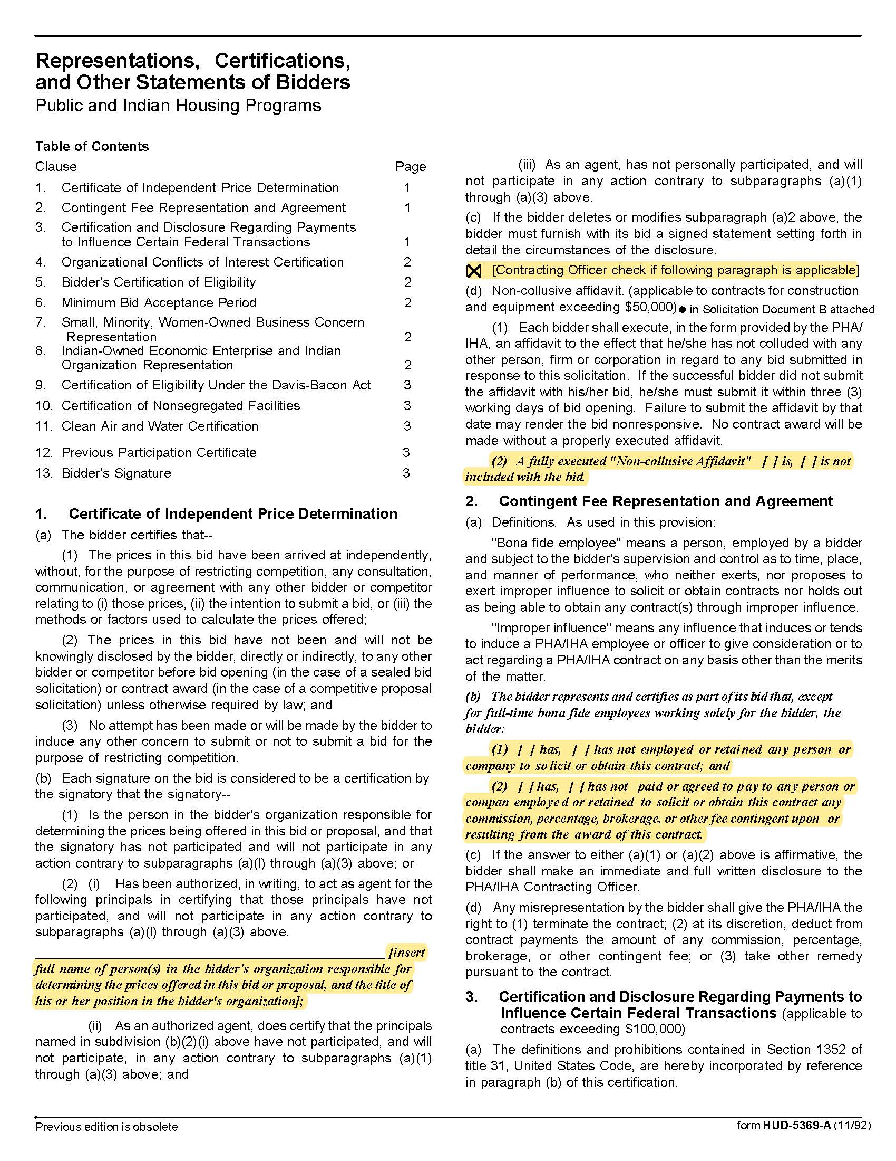

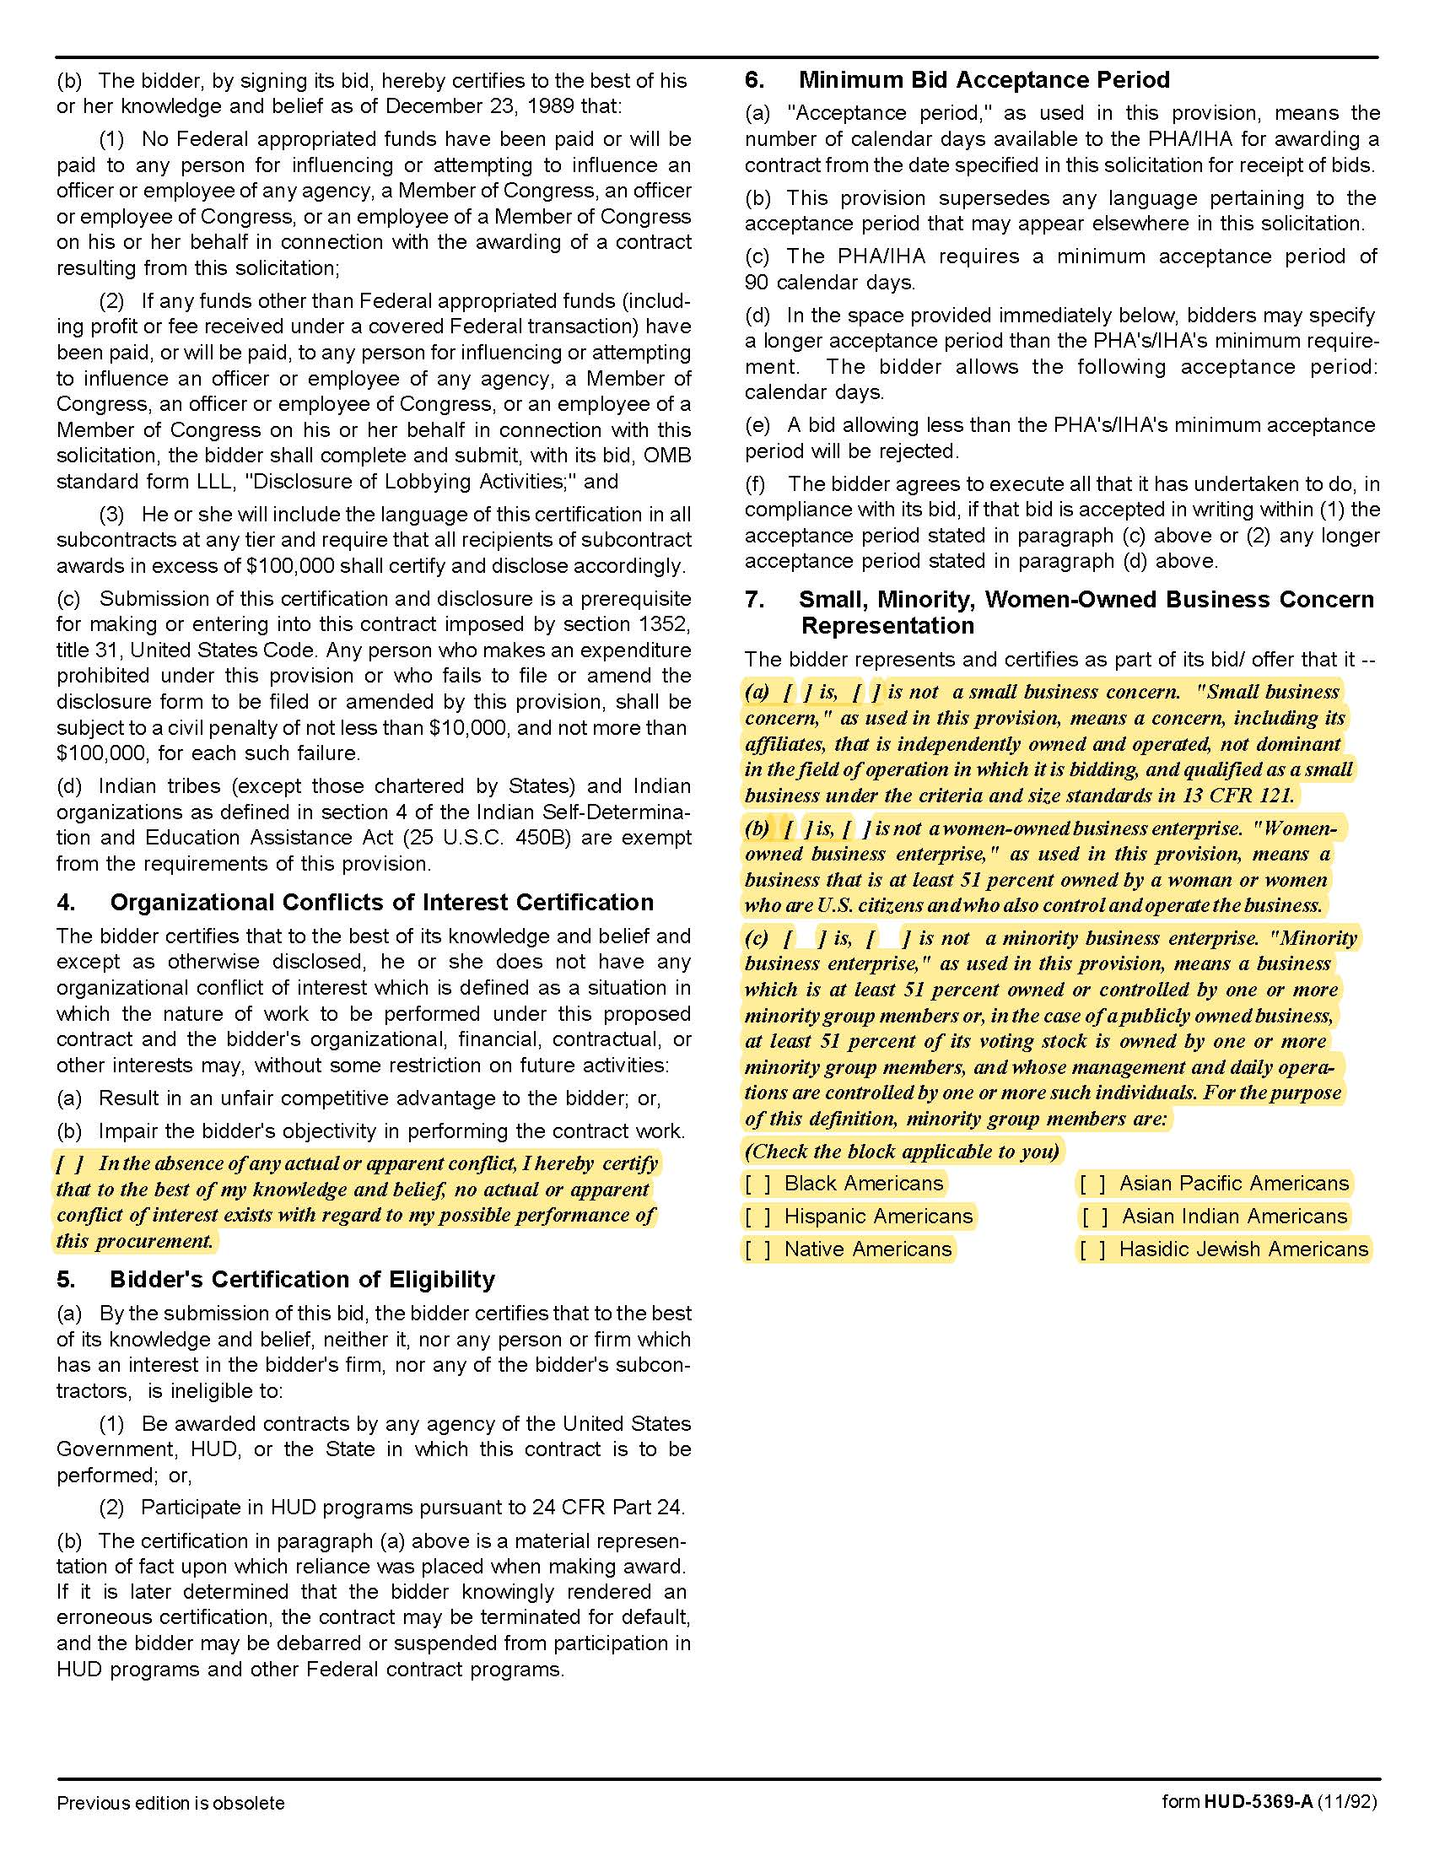

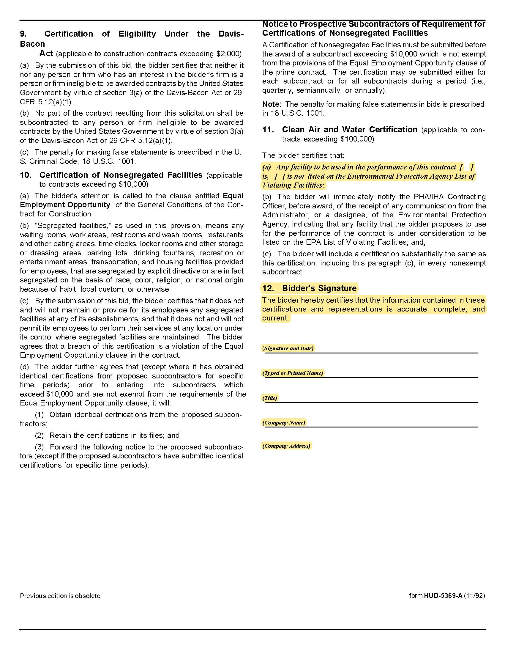

Solicitation Document D | Proposal Cost Sheet

In compliance with the solicitation documents, the supplier agrees to perform the work for the following total amount. The prices quoted cover all the supplier’s expenses including, but not limited to, overhead, profit, insurance, subcontractors, supplies and bonding. All utility connection fees (from the street to the house) are to be included in the proposal. Costs offered are valid for a minimum of 60 days from the solicitation due date.

A Notice to Proceed (NTP) is anticipated within 60 days of the Letter of Intent. Prior to issuance of the NTP the selected contractor will consider giving the selected contractor the opportunity to adjust its proposal pricing based on current market conditions. The selected contractor must provide documentation to support its proposal pricing and current market pricing. No adjustment in proposal pricing will be permitted without adequate documentation and approval from KCDC. After final pricing is approved by KCDC and financing is in place a contract will be executed and the NTP issued.

Do not change the pricing structure and complete all “blanks” even if the amount is $0.00.

 | Cost Information
 | Total Project Cost for the 4–5-bedroom houses |  | $
 | Exceptions to Specifications (Indicate the item number)
 | Final Completion or Set up is guaranteed within how many calendar days after receipt of a NTP?
 | Other Cost Items
 | Average Site Work Cost |  | $
 | Unit price for the removal of unsuitable soils |  | $ per cubic yard
 | Unit price for the replacement of unsuitable soils |  | $ per cubic yard
 | Component Pricing Portions of the Total Price Include
 | 4 Bedroom House |  | $
 | 5 Bedroom house |  | $
 | 4 Bedroom House Foundation |  | $
 | 5 Bedroom House Foundation |  | $
 | Water Tap and Line Fee from the Road to the Home Site |  | $
 | Sewer Tap and Line Fee from the Road to the Home Site |  | $
 | Electrical Connection Fees |  | $
 | Driveways and sidewalks |  | $
 | Landscaping including sod and plantings per code |  | $
 | Cost of design plans |  | $
Solicitation Document E |  | Prototype Drawing and Specifications

Provide a drawing of the prototype 4- and 5-bedroom homes for KCDC’s review. Additionally, include specifications of items such as (but not limited to):

- Structural system type
- Frame specifications
- Floor framing specifications
- Floor finish specifications
- Interior wall specifications
- Door and door hardware specifications
- Window specifications
- Narrative of electrical systems
- Emergency lighting and other safety specifications
- Narrative of HVAC systems

Solicitation Document F | Proposer’s Experience

Provide information about your experience with public entities to show proven and demonstrated ability to execute the RFP requirements. The proposal must include at least three specific references of similar accounts. Present the information in this format:

1. Name of the business/entity serviced

2. Contact name

3. Address

4. Phone number

5. Email address

6. Amount of the contract

7. Description of the contract

8. Date the contract began

9. Date the contract ended (if applicable)

Solicitation Document G | Good Faith Compliance Affidavit

The supplier must demonstrate a good faith effort to utilize Minority Owned Businesses (MOB) and Woman Owned Businesses (WOB). To assist in this effort, KCDC posts the web links of organizations, which can provide suppliers with a list of minority and women owned businesses, on its web site. These lists are useful in preparing a response to this solicitation.

Place a checkmark in either Section One or Section Two of this form. Provide the information in Section One if you check that box.

Section One ☐ The following companies were asked for pricing for the attached proposal. Provided the listed companies meet proposal document requirements and their pricing is competitive, it is our intent to use the companies listed. Attached hereto or to be provided to KCDC within five calendar days of solicitation opening is our Form of Commitment/Statement of Effort (failure to submit the Form of Commitment/Statement of Effort may result in rejection of your proposal.
Company Name | Product/Service | MOB | WOB

Section Two ☐ MOB/WOB's were not contacted because sub-suppliers/contractors will not be needed to complete the contract and all work will be completed by the supplier. Other MOB/WOB's not shown above, will be considered during the duration of the contract in the event the supplier decides additional subcontractors or supplier will be used (to complete all or part of the contract).

Signed by
Print Name and Title
Attested to on this date

Solicitation Document H | Form of Commitment: Minority Owned /Woman Owned Business

Place a checkmark in either Section One or Section Two of this form.
Section One Does not apply - MOB/WOB subcontractors will not be used. ☐ (Stop Here)
Section Two MOB/WOB Subcontractors will be used. ☐ (Complete this page)

I certify the supplier has or will enter into a formal agreement with the MOB/WOB enterprise for work listed in this schedule.
Supplier Name | M  OB | W  O  B | Type of  Supplies to be Provided | Type of Work to be Performed | Dollar Value of Supplies or Service

COMPLETE THE FOLLOWING BOXES IF BOX ABOVE WAS NOT COMPLETED
The following companies were listed on the Good Faith Compliance Affidavit submitted with my proposal.
Company Name | Product/Service | MOB | WOB

Explain why each of the above companies could not be used to provide the products or services.
Company Name | Reason

Above information submitted by ___________________________________________________

Printed/Typed Name and Title: ____________________________________________________

Appendix 1 | Insurance Requirements

INSURANCE
The Supplier shall maintain, at Supplier’s sole expense, on a primary and non‐contributory basis, at all times during the life of the contract insurance coverages, limits, and endorsements described herein. All insurance must be underwritten by insurers with an A.M. Best rating of A- : IX or better. Upon award, the Supplier shall provide Certificate(s) of Insurance and amendatory endorsements to KCDC evidencing said insurance coverages. See paragraph “g” for exact naming of certificate holders, additional insureds and mortgage interest.

The Supplier agrees the insurance requirements herein as well as KCDC’s review or acknowledgement, is not intended to and shall not in any manner limit or qualify the liabilities and obligations assumed by the Supplier under this contract. KCDC’s failure to require a Certificate of Insurance, acceptance of a non-conforming certificate, or allowing the Supplier to commence work shall not operate as a waiver of these minimum insurance requirements or the liabilities and obligations assumed by the Supplier under this contract.

a. Commercial General Liability Insurance and Umbrella Liability Insurance: occurrence version general liability insurance including contractual liability with minimum limits of $1,000,000 per occurrence and $2,000,000 in the aggregate covering the following perils: bodily injury, personal injury, and broad form property damage including products/completed operations for one year after completion of the Project(s). Limits must apply separately to the work/location in this contract.

Umbrella Liability: Umbrella Liability Insurance with a minimum limit of $5,000,000 per each occurrence and aggregate combined single limit for all liability with a $10,000 self-insured retention for exposure not covered in underlying primary policies. The policy shall name the Commercial General Liability and Automobile Liability in its underlying schedule.

Such insurance shall contain or be endorsed to contain a provision that includes the Entities listed in paragraph “g” as additional insureds with respect to the Supplier’s ongoing and completed operations, providing coverage at least as broad as CG 20 10 07 04 and 20 37 07 04 endorsements. The coverage shall contain no special limitations on the scope of its protection afforded to the listed insureds.

b. Commercial Automobile Liability Insurance: in an amount not less than $1,000,000 (combined single limit) for all owned, hired, and non-owned vehicles utilized by Supplier in connection with the Project. Coverage is to include coverage for loading and unloading hazards.

Such insurance shall contain or be endorsed to contain a provision that includes the Entities listed in paragraph “g” as additional insureds.

c. Workers’ Compensation Insurance and Employers’ Liability Insurance: Workers’ Compensation Insurance with statutory limits as required by the State of Tennessee or other applicable laws. Employers’ Liability Insurance with a limit of not less than $500,000.

d. Pollution Liability Insurance: coverage, providing defense and indemnity coverage for bodily injury, property damage, and environmental investigation and clean‐up costs for pollution conditions arising from the Contractor’s operations. Limit of liability not less than $1,000,000 each occurrence and $2,000,000 annual aggregate. The policy shall include a minimum three (3) year Discovery (tail) reporting period, and a Retroactive Date that equals or precedes the effective date of this contract or the performance of work hereunder. Coverage may be provided on a per project basis.

e. Builder’s Risk: coverage shall be written on an All-Risk, Replacement Cost, and Completed Value Form basis in an amount at least equal to one-hundred percent (100%) of the projected completed value of the Work, as well as subsequent modifications of that sum due to Change Order(s). Supplier agrees to be responsible for reporting increases in the projected completed value of the work due to Change Order(s). Owner shall be responsible for the deductible up to $10,000 for weather related losses. Supplier shall be responsible for all other deductibles.

Coverage shall insure without limitation against the perils of fire and extended coverage and physical loss or damage including, but not limited to, theft, vandalism, malicious mischief, collapse, windstorm, testing and startup, temporary buildings, portions of the work stored off site, all portions of the work in transit, debris removal including demolition occasioned by enforcement of any applicable legal requirements and shall cover reasonable compensation for Architect’s and Supplier’s services and expenses required as a result of such insured loss. Insurance is to cover all property of Suppler (and its subcontractors), Owner and all certificate holders as their interest may appear. Coverage shall cover the completed value of the construction including without limitation, slab on grade, excavations, foundations, caissons, tenant finish work, and retaining walls around the perimeter of the project. Any exclusion of so-called underground damage to pipes, collapse of structure, or damage resulting from explosion or blasting shall be deleted. Such policy shall provide that any loss thereunder shall be payable to the Supplier, Owner, and others as their interests may appear and shall also have a replacement cost endorsement.

Debris Removal shall be no less than $250,000 for removal from a casualty loss and no less than $10,000 for debris removal of pollutants.

Coverage shall include soft costs resulting from damage or destruction to insured property on-site and while in transit including flood, earthquake and earth movement when such perils are required. Such insurance shall cover continuing expenses not directly involved in the direct cost of construction/renovation, including expense incurred upon money borrowed to finance construction or repair, continuing interest on mortgage loans, advertising, promotion, realty taxes and other assessments, the cost to the insured of additional commissions incurred upon re-negotiating leases, loss of earnings and rents and other expenses incurred as a result of property loss or destruction by an insured peril.

f. Other Insurance Requirements:

- Upon award, Supplier shall furnish KCDC with original Certificate(s) of Insurance and
amendatory endorsements effecting coverage required by this section.

- Provide a waiver of subrogation for each required policy herein. When required by the
insurer, or should a policy condition not permit Supplier to enter into a pre‐loss agreement to waive subrogation without an endorsement, the policy should be endorsed with a Waiver of Transfer of Rights of Recovery Against Others, or its equivalent. This waiver of subrogation requirement shall not apply to any policy which includes a condition specifically prohibiting such an endorsement, or voids coverage should supplier enter into such an agreement on a pre‐loss basis.

- Not less than 30‐days prior written cancellation notice and no less than 10-days for non-
payment of premium for all insurances (by endorsement if necessary) is required.

- Replace certificates, policies, and endorsements for any such insurance expiring prior to
completion of services.

5. Maintain such insurance from the time services commence until services are completed or through such extended discovery/reporting/tail period as required. Failure to maintain or renew coverage or to provide evidence of renewal may be treated by KCDC as a material breach of contract.

6. Any deductibles and/or self‐insured retentions greater than $50,000 must be disclosed to and approved by KCDC prior to the commencement of services. Use of large deductibles and/or self‐insured retentions will require proof of financial ability as determined by KCDC.

7. All policies must be written on an occurrence basis with the exception of Errors and Omissions Liability (E & O) / Professional Liability and Pollution Liability which may be claims made coverage.

8. Require all subcontractors to maintain during the term of the resulting contract commercial general liability insurance, automobile liability insurance, and workers’ compensation insurance (unless subcontractor’s employees are covered by Supplier’s insurance) in the same manor and limits as specified for the Supplier.

g. Certificate Holders, Additional Insureds, Mortgage Interest and Loss Payee:

Knoxville’s Housing Development Corporation
KCDC, its officials, officers, employees, and volunteers
901 N Broadway
Knoxville, TN 37917

Home Federal Bank of Tennessee
Attn: Jonathan W. Mayfield, Vice President
515 Market Street
Knoxville TN 37902

Any other lender, investor, interest as required.

h. Right to Revise or Reject: KCDC reserves the right to revise any insurance requirement, including but not limited to, limits, coverages, and endorsements based on changes in scope of work/specifications, insurance market conditions affecting the availability or affordability of coverage.

i. No Representation of Coverage Adequacy: The coverages, limits or endorsements required herein protect the primary interests of KCDC, and the Supplier agrees in no way should these coverages, limits or endorsements required be relied upon when assessing the extent or determining appropriate types and limits of coverage to protect the Supplier against any loss exposures, whether as a result of the project or otherwise.

All limits indicated are minimums required.

Certificate Holders & Additional Insureds | See paragraph “g” above
Mortgage Interest & Additional Insured on Builder’s Risk | Home Federal Bank of Tennessee
Loss Payee & Additional Insured on Builder’s Risk | Knoxville’s Housing Development Corporation  KCDC, its officials, officers, employees, and volunteers
GL – including Contractual Liability  (Supplier & Subcontractors) | $1M / $2M
Umbrella (Supplier) | $5M
Auto (Supplier & Subcontractors) | $1M (owned, hired, & non-owned)
WC (Supplier & Subcontractors) | statutory limits
Employers’ Liability (Supplier & Subcontractors) | $500,000
Pollution (Supplier) | $1M / $2M with 3-year Discovery;  with Retro Date at least equal to contract date
Builder’s Risk (Supplier) | 100% of projected completed value
30-day cancellation (Supplier & Subcontractors) | Required– must indicate on COI
Primary non-contributory (Supplier & Subcontractors) | Required – must indicate on COI
Waiver of Subrogation (Supplier & Subcontractors) | Required for all coverages – must indicate on COI

Insurance Agent’s Statement and Certification:
I have reviewed these insurance requirements with the bidder/proposer named below and have told the bidder/proposer that the required coverage will be available and have advised the bidder/proposer of any additional costs that may be entailed with the coverages.

Insurance Agency 1 Name: _______________________________________________________

Authorizing Signature: ________________________________________________________

Insurance Agency 1 Name: _______________________________________________________

Authorizing Signature: ________________________________________________________

Insurance Agency 1 Name: _______________________________________________________

Authorizing Signature: ________________________________________________________

Bidder’s/Proposer’s Statement and Certification:
I certify that:

1. I have reviewed these requirements with my insurance agent(s).

2. If awarded the contract, I and my subcontractors (if any) will comply with the insurance requirements herein.

3. I/my insurance agency take no exceptions to the listed insurance requirements.

4. My subcontractors (if any) take no exceptions to the listed insurance requirements.

Bidder/Proposer’s Name: _______________________________________________________

Authorizing Signature: ________________________________________________________

Return this page with your bid

