Request for Proposals

Solicitation Name and Number | Supportive Staffing Services for The Manor at Northgate Terrace Q2108
Responses Must Arrive No Later Than | 11:00 a.m. on November 17, 2020 (As KCDC’s clocks indicate)
Deliver Responses to | procurementinfo@kcdc.org
Electronic Copies | Bidders are to use the MS Word version (or other software) posted on KCDC’s website to provide a typed response. The final bid is to be submitted in Adobe format.
Solicitation Meeting | ☒ Yes ☒ No
Solicitation Meeting is Mandatory | ☐ Yes ☐ No ☒ Not Applicable
Solicitation Meeting Date and Time | N/A
Solicitation Meeting Connection | N/A
Site Visit Schedule | Due to the current Pandemic, contact KCDC Procurement at procurementinfo@kcdc.org to obtain an appointment.
Questions About This Solicitation | KCDC will not accept questions via telephone.  Submit questions to purchasinginfo@kcdc.org by 6:00 p.m. on November 12, 2020.
Solicitation Opening | Since this is a proposal, only the names of those firms submitting proposals will be posted to KCDC’s webpage. Once an award recommendation is made, all information may be reviewed.
Award Results | KCDC posts the award decision to its web page
Open Records/Public Access to Documents | All document provided to KCDC are subject to the Tennessee Open Meetings Act (TCA 8-44-101) and open records requirements.
Check KCDC’s webpage (https://www.kcdc.org/procurement/) for addenda and changes before submitting your response

General Information

1. Definitions
a. “Requirements Contact” and “Term Bid” are standing arrangements between KCDC and a supplier in which prices and terms are decided and in which during the duration, KCDC may call on the supplier to deliver goods or services (or both) under the terms and at the agreed to pricing.

b. “Supplier” is inclusive of various words describing interested parties often called “vendor,” “bidders,” “contractors” and “proposers.”

2. Background and Intent
a. Knoxville's Community Development Corporation (KCDC) is the public housing and redevelopment agency for the City of Knoxville and for Knox County in Tennessee. KCDC’s affordable housing property portfolio includes 20 sites with approximately 3,525 dwelling units. Several of the properties include Low Income Housing Tax Credits units and KCDC is both the General Partner and the management company for those sites. Those properties include Eastport LP, Five Points 1, LP; Five Points 2, LP; Five Points 3, LP; Five Points 4, LP; Lonsdale Homes, LP; Northridge Crossing, LP and The Vista at Summit Hill, LP. KCDC also oversees approximately 3,958 Section 8 Vouchers, 82 Moderate Rehabilitation units and 20 Redevelopment areas. KCDC has issued this solicitation for itself and on the behalf of the various properties that it now provides “management services” as detailed above. Any resulting awards are either for KCDC itself or are on behalf of those properties which KCDC provides “management services.”

b. KCDC operates a service program for senior citizens known as The Manor. This residential program is located on the second and third floors of a high rise at Northgate Terrace located at 4301 Whittle Springs Road, Knoxville, Tennessee 37917. The program houses up to forty-two residents, and provides a package of services that enables residents to remain independent while living in the community for as long as possible. The package of services includes two daily meals, two wellness checks, light cleaning, laundry service, an emergency call pendant and case management. KCDC intends for this Request for Proposals to result in the selection of a single capable firm to perform laundry, housekeeping, meal prep/delivery, wellness checks and other miscellaneous services for The Manor.

3. Bonding
The proposer’s employees must be bonded as they will be alone in the resident’s apartments. Proof of the bond must be supplied to KCDC prior to the commencement of work.

4. Changes after Award
It is possible that after award KCDC will need to revise the service needs or requirements specified in this document. KCDC reserves the right to make such changes after consultation with the supplier. Should additional costs arise, the supplier must document increased costs. KCDC reserves the right to accept and negotiate these charges.

5. Codes and Ordinances
All work covered by these award documents is to be done in full accord with national, state and local codes, ordinances and orders that are in effect at the time the work is performed.

6. Contact Policy
Only contact KCDC’s Procurement Division about this solicitation from the issuance of this RFP until its award. Information obtained any other person will not affect the risks or obligations assumed by the proposer or relieve the proposer from fulfilling any of the conditions of the resulting award. Such contact can disqualify the proposer from the solicitation process.

7. Contract Length
The length of the contract will be for twelve months. The contract will have four one-year optional renewals that can be exercised upon KCDC's request.

8. Employees
Supplier(s) will:

a. Allow only personnel thoroughly trained and skilled to work on the job. Employees are not to be accompanied in their work area by acquaintances, family members, assistants or any person unless said person is an authorized employee of the supplier.

b. Have sufficient personnel to complete the work in a timely manner.

c. Provide adequate supervision and adequate discipline among his/her employees.

d. Provide at least one employee on every job assignment with the ability to speak, read, write and understand English so KCDC’s staff can communicate effectively with them.

e. Employ the quantity and quality of supervision necessary for both effective and efficient management at all times.

f. Ensure that employees have proper identification displayed while on the job site. Employees must wear a company uniform or have photo identification badges at all times.

g. Employees parking vehicles (whether corporately or privately owned) must ensure that company identification is on the vehicles. This may be by placards on the vehicle’s side, laminated paper with the company name placed on the dashboard or other identifying means.

h. Any and all successful proposers, proposer’s employees, proposer’s sub-contractors and the employees of any sub-contractors must submit to a criminal history records check at the proposer’s expense, conducted by the Tennessee Bureau of Investigation and the Federal Bureau of Investigation. The proposer must provide proof of satisfactory results from background checks for each employee who will work on KCDC’s property.

9. Evaluation
a. KCDC alone determines (using NIGP’s definition and other relevant sources as appropriate) the supplier’s “responsive” and “responsible” status prior to award. Responsible means a business with the financial and technical capacity to perform the requirements of the solicitation and subsequent contract. A responsive bid/proposal is one that fully conforms in all material respects to the solicitation document and all of its requirements, including all form and substance.

b. KCDC reserves the right to request additional information to assist in the evaluation process. This includes references and business capacity information.

c. KCDC will review all proposals and reserves the right to request necessary modifications, waive minor technicalities, reject all proposals, reject any proposal that does not meet mandatory requirement(s) or cancel this RFP, according to KCDC’s best interests. KCDC further reserves the right to adjust its evaluation scenario if they are in KCDC’s best interest and consistent with good business practices.

d. KCDC’s Evaluation Team may elect to interview one or more suppliers before making an award. Interviews may include an in-person examination of the proposed product. KCDC shall not reimburse the supplier for the costs associated with the interview process.

e. All materials submitted pursuant to this RFP become KCDC’s property. Information about proposals which are submitted will not be released to anyone until the process is complete and a recommendation is ready for the KCDC Board. Members of the evaluation team will not release information to anyone except the Procurement Director.

f. KCDC plans to award to the best overall proposal on the following evaluation scale:

Factors | Maximum Points
Cost | 60
Supplier Experience/Resources/Staff | 30
Supplier References | 10
Total Points Possible | 100

10. General Instructions to Suppliers
KCDC does not insert “General Instructions to Suppliers” in solicitation documents. These instructions are at www.kcdc.org. Click on “Procurement” and the link to the instructions. The supplier’s submittal means acceptance of the terms and conditions set forth in KCDC’s “General Instructions to Suppliers.”

These paragraphs in the “General Instructions” document do not apply to this solicitation: 15, 16, 28, 48, 51, and 67.

11. Inclement Weather Policy
The supplier must provide staff during inclement weather situations. If members of the supplier’s staff volunteer to spend the night at The Manor due to travel conditions, KCDC will provide space for the staff to sleep. It is the responsibility of the awarded supplier to compensate their employee.

12. Insurance
The supplier agrees to maintain at its sole expense on a primary and non-contributory basis during the term of this resulting contract insurance coverages and limits in accordance with the supplier’s standard business practices and acceptable to KCDC. Such insurance shall contain or be endorsed to contain a provision that includes KCDC, its officials, officers, employees, and volunteers as additional insureds with respect to liability arising out of work and/or operations performed by or on behalf of the supplier. Such insurance shall provide waiver(s) of subrogation. The supplier shall provide KCDC with Certificates of Insurance evidencing such insurance prior to contract execution.

13. Invoicing
a. Until a purchase order is in place, work is not to be performed nor are goods to be delivered. KCDC has no legal obligation to pay for work performed prior to the issuance of a purchase order.

b. Suppliers are asked to email invoices with 10 days following work completion and are required to submit invoices within 90 days following the delivery of the goods or services. KCDC may deny invoices submitted after the 90-day threshold.

c. KCDC pays by electronic transfer (ACH). Supplier’s accounts receivable staff must use KCDC’s Supplier Portal to ascertain payments made and to which invoices they apply. Suppliers will set up an account in KCDC’s Supplier Portal so that they receive an email with each payment detailing the invoice number and the amount paid. KCDC is not able to routinely offer payment history assistance and so if the supplier is unable or unwilling to use KCDC’s Supplier Portal to track payments, consider whether or not to submit a response to this solicitation.

d. Invoices must:
- Be numbered
- List a date on them that is after the work is completed or goods delivered
- List the purchase order number
- Breakdown pricing according to the award structure
- Show the supplier’s name and address

14. Price Structure at Renewals
a. At the end of each twelve-month period, the awarded supplier(s) may request a change to the agreed to price. The supplier(s) must provide proof of increased Producer Price Index (Knoxville) to the Procurement Division.

b. KCDC will decide whether to accept a price increase. If the price increase is accepted, the solicitation file will be so noted. If the price increase is not accepted, the supplier may:

1. Continue with the existing pricing.
2. Suggest an alternative price increase.
3. End the award.

c. KCDC does not pay fuel surcharges.

d. KCDC will consider price increases due to tariffs and embargos upon submitted documentation. KCDC reserves the right to deny such requests. Further if a price increase is granted due to a tariff or embargo, prices must return to their previous rates once the issue is resolved.

e. Suppliers may lower prices at any time with or without notice

15. Representations
By submitting a response, the supplier represents and warrants:

a. That the supplier is financially solvent and that it is experienced in and competent to perform the type of work, and/or to furnish the personnel, plans, materials, supplies or equipment to be performed or furnished by it; and

b. That the supplier is familiar with all federal, state, municipal and county laws, ordinances and regulations, which may in any way affect the work of those employed therein, including but not limited to any special acts relating to the work or to the project of which it is a part; and

c. Suppliers are required to visit the apartment property become familiar with conditions as they exist.

d. The failure or omission of the supplier to receive or examine the solicitation document or any part of the specifications, or to visit the sites and acquaint themselves as to the nature and location of the work, the general and local conditions and all matters which may in any way affect performance will not relieve the supplier of any obligation to perform as specified herein.

e. By submitting a response to this solicitation, each supplier is certifying that they have inspected the apartments/sites and have read the solicitation and all appendices and addenda.

16. Responsibilities
At no expense to KCDC, the supplier(s) will:

a. Provide quality control for all services provided.

b. Provide competent supervision.

c. Provide competent workers.

d. Take precautions necessary to protect persons or property against injury or damage and be responsible for any such damage, or injury that occurs as a result of their fault or negligence.

e. Perform work without unnecessarily interfering with the activities of KCDC, residents or other suppliers.

17. Safety/OSHA Guideline Compliance
a. Staff and public safety are of prime concern to KCDC. All costs are the supplier’s responsibility.

b. Supplier(s) shall comply with all applicable OSHA and TOSHA rules.

c. The supplier(s) shall ensure that its employees exercise all necessary caution and discretion to avoid injury to persons or damage to property.

d. Supplier(s) shall use caution signs as required by OSHA Regulation 1910.144 and 1910.145.

e. Markings or labeling of materials containing hazardous or toxic substance or wastes shall be in accordance with all Federal, State and County laws, ordinances, rules and regulations.

f. The successful supplier(s) will provide SDS’s for each product used at KCDC. Upon award, submit the SDS to the property managers at each complex. Whenever the chemicals used change, the supplier(s) will supply the new information to the apartment managers.

g. The successful supplier will, if pandemics arise, take required protective steps congruent with federal, state and local guidance. Should there be unavoidable costs associated with these steps, KCDC and the supplier may negotiate such costs. Additionally the supplier and KCDC will work together to assure continuity of service.

18. Section 3 of the HUD Act of 1968
Section 3 is a provision of the Housing and Urban Development Act of 1968 which requires that programs of direct financial assistance administered by the U.S. Department of Housing and Urban Development (HUD) provide, to the greatest extent feasible, opportunities for job training and employment to lower income residents in connection with projects in their neighborhoods.

Further, to the greatest extent feasible, contracts in connection with these projects are to be awarded to local businesses. Section 3 is a tool for fostering local economic development, neighborhood economic improvement and individual self-sufficiency.

a. Recipients and suppliers must make a good faith effort to utilize Section 3 area residents as trainees and employees in connection with the project. Targeted recruitment and the selection of Section 3 area residents for available positions are two examples of good faith efforts to meet this requirement.

b. Recipients and suppliers must make a good faith effort to award contracts to Section 3 business concerns for work in connection with the project. An example of a good faith effort to meet this requirement is the implementation of an affirmative action plan, which includes targets for the number and dollar value for awarding contracts to Section 3 business concerns.

c. Recipients and suppliers must keep records and submit reports to HUD documenting the good faith efforts taken and the results of these actions. Examples of such documentation include letters to community organizations, employment development and business development centers, copies of solicitations for bids or proposals, and copies of affirmative action plans.

d. How can businesses find Section 3 residents to work for them? This can be accomplished by recruiting in the neighborhood and public housing developments to tell about available training and job opportunities. Distributing flyers, posting signs, placing ads, and contacting resident organizations and local community development and employment agencies to find potential workers are a few effective ways of getting jobs and people together.

e. All contracts awarded are subject to Section 3 requirements. Supplier shall seek to fill all positions that are unfilled with KCDC residents. For additional information, go to http://www.hud.gov/offices/fheo/section3/Section3.pdf.

The successful supplier will give KCDC job announcements for any position that must be filled as a result of the award of KCDC work. Additionally the successful supplier will supply the same job announcement to the Knoxville-Knox County Committee Action Committee’s Workforce Connections group. These can be emailed to windie.wilson@knoxcac.org or faxed to 544-5269.

f. A Section 3 resident is one who lives within a public housing authority’s site. It is also people who live in an area with a HUD assisted program and whose income is below HUD’s low income requirements.

g. A Section 3 business is one that:
1. Is at least 51% owned by a Section 3 resident; or
2. Employs Section 3 residents for at least 30% of its employee base; or
3. Makes a commitment to sub contract at least 25% of the project’s dollars to a Section 3 business.

h. Upon award, the successful supplier will supply two documents to KCDC:
1. A Section 3 Business determination provided one is not already on file.
2. A Section 3 Business plan for this work.

19. Security
The successful supplier is responsible for providing (if necessary) all security to equipment, materials, personnel and tools that are required for this work. KCDC is not responsible for damage or losses to equipment, materials, personnel, tools or the apartment.

20. Site Visits
a. All prospective suppliers are strongly encouraged to visit the sites to assure they fully understand the scope of work at each site. The supplier shall make such investigations as they may see fit so that they may fully understand the facilities, difficulties and restrictions attending the execution of the work. Visits are to be scheduled in advance through KCDC’s Procurement office.

b. The failure or omission of the proposers to receive or examine or document, or any part of the specifications, or to visit the site and acquaint themselves as to the nature and location of the work, the general and local conditions and all matters which may in any way affect performance shall not relieve the proposer of any obligation to perform as specified herein. The proposer understands the intent and purpose thereof and their obligations there are under and that they will not make any claim for, or have any right to damages resulting from any misunderstanding or misinterpretation of this agreement or because of any lack of information.

c. Questions that may arise during the site visits/tours must be followed up in email format with procurementinfo@kcdc.org for an authoritative response. Information or answers supplied at site tours are not binding upon KCDC until the Purchasing Division responds to it in writing.

21. Smoke Free Policy
a. KCDC’s Smoke Free policy is applicable to you, your employees and subcontractors. The policy mandates:
• No smoking on KCDC’s property
• No e-vape or similar usage on owner’s property
• The Smoke Free policy applies in personal or corporate vehicles on KCDC’s property

b. Applicable definitions include:
• “Smoking” means inhaling, exhaling, burning or carrying any lighted or heated cigar, cigarette or pipe, or any other lighted or heated tobacco or plant product intended for inhalation, including hookahs and marijuana, whether natural or synthetic, in any manner or in any form. “Smoking” also includes the use of an electronic smoking device which creates an aerosol or vapor, in any manner or in any form.

• “Electronic Smoking Device” means any product containing or delivering nicotine or any other
substance intended for human consumption that can be used by a person in any manner for the purpose of inhaling vapor or aerosol from the product. The term includes any such device, whether manufactured, distributed, marketed or sold as an e-cigarette, e-cigar, e-pipe, e-hookah or vape pen or under any other product name or descriptor.

• Property means all buildings, parking lots, streets, structures and land owned by owners. Should Your staff be observed violating these requirements, KCDC’s Procurement Division will notify you about the problem. Should there be recurrences, KCDC may ask you to not send the employee to KCDC’s property. Repeated offenses may result in forfeiture of your award.

22. Solicitation Requirements
Caution: Requirements in the solicitation are not optional. If you have concerns or issues with any of the stated requirements, raise them before the solicitation due date. Examples of past issues where suppliers made faulty assumptions include bonds, insurance requirements and payment expectations.

23. Subcontractors
Subcontractors must:

a. Be approved by KCDC prior to beginning work. Any changes must be approved by KCDC.

b. Not be on HUD’s nor the State of Tennessee’s debarment lists.

c. Carry the insurance coverages as outlined herein.

d. KCDC requires the supplier(s) to reach out to small business, minority owned businesses and women owned businesses as possible subcontractors if subcontracting services are needed.

24. Submittal Instructions
Submit your information in the order indicated below:

Document Number | Title
Solicitation Document A | General Response Section
Solicitation Document B | Affidavits
Solicitation Document C | HUD Form 5369A
Solicitation Document D | References
Solicitation Document E | Business Capabilities

a. Place your company’s name on each page and number all pages consecutively

b. Do not use phrases such as “See the attached” or “Will be provided upon award.”

Scope of Work

25. Supplier Provides
a. Labor to perform supportive services duties.

b. Consumables (i.e.-cleaning rags, protective clothing specific to staff needs or requests) except for detergent, fabric sheets, residents’ cleaning supplies and food. Supplier is responsible for providing their employees with Personal Protective Equipment including, but not limited to, masks and disposable gloves.

26. Exclusions
The successful proposer will not provide any medical services nor will the successful proposer participate in the dispensing of medications.

27 KCDC Provides
a. Required appliances (i.e. washer, dryers, microwave, et cetera).

b. Utilities for all required appliances.

c. Pick up/delivery cart.

28. Laundry Service Details
a. Supplier will get the list of residents to be serviced on daily, with adjustments as needed.

b. Each morning and each afternoon the supplier will pick up the laundry to be serviced. Morning laundry is picked up when the resident’s breakfast is delivered or after all breakfasts are served. Afternoon laundry is picked up after 12:00 p.m. All laundry is delivered to residents as soon as it is completed and before the end of the day.

c. The supplier will obtain the laundry detergent, fabric sheets and hangers from the resident at the time of pickup.

d. The supplier will wash and dry the laundry.

e. The supplier will fold and/or hang up the laundry on hangers provided by the resident.

f. The supplier will deliver laundry back to the resident.

29. Housekeeping Service Details
a. Housekeeping services are provided seven days per week, fifty-two weeks per year.

b. Housekeeping services include the cleaning of resident’s rooms, common areas and the delivery of two meals per day for all residents. Staff will, at a minimum, comply with the housekeeping checklist provided by KCDC. Only KCDC/Manor staff can authorize adjustments to the checklist.

30. Meals – Details for Delivery of Meals
a. Breakfast – At 6:30 a.m. staff sets up for breakfast. Breakfast will be served by the following schedule:

7:00 – 7:30 a.m. – Serve residents as assigned
7:30 – 8:00 a.m. – Serve residents as assigned
8:00 – 8:30 a.m. – Serve residents as assigned

- Serve four breakfasts at a time only. If the food preparer gets more than four meals prepared, they help serve on the 2nd floor only.
- Breakfast food is to be covered by the protective domes upon leaving the kitchen.
- The breakfast check list is marked upon serving each resident their meal.
- Staff delivering the breakfast must pick up dinner trays from the previous day.
- Staff will clean up the kitchen upon completion of serving all residents and clean out dinner trays.

b. Dinner

8:30 a.m. – Staff puts water in the tray at the top of the warmer
9:00 a.m. – Staff will put dinner dishes in carrier for pick up by caterer
10:00 a.m. – Caterer will pick up carriers with dishes
3:15 p.m. – Staff will turn on the warmer as instructed
3:45 p.m. – Staff will confirm temperature of warmer
4:00 p.m. – Staff will transport a dinner cart to basement
4:15 p.m. – Caterer will deliver meals to 209, where they and staff will count meals and sign off
on count. Staff will then place meals in the warmer as necessary
5:00 p.m. – Staff will deliver five (5) meals at a time to residents as instructed. They will pick up
each resident’s breakfast menu. The dinner check list is marked upon serving each
resident their meal.
5:45 p.m. – Staff will verify that all residents have been served

a. Staff will adhere to their regular schedule (laundry, housekeeping, etc.) in between each of the above steps.

b. Upon delivery of each meal, staff will document that they have made contact with each resident.

c. Report any discrepancies or problems in The Manor log.

31. Other Duties
Supplier is to provide additional duties as listed below. KCDC reserves the right to add additional related duties as needs change.

a. Update (add new flyers, remove aged flyers, et cetera) and maintain the locked, glass bulletin board on second and third floors. KCDC’s representatives will supply the flyers.

b. Call the Northgate Office for select Manor residents who are unable to do so for themselves to report work order requests. After hours and on weekends, the calls go to KCDC’s emergency work order number.

c. Distribute fliers, announcements, et cetera or enable a resident to do so, within The Manor only.

d. Shred papers and documents, hole-punch and copy for KCDC staff as needed.

e. Put away supplies (for The Manor) as directed by KCDC staff. This includes, but is not limited to, food and paper products used for meals.

f. Water plants on The Manor’s second and third floors.

g. Decorate The Manor for all holidays and special events; KCDC will supply the decorations.

h. Check supplies for the workroom area and replenish them as needed; this includes but is not limited to food and paper products used for meals.

i. Keep the laundry cart clean by wiping it down as needed.

j. Keep the work areas clean by sweeping and mopping both areas (rooms 209, 210 and the laundry utility area.)

k. Check Temperatures on freezers and refrigerators used to ensure foods are stored safely.

l. Other duties directly connected to The Manor and its residents; such duties are provided by a check list or KCDC staff.

32. Training
The awarded supplier will provided an immediate supervisor who will assist with job training for staff. KCDC requires that the awarded supplier provide the following training to its employees who are placed on our site.

a. Cold/Flu/Infection precautions.

b. General training on dealing with those having dementia/Alzheimer.

c. Appropriate interaction with resident guidelines.

d. Setting appropriate boundaries.

Additionally, the immediate supervisor will serve as a contact for issues that must be addressed in a timely manner. The supervisor will also be required to perform spot checks of the staff’s work.

33. Work Hours
Shifts are scheduled as follows with two staff members working on each shift.

a. Monday – Friday Shift: 6:30 a.m. – 6:30 p.m.

- 6:30 a.m. – 12:00 p.m.
- 7:00 a.m. – 12:30 p.m.
- 12:30 p.m. – 6:00 p.m.
- 1:00 p.m. – 6:30 p.m.

b. Saturday – Sunday: 6:30 a.m. – 6:30 p.m. (split shift)

- 6:30 a.m. – 10:00 a.m.
- 7:00 a.m. – 10:30 a.m.
- 2:30 p.m. – 6:00 p.m.
- 3:00 p.m. – 6:30 p.m.

c. KCDC needs advance approval for any adjustments to be made on holidays regarding work hours. KCDC/The Manor supervisor is the only party who can approve changing the laundry or housekeeping schedule for any resident specifically. In other words, on site staff cannot change any resident’s schedule without prior approval of The Manor supervisor. If staff has a major emergency and cannot complete their tasks, only then can they make a judgment call, but must let their company supervisor know.

This and the Previous Pages Do Not Need to be Returned

General Information About the Supplier
Sign Your Name to the Right of the Arrow
If completing this document in Adobe, an electronic signature is acceptable to KCDC.
Your signature indicates you read and agree to “KCDC’s General Instructions to Suppliers” (www.kcdc.org) and that you are authorized to bind the supplier or are submitting the response on behalf of and at the direction of the suppliers’ representative authorized to contractually bind the supplier. I represent that the supplier or its applicable representative(s) has reviewed the information contained in this Solicitation Package and that the information submitted is accurate.
Printed Name and Title
Company Name
Street Address
City/State/Zip
Contact Person (Please Print Clearly)
Telephone Number
Cell Number
Supplier’s E-Mail Address (Please Print Clearly)
Addenda
Addenda are at www.kcdc.org. Click on “Procurement” and then on “Open Solicitations” to find addenda. Please check for addenda prior to submitting a proposal.
Acknowledge addenda have been issued by checking below as appropriate:
None ☐ | Addendum 1 ☐ |  |  | Addendum 2 ☐ |  | Addendum 3 ☐ |  |  | Addendum 4 ☐ | Addendum 5 ☐
Statistical Information (Check all the apply)
This business is at least 51% owned and operated by a woman |  |  |  |  |  |  |  |  |  |  | Yes ☐ No ☐
This business qualifies as a small business by the State of Tennessee  Total gross receipts of not more than $10,000,000 average over a three-year period OR employs no more than 99 persons on a full-time basis |  |  |  |  |  |  |  |  |  |  | Yes ☐ No ☐
This business qualifies as Section 3 business (as defined by HUD):  51% or more owned by a Section 3 resident (lives in Public Housing) or it employs Section 3 residents for 30% or more of its workforce or commits to subcontract at least 25% of the project’s dollars to a Section 3 business. |  |  |  |  |  |  |  |  |  |  | Yes ☐ No ☐
This business is owned & operated by persons at least 51% of the following ethnic background:
Asian/Pacific ☐ |  | Black ☐ | Hasidic Jew ☐ |  | Hispanic ☐ |  |  | Native Americans ☐ |  |  | White ☐
Prompt Payment Discount
A prompt payment discount of ________% is offered for payment within ____ days of submission of an accurate and proper invoice.
MasterCard Acceptance
Mastercard is accepted for payment without additional fees. ☐ Yes ☐ No ☐ For a fee of _________
Cost Proposal
Cost per Day per Resident |  |  |  |  |  |  | $

Solicitation Document B Affidavits

Supplier: _____________________________________________________________________________

Conflict of Interest
1. No commissioner or officer of KCDC or other person whose duty it is to vote for, let out, overlook or in any manner superintend any of the work for KCDC has a direct interest in the award or the supplier providing goods or services.

2. No employee, officer or agent of the grantee or sub-grantee will participate in selection, or in the award or administration of an award supported by Federal funds if a conflict of interest, real or apparent, would be involved. Such a conflict would arise when the employee, officer or agent, any member of his immediate family, his or her partner, or an organization, which employs, or is about to employ, any of the above, has a financial or other interest in the supplier selected for award.

3. The grantee's or sub-grantee's officers, employees or agents will neither solicit nor accept gratuities, favors or anything of monetary value from suppliers, potential suppliers or parties to sub-agreements.

4. By submission of this form, the supplier is certifying that no conflicts of interest exist.

Drug Free Workplace Requirements:
5. Private employers with five or more employees desiring to contract for construction services attest that they have a drug free workplace program in effect in accordance with TCA 50-9-112.

Eligibility
6. The supplier is eligible for employment on public contracts because no convictions or guilty pleas or pleas of nolo contender to violations of the Sherman Anti-Trust Act, mail fraud or state criminal violations with an award from the State of Tennessee or any political subdivision thereof have occurred.

General
7. Supplier fully understands the preparation and contents of the attached offer and of all pertinent circumstances respecting such offer.

8. Such offer is genuine and is not a sham offer.

Iran Divestment Act
9. Concerning the Iran Divestment Act (TCA 12-12-101 et seq.), by submission of this bid/quote/proposal, each supplier and each person signing on behalf of any supplier certifies, and in the case of a joint bid/quote/proposal, each party thereto certifies as to its own organization, under

penalty of perjury, that to the best of its knowledge and belief that each supplier is not on the list created pursuant to § 12-12-106.

Accuracy of Electronic Copies
10. If the supplier provides electronic copies of the bid/proposal/quote to KCDC, the supplier certifies that the information provided on paper and in the electronic format is identical unless specifically noted otherwise.

Non-Collusion
11. Neither the said supplier nor any of its officers, partners, owners, agents, representatives, employees or parties interest, including this affiant, has in any way colluded conspired, connived or agreed, directly or indirectly, with any other responder, supplier, or person to submit a collusive or sham offer in connection with the award or agreement for which the attached offer has been submitted or to refrain from making an offer in connection with such award or agreement, or collusion or communication or conference with any other supplier, or, to fix any overhead, profit, or cost element of the offer price or the offer price of any other supplier, or to secure through any collusion, conspiracy, connivance, or unlawful agreement any advantage against KCDC or any person interested in the proposed award or agreement.

12. The price or prices quoted in the attached offer are fair, proper and not tainted by any collusion, conspiracy, connivance, or unlawful agreement on the part of the supplier or any of its agents, representatives, owners, employees, or parties in interest, including this affiant.

No Contact/No Advocacy Affidavit
13. After this solicitation is issued, any contact initiated by any supplier with any KCDC representative concerning this proposal is strictly prohibited-except for communication with the Procurement Division. My signature signifies that no unauthorized contact occurred.

14. To ensure the integrity of the review and evaluation process, respondents to this solicitation nor any firm representing them, may not lobby or advocate to KCDC staff or Board members. My signature signifies that no unauthorized advocacy occurred.

The undersigned hereby acknowledges receipt of these affidavits and certifies that the submittal in response to this solicitation is in full compliance with the listed requirements.

Signed by
Printed Name
Title
Subscribed and sworn to before me this date
By (Notary Public)
My Commission Expires on
Notary Stamp

Solicitation Document C HUD Form 5369A

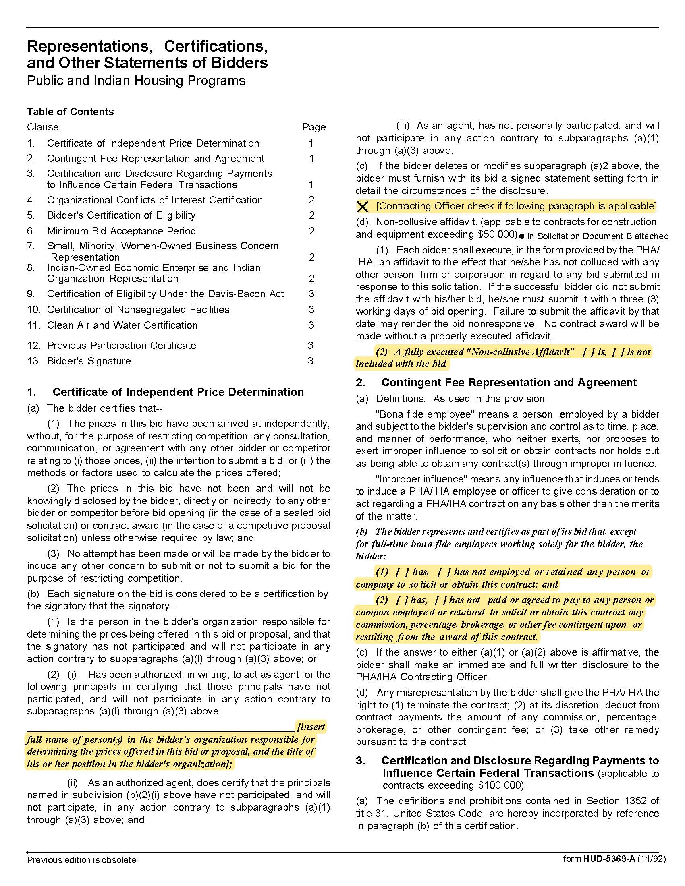

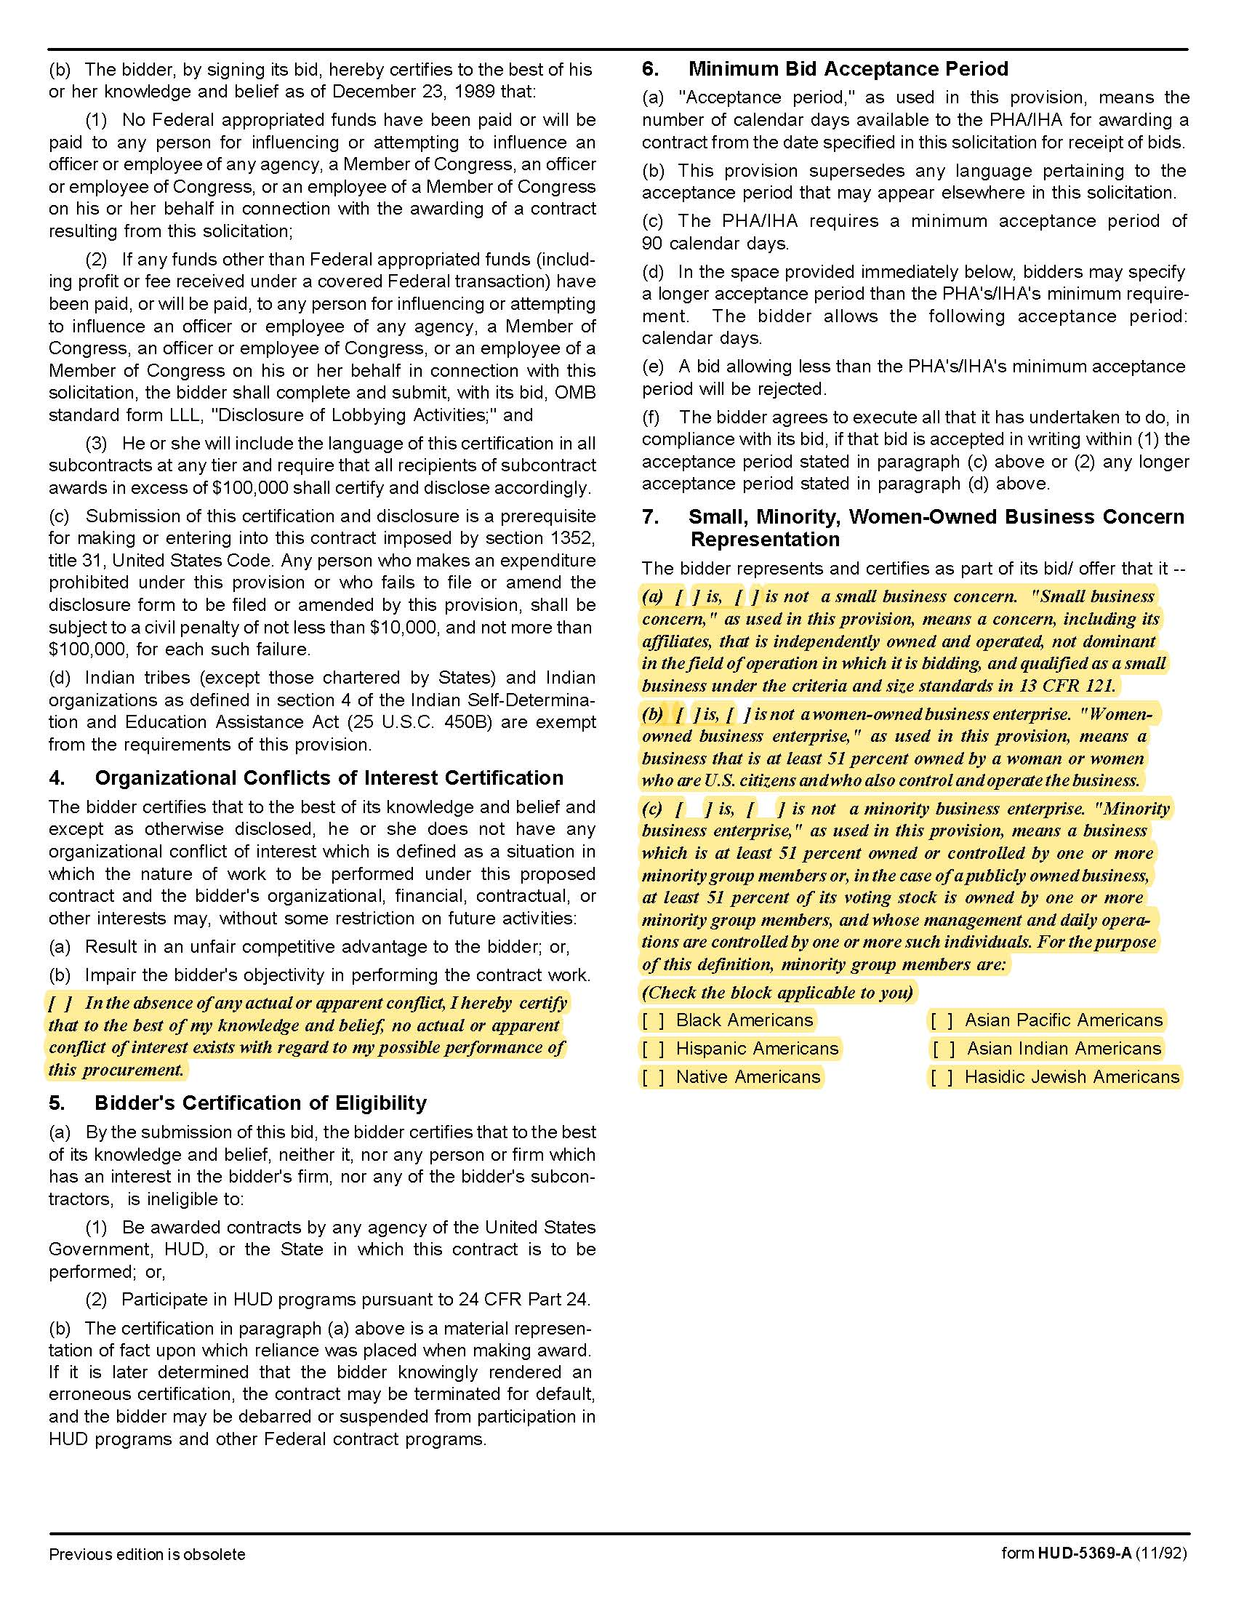

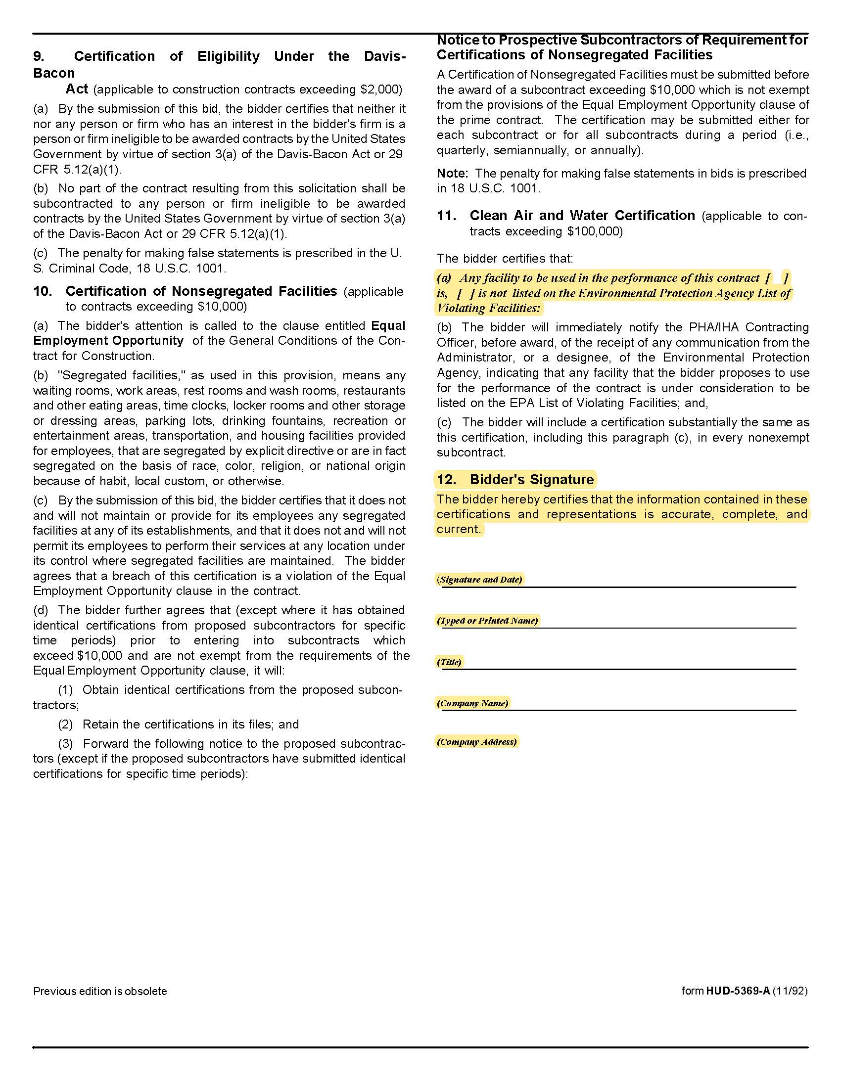

Solicitation Document D References

Supplier: ________________________________________________________________________________

The proposal must include at least three specific references of similar accounts. While you may have had numerous separate contracts with a particular company, a company can only be one reference.

Name of Business
Contact Person
Contact Person Email Address
Contact Person Telephone Number
Description of Service Provided
Date Contract Began
Date Contract Ended
Type of positions placed for this client
Identify any contract issues and describe how they were resolved
Approximate number of placements within an average 12 month period

Solicitation Document E Business Capabilities

Use this section of your response to detail your company’s qualifications. Include:
1. An overview of your company’s history
2. The names of key personnel who will be involved in this project and indicate titles and roles.
3. A list of subcontractors-if applicable
4. General business information

Years in business
Years in business under this name
Years performing this type of work
Value of work now under award
Value of work in place last year
Number of Clients
What company do you use for pre-employment criminal background checks?
Has your company:
Failed to complete an award? | Yes ☐ No ☐
Been involved in bankruptcy or reorganization? | Yes ☐ No ☐
Pending judgment claims or suits against supplier? | Yes ☐ No ☐

5. Safety:
Have you had any OSHA fines within the last three (3) years? | Yes ☐ No ☐
Have you had any job related fatalities within the last five (5) years? | Yes ☐ No ☐
If you have answered YES to either of the above questions, you MUST submit, on a separate sheet, the details describing the circumstances surrounding each incident.

6. Personnel:
Area | Fulltime | Part Time
Clerical
Management
Plumbers

Total Employees working for your company

