CITY OF MYRTLE BEACH
PURCHASING OFFICE
REQUEST FOR BEST VALUE PROPOSAL (RFP)
17-R0069
February 15, 2017
Solicitation Requirements
FOR: Train Depot - Renovations
Proposals must be received prior to 2:00PM Monday, March 6, 2017
A Mandatory Pre-Proposal Conference will be held at 10:00AM Monday, February 27, 2017 at 851 Broadway Street, Myrtle Beach, SC.
Bonds will be required if project is over $20,000
Mail or deliver Proposals to: City of Myrtle Beach Purchasing Office
3231 Mr. Joe White Avenue
Myrtle Beach, SC 29577
Direct questions to: Tina Causey, Purchasing Buyer (843) 918-2184.
NO PROPOSALS WILL BE ACCEPTED UNLESS SUBMITTED ON THE FORMS FURNISHED HEREIN. All proposals must be sealed, marked and delivered in accordance with these instructions.
Tabulations will be available on-line at www.cityofmyrtlebeach.com/purchasing.html. If more convenient, tabulations are available for pick-up after final award. No Tabulations will be faxed.
Name and Address of Proposer submitting this Proposal: (Proposer to complete the following information)
Name of Proposer:
Address:
City, State, Zip Code:
Phone Number: Fax Number:
*** Proposal Number and Due Date must be shown on the outside of the sealed envelope***
Please note: Signature Required on Page 9.

CITY OF MYRTLE BEACH
GENERAL INSTRUCTIONS
MUST BE SIGNED AS PART OF PROPOSAL PACKAGE

The instructions herein contained are given for the purpose of guidance in properly preparing, an applicable proposal. These directions have equal weight and force with the specifications and strict compliance is required with all of the provisions. Unless otherwise stated in the special instructions of the proposal, the following general instructions will apply.

- Proposals that are incomplete, unsigned, improperly signed or sealed, conditional, illegible, obscure, contain arithmetical errors, erasures, alterations or irregularities of any kind, will be declared non-responsive.
- All Offerors must be prepared to present suitable evidence of similar work recently completed or goods supplied. Products are to be brand name or equal unless otherwise specified. If submitting an equal product, supporting documents must be provided with proposal.
- Only written information from the Procurement Manager is binding; therefore no verbal instructions or verbal information from any other source will be binding on the City. The City will not be responsible for any other explanation or interpretation and the decision of the Procurement Manager shall be final and binding upon each Offeror.
- The written specifications are considered clear and complete. Failure of the Offeror to call attention in writing to any disputes, definitions, discrepancies, inconsistencies or incompleteness before the opening of the proposal in the time and manner set forth herein is a waiver of right to do so upon opening of the proposals.
- Should the Procurement Manager deem it necessary to alter proposal specifications, those alterations will be made in the form of written addenda that will be mailed to all Offerors. These addenda shall then be considered as part of these specifications.
- Submission of a proposal will be considered as conclusive evidence of the Offeror’s complete examination, understanding and acceptance of the specifications.
- When brand names or trade names and model numbers followed by the words "or equivalent" or "or other approved equal" are used, it is for the quality, style and features of those brands and models. Proposals on equivalent items of substantially the same quality, style and features are then invited. However, to receive consideration, such equivalent proposals must be accompanied by sufficient descriptive literature and/or specifications to clearly identify the units and provide for competitive evaluation with the brands or models.
- A Proposal and Signature Document is provided as part of the specifications. This form must be used in submitting a proposal and all pages of the proposal document must be completely filled out and signed by the Offeror.
- Each proposal must be enclosed in a sealed envelope, clearly marked on the outside with information as stated on the cover page and delivered to the Procurement Buyer. If the required information is not clearly stated on the outside of the envelope, the proposal is considered nonresponsive.
- No proposals may be withdrawn later than 10:30 AM on the day of the proposal opening. No modifications, clarifications or explanations of any proposals will be allowed after the proposal is sealed and delivered to the Purchasing Division, City of Myrtle Beach, 3231 Mr. Joe White Avenue, Myrtle Beach, SC 29577.
- The City expressly reserves the following rights:
- To reject any and/or all irregularities in the proposals submitted.

GENERAL INSTRUCTIONS continued

- To reject any and all proposals, or parts thereof, as deemed in the best interest of the City.
- To base awards due with regard on quality of services, experiences, compliance with specifications, and other such factors as may be necessary in the circumstances.
- To make the award to any Offeror who, in the opinion of management, is in the best interest of the City.
- To make award based on negotiations conducted in accordance with this solicitation or on the basis of a best and final offer by the Offeror.
- Only the evaluation factors specified in this solicitation may be used as a basis for award.
- The General Instructions, Scope of Work and/or Specifications, and the Proposal and Signature Document constitute the proposal packet. By submitting a proposal, Offeror is deemed to have accepted all of the terms and conditions set forth in the proposal packet documents. All proposal packet documents, after completion by the Offeror, must be returned with the proposal in the same order as received by the Offeror.
- NO PROPOSAL WILL BE ACCEPTED UNLESS SUBMITTED ON THE FORMS FURNISHED HEREIN. All proposals must be sealed, marked and delivered in accordance with these instructions. Proposals are not subject to a formal proposal opening.
- Offerors shall make all investigations necessary to thoroughly inform themselves regarding plant and facilities for delivery of material and equipment and/or service to be performed as required by the proposal conditions. No plea of ignorance by the Offeror of conditions that exist or that may hereafter exist as a result of failure or omission on the part of the Offeror to make the necessary examination and investigations, or failure to fulfill in every detail the requirements of the contract documents, will be accepted as a basis for varying the requirements of the City or the compensation.
- The City of Myrtle Beach pays South Carolina State Sales Tax. The City is exempt from Federal Excise Tax and will issue exemption certificates if required. ALL APPLICABLE TAXES SHOULD BE SHOWN AS SEPARATE LINE ITEMS UNLESS OTHERWISE INDICATED.
- The CONTRACTOR agrees to pay all taxes and license fees of whatever nature applicable to conduct business and furnish the CITY, if requested, with duplicate receipts or other satisfactory evidence showing the prompt payment of all taxes and fees when referred to and showing that all licenses are in effect.
- The award will be made within the time specified to the responsible Offeror meeting the specifications and having the lowest possible cost consistent with the quality and service needed for effective use. The following criteria will be used in making this determination:
- Superior quality and specification adherence
- Adequate maintenance and service
- Delivery and/or completion time
- Guarantees and warranties
- Company’s reputation and financial status
- Past experience and cost with similar or like equipment or service
- Anticipated future cost and experience
- Performance of proponent’s equipment by other agencies, plants, and firms
- In the event the successful Offeror fails or refuses to execute a formal written contract with the City of Myrtle Beach in form and content acceptable to the City, within ten (10) City of

GENERAL INSTRUCTIONS continued

Myrtle Beach business days after notice of acceptance of the proposal, the proposal may be revoked, and all obligations of the City in connection with the proposal may be canceled.
- Winning Offeror will be notified within a reasonable time, as judged by the City, after
proposal opening and evaluation of proposals.
- If required, Offeror shall supply a PROPOSAL BOND of 5% of the total proposal amount. The successful Offeror at its own cost and expense shall furnish, if required, a good and sufficient PERFORMANCE BOND and PAYMENT BOND (payable to the City of Myrtle Beach) in the full amount of this agreement conditioned on the full and faithful performance of the work under this agreement in accordance with the specifications and contract documents. Bonds are required if the contract work is more than $20,000 in cost for construction and/or improvements. The Performance and Payment Bonds shall be executed by the contractor and a bonding company authorized to do business in the State of South Carolina and approved by the State of South Carolina to issue such performance and payment bonds. Only the forms provided by the City for the Performance and Payment Bonds will be accepted.
- No extras or additional work will be allowed or paid for unless such extras or additional work are/is ordered in writing by the Purchasing Division and with the price for such established and agreed upon before such extras are delivered or work is performed.
- The City shall have the right, without invalidating the contract, to make additions to or deductions from the items or work covered by the specifications. In case such deductions or additions are made, an equitable price adjustment shall be made between the City and the contractor. Any such adjustments in price shall be made in writing.
- The contractor agrees to indemnify and save harmless the City of Myrtle Beach, its representatives, employees and agents, from all claims, demands, actions, suits and liabilities arising from the contractor’s own fault or negligence or through the negligence or fault of the manufacturer of goods supplied by the contractor. This obligation shall extend to and include, all litigation costs and reasonable attorney fees incurred by the City in response to such claims, demands, actions or liabilities, provided it is ultimately determined that such claims result from the contractor’s or manufacturer’s fault or negligence.
- The contractor shall not assign or otherwise transfer any of its responsibilities or obligations under the contract to any other person or entity without prior written consent of the City.
- When samples are required with a proposal, they must be submitted with the proposal unless approved by the Purchasing Manager or Purchasing Manger’s authorized representative.
- Samples submitted will become the property of the City. The entire cost of the sample(s) shall be paid for by the Offeror unless previous written arrangements are made with the City.
- When Offerors are required to make site visits or attend pre-proposal meetings, all expenses shall be paid for by the Offeror, unless previous written arrangements are made with the City.
- Offerors are required to state exactly what they intend to furnish; otherwise, they shall be required to furnish the items as specified.
- Offerors will submit, with their proposal, data necessary to evaluate and determine the quality of the item(s) they are proposing.
- In the event that materials, supplies, etc. are delivered which do not comply with specifications and have not been approved by the Purchasing Division, the contractor, upon notification, shall immediately remove from the premises any such materials, supplies, etc. and replace them with materials, supplies, etc. in full accordance with the specifications.

GENERAL INSTRUCTIONS continued
- Payments shall be made to the contractor within thirty (30) calendar days of receipt of invoice after inspection by and acceptance of the material, goods and/or service by an authorized representative of the City.
- It shall be understood that in all cases the terms and conditions, as detailed in the specifications, shall supersede terms and conditions, as detailed in the General Instructions.
- If this proposal is for the purchase of equipment, the Offeror guarantees that the equipment offered is standard new equipment, latest model or regular stock product, with parts regularly used for the type of equipment offered; also that no attachment or part has been substituted or applied contrary to the manufacturer’s recommendations and standard practices.
- Any deviation from specifications must be noted in detail and submitted in writing with this proposal. Complete specifications should be attached for any substitutions offered, or when amplifications are desirable or necessary. The absence of a specification deviation statement and accompanying specifications will hold the Offeror strictly accountable to the specifications as written herein.
- The specifications, as listed herein, represent our preference in material; however, we are fully cognizant that no two pieces of comparable material are identical and/or same in size, function, and operation; and some of the specifications will not completely coincide with ours as listed. Please list your exceptions and explanations separately. It is not our intent to write specifications for any project on which only one proponent can submit a proposal.
- Any changes in specifications, after the purchase order/contract has been awarded, must be with the written consent of the Purchasing Division; otherwise, the responsibility for such changes shall be with the Offeror.
- Proposal shall include adequate brochures, latest printed specification and advertising literature describing the product(s) offered in such a fashion as to permit ready comparison with the specifications on an item-by-item basis where applicable.
- Unless otherwise stated in the special instructions section of this proposal request, submit one complete Proposal Package using the attached form(s) for proposal price(s).
- Unless otherwise stated in the special instructions section of this proposal request, deliveries will be accepted during the hours between 9:00 AM and 3:00 PM Monday through Thursday, excluding City holidays. NO FRIDAY DELIVERIES UNLESS PRIOR APPROVAL BY WAREHOUSE PERSONNEL.
- The delivery date as stated in the proposal shall be the time required to deliver the complete item(s) after the receipt of the order or award of the contract. Where multiple items appear on a proposal request, the Offeror shall, unless otherwise stated by the City, show delivery date for each item separately. If only a single delivery date is shown, it will be assumed to mean that all items included in the proposal can and will be delivered on or before the specified date. The Offeror certifies that the delivery will be completed in the time the
Offeror states, starting at the time the order is placed, provided that the time between the proposal opening and the placing of the order does not exceed the number of days stipulated in the proposal. The right is reserved to reject any proposal on which the delivery time indicated is considered sufficient to delay the operation for which the commodity is intended. Successful Offeror(s) will be responsible for making any and all claims against carriers for missing or damaged items.
- Unit pricing will govern over extended prices unless otherwise stated in special instructions in this proposal request. All prices quoted should be firm. In those cases where

GENERAL INSTRUCTIONS continued

a firm proposal cannot be made, consideration will still be given to all Offerors. Also, maximum or ceiling prices should be quoted where possible when proposal contain non-firm prices.
- Cash discounts, if allowed, should be so stated on the proposal form. Prices must, however, be based upon payment thirty (30) calendar days after delivery.
- Questions concerning the proposal requirements or specifications should be directed in writing to the Procurement Buyer shown on the front page of the Proposal package. If you need disability-related accommodations, please contact (843) 918-2170.
- The City may reject a proposal if:
- The Offeror misstates or conceals any material fact in the proposal: or if,
- The proposal does not strictly conform to the law or requirements of proposal: or if,
- The proposal is conditional, except that the proposal may qualify his or her proposal for acceptance by the City on an “all or none” basis, or a “low item” basis. An “all or none” basis proposal must include all items upon which proposals are invited.
- The City may, however, reject all proposal whenever it is deemed in the best interest of the City to do so, and may reject any part of a proposal unless the proposal has been qualified as provided in statement. The City may also waive any minor informalities or irregularities in any proposal.
- Proposal prices are to be Delivered Price (FOB Destination). Proposal prices must include all delivery costs, including but not limited to, loading and unloading cost(s), transportation charge(s) and fuel surcharge(s). The City will not be responsible for any demurrage charge(s).
- Invoice(s), certificates of origin, warranties and guarantees must be submitted at the time of delivery of the item(s).
- If so requested in the proposed documents, a completed Material Safety Data Sheet for the item(s) indicated must be provided with the proposal documents. Failure to submit this form upon request may result in rejection of proposal.
- Offerors shall comply with all local, state, and federal directives, orders, and laws as applicable to this proposal and subsequent contract(s) including, but not limited to Equal Employment Opportunity (EEO), in compliance with executive Order 11246, Minority Business Enterprise (MBE), and Occupational Safety and Health Act (OSHA), as applicable to this contract and Immigration Bill H4400 which states that every contractor doing business with the City of Myrtle Beach for the physical performance of services with
the total value of the contract to be performed in a twelve month period exceeding fifteen thousand dollars ($15,000.00) must agree to the following:
- Register and participate in the federal work authorization program to verify the employment authorization of all new employees; and require agreement from its sub-contractors to do the same; or
- To employ only workers who:
- Possess a valid South Carolina Driver’s License or ID issued by the South Carolina Department of Motor Vehicles;
- Are eligible to obtain a South Carolina Driver’s License or ID card in that they meet the requirements.
- Possess a valid Driver’s License or ID card from another state where the requirements are at least as strict as those in South Carolina. The

GENERAL INSTRUCTIONS continued
South Carolina Department of Motor Vehicles will post on its website a list of states where the license requirements are at least as strict as those in South Carolina.
- If during the term of the contract entered into as a result of this proposal, the cost of material(s) is/are increased through no act on the part of the Contractor other than to comply with any prevailing rise in the market price(s) of material(s) used, it shall be the Contractor’s responsibility to notify the City Purchasing Office in writing of the price increase(s) and the effective date of the increase(s). Price(s) shall be increased only to the
point of absorbing additional cost(s) of material(s) paid for by the Contractor. At any time during the term of the contract, the City may request that the Contractor provide written documentation from the manufacturer/supplier of the material(s) to substantiate price increase(s). The City reserves the right to accept or reject any price increase(s) and to cancel any and all item(s) under the contract for which price increase(s) is/are considered unacceptable. If during the term of the contract, the cost of material(s) to the Contractor is reduced, then the Contractor shall reduce the contract price(s) and notify the Procurement Buyer in writing.
- All documents, reports, proposals, submittals, working papers or other material submitted to the City from the Offeror shall become the sole and exclusive property of the City, in the public domain, and are not the property of the Offeror. The Offeror shall not copyright, or cause to be copyrighted, any portion of any of said documents submitted to the City as a result of this solicitation.
- Protest of Proposal Specifications, Contract Terms and Intent To Award
- Specifications and contract terms shall be made available for inspection and copying. Unless a different deadline is specified in the Request for Proposals, protests of the proposal specifications or contract terms shall be presented to the City in writing within five (5) City of Myrtle Beach business days prior to proposal closing.
- Such protest or request for change shall include the reasons for protest or request, and any proposed changes to specifications or terms.
- Envelopes containing protests of specifications shall be marked and mailed, or hand delivered within five (5) City of Myrtle Beach business days to the Procurement Buyer.
- No protest against award because of the content of proposal specifications or contract terms shall be considered after the deadline established for submitting such protest in paragraph A above.
- Submission of a proposal without the timely submission of protest of specifications or contract terms is deemed a waiver to the right to protest specifications or contract terms.
- A decision by the Procurement Buyer shall be given in writing in each of such cases at least one (1) City of Myrtle Beach business day before the time set for the opening of proposals. A copy of the decision may be obtained at the Procurement Manager’s Office. If, in the judgment of the Procurement Manager, the previously mentioned inquiry requires explanation or interpretation, any such explanation or interpretation of said plans, specifications or other contract documents will be made by written addendum duly issued with copies mailed or delivered to each person or firm receiving a set of contract documents.
- The written Purchase Order shall constitute a final decision of the City to award the contract if no written protest is filed with the City within five (5) City of Myrtle

GENERAL INSTRUCTIONS continued

Beach business days of the posting of the Bid Tab. If a protest is timely filed, the Purchase Order is a final decision of the City only upon issuance of a written decision denying the protest and affirming the award.
- Purchasing Buyer shall notify winning Offeror at which time Bid Tab will be posted on the City of Myrtle Beach website. It is the responsibility of the Offeror to check the website. Any actual Offeror who is adversely affected or aggrieved by the award of the contract to another Offeror on the same solicitation shall have five (5) City of Myrtle Beach business days after the posting of Bid Tab to submit to the City a written protest of the award. The written protest shall specify the grounds upon which the protest is based. The City shall not entertain a protest
submitted after the time period established in this rule or such different period as may be provided in the City’s Request for Proposals.
- The written protest must include name and contact information of the protestor, solicitation title and number, the grounds upon which the protest is based and relief expected.
- Proposals may be withdrawn on a written request, received from Offerors prior to the proposal closing. Negligence on the part of the Offeror in preparing the proposal creates no right for withdrawal of the proposal after the proposal has been opened.
- The PROPOSAL response must not contain any erasures or corrections unless the Offeror initials each change.
- Proposal prices, terms and conditions shall be firm for a period of at least one hundred and twenty (120) calendar days from the deadline for receipt of submittal, or until such time as established in the PROPOSAL. The successful proposal shall not be subject to future price escalation or changes of terms if accepted during the one hundred and twenty (120) day period, or the specified PROPOSAL time. Price decreases or changes in terms by others after the acceptance of a proposal will not be considered.
- The contractor shall be wholly responsible for the performance of all subcontractors and for their acts and omissions, and those of persons either directly or indirectly employed by the contractor, and the fact that subcontractors are subject to the approval of the City shall not affect the contractor’s responsibility in this regard.
- The contractor shall be wholly responsible for the performance of all subcontractors and for their acts and omissions, and those of persons either directly or indirectly employed by the contractor, and the fact that subcontractors are subject to the approval of the City shall not affect the contractor’s responsibility in this regard.
- The Offeror shall bind every subcontractor to all terms and conditions anywhere contained in the contract documents as far as applicable to the work of such subcontractor so that the subcontractor assumes toward the contractor and toward the work all the obligations and responsibilities that the contract assumes toward the City as to the performance of the subcontractor’s portion of the work.
- The selected Offeror will be required to assume responsibility for coordination, engineering, delivery, installation, and maintenance of all equipment, software and services offered in their proposal, whether they are the manufacturer or producer of them. Further, the City will consider the selected Offeror to be the sole point of contact with regard to contractual matters, including payment of any and all charges resulting from the lease or purchase of the entire service

General Instructions (continued)

- equipment and software configuration, when applicable. Only service and equipment offered by Offerors who have installed similar systems of comparable size will be considered. All service and equipment offered will be in current standard production and of the latest design.
- The selected Offeror shall assign a competent account representative acceptable to the City who will represent the Offeror in providing contracted services to the City. If the
account representative is removed by the Offeror, the new representative must be acceptable to the City.
- If any doubt or difference of opinion arises between the City and the Offeror as to the interpretation of this RFP, the decision of the City will be final and binding upon all parties.
- The City reserves the right to obtain clarification on any point in the Offeror’s proposal. The failure of the Offeror to make additional information available could result in the rejection of the response. Such clarification might involve the delivery of demonstration
equipment to the City for evaluation purposes. Such hardware will be provided at no cost to the City. The City is not obliged to evaluate any or all products.
- The award of a contract is accomplished by executing a written agreement that incorporates the entire proposal, Offeror’s response, clarifications, addenda, and additions. All such materials constitute the contract documents. The Offeror agrees to accept the contract terms unless substantive changes are made without the approval of the Offeror. The procurement office is the sole point of contact for the issuance of the contract.
- The City will not be responsible for the loss or damage of any items during the RFP process.
- In the event that the Offeror fails to perform any material obligations, the City reserves the right to give the Offeror written notice of such failure. The Offeror will then have thirty (30) calendar days to resolve the failure. If the failure is not resolved within thirty (30) calendar days, the City reserves the right to withhold all money that is due and payable to the Offeror. Such a remedy is in addition to other remedies that might be available to the City. Moreover, the City reserves the right to terminate the contract if the Offeror exceeds thirty (30) calendar days of non-performance.
- The authorized signer of the Proposal shall represent and warrant that they have been sufficiently informed in all matters relating to the specified products; that they have checked their proposal for errors and omissions; that the prices stated in their proposal are correct and as intended are a complete and correct statement of prices.
- By Signature below the Offeror avers that they have examined, understands and accepts all instructions, specifications and conditions, and will provide for appropriate insurance, deposits, and performance bonds if required, and will comply fully with specifications as attached for the agreed contract, especially where materials and work are involved, and that any and all registration requirements where required for Offerors as set forth in law are met.

Print Name of Offeror
___________________________________________________________________________
Signature of Offeror
__________________________
Date of Signing

Proposal tabulations will be available on-line at www.cityofmyrtlebeach.com/purchasing.html. If more convenient, tabulations are available for pick-up after final award. No Proposal Tabulations will be faxed.
SPECIFICATIONS
SCOPE OF WORK
PURPOSE
The purpose of the Request for Best Value Proposals (RFP) is to solicit proposals to establish a contract through competitive negotiations for the purchase of the implementation of the Historic MB Train Depot located at 851 Broadway, Myrtle Beach, SC. This solicitation is using Best Value procurement procedures.
The scope of services will consist of tasks assigned as individual tasks during the contract period. The type of work may include, but is not limited to, inspect, repair and/or replacement the existing roof in the work area, install a coping cap and a chimney cap with new wood blocking on existing parapet wall and unforeseen conditions, etc., per scope of work in listed this proposal.

Scope of Work:
The Contractor will be responsible for the inspection of the building before submitting the proposal in order to become familiar with the conditions. The building is open for examination by the Contractors. The contractor will be responsible for itemizing and costing of each component for the Water Intrusion Building Repairs and any other repairs as indicated. The Contractor is to submit with their bid package on how the proposed Water Intrusion and Building repairs will be handled and completed.

The Contractor will need to inspect the existing roof above the (3) three exterior walls within the called work area, inspect all existing flashing at roofline and roof-block termination within the work area.
- Remove the four (4) existing window grates located in the work area – have each one of the grates sand blasted and power coated, color approved by Owner and shall match existing exterior finishes and reinstall.
- Remove the three (3) exterior doors as indicated by the Owner and shown on the attached drawings, when all doors have been removed the Contractor will be responsible for security and protection of the facility and the security will need to be approved by the Owner.
(The existing door hardware is to remain and be reused on the new doors).
- Install three (3) new exterior doors, location as shown on attached plan, fabricate and paint. New doors will need to match as close as possible to the existing doors, reinstall all existing door hardware and include any minor repair as necessary. The new doors must be in a workable fashion when completed.
- NOTE: If Cox Millwork is to perform the fabrication of the doors – give a cost/budget/allowance to the Owner for the replacement of the hardware.
- The Contractor is to remove and depose of all moisture-damaged moldings, base boards, casings, mulls and other molding that may be necessary or as instructed and replace the same as to match the existing profile and paint to match existing finishes.
- The Contractor will make all minor repairs at the arched window on the right side of building, to include all repairs at the window jamb and to the window sashes and paint all repairs and window, finishes will match as close as possible.
NOTE: The operation of the top sash may not be possible.
Scope of Work (continued)

- The Contactor will make minor repairs to the ceiling (gaps/loose) and repaint the entire ceiling in the middle foyer (including the nook, work area), paint should match the existing finishes as closely as possible.
- Repaint all of the three (3) walls in the nook area to match the existing finishes.
- The Contractor will point up all mortar joints on the exterior of the walls located at the nook (work area).
- Water proof all of the three (3) exterior walls of the nook (work area) using the product ZYCOSEAL Treatment and go by the manufacturer’s application.
- Install a new prefinished aluminum coping cap, using the necessary blocking if required, over the old fireplace and parapet wall, needs to match the existing finishes as closely as possible.
- The Contractor is to pressure wash the building and sidewalks.
- Remove the existing railing at the loading dock area at the rear of the building and have all railings sand blasted and power coated, the color should match existing finishes and reinstall all railings.
- The angle steel brackets located at the loading dock area should be cleaned, sand blasted, prime coated and two coats of rust-preventive paint.
- Clean and apply two (2) coats of paint on all metal roof drain pipes around the perimeter of the building.
- Clean and pressure wash the existing loading dock flat section and make any repairs within this section, apply a clear water sealer on all deck areas.
- Remove and replace three (3) existing foundation vents that are rusty (if possible) and sand blast, clean, paint to match existing finishes and reinstall.
- Re-secure the flat metal on the south side of the loading dock and clean, sand blast and paint to match existing finishes.
- Clean, sand blast and paint all angle iron on each side of the loading dock.
- Sand blast, clean and paint all exposed electrical metal conduit at multiple locations for the lights under overhang.
- Remove all six (6) existing round bar window grates, located at the fix windows on the left and right side of the building, sand blast and power coat, match existing finishes and reinstall.
- Re-glaze and repair all windows and apply primer and two coats of paint and match existing finishes.
- Paint with two (2) coats under the overhang and fascia, exterior doors, etc. of the building and any other wood areas through the exterior of the building project.
- Contractor is to repair or replace the existing sliding barn door at the rear of the building at the loading dock and ALL finishes to match the building.
- Use sealant (commercial graded-NP1 or better) around all windows, doors frames, any penetrations on the exterior of the building, color to match existing finishes.

SEE ATTACHED DRAWINGS ON PAGES 28-32.

EVALUATION AND AWARD CRITERIA
All proposals will be reviewed and evaluated by City of Myrtle Beach Review Panels comprised of members of the Purchasing Office. “Best Value” concepts will be used for the evaluation and award. “Best Value” means the overall combination of quality, price, and various elements of required services that in total are optimal relative to construction needs. Various elements may include of being fully qualified, references, cost and background. City will consider awards to other than the highest technically acceptable proposal when considering these elements. The Review Panels will recommend to the Purchasing Office those proposals which most closely meet the requirements of City and are considered to be “Best Value.”
Evaluation Criteria:
Proposals will be evaluated by the Purchasing Offfice using the following adjectival rating
method:
Acceptable: Offeror’s proposal demonstrates an acceptable understanding of goals and
objectives of the procurement. There may be strengths and weaknesses, however strengths outweigh the weaknesses.
Marginal: Offeror’s proposal demonstrates a fair understanding of the goals and objectives of the procurement. Weaknesses have been found that may outweigh strengths that exist. Weaknesses may be difficult to correct.
Unacceptable: Offeror’s proposal fails to demonstrate an understanding of the goals and objectives of the procurement. The proposal has one or more significant weaknesses that will be very difficult to correct or are not correctable.
The following areas of the proposal will be evaluated by reviewers for completeness, clarity and understanding as they apply to the specific specifications requested:
Award Criteria: Selection will be made of Offerors deemed to be fully qualified and best suited among those submitting proposals on the following: the adjectival ratings from the reviewers’ individual evaluation, the group consensus rating at the team review, the Best Value requirements. Negotiations will be conducted with the Offerors so selected. Price will be considered, but need not be the sole determining factor. After negotiations have been conducted with each Offeror so selected, the agency will select the Offeror(s) that, in its opinion, has made the best proposal(s), and will award the contract(s) to those Offeror(s). The City may cancel this Request for Best Value Proposals or reject proposals at any time prior to an award, and is not required to furnish a statement of the reason why a particular proposal was not deemed to be the most advantageous.

11

RFP Evaluation Form – Train Depot Renovations RFP 17-R0056
Date Evaluated:
Proposals will be evaluated on “best value” based on the evaluation criteria as stated below. The cost proposal will not be opened by the review committee until after the qualifications points are awarded. A 50-point scale will be used to create the final evaluation recommendation. When assessing points, utilize a 1-10 scale which will then be multiplied by the weight assigned.
Points | Guidance
10 | Couldn’t imagine a better response
9-8 | Excellent, insightful response
7-6 | More than adequate response
5-4 | Adequate response, no special insights
3-2 | Inadequate response
1-0 | Totally inadequate response
0 | No response given

Factor | Weight
Qualifications | 30%
Data Collection | 15%
Data Analysis | 15%
Extent Work is Performed | 10%
Cost | 30%

Evaluation
Criteria | Possible  Points | Points  Awarded | Multiplier  (To be  done by  purchasing | Total  Points
Experience & Qualifications | 0-10
Workplan & Timeline | 0-10
Technical Solution | 0-10
Project Cost | 0-10

ADDITIONAL TERMS AND CONDITIONS
1. Include with your proposal at least two (2) references of similar work performed by your company. Telephone number and person to contact must be included for proposal consideration.

- Include with your proposal any written warranties that apply.
- Insurance Requirements are attached. Work cannot begin until a valid Certificate is provided meeting all requirements. A Performance and Payment Bond in the amount of 100% of the contract price will be required. The Certificate of Insurance and the Performance and Payment Bonds must be provided on the attached forms by the successful proposer after notification of intent to award.
- List any exceptions to specifications:
- A City Business License will be required prior to commencement of work. For information contact the Business License Office at (843) 918-1200.

City of Myrtle Beach
INSURANCE REQUIREMENTS
PUBLIC LIABILITY AND PROPERTY DAMAGE
The Contractor shall purchase and thereafter maintain for the term of this agreement, and any subsequent extensions hereto, public liability insurance to protect Contractor from claims for bodily injury and/or property damage which may result from Contractor’s performance of this agreement. The policy shall provide a combined single limit of liability of $1,000,000 per occurrence for bodily injury and property damage with an aggregated limit of not less than $1,000,000.
AUTOMOBILE LIABILITY
The Contractor shall purchase and thereafter maintain for the term of this agreement and any subsequent extensions hereto, comprehensive automobile liability insurance to protect the Contractor from claims for bodily injury and property damage which may arise from Contractor’s use of motor vehicles in the performance of this agreement. The policy shall provide for a combined single limit of $1,000,000 per occurrence for bodily injury and property damage.
WORKERS’ COMPENSATION INSURANCE
Prior to beginning the work, the Contractor shall take out full compensation insurance for all persons which may be employed directly or indirectly in the performance of this agreement, coverage is to apply to all employees for statutory limits in compliance with the applicable state and federal laws. The policy must provide Employers Liability coverage in the amount of $500,000 each accident; $500,000 bodily injury by disease each employee and $500,000 bodily injury by disease policy limit and shall be maintained in full force and effect during the term and any subsequent extensions hereto.
EXCESS LIABILITY POLICY
At the option of the Contractor, the limits of the primary general liability, automobile liability and employer’s liability policies may be less than stipulated herein, with an excess policy providing the additional limits needed. This form of coverage must be approved by the City and will only be acceptable when both the primary and excess policies include the coverage and endorsements required herein.
POLICY ENDORSEMENTS
The following requirements shall apply to the policy(s) indicated below:
- General Liability and Automobile Liability
It is understood and agreed that the City of Myrtle Beach, its officials, agents and employees are recognized as additionally named insureds under the policy and, as such, will be provided thirty (30) days written notice by registered mail of non-renewal, exhaustion of aggregate limit, modification of coverage or cancellation for any reason, and the company hereby agrees to provide such notice. Failure of the company to provide the required notice shall cause the coverage to continue in force for the benefit of the City, its officials, agents and employees until proper notification, as required herein, is provided, the provisions of the policy or any Certificate of Insurance to the contrary notwithstanding.
- Workers’ Compensation
The cancellation provision is hereby amended to provide that the City of Myrtle Beach will be provided thirty (30) days written notice via certified mail, return receipt required, in the event of coverage cancellation.

INSURANCE REQUIREMENTS continued

NOTIFICATION OF INSURANCE COMPANIES
It is the responsibility of the Contractor to notify all insurance companies to familiarize themselves with all the terms and conditions of this agreement. The insurance companies shall waive their right of
notification by the City of any change or modification of this contract, or of decreased or increased work, or of the cancellation of this agreement or of any other acts by the City or its authorized employees or agents under the terms of this agreement. The waiver by the insurance companies shall in no way relieve them of their obligations under this agreement.
CERTIFICATES OF INSURANCE
Contractor shall file with the City a Certificate of Insurance, which shall be approved by the City prior to the inception of any work. Renewal certificates shall be sent to the City thirty (30) days prior to any expiration date.
INSURER LICENSING AND RATING
All insurance companies providing coverage to the City, shall be licensed to do business in the State and
have an A.M. Best rating of “A-“ or better.
INSURANCE COVERAGE ADJUSTMENTS
In response to changing circumstance of loss exposures, the City reserves the right to modify the insurance coverage, limits of liability, policy endorsements and policy terms required in this contract. The City will provide written notice to the Contractor, which outlines such changes and allow Contractor a reasonable period of time in which to comply with the new requirements. However, in no event shall Contractor compliance period be longer than thirty (30) days.
COVERAGE CANCELLATION OR UNSATISFACTORY COVERAGE
If at any time any of the foregoing policies shall be or become unsatisfactory to the City, as to form or substance, or if a company issuing any such policy shall be or become unsatisfactory to the City, the Contractor shall, upon notice to that effect from the City, promptly obtain a new policy and submit the same for approval to the City. Upon failure of the Contractor to furnish, deliver and maintain the insurance coverage’s required herein, this agreement, at the sole discretion of the City, may be forthwith declared suspended, discontinued or terminated. Failure of the Contractor to take out and/or maintain any required insurance shall not relieve the Contractor from any liability under this agreement, nor shall the insurance requirements be construed to conflict with or otherwise limit the obligations of the Contractor concerning indemnification.
HOLD HARMLESS
Contractor agrees to protect, defend, indemnify and hold the City, its officers, employees and agents free and harmless from and against any and all losses, penalties, damages, settlements, cost, charges, professional fees or other expenses and liabilities of every kind and character arising out of, or relating to, any and all claims, liens, demands, obligations, actions, proceedings or causes of action of every kind in connection with or arising out of this agreement, and/or the performance hereof, that are due to the negligence of the Contractor, its officers, employees or agents. The Contractor further agrees to investigate, handle, respond to, provide defense for and defend the same at its sole expense and agrees to bear all other costs and expenses related thereto.

INSURANCE REQUIREMENTS continued
SAMPLE
CERTIFICATE OF INSURANCE |  |  |  |  |  |  | CERTIFICATE NUMBER
PRODUCER  Insurance Agent Name  4000 Insurance Pkwy  Anytown, USA 99999 |  |  | THIS CERTIFICATE IS ISSUED AS A MATTER OF INFORMATION ONLY AND CONFERS NO RIGHTS UPON THE CERTIFICATE HOLDER OTHER THAN THOSE PROVIDED IN THE POLICY. THIS CERTIFICATE DOES NOT AMEND, EXTEND OR ALTER THE COVERAGE AFFORDED BY THE POLICIES DESCRIBED HEREIN.
COMPANIES AFFORDING COVERAGE
INSURED  Bidding Firm’s Name  1000 Any Street  Anytown, USA 99999 |  |  | COMPANY A ABC INSURANCE COMPANY  COMPANY B  COMPANY C  COMPANY D
COVERAGES-THIS CERTIFICATE SUPERCEDES AND REPLACES ANY PREVIOUSLY ISSUED CERTIFICATE FOR THE POLICY NOTED BELOW
This is to certify that policies of insurance described herein have been issued to the insured named herein for the policy indicated. Notwithstanding any requirement, term or condition of any contract or other document with respect to which the certificate may be issued or may pertain, the insurance afforded by the policies described herein is subject to all the terms, conditions and exclusions of such policies. Aggregate limits shown may have been reduced by paid claims.
CO  LTR | TYPE OF INSURANCE | POLICY NUMBER |  | POLICY EFFECTIVE DATE (MM/DD/YY) | POLICY EXPIRATION DATE (MM/DD/YY) | LIMITS
A | General Liability | XYZ1234 |  | 00/00/00 | 00/00/00 | General Aggregate Products-Comp/Op Agg Personal & Adv Injury Each Occurrence  Fire Damage (any 1 fire) |  | $ 1,000,000  $ 1,000,000  $ 1,000,000  $ 1,000,000  $ 50,000
A | X Commercial General Liability  _ Claims Made X Occur _ Owners & Contractor’s Prot
A | Automobile Liability | XYZ1234 |  | 00/00/00 | 00/00/00 | Combined Single Limit  Bodily Injury  (Per person)  Bodily Injury  (Per accident)  Property Damage |  | $ 1,000,000  $  $  $
A | X Any Auto  _ All Owned Autos  _ Scheduled Autos  X Hired Autos  X Non-Owned Autos
 | Garage Liability |  |  | 00/00/00 | 00/00/00 | Auto Only-Ea Accident Other than auto only: Each Accident Aggregate |  | $  $  $
 | _ Any Auto
 | Excess Liability |  |  | 00/00/00 | 00/00/00 | Each Occurrence  Aggregate |  | $  $
_ Umbrella Form
Other than Umbrella Form
A | Workers Compensation | XYZ1234 |  | 00/00/00 | 00/00/00 | X WC Statutory Limits  _ Other  EL Each Accident  EL Disease-Policy Ltd  EL Disease-Ea Employee |  | $ 500,000  $ 500,000  $ 500,000
A | (and Employer’s Liability) The Proprietor/Partners Executive Officers Are:  X Inc _ Excl
 | Other
Description of Operations/Locations/Vehicles/Special Items:
City of Myrtle Beach is named as additional insured with respect to General and Automobile Liability
CERTIFICATE HOLDER |  |  |  | CANCELLATION
City of Myrtle Beach  Attn: Purchasing Division  Drawer 2468  Myrtle Beach, SC 29578-2468 |  |  |  | Should any of the policies described herein be cancelled before the expiration date thereof, the insurer affording coverage will endeavor to mail 30 days written notice to the certificate holder named herein, but failure to mail such notice shall impose no obligation or liability of any kind upon the insurer affording coverage, its agents or representatives, or the issuer of this certificate.
 |  |  |  | INSURANCE AGENT SIGNATURE

Train Depot RFP 17-R0056
Price Schedule
The General Contractor will be responsible for all materials, labor, equipment, supervision and sub-contractors performing all work on site and give the best method on how to repair the water intrusion per scope of work in proposal.

See full description on pages 10 & 11
Item # | Description | Qty | Unit of Issue | Unit Price | Total Price
1.

PROPOSAL AND SIGNATURE DOCUMENT
Bid Number: 17-R0056
The undersigned, as proposal, declare that we have examined all bid documents contained herein and will contract, thereon, with the City of Myrtle Beach (hereinafter referred to as the "City") to do everything necessary for the fulfillment of this contract. We agree any addenda received are part of the proposal documents. (If no addenda has been received, please place a zero in the space provided.)
In addition, we propose to furnish the following products/services in strict conformance to the proposal specifications and proposal invitation issued by the City of Myrtle Beach for this proposal. Any exceptions are clearly noted as required.
We understand that any false statements made to meet any requirements may result in contract cancellation or initiation of action under Federal or State laws or both.
Bidder-Company Name Addenda Numbers Received
City Business License Number Telephone Number
Authorized Signature Fax Number
Printed Name Email
South Carolina Sales Tax Registration No.: If SC Sales Tax No. not supplied, please state reason:
Federal Tax ID No. (FEIN):
Mailing Address Date
City, State, Zip
Remittance Address (If different from mailing address)
City, State, Zip

BID BOND
KNOW ALL MEN BY THESE PRESENTS, that we the undersigned,
as Principal, and
as SURETY are hereby held and
firmly
bound unto as OWNER, in the penal sum
of
for the payment of
which, well and truly to be made, we hereby jointly and severally bind ourselves, successors and assigns.
THE CONDITION OF THE ABOVE OBLIGATION IS SUCH, that whereas the PRINCIPAL has submitted to the City of Myrtle Beach a certain PROPOSAL, attached hereto and hereby made a part hereof
to enter into a contract in writing for the .
NOW, THEREFORE,
- If said PROPOSAL shall be rejected, or
- If said PROPOSAL shall be accepted and the PRINCIPAL shall execute and deliver a contract in the Form of Contract attached hereto (properly completed in accordance with said PROPOSAL) and shall furnish BOND for his faithful performance of said contract, and for the payment of all persons performing labor or furnishing materials in connection therewith, and shall in all other respects perform the agreement created by the acceptance of said PROPOSAL,
then this obligation shall be void, otherwise the same shall remain in force and effect; it being expressly understood and agreed that the liability of the Surety for any and all claims hereunder shall, in no event, exceed the penal amount of this obligation as herein stated.
The SURETY, for value received, hereby stipulates and agrees that the obligations of said SURETY and its BOND shall be in no way impaired or affected by any extension of the time within which the OWNER may accept such PROPOSAL; and said SURETY does hereby waive notice of any such extension.
IN WITNESS WHEREOF, the PRINCIPAL and the SURETY have hereunto set their hands and seals and such of them as are corporations have caused their corporate seals to be hereto affixed and these to be signed by their proper officers, the day and year first set forth above.
(L.S.)
Principal Surety
By
IMPORTANT: Surety companies executing BONDS must appear on the Treasury Department’s most current list (Circular 570 as amended) and be authorized to transact business in the State where the project is located.

PERFORMANCE BOND
KNOW ALL MEN BY THESE PRESENTS: that
(Name of Contractor)
(Address of Contractor)
a hereinafter called Principal,
and
(Corporation, Partnership, or Individual)
(Name of Surety)
(Address of Surety)
hereinafter called SURETY, are held and firmly bound unto
(Name of Owner)
(Address of Owner)
hereinafter called OWNER, in the penal sum of
Dollars, ($ ____________________) in lawful money of the United
States, for the payment of which sum well and truly to be made, we bind ourselves, successors, and assigns, jointly and severally, firmly by these presents.
THE CONDITION OF THIS OBLIGATION is such that whereas, the Principal entered into a certain
contract with the OWNER, dated the ______ day of , 20 ____, a copy of which is
hereto attached and made a part hereof for the construction of:
_
_
_
_
NOW, THEREFORE, if the Principal shall well, truly and faithfully perform its duties, all the undertakings, covenants, terms, conditions, and agreements of said contract during the original term thereof, and any extensions thereof which may be granted by the OWNER, with or without notice to the Surety and during the one year guaranty period, and if he shall satisfy all claims and demands incurred under such contract, and shall fully indemnify and save harmless the OWNER from all costs and damages which it may suffer by reason of failure to do so, and shall reimburse and repay the OWNER all outlay and expense which the OWNER may incur in making good any default, then this obligation shall be void; otherwise to remain in full force and effect.
21

PROVIDED, FURTHER, that the said Surety, for value received hereby stipulates and agrees that no change, extension of time, alteration or addition to the terms of the contract or to WORK to be performed thereunder or the SPECIFICATIONS accompanying the same shall in any way affect its obligation on this BOND, and it does hereby waive notice of any such change, extension of time, alteration or addition to the terms of the contract or to the WORK or to the SPECIFICATIONS.
PROVIDED, FURTHER, that no final settlement between the OWNER and the CONTRACTOR shall abridge the right of any beneficiary hereunder, whose claim may be unsatisfied.

PERFORMANCE BOND continued
IN WITNESS WHEREOF, this instrument is executed in four (4) counterparts, each one of which shall be
deemed an original, this the ______ day of , 20 ____ .
ATTEST:
Principal
Principal Secretary
[SEAL]
By (s)
(Witness as to Principal)
(Address) (Address)
Surety
ATTEST:
(Surety) Secretary
[SEAL]
By
Witness as to Surety Attorney-in-Fact
(Address) (Address)
NOTE: Date of Bond must be prior to date of Contract. If CONTRACTOR is Partnership, all partners should execute BOND.
IMPORTANT: Surety companies executing BONDS must appear on the Treasury Department’s most current list (Circular 570 as amended) and be authorized to transact business in the state where the PROJECT is located.
23

PAYMENT BOND
KNOW ALL MEN BY THESE PRESENTS: that
(Name of Contractor)
(Address of Contractor)
a hereinafter called Principal, and
(Corporation, Partnership or Individual)
(Name of Surety)
_
(Address of Surety)
hereinafter called Surety, are held and firmly bound unto
(Name of Owner)
(Address of Owner)
hereinafter called OWNER, in the penal sum of
Dollars, ($ ) in lawful money of the United States, for payment of which sum well and
truly to be made, we bind ourselves, successors, and assigns, jointly and severally, firmly by these presents.
THE CONDITION OF THIS OBLIGATION is such that whereas, the Principal entered into a certain
contract with the OWNER, dated the day of , 20 ___, a copy of which is
hereto attached and made a part hereof for the construction of:
_
_
_
NOW, THEREFORE if the Principal shall promptly make payment to all persons, firms, SUBCONTRACTORS, and corporations furnishing materials for or performing labor in the prosecution of the WORK provided for in such contract, and any authorized extension or modification thereof, including all amounts due for materials, lubricants, oil, gasoline, coal and coke, repairs on machinery, equipment and tools, consumed or used in connection with the construction of such WORK whether by SUBCONTRACTOR or otherwise, then this obligation shall be void; otherwise to remain in full force and effect.
PROVIDED, FURTHER, that the said Surety for value received hereby stipulates and agrees that no change, extension of time, alteration or addition to the terms of the contract or to the WORK to be performed thereunder or the SPECIFICATIONS accompanying the same shall in any way affect its obligation on this BOND, and it does hereby waive notice of any such change, extension of time, alteration or addition to the terms of the contract or to the WORK or to the SPECIFICATIONS.
PROVIDED, FURTHER, that no final settlement between the OWNER and the CONTRACTOR shall abridge the right of any beneficiary hereunder, whose claim may be unsatisfied.

PAYMENT BOND continued
IN WITNESS WHEREOF, this instrument is executed in four (4) counterparts, each one of which shall be
deemed an original, this the ______ day of , 20 ____ .
ATTEST:
Principal
(Principal) Secretary
[SEAL] By (S)
(Address)
Witness as to Principal
(Address)
ATTEST:
Surety
Surety Secretary
[SEAL]
By
Witness as to Surety Attorney-in-Fact
(Address) (Address)
NOTE: Date of BOND must be prior to date of contract. If CONTRACTOR is Partnership, all partners should execute BOND.
IMPORTANT: Surety companies executing BONDS must appear on the Treasury Department’s most current list (Circular 570 as amended) and be authorized to transact business in the State where the PROJECT is located.

 | CITY OF MYRTLE BEACH  LOCAL VENDOR PREFERENCE  TO QUALIFY FOR LOCAL PREFERENCE  FORM MUST BE SUBMITTED WITH BID
First in Service

APPLICATION OF ELIGIBILITY TO QUALIFY FOR LOCAL VENDOR PREFERENCE WITHIN THE DEFINED BOUNDARIES: MYRTLE BEACH CITY LIMITS, HORRY COUNTY, NESA AREA (NESA area is comprised of Horry, Georgetown, Williamsburg, Florence, Marion, Darlington, Dillon, Chesterfield, and Marlboro Counties).
City of Myrtle Beach Business License: (To qualify for Local Vendor Preference vendor must have a current City of Myrtle Beach Business License a minimum of ninety (90) days prior to the request for bid/ proposal being made public)
City of MB Business License Number: *NOT Horry County License Number  Complete all areas below. Incomplete forms may be rejected.  - LEGAL NAME OF BUSINESS:  Mailing Address: | Date issued:

Physical Address:
(To qualify vendor must have maintained a
physical address and office as a principal
place of business within the defined boundaries of the category sought for at least one (1) year, and during that time have had a majority of full-time employees, chief officers and managers regularly conducting work and business from this office.)
- Year business was established in the City of Myrtle Beach / Horry County / NESA area:
Year: County:
(Name of County)
************************************************************************************ Under penalty of perjury, the undersigned states that the foregoing statements are true and correct. The undersigned also acknowledges that any person, firm, corporation or entity intentionally submitting false information to the City in an attempt to qualify for local preference shall be prohibited from bidding on City of Myrtle Beach products and services for a period of one (1) year.
Authorized Signature: Date:
Printed Name & Title: Phone:

LOCAL VENDOR PREFERENCE continued

Bid Amount | Within City Limits | Within Horry County | Within NESA Area
Up to $5000.00 | 5% of Bid | 4% of Bid | 3% of Bid
$5001.00 to  $10,000.00 | $250.00 plus 4% of amount between $5001.00 and $10,000.00 | $200.00 plus 3% of amount between $5001.00 and $10,000.00 | $150.00 plus 2% of amount between $5001.00 and $10,000.00
$10,001.00 and up | $450.00 plus 3% of amount above $10,000.00 with the maxium being $2000.00, including the $450.00 | $400.00 plus 2% of amount above $10,000.00 with the maxium being $1800.00, including the $400.00 | $300.00 plus 1% of amount above $10,000.00 with the maxium being $1600.00, including the $300.00

If company/individual performs services on City property a Certificate of Insurance must be provided prior to commencement of work meeting requirements of the City.
The vendor must submit a copy of their Local Vendor Preference Certificate with their bid.
An eligible business shall maintain such status throughout the term of any contract with the City. Failure to maintain such status or to keep current on all fees and taxes owed the City shall be grounds to terminate the contract.

P.DALE GILLILAND. ARCHITECT

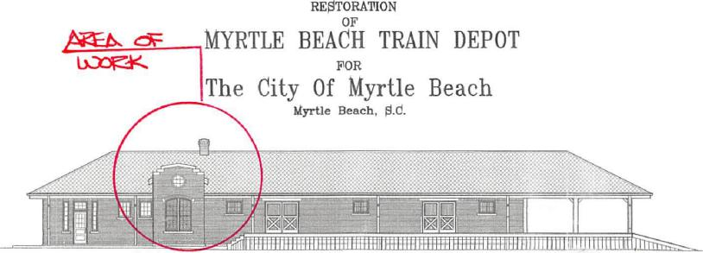
LI 1 [111 _
dilimiummaniii1111111111 I 11111111111
REOTr'PION
MYRTLE BEACH TRAIN DEPOT
FOR
The City Of Myrtle Beach
ityrtle Beach, S.d.
1333r—.44.
g
i
101C C. INIC611111 MOM olsi,
"
INDIO( TO 1)RAITINCI9
k
,TLP 5,CCT | 5,1 | C65,6 5. rE M.0.6 | C. ..71,6!• | 566 | 4.516.706 56£ |  | An0
 | A.1  621 | C65766 6.60011././6  C65765 C.6.73164 6,66,66 |  | •••• | FLOOR  Fms⁻caAnox vvreseg.
 |  | C6511,6 626.101C L1066,66.  C1.257,6 761•666 =6666 |  | 0622  651 | 61.1,C64,66 ZAVe Der6L1 ra55,04,6,4 0.6e6OR |  | .1:6 006...⁶106  4,66,6 ,61
 | 665 Y6_1 | C65•66 .,616C106 C...LW,Grae C651.6 .6.11.60.6 SE11166 |  | .662  .6.5 | 0255,64., neCIC-C6 T-C.,611715  4155•66.6•66 061,606 C.6^{,7}6•6
 | - 611 A61.2 | [65646 0,615  r651•66 0,615 |  | .655 | .4,5•roa.r.pi Wynne* Sc⁻K349 | r | FLISc.r666 6_,Yrt 06,12 nrc/•.5
 | 665 | C65.66 0,615 |  | - .•59 | 45,04416.1  66⁻nalanG6 20,65  5.£121A-05 C666.5

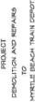
TI.1
LETEMAMIIEN  RAO & 000eigg0. Rid.  MYRTLE BEACH, SC | TRA '_{Ai 3},_{A.} At c'& r⁻r⁻Lertju

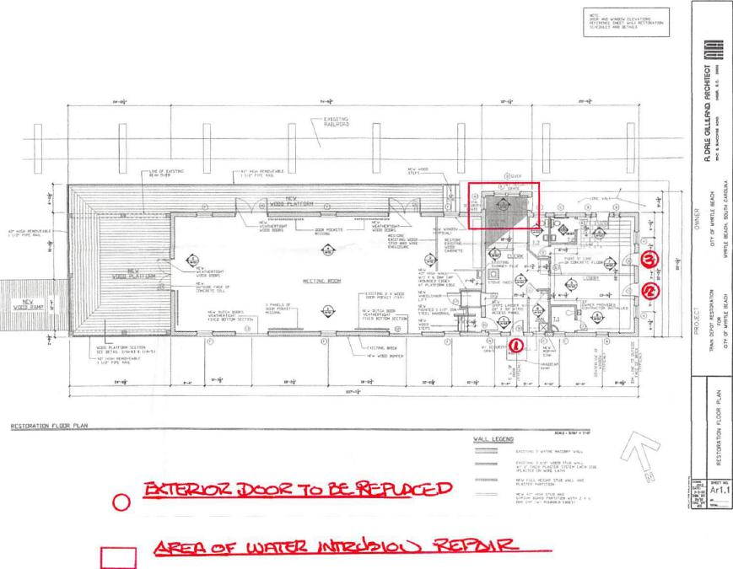
'g 1 gf
',:111111111111
alitr;÷ -
RESTORAll. rL
Jam
Tic:2oz ⁻ro te_.-F-aPLOP —
0 •
cz)v U3FMCZ Jc.tnzs.SPakoi>
RFP 17-R0056 29

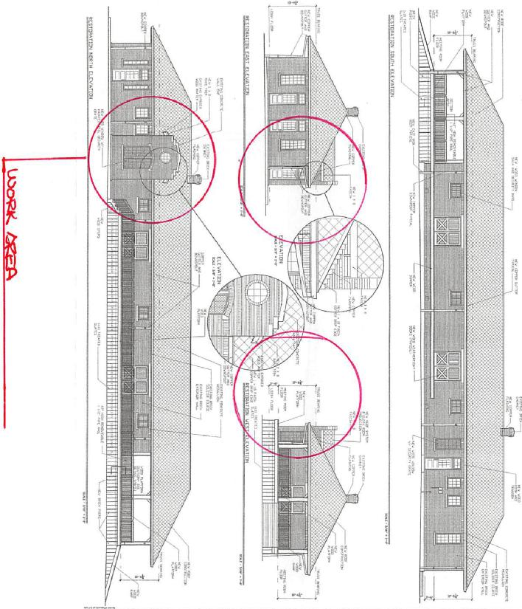
₃
₀
_{R-}
₁ PFR
+IN | AROFETECRIEML | PROJEC1 | OWNER | fLGIRLE 0111IND. ARCEITECT
 | RESTORANON EMIR. FIRVATIONS | PROJEC1 | OWNER | fLGIRLE 0111IND. ARCEITECT
 | RESTORANON EMIR. FIRVATIONS | 111A01 CCPOT R11510.1. | CIT1 Or team r | 1
 |  | CM OP IMRE KA. | BEAN, SW. GOOLINA

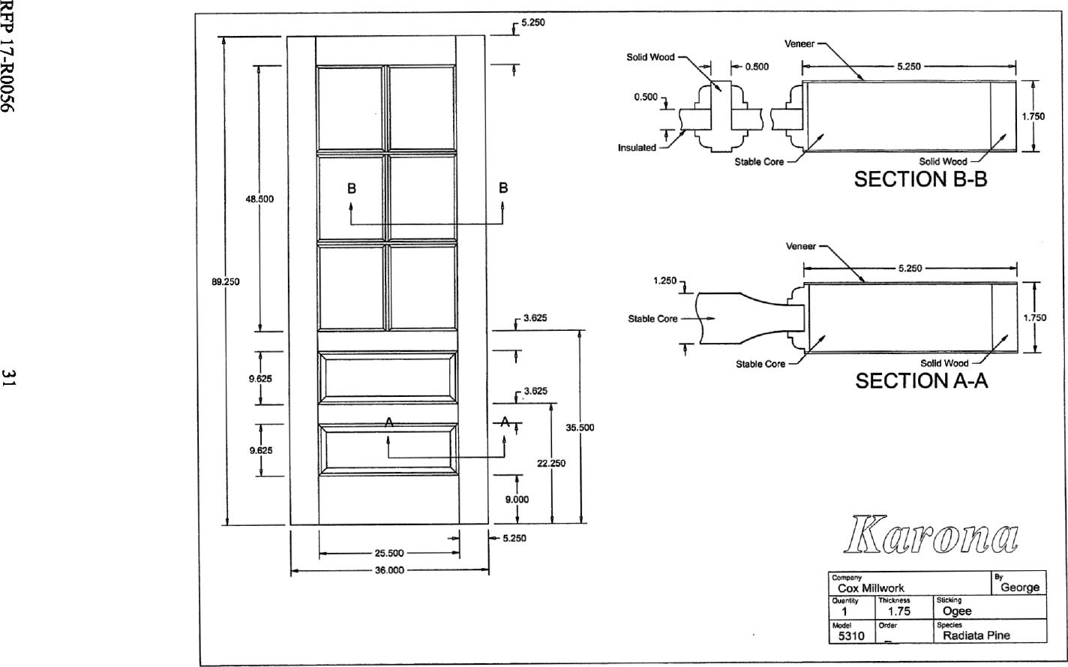
_{R-}
I ddU
9.000
5.250
25.500
36.000
5.250
SECTION B-B
B
N
A
1.250
3.625 Stable Core
3.625
35.500
22.250
89.250
9.625
T⁻⁻
9.625
B
5.250
1.750
Veneer
Stable Core Solid Wood
SECTION A-A
⁻7"
--A_{T}
Company By
Cox Millwork George
Otiontty | Thickness | Sticking
1 | 1.75 | Ogee
Model | Order | Spedes
5310 | _ | Radiata Pine

48.500

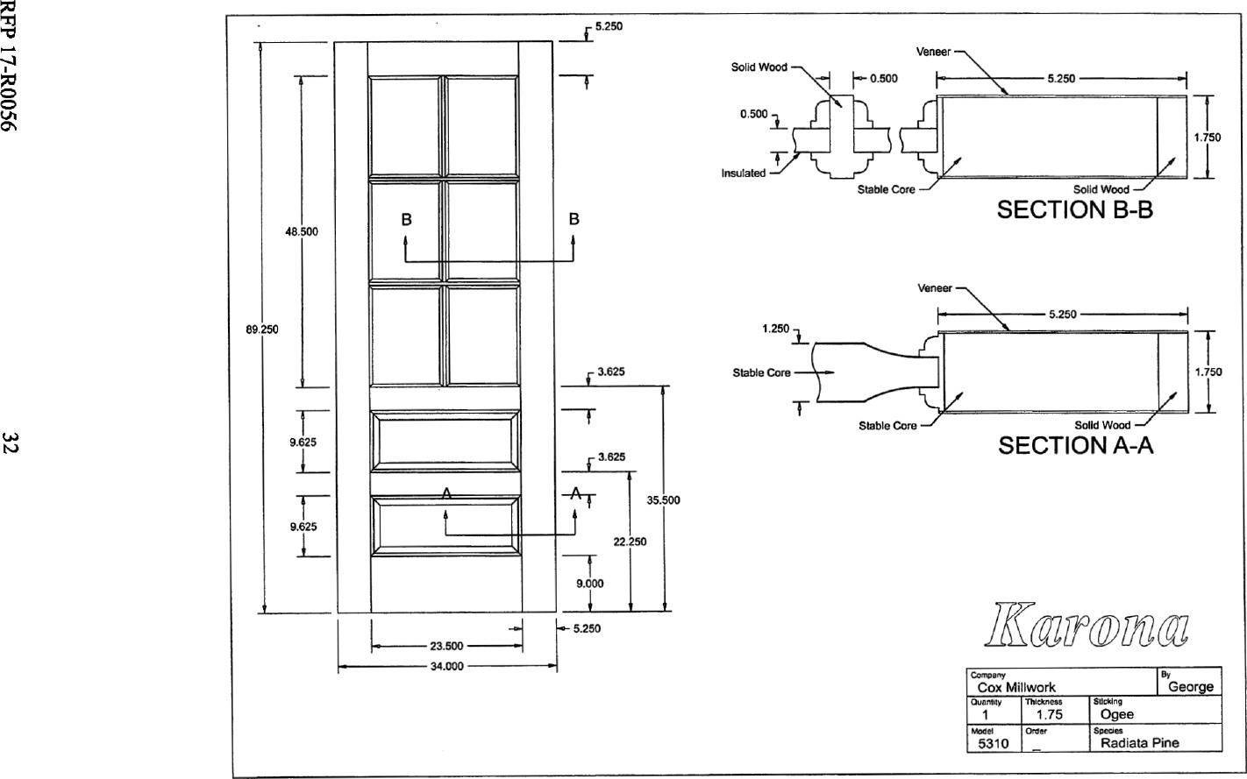
_{R-}
I ddU
35.500
A
.1/
-A_{T}
5.250
Veneer
B
1

89.250
3.625 Stable Core
Solid Wood —⁷
SECTION A-A
23.500
5.250
Company By
Cox Millwork George
OupnMy | Thickness | SVcking
1 | 1.75 | Ogee
model | Order | Speoes
5310 | _ | Radiata Pine

48.500
9.625
L
1.250₁
34.000
B
Solid Wood
0.500 5.250
0 500
1.750
Insulated
Stable Core Solid Wood
SECTION B-B
5.250
3.625
Stable Core
1.750
9.625
9.000
Veneer
22.250

