Invitation for Sealed Bids

Solicitation name | Appliance Parts Q2414
Upload responses by | 11:00 a.m. on February 28th, 2024 (as KCDC’s clocks show)
Upload your response at | https://vrapp.supplierregistry.com/Account/LogOn  - All bids/proposals must be submitted through the Vendor Registry platform as one document.  - When uploading bids/proposals, be sure to upload all required solicitation documents.  - Bids/proposals delivered by email, fax, USPS or in person will be rejected.
Post Questions to | https://vrapp.supplierregistry.com/Account/LogOn  by 6:00 p.m. on February 21, 2024.  KCDC will not accept questions via email or telephone.
Award results | KCDC posts the award decision to its web page at: http://www.kcdc.org/procurement/.
Open Records/Public Access to Documents | All document provided to KCDC are subject to the Tennessee Open Meetings Act (TCA 8-44-101) and open records requirements.
Check KCDC’s webpage for addenda and changes before submitting your response.

General Information

1. Background and Intent

a. Knoxville's Community Development Corporation (“KCDC”) is the public housing authority for the City of Knoxville and for Knox County in Tennessee. KCDC’s affordable housing property portfolio includes more than 26 properties with approximately 3,600 dwelling units. In addition to operating its public housing apartments, KCDC oversees approximately 4,097 Section 8 Vouchers and 76 Moderate Rehabilitation units. Additionally, KCDC serves as the redevelopment agency for the City of Knoxville, managing redevelopment areas, TIFs, and PILOTs.

b. Definition/Clarification: KCDC uses “suppliers” as inclusive of various words describing interested parties often called “bidders,” “contractors,” “firms,” “proposers” and “vendors.”

c. KCDC has thousands of refrigerators, stoves, water heaters and some washers, dryers and dishwashers in its units. KCDC performs many maintenance services on its appliances and from time to time needs to purchase repair and/or replacement appliance parts.

d. KCDC intends these specifications to result in the selection of a capable supplier(s) to provide replacement parts and supplies as needed. KCDC will either pick up needed parts (most common method) or require prompt delivery of ordered parts (rare). Accordingly, it is important that the supplier(s) be conveniently located to the majority of KCDC’s locations.

e. KCDC requests a “discount off percentage” for non-specified items since KCDC may need other items from time to time. The discount can be “0” if necessary. The supplier(s) must indicate to what pricing standard the discount applies. For instance, the discount percentage could apply to shelf price, catalog price, jobber’s price, et cetera.

f. KCDC has identified a number of specific commonly purchased items for the supplier to provide a firm fixed price. These items are in the pricing section of this document.

g. Pricing information is entered in Solicitation Document D.

2. Changes after Award
It is possible that after award KCDC will need to revise the requirements specified herein. KCDC reserves the right to make such changes after consultation with the supplier. Should additional costs arise, the supplier must document increased costs. KCDC reserves the right to accept or reject and negotiate these charges. Generally, such changes will not be of a “cardinal” nature.

3. Contact Policy
Only contact KCDC’s Procurement Division about this solicitation from the issuance of this solicitation until award. Information obtained from an unauthorized officer, agent, or employee will not affect the risks or obligations assumed by the supplier or relieve the supplier from fulfilling any of the conditions of the resulting award for this project. Such contact can disqualify the supplier from the solicitation process.

4. Delivery

a. Delivery will be to specified locations within Knox County, Tennessee.

b. Deliveries are accepted (approximately-may depend upon the site) between 7:30 a.m. and 3:30 p.m. each business day.

c. Deliveries will not incur additional cost to KCDC.

d. KCDC may or may not ask for delivery. Typically, KCDC picks up items in the store.

5. Evaluation

a. KCDC will evaluate this as a formal sealed bid and the award is to the “lowest and best” bidders. KCDC alone determines (using the National Institute of Governmental Procurement’s definition and other relevant sources as appropriate) the supplier’s “responsive” and “responsible” status prior to award. Responsible means a business with the financial and technical ability to perform the requirements of the solicitation and subsequent contract.

b. A responsive bid is one that fully conforms in all material respects to the solicitation document and its requirements, including all form and substance.

c. KCDC reserves the right to request additional information to assist in the evaluation process; this includes references and business ability information.

6. General Instructions to Suppliers
KCDC’s General Instructions to Suppliers are at www.kcdc.org. Click on “Procurement” and the link to the instructions. The supplier’s submittal means acceptance of the terms and conditions found in KCDC’s “General Instructions to Suppliers.” The following paragraphs in the General Instructions to Suppliers do not apply: 17, 47a, 47c, 47d, 47e, 60 and 72.

7. Invoicing/Ordering

a. Until a purchase order is in place, work is not to be performed nor are goods to be delivered. KCDC does not have a legal obligation to pay for the work performed prior to the issuance of a purchase order.
b. Suppliers must submit invoices within 90 days of the delivery of goods or services. KCDC may refuse invoices submitted after the 90-day threshold. KCDC prefers invoices arrive within 10 days following the end of the month in which goods or services were supplied.

c. Most KCDC purchases of goods are exempt from Tennessee sales and use tax pursuant to Tennessee Code Annotated 67-6-329(a) (4) and KCDC is exempt from the Federal Excise tax. However, suppliers are subject to Tennessee sales and use tax on all materials and supplies used in the performance of a contract, whether such materials and supplies are purchased by the supplier, produced by the supplier, or provided to the supplier by KCDC, pursuant to Tennessee Code Annotated 67-6-209.

d. Certain KCDC properties are not exempt from taxation and their invoices should include applicable taxes. These are: Eastport LP, First Creek (Bell Street) LP, First Creek (Bell Street) 2 LP, First Creek (Bell Street) 3 LP, Five Points 1, LP; Five Points 2, LP; Five Points 3, LP; Five Points 4, LP; Lonsdale Homes, LP; Northridge Crossing, LP, The Vista at Summit Hill, LP and Western Heights, LP.

e. The supplier pays all taxes incurred in the performance of an awarded contract. Upon the placement of a purchase order or the award of a contract, KCDC will provide a State of Tennessee Sales Tax Exemption form to the supplier. KCDC will not pay taxes on invoices.

f. KCDC pays by electronic transfer (ACH) only. Suppliers’ accounts receivable staff must use KCDC’s portal to find payments made and to which invoices they apply. Suppliers may set up KCDC’s portal so that they receive an email with each payment detailing the amount and invoice paid.

g. Invoices must:
- Be numbered
- Show a date that is after the work is complete or goods delivered
- List the purchase order number
- Breakdown pricing according to the award structure
- Reference the bid number

h. KCDC wants all invoices emailed to apadmin@kcdc.org . You may copy the requestor on the email. Do not send invoices by any other means.

8. Length of Award
The length of the contract will be twelve months with four optional annual renewals that KCDC may exercise at its discretion.

9. Price Structure

a. At the end of each twelve-month period, the awarded supplier may request a change to the percentage and/or specific item charged to KCDC. Such increases must be supported by changes to the PPI for Knoxville or other such benchmark acceptable to KCDC. The supplier must provide proof of the necessity of the increase to the Procurement Division. KCDC will decide whether to accept a price increase. If the price increase is accepted, the bid file will be so noted. If the price increase is not accepted, the supplier may:

1. Continue with the existing pricing.
2. Suggest an alternative price increase.
3. End the award.

b. KCDC does not pay fuel surcharges.

c. Suppliers may decrease prices at any time with or without notice.

10. Small Business Outreach
KCDC requires the successful supplier to reach out to small businesses, minority owned businesses and woman owned businesses for goods and subcontracted services to fulfill this award. In addition to the successful supplier reporting on dollars spent with such businesses each January, KCDC expects outreach that results in actual subcontracting arrangements with such suppliers.

This and the preceding pages do not need to be returned to KCDC.

Solicitation Document A |  |  |  | General Information about the Supplier
Note: Complete all cells even if the answer if “Does not apply”
Sign Your Name to the right
If completing this document in Adobe, an electronic signature is acceptable to KCDC.
Your signature means you read and agree to “KCDC’s General Instructions to Suppliers” (www.kcdc.org) and KCDC’s Invoicing Expectations. Further, it means that you are authorized to bind the supplier to your offer. Your signature certifies that you and any other required representative reviewed the information KCDC provided and that the information submitted is accurate.
Printed Name and Title
Legal Corporate Name
Street Address
City/State/Zip
Contact Person
Telephone Number
Cell Number
Supplier’s E-Mail Address
Addenda
Addenda are at www.kcdc.org. Click on “Procurement” and then on “Open Solicitations” to find addenda. Please check for addenda prior to submitting a proposal.
Acknowledge addenda have been issued by checking below as appropriate:
None ☐ | 1 ☐ |  |  |  | 2 ☐ |  |  | 3 ☐ |  | 4 ☐ |  | 5 ☐
Statistical Information (Check a box in each of the next four lines)
1. This business is at least 51% owned and operated by a woman |  |  |  |  |  |  |  |  |  |  |  | Yes ☐ No ☐
2. This business qualifies as a small business by the State of Tennessee  Total gross receipts of not more than $10,000,000 average over a three-year  period OR employs no more than 99 persons on a full-time basis |  |  |  |  |  |  |  |  |  |  |  | Yes ☐ No ☐
3. This business is at least 51% owned and operated by a veteran |  |  |  |  |  |  |  |  |  |  |  | Yes ☐ No ☐
4. This business is owned & operated by persons at least 51% of the following ethnic background:
Asian/Pacific  ☐ |  | Black  ☐ | Hasidic Jew  ☐ |  |  |  | Hispanic  ☐ |  | Native American ☐ |  | White  ☐ | Publicly Owned ☐
Prompt Payment Discount Statement
A ____% prompt payment discount applies when KCDC makes payment in ____ days of accurate invoicing.

Solicitation Document B | Affidavits

Conflict of Interest
1. No commissioner or officer of KCDC or other person whose duty it is to vote for, let out, overlook or in any manner superintend any of the work for KCDC has a direct interest in the award or the supplier providing goods or services.

2. No employee, officer or agent of the grantee or sub-grantee will participate in selection, or in the award or administration of an award supported by federal funds if a conflict of interest, real or apparent, would be involved. Such a conflict would arise when the employee, officer or agent, any member of his immediate family, his or her partner, or an organization, which employs, or is about to employ, any of the above, has a financial or other interest in the supplier selected for award.

3. The grantee's or sub-grantee's officers, employees or agents will neither solicit nor accept gratuities, favors or anything of monetary value from suppliers, potential suppliers, or parties to sub-agreements.

4. By submission of this form, the supplier is certifying that no conflicts of interest exist.

Drug Free Workplace Requirements
5. Private employers with five or more employees desiring to contract for construction services attest that they have a drug free workplace program in effect in accordance with TCA 50-9-112.

Eligibility
6. The supplier is eligible for employment on public contracts because no convictions or guilty pleas or pleas of nolo contender to violations of the Sherman Anti-Trust Act, mail fraud or state criminal violations with an award from the State of Tennessee or any political subdivision thereof have occurred.

General
7. Supplier fully understands the preparation and contents of the attached offer and of all pertinent circumstances respecting such offer.

8. Such offer is genuine and is not a sham offer.

Iran Divestment Act
9. Concerning the Iran Divestment Act (TCA 12-12-101 et seq.), by submission of this bid/quote/proposal, each supplier and each person signing on behalf of any supplier certifies, and in the case of a joint bid/quote/proposal, each party thereto certifies as to its own organization, under penalty of perjury, that to the best of its knowledge and belief that each supplier is not on the list created pursuant to § 12-12-106.

Accuracy of Electronic Copies
10. If the supplier provides electronic copies of the bid/proposal/quote to KCDC, the supplier certifies that the information provided on paper and in the electronic format is identical unless specifically noted otherwise.

General
11. Neither the said supplier nor any of its officers, partners, owners, agents, representatives, employees or parties interest, including this affiant, has in any way colluded conspired, connived or agreed, directly or indirectly, with any other responder, supplier, or person to submit a collusive or sham offer in connection with the award or agreement for which the attached offer has been submitted or to refrain from making an offer in connection with such award or agreement, or collusion or communication or conference with any other supplier, or, to fix any overhead, profit, or cost element of the offer price or the offer price of any other supplier, or to secure through any collusion, conspiracy, connivance, or unlawful agreement any advantage against KCDC or any person interested in the proposed award or agreement.

12. The price or prices quoted in the attached offer are fair, proper and not tainted by any collusion, conspiracy, connivance, or unlawful agreement on the part of the supplier or any of its agents, representatives, owners, employees, or parties in interest, including this affiant.

No Contact/No Advocacy Affidavit
13. After this solicitation is issued, any contact initiated by any supplier with any KCDC representative concerning this solicitation is strictly prohibited-except for communication with the Procurement Division. My signature signifies that no unauthorized contact occurred.

14. To ensure the integrity of the review and evaluation process, respondents to this solicitation nor any firm representing them, may not lobby or advocate to KCDC staff or Board members. My signature signifies that no unauthorized advocacy occurred.

Non-Boycott of Israel Affidavit
15. Concerning the Non-Boycott of Israel Act (TCA 12-4-1 et seq.), by submission of this bid/quote/proposal, each supplier and each person signing on behalf of any supplier certifies, and in the case of a joint bid/quote/proposal, each party thereto certifies as to its own organization, under penalty of perjury, that to the best of its knowledge and belief that each supplier is not boycotting Israel pursuant to § 12-4-1 and will not during the term of any award. Note: Applicable only to contracts of $250,000 or more and to suppliers with 10 or more employees.

The undersigned hereby acknowledges receipt of these affidavits and certifies that the submittal in response to this solicitation is in full compliance with the listed requirements. Failure to properly acknowledge issues concerning the above is grounds for bid rejection and may subject the signer to penalties as directed by the appropriate laws.

Signed by
Printed Name
Title

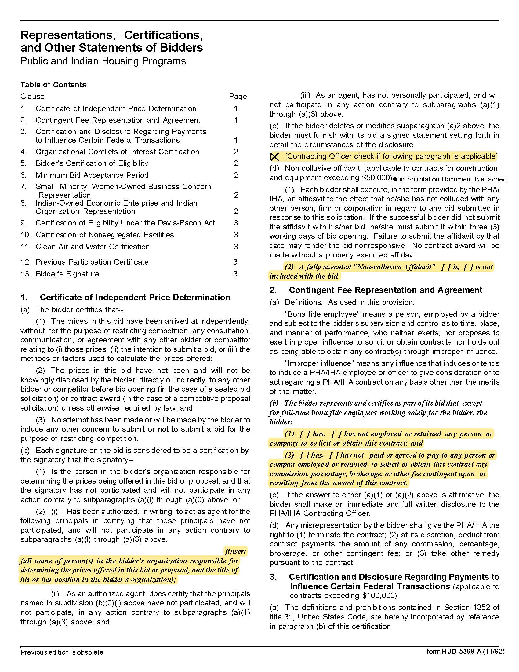
Solicitation Document C | HUD Form 5369A

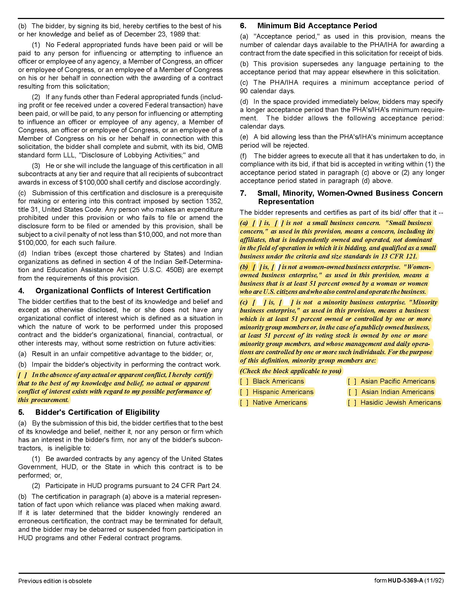

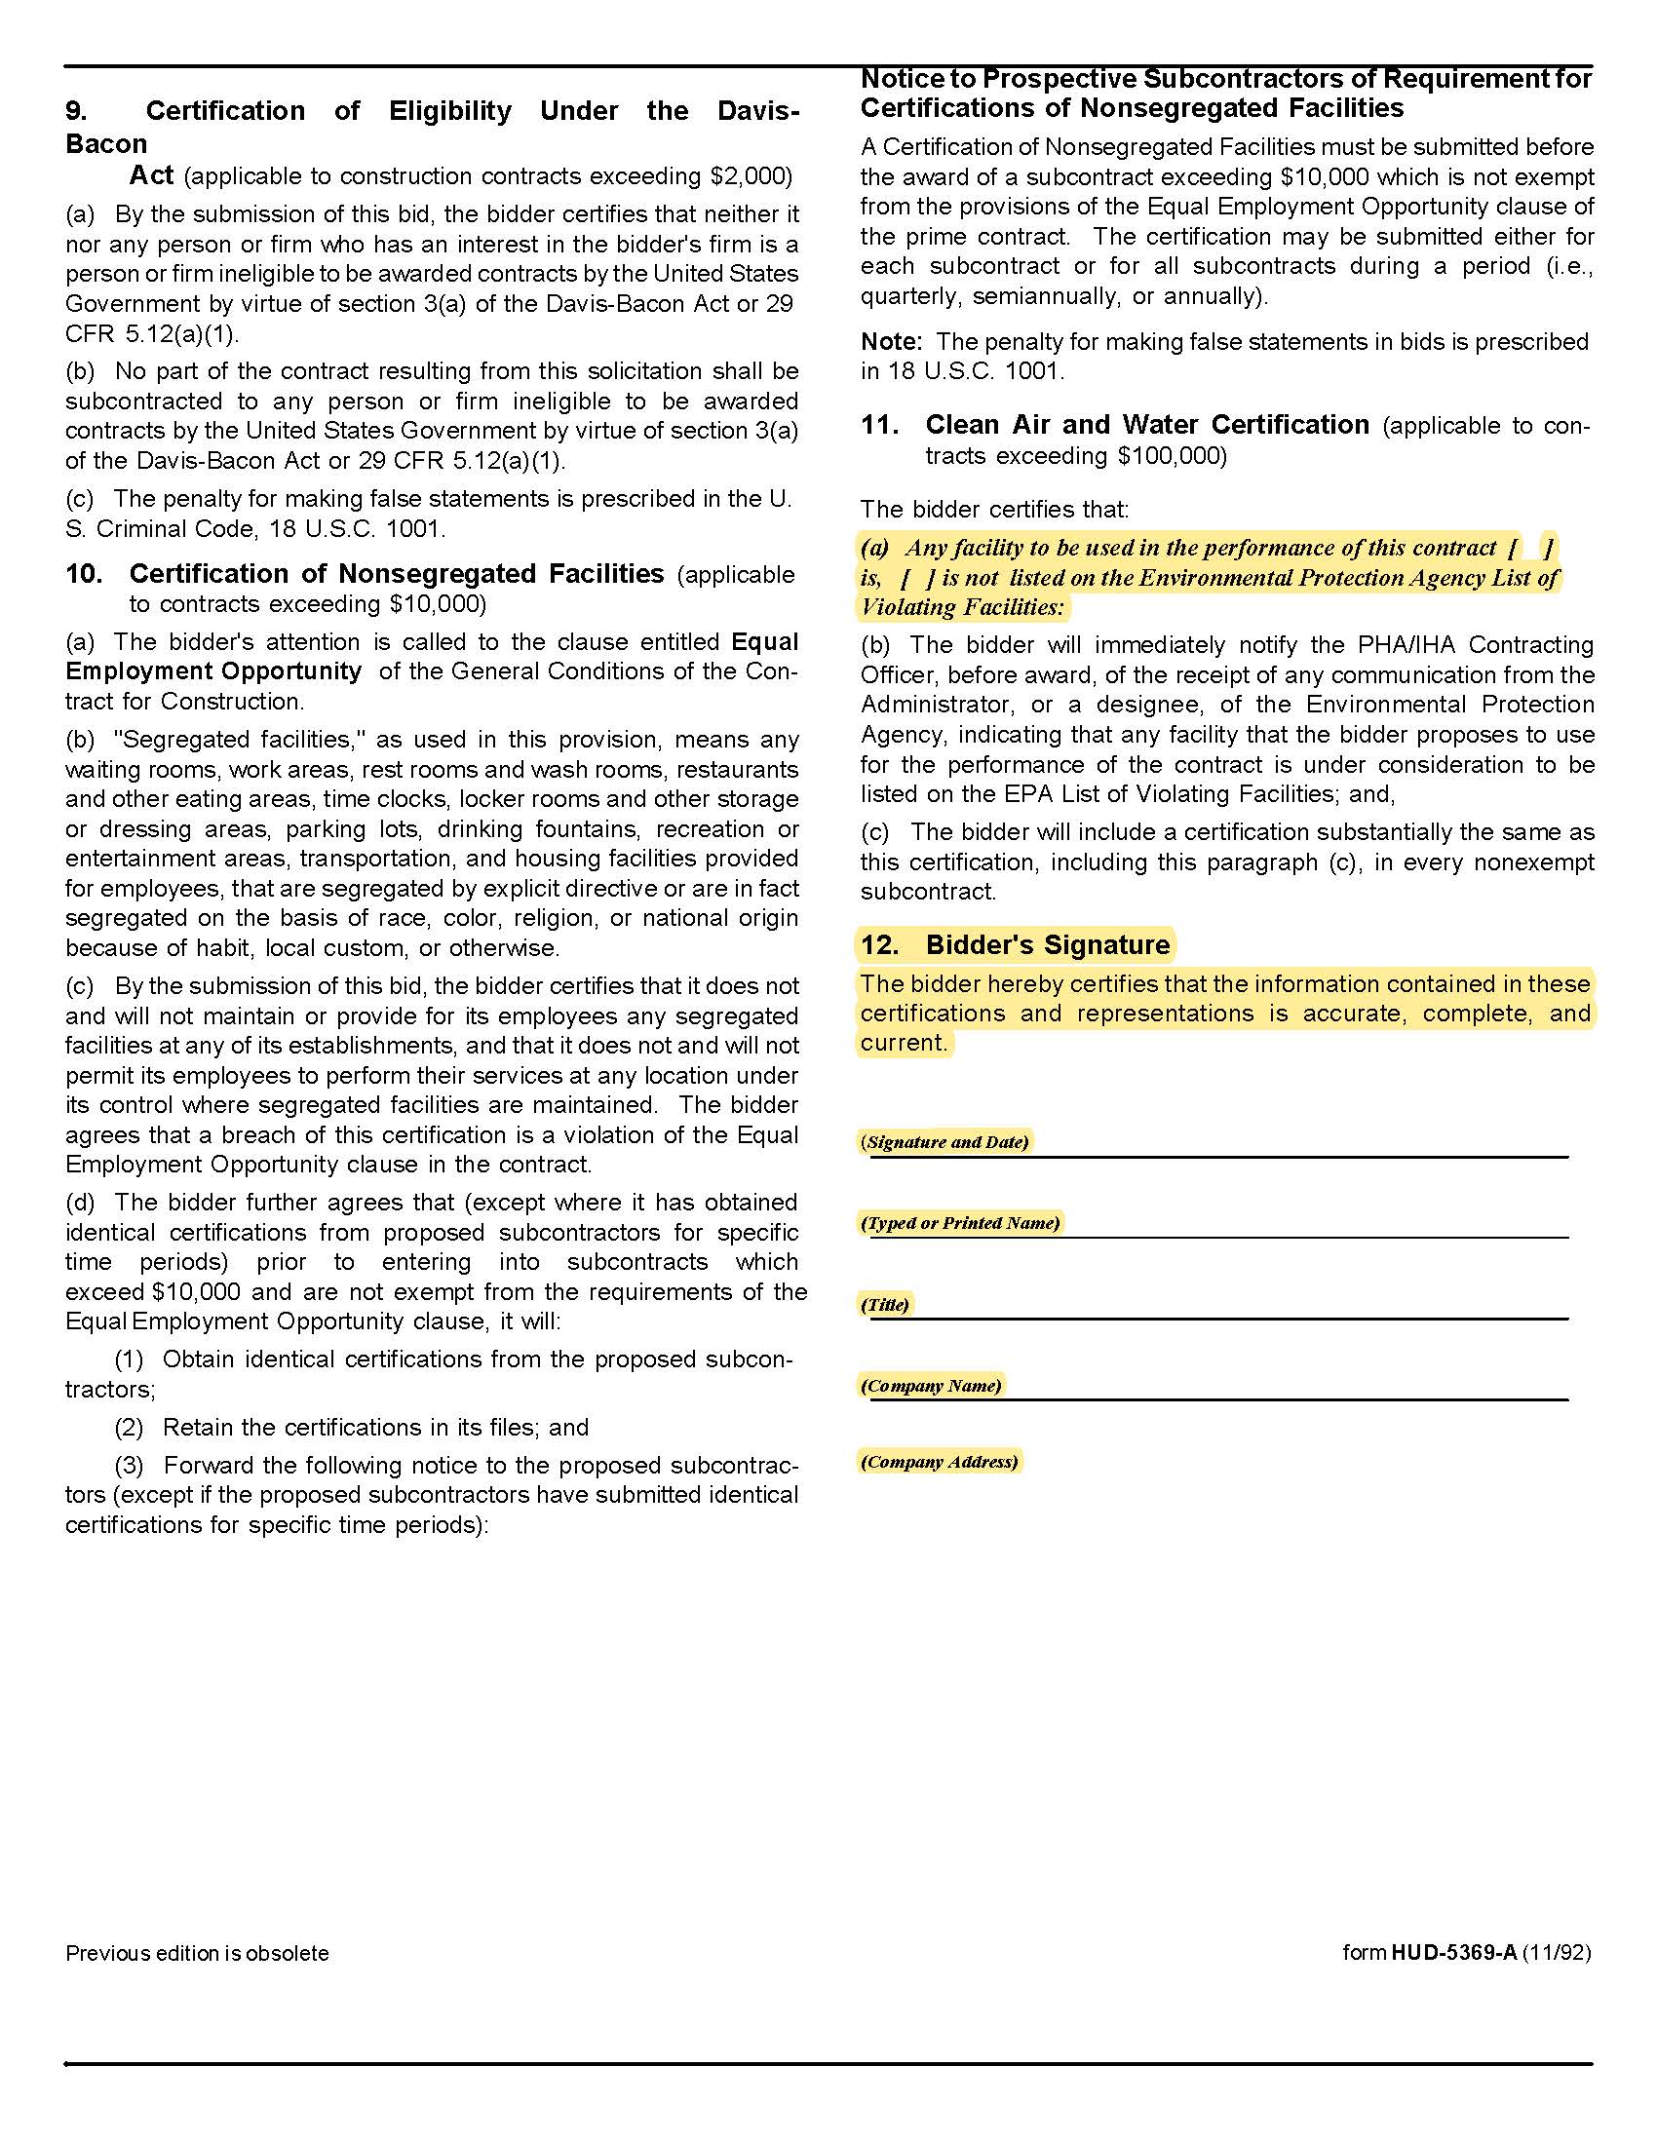

Solicitation Document D | Cost

Part I Discount Percentage:
The following percentage discount(s) will be applied to all KCDC purchases other than those itemized in Part II below.

Manufacturer | % Discount | Discount Base
Brown Stove Works | %
General Electric | %
Hotpoint | %
Kenmore | %
LG | %
Maytag | %
Whirlpool | %
Discount on additional products/services  Description: | %
Discount on additional products/services  Description: | %
Discount on additional products/services  Description: | %

Part II Specific Items:
These prices will be applied to all KCDC purchases for these items during the first twelve months of the award. After that time period, the supplier may request an increase as detailed earlier.

*Indicates probably usage but is not a guarantee that KCDC will purchase this quantity.

Item | Brand/Model | Number Bought in Previous Year* | Unit of Measure | Cost
Bowl Ring Drip Pan 6 inch | Whirlpool FSPW10196406RW | 520 | Each | $
Bowl Ring Drip Pan 8 inch | Whirlpool FSPW10196405RW | 260 | Each | $
Refrigerator Door Gasket Ranges | Universal | 50 | Each | $
Element | CL SP12MA | Small 75 | Each | $
Element | CL SP21MA | Large 125 | Each | $

