Request for Written Quotes

Door hardware & Supplies

Solicitation Number | Q1835
Due Date | June 19, 2018
Due Time | 11:00 a.m. EST
Deliver Responses to: | Knoxville’s Community Development Corporation    Procurement Division  901 N. Broadway  Knoxville, TN 37917  Note: Procurement is in a separate building behind the main office building.
Electronic Copies | Electronic copies are available on KCDC’s webpage or by email at purchasinginfo@kcdc.org.
Responses may be Emailed to KCDC | ☒ Yes ☐ No
Printed Responses Required | ☐ Yes ☒ No
Solicitation Meeting | ☐ Yes ☒ No
Solicitation Meeting is Mandatory | ☐ Yes ☐ No ☒ Not Applicable
Solicitation Meeting Date | Not applicable
Solicitation Meeting Time | Not applicable
Solicitation Meeting Location | Not applicable
Questions About This Solicitation | Submit questions to purchasinginfo@kcdc.org  KCDC will not accept questions via telephone.
Award Results | KCDC posts both a summary of the quotes received and the award decision to its web page at: http://www.kcdc.org/procurement/

Check KCDC’s webpage for addenda and changes before submitting your response

General Information

1. Background and Intent

a. Knoxville's Community Development Corporation (KCDC) is the public housing and redevelopment agency for the City of Knoxville and for Knox County in Tennessee. KCDC’s affordable housing property portfolio includes 20 sites with approximately 3,525 dwelling units. KCDC also oversees approximately 3958 Section 8 Vouchers, 82 Moderate Rehabilitation units and 20 Redevelopment areas. Several of the properties have transformed to the Project Based Rental Assistance program (PBRA) and KCDC is the management company for those sites. The properties for which KCDC is the management company include Five Points 1, LP; Lonsdale Homes, LP; Northridge Crossing, LP and The Vista at Summit Hill, LP.

b. KCDC often needs door hardware to update current equipment or replace damaged or aged equipment on its apartment doors. KCDC intends to use the contract resulting from this solicitation to purchase door hardware as needed.

KCDC reserves the right to test and analyze locks to determine if they are of same quality in KCDC’s estimation and therefore acceptable for our purposes. The items desired include:

1. Master Padlock 3KA-0356 (Key Code 0356)

- Keyed alike
- 1-9/16" (40mm) wide laminated steel body for superior strength
- Hardened steel shackle for extra cut resistance
- 4 pin cylinder helps prevent picking
- Dual locking levers provide extra pry resistance

2. Wright Products Colonial Push Button Latch

- Model #: VC333BL
- Colonial Push Button Latch
- Made for wood or metal outswing doors 3/4" to 1-1/4" thick
- 1-3/4" installation hole spacing
- Installs in three 5/16" holes
- Hardware Finish Black, Latch Color Black, Color/Finish Black

3. Heavy Duty Storm Door Closer

- Manufacturer: S Parker #62301
- Heavy duty pneumatic door closer
- For wood or metal out swinging doors
- Full 90 opening.
- Adjustable closing speed.
- Permanently lubricated

4. LSDA Passage Lock

- Grade 3 tubular lockset
- Manufacturer # 01G3
- EZ number 009699
- Finish: US3
- Adjustable backset: 2 3/8” or 2 3/4”

5. Shield Security Passage Lever Lock

- Finish: Brass
- For 2-3/8 or 2-3/4" Backset
- Adjustable Steel Latch
- Non-handed
- HD Supply Part #913814

6. Spring for Storm Door latches

7. LSDA Deadbolt- Standard Duty

- Single cylinder
- Part # 203WKD
- EZ number 050110
- Finish: US3
- Keyway: WR3
- Adjustable backset: 2-3/8” or 2-3/4”
- Keyed different
- In order to fit KCDC’s existing structures, substitutions will not be accepted for this item.

c. It is understood that KCDC intends to use the successful supplier for these products or services; however, KCDC reserves the right to purchase these products or services elsewhere if it is in KCDC’s best interest.

2. Changes after Award
It is possible that after award KCDC will need to revise the service needs or requirements specified in this document. KCDC reserves the right to make such changes after consultation with the supplier. Should additional costs arise, the supplier must document increased costs. KCDC reserves the right to accept and negotiate these charges.

3. Contact Personnel
It shall be essential to the success of this contract to develop a good working relationship with the successful supplier. It is imperative that the KCDC account be handled efficiently and professionally. KCDC should be assigned no more than two contacts to handle billing inquiries and service related issues. In the event one or both contacts leave the KCDC account, the successful bidder shall formally introduce the new contacts to KCDC personnel. These contacts must be knowledgeable of KCDC so as to avoid any interruption of service.

4. Contact Policy
The supplier may not contact an officer, agent or employee of KCDC other than the KCDC’s Procurement Division about matters pertaining to this solicitation, from the issuance of this solicitation until its award. Information obtained from an unauthorized officer, agent or employee of KCDC will not affect the risks or obligations assumed by the supplier or relieve the supplier from fulfilling any of the conditions of the project. Such contact can disqualify the supplier from participation in the solicitation process.

5. Delivery

a. Delivery will be to specified locations within Knox County, Tennessee. Please see Solicitation Document E - KCDC Site Addresses.

b. Deliveries are accepted (approximately - may depend upon the site) between 7:30 a.m. and 3:30 p.m. each business day.

c. Deliveries will not incur additional cost to KCDC.

d. KCDC may or may not ask for delivery.

6. Evaluation
KCDC will arrive at the “lowest and best” solution for the final award. This may not entail simply awarding to the supplier quoting the lowest cost. All responses are subject to a determination of “responsive” and “responsible” prior to award. KCDC is the sole judge as to supplier “responsiveness” and “responsibility.” KCDC reserves the right to request additional information to assist in the evaluation process. This includes references and business capacity information.

7. General Instructions
KCDC does not insert “General Instructions to Suppliers” in solicitation documents. These instructions are at www.kcdc.org. Click on “Procurement” and the link to the instructions. The supplier’s submittal means acceptance of the terms and conditions set forth in KCDC’s “General
Instructions to Suppliers.”

8. Invoicing/Ordering

a. Until a purchase order is in place, work is not to be performed nor are goods to be delivered. KCDC does not have a legal obligation to pay for the work performed prior to the issuance of a purchase order.

b. Suppliers must submit invoices within 90 days of the delivery of goods or services. KCDC may deny invoices submitted after the 90 day threshold. KCDC prefers invoices arrive within 10 days following the end of the month in which goods or services were supplied.

c. KCDC’s purchases of goods are exempt from Tennessee sales and use tax pursuant to Tennessee Code Annotated 67-6-329(a) (4) and KCDC is generally exempt from the Federal Excise tax. Suppliers are subject to Tennessee sales and use tax on all materials and supplies used in the performance of a contract, whether such materials and supplies are purchased by the supplier, produced by the supplier, or provided to the supplier by KCDC, pursuant to Tennessee Code Annotated 67-6-209. The supplier will pay all taxes incurred in the performance of an awarded contract. Upon the placement of a purchase order or the award of a contract, KCDC will provide a State of Tennessee Sales Tax Exemption form to the supplier. KCDC will not pay taxes on invoices.

d. KCDC pays by electronic transfer (ACH) only.

e. Since KCDC is the managing partner for four separate corporations under the KCDC umbrella, those separate corporations must receive separate invoices. Thus the supplier will generally:

- Bill each specific site for work performed or goods delivered there
- With KCDC’s permission, generate one monthly master invoice showing all locations and their individual costs (except for those listed below)
- Create separate invoices for Five Points I, Lonsdale Homes, North Ridge Crossing and The Vista.

f. KCDC requires that invoices be submitted via email.

9. Length of Award
The length of the contract will initially be 12 months with four optional annual renewals that KCDC may exercise at its discretion.

10. Price Structure

a. At the end of each twelve month period, the awarded supplier may request a change to the percentage and/or specific item charged to KCDC. The supplier must provide proof of the necessity of the increase to the Procurement Division. Suppliers may lower prices at any time with or without notice. KCDC will decide whether to accept a price increase. If the price increase is accepted, the bid file will be so noted. If the price increase is not accepted, the supplier may:

1. Continue with the existing pricing.
2. Suggest an alternative price increase.
3. End the award.

b. KCDC does not pay fuel surcharges.

11. Product Brands
The product brands listed on the pricing sheet have been previously approved and are the preferred brand for suppliers to quote. If suppliers are quoting a different brand, they are required to submit a product sample (or specification sheet) for approval at least five business days prior to the bid opening.

12. Questions
Send direct questions pertaining to this document to purchasinginfo@KCDC.org with “Door Hardware” in the subject line, at least five days prior to the due date. KCDC does not accept questions via telephone.

13. Representations
By submitting a response, the supplier represents and warrants:

- That the supplier is financially solvent and that it is experienced in and competent to perform the type of work, and/or to furnish the personnel, plans, materials, supplies or equipment to be performed or furnished by it; and

b. That the supplier is familiar with all federal, state, municipal and county laws, ordinances and regulations, which may in any way affect the work of those employed therein, including but not limited to any special acts relating to the work or to the project of which it is a part; and

c. That the supplier has carefully examined the plans, the specifications and the worksites and that from its own investigations, has satisfied itself as to the nature and location of the work, the character, quality, quantity of surface and subsurface materials likely to be encountered, and character of equipment and other facilities needed for the performance of the work, the general and local conditions and all other materials which may in any way affect the work or its performance.

14. Use of Solicitation Forms
Suppliers are to complete the solicitation forms contained in the solicitation package. Failure to complete these forms may result in rejection of your response. Do not alter the solicitation forms without KCDC’s approval. Suppliers are asked to use the MS Word version of the pricing pages to eliminate difficulties in reading handwritten text.

THIS AND THE PREVIOUS PAGES DO NOT NEED TO BE RETURNED

Door Hardware & Supplies Q1835

Solicitation Document A General Response Section

General Information about the Supplier
Sign Your Name to the Right of the Arrow
By signing, you indicate you read and agree to “KCDC’s General Instructions to Suppliers” on www.kcdc.org.
Printed Name and Title
Company Name
Street Address
City/State/Zip
Contact Person (Please Print Clearly)
Telephone Number
Cell Number
Supplier’s E-Mail Address (Please Print Clearly)
Addenda
Addenda are at www.kcdc.org. Click on “Procurement” and then on “Open Solicitations” to find addenda. Please check for addenda prior to submitting a proposal.
Acknowledge addenda have been issued by checking below as appropriate:
None ☐ | Addendum 1 ☐ |  |  | Addendum 2 ☐ |  | Addendum 3 ☐ |  |  | Addendum 4 ☐ | Addendum 5 ☐
Statistical Information (Check all the apply)
This business is at least 51% owned and operated by a woman |  |  |  |  |  |  |  |  |  |  | Yes ☐ No ☐
This business qualifies as a small business by the State of Tennessee  (Gross receipts of $10,000,000 or less and employing less than 100 full time persons ) |  |  |  |  |  |  |  |  |  |  | Yes ☐ No ☐
This business qualifies as Section 3 business (as defined by HUD):  It is at least 51% owned by a Section 3 resident (lives in Public Housing) or it employs Section 3 residents for at least 30% of its employee base; or it commits to sub contract at least 25% of the project’s dollars to a Section 3 business. |  |  |  |  |  |  |  |  |  |  | Yes ☐ No ☐
This business is owned & operated by persons at least 51% of the following ethnic background:
Asian/Pacific ☐ |  | Black ☐ | Hasidic Jew ☐ |  | Hispanic ☐ |  |  | Native Americans ☐ |  |  | White ☐
Cooperative Procurement
Subject to additional location/delivery charges, the supplier agrees to extend the offered costs to other governments if the government so desires. Yes ☐ No ☐
Prompt Payment Discount
A prompt payment discount of ________% is offered for payment within ____ days of submission of an accurate and proper invoice.
MasterCard Acceptance
Mastercard is accepted for payment without additional fees. Yes ☐ No ☐
Mastercard is accepted for payment with a fee of _______. Yes ☐ No ☐

Door Hardware & Supplies Q1835

Solicitation Document B Cost

Part I. Item Cost

 | ITEM | BRAND QUOTED | COST | UNIT OF MEASURE
1. | Master Padlock 3KA-0356 (Key Code 0356) |  | $
2. | Wright Products Colonial Push Button Latch |  | $
3. | Heavy Duty Storm Door Closer |  | $
4. | LSDA Passage Lock |  | $
5. | Shield Security Passage Lever Lock |  | $
6. | Spring for Storm Door Latches |  | $
7. | LSDA Deadbolt- Standard Duty |  | $

Part II. Discount
KCDC’s needs change from time to time and thus everything that is needed cannot be itemized. Therefore suppliers are encouraged to offer “discount” percentages for non-specified items. Such discounts may vary by classes of items and brands. Discounts may range from 0% (meaning shelf price) to 99.99%. Suppliers are to indicate the discount base: jobber’s catalog, retail, wholesale, et cetera.

Manufacturer/Product | % Discount | Discount Base
 | %
 | %
 | %
 | %
 | %
 | %
 | %
 | %

Part III. Delivery
Timely delivery of goods and services is of the essence. Delivery will be to specified locations within Knox County, Tennessee and will not incur additional costs to KCDC. Please see Solicitation Document E - KCDC Site Addresses. Deliveries are accepted (approximately - may depend upon the site) between 7:30 a.m. and 3:30 p.m. each business day.

__________ Guaranteed number of days from receipt of order to delivery at KCDC site.

Door Hardware & Supplies Q1835

Solicitation Document C Affidavits

Supplier: _____________________________________________________________________________

Conflict of Interest:

1. No commissioner or officer of KCDC or other person whose duty it is to vote for, let out, overlook or in any manner superintend any of the work for KCDC has a direct interest in the award or the supplier providing goods or services.

2. No employee, officer or agent of the grantee or sub-grantee will participate in selection, or in the award or administration of an award supported by Federal funds if a conflict of interest, real or apparent, would be involved. Such a conflict would arise when the employee, officer or agent, any member of his immediate family, his or her partner, or an organization, which employs, or is about to employ, any of the above, has a financial or other interest in the supplier selected for award.

3. The grantee's or sub-grantee's officers, employees or agents will neither solicit nor accept gratuities, favors or anything of monetary value from suppliers, potential supplier s, or parties to sub-agreements.

4. By submission of this form, the supplier is certifying that no conflicts of interest exist.

Drug Free Workplace Requirements:

5. Private employers with five or more employees desiring to contract for construction services attest that they have a drug free workplace program in effect in accordance with TCA 50-9-112.

Eligibility:

6. The supplier is eligible for employment on public contracts because no convictions or guilty pleas or pleas of nolo contender to violations of the Sherman Anti-Trust Act, mail fraud or state criminal violations with an award from the State of Tennessee or any political subdivision thereof have occurred.

General:

7. Supplier fully understands the preparation and contents of the attached offer and of all pertinent circumstances respecting such offer.

8. Such offer is genuine and is not a sham offer.

Door Hardware & Supplies Q1835

Solicitation Document C Affidavits - continued

Iran Divestment Act:

9. Concerning the Iran Divestment Act (TCA 12-12-101 et seq.), by submission of this bid/quote/proposal, each supplier and each person signing on behalf of any supplier certifies, and in the case of a joint bid/quote/proposal, each party thereto certifies as to its own organization, under penalty of perjury, that to the best of its knowledge and belief that each supplier is not on the list created pursuant to § 12-12-106.

Non-Collusion:

10. Neither the said supplier nor any of its officers, partners, owners, agents, representatives, employees or parties interest, including this affiant, has in any way colluded conspired, connived or agreed, directly or indirectly, with any other responder, supplier, or person to submit a collusive or sham offer in connection with the award or agreement for which the attached offer has been submitted or to refrain from making an offer in connection with such award or agreement, or collusion or communication or conference with any other supplier, or, to fix any overhead, profit, or cost element of the offer price or the offer price of any other supplier, or to secure through any collusion, conspiracy, connivance, or unlawful agreement any advantage against KCDC or any person interested in the proposed award or agreement.

11. The price or prices quoted in the attached offer are fair, proper and not tainted by any collusion, conspiracy, connivance, or unlawful agreement on the part of the supplier or any of its agents, representatives, owners, employees, or parties in interest, including this affiant.

Accuracy of Electronic Copies:

12. If the supplier provides electronic copies of the bid/proposal/quote to KCDC, the supplier certifies that the information provided on paper and in the electronic format is identical unless specifically noted otherwise.

Door Hardware & Supplies Q1835
Solicitation Document C Affidavits - continued

The undersigned hereby acknowledges receipt of these affidavits and certifies that the submittal in response to this solicitation is in full compliance with the listed requirements.

Signed by
Printed Name
Title
Subscribed and sworn to before me this date
By (Notary Public)
My Commission Expires on
Notary Stamp

Door Hardware & Supplies Q1835
Solicitation Document D HUD Form 5369A

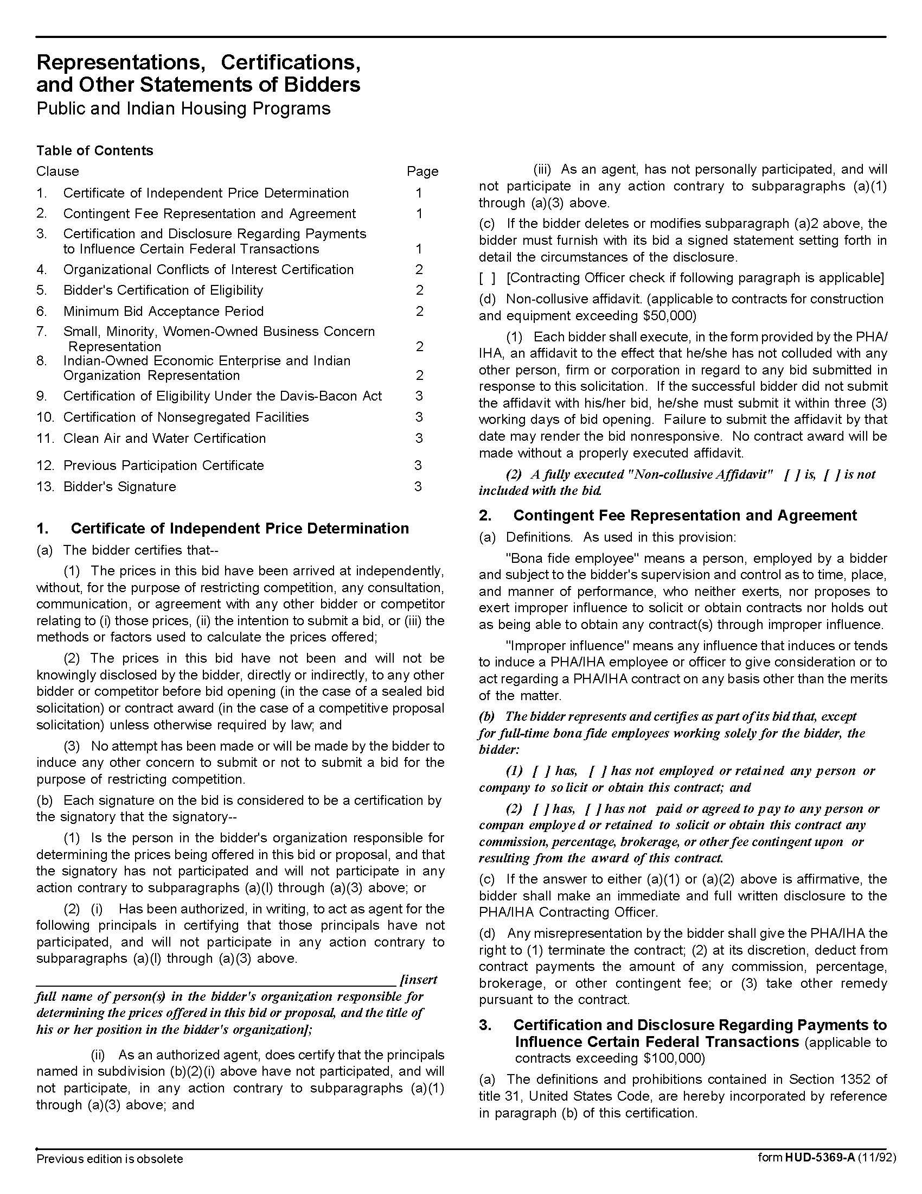

Door Hardware & Supplies Q1835
Solicitation Document D HUD Form 5369A - Continued
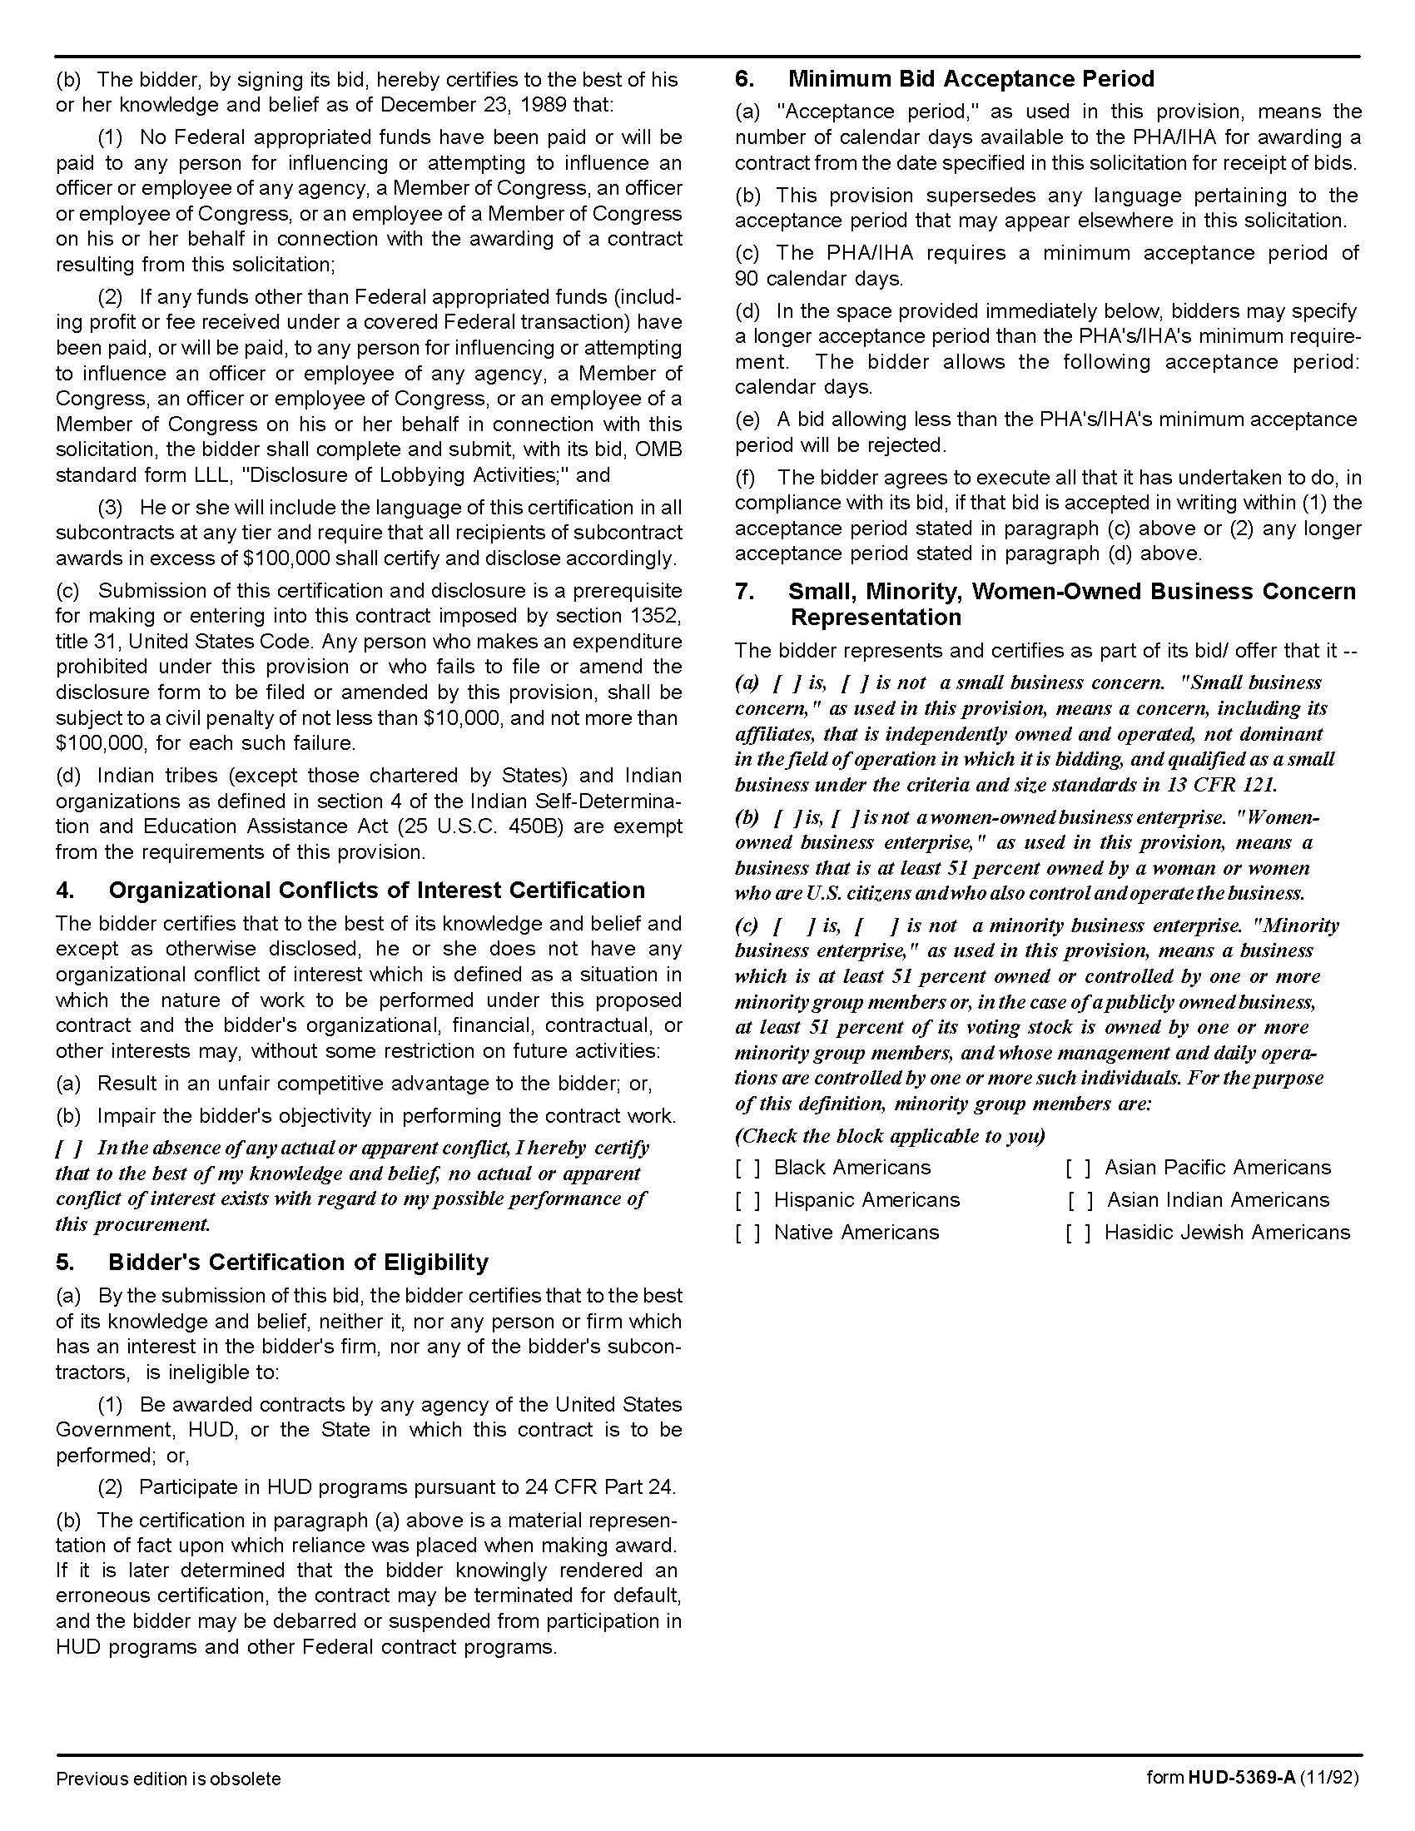

Door Hardware & Supplies Q1835
Solicitation Document D HUD Form 5369A - Continued

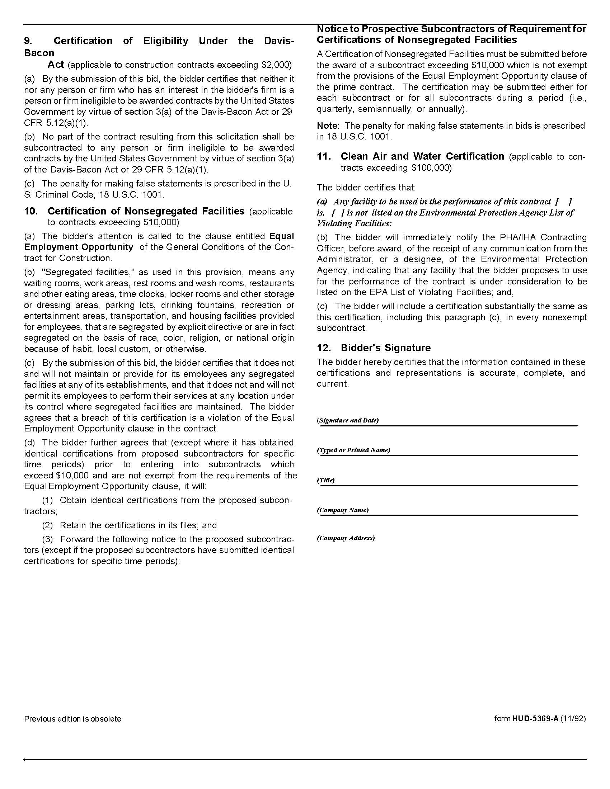

Door Hardware & Supplies Q1835
Solicitation Document E KCDC Site Addresses

Autumn Landing  Manager: James Pruitt - Phone: 865-403-1422  6331 Pleasant Ridge Road  Knoxville, TN 37921 | Austin Homes  Manager: Darrell Lindsey - Phone: 865-403-1300  801 Howard Baker Jr. Boulevard  Knoxville, TN 37915
Cagle Terrace (both buildings)  Manager: Rhonda Harris Phone: 865-403-1310  515 Renford Drive  Knoxville, TN 37919 | Five Points  Manager: Kim Clark 865-403-1390  381 McConnell Street  Knoxville, TN 37915
Isabella Towers  Manager: Linda Jeter 865-403-1340  515 Isabella Circle  Knoxville, TN 37915 | KCDC Main Office  865-403-1100  901 North Broadway  Knoxville, TN 37917
KCDC Procurement  865-403-1133  901 North Broadway  Knoxville, TN 37917 | Lonsdale Homes  Manager: Darlene Farmer 865-403-1350  2020 Minnesota Avenue  Knoxville, TN 37921
Love Towers (both buildings)  Manager: Steve Ellis 865-403-1360  1171Armstrong Avenue  Knoxville, TN 37917 | Montgomery Village  Manager: Sam Chambers 865-403-1380  4530 Joe Lewis Road  Knoxville, TN 37920
Nature's Cove Apartments  Manager: James Pruitt 865-403-1422  2639 Bakertown Road  Knoxville, TN 37931 | Northgate Terrace  Manager: Terri Evans 865-403-1400  4301 Whittle Springs Road  Knoxville, TN 37917
North Ridge Crossing  Manager: Adronicus Thomas 865-403-1320  712 Breda Drive  Knoxville, TN 37918 | Residences at Eastport  Manager: Kim Clark 865-403-1390  381 McConnell Street  Knoxville, TN 37915
Supportive Maintenance  Manager: Jack Canada 865-403-1371  1130 Cornelia Street  Knoxville, TN 37917 | Taylor Homes  Manager: Kim Clark 865-403-1390  381 McConnell Street  Knoxville, TN 37915
The Verandas  Manager: Sam Chambers 865-403-1380  107 Flenniken Avenue  Knoxville, TN 37920 | Valley Oaks Apartments  Manager: Adronicus Thomas 865-403-1320  3504 Oak Branch Circle  Knoxville, TN 37917
Vista Apartments  Manager: Darrell Lindsey 865-403-1300  957 East Hill Avenue  Knoxville, TN 37915 | Western Heights  Manager: Kristie Toby 865-403-1420  1621 Jourolman Avenue  Knoxville, TN 37921

