Invitation for Bids



Solicitation Name and Number | Appliances (as needed) Q2110 TAHRA
Responses Must Arrive No Later Than | 11:00 a.m. EST on December 21, 2020 (as KCDC’s Clocks Indicate)
Deliver Responses to | procurementinfo@kcdc.org
Electronic Copies: | Use the MS Word version posted on KCDC’s website (or other electronic means) to provide a typed response. The final proposal is to be submitted in Adobe format.
May responses be emailed to TAHRA | ☒ Yes ☐ No
Solicitation Meeting | ☐ Yes ☒ No
Solicitation Meeting is Mandatory | ☐ Yes ☒ No
Solicitation Meeting Date | Not Applicable
Solicitation Meeting Time | Not Applicable
Solicitation Meeting Location | Not Applicable
Questions About This Solicitation | KCDC will not accept questions via telephone.  Submit questions to procurementinfo@kcdc.org by 6:00 p.m. on December 16, 2020.
Solicitation Opening | The “bid opening” will be conducted via Zoom. Contact procurementinfo@kcdc.org to obtain the meeting link.
Award Results | KCDC posts the award decision to its web page at: http://www.kcdc.org/procurement/
Open Records/Public Access to Documents | All document provided to KCDC are subject to the Tennessee Open Meetings Act (TCA 8-44-101) and open records requirements.

Check TAHRA’s webpage for addenda and changes prior to submitting your response.

General Information

1. Definitions
a. “Requirements Contract” and “Term Bid” are standing arrangements between KCDC and a supplier in which prices and terms are agreed upon and in which KCDC may call on the supplier to deliver goods and/or services under the terms of the agreement.

b. “Senior Asset Manager” is the manager of one or more KCDC properties. He or she may delegate the administration of the work to an “Asset Manager” or “Maintenance” employee. In any case, the Senior Asset Manager or designee will request work as needs arise.

c. “Supplier” is inclusive of various words describing interested parties often called “vendor,” “bidders,” “contractors” and “proposers.”

2. Background and Intent
a. Knoxville's Community Development Corporation (KCDC) is the public housing and redevelopment agency for the City of Knoxville and for Knox County in Tennessee. KCDC’s affordable housing property portfolio includes 20 sites with approximately 3,525 dwelling units. Several of the properties include Low Income Housing Tax Credits units and KCDC is both the General Partner and the management company for those sites. Those properties include Eastport LP, Five Points 1, LP; Five Points 2, LP; Five Points 3, LP; Five Points 4, LP; Lonsdale Homes, LP; Northridge Crossing, LP and The Vista at Summit Hill, LP. KCDC also oversees approximately 3,958 Section 8 Vouchers, 82 Moderate Rehabilitation units and 20 Redevelopment areas. KCDC has issued this solicitation for itself and on the behalf of the various properties that it now provides “management services” as detailed above. Any resulting awards are either for KCDC itself or are on behalf of those properties which KCDC provides “management services.”

b. KCDC issued this solicitation on behalf of the Tennessee Association Housing & Redevelopment Authorities (TAHRA). Hereafter the terms “KCDC” and “TAHRA” are used interchangeably.

c. The various Public Housing Authorities (PHAs) in the State of Tennessee often purchase common items while furnishing their units, including household appliances. In order to obtain volume discounts, TAHRA agreed to coordinate one solicitation that any or all housing agencies (in addition to other governmental entities) may use. However, no PHA is mandated to use this agreement.

d. Once the award is made, the successful supplier will honor orders, at the specified prices, from any TAHRA member agency, city, county or state agency or any other municipality or political subdivision choosing to participate.

e. However, no agency or governmental entity is required to participate and may conduct separate procurements for items contained in this solicitation. Additionally, TAHRA does not guarantee any orders will be placed and assures no responsibility, financial or otherwise, for purchases made under this contract.

f. This solicitation is to provide modern, efficient and Energy Star rated (as applicable) appliances for use by Public Housing Authorities and other government entities across the State of Tennessee.

g. Upon award, the successful suppliers will need to market the program to the TAHRA membership. For such purposes, TAHRA will work with the suppliers to communicate award notice and materials.

h. The successful suppliers are strongly encouraged to consider active participation in TAHRA, including attendance at its spring and fall meetings. Additionally, the supplier may want to consider becoming an affiliate member of TAHRA. Details are on TAHRA’s webpage at http://tahranet.org/.

3. Changes after Award
It is possible that after award TAHRA will need to revise the service needs or requirements specified in this document. TAHRA reserves the right to make such changes after consultation with the supplier. Should additional costs arise, the supplier must document increased costs. TAHRA reserves the right to accept or reject and negotiate these charges.

TAHRA also reserves the right to accept proposed service changes from the supplier if they will lower the cost to TAHRA and/or provide improved service.

4. Evaluation
a. TAHRA alone determines (using NIGP’s definition and other relevant sources as appropriate) the supplier’s “responsive” and “responsible” status prior to award. Responsible means a business with the financial and technical capacity to perform the requirements of the solicitation and subsequent contract. A responsive bid is one fully conforming in all material respects to the solicitation document and all of its requirements, including all forms and substance.

b. TAHRA reserves the right to request additional information to assist in the evaluation process. This includes references and business capacity information.

c. TAHRA will review all bids and reserves the right to request necessary modifications, waive minor technicalities, reject all bids, reject any bid that does not meet mandatory requirement(s) or cancel this solicitation, according to TAHRA’s best interests. TAHRA further reserves the right to adjust its evaluation scenario if it is in TAHRA’s best interest and consistent with good business practices.

5. General Instructions
TAHRA does not insert “General Instructions to Vendors” in the solicitation document. These instructions are at www.kcdc.org. Click on “Procurement” and follow the link. By submitting a response to this solicitation, the supplier accepts the responsibility for downloading, reading and abiding by the terms and conditions set forth in KCDC’s “General Instructions to Vendors.” Suppliers may wish to review certain applicable HUD instructions also on KCDC’s webpage.

6. Invoicing/Ordering
This section is germane to KCDC only.

a. Until a purchase order is in place, work is not to be performed nor are goods to be delivered. KCDC has no legal obligation to pay for work performed prior to the issuance of a purchase order. Emergency situations are exempted from this statement and such situations can be approved by the Procurement Division.

b. Suppliers are asked to email invoices with 10 days following work completion and are required to submit invoices within 90 days following the delivery of the goods or services. KCDC may deny invoices submitted after the 90-day threshold.

c. KCDC pays by electronic transfer (ACH). Supplier’s accounts receivable staff must use KCDC’s Supplier Portal to ascertain payments made and to which invoices they apply.

Suppliers will set up an account in KCDC’s Supplier Portal so that they receive an email with each payment detailing the invoice number and the amount paid.
KCDC is not able to routinely offer payment history assistance and so if the supplier is unable or unwilling to use KCDC’s Supplier Portal to track payments, should consider whether or not to submit a response to this solicitation.

d. Since KCDC is the managing partner for nine separate corporations under the KCDC umbrella, those separate corporations must receive separate invoices. Thus, the supplier will generally:

- Bill each specific site for work performed or goods delivered.
- Create separate invoices for Eastport LP, Five Points 1, LP; Five Points 2, LP; Five Points 3, LP; Five Points 4, LP; Lonsdale Homes, LP; Northridge Crossing, LP and The Vista at Summit Hill, LP showing them as the “Owner” or “Bill To” entity.

e. Invoices must:
- Be numbered
- List a date on them that is after the work is completed or goods delivered
- List the purchase order number
- Breakdown pricing according to the award structure
- Show the supplier’s name and address

7. Length of Award
The initial award is for 12 months. The award has four one-year optional renewals that TAHRA may choose to exercise.

8. Price Structure at Renewals
a. At the end of each award year, the successful supplier may request a price increase. Proof of increased cost to the successful supplier must accompany price increase requests. TAHRA may, at its option:

1. Accept the proposed price increase.
2. Reject the proposed price increase.
3. Suggest an alternative price increase.

b. If TAHRA rejects a proposed price, the successful supplier may:

1. Continue with the existing pricing.
2. Suggest an alternative price increase.
3. End the award.

c. While the supplier may offer other goods, only those specifically awarded are “on contract.” Other goods offered are not covered by the award and can only be procured through specific purchase orders identifying the special goods to be offered and the price for them. TAHRA’s and the normal procurement thresholds of other entities will apply.

d. If one supplier elects to not renew or TAHRA elects to not renew with a supplier, the remaining suppliers may continue with the entire award or the solicitation may be re-issued.

e. If Energy Star requirements change during this award or contract, TAHRA reserves the right to renegotiate the award or contract with the successful supplier(s) to meet the new standards without going out for new bids, if so desired.

9. Quantities
While this is an “As Needed” solicitation and no specific quantities are guaranteed and while this solicitation is intended for all members of TAHRA (see Appendix I for a listing), the following quantities are estimated to have been purchased in 2019 by TAHRA, Metropolitan Development and Housing Authority (MDHA) and the Chattanooga Housing Authority (CHA).

Item | Total Units Purchased
Ranges | 200
Refrigerators | 250
Dishwashers | 50

10. Questions
Direct questions to purchasinginfo@tahra.org with “Appliances” in the subject line, at least five days prior to the due date.

11. Use of Solicitation Forms
Suppliers are to complete the solicitation forms contained in the solicitation package. Failure to complete these forms may result in rejection of your response. Do not alter the solicitation forms without TAHRA’s approval. Suppliers are asked to use the Adobe fillable version of the pricing pages to eliminate difficulties in reading handwritten text.

Specifications

12. General Requirements
The supplier shall furnish all equipment and material, and it shall be commercial quality from a regular product line. This request for bid is not intentionally written around any one manufacturer and is to indicate the general size, type and description of equipment needed.

13. Energy Star
TAHRA is very interested in energy efficiency. Energy Star certified appliances are required unless there are no such models currently so certified.

14. Delivery
a. Delivery shall be F.O.B. Destination, freight paid by the supplier, to the ordering entity. Delivery charges are included in the per unit cost. The driver will, at the minimum, assist PHA staff with unloading appliances to the tailgate of the delivery truck.

b. Agencies shall have the right to mix sizes and types of products to obtain quantity pricing. Prices given are for delivery F.O.B. to any point within Tennessee for purchases made by any participating entity. Should a governmental entity outside of Tennessee desire to use this award/contract, the supplier and the entity will negotiate shipping charges.

c. KCDC’s delivery needs have changed and now deliveries are directly to KCDC sites. While some sites can easily accommodate large trucks, many cannot accept trucks longer than fourteen (14) feet. Most KCDC sites do not have docks and so the supplier will have to arrange lift gate delivery with the sites.

15. Model and Price Change Notification
After award, if models change and/or prices increase (see above concerning price increases), the supplier(s) must notify TAHRA. Upon approval, notification will be sent to other TAHRA members.

16. Packing and Marking
Packaging, packing and marking shall be in accordance with standard commercial practices and be specified in the contract or order. TAHRA encourages environmentally friendly packaging and the general reduction of packaging materials.

17. Dishwashers
Dishwashers are to be Same as Or Equal To the Current Models listed in Column B on the pricing sheet. TAHRA wants one model made available for purchase for its members.

18. Electric Ranges
Electric Ranges are to be Same as Or Equal To the Current Models listed in Column B on the pricing sheet. TAHRA wants five models made available for purchase for its members.

Operating Service is either 115/120 volts or 120/208 volts, 3-wire or 4-wire, single-phase, 60HZ.

The standard electric range connection cords will not be ordered with the ranges. Therefore, the cost of connection cords is not to be included in the price of the range.

Ranges, at a minimum, shall have one indicator light that will indicate when any of the top burners are on and one oven indicator light to show when the oven is heating.

An oven time control is not required.

Each range shall be equipped with at least four leg levelers and anti-tilt brackets or approved anti-tilt devices.

All ranges are to be equipped with two oven racks.

The range cook top, oven box, door, control panel and door exterior shall be porcelain enamel. Range side panels, oven and storage drawers, if equipped, shall be porcelain or a suitable high-temperature baked enamel.

Ranges shall have a UL listing and the supplier shall provide a copy of the UL labels in the brochures.

19. Gas Ranges
Gas Ranges are to be Same as Or Equal To the Current Models listed in Column B on the pricing sheet. TAHRA wants two models made available for purchase for its members.

a. Ranges, or parts thereof, supplied under this specification shall fulfill the construction and performance requirements of the latest edition of the American National Standard Institute (ANSI) Z21.1 and Z21.20 (when applicable).

The cooking top shall be provided with four burners. Each burner shall be rated at no less than 9000 BTU.

Each top burner shall be provided with a porcelain enameled cast iron or steel grate.

All burners shall be equipped with automatic ignition of the gas. Failure of the over burner pilot shall activate a means for shutting off gas to the over burner. This shall meet the applicable requirements of the ANSI Z21.20-2014. The electric ignition system may be spark, coil, glow bar or a combination of these.

An oven thermostat control shall be provided for controlling oven temperatures down to 170˚F. The baking oven and broiling section shall be porcelain enamel coated steel. The broiling section shall be either of the drop door type, pull out type or swing door type. Stops shall be provided so that oven racks cannot be completely pulled out by accident.

Ovens shall be provided with a vent designed to deflect moisture and fumes away from the wall behind the range.

At a minimum, the back guard, main top, control panel and door shall be porcelain enamel. All other exterior surfaces shall be finished in synthetic, baked-on enamel capable of withstanding 250˚F. The range body, back panel, legs and/or base shall be porcelain enamel, baked-on enamel, galvanized or aluminized steel. The area under the main top may be porcelain enamel or synthetic, baked-on enamel.

Each range shall be equipped with a back splash not less than four inches higher than the top cooking surface and extending the full width of the range top.

The equipment and accessories supplied with each range, such as oven and broiler racks, shall be those normally supplied with the manufacturer’s standard production for the type range ordered.

All gas ranges are to have four adjustable legs for leveling and are to be equipped with anti-tipping brackets.

The top of the range is to be lifting top for ease of cleaning under and around the top burners with a support bracket to hold the top in an elevated position, or have a lift-off top.

20. Microwaves
Microwaves are to be Same as Or Equal To the Current Models listed in Column B on the pricing sheet. TAHRA wants four models made available for purchase for its members.

21. Range Hoods
Range Hoods are to be Same as Or Equal To the Current Models listed in Column B on the pricing sheet. TAHRA wants two models made available for purchase for its members.

22. Refrigerators
Refrigerators are to be Same as Or Equal To the Current Models listed in Column B on the pricing sheet. TAHRA wants four models made available for purchase for its members.

Refrigerator sizes are general size requirements. Suppliers may bid nearest to the size listed (i.e. 13.9 - 15.5 cubic feet refrigerators are considered 14 cubic feet models, and 15.6 - 16.5 cubic feet refrigerators are considered 16 cubic feet models).

Refrigerators shall be the self-contained and self-defrosting, household type with electric motor driven condensing units. All refrigerators shall be furnished with shelves in the door and vegetable drawers or crisper trays.

The exterior doors shall have reversible hinges which allow for left or right swing and be equipped with a magnetic gasket.

The interior liners of food storage compartments shall be porcelain enamel on steel or plastic.

The temperature control shall be equipped with an off position and contact points or setting positions for a wide range of degree of temperature.

Each refrigerator shall include one or more vegetable drawers or crisper trays which are readily removable. These shall be constructed of steel finished with porcelain enamel, anodized aluminum or durable plastic, durable glass or non-corrosive metal.

Refrigerators are to be equipped with four rollers (for ease of moving the refrigerator without damage to the floor covering.) The two backside rollers may be stationary with the two front side rollers adjustable up and down for leveling the refrigerator.

Refrigerators must meet the December 2020, United States Department of Energy Freezer/Refrigerator Energy Star standards.

This and the previous pages do not need to be returned

Solicitation Document A General Information About the Supplier
Sign Your Name to the Right of the Arrow
Your signature indicates that you have read and agree to “TAHRA’s General Instructions to Vendors” on www.kcdc.org.
Printed Name and Title
Company Name
Street Address
City/State/Zip
Contact Person (Please Print Clearly)
Telephone Number
Cell Number
Supplier’s E-mail address (Please Print Clearly)
Addenda
Addenda are at www.kcdc.org. Click on “Procurement” and then on “Open Solicitations” to find addenda. Please check for addenda prior to submitting a bid.
Acknowledge addenda have been issued by checking below as appropriate:
None ☐ | Addendum 1 ☐ |  |  | Addendum 2 ☐ |  |  | Addendum 3 ☐ |  |  | Addendum 4 ☐ |  |  | Addendum 5 ☐
Statistical Information (Check All That Apply)
This business is owned & operated by persons at least 51% of the following ethnic background:
Asian/Pacific ☐ |  | Black ☐ | Hasidic Jew ☐ |  |  | Hispanic ☐ |  | Native American ☐ |  |  |  | White ☐ |  | Publicly Owned ☐
As defined on TAHRA’s webpage (see the “General Instructions to Vendors”), this business qualifies as:
Section 3 ☐ |  |  |  |  | Small Business ☐ |  |  |  |  |  | Woman Owned ☐
Prompt Payment Discount
A ____% prompt payment discount applies when KCDC makes payment in ____ days of accurate invoicing.

Solicitation Document B: Affidavits

Conflict of Interest
1. No commissioner or officer of KCDC or other person whose duty it is to vote for, let out, overlook or in any manner superintend any of the work for KCDC has a known direct interest in the award or the supplier providing goods or services.

2. No employee, officer or agent of the grantee or sub-grantee will participate in selection, or in the award or administration of an award supported by federal funds if a conflict of interest, real or apparent, would be involved. Such a conflict would arise when the employee, officer or agent, any member of his immediate family, his or her partner, or an organization, which employs, or is about to employ, any of the above, has a financial or other interest in the supplier selected for award.

3. The grantee's or sub-grantee's officers, employees or agents will neither solicit nor accept gratuities, favors or anything of monetary value from suppliers, potential suppliers, or parties to sub-agreements.

4. By submission of this form, the supplier is certifying that no conflicts of interest exist.

Drug Free Workplace Requirements
5. Private employers with five or more employees desiring to contract for construction services attest that they have a drug free workplace program in effect in accordance with TCA 50-9-112.

Eligibility
6. The supplier is eligible for employment on public contracts because no convictions or guilty pleas or pleas of nolo contender to violations of the Sherman Anti-Trust Act, mail fraud or state criminal violations with an award from the State of Tennessee or any political subdivision thereof have occurred.

General
7. Supplier fully understands the preparation and contents of the attached offer and of all pertinent circumstances respecting such offer.

8. Such offer is genuine and is not a sham offer.

Iran Divestment Act
9. Concerning the Iran Divestment Act (TCA 12-12-101 et seq.), by submission of this bid/quote/quotes, each supplier and each person signing on behalf of any supplier certifies, and in the case of a joint bid/quote/quotes, each party thereto certifies as to its own organization, under penalty of perjury, that to the best of its knowledge and belief that each supplier is not on the list created pursuant to § 12-12-106.

Accuracy of Electronic Copies
10. If the supplier provides electronic copies of the bid/proposal/quote to KCDC, the supplier certifies that the information provided on paper and in the electronic format is identical unless specifically noted otherwise.

Non-Collusion
11. Neither the said supplier nor any of its officers, partners, KCDC, agents, representatives, employees or parties interest, including this affiant, has in any way colluded conspired, connived or agreed, directly or indirectly, with any other responder, supplier, or person to submit a collusive or sham offer in connection with the award or agreement for which the attached offer has been submitted or to refrain from making an offer in connection with such award or agreement, or collusion or communication or conference with any other supplier, or, to fix any overhead, profit, or cost element of the offer price or the offer price of any other supplier, or to secure through any collusion, conspiracy, connivance, or unlawful agreement any advantage against KCDC or any person interested in the proposed award or agreement.

12. The price or prices quoted in the attached offer are fair, proper and not tainted by any collusion, conspiracy, connivance, or unlawful agreement on the part of the supplier or any of its agents, representatives, KCDC, employees, or parties in interest, including this affiant.

No Contact/No Advocacy Affidavit
13. After this solicitation is issued, any contact initiated by any supplier or proposer with any owner’s representative concerning this proposal is strictly prohibited-except for communication with the Procurement Division. My signature signifies that no unauthorized contact occurred.

14. To ensure the integrity of the review and evaluation process, respondents to this solicitation nor any firm representing them, may not lobby or advocate to owner’s staff or Board members. My signature signifies that no unauthorized advocacy occurred.

The undersigned hereby acknowledges receipt of these affidavits and certifies that the submittal in response to this solicitation is in full compliance with the listed requirements.

Signed by
Printed Name
Title
Subscribed and sworn to before me this date
By (Notary Public)
My Commission Expires on
Notary Stamp

Solicitation Document C: HUD Form 5369A
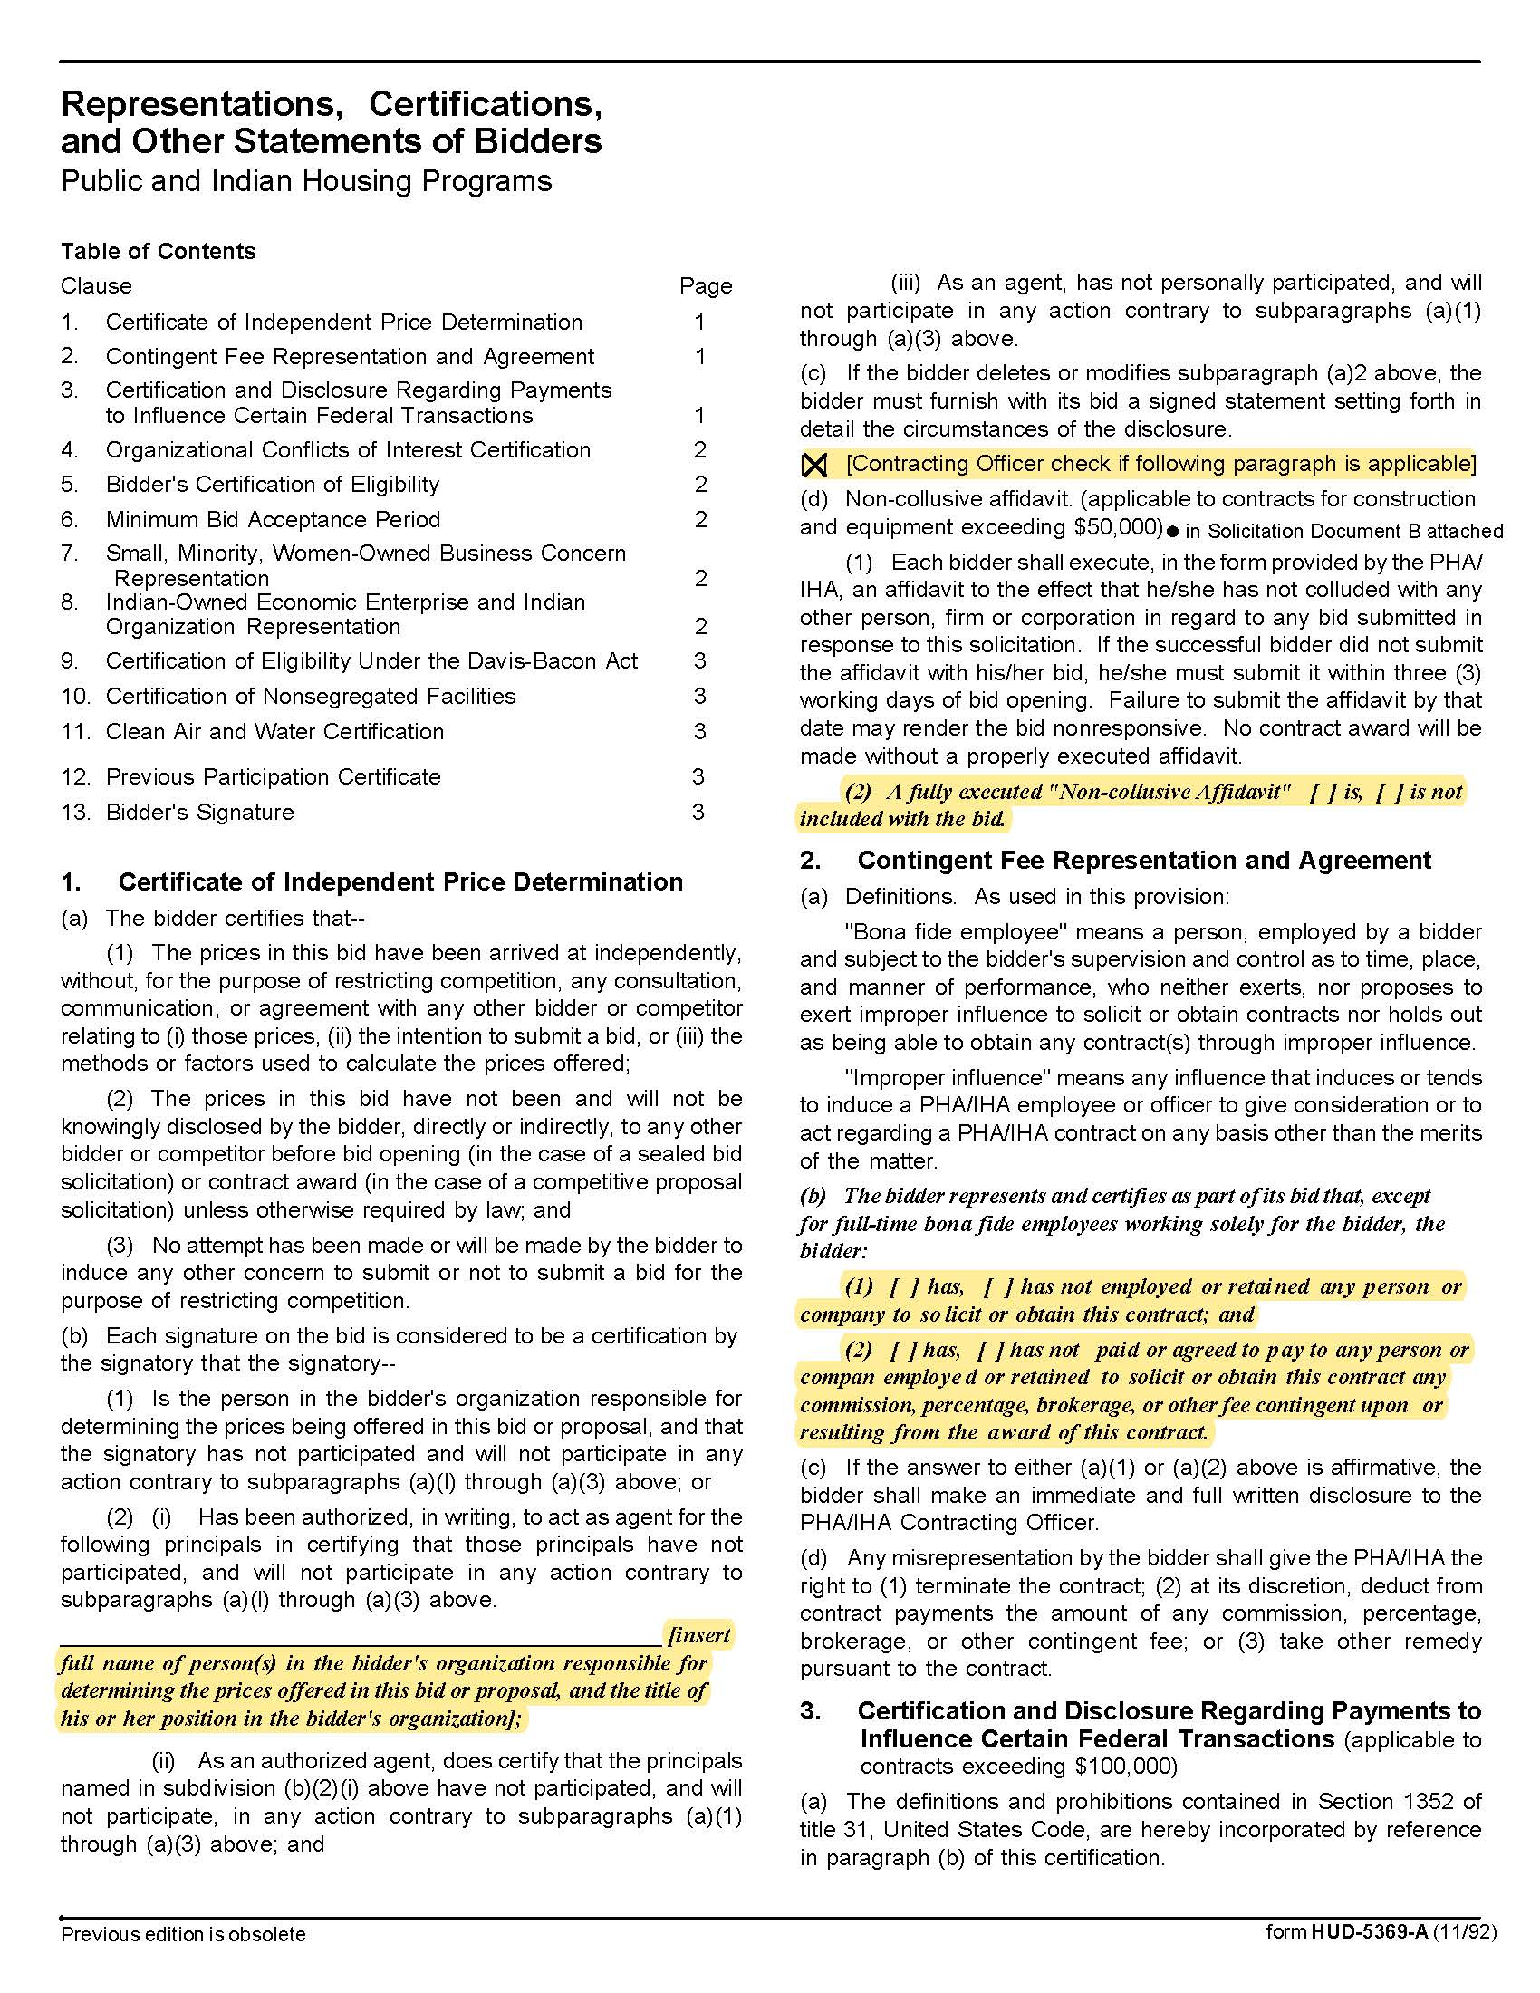

Solicitation Document C: HUD Form 5369A
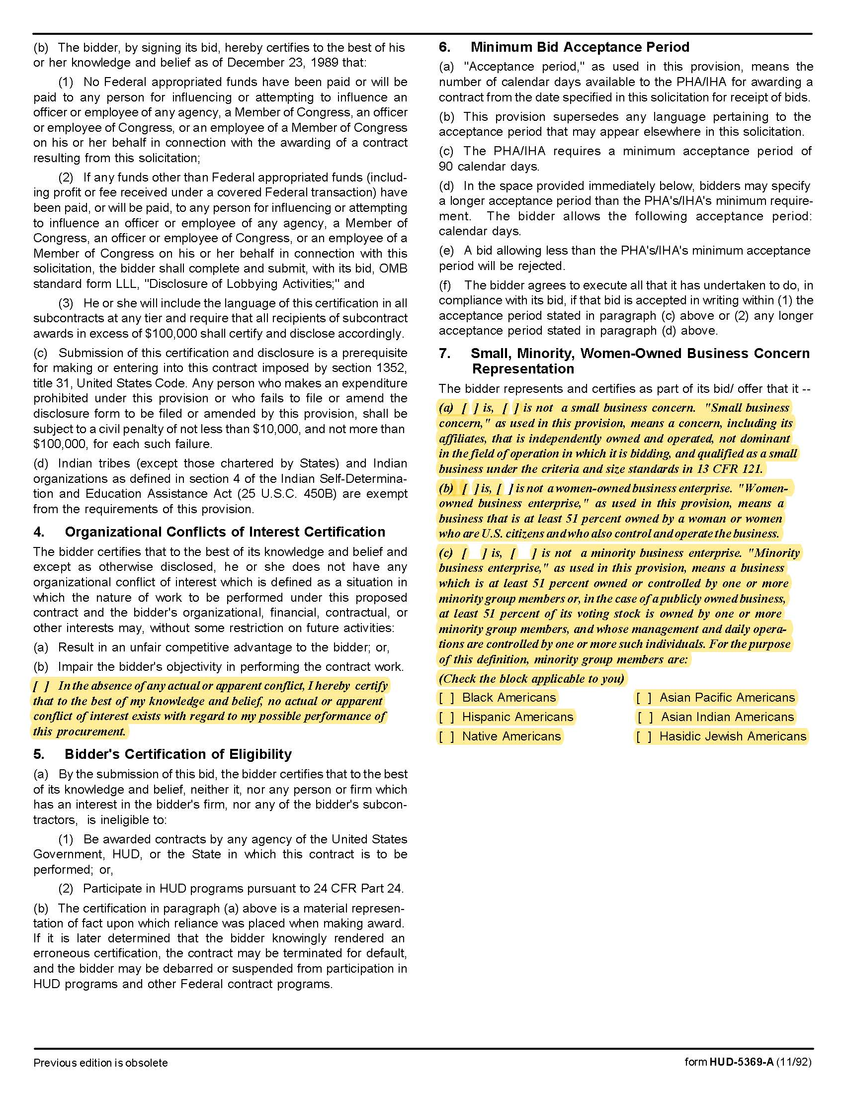

Solicitation Document C: HUD Form 5369A
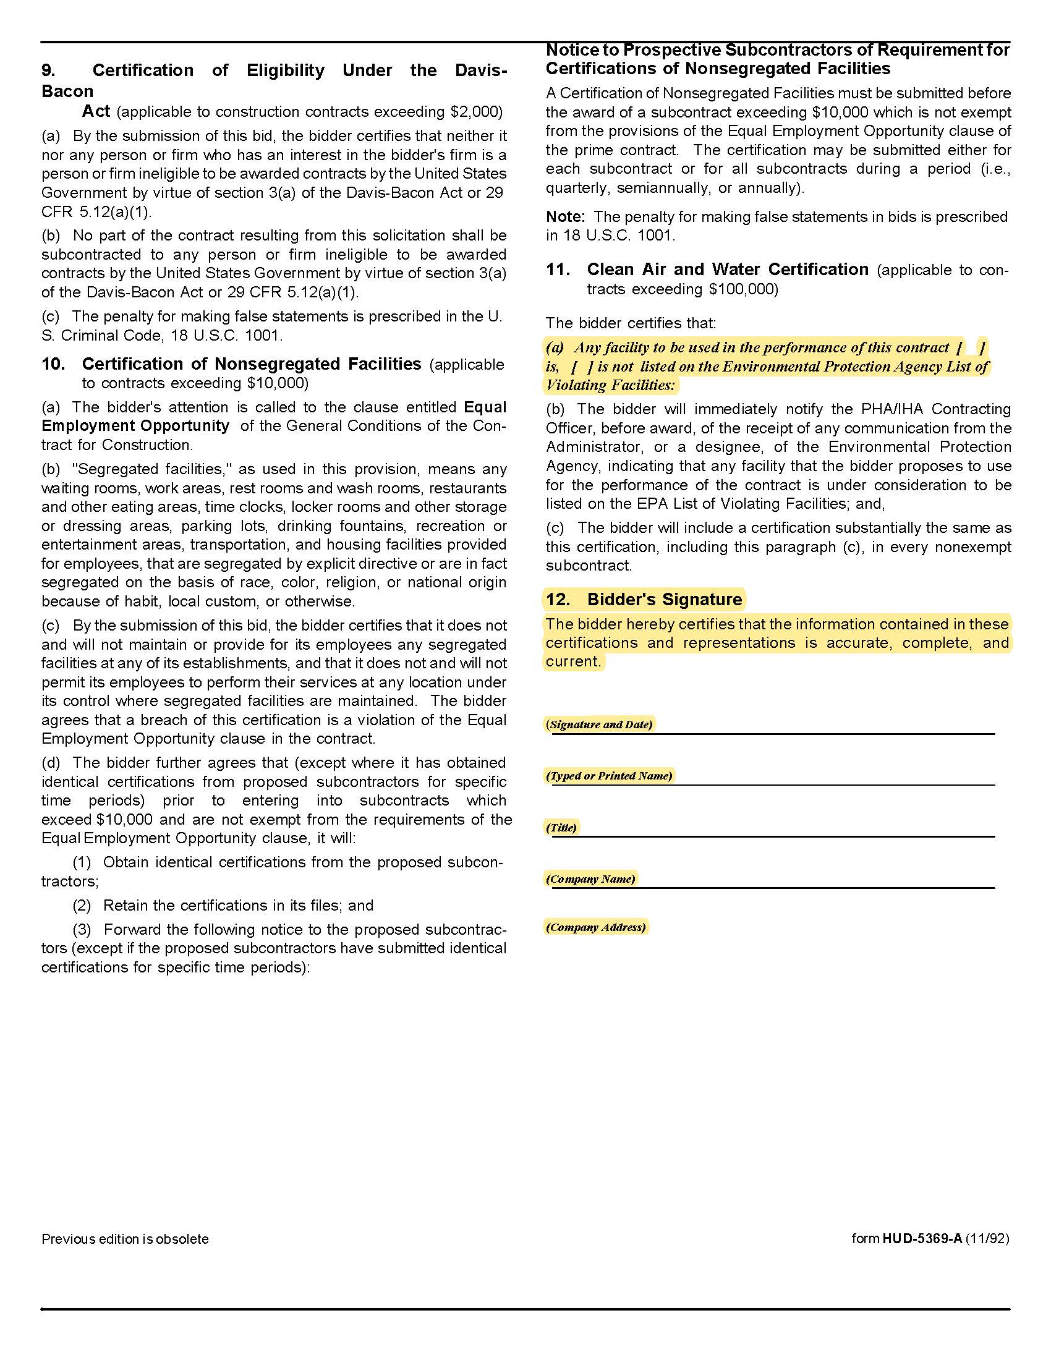

Appendix I: TAHRA Member Listing

ENTITY | EXECUTIVE DIRECTOR | EMAIL | ADDRESS | PHONE | NUMBER OF UNITS
Athens Housing  Authority | Ross Dodson | ross@athenstnha.com | P. O. Box 928  Athens, TN 37301 | 423.745.0341 | 441
Bolivar Housing  Authority | Michael A. Miller | bhahhs@bellsouth.net | 621 Hatchie Haven  Bolivar, TN 38008 | 731.658.3419 | 119
Bristol Housing  Authority | Steve Scyphers | jss@bthra.org | 204 Bluff City Hwy.  Bristol, TN 37621 | 423.274.8150 | 354
Brownsville  Housing Authority | Brenda Lonon | blonon@brownsvilleha.org | P. O. Box 194, 254 Anderson Ave.  Brownsville, TN 38012 | 731.772.0274 | 135
Chattanooga  Housing Authority | Debbie Chadwick | dchadwick@chahousing.org | P. O. Box 1486  801 N. Holtzclaw Ave. (37404)  Chattanooga,TN 37401 | 423.668.2374 | 2,672
Clarksville  Housing Authority | Wanda B. Mills | wmills@clarksvillehousing.org | P. O. Box 603, 721 Richardson St.  Clarksville, TN 37041 | 931.647.2303 | 508
Cleveland  Housing Authority | Paul A. Dellinger | paul@clevelandhousingauthority.org | P. O. Box 2846, 450 Walker St., NE  Cleveland, TN 37320 | 423.479.9659  EXT 109 | 420
Clinton  Housing Authority | John H. Greer | clintonha@bellsouth.net | 825 McAdoo Street  Clinton, TN 37716 | 865.457.9692 | 150
Columbia Housing &  Redevelopment Corp. | Trent Ogilvie | trent@chrc-tn.org | 101 Penny Ave.  Columbia, TN 38401 | 931.388.5203  EXT 224 | 296
Covington  Housing Authority | Christi Billings | covhouse@bellsouth.net | P. O. Box 88, 1701 Shoaf St.  Covington, TN 38019 | 901.476.6135 | 246
Crossville  Housing Authority | Don Alexander | dra@crossvillehousing.org | P. O. Box 425, 67 Irwin Ave.  Crossville, TN 38557 | 931.484.2990 | 757
Dayton  Housing Authority | Lisa Bonadio | lbonidao@daytonhousingauthority.org | P. O. Box 257, 270 Railroad St.  Dayton, TN 37321 | 423.775.1871  EXT 227 | 342
Dickson  Housing Authority | Buford Reed, Jr. | booty@dichsonhousing.com | 333 Martin Luther King Jr. Blvd.  Dickson, TN 37055 | 615.446.4708 | 164
Ducktown  Housing Authority | Sheryl Miller | ducktownhousing@gmail.com | P. O. Box 214  Ducktown, TN 37326 | 423.496.3546
Dyersburg  Housing Authority | Paula Ledford | dhapl@ecsis.net | P. O. Box 824, 541 Hike Ave.  Dyersburg, TN 38025 | 731.285.6771 | 502
Elizabethton  Housing Authority | Kelly Geagley | ehdatn@gmail.com | P. O. Box 637  Elizabethton, TN 37644 | 423.543.3571 | 326
Erin  Housing Authority | Melinda Deason | erinha@peoplestel.net | P. O. Box 384, 44 Griffin Dr.  Erin, TN 37061 | 931.289.4261 | 60
Erwin  Housing Authority | Lori Rice | lori@erwinhousing.comcastbiz.net | 750 Carolina Ave., Building 100  Erwin, TN 37650 | 423.743.5231 | 73
Etowah  Housing Authority | Carolyn Jonnson | cjeha@comcast.net | 400 Sunset Dr.  Etowah, TN 37331 | 423.263.2674 | 136
Fayetville  Housing Authority | Jimmy Bills | fayhous@fpunet.com | P. O. Box 999  Fayetville, TN 37334 | 931.433.1587 | 276
Franklin Co. Consolidated  Housing Authority | Lydia McBee | lmfccha@bellsouth.net | P. O. Box 502  Winchester, TN 37398 | 931.967.0344 | 248
Franklin  Housing Authority | Derwin Jackson | djackson@franklinhousingauthority.com | 200 Spring St.  Franklin, TN 37064 | 615.794.1247 | 273
Gallatin  Housing Authority | Michael Bates | gallhsg@comcast.net | 401 N. Boyers Ave.  Gallatin, TN 37066 | 615.452.1661 | 389
Gallaway  Housing Authority | Brian Harris | brian@martinhousing.org | 200 Jackson St.  Arlington, TN 38002 | 901.867.8101 | 60
Greeneville  Housing Authority | Rebecca Moyer | grneha@comcast.net | P. O. Box 279, 100 Cox Circle  Greeneville, TN 37743 | 423.638.3111 | 325
Grundy  Housing Authority | Derryl Graham | dgraham@blomand.net | 187 Raulston St.  Monteagle, TN 37356 | 931.924.2496 | 110
Harriman  Housing Authority | Amy Hall | ahall@harrimanhsg.org | 924 Sewanee St.  Harriman, TN 37748 | 865.882.9636 | 324
Hartsville  Housing Authority | Kim Satterfield | hartsvha@bellsouth.net | P. O. Box 44, 212 Rogers St.  Hartsville, TN 37074 | 615.374.3959 | 34
Highland Residential  Services (formerly Cookeville HA | Chris Cassetty  Director of Operations | ccassetty@highlandsrs.com | P. O. Box 400  Cookeville,TN 38501 | 931.526.9793 | 529
Hohenwald  Housing Authority | Terry Bunch | terry@hohenwaldhousing.com | 107 Allison Ave.  Hohenwald, TN 38462 | 931.796.3642 | 116
Humboldt  Housing Authority | Patricia Taylor | humhouse@bellsouth.net | 3532 Seymour Loop  Humboldt, TN 38343 | 731.784.9722 | 232
Huntingtondon  Housing Authority | Denelda Price | director@huntingdonhousing.org | 433 Hillcourt Circle  Huntingdon, TN 38344 | 731.986.4442 | 148
Jackson  Housing Authority | C. Winston Henning | whenning@jacksonha.com | P. O. Box 3188, 125 Preston St.  Jackson, TN 38303 | 731.422.1671  EXT 103 | 982
Jefferson City  Housing Authority | Keith Godwin | 1jcha@bellsouth.net | 942 East Ellis St.  Jefferson City, TN 37760 | 865.475.2064 | 199
Jellico  Housing Authority | Crystal Creekmore | jellicoha@bellsouth.net | P. O. Box 240  Jellico, TN 37762 | 423.784.8809 | 122
Johnson City  Housing Authority | Richard McClain | richardm@jchousing.org | 901 Pardee St.  Johnson City, TN 37601 | 423.232.4784 | 752
Kingsport Housing & Redevelopment Authority | Terry W. Cunningham | khra@kingsporthousing.org | P. O. Box 44, 906 E. Sevier Ave.  Kinsgport, TN 37662 | 423.392.2513 | 529
Knoxville's Community  Development Corp.  KCDC | Terry  McKee | tmckee@kcdc.org | 901 N. Broadway  Knoxville, TN 37917 | 865.403.1100 | 3,870
Lafayette  Housing Authority | Lisa Gentry | lafhouse@nctc.com | 613 Dycus Circle  Lafayette, TN 37083 | 615.666.2140 | 102
LaFollette  Housing Authority | John Snodderly | john@lafollettehousing.org | P. O. Box 392  LaFollette, TN 37766 | 423.562.2261 | 1,116
Lawrenceburg  Housing Authority | Eddy Casteel | houseaut@lawrenceburgha.org | P. O. Drawer C, 1020 Smith Ave.  Lawrenceburg, TN 38464 | 931.762.7532 | 303
Lebanon  Housing Authority | Patrick Johnson | pjohnson@lhatn.org | 49 Upton Heights  Lebanon, TN 37087 | 615.444.1872  EXT 117 | 354
Lenoir City  Housing Authority | Mary Sue Jordan | msjordan@lcityha.org | 101 Oakwood Dr.  Lenoir City,TN 37771 | 865.986.8707 | 170
Lewisburg  Housing Authority | Ronald Robinson | lha@tnweb.com | 744 Bark St.  Lewisburg, TN 37091 | 931.359.4517 | 220
Lexington  Housing Authority | Melba J. Johnson | melbalha@gmail.com | 100 Willow Court  Lexington, TN 38351 | 731.968.7506 | 120
Livingston  Housing Authority | Ken Mabry | livhouseauth@twlakes.net | P. O. Box 98, East 7th St.  Livingston, TN 38570 | 931.823.6423 | 65
Loudon  Housing Authority | Lori Everett | lhalori@bellsouth.net | P. O. Box 425, 124 Pathkiller Trail  Loudon, TN 37774 | 865.458.2061 | 121
Manchester  Housing Authority | Nancy Huddleston | mha@cafes.net | 710 Butler Circle  Manchester, TN 37355 | 931.728.2596 | 166
Martin  Housing Authority | Brian Harris | brian@martinhousing.org | 134 E. Heights Dr.  Martin, TN 38237 | 731.587.3186 | 433
Maryville  Housing Authority | Nancy Burnette | nburnette@mhatn.com | 311 Atlantic Ave.  Maryville, TN 37801 | 865.983.4958 | 517
McKenzie  Housing Authority | Barbara Cooper | coopermha@bellsouth.net | 22 McDonald Ave.  McKenzie, TN 38201 | 731.352.5335 | 148
McMinnville  Housing Authority | Patricia Basham | mmha@blomand.net | 301 Hardaway St.  McMinnville, TN 37110 | 931.473.3286 | 422
Memphis  Housing Authority | Dorian Jenkins | swilkins@mhanewday.com | P. O. Box 3664, 700 Adams Ave.  Memphis, TN 38103 | 901.544.1102 | 2,990
Metropolotin (Nashville)  Development & Housing  Agency (MDHA) | Rita James | rjames@nashville-mdha.org | 701 South 6th St.  Nashville, TN 37206 | 615.252.8412 | 6129
Milan  Housing Authority | Mark A. Dodson | tn31@milanhousing.org | 1000 Northside Terrace  Milan, TN 38358 | 731.686.8571 | 100
Millington  Housing Authority | Tanya Martchek | themha@rittermail.com | P. O. Box 55, 4888 Bill Knight Ave.  Millington, TN 38083 | 901.872.3677 | 90
Morristown  Housing Authority | Marilyn J. Medley | mmedley@morristownpha.org | P. O. Box 497, 600 Sulphur Springs Rd.  Morristown, TN 37815 | 423.586.5115 | 676
Mt. Pleasant  Housing Authority | Dawn Hudson | mphauth@bellsouth.net | 138 Thomas Circle  Mt. Pleasant, TN 38474 | 931.379.5811 | 116
Murfreesboro  Housing Authority | Thomas Rowe | trowe@mha-tn.org | 415 N. Maple St.  Murfreesboro, TN 37130 | 615.893.9414 | 430
Newbern  Housing Authority | Jane Norsworthy | jnorsworthy@aeneas.net | P. O. Box 100  Newbern, TN 38059 | 731.627.2142 | 145
Newport  Housing Authority | Charlie Boggan | cwbogan4nha@newporttnhousing.com | 440 Lennon Circle  Newport, TN 37821 | 423.623.1575 | 400
Oak Ridge  Housing Authority | James A. Carson | jacarson@orha.net | 10 Van Hicks Lane  Oak Ridge, TN 37830 | 865.482.1006 | 128
Oliver Springs  Housing Authority | Karen Leffew | oshousing@aol.com | 131 Brittain Village  Oliver Springs, TN 37840 | 865.435.1711 | 113
Paris  Housing Authority | Lisa Wimberley | parhsing@bellsouth.net | 917 Minor St.  Paris, TN 38242 | 731.642.4451 | 196
Parsons-Decaturville  Housing Authority | Mecca Derre | meccapdha@gmail.com | 155 Miller St., Unit 301C  Parsons, TN 38363 | 731.847.2638 | 68
Portland  Housing Authority | Sabrina Woodard | ptldhsgdirector@gmail.com | P. O. Box 37, 107 Potts Ave.  Portland, TN 37148 | 615.325.4559 | 120
Pulaski  Housing Authority | Vivian Gordon | viviango@pulaskihousing.com | 2006 Garden Meadow Drive  Pulaski, TN 38478 | 931.363.6525 | 209
Ripley  Housing Authority | Justin Jones | jjones@ripleyha.net | 101 Northcrest  Ripley, TN 38063 | 731.635.1901  EXT 28 | 265
Rockwood  Housing Authority | Jill Jiles-Everhart | jjeverhart@bellsouth.net | 320 Carpenter St.  Rockwood, TN 37854 | 865.354.9841 | 159
Rogersville  Housing Authority | Rebecca Wolf | rhabecky@rogersvillehousing.net | 902 Locust St.  Rogersville,TN 37857 | 423.272.8540 | 204
Savannah  Housing Authority | C. Hardin Hughes | hardin@savhousing.com | 80 Jefferson St.  Savannah, TN 38372 | 731.925.2020 | NO ANSWER
Sevierville  Housing Authority | Ronald Franklin | sevshng@bellsouth.net | 500 Leo Sharp Road  Sevierville, TN 37862 | 865.453.8500 | 245
Shelbyville  Housing Authority | William Hershel Thrasher | whthrashersha@bellsouth.net | P. O. Box 560, 316 Templeton St.  Shelbyville, TN 37160 | 931.684.1341  EXT 20 | 422
Smithville  Housing Authority | Sharon Prater | smthvhou@dtccom.net | P. O. Box 117, 415 Jackson St.  Smithville, TN 37166 | 615.597.4140  EXT 3 | 182
Smyrna  Housing Authority | Sean Lee | sean_lee@comcast.net | 701 Stan Circle  Smyrna, TN 37167 | 615.459.8866 | 736
South Carthage  Housing Authority | Michael Bates |  | P. O. Box 197, 109 Hazel Drive  Carthage, TN 37030 | 615.735.1940 | 70
South Pittsburg  Housing Authority | Lisa Bradford | sphalb@bellsouth.net | P. O. Box 231, 214 Elm Ave.  South Pittsburg, TN 37380 | 423.837.6600 | 202
Sparta  Housing Authority | Jim Payne | jim@spartahousing.com | 300 Cragrock Drive  Sparta, TN 38583 | 931.836.3357 | 162
Springfield  Housing Authority | Seth Hudson | springfield101@comcast.net | 808 Rose Hill Circle  Springfield, TN 37172 | 615.384.4591 | NO ANSWER
Sweetwater  Housing Authority | Vicki Barnes | vbarnes@sweetwaterhousing.com | P. O. Box 88, #3 Valley View Village Dr.  Sweetwater, TN 37874 | 423.337.6224 | 158
Trenton  Housing Authority | Doug Lockard | doug@trentonhousing.org | 128 Burnett Drive  Trenton, TN 38382 | 731.855.1231 | 210
Tullahoma  Housing Authority | James H. (Jim) Rock | tn024@bellsouth.net | 2401 Cedar Lane Village Drive  Tullahoma, TN 37388 | 931.455.9319  EXT 225 | 310
Union City  Housing Authority | Gena Burden | gena@uchousing.org | 1409 E. Main St.  Union City, TN 38261 | 731.885.1971 | 286
Waverly  Housing Authority | Buford Reed | booty@dicksonhousing.com | 35 W. Brookside Drive  Waverly, TN 37185 | 931.296.2256 | 70
Woodbury  Housing Authority | Pam P. Cunningham | whatn@dtccom.net | 401 McFerrin St.  Woodbury, TN 37190 | 615.563.5276 | 100

Appendix II: Price Sheet
A | B | C | D | E | F | G | H | I | J
Line Item  # | Current Model Number | Description | Unit of Measure | Item Bid Model Number | Item Bid Description | White | Bisque | Black | Stainless
1 | WDF330PAHW | Dishwasher - Standard | Each |  |  | $ | $ | $ | $
2 | WDF520PADB | Dishwasher - Standard (Upgrade 1) | Each |  |  | $ | $ | $ | $
3 | WDF550SAHW | Dishwasher - ADA Height Compliant | Each |  |  | $ | $ | $ | $
4 | RAS200DM | Electric Range (ADA Compliant): 20 Inch | Each |  |  | $ | $ | $ | $
5 | RAS240DM | Standard Electric Range: 24 Inch | Each |  |  | $ | $ | $ | $
6 | RBS160DM | Standard Electric Range: 30 Inch | Each |  |  | $ | $ | $ | $
7 | JB258DM | Standard Electric Range: 30 Inch (Upgrade 1) | Each |  |  | $ | $ | $ | $
8 | JBS460DM | ADA Electric Range: 30 Inch | Each |  |  | $ | $ | $ | $
9 | RGAS200DM | Gas Range: 20 Inch | Each |  |  | $ | $ | $ | $
10 | RGB518PCH | Gas Range with Battery 30 Inch | Each |  |  | $ | $ | $ | $
11 | HPE16BTN | Standard Refrigerator: 15.6 Cubic Ft. Capacity | Each |  |  | $ | $ | $ | $
12 | GTE17DTN | Standard Refrigerator: GE 16.6 Cubic Ft. Capacity | Each |  |  | $ | $ | $ | $
13 | GTE19DTN | ADA Refrigerator: 19.2 Cubic Ft. Capacity | Each |  |  | $ | $ | $ | $
14 | GSE23GG | ADA Refrigerator: 23.2 Cubic Ft. Capacity | Each |  |  | $ | $ | $ | $
15 | JEM3072D | Countertop Microwave | Each |  |  | $ | $ | $ | $
16 | JVM3160D | Spacemaker Microwave | Each |  |  | $ | $ | $ | $
17 | JVM6172D | Spacemaker Microwave | Each |  |  | $ | $ | $ | $
18 | JVM7195D | Spacemaker Microwave | Each |  |  | $ | $ | $ | $
19 | FireStop Part #675-3D | Range Hood Fire Suppressors | Per Pair |  |  | $ | $ | $ | $
20 | JV338H | Standard Vented Range Hood | Each |  |  | $ | $ | $ | $
21 | JN327H | Standard Non-Vented Range Hood | Each |  |  | $ | $ | $ | $
22 | WX9X6 | 3 Prong Range Power Cord | Each |  |  | $ | $ | $ | $
23 | WX9X35 | 4 Prong Range Power Cord | Each |  |  | $ | $ | $ | $
24 | N/A | Dishwasher Installation | Each |  |  | $ | $ | $ | $
25 | N/A | Removal & Proper Disposal of Old Dishwashers | Each |  |  | $ | $ | $ | $
26 | N/A | Range Installation | Each |  |  | $ | $ | $ | $
27 | N/A | Removal & Proper Disposal of Old Ranges | Each |  |  | $ | $ | $ | $
28 | N/A | Refrigerator Installation | Each |  |  | $ | $ | $ | $
29 | N/A | Removal & Proper Disposal of Old Refrigerators | Each |  |  | $ | $ | $ | $
30 | N/A | Minimum Order (Dollar Value) | Each |  |  | $ | $ | $ | $

