

Demolition over $50,000

TABLE OF CONTENTS

NOTICE TO BIDDERS 3
GENERAL TERMS AND CONDITIONS 5
TERMS AND CONDITIONS FOR DEMOLITION 6
SPECIAL TERMS AND CONDITIONS 7
SECTION I – SCOPE OF WORK 10
SECTION II – STRUCTURE PHOTOS 11
SECTION III – PRICE SHEET submit with bid 12
SECTION IV – OFFER TO CONTRACT submit with bid 13
SECTION V - CONTRACTOR'S BID FORMS 14
STATEMENT OF EXPERIENCE OF BIDDER Submit with bid 17
SECTION VI - DISADVANTAGED BUSINESS (DBE) FORM submit with bid 18
SECTION VII - CONTRACTOR'S CONTRACT FORMS 19
SECTION VIII – PREVAILING WAGES If bid is over $50,000 24

CITY OF BATTLE CREEK, MICHIGAN
NOTICE OF INVITATION FOR BIDS for DEMOLITION
IFB #2018-061B

IFB DUE DATE and TIME: March 8, 2018 at 2:00 pm local time (office hours 8-12 and 1-5) NOTE! City Hall now has Security on the 1st floor. Please allow extra time to get through Security when dropping off your bid.

PROJECT DESCRIPTION: The City is soliciting bids for the purpose of contracting for the demolition of Full Blast’s indoor slides and supporting concrete structure. Bidders should read entire IFB or call the Purchasing Contact listed above if they have any questions before submitting their bids

BID SUBMITTAL: Bids must be submitted in a sealed envelope with the IFB number, the due date/time and the bidder's name and address clearly indicated on the envelope. Bids must be in the actual possession of the Purchasing Department Room 214, City Hall, 10 N. Division Street, Battle Creek, Michigan 49014 on or prior to the exact time and date indicated above. The prevailing clock shall be www.time.gov. Late bids shall not be considered. All bids will be publicly opened and read aloud at the aforementioned address. All interested parties are invited to attend.

PRE-BID CONFERENCE:  February 27, 2018 10:00am  Full Blast, 35 Hamblin Ave, Battle Creek, MI | FUNDING: This project has no federal or state funding. All project funding is provided by the City of Battle Creek.
TECHNICAL QUESTIONS OR SITE VISITATION:  Chris Huff  clhuff@battlecreekmi.gov | PREVAILING WAGES: Required for this project, if your bid exceeds $50,000. See attached wage rates at the end of this document. Contractor shall abide by all the requirements set forth in Section 208.09, PREVAILING WAGES ON CITY PROJECTS, of the City’s Administrative Code if the contract exceeds $50,000.
COPIES OF IFB and PLANHOLDERS’ LIST:  Purchasing Division  10 N. Division Rm 214  Battle Creek, MI 49014  269-966-3390 | FEE: No fee
 | IFB ISSUE DATE: February 16, 2018
DOCUMENT EXAMINATION: During normal business hours  City of Battle Creek, Purchasing Division  Dodge Corporation in Kalamazoo, Michigan  Builders Exchange in Grand Rapids, Kalamazoo & Lansing, Michigan | ADDENDA: Each addendum will be on file in the Office of the Purchasing Agent. To the extent possible, copies will be mailed to each person registered as having received a set of bid documents. It shall be the bidder's responsibility to make inquiry as to addenda issued. All such addenda shall become a binding part of the contract.
BID BOND: REQUIRED ONLY IF YOUR BID IS OVER $50,000. Each bid must be accompanied by a certified check, cashier's check, or standard form bid bond, made payable to the City of Battle Creek, in an amount of not less than five (5%) percent of the base bid submitted. Failure of any accepted bidder to enter into a contract for the work will cause forfeit of the bid security. After contracts for the work have been signed, all bid securities will be returned. | PERFORMANCE/LABOR/MATERIALS BOND:  REQUIRED ONLY IF YOUR BID IS OVER $50,000. The accepted bidder will be required to furnish a satisfactory performance bond and labor/materials payment bond, each in an amount equal to 100% of the contract and insurance certificate upon forms acceptable to the City. Obtaining a

Bids may be withdrawn up to the time and date of the bid opening. After the bid opening, bids may not be withdrawn for a period of ninety (90) days thereafter. The City of Battle Creek reserves the right to waive any irregularity or informality in bids, to reject any and/or all bids, in whole or in part, or to award any contract to other than the low bidder, should it be deemed in its best interest to do so.

NOTICE TO BIDDERS
1. BID SUBMISSION:
A. Bids must be submitted in complete original form by mail or messenger to the following address:
Office of the Purchasing Agent, Room 214, City Hall, 10 N. Division Street, Battle Creek, MI 49014
B. Bids will be accepted at the above address until the time and date specified herein, and immediately after will be publicly opened and read aloud. The prevailing clock shall be www.time.gov.
C. All bids shall be tightly sealed in an opaque envelope and plainly marked with the Invitation for Bid number, due date and the bidder's name and address clearly indicated on the envelope.
D. Late bids will not be accepted and will be returned to the bidder.
E. All bids submitted in response to this invitation shall become the property of the City and be a matter of public record available for review.

2. PREPARATION OF BIDS:
A. The Bid shall be legibly prepared with ink or typed.
B. If a unit price or extension already entered is to be altered, it shall be crossed out and initialed by the bidder with ink.
C. The bid shall be legally signed on the OFFER TO CONTRACT PAGE and the complete address of the bidder given thereon.
D. The City is exempt from Federal Excise and State Sales taxes, and such taxes shall not be included in bid prices.

3. SIGNATURES: All bids, notifications, claims and statements must be signed as follows:
All bids, notifications, claims and statements must be signed by an individual authorized to bind the bidder. Any individual signing certifies, under penalty of perjury, that he or she has the legal authorization to bind the bidder.

4. REJECTION OR WITHDRAWAL: Submission of additional terms, conditions or agreements with the bid document is grounds for deeming a bid nonresponsive and may result in bid rejection. The City reserves the right to reject any or all bids and to waive any informalities and minor irregularities defects in bids. Bids may be withdrawn in person by a bidder, or authorized representative, provided their identity is made known and a receipt is signed for the bid, but only if the withdrawal is made prior to the time set for receipt of bids. Bids are an irrevocable offer and may not be withdrawn within 90 days after opening date and time.

5. AWARD: The bid will be awarded to that responsible, responsive bidder whose bid, conforming to this solicitation, will be most advantageous to the City, price and other factors considered. Any bidder who is in default to the City at the time of submittal of the bid shall have his bid rejected. The City reserves the right to clarify any contractual terms with the concurrence of the Contractor; however, any substantial non-conformity in the offer, as determined by the City, shall be deemed non-responsive and the offer rejected.

In evaluating bids, the City of Battle Creek shall consider the qualifications of the bidders, and where applicable, operating costs, delivery time, maintenance requirements, performance data, and guarantees of materials and equipment. In addition, the City may conduct such investigations as the City deems necessary to assist in the evaluation of a bid and to establish the responsibility, qualifications and financial ability of the bidders to fulfill the contract.

6. CONTRACT: A response to an IFB is an offer to contract with the City based upon the terms, conditions, and specifications contained in the City's IFB. Bids do not become contracts unless and until they are executed by the City, eliminating a formal signing of a separate contract. For that reason, all of the terms and conditions of the contract are contained in the IFB, unless any of the terms and conditions are modified by an IFB addendum or amendment, a contract amendment, or by mutually agreed terms and conditions in the contract documents.

7. BID RESULTS: A bid tabulation will be posted on the City’s website and will also be on file and available for review after contract award in the Purchasing Department.

8. CHANGES AND ADDENDA TO BID DOCUMENTS: Each change or addendum issued in relation to this bid document will be on file in the Office of the Purchasing Agent. In addition, to the extent possible, copies will be mailed to each person registered as having received a set of bid documents. It shall be the bidder's responsibility to make inquiry as to changes or addenda issued. All such changes or addenda shall become part of the contract and all bidders shall be bound by such addenda. Information on all changes or addenda issued will be available at the office of the City Purchasing Agent.

9. SPECIFICATIONS: SPECIFICATIONS: Unless otherwise stated by the bidder, the bid will be considered as being in accordance with the City's applicable standard specifications, and any special specifications outlined in the Bid document. References to a particular trade name, manufacturer's catalogue, or model number are made for descriptive purposes to guide the bidder in interpreting the requirements of the City, and should not be construed as excluding bids on other types of materials, equipment and supplies. However, the City does reserve the right to specify a sole brand, with no brand substitutions allowed. The bidder, if awarded a contract, will be required to furnish the particular item referred to in the specifications or description unless departure or substitution is clearly noted and described in the bid. The City reserves the right to determine if equipment/product being bid is an acceptable alternate. All goods shall be new unless otherwise so stated in the bid. Any unsolicited alternate bid, or any changes, insertions, or omissions to the terms and conditions, specifications, or any other requirements of this bid, may be considered non-responsive. The City reserves the right to disregard any conflicting terms and conditions submitted by the contractor and hold the contractor to the submitted bid price. Contractors are strongly encouraged to not submit anything with their bid that is not specifically requested in this solicitation.

10. DELIVERY: Bids shall include all charges for mobilization, delivery, packing, crating, containers, etc. Prices bid will be considered as being based on F.O.B. Delivered, freight included.

11. INTERPRETATION OF BID AND/OR CONTRACT DOCUMENTS: All inquiries shall be made within a reasonable time prior to the date and time fixed for the bid opening in order that a written response in the form of an addendum, if required, can be processed before the bids are opened. (Inquiries received that are not made in a timely fashion may or may not be considered).

12. CURRENCY: Prices calculated by the bidder shall be stated in U.S. dollars.

13. PURCHASE ORDER: The successful bidder may not commence work under this contract until authorized to do so by the Purchasing Agent as evidenced by a purchase order.

14. CERTIFICATION: By signature in the offer section of the Offer and Acceptance page, bidder certifies:
A The submission of the offer did not involve collusion or other anti-competitive practices.
B. The bidder has not given, offered to give, nor intends to give at any time hereafter, any economic opportunity, future employment, gift, loan, gratuity, special discount, trip, favor, or service to a public servant in connection with the submitted offer.
C. The bidder hereby certifies that the individual signing the bid is an authorized agent for the bidder and has the authority to bind the bidder to the contract.
D. The bidder hereby certifies that the firm will abide by the COPELAND ANTI-KICKBACK ACT, Title 18, U.S.C. June 25, 1948, Section 874, Kickbacks from Public Employees.

15. DEFINITIONS:
"CITY" - The City of Battle Creek.
"CITY UNIT" - The department of the City that intends to use the resulting contract.
"CONTRACTOR" - The bidder whose proposal is accepted by the City.

GENERAL TERMS AND CONDITIONS
1. MATERIALS AND WORKMANSHIP: Unless otherwise specified, all materials and workmanship shall be new and of the best grade of their respective kinds for the purpose.

2. NON-DISCRIMINATION CLAUSE: The bidder agrees not to discriminate against any employee or applicant for employment, to be employed in the performance of such contract with respect to hire tenure, terms, conditions or privileges, of employment, or any matter directly or indirectly related to employment because of his or her actual or perceived race, color, religion, national origin, sex, age, height, weight, marital status, physical or mental disability, family status, sexual orientation, or gender identity. Breach of this covenant may be regarded as a material breach of the contract as provided for in Act 220 and Act 453 of the Public Acts of 1976, as amended, entitled "Michigan Handicapper's Civil Rights Act" and/or the "Michigan Elliott Larson Civil Rights Act" and/or City of Battle Creek Chapter 214 "Discrimination Prohibited" Ordinance. The bidder further agrees to require similar provisions from any subcontractors, or suppliers. The bidder agrees to comply with the Executive Order 11246 of September 24, 1965, entitled "Equal Employment Opportunity," as amended by Executive Order 11375 of October 13, 1967, as supplemented in Department of Labor regulations (41 CFR, Chapter 60).

3. ASSIGNMENT OF CONTRACT: No right or interest in this contract shall be assigned in whole or in part by the contractor and no delegation of any duty of Contractor shall be made without prior written permission of the City.

4. INDEMNIFICATION: The contractor shall protect, defend, and save the City, its officials, employees, departments and agents harmless against any demand for payment for the use of any patented material, process, or device that may enter into the manufacture, construction, or form a part of the work covered by either order or contract; and from suits or a charge of every nature and description brought against it for, or on account of, any injuries or damages received or sustained by the party or parties by or from any of the acts of the contractor, their employees, or agents; from all liability claims, demands, judgments and expenses to the persons or property occasioned, wholly, or in part, by the acts or omissions of contractor, agents or employees.

5. CONTRACT: The contract shall contain the entire agreement between the City and the Contractor and shall prevail over any previous contracts, proposals, negotiations, or master agreements. By signing the Offer to Contract, it is agreed to that the IFB in its entirety and all enclosed forms are fully incorporated herein as a material part of the contract. In case of conflicts, the following order shall prevail:1) Addendum 2) Specifications 3) Special Terms and Conditions 4) General Terms and Conditions 5) Instructions to Bidders 6) Insurance forms.

6. PROVISIONS REQUIRED BY LAW: Every provision of law and any clause required by law to be in the contract shall be read and enforced as though it were included herein, and if through mistake or otherwise any such provision is not inserted, or is not correctly inserted, then upon the application of either party the contract shall forthwith be physically amended to make such insertion or correction.

7. RELATIONSHIP OF PARTIES: It is clearly understood that each party shall act in its individual capacity and not as an agent, employee, partner, joint venture, or associate of the other. An employee or agent of one party shall not be deemed or construed to be the employee or agent of the other party for any purpose whatsoever. The Contractor is advised that taxes or social security payments shall not be withheld from a City payment issued hereunder and that Contractor should make arrangements to directly pay such expenses, if any.

8. RIGHTS AND REMEDIES: No provision in this document or in the bidder's offer shall be construed, expressly or by implication as a waiver by either party of any existing or future right and/or remedy available by law in the event of any claim or default or breach of contract. The failure of either party to insist upon the strict performance of any term or condition of the contract or to exercise or delay the exercise of any right or remedy provided in the contract, or by law, or the acceptance of materials or services, obligations imposed by this contract or by law, and shall not be deemed a waiver of any right of either party to insist upon the strict performance of the contract.

9. ADVERTISING: Contractor shall not advertise, issue a press release or otherwise publish information concerning this IFB or contract without prior written consent of the City. The City shall not unreasonably withhold permission.

10. APPLICABLE REGULATIONS/POLICIES: The Revised Code of the State of Michigan, the Charter of the City of Battle Creek, all City Ordinances, Rules and Regulations and Policies shall apply. It shall be the responsibility of the Bidder to comply with said regulations/policies.

11. ROYALTIES, PATENTS, NOTICES AND FEES: Contractor shall give all notices and pay all royalties and fees, and shall defend all suits or claims for infringement of any patent rights and shall save the City harmless from loss on account thereof. He shall comply with all laws, ordinances and codes applicable to any portion of the work.

12. NON-COLLUSION: By signing the Offer to Contract, the bidder, by its officers and authorized agents or representatives present at the time of filing this bid, being duly sworn on their oaths say, that neither they nor any of them have in any way, directly or indirectly entered into any arrangement or agreement with any other bidder or with any public officer of such City of Battle Creek, Michigan, whereby such affidavit or affiants or either of them has paid or is to pay to such other bidder or public officer any sum of money, or has given or is to give to such other bidder or public officer anything of value whatever, or such affidavit or affiants or either of them has not directly or indirectly, entered into any arrangement or agreement with any other bidder or bidders, which tends to or does lessen or destroy free competition in the letting of the contract sought for by the attached bids, that no inducement of any form or character other than that which appears on the face of the bid will be suggested, offered, paid or delivered to any person whomsoever to influence the acceptance of the bid or awarding of the contract, nor has this bidder any agreement or understanding of any kind whatsoever, with any person whomsoever to pay, deliver to, or share with any other person in any way or manner, any of the proceeds of the contract sought by this bid.

13. MICHIGAN CONSTITUTIONAL REQUIREMENT:
a). Notwithstanding any provision in this Contract to the contrary, and in accordance with Article I, Section 26 of the Michigan Constitution as adopted by the electorate November 7, 2006, City and its general contractors shall not discriminate against, or grant preferential treatment to, any individual or group on the basis of race, sex, color, ethnicity, or national origin in the operation of this Contract.
b). This section shall not prohibit any action that must be taken to establish or maintain eligibility for any federal program if ineligibility would result in a loss of federal funds in connection with this Contract, nor shall this section be interpreted as prohibiting bona fide qualifications based on sex that are reasonable necessary to the execution of this Contract.
c). In the event of conflict between any term of this Contract and this section, the language of this section shall control.

TERMS AND CONDITIONS FOR DEMOLITION

1. ACCIDENT PREVENTION: The Contractor shall exercise proper precaution at all times for the protection of persons and property and shall be responsible for all the damages to persons or property either on or off the site, which occur as a result of his fault or negligence in connection with the prosecution of the work. The safety provisions of applicable laws and OSHA standards shall be observed and the Contractor shall take or cause to be taken such additional safety and health measures as the city may determine to be reasonably necessary.

2. CONFLICTS AND OMISSIONS: The intent of the contract documents is to provide everything necessary for the proper execution of the work. In case of conflict, the work shall not proceed until a decision has been agreed upon by all parties concerned. The City’s decision shall be final.

3. WORKING CONDITIONS: All work shall be done in accordance with all regulations governing the City Unit wherein the work is to be performed and with minimum possible interference with the proper functioning of the activities of the City Unit. Materials, tools, etc., shall be confined so as not to unduly encumber the premises.

4. PRIOR EXAMINATION: Contractor shall familiarize himself with local conditions affecting the job prior to submitting the bid. He shall take his own measurements and be responsible for the correctness of same. Contractor shall be held to have made such examinations and no allowances will be made in his behalf by reason of error or omission on his part. If any part of the Contractor's work depends for proper results upon existing work or the work of another contractor, the Contractor, before commencing work, shall notify the Director in writing of any defects that will affect the results.

5. OTHER CONTRACTS: The City may let other contracts in connection with the work and the Contractor shall properly connect and coordinate his work with the work of such other contractors. The City shall not be liable for any damages or increased costs occasioned by the failure of other contractors or sub-contractors to execute their work as may be anticipated by these documents.

6. INSPECTION: Contractor shall at all times permit and facilitate inspection of the work by the City.

7. CHANGES: Contractor shall make changes in the contracted work only as ordered in writing by the City.

8. PROTECTION: Contractor shall properly protect all new and existing structures from damage. Contractor shall comply with all safety rules and regulations as published by the Michigan Dept. of Labor, Bureau of Safety and Regulations.

9. CLEAN-UP: Contractor shall at all times keep the premises free from accumulations of waste materials or rubbish caused by his employees or work and at the completion of the work he shall remove all his waste, tools, equipment, staging and surplus materials from the structure and grounds and leave work clean and ready for use.

10. SAFETY RULES: It is understood that the contractor shall perform all work under this contract in conformance with the State of Michigan general safety rules and regulations for the construction industry, being Act 89 of the Public Acts of 1963, as amended.

11. TERMINATION FOR BREACH: The City may terminate this contract for violations hereof when violations are not stopped immediately and corrected within a reasonable length of time after notification by the City. In the event of such termination, the City may complete the contracted work and the Contractor will be liable for any excess cost occasioned the City thereby and in such case the City may take possession of and utilize in completing the work such materials and equipment as may be on the site and necessary therefore.

12. SUBCONTRACTORS: Bidders shall submit with the Bid all subcontractors to be associated with their bid, including the type of work to be performed. All subcontractors shall be bound by all of the terms, conditions and requirements of the bid/contract; however, the prime contractor shall be responsible for the performance of the total work requirements. Contractor must provide copies of licenses for subcontractors.

14. EMPLOYEES AND SUPERINTENDENCE: Contractor shall enforce good order among his employees and shall not employ on the work site any disorderly, intemperate or unfit person or anyone not skilled in the work assigned to him. Contractor, or a competent person having authority to act for him, shall be at the worksite at all times.

SPECIAL TERMS AND CONDITIONS
1. AWARD: The City reserves the right to award to other than low bid, all factors considered.

2. PROPER DISPOSAL OF DEBRIS: The Contractor must provide the Kim Walden at Full Blast with landfill dump tickets for debris before payment will be made.

3. CITY WRECKER'S LICENSE: The Contractor must hold a Wrecker's License with the City of Battle Creek Inspection Division in order to obtain a permit. The Wrecker's License requires a $5000 performance bond and current insurance verification meeting the requirements herein.

4. STATE LICENSE: The State of Michigan requires that any individual or company contracting for the wrecking of a residential structure must have a Residential Builders License or Maintenance and Alteration Contractors License. If a Maintenance and Alteration Contractors license is in force, the license must specify "wrecking" as part of the license. The bidder MUST provide evidence of the State license with the bid.

5. LIQUIDATED DAMAGES FOR DELAY: If the work is not completed within the time stipulated in the contract documents, including any extensions of time for excusable delays as pre-approved by the Purchasing Agent or Code Compliance Manager, the contractor shall pay the City for the liquidated damages, and not as punishment, a rate of $500.00 per day for each calendar day of delay beyond the completion date, unless extended in writing by the City, until the work is completed. No extra allowance will be made for holidays. The City will enforce the liquidated damages for failure to complete the work within the allotted time frame. The City shall have the right to deduct from payment due, or to become due, to the Contractor or to sue for and recover compensation or damages for non performance of this Contract at the time stipulated herein.

6. CONTRACTOR'S OBLIGATIONS: The contractor shall give all notices required by, and comply with, all applicable laws, ordinances and codes of federal, state and local government. All disconnections and demolition shall comply with all applicable ordinances and codes, inclusive of all written waivers. Should the contractor fail to observe the foregoing provision and do demolition work at variance with any ordinance, code or written waivers, the contractor shall correct, with no additional cost to the City.

7. HAZARDOUS MATERIAL REMOVAL: The material being removed is a concrete stair and fiberglass slide.

8. DUST CONTROL:
A. The Contractor will use all means necessary, and as required by Federal and/or State and/or local laws, if applicable, to control dust on or near the work site during performance of the work and when the Contractor leaves the site.
B. The Contractor will use all means necessary to protect the adjacent structures during demolition and clean up.
C. In the event of damage, Contractor shall immediately make all repairs and replacements necessary, to the approval of the City of Battle Creek and at no cost to the City of Battle Creek.
D. Contractor is responsible for conducting operations in a safe and orderly fashion and in compliance with PA 154 of 1974.

9. TIME OF COMPLETION: The Contractor shall promptly begin work under this contract upon receipt of the Purchase Order, and all portions of the project made the subject of these contracts shall be begun and so prosecuted that they shall be completed and ready for final inspection within the time specified elsewhere in these Contract Documents.

10. EXTENSION OF TIME:
- AVOIDABLE DELAYS: Avoidable delays in the prosecution or completion of the work shall include all delays that might have been avoided by the exercise of care, prudence, foresight or diligence on the part of the contractor.
- UNAVOIDABLE DELAYS: Unavoidable delays in the prosecution or completion of the work under these contracts shall include all delays that are caused by an act of God, and delays which may be the result of causes beyond the control of the Contractor and which he could not have provided against by the exercise of care, prudence, foresight or diligence. CITY SCHEDULED DELAYS: If the City deems it necessary, completion dates may be scheduled.

11. NOTICE OF DELAYS: Whenever the Contractor foresees any delay in the prosecution of the work, and in any event, immediately upon the occurrence of any delay, he shall notify Full Blast Recreation Technician Kim Walden in writing of the probability of the occurrence and its cause. After the completion of the work, Full Blast Recreation Technician Kim Walden, in approving the amount due to the Contractor, will assume that any delays that have occurred in its prosecution and completion have been avoidable delays, except such delays that have been requested in writing and have been approved in advanced by Full Blast Recreation Technician Kim Walden. The Contractor shall make no claims that any delay not called to the attention of Kim Walden at the time of its occurrence has been an unavoidable delay.

12. THE CITY OF BATTLE CREEK'S RIGHT TO WITHHOLD CERTAIN AMOUNTS: The City may withhold from payments to the Contractor such an amount or amounts as may be necessary to cover:

- Any Liquidated Damages that have accrued, due to delay;
- Failure of the Contractor to make proper payments to a subcontractor;
- Failure to provide the City with landfill tickets;
- Damage to property caused by the Contractor and not remedied.

13. PENALTIES FOR TERMINATION FOR NON-PERFORMANCE: If a Contractor has a contract terminated by the City for non-performance, the Contractor may be removed from the bidders list and debarred from bidding on future bids for an indefinite period of time, commencing on the date of the termination notice. The City may reinstate a vendor when it is in the City’s best interest to do so.

19. CONTRACTOR'S INSURANCE:
A. The Contractor shall at the time of execution of this contract, file with the City the Certificate of Insurance, which shall cover all of his insurance as required herein, including evidence of payment of premiums thereon, and the policy or policies or insurance covering said City and their officers, agents and employees. Each such policy and certificate shall be satisfactory to the City. Nothing contained in these insurance requirements is to be construed as limiting the extent of the Contractor's responsibility for payment of damages resulting from his operations under this Contract.
B. The contractor shall maintain insurances in force at all times during the term of this agreement at the minimum amounts and types as indicated.
Coverage Afforded Limits of Liability
Workers' Compensation: $ 100,000 or statutory limit
Commercial General Liability: Bodily Injury $1,000,000 each occurrence
including XCU Property Damage $1,000,000 each occurrence
or Combined Single Limit $1,000,000

Automobile Liability: Bodily Injury $ 300,000 each person
Liability $ 500,000 each occurrence
Property Damage $ 500,000
or Combined Single Limit $ 500,000

The City of Battle Creek shall be listed as an additional insured on general liability coverage, and shall be provided with a Certificate of Insurance, prior to award, that reflects this additional insured status. A 30-day notice of cancellation or material change shall be provided to the City and so noted on the Certificate of Insurance. All certificates and notices shall be sent to City of Battle Creek, P.O. Box 1717, Battle Creek, Michigan 49016.

- VENDOR EVALUATION: Experience with the City shall be taken into consideration when evaluating responsibility of the vendor.

- PAYMENT: Payment shall be made within 30 days of submittal of a correct invoice for project completion.

- FINES: In the event that the City is fined by any agency solely due to the negligence of the contractor in following the rules and regulations of that government agency, the City may seek actual damages against Contractor, pursuant to all legal means of collection. In no case shall the City seek damages greater than the fine(s).

- VENUE: Any party bringing a legal action or proceeding against any other party arising out of or relating to this Agreement or the transactions it contemplates shall bring the legal action or proceeding:

(i) in the United States District Court for the Western District of Michigan; or
(ii) in any court of the State of Michigan sitting in Calhoun County, if there is no federal subject matter jurisdiction.
- GOVERNING LAW: This agreement shall be enforced under the laws of the State of Michigan. Contractor must comply with all applicable federal, state, county, and City laws, ordinances, and regulations. Contractor shall ensure payment of all taxes, licenses, permits, and other expenses of any nature associated with the provision of services herein. Contractor shall maintain in current status all Federal, State and Local licenses and permits required for the operation of the business conducted by the Contractor.

SECTION I – SCOPE OF WORK
Contractor shall:

- Remove both indoor water slides and supporting structure/stairs. No construction debris shall be left on site.

- Remove above-ground water piping and cap off at the floor, with an access hatch for future needs.

- Grade the site to match the elevations of the surrounding floor.

- Install tile flooring to match surrounding floor tiles, so the space is cohesive and usable. Use of subcontractors is acceptable, and all costs shall be included in the not-to-exceed bid price. Please list any subcontractors.

- Protect the pool lining and surrounding floors and walls from damage.

- Provide protection of persons and property at all times. Contractor shall insure that the work area is clear of pedestrians or dangerous situations. Execute work in such a way as to avoid hazards to persons and property, protect entrance to the use of adjacent walls and structures.

- Conduct work in conformance with all State and Local laws.

- The contractor shall, at his own expense, secure and pay to the appropriate department of the local government, the fees or charges for all permits necessary to do this work.

- Comply with the applicable laws and ordinances governing the disposal of materials, debris, rubbish and trash on or off the project area, and shall commit no trespass on any public or private property in any operation due to or connected with the demolition and site clearance.

- In the event of any doubt respecting the ownership or the right of salvage of any particular property, the contractor shall request from the City a written statement with respect thereto.

- Subject to the above, all salvage becomes the property of the contractor, but storage of such materials and equipment on the project area will not be permitted after the work is completed.

- All waste materials shall be removed in a manner that prevents injury or damage to persons, adjoining structures, properties, and public rights-of-way.

- The contractor shall daily keep the work area clean to the satisfaction of the City of Battle Creek.

- The contractor shall insure that the work site is completely cleaned at the end of the project.

SECTION II – STRUCTURE PHOTOS

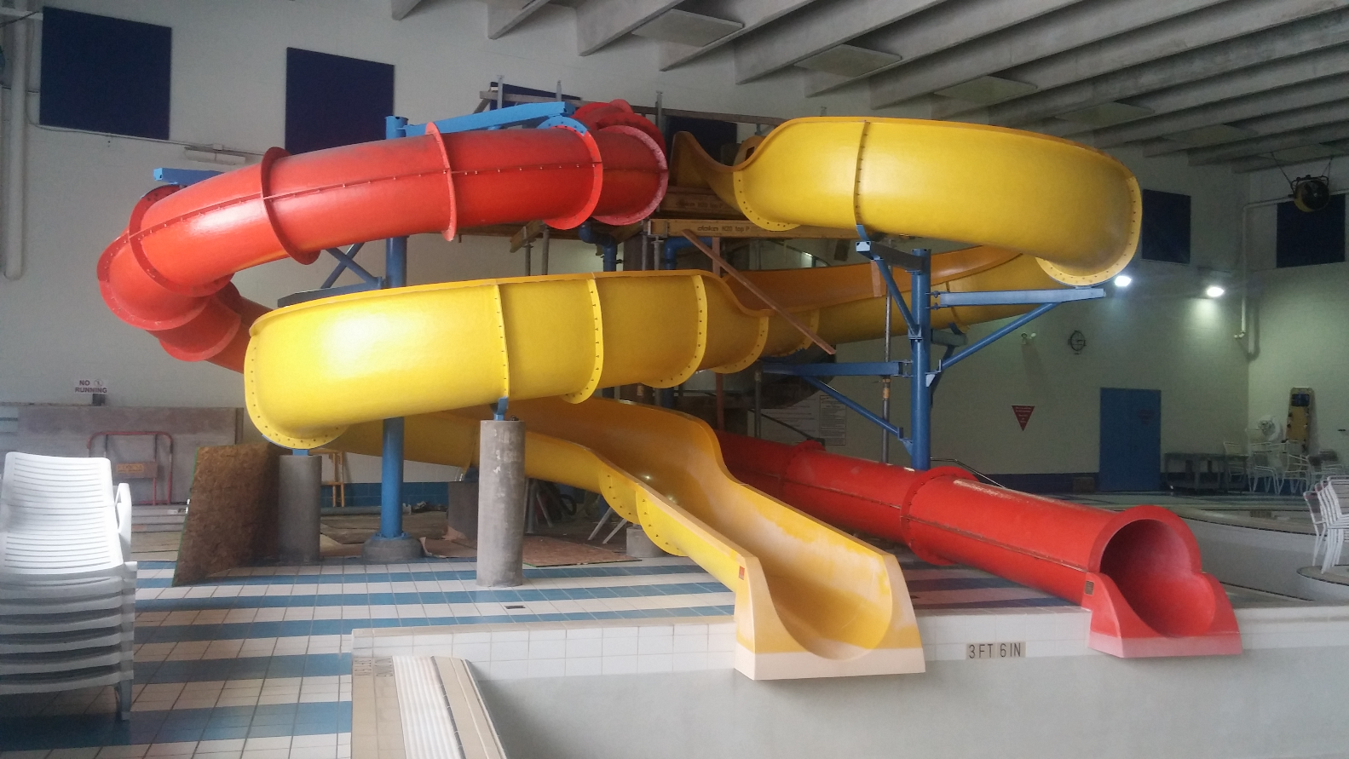
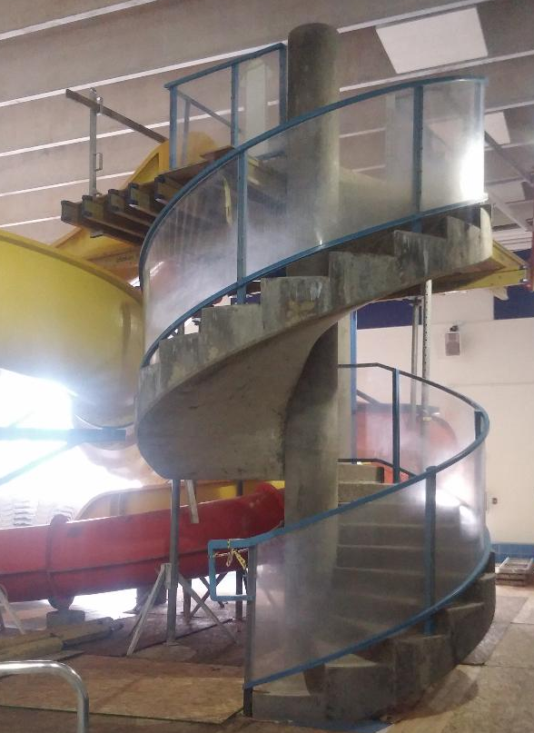
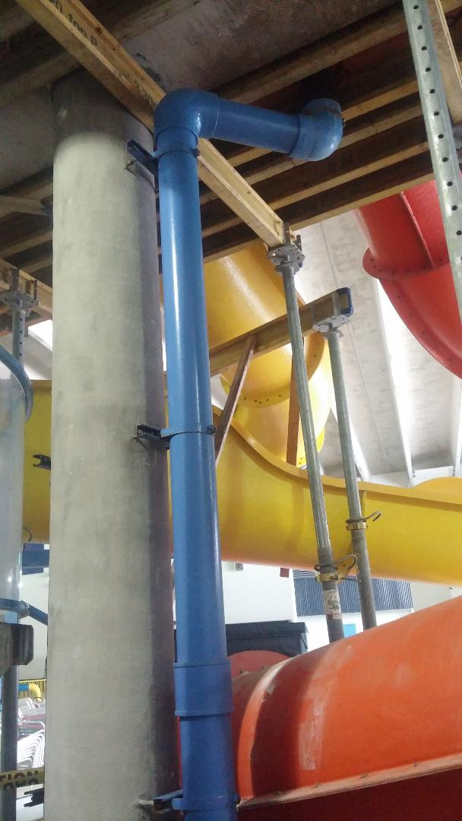

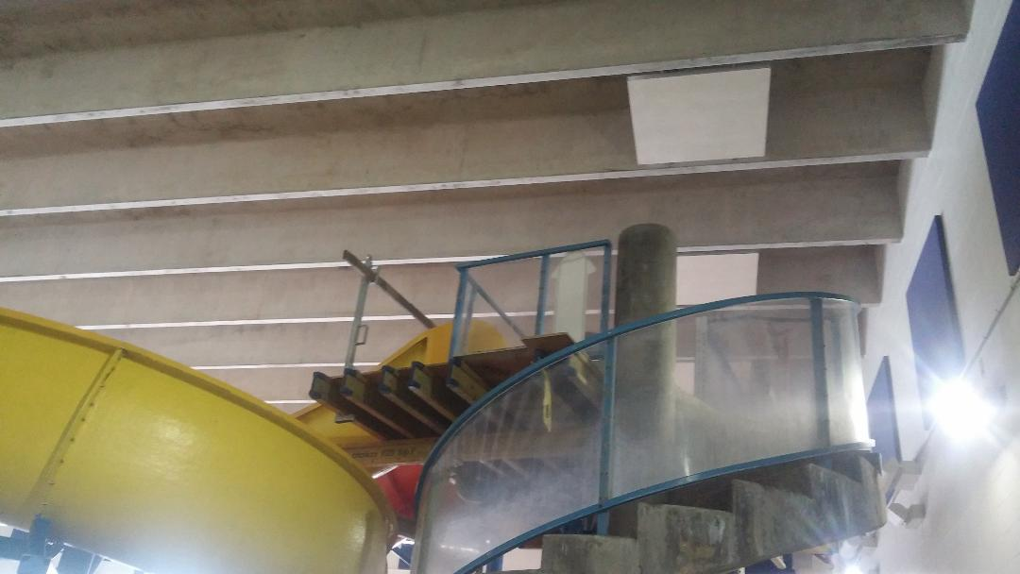

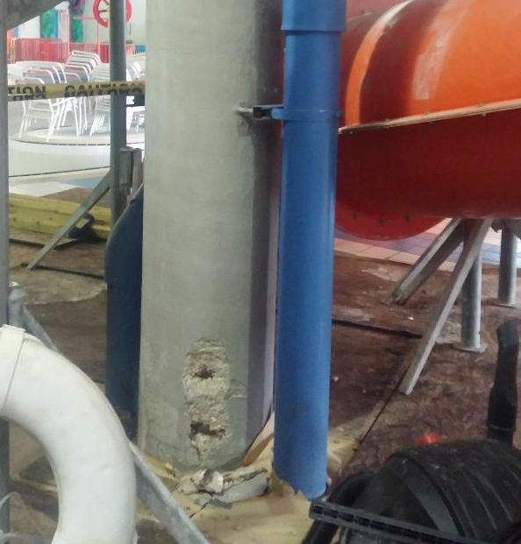

SECTION III – PRICE SHEET submit with bid

We propose to furnish all labor, materials, equipment, tools and services required to complete the work in accordance with the specifications and conditions contained herein in consideration of the sum or sums stated below.

Bidder certifies that all costs listed below are all-inclusive, not-to-exceed pricing for this project. There will be no change orders allowed for additional items such as, but not limited to, permits, mobilization, overtime, bidder omissions, dumping fees, or insurance.

Acknowledgement of addenda: _______; ________;

Total not-to-exceed price: $_____________________

SECTION IV – OFFER TO CONTRACT submit with bid

The undersigned has carefully checked the attached Bidding Schedule against the Contract Drawings and Specifications and other Contract Documents before preparing this Bid and accepts the said quantities to be substantially correct, both as to classification and amount, and as correctly listing the complete work to be done in accordance with the Contract Drawings, Specifications and other Contract Documents.

BID SECURITY
Accompanying this bid is a ________________ in the amount of five percent (5%) or ___________________ Dollars ($___________). The total amount of bid security is based on the total base bid of this proposal.

COMPLETION
If awarded a contract under this proposal, the undersigned agrees to start work at the site upon notice to proceed. The undersigned further agrees to complete the project by May 9, 2018.

LIQUIDATED DAMAGES
Liquidated damages of $500.00 per calendar day will be assessed for failure to meet any deadline, as noted in the Project Specifications.

BIDDER'S SIGNATURE: Complete the applicable paragraph below.

I certify, under penalty of perjury, that I have the legal authorization to bind the firm hereunder, and that our firm is not debarred from doing business under the Federal Excluded Parties List System (epls.gov).

I, the Contractor or Contractor’s legally authorized signer, further certify compliance with the City of Battle Creek Ordinance Chapter 214, Discrimination Prohibited. I further acknowledge and agree that the Contractor's violation of Chapter 214 shall be a material breach of this contract. In addition, Contractor acknowledges and agrees that it shall be liable for any costs or expenses incurred by the City in obtaining from other sources, the work and services to be rendered or performed or the goods or properties to be furnished or delivered to the City under the contract as a result of a material breach in the Contract for violations of Chapter 214.

(a) Corporation  The bidder is a corporation organized and existing under the State of _______________________, which operates under the legal name of __________________________, and the full names of its officers are as follows:  President: __________________________________  Secretary: __________________________________  Treasurer: __________________________________  Manager: __________________________________  (b) Co-Partnership  The bidder is a co-partnership consisting of individual partners whose full names are as follows:  _______________________ ______________________  ________________________ ______________________  ________________________ ______________________  ________________________ ______________________  (c) Individual  The bidder is an individual whose full name is __________________ and, if operating under a trade name, said trade name is _________________________________.  NAME: ________________________  ADDRESS: _____________________  CITY & STATE: __________________ | THIS BID OFFERED BY:  SIGNATURE:  NAME:  TITLE:  PHONE:  FAX:

SECTION V - CONTRACTOR'S BID FORMS

THESE FORMS MUST BE RETURNED WITH THE BID

TABLE OF CONTENTS

CONTRACTOR'S BID BOND (if bid is over $50,000)

CORPORATION CERTIFICATE

SUBCONTRACTOR AND DBE FORM

STATEMENT OF EXPERIENCE OF BIDDERS

CONTRACTOR'S BID BOND if bid is over $50,000

KNOW ALL MEN BY THESE PRESENTS, That we, , (hereinafter called the "Principal"), and (hereinafter called the "Principal"), and hereinafter called the "Surety"), a corporation chartered and existing under the laws of the State of , with its principal offices in the City of and authorized to do business in the State of Michigan, are held and firmly bound unto the City of Battle Creek (hereinafter called the "Owner"), in the full and just sum of Dollars ($ ) good and lawful money of the United States of America, to be paid upon demand of the Owner, to which payment well and truly to be made, the Principal and Surety bind themselves, their heirs, executors, administrators, and assigns, jointly and severally and firmly by these presents.

WHEREAS, the Principal is about to submit, or has submitted to the Owner, a proposal for furnishing all labor, materials, equipment and incidentals necessary to complete this contract.

WHEREAS, the Principal desires to file this bond in accordance with law, in lieu of a certified bidder's check otherwise required to accompany this Proposal.

NOW, THEREFORE: The conditions of this obligation are such that if the Proposal be accepted, the Principal shall, within ten (10) days after the date of receipt of a written notice of award of contract, execute a contract in accordance with the Proposal and upon the terms, conditions and price(s) set forth therein, of the form and manner required by the Owner, and execute a sufficient and satisfactory contract performance bond payable to the Owner, and in an amount of One Hundred Percent (100%) of the total contract price in the form and with security satisfactory to said Owner, then this obligation to be void; otherwise to be and remain in full force and virtue in law; and the Surety shall, upon failure of the Principal to comply with any or all of the foregoing requirements within the time specified above, immediately pay to the aforesaid Owner, upon demand, the amount hereof in good and lawful money of the United States of America, not as a penalty but as liquidated damages.

IN TESTIMONY THEREOF, the Principal and Surety have caused these presents to be duly signed and sealed this day of , 20___.

Principal

By:
(Seal)

Surety

By:
(Seal)

Countersigned:

CERTIFICATE TO BE EXECUTED

IF

CONTRACTOR IS A CORPORATION

I, , certify that I am the of the Corporation named as Contractor hereinabove; that who signed the foregoing Agreement on behalf of the Contractor was then the of said Corporation; that said Agreement was duly signed for and in behalf of said Corporation by authority of its governing body and is within the scope of its corporate powers.

(Corporate Seal)

STATEMENT OF EXPERIENCE OF BIDDER Submit with bid
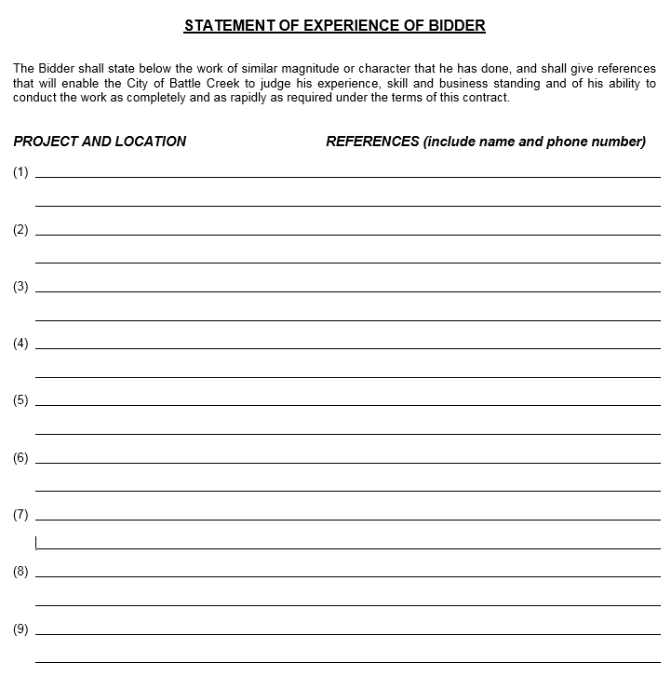

SECTION VI - DISADVANTAGED BUSINESS (DBE) FORM submit with bid

I. YOUR FIRM’S BACKGROUND:

Is your firm an MBE (at least 51% minority ownership)? _____YES _____NO

Is your firm a WBE (at least 51% woman ownership)? _____YES _____NO

Are you subcontracting any part of this project? _____YES _____NO

II. SUBCONTRACTING INFORMATION: If subcontracting any part of the project, the bidder/contractor expressly agrees that:

(1) If awarded a contract as a result of this bid, the major subcontractors used in the prosecution of the work will be those listed below, and
(2) The following list includes all subcontractors who will perform work representing approximately five percent (5%) or more of the Total Base Bid.
- The Bidder represents that the subcontractors listed below are financially responsible and are qualified to do the work required.

SUBCONTRACTOR NAME | City/State | Trade or Commodity | MBE | WBE | Approximate dollar value
________________________________________ |  | ______________ | Y / N | Y / N | $____________________
________________________________________ |  | ______________ | Y / N | Y / N | $____________________
________________________________________ |  | ______________ | Y / N | Y / N | $____________________
________________________________________ |  | ______________ | Y / N | Y / N | $____________________
________________________________________ |  | ______________ | Y / N | Y / N | $____________________
________________________________________ |  | ______________ | Y / N | Y / N | $____________________
________________________________________ |  | ______________ | Y / N | Y / N | $____________________
________________________________________ |  | ______________ | Y / N | Y / N | $____________________

III. DBE RECRUITMENT ACTIVITY LOG: List the MBE’s and WBE’s that were approached about being a subcontractor for this job, but who are NOT listed above as a subcontractor.

NAME OF FIRM APPROACHED, BUT NOT USED ON THIS PROJECT | City/State | Trade or Commodity | MBE | WBE | Reason not used on this project
________________________________________ |  | ______________ | Y / N | Y / N | _______________________
________________________________________ |  | ______________ | Y / N | Y / N | _______________________
________________________________________ |  | ______________ | Y / N | Y / N | _______________________
________________________________________ |  | ______________ | Y / N | Y / N | _______________________

SECTION VII - CONTRACTOR'S CONTRACT FORMS

THESE FORMS WILL BE REQUIRED FOR AWARD

CONTRACT FORM

PERFORMANCE BOND

LABOR AND MATERIAL BOND

CONTRACT FORM
CONTRACT NO. 2018-061B

THIS AGREEMENT, made and entered into this day of _______, 2018, by and between hereinafter called the "Contractor" and the City of Battle Creek, hereinafter called the "Owner.”

WITNESSETH: In consideration for the mutual covenants hereinafter stated, the parties agree for themselves, their personal representatives, successors, assigns as follows:

I. The Contractor promises and agrees:

A. To furnish all materials, construction water, equipment, tools, dewatering devices, skill and labor of every description necessary or reasonable incidental to carrying forth and completing in good, firm, substantial and workmanlike manner, the work specified, in strict conformity with the true intent of the NOTICE TO BIDDERS, SPECIAL INSTRUCTIONS, GENERAL INSTRUCTIONS, PROPOSAL, SPECIAL CONDITIONS, GENERAL CONDITIONS, AGREEMENT, BONDS, GENERAL SPECIFICATIONS, and Project Specifications, and other contract documents and addenda thereto, which are hereby made a part hereof as fully and to the same effect as though they had been set forth at length herein.

B. To commence work under this contract on or before a date to be specified by the owner in a written Notice to Proceed and complete the project by the date specified in Proposal.

C. Requirements for a specific trade or contract will generally be described in that portion of the specifications or drawings related to that trade or contract. Such requirements may, however, be described in other sections of the Contract Documents. The Contractor will be held responsible for having carefully examined all drawings and read all requirements of the specifications and all Contract Documents to avoid omissions or duplications and to insure a complete job.

D. The Contractor must be fully informed about conditions relating to the construction of the project and the employment of labor thereon. Failure to do so will not relieve a successful bidder of his obligation to furnish all material and labor necessary to carry out the provisions of his contract.

E. Any claim by the Contractor of an inability to meet any requirement set forth in the Contract Documents, or that any requirement of these documents is impractical or unreasonable, will not be recognized, unless the claim was made at the time his proposal was submitted, and specific provision is made for such claim in the Agreement between Owner and Contractor (Proposal and Agreement).

F. NON-DISCRIMINATION CLAUSE: The bidder agrees not to discriminate against any employee or applicant for employment, to be employed in the performance of such contract with respect to hire tenure, terms, conditions or privileges, of employment, or any matter directly or indirectly related to employment because of his or her actual or perceived race, color, religion, national origin, sex, age, height, weight, marital status, physical or mental disability, family status, sexual orientation, or gender identity. Breach of this covenant may be regarded as a material breach of the contract as provided for in Act 220 and Act 453 of the Public Acts of 1976, as amended, entitled "Michigan Handicapper's Civil Rights Act" and/or the "Michigan Elliott Larson Civil Rights Act" and/or City of Battle Creek Chapter 214 "Discrimination Prohibited" Ordinance. The bidder further agrees to require similar provisions from any subcontractors, or suppliers. The bidder agrees to comply with the Executive Order 11246 of September 24, 1965, entitled "Equal Employment Opportunity," as amended by Executive Order 11375 of October 13, 1967, as supplemented in Department of Labor regulations (41 CFR, Chapter 60).

II. The Owner promises and agrees:

- To pay the Contractor for said work when completed in accordance with the provisions of these contract documents, and for the contract sum of:

dollars ($ ). Payment for work is subject to additions provided therein and for the authorized work complete in place and accepted by the Owner or its authorized representatives.

III. It is further understood and agreed between the parties hereto as follows:

A. The said work is to be done in accordance with the laws of the State of Michigan to the entire satisfaction and approval of the Owner or its duly authorized representatives.

B. The decision of said Owner's authorized representative upon any questions connected with the execution of this Agreement or any failure or delay in the prosecution of the work by said Contractor shall be final and conclusive.

C. If, at any time after the execution of the Agreement and the Bond for its faithful performance, the Owner shall deem the surety or sureties then upon said bond to be unsatisfactory or, if, for any reason said bond shall cease to be adequate security for the performance of the work, the Contractor shall, at his expense, within fifteen (15) calendar days after receipt of written notice from the Owner to do so, furnish an additional bond or bonds in such form and amount and with such surety or sureties as shall be satisfactory to the Owner. In such event, no further payment to the Contractor shall be deemed to be due under this Agreement until such new or additional security for the faithful performance of the work shall be furnished in a manner and form satisfactory to the Owner.

D. VENUE: Any party bringing a legal action or proceeding against any other party arising out of or relating to this Agreement or the transactions it contemplates shall bring the legal action or proceeding:

(i) in the United States District Court for the Western District of Michigan; or

(ii) in any court of the State of Michigan sitting in Calhoun County, if there is no federal subject matter jurisdiction.

E. GOVERNING LAW: This agreement shall be enforced under the laws of the State of Michigan. Contractor must comply with all applicable federal, state, county, and City laws, ordinances, and regulations. Contractor shall ensure payment of all taxes, licenses, permits, and other expenses of any nature associated with the provision of services herein. Contractor shall maintain in current status all Federal, State and Local licenses and permits required for the operation of the business conducted by the Contractor.

IN WITNESS WHEREOF, the said parties have hereunto set their hands and affixed their seals, the day and year first above written.

STATE OF MICHIGAN)
) ss
COUNTY OF CALHOUN)

In the Presence of:

Notary Public

CONTRACT FORM APPROVED BY:

City Attorney
SIGNED, SEALED, AND
EXECUTED BY CONTRACTOR:

I certify, under penalty of perjury, that I have the legal authorization to bind the firm hereunder, and that our firm is not debarred from doing business under the Federal Excluded Parties List System (epls.gov):

By:

Title:

SIGNED, SEALED, & EXECUTED
BY CITY OF BATTLE CREEK

City Manager

PERFORMANCE BOND if bid is over $50,000

KNOW ALL MEN BY THESE PRESENTS, that , as Principal, and , as Surety, are held and firmly bound unto the City of Battle Creek in the full and just sum of Dollars ($ ) lawful money of the United States of America for the payment of which sum of money well and truly to be made, we bind ourselves, heirs, executors, administrators, successors and assigns, jointly and severally, firmly by these presents.

WHEREAS, the Principal has entered into a certain written contract dated the day of , 20 for the complete, as described in the foregoing Proposal and Agreement.

NOW THE CONDITIONS OF THIS OBLIGATION ARE SUCH, that if the said Principal shall in all respects well and truly keep and perform the said contract, and shall pay all sums of money due or to become due, for any labor, materials, apparatus, fixtures or equipment furnished for the purpose of constructing the work provided in said contract, and shall defend, indemnify and save harmless said City of Battle Creek against any and all liens, encumbrances, damages, claims, demands, expenses, costs and charges of every kind except as otherwise provided in said specifications and other Contract Documents arising out of or in relation to the performance of said work and the provisions of said contract, and shall remove and replace any defects in workmanship or materials which may be apparent or may develop within a period of one (1) year from the date of final acceptance, then this obligation shall be null and void; otherwise it shall remain in full force and effect.

And the said Surety, for value received, hereby stipulates and agreed that no change, extension of time, alteration or addition to the terms of the contract or to work to be performed thereunder or the specifications accompanying the same shall in any wise affect its obligation on this bond, and it does hereby waive notice of any such change, extension of time, alteration or addition to the terms of the Agreement or to the work or to the specifications.

IN WITNESS WHEREOF, we have hereunto set our hands and seals this day of , 20__.

PRINCIPAL ATTEST:
Principal Business Name  Address  City, State, Zip | Principal Secretary Signature & Seal  Principal Secretary Printed Name  Witness of Principal
SURETY ATTEST:
Surety Business Name  Address  City, State, Zip | BY:  Attorney-in-Fact Signature & Seal  Attorney-in-Fact Printed Name
LABOR AND MATERIALS BOND if bid is over $50,000

KNOW ALL MEN BY THESE PRESENT, that we, the undersigned, ____________________, hereinafter called the "Principal,” and _________________________, a corporation organized and existing under the laws of the State of ______________, having its principal office at ________________________, hereinafter called the "Surety,” are held and firmly bound unto the City of Battle Creek, hereinafter called the "Owner,” for use of any and every person, co-partnership, association or corporation interested in the full and just sum of ___________________________Dollars ($__________), lawful money of the United States of America, to be paid to the said obligees or its or their assigns, to which payment well and truly to be made we bind ourselves, our heirs, executors, administrators, successors and assigns, jointly and severally, firmly by these presents. Sealed with our respective seals and dated this ____ day of ____________, 20___.

WHEREAS, the above bounded _________________________, Principal, has entered into a contract with the City of Battle Creek.

Dated the ______ day of ________________, 20___, for the ____________________________.

NOW, THEREFORE, THE CONDITION OF THIS CONDITION IS SUCH, that if the above bounded Principal shall and will promptly pay or cause to be paid all sums of money which may be due any person, co-partnership, association or corporation for all material furnished and labor supplied or performed in the prosecution of the work, whether or not the said material or labor enter into and become component parts of the work or improvement contemplated, then this obligation to be void; otherwise to remain in full force and effect.

The Principal and Surety further jointly and severally agree with the obligee herein that every person, co-partnership, association or corporation who, whether as subcontractor or otherwise, has furnished material or supplied or performed labor in the prosecution of the work as above provided and who has not been paid therefore may sue in assumption on this bond in the name of the Owner for his, their, or its use, prosecute the same to final judgment for such sum or sums as may be justly due him, them, or it, and have execution thereon, provided, however, that the Owner shall not be liable for payment of any costs or expenses of any such suit.

IT IS FURTHER AGREED, that any alterations which may be made in the terms of the contract or in the work to be done or materials to be furnished or labor to be supplied or performed under it or the giving by the Owner or any extension of time for the performance of the contract or any other forbearance on the part of either the Owner or the Principal to the other, shall not in any way release the Principal and Surety or Sureties or either or any of them their heirs, executors, administrators, successors or assigns, from their liability hereunder, notice to the Surety or Sureties of any such alteration, extension or forbearance being hereby waived.

IN WITNESS WHEREOF, the said Principal and Surety have duly executed this bond under the seal and day and year first above written.

ATTEST:
Principal

BY:
(Seal)

Surety

ATTEST BY:
Attorney-in-Fact

(SEAL)

SECTION VIII – PREVAILING WAGES If bid is over $50,000

General Decision Number: MI180079 01/05/2018 MI79

Superseded General Decision Number: MI20170079

State: Michigan

Construction Type: Building

County: Calhoun County in Michigan.

BUILDING CONSTRUCTION PROJECTS (does not include single family
homes or apartments up to and including 4 stories).

Note: Under Executive Order (EO) 13658, an hourly minimum wageof $10.35 for calendar year 2018 applies to all contracts subject to the Davis-Bacon Act for which the contract is awarded (and any solicitation was issued) on or after January 1, 2015.
If this contract is covered by the EO, the contractor must pay all workers in any classification listed on this wage determination at least $10.35 per hour (or the applicable wage rate listed on this wage determination, if it is higher) for all hours spent performing on the contract in calendar year 2018. The EO minimum wage rate will be adjusted annually. Please note that this EO applies to the above-mentioned types
of contracts entered into by the federal government that are subject to the Davis-Bacon Act itself, but it does not apply to contracts subject only to the Davis-Bacon Related Acts, including those set forth at 29 CFR 5.1(a)(2)-(60). Additional
information on contractor requirements and worker protections
under the EO is available at www.dol.gov/whd/govcontracts.

Modification Number Publication Date
0 01/05/2018

ASBE0047-002 07/01/2016

Rates Fringes

ASBESTOS WORKER/HEAT & FROST
INSULATOR........................$ 30.22 16.48
----------------------------------------------------------------
BOIL0169-001 01/01/2016

Rates Fringes

BOILERMAKER......................$ 33.88 30.39
----------------------------------------------------------------
BRMI0009-031 08/01/2016

Rates Fringes

BRICKLAYER.......................$ 27.69 16.93
TILE FINISHER....................$ 21.79 11.04
TILE SETTER......................$ 23.04 12.39
----------------------------------------------------------------
CARP0525-003 06/01/2017

Rates Fringes

CARPENTER, Includes
Acoustical Ceiling
Installation, Drywall
Hanging, and Form Work...........$ 22.15 19.30
----------------------------------------------------------------
CARP1102-001 06/01/2017

Rates Fringes

MILLWRIGHT.......................$ 25.24 24.54
----------------------------------------------------------------
ELEC0445-011 05/29/2017

Rates Fringes

ELECTRICIAN......................$ 31.00 19.38
----------------------------------------------------------------
ENGI0324-002 06/01/2017

Rates Fringes

OPERATOR: Power Equipment
GROUP 1.....................$ 37.58 23.30
GROUP 2.....................$ 34.28 23.30
GROUP 3.....................$ 31.63 23.30
GROUP 4.....................$ 29.92 23.30
GROUP 5.....................$ 29.92 23.30
GROUP 6.....................$ 24.06 23.30
GROUP 7.....................$ 21.58 23.30

FOOTNOTES:

Crane operator with main boom and jib 300' or longer: $1.50 per hour above the group 1 rate.
Crane operator with main boom and jib 400' or longer: $3.00
per hour above the group 1 rate.

PAID HOLIDAYS: New Year's Day, Memorial Day, Fourth of July, Labor Day, Thanksgiving Day and Christmas Day.

POWER EQUIPMENT OPERATOR CLASSIFICATIONS

GROUP 1: Crane operator with main boom and jib 400', 300', or 220' or longer.

GROUP 2: Crane operator with main boom and jib 140' or longer, tower crane, gantry crane, whirley derrick

GROUP 3: Backhoe/Excavator/Trackhoe; Crane; Concrete Pump; Grader/Blade; Highlift; Hoist; Loader; Roller; Scraper; Stiff Leg Derrick; Trencher

GROUP 4: Bobcat/Skid Loader; Broom/Sweeper; Fork Truck (over 20' lift)

GROUP 5: Boom Truck (non-swinging)

GROUP 6: Fork Truck (20' lift and under for masonry work)

GROUP 7: Oiler

----------------------------------------------------------------
* IRON0340-002 06/19/2017

Rates Fringes

IRONWORKER, REINFORCING AND
STRUCTURAL.......................$ 24.43 24.67
----------------------------------------------------------------
LABO0355-022 06/01/2016

Rates Fringes

LABORER
Common or General; Grade Checker; Mason Tender - Brick; Mason Tender -
Cement/Concrete;
Sandblaster.................$ 20.09 12.85
Pipelayer...................$ 20.34 12.85
----------------------------------------------------------------
PAIN0312-002 06/01/2017

Rates Fringes

PAINTER: Brush and Roller.......$ 23.72 12.52
PAINTER: Drywall
Finishing/Taping.................$ 23.72 12.52
PAINTER: Spray..................$ 24.92 12.52
----------------------------------------------------------------
PLAS0016-007 04/01/2014

Rates Fringes

PLASTERER........................$ 21.18 12.43
----------------------------------------------------------------
PLUM0333-006 06/01/2017

Rates Fringes

PIPEFITTER, Includes HVAC
Pipe and Unit Installation.......$ 35.89 21.13
PLUMBER, Excludes HVAC Pipe
and Unit Installation............$ 35.89 21.13

FOOTNOTE:

Paid Holidays: Memorial Day, Independence Day and Labor Day, if the employee works the work day preceding and following the holiday unless proven illness or injury prevents the employee from working.
----------------------------------------------------------------
ROOF0070-002 06/01/2017

Rates Fringes

ROOFER...........................$ 27.80 13.79
----------------------------------------------------------------
SFMI0669-001 04/01/2017

Rates Fringes

SPRINKLER FITTER (Fire
Sprinklers)......................$ 34.87 15.84
----------------------------------------------------------------
SHEE0007-004 07/01/2017

Rates Fringes

SHEET METAL WORKER (Including HVAC Duct Installation;
Excluding HVAC System
Installation)....................$ 31.26 19.71
----------------------------------------------------------------
SUMI2011-004 02/01/2011

Rates Fringes

CEMENT MASON/CONCRETE FINISHER...$ 25.23 1.80

IRONWORKER, ORNAMENTAL...........$ 18.48 7.93

LABORER: Landscape &
Irrigation.......................$ 10.38 0.50

OPERATOR: Bulldozer.............$ 19.68 6.64

OPERATOR: Compactor.............$ 17.68 6.70

OPERATOR: Tractor...............$ 19.10 8.48

TRUCK DRIVER, Includes Dump
and Tandem Truck.................$ 17.26 11.42

TRUCK DRIVER: Lowboy Truck......$ 14.50 0.44

TRUCK DRIVER: Tractor Haul
Truck............................$ 13.57 1.18
----------------------------------------------------------------

WELDERS - Receive rate prescribed for craft performing
operation to which welding is incidental.

================================================================

Note: Executive Order (EO) 13706, Establishing Paid Sick Leave for Federal Contractors applies to all contracts subject to the Davis-Bacon Act for which the contract is awarded (and any solicitation was issued) on or after January 1, 2017. If this
contract is covered by the EO, the contractor must provide employees with 1 hour of paid sick leave for every 30 hours they work, up to 56 hours of paid sick leave each year.Employees must be permitted to use paid sick leave for their own illness, injury or other health-related needs, including preventive care; to assist a family member (or person who is like family to the employee) who is ill, injured, or has other
health-related needs, including preventive care; or for reasons resulting from, or to assist a family member (or person who is like family to the employee) who is a victim of, domestic violence, sexual assault, or stalking. Additional information on contractor requirements and worker protections under the EO is available at www.dol.gov/whd/govcontracts.

Unlisted classifications needed for work not included within the scope of the classifications listed may be added after award only as provided in the labor standards contract clauses (29CFR 5.5 (a) (1) (ii)).

----------------------------------------------------------------

The body of each wage determination lists the classification and wage rates that have been found to be prevailing for the cited type(s) of construction in the area covered by the wage determination. The classifications are listed in alphabetical
order of "identifiers" that indicate whether the particular rate is a union rate (current union negotiated rate for local), a survey rate (weighted average rate) or a union average rate (weighted union average rate).

Union Rate Identifiers

A four letter classification abbreviation identifier enclosed in dotted lines beginning with characters other than "SU" or "UAVG" denotes that the union classification and rate were prevailing for that classification in the survey. Example: PLUM0198-005 07/01/2014. PLUM is an abbreviation identifier of the union which prevailed in the survey for this classification, which in this example would be Plumbers. 0198 indicates the local union number or district council number where applicable, i.e., Plumbers Local 0198. The next number, 005 in the example, is an internal number used in processing the wage determination. 07/01/2014 is the effective date of the most current negotiated rate, which in this example is July 1,2014.

Union prevailing wage rates are updated to reflect all rate changes in the collective bargaining agreement (CBA) governing this classification and rate.

Survey Rate Identifiers

Classifications listed under the "SU" identifier indicate that no one rate prevailed for this classification in the survey and the published rate is derived by computing a weighted average rate based on all the rates reported in the survey for that classification. As this weighted average rate includes all rates reported in the survey, it may include both union and non-union rates. Example: SULA2012-007 5/13/2014. SU indicates the rates are survey rates based on a weighted average
calculation of rates and are not majority rates. LA indicates the State of Louisiana. 2012 is the year of survey on which these classifications and rates are based. The next number, 007 in the example, is an internal number used in producing the
wage determination. 5/13/2014 indicates the survey completion date for the classifications and rates under that identifier. Survey wage rates are not updated and remain in effect until a new survey is conducted.

Union Average Rate Identifiers

Classification(s) listed under the UAVG identifier indicate that no single majority rate prevailed for those classifications; however, 100% of the data reported for the
classifications was union data. EXAMPLE: UAVG-OH-0010 08/29/2014. UAVG indicates that the rate is a weighted union average rate. OH indicates the state. The next number, 0010 in the example, is an internal number used in producing the wage determination. 08/29/2014 indicates the survey completion date for the classifications and rates under that identifier.

A UAVG rate will be updated once a year, usually in January of each year, to reflect a weighted average of the current negotiated/CBA rate of the union locals from which the rate is based.
----------------------------------------------------------------
WAGE DETERMINATION APPEALS PROCESS

1.) Has there been an initial decision in the matter? This can be:

* an existing published wage determination
* a survey underlying a wage determination
* a Wage and Hour Division letter setting forth a position on
a wage determination matter
* a conformance (additional classification and rate) ruling

On survey related matters, initial contact, including requests for summaries of surveys, should be with the Wage and Hour Regional Office for the area in which the survey was conducted because those Regional Offices have responsibility for the
Davis-Bacon survey program. If the response from this initial contact is not satisfactory, then the process described in 2.)
and 3.) should be followed.

With regard to any other matter not yet ripe for the formal
process described here, initial contact should be with the
Branch of Construction Wage Determinations. Write to:

Branch of Construction Wage Determinations
Wage and Hour Division
U.S. Department of Labor
200 Constitution Avenue, N.W.
Washington, DC 20210

2.) If the answer to the question in 1.) is yes, then an interested party (those affected by the action) can request review and reconsideration from the Wage and Hour Administrator (See 29 CFR Part 1.8 and 29 CFR Part 7). Write to:

Wage and Hour Administrator
U.S. Department of Labor
200 Constitution Avenue, N.W.
Washington, DC 20210

The request should be accompanied by a full statement of the interested party's position and by any information (wage payment data, project description, area practice material, etc.) that the requestor considers relevant to the issue.

3.) If the decision of the Administrator is not favorable, an interested party may appeal directly to the Administrative Review Board (formerly the Wage Appeals Board). Write to:

Administrative Review Board
U.S. Department of Labor
200 Constitution Avenue, N.W.
Washington, DC 20210

4.) All decisions by the Administrative Review Board are final.

================================================================

END OF GENERAL DECISION

