
Pierce County

Board of Commissioners

REQUEST FOR PROPOSAL
TIMBER HARVESTING AND SALE
FOUR PARCELS TOTALING +/- 32.50 ACRES IN BLACKSHEAR, GEORGIA

Prepared by:

Pierce County Board of Commissioners
312 Nichols Street
Blackshear, GA 31516
(912) 449-2022

- Request for Proposal

The Pierce County Board of Commissioners (County) are seeking proposals from qualified and appropriately licensed contractors to harvest and sell timber for +/- 32.50 acres of property located in the City of Blackshear and the unincorporated area of Pierce County. The County intends to enter into contract with the selected Respondent within thirty days of a Notice of Award. Should there be reasons why the contract cannot be awarded within the specified period, the time may be extended by mutual agreement between the County and the selected Respondent.

- Property Description

The four parcels designated for this RFP are located on County-owned property. (See aerial photos in Exhibit A)

- Non-Mandatory Pre-Submittal Meeting and Site Inspection

A non-mandatory pre-submittal meeting will be held on November 13, 2019 at 10:00 AM EST in the Board of Commissioners Conference Room located at 312 Nichols Street, Blackshear, GA 31516. A site inspection will be conducted immediately following this meeting. Any Contractor intending to attend this meeting must have their representatives present by the start of the meeting at 10:00 AM. Contractors who attend the meeting or are unable to attend, but wish to visit the sites may do so by calling Mamie Jackson at (912) 449-2022 to set up an appointment at least 48 hours in advance of the proposed site visit.

- Scope of Work
  - Contractor will provide all labor, materials and equipment necessary to harvest and sell timber on +/- 32.50 acres of property as depicted in Exhibit A of this RFP. All timber will be expected to be harvested and sold for hardwood, sawn lumber, pulp wood, chip wood, and any other marketable forms.
  - Additional Scope of Work details can be found in Exhibit C.

- Additional Requirements
  - Bonds: Contractor will be required to provide a Payment Bond and Performance Bond no later than seven (7) days after receiving Notice of Contract Award. Both the Payment Bond and Performance Bond will be in the amount of one hundred percent (100%) of the Contract price.
  - Minimum Insurance Coverage: Contractor will be required to maintain in force a policy or policies of insurance written by one or more responsible insurance carriers licensed to do business in the State of Georgia that shall insure against liability for injury to and/or death of and/or damage to property of any person or persons, with policy limits of not less than the following: $1,000,000.00 combined single limit for injury to or death of any number of persons or for damage to property of others arising out of any one occurrence and $1,000,000.00 combined aggregate and umbrella coverage for any and all actions of Contractor based on the Operations to be provided and shall name, as additional insured and loss payee, the County.
  - Worker’s Compensation: Contractor will be required to provide proof of worker’s compensation insurance in coverage amounts required by the State of Georgia for the Operations to be provided that covers Contractor’s employees for any on-the-job injuries. Contractor must be willing and able to provide evidence of insurance not later than seven (7) days after receiving Notice of Contract Award.
  - Hold Harmless and Indemnification: Contractor agrees to indemnify, defend, and hold the County, its officers, employees, agents and assigns harmless from any judgements, liabilities and associated costs for bodily injury, death or damage to property resulting, in whole or part, from any and all acts or omissions of Contractor, its officers, employees, agents and assigns.

- Submittal Requirements: Respondents are encouraged to have attended the optional pre-submittal meeting and site inspection as described in paragraph III.
  - Respondent submittals will include:
    - Respondent qualifications and experience to complete the project.
    - Letter confirming current bonding capabilities.
    - Copies of all current licenses required to complete the work.
    - Proposed work plan, level of effort, and timeline required to complete the project.
    - Identification of any work to be performed by sub-contractors. Include names of sub-contractors and copies of their current licenses.
    - Complete and signed “County RFP Submittal 19-10 Form”.
  - Number of submittal copies: Five (5)

- RFP submittal delivery method: Registered, certified mail, overnight delivery service (UPS/FedEx), or hand delivery in a seal envelop marked “Timber Harvest & Sales”. Submittals using facsimile transmission and/or bids that are not sealed as described above will not be accepted.

- SUBMISSION DEADLINE: November 27, 2019, 10:00 AM EDT. Any submittal received after the date and time specified herein shall not be considered.

- Submit documents to:

Pierce County Board of Commissioner
Attn: Mamie Jackson
P.O. Box 679
312 Nichols Street
Blackshear, GA 31516

- Questions/clarifications: Respondents may submit questions or requests for clarification up to the submission deadline. Answers to all questions will be emailed to all other contractors who have submitted a bid or have attended the optional pre-submittal meeting and site inspection that have provided their appropriate contact information.

Email: mamie.jackson@piercecountyga.gov
Phone: (912) 449-2022
Fax: (912) 449-2024

- Evaluation Criteria:
  - The following evaluation criteria will be used to select the successful Respondent:
    - Submittal details and completeness of information provided
    - Proposed plan and level of effort required to complete Project
    - Timber harvest & sale valuations
    - Complete estimated harvesting costs and revenues returned to the county based on current market rates

- Contractor Selection:
The County reserves the right to reject any or all proposals received, request additional information, use the information in any matter deemed to be in the best interest of the County, utilize outside assistance in evaluating proposals, waive informalities, and undertake the described work in a manner other than that set forth herein as applicable law allows.

- Additional Information:
  - This RFP is not intended as a formal offering for the award of a contract or for participation in any future solicitation.
  - All submissions shall become the property of the County and shall not be returned. Upon execution of a binding contract, all submission shall become a matter of public record and regarded as public records except for those parts of each submission defined by Respondent as business or trade secrets provided that said parts are submitted in a separate, sealed envelope and clearly marked as “trade secret” or “proprietary”.
  - The County shall not be liable for any costs incurred by any respondent in the preparation, submittal, presentation, or revision of its submission.
Pierce County Board of Commissioners
Request for Proposal: Timber Harvesting & Sales
(include in RFP Submittal Package)

Project: Harvesting & Sale of Timber of +/- 32.50 acres of property
Property locations: Pierce County (as depicted in Exhibit 1)
Blackshear, Georgia 31516

Submitting Firm:
Address:
Email: Phone:

County’s Projected Revenue from Timber Sales: $
Price to Cut Timber: $ ____ __________
Estimated revenues after expenses to be paid to County: $
Estimated Completion Date: _________________________________

Authorize Signature: Date:

Firm Pricing
Submitted bid and projected timber harvesting & sales are firm through (minimum 60 days):

Date:
EXHIBIT 1:
Four Parcels, +/- 32.50 acres

Parcel #034A117 Ware Street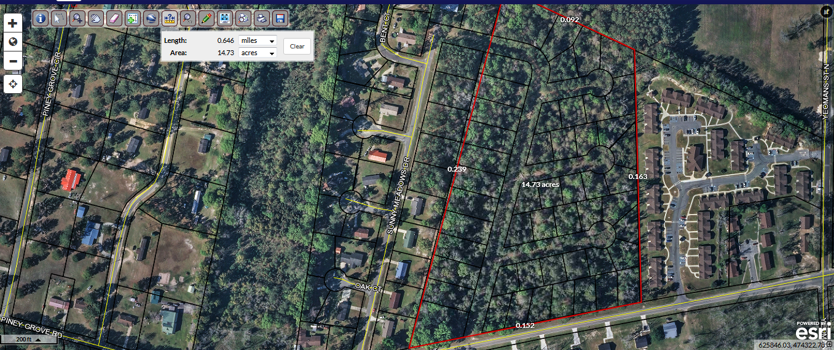
Parcel #034A046 Yeomans Street
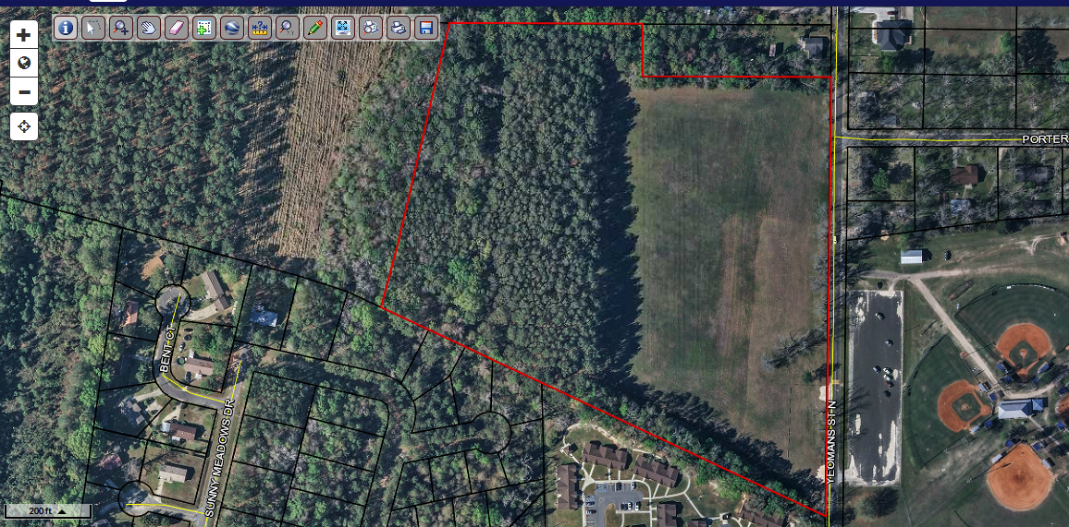

Parcel #045033 New School Road (County Farm Road)
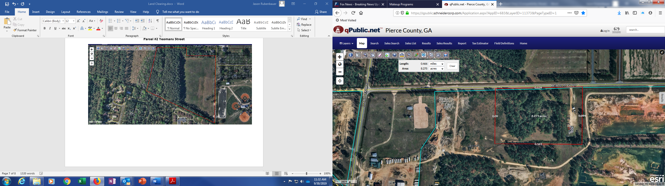
Parcel #049065 St. Johns Church Road
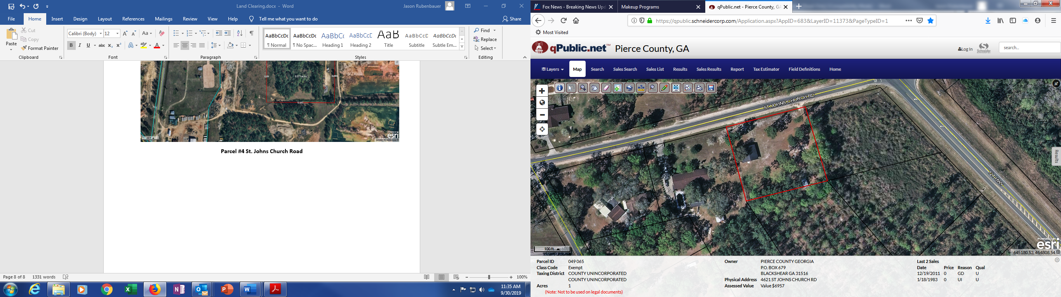

EXHIBIT #2

SCOPE OF WORK DETAILS

- TIMBER AND LAND PRODUCTION REVENUES
  - All timber and other products of the property that can be sold shall be. All proceeds from the sale of timber, pulp wood, chip materials, and all other available uses shall be paid to the County.

- PROJECT CONDITIONS
  - Traffic: Minimize interference with adjoining roads, streets, walks and other adjacent or used facilities during site-clearing operations.
    - Do not close or obstruct streets, or other adjacent occupied or used facilities without permission from Owner and authorities having jurisdiction.
    - Provide alternate routes around closed or obstructed traffic ways if required by Owner or authorities having jurisdiction.
    - Utility Locator Service: Notify utility locator service for area where Project is located before site clearing.
    - Do not commence site clearing operations until temporary erosion and sedimentation control measures are in place.
    - Communication with the City of Blackshear Public Works will be required for water and sewer services located on Parcel #034A117 and Parcel #034A046. The point of contact for Blackshear Public Works is Wallace Tomlinson (912) 590-5769

- PREPARATION
  - Protect and maintain benchmarks and survey control points from disturbance during construction.
    - Protect existing site improvements to remain free from damage during clearing operations.
    - Restore damaged improvements to their original condition, as acceptable to Owner.

- TIMBER HARVESTING
  - Timber will be sold on a “lump sum” basis and all bids should set forth the price the bidder is offering for each lump sum of merchantable timber located within the timber sales area.
  - All timber harvesting will be completed in accordance with a timber harvest agreement which contains industry standard provisions. If the successful contractor is unable or unwilling to enter into a timer harvest agreement, with terms suitable to the COUNTY, the COUNTY shall have the right to reject the bid.

