Request for Written Quotes

Forklift (Pre-owned)

Solicitation Number | Q1821
Due Date | February 15, 2018
Due Time | 11:00 a.m. eastern standard time
Deliver Responses to: |   Knoxville’s Community Development Corporation  Procurement Division  901 N. Broadway  Knoxville, TN 37917  Note: Procurement is in a separate building behind the main office building
Electronic Copies: | Electronic copies are available on KCDC’s webpage or by email at purchasinginfo@kcdc.org.
May responses be emailed to KCDC | ☒ Yes ☐ No  Paper copies must also be provided, if the solicitation so indicates.
Solicitation Meeting | ☐ Yes ☒ No
Solicitation Meeting is Mandatory | ☐ Yes ☒ No
Solicitation Meeting Date | Not applicable
Solicitation Meeting Time | Not applicable
Solicitation Meeting Location | Not applicable
Questions About This Solicitation | Submit questions to purchasinginfo@kcdc.org

Check KCDC’s webpage for addenda and changes before submitting your response

General Information

1. BACKGROUND AND INTENT

- Knoxville's Community Development Corporation (KCDC) is the public housing and redevelopment agency for the City of Knoxville and for Knox County in Tennessee. KCDC’s affordable housing property portfolio includes 20 sites with approximately 3,525 dwelling units. KCDC also oversees approximately 3958 Section 8 Vouchers, 82 Moderate Rehabilitation units and 20 Redevelopment areas. Several of the properties have transformed to the Project Based Rental Assistance program (PBRA) and KCDC is the management company for those sites. The properties for which KCDC is the management company include Five Points 1, LP; Lonsdale Homes, LP; Northridge Crossing, LP and The Vista at Summit Hill, LP.

b. KCDC desires to purchase one pre-owned forklift same as or equal to:

Brand/Model | Toyota Model 8FGU18 Forklift
Year | 2008 or newer
Type | LP
Capacity | 3,500 lbs.
Tire Type | Pneumatic (new)
Forks | 42 inch
Side Shifter | Yes
Mast Maximum Fork Height | 189
Power Source | Propane
Hours of Use | Not greater than 5,500
Warranty | 30 days

c. KCDC desires to trade its existing forklift. This forklift is a:

Brand/Model/Serial # | Nissan MCPL01A15LV/CPL01-9N1947
Year | 2005 (KCDC believes the model year to be correct but vendor will need to verify)
Type | LP
Capacity | 4,750 lbs.
Power Source | Propane
Hours of Use | 6,238

Pictures of the existing forklift are on Attachment A.

2. CHANGES AFTER AWARD
It is possible that after award KCDC will need to revise the service needs or requirements specified in this document. KCDC reserves the right to make such changes after consultation with the supplier. Should additional costs arise, the supplier must document increased costs. KCDC reserves the right to accept and negotiate these charges.

3. EVALUATION
KCDC will arrive at the “lowest and best” solution for the final award. This may not entail simply awarding to the supplier quoting the lowest cost. All responses are subject to a determination of “responsive” and “responsible” prior to award. KCDC is the sole judge as to supplier “responsiveness” and “responsibility.” KCDC reserves the right to request additional information to assist in the evaluation process. This includes references and business capacity information.

4. GENERAL INSTRUCTIONS
KCDC does not insert “General Instructions to Suppliers” in solicitation documents. These instructions are at www.kcdc.org. Click on “Procurement” and the link to the instructions. The supplier’s submittal means acceptance of the terms and conditions set forth in KCDC’s “General Instructions to Suppliers.”

5. INVOICING/ORDERING

a. Until a purchase order is in place, work is not to be performed nor are goods to be delivered. KCDC does not have a legal obligation to pay for the work performed prior to the issuance of a purchase order.

b. Suppliers must submit invoices within 90 days of the delivery of goods or services. KCDC may deny invoices submitted after the 90-day threshold. KCDC prefers invoices arrive within 10 days following the end of the month in which the supplier supplied goods or services.

c. KCDC’s purchases of goods are exempt from Tennessee sales and use tax pursuant to Tennessee Code Annotated 67-6-329(a) (4) and KCDC is generally exempt from the Federal Excise tax. Contractors are subject to Tennessee sales and use tax on all materials and supplies used in the performance of a contract, whether such materials and supplies are purchase by the contractor, produced by the contractor, or provided to the contractor by KCDC, pursuant to Tennessee Code Annotated 67-6-209. The contractor will pay all taxes incurred in the performance of an awarded contract. Upon the placement of a purchase order or the award of a contract, KCDC will provide a State of Tennessee Sales Tax Exemption form to the supplier. KCDC will not pay taxes on invoices.

d. KCDC pays by electronic transfer (ACH) only.

6. QUESTIONS
Direct questions pertaining to this document to purchasinginfo@KCDC.org with “Forklift” in the subject line, at least five days prior to the due date.

This and the previous pages do not need to be returned

Forklift (Pre-owned) Q1821
Solicitation Document A General Response Section
Sign Your Name to the Right of the Arrow
Your signature indicates that you have read and agree to “KCDC’s General Instructions to Suppliers” on www.kcdc.org.
Printed Name and Title
Company Name
Street Address
City/State/Zip
Contact Person (Please Print Clearly)
Telephone Number
Cell Number
Supplier’s e-mail address (Please Print Clearly)
Addenda
Addenda are at www.kcdc.org. Click on “Procurement” and then on “Open Solicitations” to find addenda. Please check for addenda prior to submitting a bid.
Acknowledge addenda have been issued by checking below as appropriate:
None ☐ | Addendum 1 ☐ |  |  | Addendum 2 ☐ |  |  | Addendum 3 ☐ |  |  | Addendum 4 ☐ |  |  | Addendum 5 ☐
Statistical Information
This business is owned & operated by persons at least 51% of the following ethnic background:
Asian/Pacific ☐ |  | Black ☐ | Hasidic Jew ☐ |  |  | Hispanic ☐ |  |  | Native ☐ Americans |  |  | White ☐
As defined on KCDC’s webpage (see the “General Instructions to Vendors”), this business qualifies as:
Section 3 ☐ |  |  |  |  | Small Business ☐ |  |  |  |  |  | Woman Owned ☐
Cooperative Procurement by Other Governmental Entities
Subject to additional location/delivery charges, the supplier agrees to extend the offered costs to other governments if the government so desires. Yes ☐ No ☐
Prompt Payment Discount
A discount of _____% is offered if payment is made within 30 days
Equipment Offered and Cost
Cost delivered to KCDC’s Cagle Terrace - including trade in value of KCDC’s existing forklift |  |  |  |  |  |  |  |  |  |  |  |  |  | $
Brand/Model
Used how many hours
Warranty
Submit documentation about the forklifts that are offered to include specifications, hours used, et cetera.
Amount Offered for KCDC’s current forklift |  |  |  |  |  |  |  |  |  |  |  |  |  | $

Forklift (Pre-owned) Q1821

Solicitation Document B Affidavits

Supplier: _____________________________________________________________________________

Conflict of Interest:

1. No commissioner or officer of KCDC or other person whose duty it is to vote for, let out, overlook or in any manner superintend any of the work for KCDC has a direct interest in the award or the supplier providing goods or services.

2. No employee, officer or agent of the grantee or sub-grantee will participate in selection, or in the award or administration of an award supported by Federal funds if a conflict of interest, real or apparent, would be involved. Such a conflict would arise when the employee, officer or agent, any member of his immediate family, his or her partner, or an organization, which employs, or is about to employ, any of the above, has a financial or other interest in the supplier selected for award.

3. The grantee's or sub-grantee's officers, employees or agents will neither solicit nor accept gratuities, favors or anything of monetary value from suppliers, potential supplier s, or parties to sub-agreements.

4. By submission of this form, the supplier is certifying that no conflicts of interest exist.

Drug Free Workplace Requirements:

5. Private employers with five or more employees desiring to contract for construction services attest that they have a drug free workplace program in effect in accordance with TCA 50-9-112.

Eligibility:

6. The supplier is eligible for employment on public contracts because no convictions or guilty pleas or pleas of nolo contender to violations of the Sherman Anti-Trust Act, mail fraud or state criminal violations with an award from the State of Tennessee or any political subdivision thereof have occurred.

General:

7. Supplier fully understands the preparation and contents of the attached offer and of all pertinent circumstances respecting such offer.

8. Such offer is genuine and is not a sham offer.

Forklift (Pre-owned) Q1821

Solicitation Document B Affidavits-continued

9. Iran Divestment Act:
Concerning the Iran Divestment Act (TCA 12-12-101 et seq.), by submission of this bid/quote/proposal, each supplier and each person signing on behalf of any supplier certifies, and in the case of a joint bid/quote/proposal, each party thereto certifies as to its own organization, under penalty of perjury, that to the best of its knowledge and belief that each supplier is not on the list created pursuant to § 12-12-106.

Non-Collusion:

10. Neither the said supplier nor any of its officers, partners, owners, agents, representatives, employees or parties interest, including this affiant, has in any way colluded conspired, connived or agreed, directly or indirectly, with any other responder, supplier, or person to submit a collusive or sham offer in connection with the award or agreement for which the attached offer has been submitted or to refrain from making an offer in connection with such award or agreement, or collusion or communication or conference with any other supplier, or, to fix any overhead, profit, or cost element of the offer price or the offer price of any other supplier, or to secure through any collusion, conspiracy, connivance, or unlawful agreement any advantage against KCDC or any person interested in the proposed award or agreement.

11. The price or prices quoted in the attached offer are fair, proper and not tainted by any collusion, conspiracy, connivance, or unlawful agreement on the part of the supplier or any of its agents, representatives, owners, employees, or parties in interest, including this affiant.

The undersigned hereby acknowledges receipt of these affidavits and certifies that the submittal in response to this solicitation is in full compliance with the listed requirements.

Signed by
Printed Name
Title
Subscribed and sworn to before me this date
By (Notary Public)
My Commission Expires on
Notary Stamp

Forklift (Pre-owned) Q1821
Attachment A Information about KCDC’s current forklift offered as a trade in

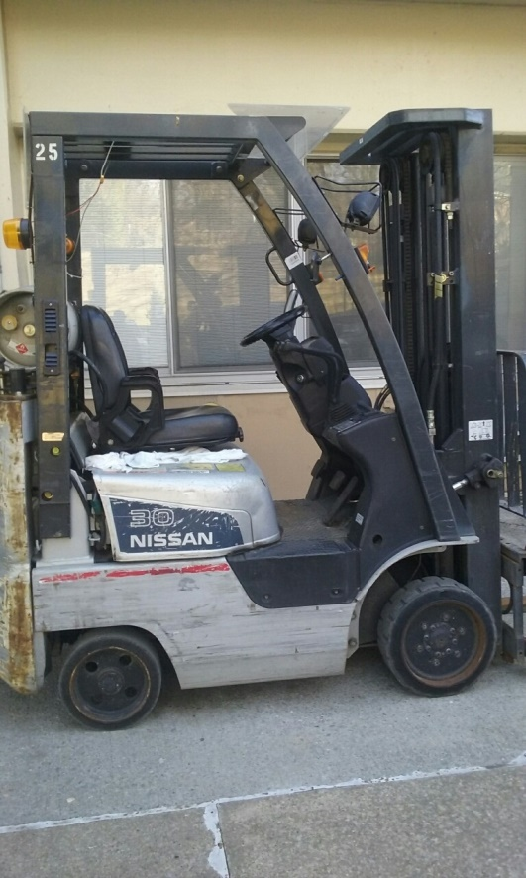

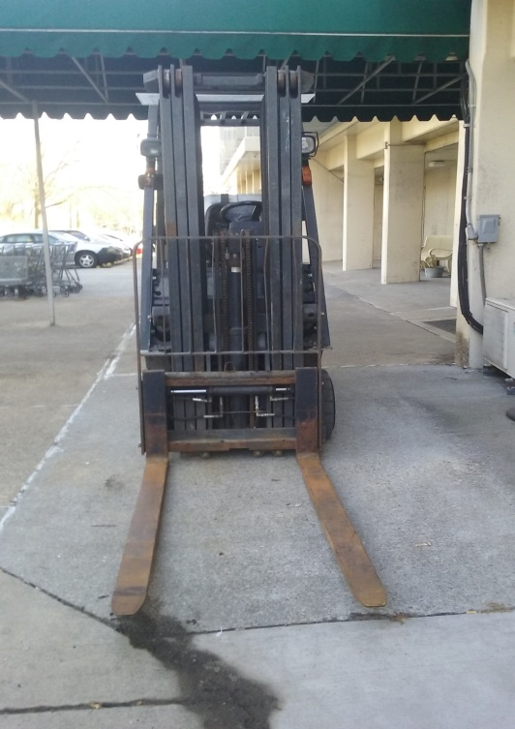

Pre-owned) Q1821
DC’s current forklift offered as a trad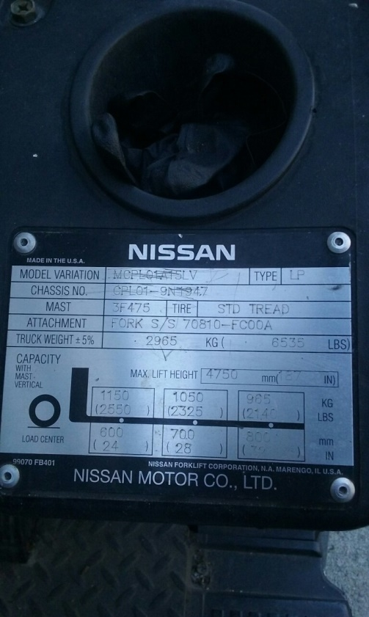e in

