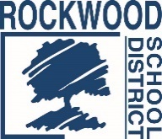
Addendum #1
Date: February 2, 2023
Rockwood School District – RFP No. RFP0123DWBEV
District Beverage Vending Services
The Request for Proposals (RFP) for the above-named project is amended as noted in this Addendum. This Addendum consists of questions and Rockwood School District’s responses.
- Are the estimated annual beverage volumes provided in Exhibit A, based on historical averages (pre-Covid) or are these volume estimates based solely on post Covid volumes? The volumes are based on last year’s vending sales.
- Would you be able to provide me a copy of the winning bid for the last Beverage Vending Agreement RFP? In order to obtain this information, you will need to submit a formal request for public records. Instructions can be found on our website.
- If we were to provide a secondary bid for District/Board to review for consideration that would showcase additional benefits, services, and funding for an exclusive beverage rights bid in addition to the vending services, would doing so potentially be view as grounds for rejecting the primary bid? The district is not interested in an exclusivity agreement at this time.
End of Addendum #1

