Request for Written Quotes

Electronic Door repair & related services

Solicitation Number | Q1813
Due Date | November 21, 2017
Due Time | 2:00 p.m. EST
Deliver Responses to: | Knoxville’s Community Development Corporation    Procurement Division  901 N. Broadway  Knoxville, TN 37917  Note: Procurement is in a separate building behind the main office building
Electronic Copies: | Electronic copies are available on KCDC’s webpage or by email at purchasinginfo@kcdc.org.
May responses be emailed to KCDC | ☒ Yes ☐ No  Paper copies must also be provided, if the solicitation so indicates.
Solicitation Meeting | ☐ Yes ☒ No
Solicitation Meeting is Mandatory | ☐ Yes ☒ No
Solicitation Meeting Date | Not applicable
Solicitation Meeting Time | Not applicable
Solicitation Meeting Location | Not applicable
Questions About This Solicitation | Submit questions to purchasinginfo@kcdc.org.

Check KCDC’s webpage for addenda and changes before submitting your response

General Information

1. BACKGROUND AND INTENT

a. Knoxville's Community Development Corporation (KCDC) is the public housing and redevelopment agency for the City of Knoxville and for the County of Knox in Tennessee. KCDC’s public housing property portfolio includes 20 sites with approximately 3,525 dwelling units. KCDC also administers approximately 3958 Section 8 Vouchers, 82 Moderate Rehabilitation units and 20 Redevelopment areas.

b. KCDC intends for this solicitation to result in the selection of one supplier to meet our electronic door access installation and repair needs. Upon award, sites will create requisitions using KCDC’s catalog software and the system will auto create purchase orders (based upon the award specifics) that they will use to request services as they are needed. Work is not to commence until a KCDC purchase order is received by the supplier. Emergency service provisions do exist and will be used if truly needed by KCDC.

c. KCDC envisions the winner of this solicitation being on call, at a predetermined cost, whenever KCDC needs door, electronic access systems or other similar installations or repairs.

d. Generally electronic door repair services occur at Cagle Terrace, Isabella Towers, Love Towers and Northgate Terrace. This does not mean that other KCDC sites might not need these services in the future. Additionally, KCDC intends for this award to be as broad as possible and it may cover the installation of new electronic doors if desired.

e. KCDC also desires a price and description of a preventative maintenance program for the electronic doors at the four sites referenced above, with a list of covered services.

f. Below are actual descriptions of the work that has been performed in the past. This information is intended to be descriptive of the type of work that may be required. It is not intended to be an all-inclusive list.

- Cannot open the door from the outside - replaced door handle.
- Door will not open - post broken on surface box.
- Door would not stay closed - replaced PIR Rex on entrance door.
- Lobby door will not lock – swapped relay contacts on PIR and adjusted range.
- Front entrance remote does not work.
- Front door not locking - replaced PIR sensor.
- Resident knocked door off hinges - set door back on pivot, lubricated pivots and replaced missing bolt on arm.
- Entrance doors would not lock - adjusted Adams Rite Panic Device and replaced top pivot.
- Front door knocked off hinges - replaced bottom pivot on inner door.
- Added a push bar on the Social Hall Door and replaced the FOB box.
- Installed Horton 8000 Operator.
- Installed center pivot and three foot long bar stock.
- Main entrance door was not working – repaired wire in tele-entry power unit.
- Bottom pivot was worn out - replaced the pivot.
- Basement door would not lock - adjusted closer speeds where the doors were slamming and repaired DRS rubbing frame that was loose.
- Tightened the pivot on the door and put screws in Horton 7000 and adjusted manual door so it would not ‘hang’ on the threshold.
- Exit door would not lock - replaced dogging assembly on left door.
- Back door would not lock - reset sequencer on outer door and remounted operator that was loose at the inner door.
- Replaced MC25 relay.
- Emergency exit door repair - bottom latch stuck on one and the top rod had to adjusted on the other.
- Replaced MC65 Door Sequencer.
- Panic screws had been stripped - remounted panic device and checked time delay.

g. KCDC utilizes the “catalog” function of its financial software. This enables KCDC employees to quickly and easily place one item orders for items that are on contract. Please note:

1. KCDC issues individual purchase orders for specific orders.
2. KCDC transmits purchase orders via email.

2. CHANGES AFTER AWARD
It is possible that after award KCDC will need to revise the service needs or requirements specified in this document. KCDC reserves the right to make such changes after consultation with the supplier. Should additional costs arise, the supplier must document increased costs. KCDC reserves the right to accept and negotiate these charges.

3. EVALUATION
KCDC will arrive at the “lowest and best” solution for the final award. This may not entail simply awarding to the supplier quoting the lowest cost. All responses are subject to a determination of “responsive” and “responsible” prior to award. KCDC is the sole judge as to supplier “responsiveness” and “responsibility.” KCDC reserves the right to request additional information to assist in the evaluation process. This includes references and business capacity information.
Supplier’s location relative to KCDC locations will be a factor in the evaluation.

4. GENERAL INSTRUCTIONS
KCDC does not insert “General Instructions to Suppliers” in solicitation documents. These instructions are at www.kcdc.org. Click on “Procurement” and the link to the instructions. The supplier’s submittal means acceptance of the terms and conditions set forth in KCDC’s “General Instructions to Suppliers.”

5. INSURANCE
The contractor shall maintain, at contractor’s sole expense, on a primary and non-contributory basis, at all times during the life of the contract insurance coverages, limits, and endorsements described herein. All insurance must be underwritten by insurers with an A.M. Best rating of A-:VI or better. Upon award, the contractor shall provide Certificate(s) of Insurance to KCDC evidencing said insurance coverages.

The contractor agrees the insurance requirements herein as well as KCDC’s review or acknowledgement, is not intended to and shall not in any manner limit or qualify the liabilities and obligations assumed by the contractor under this contract.

a. Commercial General Liability Insurance: occurrence version commercial general liability insurance with a limit of not less than $1,000,000 each occurrence for bodily injury, personal injury, property damage, and products and completed operations. If such insurance contains a general aggregate limit, it shall apply separately to the work/location in this contract or be no less than $2,000,000.

Such insurance shall contain or be endorsed to contain a provision that includes KCDC, its officials, officers, employees, and volunteers as additional insureds with respect to liability arising out of work or operations performed by or on behalf of the contractor including materials, parts, or equipment furnished in connection with such work or operations. The coverage shall contain no special limitations on the scope of its protection afforded to the above-listed insureds.

The Additional Insured shall read “Knoxville’s Community Development Corporation (KCDC)”.

If necessary, umbrella/excess liability insurance can be used in conjunction with the general liability insurance to meet these requirements. Unless the umbrella/excess liability insurance provides coverage on a pure/true follow-form basis, or KCDC is automatically defined as an additional insured, the contractor shall add by endorsement, KCDC its officials, officers, employees, and volunteers as an additional insured.

b. Automobile Liability Insurance: including vehicles owned, hired, and non-owned, with a combined single limit of not less than $1,000,000 each occurrence. Such insurance shall include coverage for loading and unloading hazards.

c. Workers’ Compensation Insurance and Employers Liability Insurance: with statutory limits as required by the State of Tennessee or other applicable laws.

d. Pollution Liability Insurance: pollution liability coverage, providing defense and indemnity coverage for bodily injury, property damage, and environmental investigation and clean-up costs for pollution conditions arising from the contractor’s operations. Limit of liability not less than $1,000,000 each occurrence and $2,000,000 annual aggregate. The policy shall include a minimum three (3) year Discovery (tail) reporting period, and a Retroactive Date that equals or precedes the effective date of this contract or the performance of work hereunder. Coverage may be provided on a per project basis.

e. Other Insurance Requirements: Contractor shall:

1. Upon award, furnish KCDC with original Certificates of Insurance and amendatory endorsements effecting coverage required by this section. Certificates of Insurance shall provide a minimum 30-day endeavor to notify KCDC of cancellation when available by contractor’s insurance. If the contractor receives a non-renewal or cancellation notice from an insurance carrier affording the required coverage, or receives notice that coverage no longer complies with the insurance requirements herein, contractor shall notify KCDC by email or fax within five (5) business days and provide a copy of the non-renewal for cancellation notice or written specifics as to which coverage is no longer in compliance.

2. The certificate holder address shall read:
Knoxville’s Community Development Corporation
Attn: Contracting Officer
901 N. Broadway
Knoxville, TN 37917

3. Provide certified copies of endorsements and policies if requested by KCDC in lieu of or in addition to Certificates of Insurance.

4. Replace certificates, policies, and endorsements for any such insurance expiring prior to completion of services.

5. Maintain such insurance from the time services commence until services are completed. Failure to maintain or renew coverage or to provide evidence of renewal may be treated by KCDC as a material breach of contract.

6. Require all subcontractors to maintain during the term of the resulting contract commercial general liability insurance, automobile liability insurance, and workers’ compensation/employers liability insurance (unless subcontractor’s employees are covered by contractor’s insurance) in the same manor and limits as specified for the contractor.

Contractor shall furnish subcontractor(s)’ Certificates of Insurance to KCDC without expense prior to subcontractor(s) commencing work.

7. Any deductibles and/or self-insured retentions greater than $50,000 must be disclosed to and approved by KCDC prior to the commencement of services. Use of large deductibles and/or self-insured retentions will require proof of financial ability as determined by KCDC.

8. Provide a waiver of subrogation for each required policy herein. When required by the insurer, or should a policy condition not permit contractor to enter into a pre-loss agreement to waive subrogation without an endorsement, the policy should be endorsed with a Waiver of Transfer of Rights of Recovery Against Others, or its equivalent. This waiver of subrogation requirement shall not apply to any policy which includes a condition specifically prohibiting such an endorsement, or voids coverage should contractor enter into such an agreement on a pre-loss basis.

9. All policies must be written on an occurrence basis.

f. Right to Revise or Reject: KCDC reserves the right, but not the obligation, to review or revise any insurance requirement, not limited to limits, coverages and endorsements based on insurance market conditions affecting the availability or affordability of coverage; or changes in the scope of work / specifications affecting the applicability of coverage.

g. No Representation of Coverage Adequacy: The coverages, limits or endorsements required herein protect the primary interests of KCDC, and the contractor agrees in no way should these coverages, limits or endorsements required be relied upon when assessing the extent or determining appropriate types and limits of coverage to protect the contractor against any loss exposures, whether as a result of the project or otherwise.

h. Once KCDC sends the successful supplier the notification of intent to award, the supplier is required to provide a Certificate(s) of Insurance evidencing coverage as required above within the timeline detailed noted below. Failure to comply within the set timeframe may constitute unresponsiveness and KCDC reserves the right, at its sole discretion, to reconsider the award.

KCDC has determined the following timeline applies to this solicitation:

General Services 7 calendar days ☒ Yes ☐ No
Construction Services 15 calendar days ☐ Yes ☒ No

6. INVOICING/ORDERING

a. Until a purchase order is in place, work is not to be performed nor are goods to be delivered. KCDC does not have a legal obligation to pay for the work performed prior to the issuance of a purchase order.

b. Suppliers must submit invoices within 90 days of the delivery of goods or services. KCDC may deny invoices submitted after the 90-day threshold. KCDC prefers invoices arrive within 10 days following the end of the month in which goods or services were supplied.

c. KCDC’s purchases of goods are exempt from Tennessee sales and use tax pursuant to Tennessee Code Annotated 67-6-329(a) (4) and KCDC is generally exempt from the Federal Excise tax. Contractors are subject to Tennessee sales and use tax on all materials and supplies used in the performance of a contract, whether such materials and supplies are purchased by the contractor, produced by the contractor, or provided to the contractor by KCDC, pursuant to Tennessee Code Annotated 67-6-209. The contractor will pay all taxes incurred in the performance of an awarded contract. Upon the placement of a purchase order or the award of a contract, KCDC will provide a State of Tennessee Sales Tax Exemption form to the supplier. KCDC will not pay taxes on invoices.

d. KCDC pays by electronic transfer (ACH) only.

7. LENGTH OF AWARD
The length of the contract will initially be 12 months along with four optional yearly renewals that KCDC may exercise at its discretion.

8. MULTIPLE AWARDS
KCDC reserves the right to award to more than one supplier if that best meets its needs.

9. PRICE STRUCTURE

- At the end of each twelve-month period, the awarded supplier may request a change to the
percentage and/or specific item charged to KCDC. The supplier must provide proof of the necessity of the increase to the Procurement Division. Suppliers may lower prices at any time with or without notice. KCDC will decide whether to accept the price increase. If the price increase is accepted, the bid file will be so noted. If the price increase is not accepted, the supplier may:

1. Continue with the existing pricing.
2. Suggest an alternative price increase.
3. End the award.

b. KCDC does not pay fuel surcharges.

10. REPORTING
At the end of each quarter, the supplier will provide KCDC with a summary recap of items and services purchased during that quarter. The supplier will email the report to purchasinginfo@kcdc.org. For each purchase or service provided please include the following details:

- Item purchased or service provided
- Cost
- Discount applied, if any
- Name of the KCDC site requesting service or purchase

11. QUESTIONS
Direct questions pertaining to this document to purchasinginfo@KCDC.org with “Electronic Door Repair & Related Services” in the subject line, at least five days prior to the due date.

12. USE OF SOLICITATION FORMS
Suppliers are to complete the solicitation forms contained in the solicitation package. Failure to complete these forms may result in rejection of your response. Do not alter the solicitation forms without KCDC’s approval. Suppliers are asked to use the MS Word version of the pricing pages to eliminate difficulties in reading handwritten text.

THIS AND THE PREVIOUS PAGES DO NOT NEED TO BE RETURNED

Electronic Door Repair & Related Services Q1813

Solicitation Document A General Response Section

General Information about the Supplier
Sign Your Name to the Right of the Arrow
Your signature indicates that you have read and agree to “KCDC’s General Instructions to Suppliers” on www.kcdc.org.
Printed Name and Title
Company Name
Street Address
City/State/Zip
Contact Person (Please Print Clearly)
Telephone Number
Cell Number
Supplier’s e-mail address (Please Print Clearly)
Addenda
Addenda are at www.kcdc.org. Click on “Procurement” and then on “Open Solicitations” to find addenda. Please check for addenda prior to submitting a bid.
Acknowledge addenda have been issued by checking below as appropriate:
None ☐ | Addendum 1 ☐ |  |  | Addendum 2 ☐ |  |  | Addendum 3 ☐ |  |  | Addendum 4 ☐ |  |  | Addendum 5 ☐
Statistical Information
This business is owned & operated by persons at least 51% of the following ethnic background:
Asian/Pacific ☐ |  | Black ☐ | Hasidic Jew ☐ |  |  | Hispanic ☐ |  |  | Native ☐ Americans |  |  | White ☐
As defined on KCDC’s webpage (see the “General Instructions to Suppliers”), this business qualifies as:
Section 3 ☐ |  |  |  |  | Small Business ☐ |  |  |  |  |  | Woman Owned ☐
Prompt Payment Discount
A prompt payment discount of ________% is offered for payment within ____ days of submission of an
accurate and proper invoice.
Mastercard Acceptance
Mastercard is accepted for payment without additional fees. Yes ☐ No ☐
Mastercard is accepted for payment with a fee of _______. Yes ☐ No ☐

Electronic Door Repair & Related Services Q1813

Solicitation Document B Affidavits

Suppliers: _____________________________________________________________________________

Conflict of Interest:

1. No commissioner or officer of KCDC or other person whose duty it is to vote for, let out, overlook or in any manner superintend any of the work for KCDC has a direct interest in the award or the supplier providing goods or services.

2. No employee, officer or agent of the grantee or sub-grantee will participate in selection, or in the award or administration of an award supported by Federal funds if a conflict of interest, real or apparent, would be involved. Such a conflict would arise when the employee, officer or agent, any member of his immediate family, his or her partner, or an organization, which employs, or is about to employ, any of the above, has a financial or other interest in the supplier selected for award.

3. The grantee's or sub-grantee's officers, employees or agents will neither solicit nor accept gratuities, favors or anything of monetary value from suppliers, potential supplier s, or parties to sub-agreements.

4. By submission of this form, the supplier is certifying that no conflicts of interest exist.

Drug Free Workplace Requirements:

5. Private employers with five or more employees desiring to contract for construction services attest that they have a drug free workplace program in effect in accordance with TCA 50-9-112.

Eligibility:

6. The supplier is eligible for employment on public contracts because no convictions or guilty pleas or pleas of nolo contender to violations of the Sherman Anti-Trust Act, mail fraud or state criminal violations with an award from the State of Tennessee or any political subdivision thereof have occurred.

General:

7. Supplier fully understands the preparation and contents of the attached offer and of all pertinent circumstances respecting such offer.

8. Such offer is genuine and is not a sham offer.

Electronic Door Repair & Related Services Q1813

Solicitation Document B Affidavits - continued

Iran Divestment Act:

9. Concerning the Iran Divestment Act (TCA 12-12-101 et seq.), by submission of this bid/quote/proposal, each supplier and each person signing on behalf of any supplier certifies, and in the case of a joint bid/quote/proposal, each party thereto certifies as to its own organization, under penalty of perjury, that to the best of its knowledge and belief that each supplier is not on the list created pursuant to § 12-12-106.

Non-Collusion:

10. Neither the said supplier nor any of its officers, partners, owners, agents, representatives, employees or parties interest, including this affiant, has in any way colluded conspired, connived or agreed, directly or indirectly, with any other responder, supplier, or person to submit a collusive or sham offer in connection with the award or agreement for which the attached offer has been submitted or to refrain from making an offer in connection with such award or agreement, or collusion or communication or conference with any other supplier, or, to fix any overhead, profit, or cost element of the offer price or the offer price of any other supplier, or to secure through any collusion, conspiracy, connivance, or unlawful agreement any advantage against KCDC or any person interested in the proposed award or agreement.

11. The price or prices quoted in the attached offer are fair, proper and not tainted by any collusion, conspiracy, connivance, or unlawful agreement on the part of the supplier or any of its agents, representatives, owners, employees, or parties in interest, including this affiant.

The undersigned hereby acknowledges receipt of these affidavits and certifies that the submittal in response to this solicitation is in full compliance with the listed requirements.

Signed by
Printed Name
Title
Subscribed and sworn to before me this date
By (Notary Public)
My Commission Expires on
Notary Stamp

Electronic Door Repair & Related Services Q1813
Solicitation Document C HUD Form 5369A

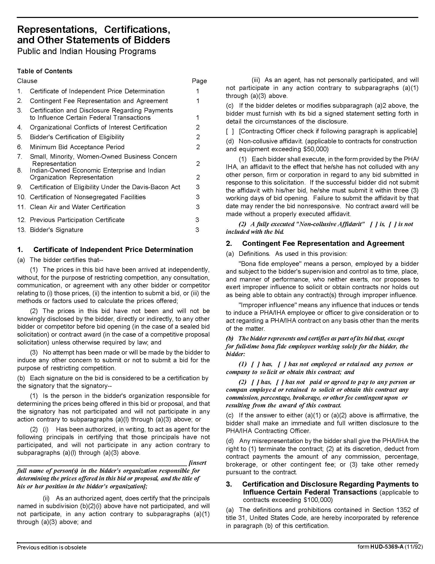

Electronic Door Repair & Related Services Q1813
Solicitation Document C HUD Form 5369A - Continued
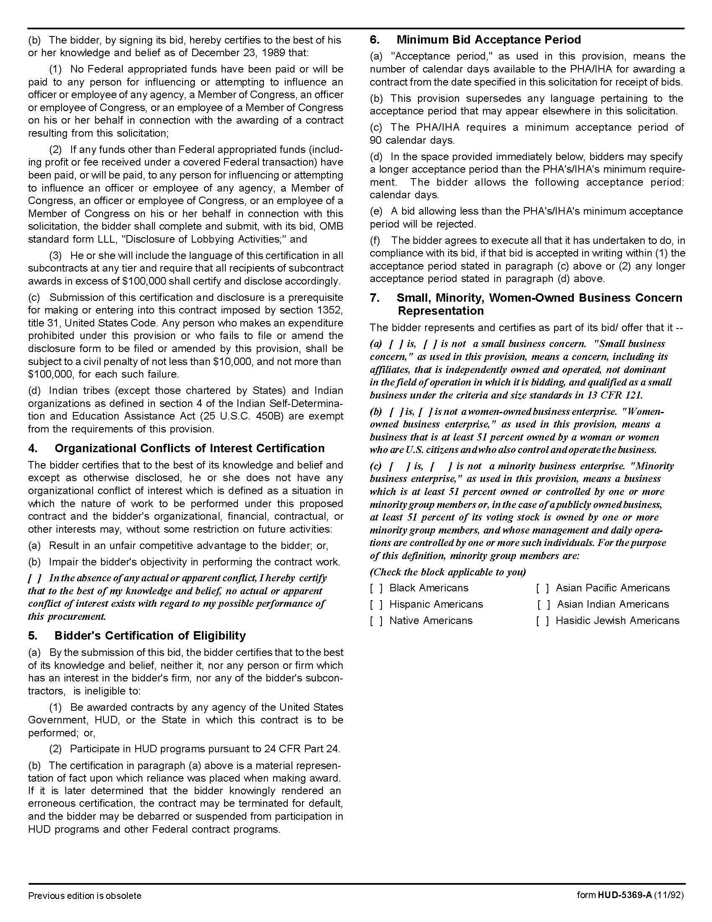

Electronic Door Repair & Related Services Q1813
Solicitation Document C HUD Form 5369A - Continued

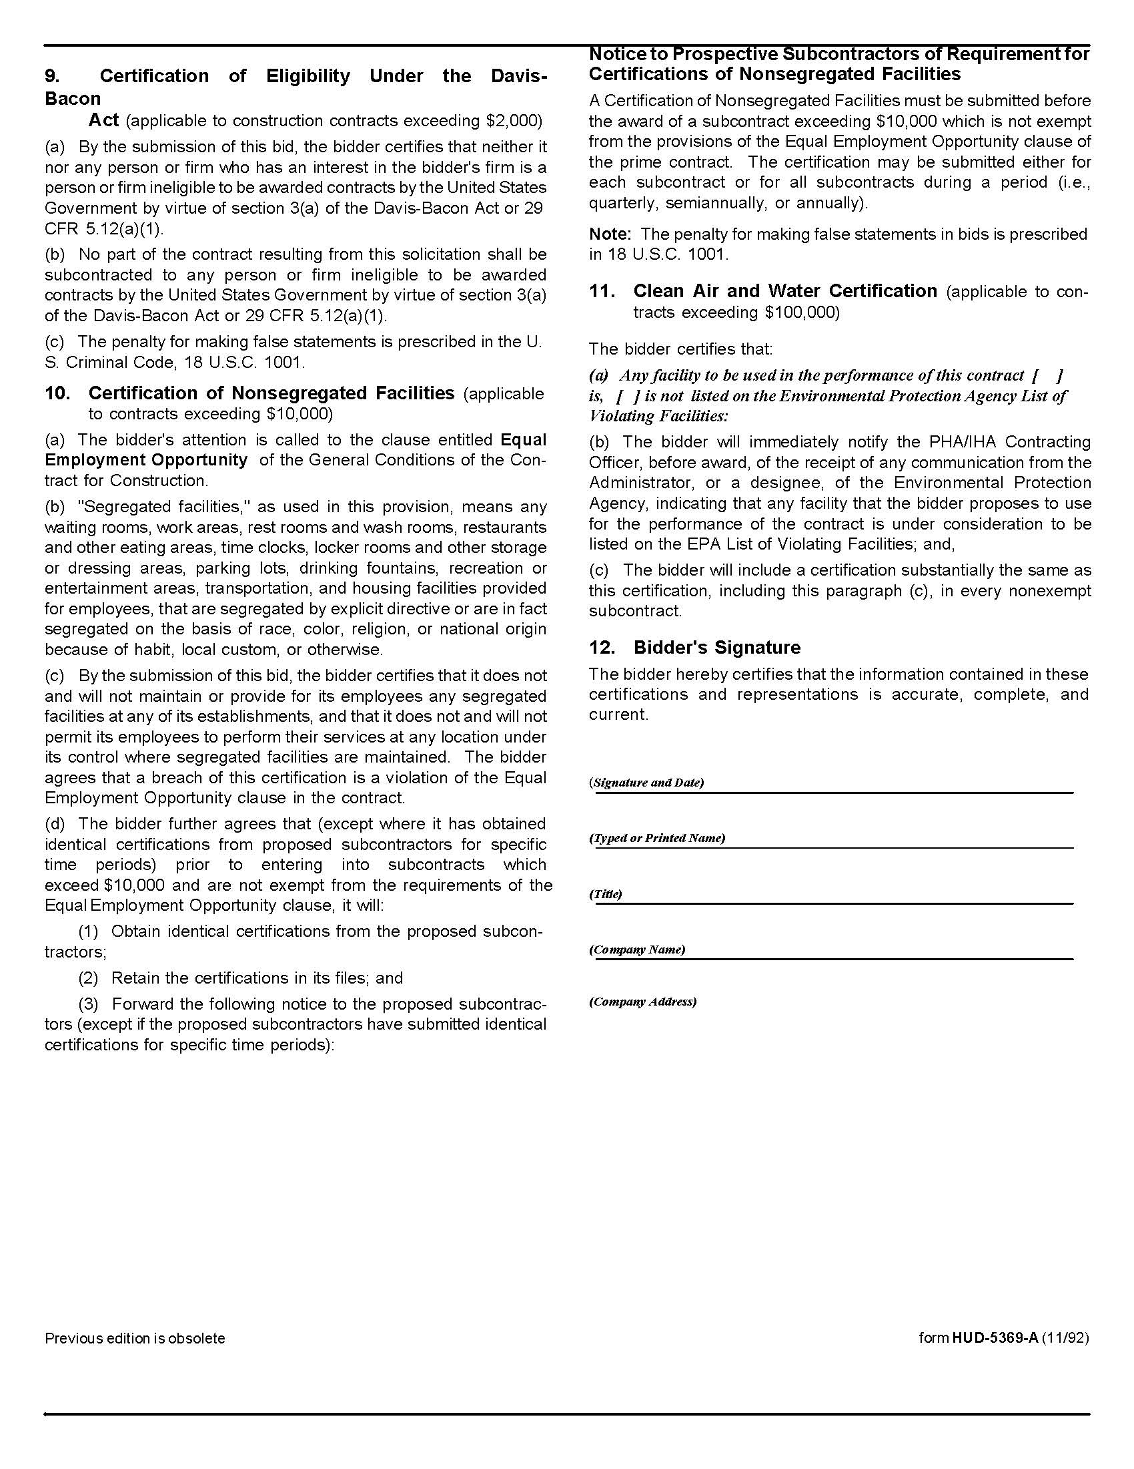

Electronic Door Repair & Related Services Q1813
Solicitation Document D Pricing Form
Vendor: _________________________________________________________________________________

Service Cost | Unit of Measure | Cost per Hour
Service between 7:30 a.m. & 4:30 p.m. weekdays | Per Hour | $
Service between 4:30 p.m. & 7:30 a.m.  Weekdays and all hours on weekends and holidays | Per Hour | $
Installation of new doors | Per Hour | $

Preventative Maintenance
KCDC may be interested in a preventative maintenance agreement for one or more of its sites. If you can
provide such services, please enter a price below. Submit additional pages that detail the plan. KCDC will
analyze the preventative maintenance plan and determine whether or not to proceed with it.

Preventative Maintenance | Unit of Measure | Cost per Year
Preventative Maintenance Program for Cagle Terrace | Per Year | $
Preventative Maintenance Program for Isabella Towers | Per Year | $
Preventative Maintenance Program for Love Towers | Per Year | $
Preventative Maintenance Program for Northgate Terrace | Per Year | $

Item | Discount Level | Discount Base
Parts Discount | %

Please explain any minimum or additional charges that may apply. If there are none, please state so in
your response.

