

Request for Proposals

Solicitation Name and Number | Construction Manager at Risk Services for Austin Homes/Bell Street Flats Phase 1B C21004
Responses Must Arrive No Later Than | 11:00 a.m. on August 26, 2020 (as KCDC’s clocks indicate)
Deliver Responses to | procurementinfo@kcdc.org
Electronic Copies | Proposers are to use the MS Word version posted on KCDC’s website (or other electronic means) to provide a typed response. The final proposal is to be submitted in Adobe format.
Solicitation Meeting | ☒ Yes ☐ No
Solicitation Meeting is Mandatory | ☐ Yes ☒ No ☐ Not Applicable
Solicitation Meeting Date and Time | August 18, 2020 at 9:00 a.m.
Solicitation Meeting Connection | KCDC will host an on-line meeting. Email procurementinfo@kcdc.org for the web link.
Questions About This Solicitation | Submit questions to procurementinfo@kcdc.org. by 4:00 p.m. on August 21, 2020.  KCDC will not accept questions via telephone.
Award Results | KCDC posts the award decision to its web page at: https://www.kcdc.org/procurement/
Open Records/Public Access to Documents | All document provided to KCDC are subject to the Tennessee Open Meetings Act (TCA 8-44-101) and open records requirements.
Check KCDC’s webpage (https://www.kcdc.org/procurement/) for addenda and changes before submitting your response

General Information

1. Definitions
a. Construction Manager at Risk (CMAR) is a delivery method, which includes a contractual commitment by a construction manager to deliver the specified project within a Guaranteed Maximum Price.

b. “Supplier” is inclusive of various words describing interested parties often called “vendor,” “bidders,” “contractors” and “proposers.”

2. Background and Intent of Solicitation
a. Knoxville's Community Development Corporation (KCDC) is the public housing and redevelopment agency for the City of Knoxville and for Knox County in Tennessee. KCDC’s affordable housing property portfolio includes 20 sites with approximately 3,525 dwelling units

b. KCDC is soliciting proposals from qualified construction companies who desire to function as the Construction Manager at Risk for Phase 1B of the redevelopment of the Austin Homes site in Knoxville, TN (Project). For this purpose, KCDC is soliciting proposals from construction firms with recent, comparable experience as a Construction Manager at Risk (“CMAR”), working under a guaranteed maximum price (GMP), and that are skilled in construction of new multifamily developments with a similar size and complexity.

c. This project consists of a preconstruction phase and a construction phase with separate notices to proceed for each phase. During the preconstruction phase, the CMAR will collaborate with the architect on the design, constructability, cost and schedule of the project, and develop a Guaranteed Maximum Price (GMP) proposal to construct the project. Upon KCDC’s acceptance of the GMP, KCDC will issue a contract to the CMAR for the construction phase without additional public competition. If KCDC and the CMAR do not agree upon a GMP, KCDC will not award the construction phase of the project and will instead issuance another solicitation for that phase. See paragraph 18 of this document for more details on Scope of Work.

d. The CMAR shall be incorporated within the project team, which shall consist of KCDC, Johnson Architecture and Southeast Venture (the “Architects”), and other consultants as KCDC may deem necessary or appropriate (“Project Team”). The CMAR shall furnish the project team with construction expertise and pricing during the design process and then manage all trades during the construction.

3. History
a. Austin Homes is a 23 acre site that is located less than one mile east of Knoxville’s revitalized downtown and a half mile from the “Old City.” The site was initially developed in 1941 and over the last 80 years has served as low-income public housing for hundreds of Knoxville families.

b. Most recently, Austin Homes had 129 residential units. Although the 129 units had been well maintained, the physical design became obsolete. Individual units were small and outdated; aging infrastructure was in need of replacement; site access and connectivity to the surrounding area was limited; and off street parking was inadequate. In late 2019, KCDC relocated all 129 families to other KCDC properties and proceeded with the demolition of all the structures on the Austin Homes site.

c. Beginning in late 2018, prior to the demolition of the 129 units, KCDC, along with its consultants, Gensler Architecture and Johnson Architecture, conducted an extensive master planning process. The master planning process involved assessing the existing site conditions, engaging the community and its stakeholders, developing a collaborative vision for the future of Austin homes, establishing a program for development, and designing a new mixed-income community that embodies the community’s aspirations.

d. Following an eight month master planning process, involving former and current Austin Homes residents, community members, neighboring property owners, elected officials and other stakeholders, KCDC began designing the Austin Home’s site plan.

e. Working with Civil Engineering Consultants (CEC), a comprehensive infrastructure and site work/grading site plan was prepared for a portion of the 22+/- acre Austin Home’s site. The site plan was submitted and approved by the City of Knoxville in the Spring of 2020. KCDC selected East Tennessee Turf and Landscape to complete the construction of the site’s infrastructure and utility improvements. This scope of work started construction in June 2020 and will be completed by July 2021.

f. KCDC is expected to begin construction on the first phase (Phase 1) of Austin Homes redevelopment in August 2020. Phase 1 will include nine residential buildings containing a total of 105 multifamily housing units. KCDC has selected J.A. Fielden to serve as the general contractor for the construction of Phase. Phase 1 will be generally located in the northeast portion of the Austin Homes site.

4. Austin Homes Phase 1B Overview
a. Phase 1B will be generally located on the south portion of the Austin Homes site along Summit Hill Drive and will encompass approximately 7 acres. KCDC is initially contemplating approximately 180+/- units of multifamily housing across of several different buildings. With an emphasis on medium density multifamily residential, KCDC envisions building types that may include townhomes/row houses, 4+ story midrise buildings, and 2-3 story garden style buildings. The unit mix will include one, two and three bedroom units and the common area will likely include some resident amenities such as a fitness center and lounge. Depending on building configurations and density, the site will likely have surface parking, tuck-under parking and/or garage parking.

b. During the preconstruction phase, KCDC, working with the selected CMAR and Project Team, desires to review various site plan options (e.g. building counts, building locations, building types, parking layouts, et cetera) and select the most optimal site plan based on several key factors that include but are not limited to: total development costs, maximum utility of the site area and design aesthetics. The CMAR is expected to play an integral role in assisting the project team to develop several different site plan options.
c. KCDC anticipates a 6-8 month preconstruction/design phase and a construction start date in the second quarter of 2021.

d. For the purposes of this RFP, KCDC is anticipating a Construction Cost range of $28,000,000 to $32,000,000.

5. Bonds
The Construction Manager will provide both Payment and Performance bonds, each equal to 100% of the construction project’s cost, as a condition precedent to the award of the second phase of the contract. Documentation of bonds shall be in a format acceptable to KCDC.

6. Changes after Award
It is possible that after award KCDC will need to revise the service needs or requirements specified in this document. KCDC reserves the right to make such changes after consultation with the supplier. Should additional costs arise, the supplier must document increased costs. KCDC reserves the right to accept and negotiate these charges.

7. Codes and Ordinances
All work covered by these award documents is to be done in full accord with national, state and local codes, ordinances and orders that are in effect at the time the work is performed.

8. Contact Policy
Only contact KCDC’s Procurement Division about this solicitation from the issuance of this RFP until its award. Information obtained any other person will not affect the risks or obligations assumed by the supplier or relieve the supplier from fulfilling any of the conditions of the resulting award. Such contact can disqualify the supplier from the solicitation process.

9. Contract Sample
KCDC’s proposed contract for pre-construction services and construction services are posted with this RFP on KCDC’s webpage. Please review these carefully as no material changes will be made to the agreement.

10. Employees
Supplier(s) will:

a. Allow only personnel thoroughly trained and skilled to work on the job. Employees are not to be accompanied in their work area by acquaintances, family members, assistants or any person unless said person is an authorized employee of the supplier.

b. Have sufficient personnel to complete the work in a timely manner.

c. Provide adequate supervision and adequate discipline among his/her employees.

d. Provide at least one employee on every job assignment with the ability to speak, read, write and understand English so KCDC’s staff can communicate effectively with them.
e. Employ the quantity and quality of supervision necessary for both effective and efficient management at all times.

f. Ensure that employees have proper identification displayed while on the job site. Employees must wear a company uniform or have photo identification badges at all times.

g. Employees parking vehicles (whether corporately or privately owned) must ensure that company identification is on the vehicles. This may be by placards on the vehicle’s side, laminated paper with the company name placed on the dashboard or other means.

h. Any and all successful suppliers, supplier’s employees, supplier’s sub-contractors and the employees of any sub-contractors must submit to a criminal history records check at the supplier’s expense, conducted by the Tennessee Bureau of Investigation and the Federal Bureau of Investigation. The supplier must provide proof of satisfactory results from background checks for each employee who will work on KCDC’s property.

11. Evaluation
a. KCDC alone determines (using NIGP’s definition and other relevant sources as appropriate) the supplier’s “responsive” and “responsible” status prior to award. Responsible means a business with the financial, technical, relevant experience and capacity to perform the requirements of the solicitation and subsequent contract. A responsive proposal is one that fully conforms in all material respects to the solicitation document and all of its requirements, including all form and substance.

b. KCDC will review all proposals and reserves the right to request additional necessary information, modifications, waive minor technicalities, reject all proposals, reject any proposal that does not meet mandatory requirement(s) or cancel this RFP, according to KCDC’s best interests. KCDC further reserves the right to make adjustments to its evaluation scenario if they are in KCDC’s best interest and consistent with good business practices.

c. KCDC may require oral presentations as part of the evaluation process.

d. KCDC reserves the right to ordinally rank proposals as a first step and then only detail score the top tier of proposals if determined to be in KCDC’s best interest.

e. KCDC plans to award to the best overall proposal on the following evaluation scale:

Factors | Maximum Points
Construction Manager's Experience  Similar projects  Multiple Phase Construction  Construction Management At-Risk  References | 30
Resources  Key Personnel  Current Workload  Consultants | 20
Technical Approach  Estimating  Cost Control  Schedule Control  Quality Control  Communication  Small businesses (and MBE, WBE, VBE) inclusion plan | 20
Cost of Services  Fees | 30
Total | 100

12. General Instructions
a. KCDC does not insert “General Instructions to Suppliers” in solicitation documents. These instructions are at www.kcdc.org. Click on “Procurement” and then follow the link to the instructions. The supplier’s submittal means acceptance of the terms and conditions set forth in KCDC’s “General Instructions to Suppliers.”

b. Paragraphs in the “General Instructions” document that do not apply to this solicitation: 16, 33a, 33b, 33c, 33e, 33g, 53, 65, 69.

13. Insurance
See Appendix 1. These insurances and levels are required and not optional. If you or your insurance agent have concerns or believe that some coverages are not necessary, email procurementinfo@kcdc.org detailing any requested changes before this solicitation’s due date.

14. Licenses
a. The supplier shall maintain all licenses necessary to conduct business in the Knox County and the City of Knoxville.

b. The supplier must comply with all of the provisions of the Contractors Licensing Act of 1976 of the State of Tennessee, the same being set out in Tennessee Code Annotated, 62-6-101 et seq., and Section 62-6-119 as amended by 1997 Tennessee Public Act No. 153. Said Act and amendments are incorporated herein by reference.

The Executive Director of the State of Tennessee Contractor Licensing Board opined that the CMAR must hold a commercial license classification (BC or BC-B) with an unlimited monetary limit. Provide a copy of the license with your submittal.

b. Subcontractor's performing the electrical, geothermal, HVAC, plumbing must be licensed when their total portion is $25,000 or more. Masonry subcontractors must be licensed when their portion equals or exceeds $100,000. Note that these subcontractor limits are reflective of total cost including materials and labor. Subcontractor licenses do not have to be provided with your submittal but at the time subcontractors are selected.

c. All specific licensure requirements of the Tennessee Department of Environment and Conservations (TDEC) must be compiled with.

d. Failure to include the required licensure information may result in an offer being deemed nonresponsive.

15. Smoke Free Policy
a. KCDC’s Smoke Free policy is applicable to you, your employees and subcontractors. The policy mandates:
- No smoking on owner’s property
- No e-vape or similar usage on owner’s property
- The Smoke Free policy applies in personal or corporate vehicles on owner’s property

b. Applicable definitions include:
- “Smoking” means inhaling, exhaling, burning or carrying any lighted or heated cigar, cigarette or pipe, or any other lighted or heated tobacco or plant product intended for inhalation, including hookahs and marijuana, whether natural or synthetic, in any manner or in any form. “Smoking” also includes the use of an electronic smoking device which creates an aerosol or vapor, in any manner or in any form.

- “Electronic Smoking Device” means any product containing or delivering nicotine or any other
substance intended for human consumption that can be used by a person in any manner for the purpose of inhaling vapor or aerosol from the product. The term includes any such device, whether manufactured, distributed, marketed or sold as an e-cigarette, e-cigar, e-pipe, e-hookah or vape pen or under any other product name or descriptor.

- Property means all buildings, parking lots, streets, structures and land owned by owners. Should
CMAR staff be observed violating these requirements, KCDC’s Procurement Division will notify the CMAR about the problem. Should there be recurrences, KCDC may ask the CMAR to not send the employee to KCDC’s property. Repeated offenses may result in forfeiture of your awarded “contract.”

16. Solicitation Requirements
Caution: Requirements in the solicitation are not optional. If you have concerns or issues with any of the stated requirements, raise them before the bid due date. Examples of past issues where suppliers made faulty assumptions include bonds, Davis Bacon requirements, Insurance requirements and payment expectations.

17. Subcontracting
a. If the CMAR and KCDC agree to the second stage and sign a contract for construction services, the successful CMAR is required to schedule and conduct at least one overall Pre-Solicitation Conference for subcontractors in cooperation with KCDC’s Procurement representatives. This conference will be publicly advertised to communicate to any interested minority owned, women-owned, veteran- owned, or other disadvantaged businesses, the scope, qualifications and general bidding requirements of each discipline. The intent of this meeting is to provide any attending company the fair opportunity to know and understand the bidding requirements to submit and gain awards through responsible, competitive bidding practices. Note that such meetings may be in person, via electronic means such as Zoom or a combination of methods so that current governmental limitations on gatherings are met.

b. If KCDC approves the option for the CMAR to self-perform certain trade work, the work must be competitively bid in accordance with KCDC’s policies. In such cases, bids for the specific trade work will be submitted directly to KCDC for opening.

c. In addition to other requirements set forth herein, all subcontractors must:

1. Be approved by KCDC prior to beginning work. Any changes must be approved by KCDC.
2. Not be on federal nor the State of Tennessee’s debarment lists.
3. Carry the insurance coverages as outlined herein.
4. Adhere to the Davis Bacon requirements in place and applicable at the time.

Scope of Work

18. Scope of CMAR’s Work
a. During the preconstruction phase, the CMAR will provide the KCDC and the Project Team with construction expertise and experience that will assist in project decision making and ensure that procedures are implemented to aggressively manage the construction costs and project schedule. During the construction phase, the CMAR will manage and administer the project construction to achieve construction completion within the contract time and budget and with high quality workmanship. KCDC seeks the CMAR who can best provide the services needed to achieve these goals.

b. Preconstruction Scope
Consultation is required with the Project Team during the design phase of the project until such time that a Guaranteed Maximum Price (“GMP”) for construction is accepted. The CMAR will provide pre-construction services including but not limited to:
1. Consult with, advise, assist and provide recommendations to the Project Team on all aspects of the design of the project, including early verification of budget and schedule.

2. Provide information, estimates and alternative schemes, and participate in decisions regarding existing conditions, site utilization and construction phasing.

3. Develop information and participate in decisions regarding value engineering. Provide information on construction materials, methods, systems, phasing and costs to assist in determinations that are aimed at providing the highest quality facility within the budget.

4. Provide input to the Project Team regarding current construction industry practices, labor market and materials availability.

5. Review in-progress design documents and provide input and advice with respect to construction feasibility, construction sequencing, site utilization, alternative materials/methods and long-lead material procurements.

6. Review design documents in progress and suggest modifications to improve completeness or clarity and constructability.

7. Recommend division of the work to facilitate bidding and award of trade contracts considering such factors as minimizing disruption of existing facilities, improving or accelerating construction completion, minimizing trade jurisdiction disputes, increasing minority-owned business participation and other related issues.

8. Develop and continuously monitor the project schedule and recommend adjustments in the design documents or construction bid package to ensure completion of the project in the most expeditious manner possible.

9. Assist in cost management, including the preparation of construction cost estimates for the project throughout each design phase of the work.

10. Develop with the Project Team a continuing list of additive and deductive cost items, prioritized by KCDC, to be considered as needed to remain within the budget.

11. Develop a GMP for owner review.

c. Construction and General Requirements
The CMAR’s duties include construction of the project in accordance with all construction documents, including but not limited to:

1. Solicit and select subcontractors and material suppliers in accordance with KCDC’s desire for the inclusion of small businesses as well as minority, woman and veteran owned businesses and the CMAR contract.

2. Maintain a qualified, full-time superintendent with necessary staff at the job site to coordinate and provide direction of the work, as well as to provide quality assurance/quality control.

3. Work with the Project Team to establish and implement procedures for expediting and processing all shop drawings and other submittal documents. The CMAR is responsible for the initial review and verification of all shop drawings to ensure they comply with the intent of the Construction Documents and are in fact ready for the Architect’s review and approval.

4. Prepare and maintain a detailed Critical Path Schedule for monitoring project progress and managing the work. Keep the Project Team fully advised on work progress status. This will include a “look-ahead” or “near-term” schedule to be provided at project meetings. If progress falls behind, the CMAR will provide a recovery schedule.

5. Make available all cost and budget estimates, including supporting materials and records, to the Project Team. Provide monthly reports of actual costs and work progress as compared to estimated cost projections and scheduled work progress. Explain significant variations and provide information as requested by the Project Team.

6. Assist KCDC to communicate effectively with potential residents, adjacent property owners and the community at large.

7. Establish an effective Quality Assurance/Quality Control Plan for all construction and inspect the work as it is being performed to assure that materials furnished and quality of work performed is in accordance with the Construction Documents.

8. Prepare Requests for Information (RFIs) when clarifications of documents are required.

9. Establish effective programs for job-site safety and for maintaining current job-site records, labor relations and minority participation.

10. Prepare and distribute weekly and monthly progress reports.

11. Provide continuous change order review and processing services.

12. Manage and administer subcontractors and/or material suppliers in accordance with the terms of their contracts.

13. Schedule and conduct job meetings to ensure orderly progress of the work. Prepare and distribute a record of the meeting to the Project Team and other interested parties within three business days of each meeting.

14. Resolve, with KCDC’s approval, disputes that may arise between subcontractors and/or material suppliers as a result of the construction.

15. Comply with Davis Bacon requirements in force at the time and as applicable.
16. As construction is completed, the CMAR shall provide the following close-out services:
  - Coordinate and expedite the submittal of record documents.

  - Organize and index three operations and maintenance manuals (including warranties). Provide electronic and paper copies.

  - Acquire all necessary or required permits, including Certificate of Occupancy.

  - Start up, testing and documentation of buildings systems.

  - Prepare a project completion report for assistance in turnover of the facilities to KCDC.

  - Prepare final report of all construction costs. Assist with KCDC’s audit of final cost report and all supporting documentation. Provide lien waivers from all subcontractors and material suppliers.

d. Post-Construction Services
  - Provide prompt satisfaction of all warranty items reported by KCDC.
  - Participate in a joint inspection of the facility, with the Project Team at the end of the one-year basic warranty period, and satisfy any warranty items identified at that time.

19. Contingency
The stated contingency within the GMP will be determined based on the progress of the design at the time the GMP is determined and will be agreed upon by both KCDC and supplier. Any unused contingency at the completion of the project will be returned to KCDC.

20. Submittal Instructions
Submit your information in the order indicated below:
Document Number | Title
Solicitation Document A | General Response Section
Solicitation Document B | Affidavits
Solicitation Document C | HUD Form 5369A
Solicitation Document D | Introduction
Solicitation Document E | Construction Manager’s Experience
Solicitation Document F | Resources
Solicitation Document G | Technical Approach
Solicitation Document H | Cost of Services

a. Place your company’s name on each page and number all pages consecutively
b. The use of tables in presenting information facilitates the evaluation team’s review.
c. Do not use phrases such as “See the attached” or “Will be provided upon award.”
d. Proposals are limited to 30 pages’ total. A page is the front and reverse of one 8.5 x 11 sheet of paper.
This and the Previous Pages Do Not Need to be Returned

Construction Manager at Risk Services for Austin Homes/Bell Street Flats Phase 1B C21004

Solicitation Document A: General Response Section

General Information about the Supplier
Sign Your Name to the Right of the Arrow
Your signature indicates you read and agree to “KCDC’s General Instructions to Suppliers” (www.kcdc.org) and that you are authorized to bind the supplier or are submitting the response on behalf of and at the direction of the suppliers’ representative authorized to contractually bind the supplier. I represent that the supplier or its applicable representative(s) has reviewed the information contained in this Solicitation Package and that the information submitted is accurate.
Printed Name and Title
Company Name
Street Address
City/State/Zip
Contact Person (Please Print Clearly)
Telephone Number
Cell Number
Supplier’s E-Mail Address (Please Print Clearly)
Addenda
Addenda are at www.kcdc.org. Click on “Procurement” and then on “Open Solicitations” to find addenda. Please check for addenda prior to submitting a proposal.
Acknowledge addenda have been issued by checking below as appropriate:
None ☐ | Addendum 1 ☐ |  |  | Addendum 2 ☐ |  | Addendum 3 ☐ |  |  | Addendum 4 ☐ | Addendum 5 ☐
Statistical Information (Check all the apply)
This business is at least 51% owned and operated by a woman |  |  |  |  |  |  |  |  |  |  | Yes ☐ No ☐
This business qualifies as a small business by the State of Tennessee  Total gross receipts of not more than $10,000,000 average over a three-year period OR employs no more than 99 persons on a full-time basis |  |  |  |  |  |  |  |  |  |  | Yes ☐ No ☐
This business qualifies as Section 3 business (as defined by HUD):  It is at least 51% owned by a Public Housing resident or it employs Section 3 residents for at least 30% of its employee base; or it commits to subcontract at least 25% of the project’s dollars to a Section 3 business. |  |  |  |  |  |  |  |  |  |  | Yes ☐ No ☐
This business is owned & operated by persons at least 51% of the following ethnic background:
Asian/Pacific ☐ |  | Black ☐ | Hasidic Jew ☐ |  | Hispanic ☐ |  |  | Native Americans ☐ |  |  | White ☐
Prompt Payment Discount
A prompt payment discount of ________% is offered for payment within ____ days of submission of an accurate and proper invoice.
MasterCard Acceptance
Mastercard is accepted for payment without additional fees. ☐ Yes ☐ No ☐ For a fee of _________

Construction Manager at Risk Services for Austin Homes/Bell Street Flats Phase 1B C21004

Solicitation Document B: Affidavits

Conflict of Interest
1. No commissioner or officer of KCDC or other person whose duty it is to vote for, let out, overlook or in any manner superintend any of the work for KCDC has a direct interest in the award or the supplier providing goods or services.

2. No employee, officer or agent of the grantee or sub-grantee will participate in selection, or in the award or administration of an award supported by Federal funds if a conflict of interest, real or apparent, would be involved. Such a conflict would arise when the employee, officer or agent, any member of his immediate family, his or her partner, or an organization, which employs, or is about to employ, any of the above, has a financial or other interest in the supplier selected for award.

3. The grantee's or sub-grantee's officers, employees or agents will neither solicit nor accept gratuities, favors or anything of monetary value from suppliers, potential suppliers or parties to sub-agreements.

4. By submission of this form, the supplier is certifying that no conflicts of interest exist.

Drug Free Workplace Requirements
5. Private employers with five or more employees desiring to contract for construction services attest that they have a drug free workplace program in effect in accordance with TCA 50-9-112.

Eligibility
6. The supplier is eligible for employment on public contracts because no convictions or guilty pleas or pleas of nolo contender to violations of the Sherman Anti-Trust Act, mail fraud or state criminal violations with an award from the State of Tennessee or any political subdivision thereof have occurred.

General
7. Supplier fully understands the preparation and contents of the attached offer and of all pertinent circumstances respecting such offer.

8. Such offer is genuine and is not a sham offer.

Iran Divestment Act
9. Concerning the Iran Divestment Act (TCA 12-12-101 et seq.), by submission of this bid/quote/proposal, each supplier and each person signing on behalf of any supplier certifies, and in the case of a joint bid/quote/proposal, each party thereto certifies as to its own organization, under penalty of perjury, that to the best of its knowledge and belief that each supplier is not on the list created pursuant to § 12-12-106.

Construction Manager at Risk Services for Austin Homes/Bell Street Flats Phase 1B C21004

Solicitation Document B: Affidavits - continued

Non-Collusion
10. Neither the said supplier nor any of its officers, partners, owners, agents, representatives, employees or parties interest, including this affiant, has in any way colluded conspired, connived or agreed, directly or indirectly, with any other responder, supplier, or person to submit a collusive or sham offer in connection with the award or agreement for which the attached offer has been submitted or to refrain from making an offer in connection with such award or agreement, or collusion or communication or conference with any other supplier, or, to fix any overhead, profit, or cost element of the offer price or the offer price of any other supplier, or to secure through any collusion, conspiracy, connivance, or unlawful agreement any advantage against KCDC or any person interested in the proposed award or agreement.

11. The price or prices quoted in the attached offer are fair, proper and not tainted by any collusion, conspiracy, connivance, or unlawful agreement on the part of the supplier or any of its agents, representatives, owners, employees, or parties in interest, including this affiant.

Accuracy of Electronic Copies
12. If the supplier provides electronic copies of the bid/proposal/quote to KCDC, the supplier certifies that the information provided on paper and in the electronic format is identical unless specifically noted otherwise.
No Contact/No Advocacy Affidavit
13. After this solicitation is issued, any contact initiated by any proposer with any KCDC representative concerning this proposal is strictly prohibited-except for communication with the Procurement Division. My signature signifies that no unauthorized contact occurred.

14. To ensure the integrity of the review and evaluation process, respondents to this solicitation nor any firm representing them, may not lobby or advocate to KCDC staff or Board members. My signature signifies that no unauthorized advocacy occurred.

The undersigned hereby acknowledges receipt of these affidavits and certifies that the submittal in response to this solicitation is in full compliance with the listed requirements.

Signed by
Printed Name
Title
Subscribed and sworn to before me this date
By (Notary Public)
My Commission Expires on
Notary Stamp

Construction Manager at Risk Services for Austin Homes/Bell Street Flats Phase 1B C21004
Solicitation Document C: HUD Form 5369A
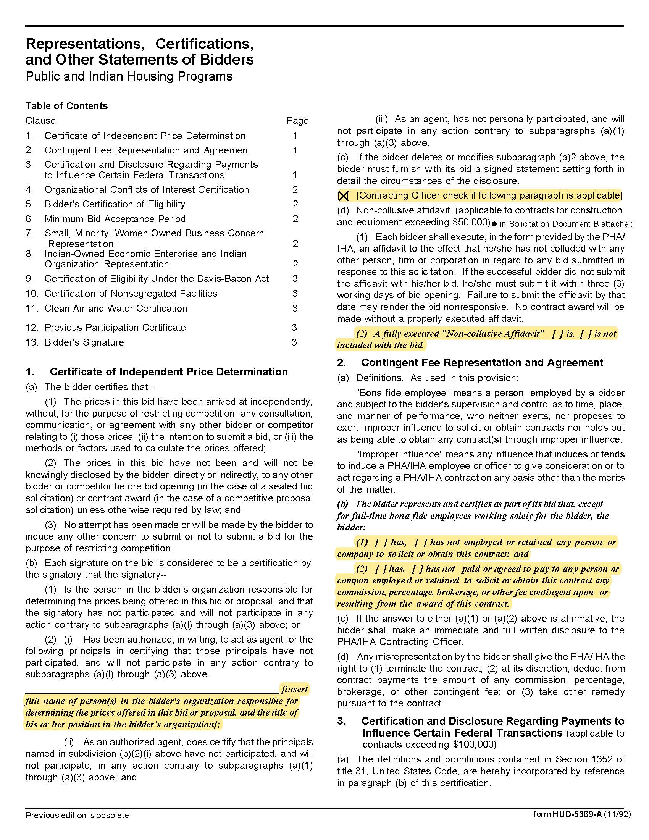

Construction Manager at Risk Services for Austin Homes/Bell Street Flats Phase 1B C21004
Solicitation Document C: HUD Form 5369A - Continued
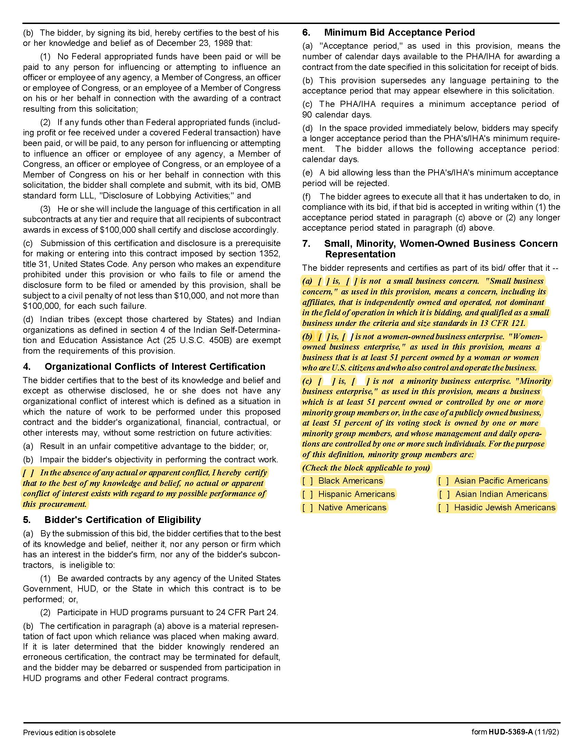

Construction Manager at Risk Services for Austin Homes/Bell Street Flats Phase 1B C21004
Solicitation Document C: HUD Form 5369A - Continued

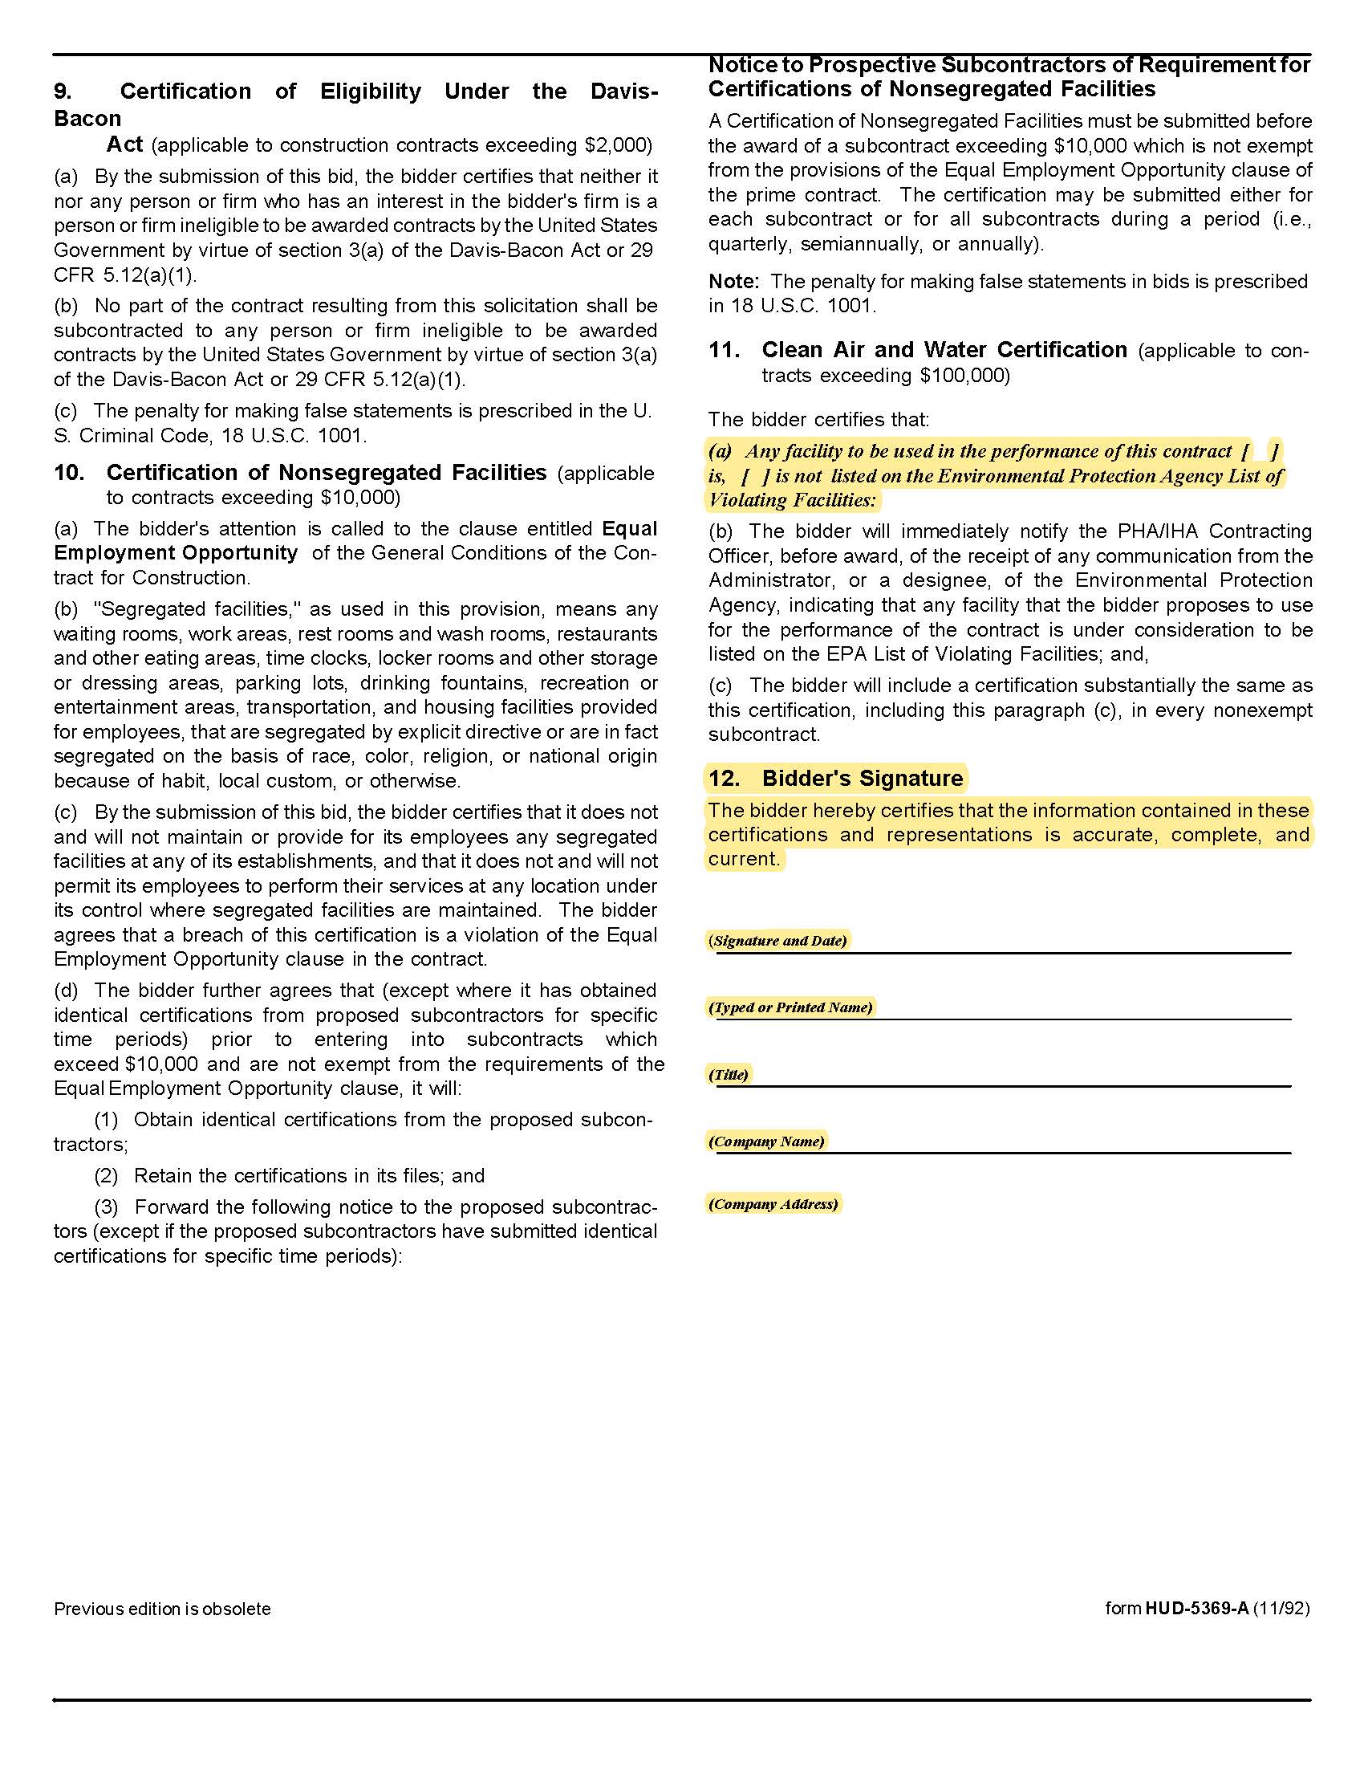

Construction Manager at Risk Services for Austin Homes/Bell Street Flats Phase 1B C21004

Solicitation Document D: Introduction

This is a one to two page introductory letter that:

- Provides a high level introduction of your company.

- Explains the type of organization (Corporation, Partnership, Joint Venture, LLC, et cetera).

- State of Tennessee Contractor's License Number, Expiration Date, Classification and Limit.

- Details of your company’s history and expertise.

- Details why the project is of interest to you.

- Explains why KCDC should select your company.

Construction Manager at Risk Services for Austin Homes/Bell Street Flats Phase 1B C21004
Solicitation Document E: Construction Manager’s Experience

Use this section to provide:

- Provide a summary of similar projects completed in the last five years. Specifically, highlight and
provide details (project dates, client info, budget/costs, project size, et cetera) for projects that were multifamily residential, a part of a multiphase development, and utilized the construction manager at risk delivery method.

- Please provide three references. References should include clients on one or more of the projects
highlighted in the section above.

Construction Manager at Risk Services for Austin Homes/Bell Street Flats Phase 1B C21004
Solicitation Document F: Resources

Use this section to provide:

1. Provide an organizational chart showing the proposed structure, interrelationships and interactions of the proposed CMAR team. Describe the proposed roles and estimated involvement for the listed key personnel during pre-construction, construction, and/or throughout the project and include resumes for each. Include similar project experience for each proposed team member.

2. Your current workload (committed projects that are either in construction and pre-construction) and the respective scheduled completion dates for each project.

3. Identify any consultants you would propose to engage during the preconstruction and construction phase. Please describe previous professional experiences or collaboration, if any, with Johnson Architecture, Southeast Ventures, Civil Engineering Consultants, or Partners’ Development.

Construction Manager at Risk Services for Austin Homes/Bell Street Flats Phase 1B C21004
Solicitation Document G: Technical Approach

Use this section to provide information that explains your technical approach to the project. Include:

1. A brief description of the organization’s approach to ensure the successful development of the project. Include how your organization will fit within the Project Team and the anticipated level of involvement from different members of the project team throughout each phase.

2. Identify any components of the Scope of Work included in the RFP (see paragraph18) that the organization is unable to perform or if additional scope should be included but is not currently listed.

3. Your process for assuring the project cost is within the scope and budget and completed on time.

4. Identification of the risks you would anticipate on this type of project, and provide the countermeasures you would employ to minimize those risks.

5. Your plan to attract, retain and use small businesses plus minority, women and veteran owned subcontractors. Inclusion of these companies is very important to KCDC and the supplier must have an effective plan for attracting these companies as participants.

Construction Manager at Risk Services for Austin Homes/Bell Street Flats Phase 1B C21004
Solicitation Document H: Cost of Services

Use this section to provide information that explains your fee proposal and supports your financial strength to provide the necessary bonding capacity. Include:

1. Cost Items Details (do not alter the structure below)

a | Assuming a construction budget of $30,000,000 state the lump sum preconstruction fee. | $
b | Provide a proposed construction management fee including overhead and profit applicable to a project construction budget of approximately $30,000,000. | %
c | State the general conditions cost during construction (on a monthly basis) based on the General Requirements required per Appendix 3 | $
d | General Liability Insurance Rate | $
e | Builders Risk Rate | $
f | Performance and Payment Bond Rate | $

2. Provide a summary of the organization’s financial capability to ensure a payment and performance bond in an amount equal to 100% of the construction cost limitation noted above.

3. A listing of current and projected bonding capacity within the next 12 months to 24 months.

4. A demonstration of your organization's safety record by providing your Experience Modification
Rating (EMR) and corresponding man-hours of work performed for the past 5 years.

Construction Manager at Risk Services for Austin Homes/Bell Street Flats Phase 1B C21004

Appendix 1: Insurance Requirements

INSURANCE
The Supplier shall maintain, at Supplier’s sole expense, on a primary and non‐contributory basis, at all times during the life of the contract insurance coverages, limits, and endorsements described herein. All insurance must be underwritten by insurers with an A.M. Best rating of A- :VI or better. Upon award, the Supplier shall provide Certificate(s) of Insurance and amendatory endorsements to KCDC evidencing said insurance coverages. See paragraph “h” for exact naming of certificate holder and additional insured.

The Supplier agrees the insurance requirements herein as well as KCDC’s review or acknowledgement, is not intended to and shall not in any manner limit or qualify the liabilities and obligations assumed by the Supplier under this contract. KCDC’s failure to require a certificate of insurance, acceptance of a non-conforming certificate, or allowing the Supplier to commence work shall not operate as a waiver of these minimum insurance requirements or the liabilities and obligations assumed by the Supplier under this contract.

a. Commercial General Liability Insurance: occurrence version general liability insurance with a minimum combined single limit of $1,000,000 per occurrence with $2,000,000 in the aggregate with a minimum of $5,000,000 per occurrence umbrella covering the following perils: bodily injury, personal injury, and broad form property damage including products/completed operations for one year after completion of the Project(s). Limits must apply separately to the work/location(s) in this contract.

Such insurance shall contain or be endorsed to contain a provision that includes KCDC, its officials, officers, employees, and volunteers and any lender and/or investor as required as additional insureds with respect to the Supplier’s ongoing and completed operations, providing coverage at least as broad as CG 20 10 07 04 and 20 37 07 04 endorsements. The coverage shall contain no special limitations on the scope of its protection afforded to the listed insureds.

b. Commercial Automobile Liability Insurance: in an amount not less than $1,000,000 (combined single limit) for all owned, hired, and non-owned vehicles utilized by Supplier in connection with the Project. Coverage is to include coverage for loading and unloading hazards.

Such insurance shall contain or be endorsed to contain a provision that includes KCDC, its officials, officers, employees, and volunteers and any lender and/or investor as required as additional insureds

c. Umbrella Liability Insurance: following form in the amount of $5,000,000 per occurrence in excess of the Commercial General Liability, Commercial Automobile Insurance, and Employers’ Liability Insurance.

Unless the Umbrella Liability provides coverage on a pure/true follow‐form basis, or KCDC, its officials, officers, employees, and volunteers and any lender and/or investor as required are automatically defined as additional insureds, the Supplier shall add them by endorsement.

d. Workers’ Compensation Insurance and Employers’ Liability Insurance: Workers’ Compensation Insurance with statutory limits as required by the State of Tennessee or other applicable laws.

e. Pollution Liability Insurance: coverage, providing defense and indemnity coverage for bodily injury, property damage, and environmental investigation and clean‐up costs for pollution conditions arising from the Contractor’s operations. Limit of liability not less than $1,000,000 each occurrence and $2,000,000 annual aggregate. The policy shall include a minimum three (3) year Discovery (tail) reporting period, and a Retroactive Date that equals or precedes the effective date of this contract or the performance of work hereunder. Coverage may be provided on a per project basis.

Such insurance shall contain or be endorsed to contain a provision that includes KCDC, its officials, officers, employees, and volunteers and any lender and/or investor as required as additional insureds

f. Builder’s Risk (Supplier shall procure and maintain or shall cause to be procured and maintained Builder’s Risk Insurance: : coverage shall be written on an All‐Risk, Replacement Cost, and Completed Value Form basis in an amount at least equal to one‐hundred percent (100%) of the projected completed value of the Work, as well as subsequent modifications of that sum due to Change Order(s). Supplier agrees to be responsible for reporting increases in the projected completed value of the work due to Change Order(s).

Coverage shall insure without limitation against the perils of fire(with extended coverage) and physical loss or damage including, but not limited to and without duplication of coverage, theft, vandalism, malicious mischief, collapse, windstorm, testing and startup, temporary buildings, portions of the work stored off site, all portions of the work in transit, debris removal including demolition occasioned by enforcement of any applicable legal requirements and shall cover reasonable compensation for Architect’s and Supplier’s services and expenses required as a result of such insured loss.

Coverage shall insure without limitation slab on grade, excavations, foundations, caissons, tenant finish work, and retainage walls around the perimeter of the project. Any exclusion of so‐called underground damage to pipes, collapse of structure, or damage resulting from explosion or blasting shall be deleted.

Insurance is to cover all property of Supplier (and its subcontractors), KCDC and all certificate holders
as their interest may appear.

Coverage shall include soft costs resulting from damage or destruction to insured property on‐site and while in transit including flood, earthquake and earth movement when such perils are required. Such insurance shall cover continuing expenses not directly involved in the direct cost of construction/renovation, including expense incurred upon money borrowed to finance construction or repair, continuing interest on mortgage loans, advertising, promotion, realty taxes and other assessments, the cost to the insured of additional commissions incurred upon re‐negotiating leases, and other expenses incurred as a result of property loss or destruction by an insured peril.

g. Other Insurance Requirements:

- Upon award, Supplier shall furnish KCDC with original Certificate(s) of Insurance and amendatory endorsements effecting coverage required by this section.

- Provide a waiver of subrogation for each required policy herein. When required by the insurer, or should a policy condition not permit Supplier to enter into a pre‐loss agreement to waive subrogation without an endorsement, the policy should be endorsed with a Waiver of Transfer of Rights of Recovery Against Others, or its equivalent. This waiver of subrogation requirement shall not apply to any policy which includes a condition specifically prohibiting such an endorsement, or voids coverage should supplier enter into such an agreement on a pre‐loss basis.

- A minimum 30‐day cancellation notice for all insurances (by endorsement if necessary) is required.

- Replace certificates, policies, and endorsements for any such insurance expiring prior to completion of services.

- Maintain such insurance from the time services commence until services are completed or through such extended discovery/reporting/tail period as required. Failure to maintain or renew coverage or to provide evidence of renewal may be treated by KCDC as a material breach of contract.

- Any deductibles and/or self‐insured retentions greater than $50,000 must be disclosed to and approved by KCDC prior to the commencement of services. Use of large deductibles and/or self‐ insured retentions will require proof of financial ability as determined by KCDC.

- All policies must be written on an occurrence basis with the exception of Errors and Omissions Liability (E & O) / Professional Liability and Pollution Liability which may be claims made coverage.

8. Require all subcontractors to maintain during the term of the resulting contract commercial general liability insurance, automobile liability insurance, and workers’ compensation/employers liability insurance (unless subcontractor’s employees are covered by supplier’s insurance) in the same manor and limits as specified for the Supplier.

h. Certificate Holders and Additional Insured:
KCDC, its officials, officers, employees, and volunteers
901 N Broadway
Knoxville, TN 37917
Any KCDC affiliates as required

And any lender and/or investor as required.

i. Right to Revise or Reject: KCDC reserves the right to revise any insurance requirement, including but not limited to, limits, coverages, and endorsements based on changes in scope of work/specifications, insurance market conditions affecting the availability or affordability of coverage.

j. No Representation of Coverage Adequacy: The coverages, limits or endorsements required herein protect the primary interests of KCDC, and the Supplier agrees in no way should these coverages, limits or endorsements required be relied upon when assessing the extent or determining appropriate types and limits of coverage to protect the Supplier against any loss exposures, whether as a result of the project or otherwise.

Certificate Holder & Additional Insured | KCDC, its officials, officers, employees, and volunteers  901 N Broadway  Knoxville, TN 37917
GL (Supplier & Subcontractors) | $1M / $2M
Umbrella (Supplier only) | $5M
Auto (Supplier & Subcontractors) | $1M (owned, hired, & non-owned)
WC & Employers Liability (Supplier & Subcontractors) | Statutory limits
Pollution Liability (Supplier only) | $1M / $2M ISO CG 0039, or equivalent
Builders Risk (Supplier only) | 100% of projected completed value
30-day cancellation (Supplier & Subcontractors) | Required– must indicate on COI
Primary non-contributory (Supplier & Subcontractors) | Required – must indicate on COI
Waiver of Subrogation (Supplier & Subcontractors) | Required for each policy – must indicate on COI

Construction Manager at Risk Services for Austin Homes/Bell Street Flats Phase 1B C21004

Appendix 2: Austin Homes Site Plan

Construction Manager at Risk Services for Austin Homes/Bell Street Flats Phase 1B C21004

Appendix 3: Service Fee Allocation

 | General Conditions | CM Fee | Preconstruction | Paid By Owner
Personnel Expenses, Including
Superintendent | X
Assistant Superintendent (Indicate if required) | X
Estimator |  | X | X
Project Manager | X |  | X
Project Engineer (Indicate if required) | X
Project Assistants/Office Staff | X
Project Accounting |  | X
Project Executive |  | X | X
Monthly Photos & Reports | X
Scheduling |  | X | X
As-Builts | X
Manuals | X
Prints, Copies, etc. |  |  | X
Mileage | X
Toilets, Temporary Building | X
Cell Phone Service/Internet | X
Equipment: Cameras, Computers, Phone, Print, Copy, Fax | X
Safety Supplies (First Aid, Hard Hats, etc.) | X
Testing (Pre-specified) |  |  |  | X
Mobilization | X
Temporary Utilities |  |  |  | X
Project Signage | X
General Liability Insurance (Provide Rate) | X
Builders Risk (Provide Rate) | X
Performance & Payment Bond (Provide Rate) | X

