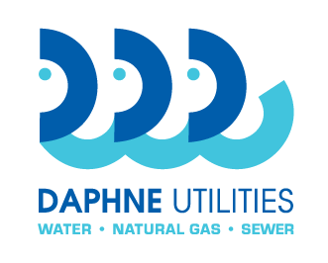
Daphne Utilities
Request for Bid
Sludge dewatering
RFB 21-08

Scope of Work
Contractor shall provide a turnkey operation which will include all materials,
equipment, labor and required permits necessary to complete
sludge dewatering, removal and disposal in full compliance with EPA guidelines.

Sludge must be converted into Class A/EQ material in full compliance with 40 CFR part 503. Bulk density shall be 70lb/ft. Total pathogen destruction shall be in accordance with EPA’s Class A requirements. The processed sludge shall meet or exceed Class A EPA and DPNR standards. Contractor must submit the PFRP permits from EPA approving their process as set forth above to Daphne Utilities as part of their bid submittal.
Contractor must have on retainer an EPA certified lab, approved by the WRF Manager or designee, to test the processed sludge for compliance with 40 CFR part 503, including monitoring for metals, pathogens and vector attraction reduction. Contractor shall be responsible for sampling pursuant to all regulatory requirements. Chain of custody reports and all test reports and analyses must be provided to Daphne Utilities in a timely manner. All sampling shall be conducted in accordance with EPA guidelines. Contractor is solely responsible for payment and scheduling of testing and sampling.
Daphne Utilities will schedule dewatering service as needed with at least three (3) days lead time to begin the process. If Contractor fails to meet a scheduled start date, the cost of alternative measures taken to dewater, remove and dispose of sludge will be deducted from any payments as liquidated damages. Any defects in the work performed must be corrected before payment for services is accomplished. Daphne Utilities does not guarantee any amount of sludge to be processed on a monthly or annual basis. Based on current data, Daphne Utilities estimates 450,000 gallons to be processed monthly.

Bid Form

Cost per gallon $__________
Daphne Utilities does not guarantee any amount of sludge to be processed
on a monthly or annual basis. Based on current data, Daphne Utilities
estimates 450,000 gallons to be processed monthly.

I have read and understood the terms and conditions and the bid specifications of this bid. I have provided or will provide at the appropriate time, all documentation required. Omission of any required documentation may result in the bid being deemed unresponsive by Daphne Utilities.
Under penalty of perjury, bidder certifies that this bid has been arrived at by the bidder independently and has been submitted without collusion with any other vendor of materials or services for the type described in this invitation to bid.

Submitted by: __________________________________________________________ Company name of bidder

_________________________________________________________________________________________
By: company officer name

_________________________________________________________________________________________
Signature

__________________________________________ ________________________________ Title Date

_________________________________________________________________________________________
Company address, city, state, zip

___________________________________________ ________________________________
Phone EIN / tax id number

___________________________________________ ________________________________
Point of contact name Point of contact phone

___________________________________________
Point of contact email

