Solicitation Document A |  |  |  | General Information about the Supplier
Note: Complete all cells even if the answer if “Does not apply”
Sign Your Name to the Right of the Arrow
If completing this document in Adobe, an electronic signature is acceptable to KCDC.
Your signature indicates you read and agree to “KCDC’s General Instructions to Suppliers” (www.kcdc.org) and that you are authorized to bind the supplier or are submitting the response on behalf of and at the direction of the suppliers’ representative authorized to contractually bind the supplier. I represent that the supplier or its applicable representative(s) has reviewed the information contained in this Solicitation Package and that the information submitted is accurate.
Printed Name and Title
Legal Corporate Name
Street Address
City/State/Zip
Contact Person (Please Print Clearly)
Telephone Number
Cell Number
Supplier’s E-Mail Address (Please Print Clearly)
Addenda
Addenda are at www.kcdc.org. Click on “Procurement” and then on “Open Solicitations” to find addenda. Please check for addenda prior to submitting a proposal.
Acknowledge addenda have been issued by checking below as appropriate:
None ☐ | Addendum 1 ☐ |  |  |  | Addendum 2 ☐ |  | Addendum 3 ☐ |  | Addendum 4 ☐ |  | Addendum 5 ☐
Statistical Information (Check a box in each of the next four lines)
1. This business is at least 51% owned and operated by a woman |  |  |  |  |  |  |  |  |  |  | Yes ☐ No ☐
2. This business qualifies as a small business by the State of Tennessee  Total gross receipts of not more than $10,000,000 average over a three-year period  OR employs no more than 99 persons on a full-time basis |  |  |  |  |  |  |  |  |  |  | Yes ☐ No ☐
3. This business is at least 51% owned and operated by a veteran |  |  |  |  |  |  |  |  |  |  | Yes ☐ No ☐
4. This business is owned & operated by persons at least 51% of the following ethnic background:
Asian/Pacific  ☐ |  | Black  ☐ | Hasidic Jew  ☐ |  |  | Hispanic  ☐ |  | Native American ☐ |  | White  ☐ | Publicly Owned ☐
Prompt Payment Discount Statement
A ____% prompt payment discount applies when KCDC makes payment in ____ days of accurate invoicing.

Cooperative Procurement
Subject to additional location/delivery charges, the supplier agrees to extend the offered costs to other governments if the government so desires. Yes ☐ No ☐
RRP Statement
As described in paragraph 20, this firm is RRP certified or intends to use a RRP certified subcontractor to satisfy these requirements. Submit copies of certifications Yes ☐ No ☐

Solicitation Document A | Pricing

1. Regular Work Hours/Timeframes

Pricing (inclusive of all labor, miscellaneous supplies, overhead, profit, administration and all other fees)
Plumbing Technician | $ per man-hour
Plumbing Apprentice | $ per man-hour
Plumbing Helper | $ per man-hour
Plumbing Journeyman | $ per man-hour
Backhoe Operator | $ per man-hour
Skidsteer Operator | $ per man-hour
Dump Truck Driver | $ per man-hour

2. Emergency Work Hours/Timeframes

Pricing (inclusive of all labor, miscellaneous supplies, overhead, profit, administration and all other fees)
Plumbing Technician | $ per man-hour
Plumbing Apprentice | $ per man-hour
Plumbing Helper | $ per man-hour
Plumbing Journeyman | $ per man-hour
Backhoe Operator | $ per man-hour
Skidsteer Operator | $ per man-hour
Dump Truck Driver | $ per man-hour

3. Other Fees (applies to both routine and emergency situations)

Work (labor) is guaranteed for how many years?
Materials are guaranteed for how many years?
Mark up on materials | %
Service Truck Charge (total for each day) | $
Service Charge per Job | $
Mini-Excavator Per Day | $
Dump Truck Per Day | $
Pump Vacuum Truck per Day | $
Backhoe Per Day including Transport Fees | $
Camera Sewer Lines | $ Per:

Solicitation Document B | Affidavits

Conflict of Interest
1. No commissioner or officer of KCDC or other person whose duty it is to vote for, let out, overlook or
in any manner superintend any of the work for KCDC has a direct interest in the award or the supplier providing goods or services.

2. No employee, officer or agent of the grantee or sub-grantee will participate in selection, or in the award or administration of an award supported by federal funds if a conflict of interest, real or apparent, would be involved. Such a conflict would arise when the employee, officer or agent, any member of his immediate family, his or her partner, or an organization, which employs, or is about to employ, any of the above, has a financial or other interest in the supplier selected for award.

3. The grantee's or sub-grantee's officers, employees or agents will neither solicit nor accept gratuities, favors or anything of monetary value from suppliers, potential suppliers, or parties to sub-agreements.

4. By submission of this form, the supplier is certifying that no conflicts of interest exist.

Drug Free Workplace Requirements
5. Private employers with five or more employees desiring to contract for construction services attest that they have a drug free workplace program in effect in accordance with TCA 50-9-112.

Eligibility
6. The supplier is eligible for employment on public contracts because no convictions or guilty pleas or pleas of nolo contender to violations of the Sherman Anti-Trust Act, mail fraud or state criminal violations with an award from the State of Tennessee or any political subdivision thereof have occurred.

General
7. Supplier fully understands the preparation and contents of the attached offer and of all pertinent circumstances respecting such offer.

8. Such offer is genuine and is not a sham offer.

Iran Divestment Act
9. Concerning the Iran Divestment Act (TCA 12-12-101 et seq.), by submission of this bid/quote/proposal, each supplier and each person signing on behalf of any supplier certifies, and in the case of a joint bid/quote/proposal, each party thereto certifies as to its own organization, under penalty of perjury, that to the best of its knowledge and belief that each supplier is not on the list created pursuant to § 12-12-106.

Accuracy of Electronic Copies
10. If the supplier provides electronic copies of the bid/proposal/quote to KCDC, the supplier certifies that the information provided on paper and in the electronic format is identical unless specifically noted otherwise.

General
11. Neither the said supplier nor any of its officers, partners, owners, agents, representatives, employees or parties interest, including this affiant, has in any way colluded conspired, connived or agreed, directly or indirectly, with any other responder, supplier, or person to submit a collusive or sham offer in connection with the award or agreement for which the attached offer has been submitted or to refrain from making an offer in connection with such award or agreement, or collusion or communication or conference with any other supplier, or, to fix any overhead, profit, or cost element of the offer price or the offer price of any other supplier, or to secure through any collusion, conspiracy, connivance, or unlawful agreement any advantage against KCDC or any person interested in the proposed award or agreement.

12. The price or prices quoted in the attached offer are fair, proper and not tainted by any collusion, conspiracy, connivance, or unlawful agreement on the part of the supplier or any of its agents, representatives, owners, employees, or parties in interest, including this affiant.

No Contact/No Advocacy Affidavit
13. After this solicitation is issued, any contact initiated by any supplier with any KCDC representative concerning this solicitation is strictly prohibited-except for communication with the Procurement Division. My signature signifies that no unauthorized contact occurred.

14. To ensure the integrity of the review and evaluation process, respondents to this solicitation nor any firm representing them, may not lobby or advocate to KCDC staff or Board members. My signature signifies that no unauthorized advocacy occurred.

Non-Boycott of Israel Affidavit
15. Concerning the Non-Boycott of Israel Act (TCA 12-4-1 et seq.), by submission of this bid/quote/proposal, each supplier and each person signing on behalf of any supplier certifies, and in the case of a joint bid/quote/proposal, each party thereto certifies as to its own organization, under penalty of perjury, that to the best of its knowledge and belief that each supplier is not boycotting Israel pursuant to § 12-4-1 and will not during the term of any award. Note: Applicable only to contracts of $250,000 or more and to suppliers with 10 or more employees.

The undersigned hereby acknowledges receipt of these affidavits and certifies that the submittal in response to this solicitation is in full compliance with the listed requirements. Failure to properly acknowledge issues concerning the above is grounds for bid rejection and may subject the signer to penalties as directed by the appropriate laws.

Signed by
Printed Name
Title

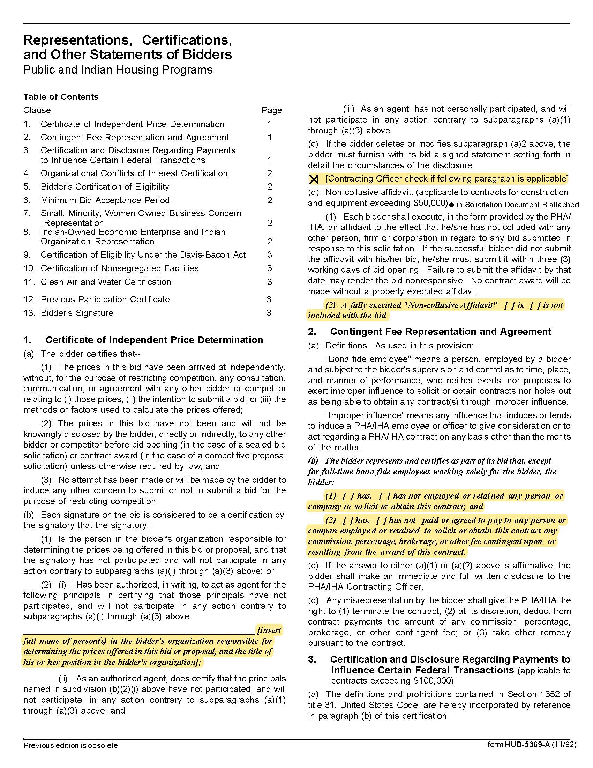
Solicitation Document C | HUD Form 5369A

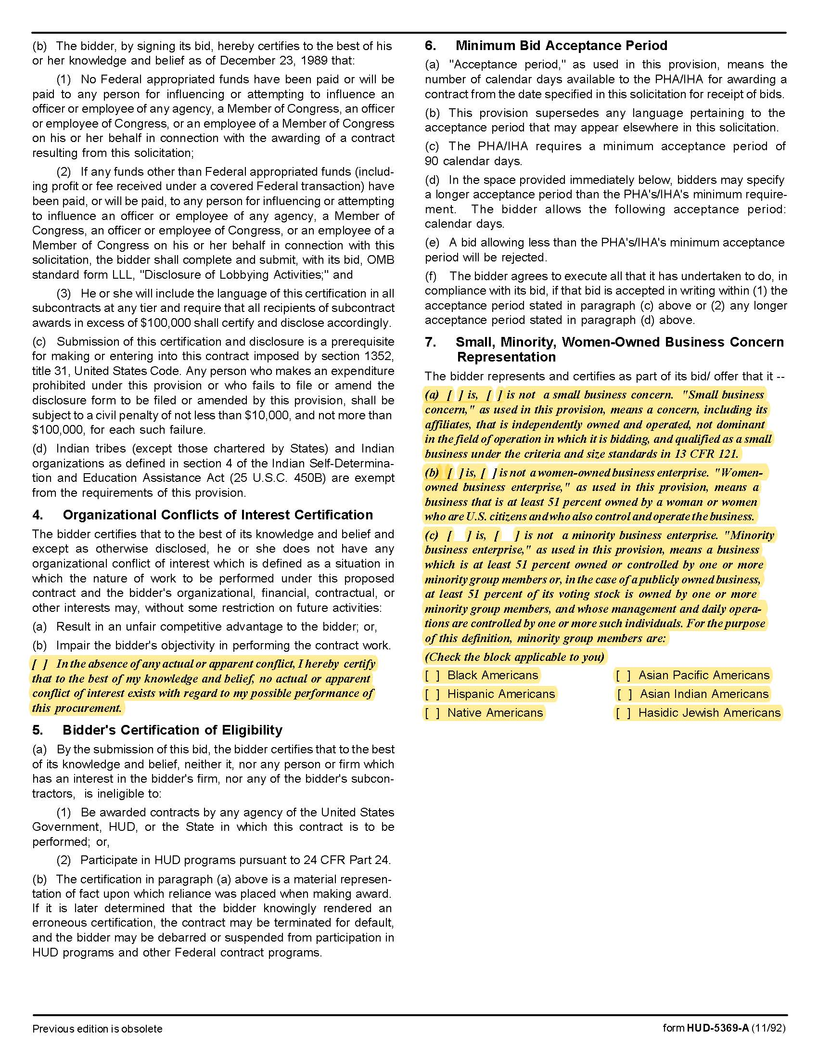

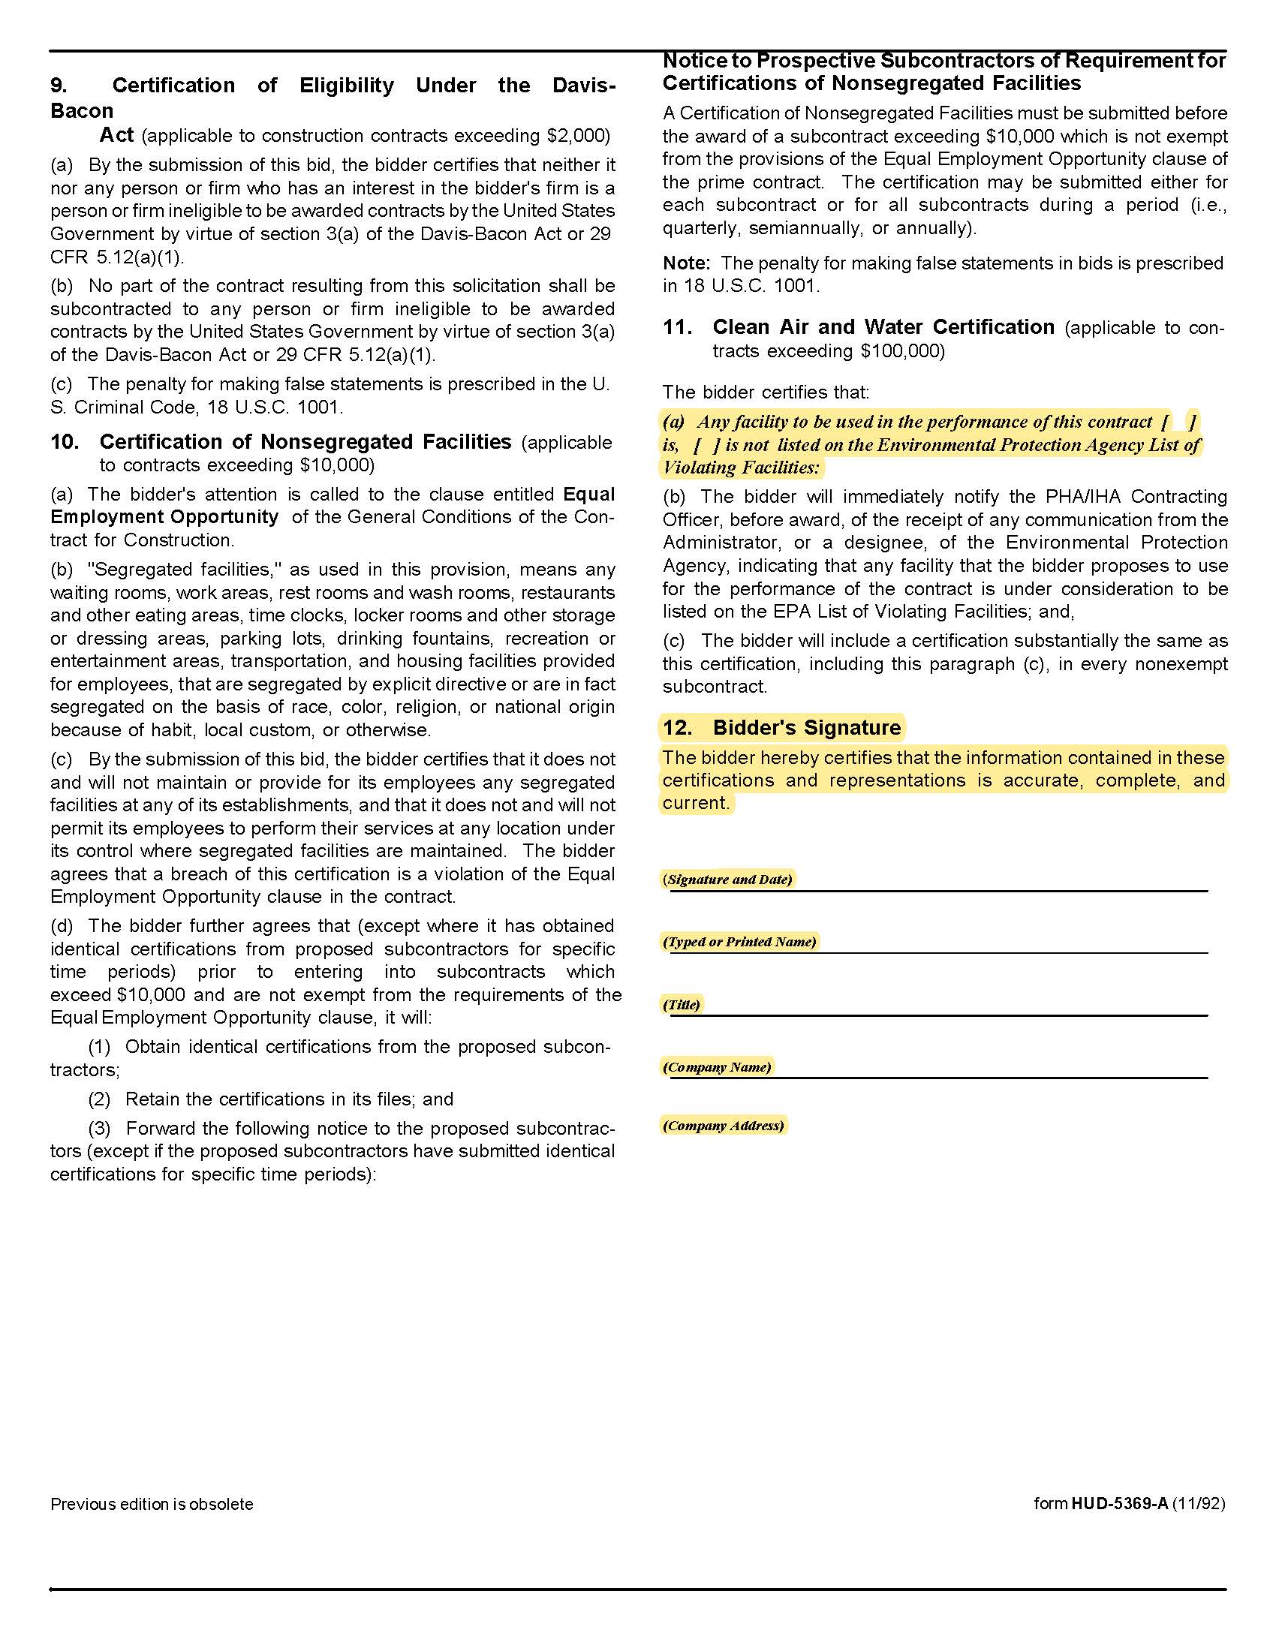

Appendix 1 | Insurance Requirements

Insurance Agent’s Statement and Certification:
I have reviewed these insurance requirements with the bidder/proposer named below and have told the bidder/proposer that the required coverage will be available and have advised the bidder/proposer of any additional costs that may be entailed with the coverages.

Insurance Agency 1 Name: ______________________________________________________________

Authorizing Signature: _______________________________________________________________

Insurance Agency 2 Name: ______________________________________________________________

Authorizing Signature: _______________________________________________________________

Insurance Agency 3 Name: ______________________________________________________________

Authorizing Signature: _______________________________________________________________

Bidder’s/Proposer’s Statement and Certification:
I certify that:

1. I have reviewed these requirements with my insurance agent(s).

2. If awarded the contract, I and my subcontractors (if any) will comply with the insurance requirements herein.

3. I/my insurance agency take no exceptions to the listed insurance requirements.

4. My subcontractors (if any) take no exceptions to the listed insurance requirements.

Bidder’s Name: _______________________________________________________________

Authorizing Signature: _______________________________________________________________

