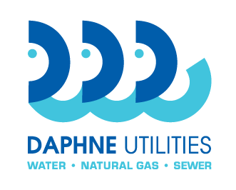
Daphne Utilities
Marinda Turner, Buyer
251-210-1647 Office
marinda@daphneutilities.com

Request for Bid no.: | RFB 21-03
Name of bid: | Digester Aeration/Mixing Modifications
Contact person: | Goeff Wilkins 251-533-5342  Marinda Turner 251-210-1647

Bid Form
I have read and understood the terms and conditions and the bid specifications of this bid. I have provided or will provide at the appropriate time, all documentation required. Omission of any required documentation may result in the bid being deemed unresponsive by Daphne Utilities.

Submitted by: __________________________________________________________ Company name of bidder

_________________________________________________________________________________________
By: company officer name

_________________________________________________________________________________________
Signature

__________________________________________ ________________________________ Title Date

_________________________________________________________________________________________
Company address, city, state, zip

___________________________________________ ________________________________
Phone EIN / tax id number

___________________________________________ ________________________________
Point of contact name Point of contact phone

___________________________________________
Point of contact email

