Attachment A
2024-2026 Mowing Specifications
- Fill out a per-one-time mowing of the Winchester Airport grounds for each mowing season/year on the bid submittal form. A minimum of five (5) per-one-time mowings will be granted to the winning bidder, per mowing season/year. Submit your bid for the total price for five (5) mowings for each mowing season/year on the provided line of the bid submittal form. Additional one-time mowings may be requested, as needed, based on the seasonal per-one-time mowing season price listed on the Bid Submittal Form for the corresponding year.
- The term of the mowing contract is for the duration of the 2024, 2025, and 2026 calendar years that encompass a total of three mowing seasons.
- For reference, the main airport property is approximately 6,400 feet long, north to south, and 1,000 feet wide, west to east. Total mowing acreage (including off airport) is approximately 200 - 225 acres.
- Bidder must be able to commence mowing operations within five (5) calendar days upon the request of the Airport Manager. (Time may be extended at the Airport Manager’s discretion due to weather or airport events.)
- Bidder must be able to fully complete each one-time mowing within three (3) days upon commencing. (Time may be extended at the Airport Manager’s discretion due to weather or airport events.)
- The areas to be mowed are designated on the attached document. All designated areas must be cut NO LOWER than five (5) inches and NO HIGHER than eight (8) inches. Ideal cut height is six (6) inches.
- Once the contract is granted the winning bidder may be able to omit certain areas to be mowed due to a potentially hazardous condition; however, only with the Airport Manager’s permission.
- Once the contract is granted the winning bidder WILL NOT be permitted to operate equipment upon or within ten (10) feet of areas indicated as runway or ramp areas. Equipment must be operated in the grass as much as possible. When the crossing of a taxiway is required, great care MUST be given to the tracking of dirt, rocks, and mud onto any aircraft operating areas.
- Once the contract is granted the winning bidder can only operate equipment inspected and approved by the Airport Manager. (For the safety of airmen and to ramped aircraft.)
- Once the contract is granted the winning bidder shall be allowed to store equipment in a designated area of the Airport designated by the Airport Manager for a period of no more than five (5) days.
- It is at the Airport Manager’s discretion to terminate any contract granted to any persons due to safety concerns or breach of contract. (Appeals may be granted through Winchester Airport Authority, Inc.)

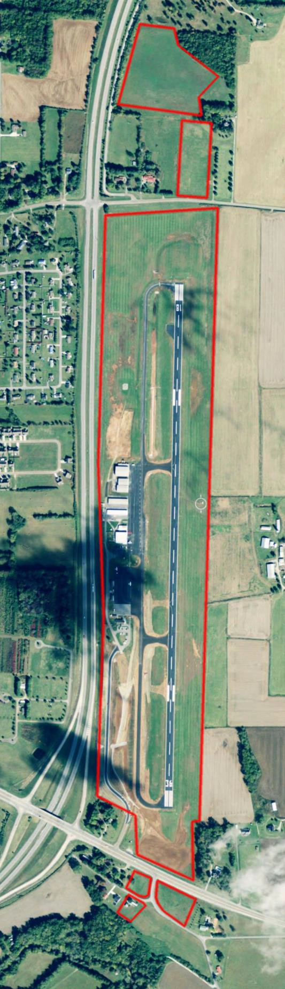

Attachment B

Attachment C
CONFLICT OF INTEREST CERTIFICATION
(This form must be completed and submitted with your bid).

The Winchester Airport Authority, Inc. operates pursuant to certain general procurement standards that address conflicts of interest, which are set out in its Purchasing Policy and state that Authority “officers, employees, and agents who participate in any phase of the purchasing function are to be free of interests or relationships which are actually or potentially hostile or detrimental to the best interests of the Winchester Airport Authority, Inc. and shall not engage in or participate in any commercial transaction involving the Winchester Municipal Airport, in which they have a real or apparent conflict of interest.” The Authority’s written Purchasing Policy further states; “Such a conflict of interest would arise when the employee, officer, agent, or any member of his or her immediate family, his or her partner, or an organization which employs or is about to employ any of the parties indicated herein, has a financial or other interest in or a tangible personal benefit from a firm considered for a contract.”

Your signature below certifies that according to the above guidelines, there is no conflict of interest for your company to submit a bid or proposal.

Signature:

PLEASE PRINT THE FOLLOWING INFORMATION:

Name:

Title or Position:

Company Name:

Address:

City, State & Zip:

Telephone Number(s):

Email Address:

Attachment D
DRUG FREE WORKPLACE AFFIDAVIT

STATE OF COUNTY OF

The undersigned, principal officer of , the Contractor, an employer of five or more employees contracting with , the Owner, to provide Bush hogging/land clearing services, hereby states under oath as follows:
- The undersigned is a principal officer of the Contractor and is duly authorized to execute this Affidavit on behalf of the Contractor.
- The Contractor submits this Affidavit pursuant to Tennessee Code Annotated (TCA) § 50-9- 113, which requires each employer with five or more employees receiving pay who contracts with the state to provide construction services to submit an affidavit stating that such employer has a drug-free workplace program that complies with TCA Title 50, Chapter 9.
- The Company is in compliance with TCA § 50-9-113. Further affiant stateth not.

Principal Officer

STATE OF COUNTY OF _

Before me personally appeared , with whom I am personally acquainted (or proved to me on the basis of satisfactory evidence), and who acknowledged that such person executed the foregoing affidavit for the purposes therein contained.
Witness my hand and seal at office this day of , 20__.

Notary Public

My commission expires:

END OF AFFIDAVIT

Drug Free Affidavit Page 1 of 1

