

ROCKWOOD SCHOOL DISTRICT

REQUEST FOR PROPOSALS

RFP No.: RFP0523OBSOLTEXTBKS

Title: Sale of Obsolete Textbooks 2023

Issue Date: May 8, 2023

Sealed Bid Due Date: May 22, 2023 @ 2:00 p.m. CST

GENERAL INTRODUCTION TO BIDDERS

The Rockwood School District (the District) will be accepting sealed bids for the sale of obsolete textbooks grades K-12. The obsolete textbooks are located throughout the district located in St Louis County Missouri. A comprehensive list of books with ISBN numbers is attached as Exhibit A.

Please follow the mailing or delivery instructions below. All inquiries of the RFP shall be in writing and directed to Veronica Woll, Purchasing Agent at wollveronica@rsdmo.org.

Bidders will submit the enclosed Bid Form as their proposal. Sealed bids must be received no later than 2:00 p.m. CST on Monday, May 22, 2023. Please make sure the envelope is clearly marked “RFP0523OBSOLTEXTBKS”.

BIDS SHALL BE SUBMITTED TO:

Purchasing Agent
Rockwood School District
RFP0523OBSOLTEXTBKS
111 East North Street
Eureka, Missouri 63025

Bids will be opened at that time and the successful bidder will be notified by close of business on May 22, 2023. The District reserves the right to reject any and all proposals, and to waive any irregularities or informalities in any proposals. Conditional proposals will not be accepted.

Terms of this sale are a Cashier’s Check or Money Order, payable to Rockwood School District, and must be received by 3:30 p.m. Monday, June 5, 2023. All books must be removed by the winning bidder by 3:00 p.m. on Friday, June 30, 2023.

Sincerely,


Veronica Woll
Purchasing Agent
(636) 733-2033

IMPORTANT DATES

May 8, 2023 (Mon) Issue RFP /2:00 PM CST
May 12, 2023 (Fri) Deadline for Vendor Clarification /Noon
May 22, 2023 (Mon) Bid Due 2:00 p.m. CST & Awarded by End of Business Day
June 5, 2023 (Mon) Payment Due by 3:30 p.m. CST
June 5--30, 2023 Vendor to Pick-Up Books from Each School Building

TERMS & CONDITIONS

INFORMATION
Rockwood School District offers for sale all items on an “as is, where is” basis. The District is a “casual seller” of obsolete property and does not inspect, test, certify, or provide an express or implied warranty on the items(s) sold. The Buyer accepts the items(s) “as is, where is” and is responsible for their own verification of the item’s condition. Rockwood School District has strived to provide an accurate count of all items; however, some quantities may vary. The District is not responsible for accidents or items left after June 30, 2023.

BID PRICE
The bid process quoted must be the actual price Rockwood School District will receive. No deductions will be allowed for transportation charges, permits, commissions, etc. The bid price shall be inclusive of all textbooks listed on the included spreadsheet(s).

Bid price must be entered in the space provided on the Bid Form. All information requested on the Bid Form must be entered, and the Bid Form must be signed to validate your bid. Unsigned bids will be rejected.

AWARD
The District reserves the right to split the award or to make multiple awards, and to make award on a part or portion of a proposal.

PAYMENT & REMOVAL
Terms of this sale are a Cashier’s Check or Money Order, payable to Rockwood School District, and the successful bidder will make full payment by 3:30 p.m. on Monday, June 5, 2023. The Rockwood School District will not be responsible for property after 3:00 p.m. on June 30, 2023. The successful bidder will be required to provide all equipment and labor or compete removal of property. The successful bidder will be responsible for damage to District property caused by moving. The locations of textbooks on campuses are found in Exhibit A: Building Contact & Location Information.

ROCKWOOD SCHOOL DISTRICT

BID FORM

RFP No.: RFP0523OBSOLTEXTBKS

Sealed Bid Due Date: May 22, 2023 (Mon) @ 2:00 p.m., CST

Company Name:____________________________________________________
Address:__________________________________________________________
City/State/Zip: _____________________________________________________
Telephone:________________________________Fax:_____________________

Representative's Name: ______________________________________________
Title:_____________________________________________________________
Telephone:________________________________Fax:_____________________
E-mail Address:_____________________________________________________

BID PRICE for OBSOLETE TEXTBOOKS & SUPPLIES: $ ______ _______

By signing the bid form, you agree to adhere to the stated Terms & Conditions

Company Name:_______________________________________
Authorized Signature:___________________________________
Printed Name:_________________________________________
Date:_________________________________________________

Exhibit A: Building Contact & Location Information

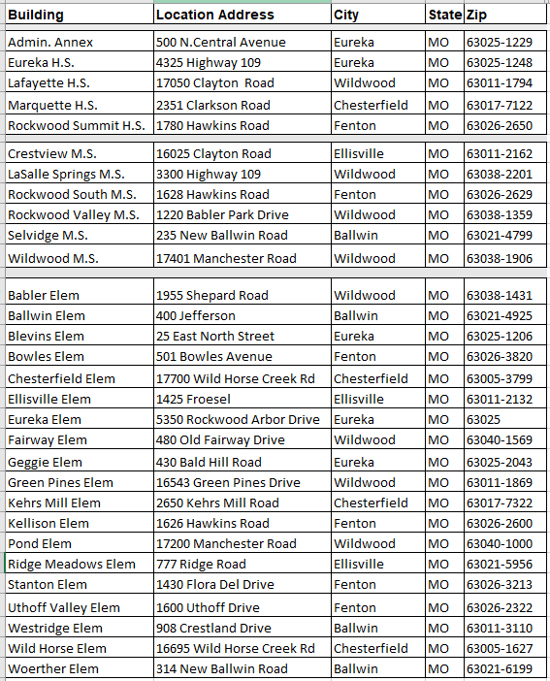

District Map
