Request for Written Quotes

Window Glass, parts & Units

Solicitation Number | Q1910
Due Date | October 9, 2018
Due Time | 11:00 a.m. EST
Deliver Responses to: | Knoxville’s Community Development Corporation    Procurement Division  901 N. Broadway  Knoxville, TN 37917  Note: Procurement is in a separate building behind the main office building.
Electronic Copies | Electronic copies are available on KCDC’s webpage or by email at purchasinginfo@kcdc.org.
Responses may be Emailed to KCDC | ☒ Yes ☐ No
Printed Responses Required | ☐ Yes ☒ No
Solicitation Meeting | ☐ Yes ☒ No
Solicitation Meeting is Mandatory | ☐ Yes ☐ No ☒ Not Applicable
Solicitation Meeting Date | Not applicable
Solicitation Meeting Time | Not applicable
Solicitation Meeting Location | Not applicable
Questions About This Solicitation | Submit questions to purchasinginfo@kcdc.org  KCDC will not accept questions via telephone.
Award Results | KCDC posts both a summary of the quotes received and the award decision to its web page at: http://www.kcdc.org/procurement/
Open Records/Public Access to Documents | All document provided to KCDC are subject to the Tennessee Open Meetings Act (TCA 8-44-101) and open records requirements.

Check KCDC’s webpage for addenda and changes before submitting your response

General Information

1. Background and Intent

a. Knoxville's Community Development Corporation (KCDC) is the public housing and redevelopment agency for the City of Knoxville and for Knox County in Tennessee. KCDC’s affordable housing property portfolio includes 20 sites with approximately 3,525 dwelling units. KCDC also oversees approximately 3958 Section 8 Vouchers, 82 Moderate Rehabilitation units and 20 Redevelopment areas. Several of the properties have transformed to the Project Based Rental Assistance program (PBRA) and KCDC is the management company for those sites. The properties for which KCDC is the management company include Five Points 1, LP; Lonsdale Homes, LP; Northridge Crossing, LP and The Vista at Summit Hill, LP.

b. The intent of this solicitation is to have a supplier under contract to provide replacement windows, parts and supplies and remove and re-install glass as needed for KCDC. As such needs arise, the site manager will contact the successful supplier to request services.

c. KCDC desires to purchase quality products; not the “cheapest” initial cost. Accordingly:

1. A five year warranty is required on windows and parts.
2. Thermal windows shall be constructed from “Super Spacer,” “Intercept Spacer” or “Conventional Metal Band” methods.

d. Any agreement resulting from this solicitation will be an “open-end” type of agreement. There is no guarantee that any specified or minimum level of services will be required by KCDC or provided by the supplier.

e. It is understood that KCDC intends to use the successful supplier for these products or services; however, KCDC reserves the right to purchase these products or services elsewhere if it is in KCDC’s best interest.

2. Changes after Award
It is possible that after award KCDC will need to revise the service needs or requirements specified in this document. KCDC reserves the right to make such changes after consultation with the supplier. Should additional costs arise, the supplier must document increased costs. KCDC reserves the right to accept and negotiate these charges.

3. Codes and Ordinances
All work covered is to be done in full accord with national, state and local codes and ordinances
and orders that are in effect at the time the work is performed.

4. Contact Personnel
The supplier will assign no more than two contacts to handle billing inquiries and service related issues. In the event one or both contacts leave the KCDC account, the supplier will introduce the new contacts to KCDC personnel. These contacts must be knowledgeable of KCDC’s account to avoid any interruption of service.

5. Contact Policy
The supplier may not contact an officer, agent or employee of KCDC other than the KCDC’s Procurement Division about matters pertaining to this solicitation, from the issuance of this solicitation until its award. Information obtained from an unauthorized officer, agent or employee of KCDC will not affect the risks or obligations assumed by the supplier or relieve the supplier from fulfilling any of the conditions of the project. Such contact can disqualify the supplier from participation in the solicitation process.

6. Damage
The awarded supplier is responsible for any and all damage to buildings, equipment, grounds, premises and all other types of potential damage resulting from the provision of the services requested herein.

7. Delivery

a. Delivery will be to specified locations within Knox County, Tennessee. Please see Solicitation Document E - KCDC Site Addresses.

b. Deliveries are accepted (approximately - may depend upon the site) between 7:30 a.m. and 3:30 p.m. each business day.

c. Deliveries will not incur additional cost to KCDC.

d. KCDC may or may not ask for delivery.

8. Employees
Supplier will:

a. Allow only personnel thoroughly trained and skilled to work on the job.

b. Have sufficient personnel to complete the work in a timely manner.

c. Enforce strict discipline and good order among his/her employees.

d. Provide at least one employee on every job assignment with the ability to speak, read, write and understand English so KCDC’s staff can communicate effectively with them.

e. Employ the quantity and quality of supervision necessary for both effective and efficient management at all times.

f. Employees parking vehicles (whether corporately or privately owned) must ensure that company identification is on the vehicles. This may be by placards on the vehicle’s side, laminated paper with the company name placed on the dashboard or other means.

9. Entrance to Sites
Supplier’s employees are not to be on KCDC premises unless they are working on a KCDC project. Acquaintances, family members, assistants or any person not working on KCDC’s behalf will not accompany employees on KCDC sites.

10. Evaluation
KCDC will arrive at the “lowest and best” solution for the final award. This may not entail simply awarding to the supplier quoting the lowest cost. All responses are subject to a determination of “responsive” and “responsible” prior to award. KCDC is the sole judge as to supplier “responsiveness” and “responsibility.” KCDC reserves the right to request additional information to assist in the evaluation process. This includes references and business capacity information.

11. General Instructions
KCDC does not insert “General Instructions to Suppliers” in solicitation documents. These instructions are at www.kcdc.org. Click on “Procurement” and the link to the instructions. The supplier’s submittal means acceptance of the terms and conditions set forth in KCDC’s “General
Instructions to Suppliers.”

12. Identification
The supplier’s employees shall have proper identification displayed, at all times, while on KCDC property. All employees must wear a company uniform or have photo identification badges or other company identification at all times.

13. Insurance
The contractor shall maintain, at contractor’s sole expense, on a primary and non-contributory basis, at all times during the life of the contract the following minimum insurance coverages, limits, and endorsements described herein. All insurance must be underwritten by insurers with an A.M. Best rating of A-:VI or better. Upon award, the contractor shall provide Certificate(s) of Insurance to KCDC evidencing said insurance coverages.

The contractor agrees the insurance requirements herein as well as KCDC’s review or acknowledgement, is not intended to and shall not in any manner limit or qualify the liabilities and obligations assumed by the contractor under this contract. KCDC’s failure to require a certificate of insurance, acceptance of a non-conforming certificate, or allowing the contractor to commence work shall not operate as a waiver of these minimum insurance requirements or the liabilities and obligations assumed by the contractor under this contract.

a. Commercial General Liability Insurance: occurrence version commercial general liability insurance with a limit of not less than $1,000,000 each occurrence for bodily injury, personal injury, property damage, and products and completed operations. If such insurance contains a general aggregate limit, it shall apply separately to the work/location in this contract or be no less than $2,000,000.

Such insurance shall contain or be endorsed to contain a provision that includes the Owner Entities listed in paragraph g below. as additional insureds with respect to the contractor’s ongoing and completed operations, providing coverage at least as broad as CG 20 10 07 04 and 20 37 07 04 endorsements. The coverage shall contain no special limitations on the scope of its protection afforded to the above-listed insureds.

If necessary, umbrella/excess liability insurance can be used in conjunction with the general liability insurance to meet these requirements. Unless the umbrella/excess liability insurance provides coverage on a pure/true follow-form basis, or the Owner Entities are automatically defined as an additional insureds, the contractor shall add by endorsement, the Owner Entities as an additional insured for both ongoing and completed operations, providing coverage at least as broad as CG 20 10 07 04 and 20 37 07 04 endorsements.

b. Automobile Liability Insurance: including vehicles owned, hired, and non-owned, with a combined single limit of not less than $1,000,000 each occurrence. Such insurance shall include coverage for loading and unloading hazards.

Such insurance shall contain or be endorsed to contain a provision that includes the Owner Entities listed in paragraph g below as additional insureds

c. Workers’ Compensation Insurance and Employers Liability Insurance: with statutory limits as required by the State of Tennessee or other applicable laws.

d. Other Insurance Requirements: Contractor shall:

1. Upon award, furnish KCDC with original Certificates of Insurance and amendatory endorsements effecting coverage required by this section. Certificates of Insurance shall provide a minimum 30-day endeavor to notify KCDC of cancellation when available by contractor’s insurance. If the contractor receives a non-renewal or cancellation notice from an insurance carrier affording the required coverage, or receives notice that coverage no longer complies with the insurance requirements herein, contractor shall notify KCDC by email or fax within five (5) business days and provide a copy of the non-renewal for cancellation notice or written specifics as to which coverage is no longer in compliance.

2. Provide certified copies of endorsements and policies if requested by KCDC in lieu of or in addition to Certificates of Insurance.

3. Replace certificates, policies, and endorsements for any such insurance expiring prior to completion of services.

4. Maintain such insurance from the time services commence until services are completed. Failure to maintain or renew coverage or to provide evidence of renewal may be treated by KCDC as a material breach of contract.

5. Require all subcontractors to maintain during the term of the resulting contract commercial general liability insurance, automobile liability insurance, and workers’ compensation/employers liability insurance (unless subcontractor’s employees are covered by contractor’s insurance) in the same manner and limits as specified for the contractor, including requirements for additional insured endorsements and waivers of subrogation. Contractor shall furnish subcontractor(s)’ Certificates of Insurance to KCDC without expense prior to subcontractor(s) commencing work.

6. Any deductibles and/or self-insured retentions greater than $50,000 must be disclosed to and approved by KCDC prior to the commencement of services. Use of large deductibles and/or self-insured retentions will require proof of financial ability as determined by KCDC.

7. Provide a waiver of subrogation for each required policy herein. When required by the insurer, or should a policy condition not permit contractor to enter into a pre-loss agreement to waive subrogation without an endorsement, the policy should be endorsed with a Waiver of Transfer of Rights of Recovery Against Others, or its equivalent. This waiver of subrogation requirement shall not apply to any policy which includes a condition specifically prohibiting such an endorsement, or voids coverage should contractor enter into such an agreement on a pre-loss basis.

8. All policies must be written on an occurrence basis.

e. Right to Revise or Reject: KCDC reserves the right, but not the obligation, to review or revise any insurance requirement, not limited to limits, coverages and endorsements based on insurance market conditions affecting the availability or affordability of coverage; or changes in the scope of work / specifications affecting the applicability of coverage.

f. No Representation of Coverage Adequacy: The coverages, limits or endorsements required herein protect the primary interests of KCDC, and the contractor agrees in no way should these coverages, limits or endorsements required be relied upon when assessing the extent or determining appropriate types and limits of coverage to protect the contractor against any loss exposures, whether as a result of the project or otherwise.

g. Certificate Holder and Owner Entities:

The certificate holder shall be:

Knoxville’s Community Development Corporation (KCDC)
Attn: Contracting Officer
901 Broadway, NE
Knoxville, TN 37917

Owner Entities include:

KCDC, its officials, officers, employees, and volunteers
Eastport Development, LP
Five Points 1 LP
Five Points 2 LP
Five Points 3 LP
Five Points 4 LP
Lonsdale, LP
North Ridge Crossing, LP
Vista at Summit Hill, LP

(Note: Only one (1) certificate needs to be provided. Certificate must reflect KCDC as the Certificate Holder and specify all coverages and terms apply to all Owner Entities.)

KCDC has determined the following timeline applies to this solicitation:

General Services: 7 calendar days ☒ Yes ☐ No
Construction Services 15 calendar days ☐ Yes ☐ No

14. Invoicing/Ordering

a. Until a purchase order is in place, work is not to be performed nor are goods to be delivered. KCDC does not have a legal obligation to pay for the work performed prior to the issuance of a purchase order.

b. Suppliers must submit invoices within 90 days of the delivery of goods or services. KCDC may deny invoices submitted after the 90 day threshold. KCDC prefers invoices arrive within 10 days following the end of the month in which goods or services were supplied.

c. KCDC’s purchases of goods are exempt from Tennessee sales and use tax pursuant to Tennessee Code Annotated 67-6-329(a) (4) and KCDC is generally exempt from the Federal Excise tax. Suppliers are subject to Tennessee sales and use tax on all materials and supplies used in the performance of a contract, whether such materials and supplies are purchased by the supplier, produced by the supplier, or provided to the supplier by KCDC, pursuant to Tennessee Code Annotated 67-6-209. The supplier will pay all taxes incurred in the performance of an awarded contract. Upon the placement of a purchase order or the award of a contract, KCDC will provide a State of Tennessee Sales Tax Exemption form to the supplier. KCDC will not pay taxes on invoices.

d. KCDC pays by electronic transfer (ACH) only.

e. Since KCDC is the managing partner for four separate corporations under the KCDC umbrella, those separate corporations must receive separate invoices. Thus the supplier will generally:

- Bill each specific site for work performed or goods delivered
- With KCDC’s permission, generate one monthly master invoice showing all locations and their individual costs (except for those listed below)
- Create separate invoices for Five Points I, Lonsdale Homes, North Ridge Crossing and The Vista.

f. Invoices must:

1. Be numbered
2. List a date on them that is after the work is completed or goods delivered
3. List the purchase order number
4. Breakdown pricing according to the award structure

g. KCDC requires that invoices be submitted via email.

15. Length of Award
The length of the contract will be twelve months with four optional annual renewals that KCDC may exercise at its discretion.

16. Price Structure

a. At the end of each twelve month period, the awarded supplier may request a change to the percentage and/or specific item charged to KCDC. The supplier must provide proof of the necessity of the increase to the Procurement Division. Suppliers may lower prices at any time with or without notice. KCDC will decide whether to accept a price increase. If the price increase is accepted, the bid file will be so noted. If the price increase is not accepted, the supplier may:

1. Continue with the existing pricing.
2. Suggest an alternative price increase.
3. End the award.

b. KCDC does not pay fuel surcharges.

c. Suppliers may decrease prices at any time with our without notice.

17. Questions
Send direct questions pertaining to this document to purchasinginfo@KCDC.org with “Window Glass, Parts & Units” in the subject line, at least five business days prior to the due date.

18. Response Time

a. Supplier shall supply and install glass within 48 hours, or a time frame that is agreed upon at time of work request, and be available for service calls 365 days a year and 24 hours per day during normal working hours.

19. Section 3 of the HUD Act of 1968
Section 3 is a provision of the Housing and Urban Development Act of 1968 which requires that programs of direct financial assistance administered by the U.S. Department of Housing and Urban Development (HUD) provide, to the greatest extent feasible, opportunities for job training and employment to lower income residents in connection with projects in their neighborhoods. Further, to the greatest extent feasible, contracts in connection with these projects are to be awarded to local businesses. Section 3 is a tool for fostering local economic development, neighborhood economic improvement and individual self-sufficiency.

a. Recipients and suppliers must make a good faith effort to utilize Section 3 area residents as trainees and employees in connection with the project. Targeted recruitment and the selection of Section 3 area residents for available positions are two examples of good faith efforts to meet this requirement.

b. Recipients and suppliers must make a good faith effort to award contracts to Section 3 business concerns for work in connection with the project. An example of a good faith effort to meet this requirement is the implementation of an affirmative action plan, which includes targets for the number and dollar value for awarding contracts to Section 3 business concerns.

c. Recipients and suppliers must keep records and submit reports to HUD documenting the good faith efforts taken and the results of these actions. Examples of such documentation include letters to community organizations, employment development and business development centers, copies of solicitations for bids or proposals; and copies of affirmative action plans.

d. How can businesses find Section 3 residents to work for them? This can be accomplished by recruiting in the neighborhood and public housing developments to tell about available training and job opportunities. Distributing flyers, posting signs, placing ads, and contacting resident organizations and local community development and employment agencies to find potential workers are a few effective ways of getting jobs and people together.

e. All contracts awarded are subject to Section 3 requirements. Supplier shall seek to fill any and all position that are needed and unfilled with residents of KCDC communities. For additional information, please go to http://www.hud.gov/offices/fheo/section3/Section3.pdf. The successful supplier will supply KCDC with job announcements for any position that must be filled as a result of the award of KCDC work. Additionally the successful supplier will supply the same job announcement to the Knoxville-Knox County Committee Action Committee’s Workforce Connections group. These can be faxed to 544-5269.

f. A Section 3 resident is one who lives within a public housing authority’s site. It is also people who live in an area with a HUD assisted program and whose income is below HUD’s low income requirements.

g. A Section 3 business is one that:

1. Is at least 51% owned by a Section 3 resident; or
2. Employs Section 3 residents for at least 30% of its employee base; or
3. Makes a commitment to sub contract at least 25% of the project’s dollars to a Section 3 business.

h. Upon award, the successful supplier will supply two documents to KCDC:

1. A Section 3 Business determination (forms supplied by KCDC) provided one is not already on file.
2. A Section 3 Business plan for this work.

20. Smoking Policy
On July 31, 2018 KCDC implements a new Smoke Free policy goes into effect and it applies to you and your employees. Specifically, the policy (which is HUD required) mandates:

- No smoking on KCDC property
- No e-vape or similar usage on KCDC property
- The Smoke Free policy applies in personal or corporate vehicles on KCDC’s property
HUD definitions include:

- “Smoking” means inhaling, exhaling, burning, or carrying any lighted or heated cigar, cigarette, or pipe, or any other lighted or heated tobacco or plant product intended for inhalation, including hookahs and marijuana, whether natural or synthetic, in any manner or in any form. “Smoking” also includes the use of an electronic smoking device which creates an aerosol or vapor, in any manner or in any form.

- “Electronic Smoking Device” means any product containing or delivering nicotine or any other substance intended for human consumption that can be used by a person in any manner for the purpose of inhaling vapor or aerosol from the product. The term includes any such device, whether manufactured, distributed, marketed, or sold as an e-cigarette, e-cigar, e-pipe, e-hookah, or vape pen or under any other product name or descriptor.

- Property means all buildings, parking lots, streets, structures and land owned by KCDC.

Should vendor staff be observed violating these requirements, KCDC’s Procurement Division will notify the corporate level contact about the problem. Should there be recurrences, KCDC may ask the vendor to not send the employee to KCDC property. Repeated offenses may result in forfeiture of your awarded “contract.”

21. Use of Solicitation Forms
Suppliers are to complete the solicitation forms contained in the solicitation package. Failure to complete these forms may result in rejection of your response. Do not alter the solicitation forms without KCDC’s approval. Suppliers are asked to use the MS Word version of the pricing pages to eliminate difficulties in reading handwritten text.

Scope of Work

22. General Requirements
KCDC desires to have a supplier under contract to provide replacement windows, parts and supplies and remove and re-install glass as needed for KCDC. KCDC seeks to purchase quality products with a minimum of a five year warranty on windows and parts.

a. The supplier shall provide all supervision, labor, service trucks, materials, tools, equipment and appurtenances necessary for the completion of the work specified in this document.

b. Historically, most of KCDC’s welding work has been repairs for dumpsters and handrails.

23. After Hours Work
The supplier may have to perform work during KCDC’s non-working hours or on weekends or holidays. The Project Manager must approve all repairs, including afterhours work.

24. Cleanup
The supplier shall keep KCDC’s premises free from accumulation of waste materials or rubbish caused by their operations at all times. Upon completion of the work, the supplier shall remove all waste materials and rubbish from and around the facility, as well as all tool construction equipment, machinery and surplus materials; and shall clean all building surfaces and leave the area "broom-clean."

25. Contact Personnel
It shall be essential to the success of this contract to develop a good working relationship with the successful supplier. It is imperative that the KCDC account be handled efficiently and professionally. KCDC should be assigned no more than two contacts to handle billing inquiries and service related issues. In the event one or both contacts leave the KCDC account, the successful bidder shall formally introduce the new contacts to KCDC personnel. These contacts must be knowledgeable of KCDC so as to avoid any interruption of service.

26. Estimates
The supplier will be required to visit the potential job sites and submit accurate quotations before the work is authorized. If the quotation is accepted and the work is performed, the
supplier’s invoice shall not exceed the quote. Quotations must be provided within five business days of request. All quotations are to be accompanied by a list of any subcontractors to be employed for the job. Quotations must show the approved labor and material rates.

27. Labor Charges

a. Suppliers shall include all costs (overhead, insurance, workmen’s compensation unemployment insurance, unemployment insurance, social security, routine supplies and materials, et cetera) in the hourly rate.

b. Additional charges will not be allowed for truck mileage.

28. Licensing
If applicable, suppliers must be properly licensed by the State of Tennessee and all other authorities having jurisdiction. Copies of all such licenses and/or permits are to be submitted with the informal response. Failure to submit copies of such may lead to informal response rejection.

29. Quality
All work must meet the applicable requirements of all authorities having jurisdiction.

30. Scheduling of Work
a. Supplier shall cooperate with KCDC officials in performing the work so that interference with KCDC’s normal program is minimized.

b. The supplier must cooperate in scheduling work so work by other suppliers is not impeded.

31. Subcontractors
Subcontractors must:

a. Be approved by KCDC prior to beginning work.

b. Carry the insurance coverages as outlined herein.

c. Comply with the Davis Bacon requirements and submit certified payrolls.

d. Not be on HUD’s Debarment List.

e. Not be changed without KCDC’s permission.

32. Supplier Service Tickets
The supplier shall furnish Service Tickets for all work performed. Each project requires individual Service Tickets that shall detail labor, material utilized, rental equipment and subcontractors utilized. The Service Tickets shall be imprinted with the company's name and submitted to the Project Manager or his designated representative at the completion of each workday. If Service Tickets are not left at the site, KCDC has the right to withhold payment.
Service Tickets must include the following:

a. Facility name

b. Equipment name and ID number

c. Personnel name, labor classification, and hours worked

d. Materials used

e. A detailed description of work performed.

33. Work Hours
Acceptable work hours are Monday through Saturday from 7:30 a.m. until 4:00 p.m. However the supplier must understand KCDC’s staff will not be on site or readily available after 4:00 p.m. during the workweek nor at all on Saturdays. Work on Sundays or holidays requires KCDC’s advance approval.

THIS AND THE PREVIOUS PAGES DO NOT NEED TO BE RETURNED

Window Glass, Parts & Units Q1910

Solicitation Document A General Response Section

General Information about the Supplier
Sign Your Name to the Right of the Arrow
By signing, you indicate you read and agree to “KCDC’s General Instructions to Suppliers” on www.kcdc.org.
Printed Name and Title
Company Name
Street Address
City/State/Zip
Contact Person (Please Print Clearly)
Telephone Number
Cell Number
Supplier’s E-Mail Address (Please Print Clearly)
Addenda
Addenda are at www.kcdc.org. Click on “Procurement” and then on “Open Solicitations” to find addenda. Please check for addenda prior to submitting a proposal.
Acknowledge addenda have been issued by checking below as appropriate:
None ☐ | Addendum 1 ☐ |  |  | Addendum 2 ☐ |  | Addendum 3 ☐ |  |  | Addendum 4 ☐ | Addendum 5 ☐
Statistical Information (Check all the apply)
This business is at least 51% owned and operated by a woman |  |  |  |  |  |  |  |  |  |  | Yes ☐ No ☐
This business qualifies as a small business by the State of Tennessee  (Gross receipts of $10,000,000 or less and employing less than 100 full time persons ) |  |  |  |  |  |  |  |  |  |  | Yes ☐ No ☐
This business qualifies as Section 3 business (as defined by HUD):  It is at least 51% owned by a Section 3 resident (lives in Public Housing) or it employs Section 3 residents for at least 30% of its employee base; or it commits to sub contract at least 25% of the project’s dollars to a Section 3 business. |  |  |  |  |  |  |  |  |  |  | Yes ☐ No ☐
This business is owned & operated by persons at least 51% of the following ethnic background:
Asian/Pacific ☐ |  | Black ☐ | Hasidic Jew ☐ |  | Hispanic ☐ |  |  | Native Americans ☐ |  |  | White ☐
Cooperative Procurement
Subject to additional location/delivery charges, the supplier agrees to extend the offered costs to other governments if the government so desires. Yes ☐ No ☐
Prompt Payment Discount
A prompt payment discount of ________% is offered for payment within ____ days of submission of an accurate and proper invoice.
MasterCard Acceptance
Mastercard is accepted for payment without additional fees. Yes ☐ No ☐
Mastercard is accepted for payment with a fee of _______. Yes ☐ No ☐

Window Glass, Parts & Units Q1910

Solicitation Document B Cost

Item Group/Brand/Catalog | Discount Offered
Alenco Windows | %
Alside Windows | %
Andersen Windows | %
Jeld-Wen Windows | %
Ply-Gem Windows | %
Traco Windows | %
Viwintech Windows | %
Other: Replacement Window Glass | %
Other: Window Locks & Parts | %
Other: | %
Other: | %
Other: | %
Remove & Re-install Glass Charges | Charge
Service Calls & Assessment Fee: Measure & Determine Material List | $
No Show/No Entry Allowed: KCDC occupant is no show or denies entry | $
Installation Cost per Window | $
Document C Affidavits

Window Glass, Parts & Units Q1910

Solicitation Document C Affidavits

Supplier: _____________________________________________________________________________

Conflict of Interest:
1. No commissioner or officer of KCDC or other person whose duty it is to vote for, let out, overlook or in any manner superintend any of the work for KCDC has a direct interest in the award or the supplier providing goods or services.

2. No employee, officer or agent of the grantee or sub-grantee will participate in selection, or in the award or administration of an award supported by Federal funds if a conflict of interest, real or apparent, would be involved. Such a conflict would arise when the employee, officer or agent, any member of his immediate family, his or her partner, or an organization, which employs, or is about to employ, any of the above, has a financial or other interest in the supplier selected for award.

3. The grantee's or sub-grantee's officers, employees or agents will neither solicit nor accept gratuities, favors or anything of monetary value from suppliers, potential supplier s, or parties to sub-agreements.

4. By submission of this form, the supplier is certifying that no conflicts of interest exist.

Drug Free Workplace Requirements:
5. Private employers with five or more employees desiring to contract for construction services attest that they have a drug free workplace program in effect in accordance with TCA 50-9-112.

Eligibility:
6. The supplier is eligible for employment on public contracts because no convictions or guilty pleas or pleas of nolo contender to violations of the Sherman Anti-Trust Act, mail fraud or state criminal violations with an award from the State of Tennessee or any political subdivision thereof have occurred.

General:
7. Supplier fully understands the preparation and contents of the attached offer and of all pertinent circumstances respecting such offer.

8. Such offer is genuine and is not a sham offer.

Iran Divestment Act:
9. Concerning the Iran Divestment Act (TCA 12-12-101 et seq.), by submission of this bid/quote/proposal, each supplier and each person signing on behalf of any supplier certifies, and in the case of a joint bid/quote/proposal, each party thereto certifies as to its own organization, under penalty of perjury, that to the best of its knowledge and belief that each supplier is not on the list created pursuant to § 12-12-106.

Window Glass, Parts & Units Q1910

Solicitation Document C Affidavits - continued

Non-Collusion:
10. Neither the said supplier nor any of its officers, partners, owners, agents, representatives, employees or parties interest, including this affiant, has in any way colluded conspired, connived or agreed, directly or indirectly, with any other responder, supplier, or person to submit a collusive or sham offer in connection with the award or agreement for which the attached offer has been submitted or to refrain from making an offer in connection with such award or agreement, or collusion or communication or conference with any other supplier, or, to fix any overhead, profit, or cost element of the offer price or the offer price of any other supplier, or to secure through any collusion, conspiracy, connivance, or unlawful agreement any advantage against KCDC or any person interested in the proposed award or agreement.

11. The price or prices quoted in the attached offer are fair, proper and not tainted by any collusion, conspiracy, connivance, or unlawful agreement on the part of the supplier or any of its agents, representatives, owners, employees, or parties in interest, including this affiant.

Accuracy of Electronic Copies:
12. If the supplier provides electronic copies of the bid/proposal/quote to KCDC, the supplier certifies that the information provided on paper and in the electronic format is identical unless specifically noted otherwise.

The undersigned hereby acknowledges receipt of these affidavits and certifies that the submittal in response to this solicitation is in full compliance with the listed requirements.

Signed by
Printed Name
Title
Subscribed and sworn to before me this date
By (Notary Public)
My Commission Expires on
Notary Stamp

Window Glass, Parts & Units Q1910
Solicitation Document D HUD Form 5369A

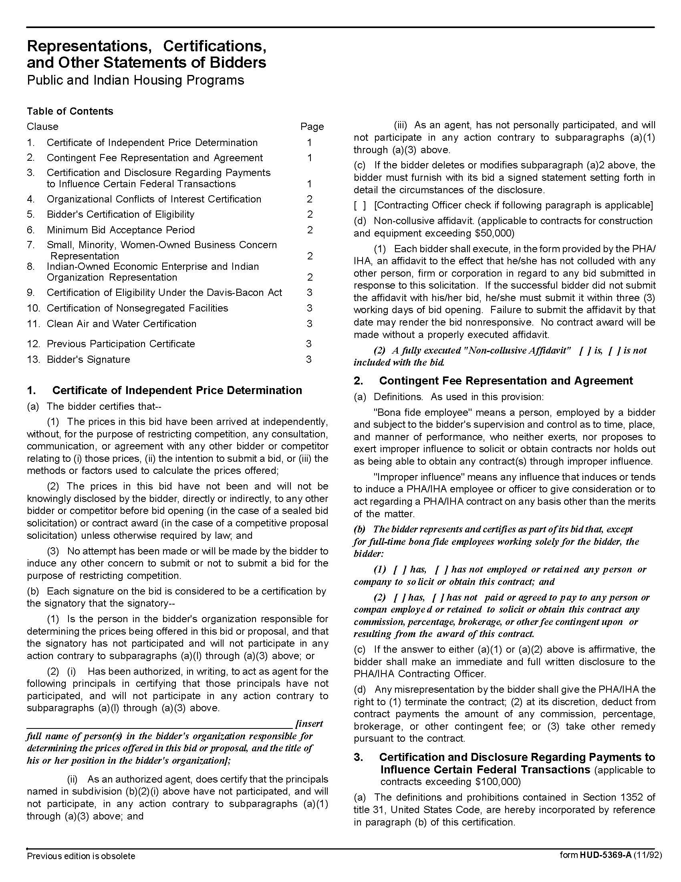

Window Glass, Parts & Units Q1910
Solicitation Document D HUD Form 5369A - Continued
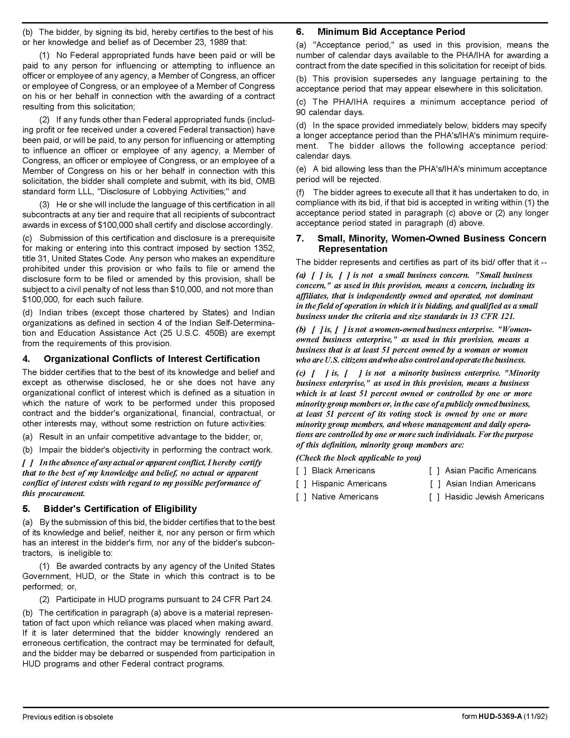

Window Glass, Parts & Units Q1910
Solicitation Document D HUD Form 5369A - Continued

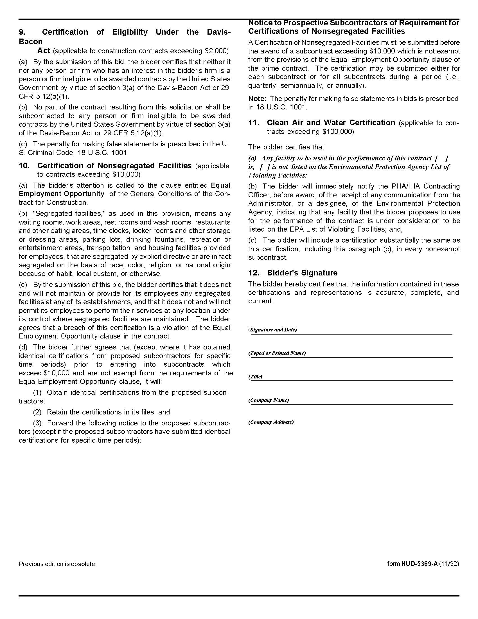

Window Glass, Parts & Units Q1910
Solicitation Document E KCDC Site Addresses

Autumn Landing Apartments |  | Austin Homes
Manager: James Pruitt |  | Manager: Darrell Lindsey
jpruitt@kcdc.org |  | dlindsey@kcdc.org
865-403-1422 |  | 865-403-1300
6331 Pleasant Ridge Road |  | 801 Howard Baker Jr. Boulevard
Knoxville, TN 37921 |  | Knoxville, TN 37915
Cagle Terrace (both buildings) |  | Isabella Towers
Manager: Rhonda Harris |  | Manager: Linda Jeter
rharris@kcdc.org |  | ljeter@kcdc.org
865-403-1310 |  | 865-403-1340
515 Renford Drive |  | 515 Isabella Circle
Knoxville, TN 37919 |  | Knoxville, TN 37915
KCDC Main Office |  | KCDC Procurement
Jack Canada |  | Terry McKee
jcanada@kcdc.org |  | tmckee@kcdc.org
865-403-1371 |  | 865-403-1133
901 North Broadway |  | 901 North Broadway
Knoxville, TN 37917 |  | Knoxville, TN 37917
Lonsdale Homes |  | Love Towers (both buildings)
Manager: Darlene Farmer |  | Manager: Steve Ellis
dfarmer@kcdc.org |  | sellis@kcdc.org
865-403-1350 |  | 865-403-1360
2020 Minnesota Avenue |  | 1171Armstrong Avenue
Knoxville, TN 37921 |  | Knoxville, TN 37917
Nature's Cove Apartments |  | Montgomery Village
Manager: James Pruitt |  | Manager: Sam Chambers
jpruitt@kcdc.org |  | schambers@kcdc.org
865-403-1422 |  | 865-403-1380
2639 Bakertown Road |  | 4530 Joe Lewis Road
Knoxville, TN 37931 |  | Knoxville, TN 37920
North Ridge Crossing |  | Northgate Terrace
Manager: Adronicus Thomas |  | Manager: Terri Evans
athomas@kcdc.org |  | tevans@kcdc.org
865-403-1320 |  | 865-403-1400
712 Breda Drive |  | 4301 Whittle Springs Road
Knoxville, TN 37918 |  | Knoxville, TN 37917
Supportive Maintenance |  | The Verandas
Manager: Jack Canada |  | Manager: Sam Chambers
jcanada@kcdc.org |  | schambers@kcdc.org
865-403-1371 |  | 865-403-1380
1130 Cornelia Street |  | 107 Flenniken Avenue
Knoxville, TN 37917 |  | Knoxville, TN 37920
Valley Oaks Apartments |  | Vista Apartments
Manager: Adronicus Thomas |  | Manager: Darrell Lindsey
athomas@kcdc.org |  | dlindsey@kcdc.org
865-403-1320 |  | 865-403-1300
3504 Oak Branch Circle |  | 957 East Hill Avenue
Knoxville, TN 37917 |  | Knoxville, TN 37915
Western Heights |  | Five Points I & II
Manager: Kristie Toby |  | Passport Homes
ktoby@kcdc.org |  | Passport Residences
865-403-1420 |  | Residences at Eastport I & II
1621 Jourolman Avenue |  | Manager: Kim Clark
Knoxville, TN 37921 |  | kclark@kcdc.org
 |  | 865-403-1390
 |  | 381 McConnell Street
 |  | Knoxville, TN 37915

