Request for Written Quotes

plumbing parts & supplies

Solicitation Number | Q1814
Due Date | January 23, 2018
Due Time | 2:00 p.m. EST
Deliver Responses to: |   Knoxville’s Community Development Corporation  Procurement Division  901 N. Broadway  Knoxville, TN 37917  Note: Procurement is in a separate building behind the main office building
Electronic Copies: | Electronic copies are available on KCDC’s webpage or by email at purchasinginfo@kcdc.org.
May responses be emailed to KCDC | ☒ Yes ☐ No  ☐ Paper copies must also be provided
Solicitation Meeting | ☐ Yes ☒ No
Solicitation Meeting is Mandatory | ☐ Yes ☒ No
Solicitation Meeting Date | Not applicable
Solicitation Meeting Time | Not applicable
Solicitation Meeting Location | Not applicable
Questions About This Solicitation | Submit questions to purchasinginfo@kcdc.org.

Check KCDC’s webpage for addenda and changes before submitting your response

General Information

1. BACKGROUND AND INTENT

a. Knoxville's Community Development Corporation (KCDC) is the public housing and redevelopment agency for the City of Knoxville and for Knox County in Tennessee. KCDC’s affordable housing property portfolio includes 20 sites with approximately 3,525 dwelling units. KCDC also oversees approximately 3958 Section 8 Vouchers, 82 Moderate Rehabilitation units and 20 Redevelopment areas. Several of the properties have transformed to the Project Based Rental Assistance program (PBRA) and KCDC is the management company for those sites. The properties for which KCDC is the management company include Five Points 1, LP; Lonsdale Homes, LP; Northridge Crossing, LP and The Vista at Summit Hill, LP.

b. KCDC performs plumbing services on its properties and KCDC intends to use the contract resulting from this solicitation to purchase supplies as needed. The amount spent fluctuates with needs. However, it is anticipated that around $100,000 will be spent over the next five years. Therefore, to meet its expected needs, KCDC is soliciting quotes.

c. KCDC utilizes the “catalog” function of its financial software. This enables KCDC employees to quickly and easily place one item orders for items that are on contract. Please note:

- KCDC issues individual purchase orders for specific orders.
2. KCDC transmits purchase orders via email.

d. KCDC is interested in partnering with a vendor who can:

- Supply plumbing equipment, parts and supplies in a timely manner;
- Supply quality equipment, parts and supplies; and
- Supply quality equipment, parts and supplies at a reasonable cost.

2. DELIVERY

a. Delivery will be to specified locations within Knox County, Tennessee.

b. Deliveries are accepted (approximately-may depend upon the site) between 7:30 a.m. and 3:30 p.m. each business day.

c. Deliveries will not incur additional cost to KCDC.

d. KCDC may or may not ask for delivery. Typically KCDC picks up items in the store.

3. CHANGES AFTER AWARD
It is possible that after award KCDC will need to revise the service needs or requirements specified in this document. KCDC reserves the right to make such changes after consultation with the supplier. Should additional costs arise, the supplier must document increased costs. KCDC reserves the right to accept and negotiate these charges.

4. EVALUATION
KCDC will arrive at the “lowest and best” solution for the final award. This may not entail simply awarding to the supplier quoting the lowest cost. All responses are subject to a determination of “responsive” and “responsible” prior to award. KCDC is the sole judge as to supplier “responsiveness” and “responsibility.” KCDC reserves the right to request additional information to assist in the evaluation process. This includes references and business capacity information.
Supplier’s location relative to KCDC locations will be a factor in the evaluation.

5. GENERAL INSTRUCTIONS
KCDC does not insert “General Instructions to Suppliers” in solicitation documents. These instructions are at www.kcdc.org. Click on “Procurement” and the link to the instructions. The supplier’s submittal means acceptance of the terms and conditions set forth in KCDC’s “General Instructions to Suppliers.”

6. INVOICING/ORDERING

a. Until a purchase order is in place, work is not to be performed nor are goods to be delivered. KCDC does not have a legal obligation to pay for the work performed prior to the issuance of a purchase order.

b. Suppliers must submit invoices within 90 days of the delivery of goods or services. KCDC may deny invoices submitted after the 90-day threshold. KCDC prefers invoices arrive within 10 days following the end of the month in which goods or services were supplied.

c. KCDC’s purchases of goods are exempt from Tennessee sales and use tax pursuant to Tennessee Code Annotated 67-6-329(a) (4) and KCDC is generally exempt from the Federal Excise tax. Contractors are subject to Tennessee sales and use tax on all materials and supplies used in the performance of a contract, whether such materials and supplies are purchased by the contractor, produced by the contractor, or provided to the contractor by KCDC, pursuant to Tennessee Code Annotated 67-6-209. The contractor will pay all taxes incurred in the performance of an awarded contract. Upon the placement of a purchase order or the award of a contract, KCDC will provide a State of Tennessee Sales Tax Exemption form to the supplier. KCDC will not pay taxes on invoices.

d. KCDC pays by electronic transfer (ACH) only.

7. LENGTH OF AWARD
The length of the contract will initially be 12 months along with four optional yearly renewals that KCDC may exercise at its discretion.

8. LIST OF ITEMS
A list of frequently purchase items is attached in Solicitation Document D Pricing Form. While this list is reflective of actual items that KCDC purchased in the last twelve months, it is not a guarantee as to the quantity or needs that will arise in the future.
9. MULTIPLE AWARDS
KCDC reserves the right to award to more than one supplier if that best meets its needs.

10. PRICE STRUCTURE

- At the end of each twelve month period, the awarded supplier may request a change to the
percentage and/or specific item charged to KCDC. The supplier must provide proof of the necessity of the increase to the Procurement Division. Suppliers may lower prices at any time with or without notice. KCDC will decide whether to accept the price increase. If the price increase is accepted, the bid file will be so noted. If the price increase is not accepted, the supplier may:

1. Continue with the existing pricing.
2. Suggest an alternative price increase.
3. End the award.

b. KCDC does not pay fuel surcharges.

11. QUESTIONS
Direct questions pertaining to this document to purchasinginfo@KCDC.org with “Plumbing Parts” in the subject line, at least five days prior to the due date.

12. USE OF SOLICITATION FORMS
Suppliers are to complete the solicitation forms contained in the solicitation package. Failure to complete these forms may result in rejection of your response. Do not alter the solicitation forms without KCDC’s approval. Suppliers are asked to use the MS Word version of the pricing pages to eliminate difficulties in reading handwritten text.

THIS AND THE PREVIOUS PAGES DO NOT NEED TO BE RETURNED

Plumbing Parts & Supplies Q1814

Solicitation Document A General Response Section

General Information about the Supplier
Sign Your Name to the Right of the Arrow
Your signature indicates that you have read and agree to “KCDC’s General Instructions to Suppliers” on www.kcdc.org.
Printed Name and Title
Company Name
Street Address
City/State/Zip
Contact Person (Please Print Clearly)
Telephone Number
Cell Number
Supplier’s e-mail address (Please Print Clearly)
Addenda
Addenda are at www.kcdc.org. Click on “Procurement” and then on “Open Solicitations” to find addenda. Please check for addenda prior to submitting a bid.
Acknowledge addenda have been issued by checking below as appropriate:
None ☐ | Addendum 1 ☐ |  |  | Addendum 2 ☐ |  |  | Addendum 3 ☐ |  |  | Addendum 4 ☐ |  |  | Addendum 5 ☐
Statistical Information
This business is owned & operated by persons at least 51% of the following ethnic background:
Asian/Pacific ☐ |  | Black ☐ | Hasidic Jew ☐ |  |  | Hispanic ☐ |  |  | Native ☐ Americans |  |  | White ☐
As defined on KCDC’s webpage (see the “General Instructions to Suppliers”), this business qualifies as:
Section 3 ☐ |  |  |  |  | Small Business ☐ |  |  |  |  |  | Woman Owned ☐
Prompt Payment Discount
A prompt payment discount of ________% is offered for payment within ____ days of submission of an
accurate and proper invoice.
Mastercard Acceptance
Mastercard is accepted for payment without additional fees. Yes ☐ No ☐
Mastercard is accepted for payment with a fee of _______. Yes ☐ No ☐

Plumbing Parts & Supplies Q1814

Solicitation Document B Affidavits

Supplier: _____________________________________________________________________________

Conflict of Interest:

1. No commissioner or officer of KCDC or other person whose duty it is to vote for, let out, overlook or in any manner superintend any of the work for KCDC has a direct interest in the award or the supplier providing goods or services.

2. No employee, officer or agent of the grantee or sub-grantee will participate in selection, or in the award or administration of an award supported by Federal funds if a conflict of interest, real or apparent, would be involved. Such a conflict would arise when the employee, officer or agent, any member of his immediate family, his or her partner, or an organization, which employs, or is about to employ, any of the above, has a financial or other interest in the supplier selected for award.

3. The grantee's or sub-grantee's officers, employees or agents will neither solicit nor accept gratuities, favors or anything of monetary value from suppliers, potential supplier s, or parties to sub-agreements.

4. By submission of this form, the supplier is certifying that no conflicts of interest exist.

Drug Free Workplace Requirements:

5. Private employers with five or more employees desiring to contract for construction services attest that they have a drug free workplace program in effect in accordance with TCA 50-9-112.

Eligibility:

6. The supplier is eligible for employment on public contracts because no convictions or guilty pleas or pleas of nolo contender to violations of the Sherman Anti-Trust Act, mail fraud or state criminal violations with an award from the State of Tennessee or any political subdivision thereof have occurred.

General:

7. Supplier fully understands the preparation and contents of the attached offer and of all pertinent circumstances respecting such offer.

8. Such offer is genuine and is not a sham offer.

Plumbing Parts & Supplies Q1814

Solicitation Document B Affidavits - continued

Iran Divestment Act:

9. Concerning the Iran Divestment Act (TCA 12-12-101 et seq.), by submission of this bid/quote/proposal, each supplier and each person signing on behalf of any supplier certifies, and in the case of a joint bid/quote/proposal, each party thereto certifies as to its own organization, under penalty of perjury, that to the best of its knowledge and belief that each supplier is not on the list created pursuant to § 12-12-106.

Non-Collusion:

10. Neither the said supplier nor any of its officers, partners, owners, agents, representatives, employees or parties interest, including this affiant, has in any way colluded conspired, connived or agreed, directly or indirectly, with any other responder, supplier, or person to submit a collusive or sham offer in connection with the award or agreement for which the attached offer has been submitted or to refrain from making an offer in connection with such award or agreement, or collusion or communication or conference with any other supplier, or, to fix any overhead, profit, or cost element of the offer price or the offer price of any other supplier, or to secure through any collusion, conspiracy, connivance, or unlawful agreement any advantage against KCDC or any person interested in the proposed award or agreement.

11. The price or prices quoted in the attached offer are fair, proper and not tainted by any collusion, conspiracy, connivance, or unlawful agreement on the part of the supplier or any of its agents, representatives, owners, employees, or parties in interest, including this affiant.

The undersigned hereby acknowledges receipt of these affidavits and certifies that the submittal in response to this solicitation is in full compliance with the listed requirements.

Signed by
Printed Name
Title
Subscribed and sworn to before me this date
By (Notary Public)
My Commission Expires on
Notary Stamp

Plumbing Parts & Supplies Q1814
Solicitation Document C HUD Form 5369A

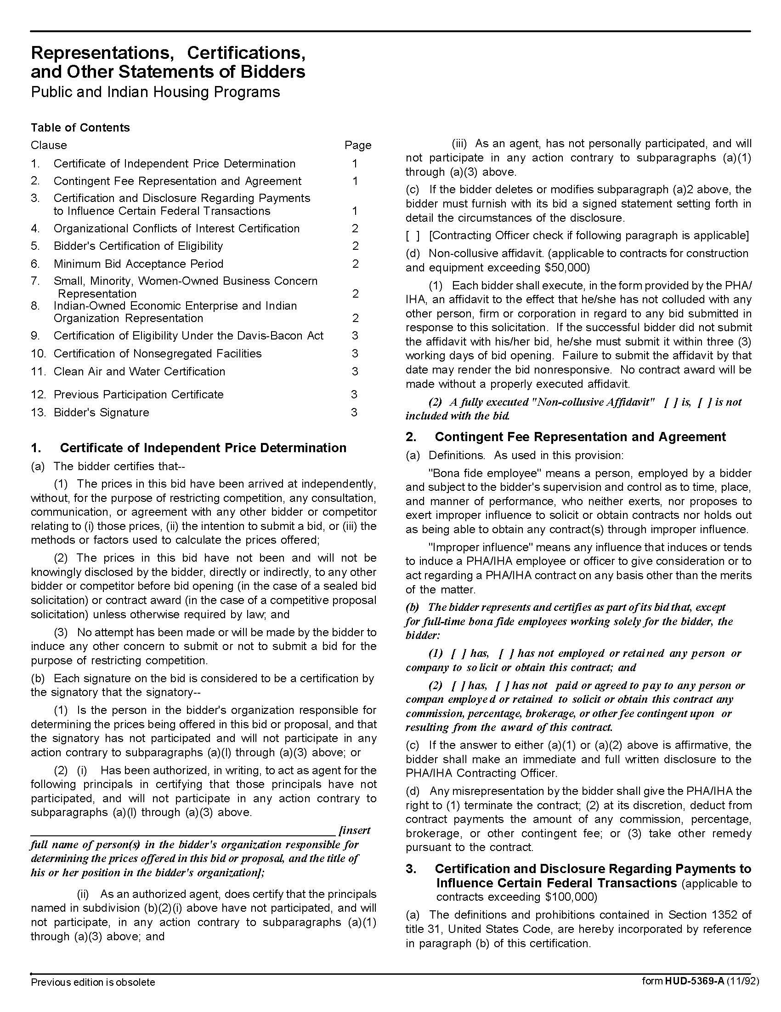

Plumbing Parts & Supplies Q1814
Solicitation Document C HUD Form 5369A - Continued
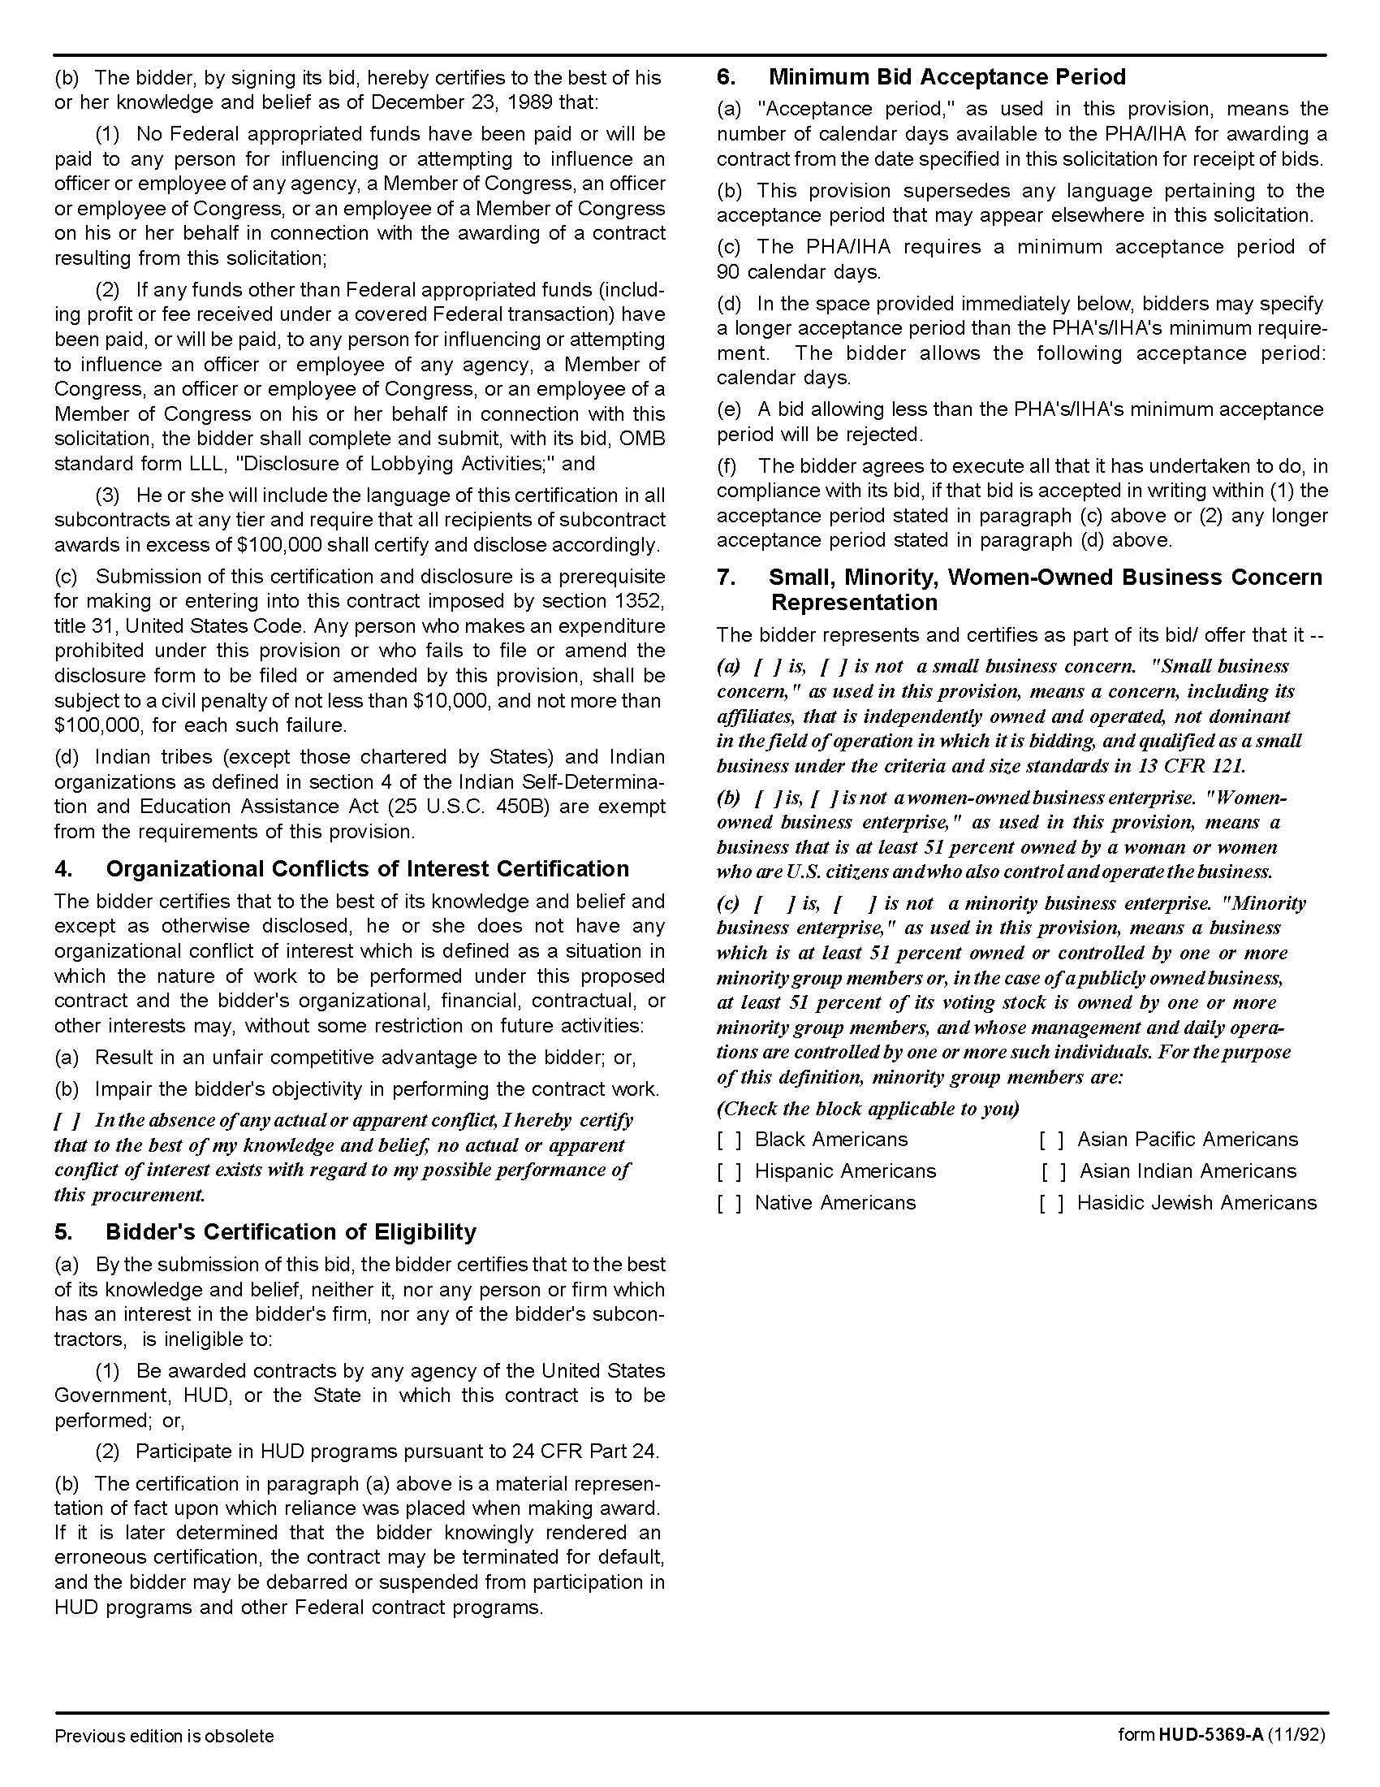

Plumbing Parts & Supplies Q1814
Solicitation Document C HUD Form 5369A - Continued

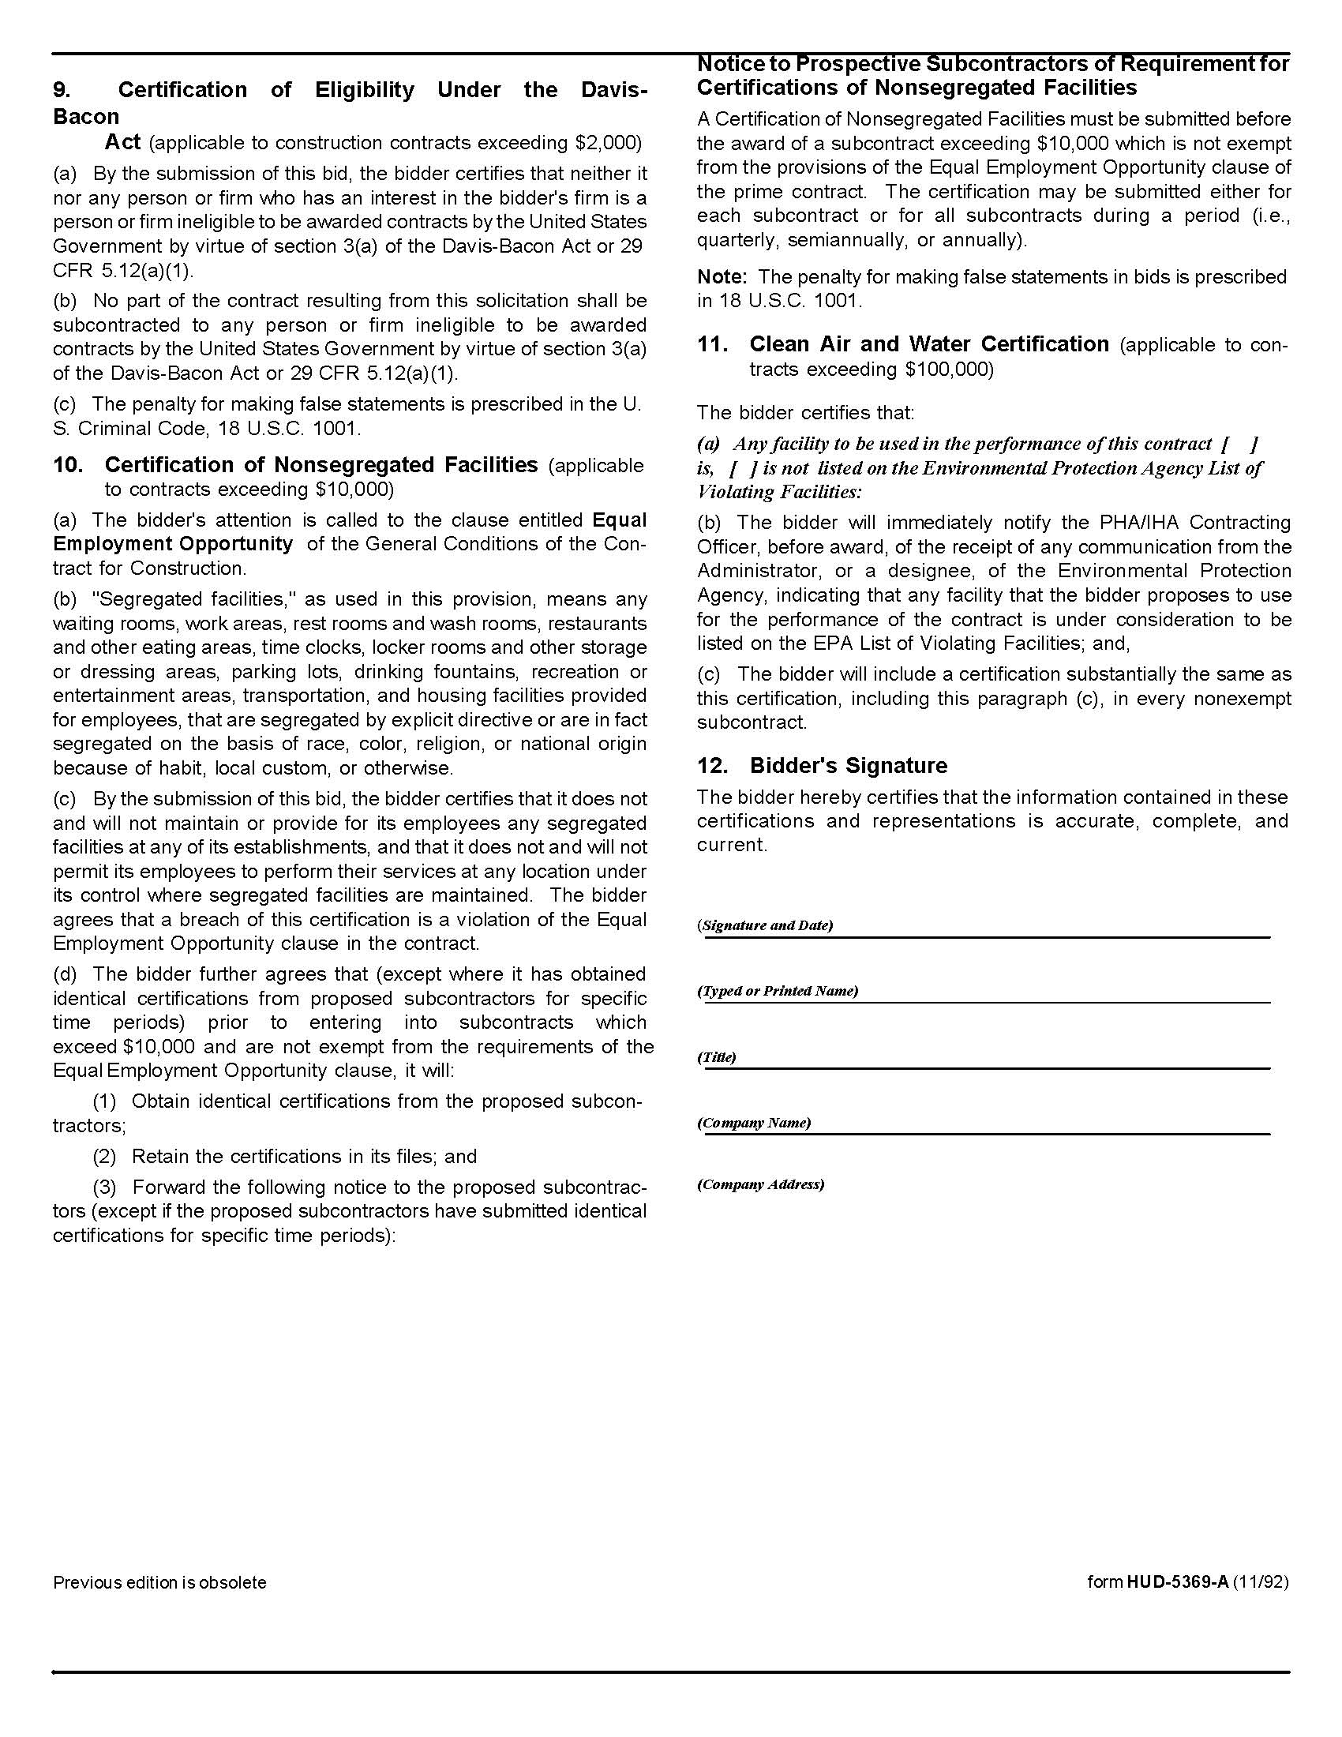

Plumbing Parts & Supplies Q1814
Solicitation Document D Pricing Form

Supplier: _______________________________________________________________________________

Directions:

1. Use as many or as few pricing lines as is necessary to properly quote the discount you will offer on your products.

2. Under the heading “Manufacturer” please enter a succinct phrase such as “All,” or “Delta,” “American Standard,” or “Copper,” or “PVC," or “Fixtures,” et cetera. Feel free to insert the appropriate brand, category or other nomenclature as appropriate.

3. Under the heading “Discount Base” please enter the base that the discount will be applied to in that category of items; such as “Shelf Price,” “Manufacturer Price,” “List Price,” et cetera.

Manufacturer/Product | % Discount | Discount Base
 | %
 | %
 | %
 | %
 | %
 | %
 | %
 | %
 | %
 | %
 | %
 | %
 | %

Plumbing Parts & Supplies Q1814
Solicitation Document D Pricing Form

Plumbing Parts & Supplies Q1814
Solicitation Document D Pricing Form - Continued

Item | List Price | Discount | Sell Price
1 1/2 X 6 PVC Slip Ext Tube
1" PVC Adapter for Water Heater Pan
3" X 3/4" SCK X FPT Bushing
3/4 cop 90 ell 107-c
Angle Stop Comp 5/8 X 3/8 Chrome
BRZ Propress FM ADPT 1/2C X ½ FM
Channel 1 5/8 x 1 5/8 14GA EL Hole Green 10 ' Length
COP Propress 90 ELL 1/2"
COP Propress Coupling g w/stop 1"
COP Propress Coupling no stop 3/4"
COP Propress ftg red 1 ½ ftg c 1c
COP Propress Tee CXCXC 1"
Ell PVC S-40 1"
Female PVC DWV 4"
Female PVC DWV 6"
FP Ball Valve Bronze 600WOG 1 1/4" THD
FTG CO ADPT PVC DWV 4" W/Cleanout Plug
T/S Valve Body Multi-choice Universal
Trim Pack T/S 1HDL MTL LVR T-C Shower Head Cp
T-Y 2PCE P VC DWV 6"
TYPEW A End Cap Pre-galvanized for use with As500
Wall HYD FRZ-Less 12" 3/4 Hose Conn
1 1/2 Legend Press Ball Valve
1 1/2 P-Trap PVC w/ THRD ADPT Bagged
1 1/2 x 1 1/2x1/2 Copper Tee 111-R
1 1/2 X 8 PVC FLNG TLPC
1 1/2" x 20' L Hard Copper Pipe
1 1/4 P-Trap WHT PP Bagged
1 1/4 X 16 PVC DBL Slip Ext Tube
1 1/4 X 20' L Hard Copper Pipe
1" BARB X 3/4" MPT BRS Hose Barb Adapter
1" L Hard Copper Pipe
1" L Soft Copper Pipe
1/2 cop 90 ell 107-C-2
1/2 Square Washer Electro-Galvanized
1/2 x 10' L Hard Copper Pipe
1/2" X 520" Teflon Tape
1/2C X 1/2M, 1 PRV 25-75# @50 3/4
2 Legend Press Ball Valve
2 X 2 SAN TAP TEE NH
2 X 20' L Hard Copper Pipe
20 FT 1 X 20' L Hard Copper Pipe
22" Aluminum Water Heater Pan
24" Aluminum Water Heater Pan
250' X 1/2" ID Jet Hose
3/4 cop cplg w/s Top 100
3/4 Copper Female Adapter CXF 103
3/4 Copper Male Adapter CXM 104
3/4 HB X 3/4 MHT Garden Hose Adapter
3/4 Legend Press Ball
3/4 mht x (3/4 mx1/2fpt) Garden Hose Adapter
3/4 Tube Cap Tectite Push Fit 217
3/4 x 10' L Hard Copper Pipe
3/4 X 60' L Soft Copper Pipe
3/8 COP 90 ELL 107-C
4 -IN- 1 Brush 1/2 X 3/4 ID
4" CPLG PVC - SDR35 SW
4" X 3" PVC Saddle
45D ELL PVC S-40 3/4
50' PVC2729 PE S/D Pipe 4" x 10'
6 X9 Access Panels
90D Ell Galvanized 2", 1
Angle Stop Comp 5/8 X 3/8 Chrome
Backwater Valve 4" PVC
BFP Red Press 3/4" Test Cocks Up W/STR AG
Boiler Drain 1/2 mip
Boring Gimlet
Bowl Back Outlet and Press Assist Tank
BRZ Propress Female Adapter 1 1/2c x 1 1/2fm
BRZ Propress Male Adapter 3/4C X 3/4M
BRZ Propress Male ADPT 2C X 2M
BRZ Propress Male Adapt 1c x 1m
BRZ Propress Male Adapter 1- 1/2C X 1-1/2M
BRZ Propress Male Adapter 1 1/4C X 1 1/4M
Bush PVC S-40 1 X 3/4
C/O ADJ PVC 4"
C/O Plug PVC DWV 2"
C/O Plug PVC DWV 3"
C/O Plug PVC DWV 6"
C/O Plug PVC DWV 8"
CAP PVC S-40 2"
Caution Tape 3" X 300'
Closet Flange Ci 3x2 Inside Pipe 2-Finger
Closet Flange PVC 4x3 F/F Wko
Closet Riser Bearded 9" 3/8 Compr X 7/8 Bc Thread
Closet Riser Brded Ss 12" 3/8 Compr X 7/8 Bc Th Rd
Combination NH 4"X 2 T-WYE
Commode Tank
COMP CPLG GALVANIZED, 1" Long Pattern
Comp CPLG PVC 3/4 IPS
Comp S Leeve Plst 3/8
Comp Tee 5/8
Comp Union 1/4
Comp Union 5/8
Complete Fm System For Close Cpld Toilet-Am S Td
Cop Pp Ftg Red Ftgxc 1 1/2" X 3/4"
Cop Propress Coupling No Stop 1 1/2"
Cop Propress 45 Ell
Cop Propress 45 Ell 1 1/2"
Cop Propress 45 Ell 1/2"
Cop Propress 45 Ell 2"
Cop Propress 45 Ell 3/4"
Cop Propress 90 Ell 1 1/4"
Cop Propress 90 Ell 1"
Cop Propress 90 Ell 1/2"
Cop Propress 90 Str Ell Ftgxc 1/2"
Cop Propress 90 Str Ell Ftgxc 2"
Cop Propress 90 Str Ell Ftgxc 3/4"
Cop Propress Coupling No Stop 1 1/4"
Cop Propress Coupling No Stop 1"
Cop Propress Coupling No Stop 1/2
Cop Propress Coupling No Stop 3/4"
Cop Propress Coupling W/Stop 1/2"
Cop Propress Ftg Red 1ftg X 1/2c
Cop Propress Ftg Red 1ftg X 3/4c
Cop Propress Te E Cxcxc 1"
Cop Propress Tee Cxcxc 1"
Coupling PVC DWV 1 1 /2"
Coupling PVC DWV 2"
Coupling PVC DWV 4"
Coupling PVC S-40 3/ 4
Cross PVC DWV 2 X 1 1/2
Delta Seats & Springs
Dial-Set Prv 15-90 Psi Set @ 60 3/4" Sgl Union
Disconnect Clip 1/2"
Disconnect Clip 3/4"
Drain Trap Conn 1 - 1/2 X 1- 1/4
Element 208v 5500w
Ell PVC DWV 1 - 1/2
Ell PVC DWV 2"
Ell PVC S- 40 3/4
Fct Rise R Brded Ss 12" 3/8 Compr X 1/2 Fip
Female PVC DWV 2"
Female PVC DWV 3"
Female PVC DWV 6"
Flanged Sill Faucet 3/4 Fip X 3/4 Hose
Flex Coupling 3 X 3 CI/PI X CI/PI
Flex CPLG 2 X 2 CI/PL X CI/PL
Flex Coupling 2 X 2 Ci/Pl X Ci/Pl
Flex Coupling 4 X 4 Ci/Pl X Ci/Pl
Flex Coupling 6 X 6 CI/PL X CI/PL
Flex Coupling 6" C ON X 6" CI/PL
Flex Coupling 6" Con X 4" Ci/Pl
Flush Bush PVC DWV
Fp Ball Valve Bronze 600wog 3/4" Swt
Fp Ball Valve Bronze 600wog 1 1/4" Thd
FP Ball Valve Bronze 600wog 1" Thd
Fp Ball Valve Bronze 600wog 1/2" Thd
Fp Ball Valve Bronze 600wog 3/4" Thd
Ftg Co Adapter PVC DWV 4" W/Cleanout Plug
Galvanized Pipe Nipple 1/2 X 1 1/2 Imp
Garden Hose Dw Ftg 3/4 F H X 3/8 Od Compr
Gripper Plug 4"
Gripper Plug 1 1/2
Gripper Plug 2"
Hex Bushing Brs 1 X 3/4
Hex Bushing Brs 1/2 X 1/4, 1 Bush Sxf Pvc S40 1 X 1/2
Hex Bushing Brs 3/4 X 1/2-
Johni Bolt 5/16"
Johni Ring Standard Wax Ring Horned
Johni Ring Standard Wax Ring Regular
Lav Drain W/Overflow Cp
Ls Ell PVC DWV 2"
Male PVC S-40 2"
Male Pvc S-40 3/4 Duraplastic
MININ BALL Valve Bronze
Nipple Galvanized St D 1 1/4 X 3 Imp
Nipple Galvanized Std 1 1/4 X 4 Imp
Nipple GLV STD 2 X8 IMP
Nozzle Assembly F/P8am, Cp
OEM Delta Sea+A86ts/Springs
Plug Cored Brs 1"
Plug Cored Brs 1/2"
Plug Cored Brs 3/4"
Plug S-Cde Brass 2 1/2 Countersunk Head
Plug S-Cde Brass 3 1/2 Countersunk Head
Plug S-Cde Brass 3" Raised Head
Plug S-Cde Brass 6" Countersunk Head
Plumbers Putty
Pou W/H Single Poin T 120v 3.5w 29a
Press Ga. 2.5 0-200
Pressure Reducing Valves 25-75# @50 3/4
Probing Rod Ss, 5'
Probite Coupling 1/2" X 1/2"
Probite Coupling 3/4 X 3/4
Probite Elbow 1/2" X 1/2"
Probite End Cap 1/2"
Probite End Cap 3/4 "
Probite Female Adapter 3/4" X 3/4" Fip
Probite Male Adapter 1/2" Pc X 1/2" Mip
Probite Male Adapter 3/4" Pc X 3/4" Mip
Probite Red Coupling 3/4" X 1/2"
Probite Tee 1/2" X 1/2" X 1/2"
Prv 25-75# #50 2"
Prv 25-75# @50 3/4
P-T Rap PVC DWV 2"
Putty, 14 Oz
PVC Medium Clear Cement 32 Oz
PVC S/40 Be Pipe 3/4" X 20
PVC S/40 Pe Pipe 2" X 10'
PVC S/40 Pe Pipe 4" X 10', 300' Pvc S/40 Pe Pipe 3" X 10'
PVC S/40 Pe Pipe 6" X 10'
Quad 1/4 Copr Std 1/4 Turn Vlv Swt/Mip
Reducer PVC DWV 6 X 4
Repair Kit Peerless Pr-5w
Rubber Cap W/*Clamp, 2"
Sand Cloth Open Mesh 1 1/2" X 5 Yds 180-AO
Saw Blade Bimetal 10/14t 12l
Saw Blade Bimetal 6t 12l
Sayco P310 Bradtrol Cartridge T&S
Short Reducer Nh 4 X 2
Shwr Arm And Flng Cp
Silicone Grease, 7 Ea Repair Kit F/ Delta Lvr Hdl
Spanner Flange
Srv Snk Fct 2lvr Hdls Vb-Spt Rgh Chr
St 45d Ell PVC Dwv 1 1/2"
St 45d Ell PVC Dwv 2"
St 45d Ell PVC Dwv 4"
St 90d Ell Galv 3/4
St Ell Pvc DWV 6"
Stainless Steel 90 Degree El Brackets (3/4")
Stk-9 Torch Mapp/Propane
Storm Drain Grate
Str Stop Comp 5/8 X 3/8 Chrome
Straight Tee PVC Dwv 2"
Strap 2-Hole Galv 4" Ips
T/S Valve Body Multichoice Universal
T-571 1/2" Dielectri C Union FIPXSWT
T-571 3/4" Diele Ctric Union Fipxswt
Tee Galvanized 1/2
Tee PVC DWV 4"
Test Ball Plug 4"
T-Plus 2 Pipe Thrd Sealant Pt
Trim Pack Shower Only 1 Hdl M/Lvr Cp
Trim Pack T/S 1HDL CLR Knob PD SPT CP
Trim Pack T/S 1hdl Mtl Lvr T-C Shower Head Cp
Trp Adpt-Male Sxslip W/Chrm Nut 1 1/2
Trp Adpt-Male Sxslip W/Chrm Nut 1 1/2 X 1 1/4
T-Y 2pce Pv C Dwv 6 X 4
Type A End Pre-Galv For Use With As500
W&O Fk Wpt Ul Chr PVC Chrome Trim
Wash Machine Hose 48" 3/4 Fht X 3/4 Fht
Washer Box
Washer Flat Zinc Pltd 3/4"
Washer Flat Zinc Pltd 5/8"
Water Heater 208v 3 Phase
Water Heater, 120 Gal Electric Residential
Water Key 1 1/2 X 1 1/2 X 1/2
White Marking Paint, 17 Oz

COOPERATIVE PROCUREMENT BY OTHER GOVERMENTAL ENTITIES
Subject to additional location/delivery charges, the proposer agrees to extend the offered costs to other
governmental entities if the entity so desires. Yes ☐ No ☐

