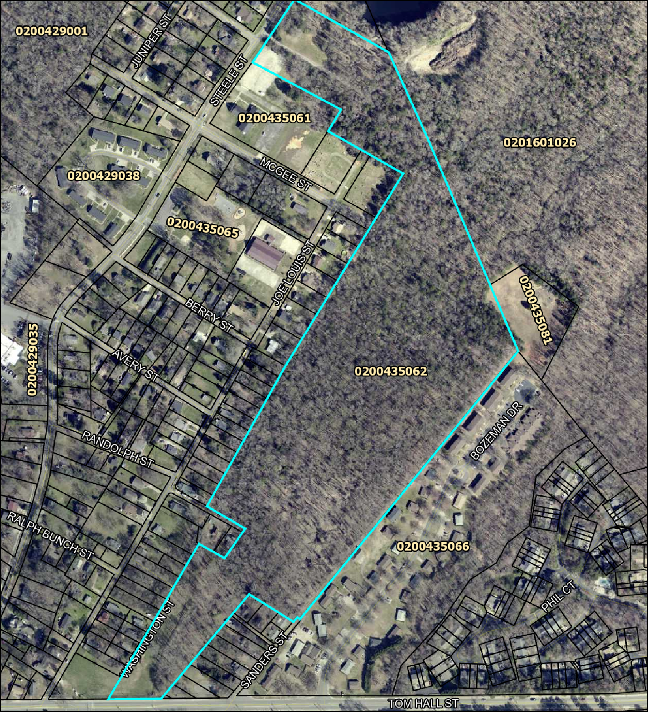
 York County, SC
EXHIBIT A
ECD Center Site

Boring Locations
Parcel Location - Tax Map ID#: 0200435062

350 ft

EX. STOP CONTROLLED INTERSECTION: STEELE STREET @ ANDERSON STREET

Esri Community Maps Contributors, mecknc, York County Govern NPS, US Census Bureau, USDA, USFWS
EX. SIGNALIZED INTERSECTION: STEELE STREET @ TOM HALL STREET

min, SafeGraph, GeoTechnologies, Inc, METI/NASA, USGS, EPA,

SITE
- Exhibit B
0 1000 2000
ment, SC, State of North Carolina DOT, Esri, TomTom, Gar
ft
Disclaimer: While every effort is made to keep information provided over the internet accurate and up-to-date, York County does not certify the authenticity or accuracy of such information. No warranties, express or implied, are provided for the records and/or

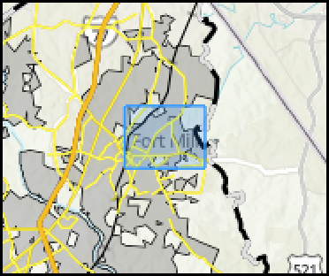
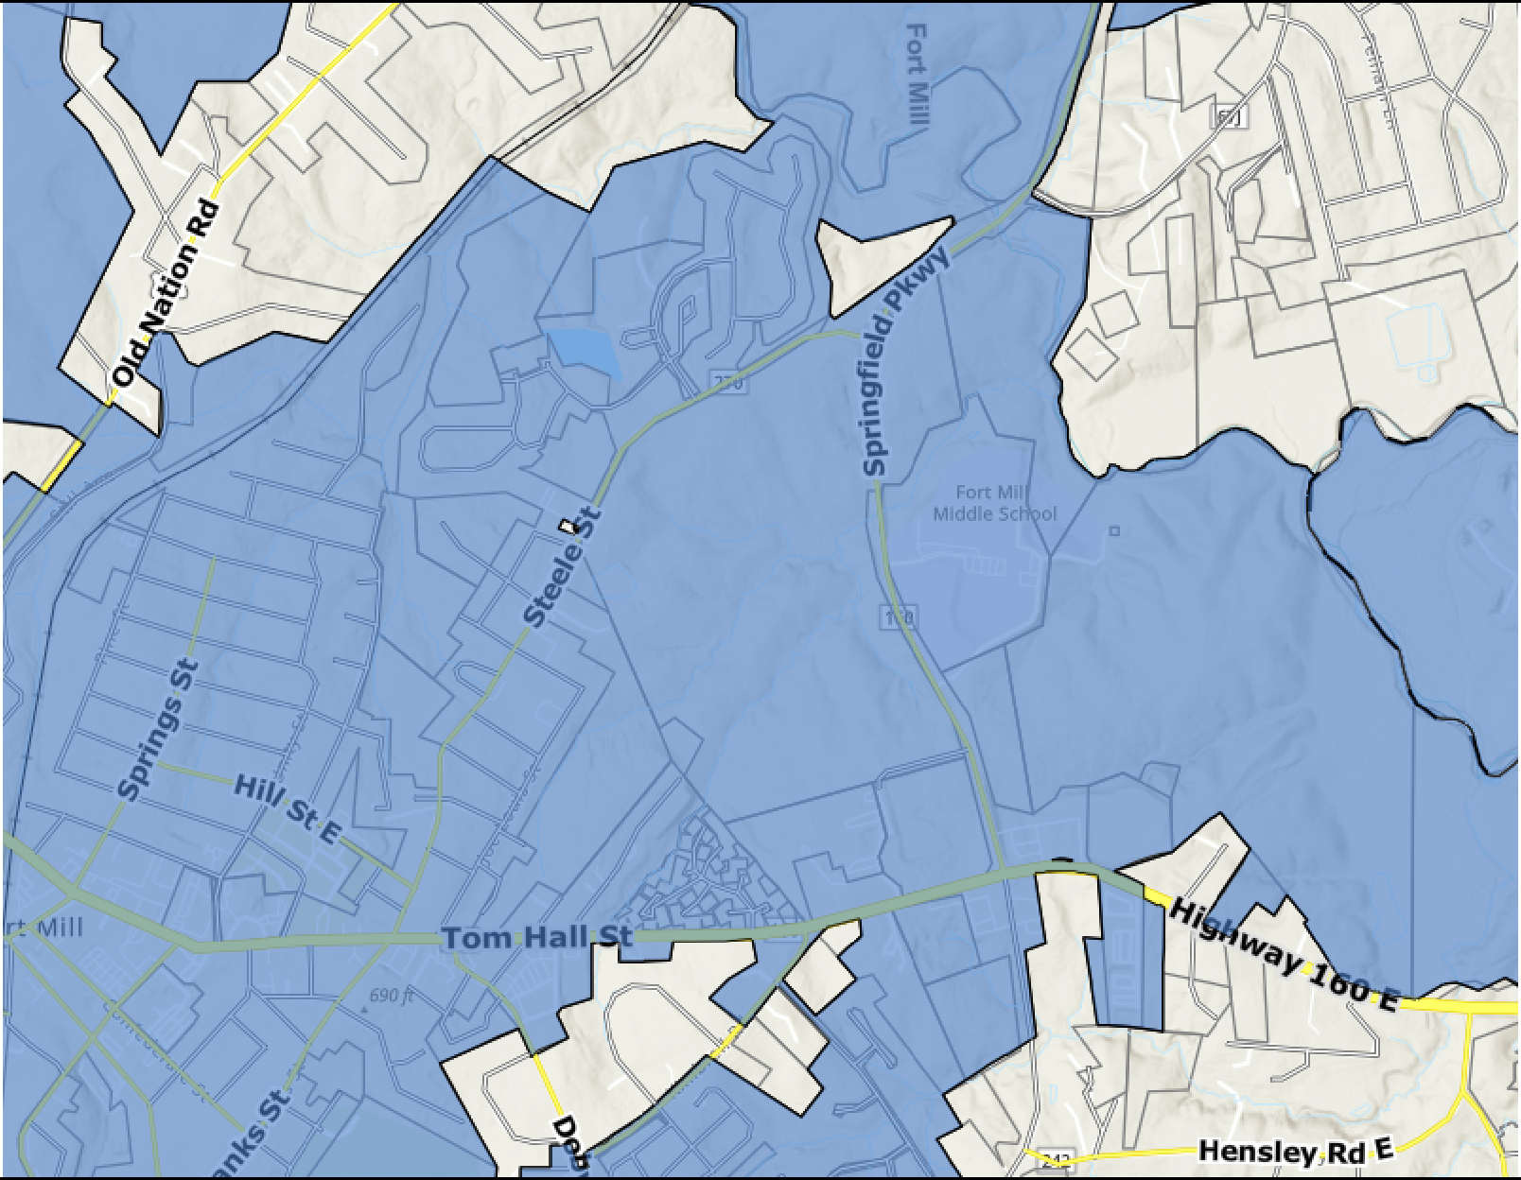
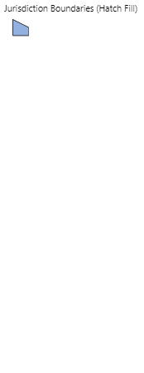
mapping data herein, or for their use or interpretation by the User.
FMSD Early Childhood Development Center
EX. SIGNALIZED INTERSECTION: TOM HALL STREET (SC-160) @ SPRINGFIELD PARKWAY
Legend
Jurisdiction Boundaries (Hatch Fill)
EX. STOP CONTROLLED INTERSECTION: TOM HALL STREET @ AQUATIC CENTER DRIVE
EX. SIGNALIZED INTERSECTION: STEELE STREET @ SPRINGFIELD PARKWAY
Notes
TIA Intersections

