

CITY OF BATTLE CREEK

NOTICE OF INVITATION FOR BIDS

IFB#: 2018-052S

SURPLUS MATERIAL: Transit Vehicles

ISSUE DATE: February 2, 2018

BID DUE DATE: February 20, 2018, at 2:00 PM Local Time
LOCATION: Purchasing Department
10 N. Division Street, Suite 214
Battle Creek, MI 49014
(269) 966-3390

Technical Contact Merritt Wilson, Transit Maintenance Supervisor
Phone: (269) 966-3558
E-mail: mgwilson@battlecreekmi.gov

Purchasing Contact: Nils Vos, Senior Buyer
Phone: (269) 966- 3381
E-mail: npvos@battlecreekmi.gov

DESCRIPTION: The City is soliciting bids for the purpose of selling four (4) Bluebird transit buses as bundle.

Download this solicitation from our website at:
battlecreekmi.gov
Copies of the complete Invitation for Bids document may also be obtained from the Purchasing Department, Room 214, 10 N. Division Street, Battle Creek, Michigan 49014, (269) 966-3390.

Bids must be in the actual possession of the Purchasing Department at the location indicated, on or prior to the exact time and date indicated above. Bids received by the correct time and date shall be opened and the amount bid shall be publicly read. Late bids shall not be considered.

BIDDERS ARE STRONGLY ENCOURAGED TO CAREFULLY READ THE ENTIRE INVITATION FOR BID.

THIS BID IS OFFERED BY: ______________________________________________
(Company or Individual’s Name)

INSTRUCTIONS TO BIDDERS
1. BID SUBMISSION:
A. Bids must be submitted in complete original form by mail or messenger to the following address:
Office of the Purchasing Agent, Room 214, City Hall, 10 N. Division Street, Battle Creek, MI 49014
B. Bids will be accepted at the above address until the time and date specified herein, and immediately after will be publicly opened and read aloud. The prevailing clock shall be www.time.gov.
C. All bids shall be tightly sealed in an opaque envelope and plainly marked with the Invitation for Bid number, due date and the bidder's name and address clearly indicated on the envelope.
D. Late bids will not be accepted and will be returned to the bidder.
E. All bids submitted in response to this invitation shall become the property of the City and be a matter of public record available for review.
2. PREPARATION OF BIDS:
A. The Bid shall be legibly prepared with ink or typed.
B. If a unit price or extension already entered is to be altered, it shall be crossed out and initialed by the bidder with ink.
C. The bid shall be legally signed on the OFFER TO CONTRACT page and the complete address of the bidder given thereon.
3. SIGNATURES: All bids, notifications, claims and statements must be signed as follows:
All bids, notifications, claims and statements must be signed by an individual authorized to bind the bidder. Any individual signing certifies, under penalty of perjury, that he or she has the legal authorization to bind the bidder.
4. REJECTION OR WITHDRAWAL: Submission of additional terms, conditions or agreements with the bid document are grounds for deeming a bid nonresponsive and may result in bid rejection. The City reserves the right to reject any or all bids and to waive any informalities and minor irregularities defects in bids. Bids may be withdrawn in person by a bidder, or authorized representative, provided their identity is made known and a receipt is signed for the bid, but only if the withdrawal is made prior to the time set for receipt of bids. Bids are an irrevocable offer and may not be withdrawn within 90 days after opening date.
5. AWARD: The bid will be awarded to that responsible, responsive bidder whose bid, conforming to this solicitation, will be most advantageous to the City, price and other factors considered. Unless otherwise specified in this IFB, the City reserves the right to accept a bid in whole or in part, and to award by item or by group, whichever is deemed to be in the best interest of the City. Any bidder who is in default to the city at the time of submittal of the bid shall have his bid rejected. The City reserves the right to clarify any contractual terms with the concurrence of the Contractor; however, any substantial non-conformity in the offer, as determined by the City, shall be deemed non-responsive and the offer rejected.
6. CURRENCY: Prices calculated by the bidder shall be stated in U.S. dollars.
7. CONTRACT: A response to an IFB is an offer to contract with the City based upon the terms, conditions, and specifications contained in the City's IFB. Bids do not become contracts unless and until they are executed by the City, eliminating a formal signing of a separate contract. For that reason, all of the terms and conditions of the contract are contained in the IFB, unless any of the terms and conditions are modified by an IFB Amendment, a Contract Amendment, or by mutually agreed terms and conditions in the contract documents. All terms and conditions, specifications, and drawings related to this solicitation shall prevail over anything submitted by the contractor unless it is in the City’s best interest to do otherwise.
8. BID RESULTS: Bid A bid tabulation will be posted on the City’s website and will also be on file and available for review after contract award in the Purchasing Department.
9. CHANGES AND ADDENDA TO BID DOCUMENTS: Each change or addendum issued in relation to this bid document will be on file in the Office of the Purchasing Agent. In addition, to the extent possible, copies will be mailed to each person registered as having received a set of bid documents. It shall be the bidder's responsibility to make inquiry as to changes or addenda issued. All such changes or addenda shall become part of the contract and all bidders shall be bound by such addenda. Information on all changes or addenda issued will be available at the office of the City Purchasing Agent.
10. INTERPRETATION OF BID AND/OR CONTRACT DOCUMENTS: All inquiries shall be made within a reasonable time prior to the date and time fixed for the bid opening in order that a written response in the form of an addendum, if required, can be processed before the bids are opened. (Inquiries received that are not made in a timely fashion may or may not be considered).
11. CERTIFICATION: By signature in the offer section of the Offer and Acceptance page, bidder certifies:
A. The submission of the offer did not involve collusion or other anti-competitive practices.
B. The bidder has not given, offered to give, nor intends to give at any time hereafter, any economic opportunity, future employment, gift, loan, gratuity, special discount, trip, favor, or service to a public servant in connection with the submitted offer.
C. The bidder hereby certifies that the individual signing the bid is an authorized agent for the bidder and has the authority to bind the bidder to the contract.
D. The bidder hereby certifies that the firm will abide by the COPELAND ANTI-KICKBACK ACT, Title 18, U.S.C. June 25, 1948, Section 874, Kickbacks from Public Employees.
TERMS AND CONDITIONS

1. All bids submitted shall be deemed to have been made with the full knowledge of the information contained in this document.

2. The failure of any bidder to fully inspect the item(s) indicated, or negligence or mistake on the part of the bidder in preparing the bid will not constitute grounds for any claims or demands for adjusting the bid after opening. The item(s) as above mentioned is offered for sale as is. The City does not make any guarantee or warranty, expressed or implied, with respect to quality or condition of the item(s).

3. Inspection of Items: All vehicles are available for viewing prior to bid at the Battle Creek Transit Dept. by appointment only. See Technical contact information on page 1.

4. The sale will be on an all cash basis, at time of acceptance. If payment is by check, then the City can hold the item for up to 10 business days.

5. The successful bidder will remove the items(s) from the present location within 21 calendar days from the date of notice. The item(s) will be removed at the buyer's expense. No extension of the time herein specified for removal will be granted unless justified in the opinion of the Purchasing Agent. Only unusual and unforeseen circumstances could justify such extension.

6. In the event of any default by any bidder hereunder, all claim to the apparatus will be forfeited and all payments made by the defaulting bidder will be applied by the City to any loss, cost or expense of the disposing of the apparatus at said location.

7. The successful bidder will assume responsibility and liability for all injuries to persons or damages to property directly or indirectly, due to or arising out of, the removal operations by the successful bidder. Said bidder agrees to indemnify and save harmless the City of Battle Creek against any or all claims whatsoever kind and nature due to or arising out of the sale or removal of said apparatus.

8. The successful bidder will not resell or advertise the item(s) for resale until same has been removed from the site.

9. Michigan Constitutional Requirement:
a). Notwithstanding any provision in this Contract to the contrary, and in accordance with Article I, Section 26 of the Michigan Constitution as adopted by the electorate November 7, 2006, CONTRACTOR shall not discriminate against, or grant preferential treatment to, any individual or group on the basis of race, sex, color, ethnicity, or national origin in the operation of this Contract.

b). This section shall not prohibit any action that must be taken to establish or maintain eligibility for any federal program if ineligibility would result in a loss of federal funds in connection with this Contract, nor shall this section be interpreted as prohibiting bona fide qualifications based on sex that are reasonable necessary to the execution of this Contract.

c). In the event of conflict between any term of this Contract and this section, the language of this section shall control.

- VENUE: Any party bringing a legal action or proceeding against any other party arising out of or relating to this Agreement or the transactions it contemplates shall bring the legal action or proceeding:

(i) in the United States District Court for the Western District of Michigan; or

(ii) in any court of the State of Michigan sitting in Calhoun County, if there is no federal subject matter jurisdiction.
SPECIFICATIONS

Vehicle 1
2006 Bluebird Excell, 29ft. Mileage: 360,000.

Engine 8.3 Cummins ISC, Allison BR400 transmission are complete. HVAC system and wheelchair lift are missing some components. Also missing driver’s seat, mirror’s, and some interior pieces.

Vehicle 2
2006 Bluebird Excell, 29ft. Mileage: 325,000.

This bus is a rolling chassis missing engine, transmission, driveshaft, radiator, CAC, lift, HVAC components, interior pieces, bumpers, windshield and drivers seat.

Vehicle 3
2006 Bluebird Excell, 29ft. Mileage: 340,000.

Engine 8.3 Cummins ISC, Allison BR400 transmission are complete. HVAC system and wheelchair lift are missing some components. Also missing driver’s seat, mirror’s, and some interior components.

Vehicle 4
2005 Bluebird Ultra Excell LF, 29ft. Mileage: 290,000.

This bus is just a shell. Missing engine, transmission, drive shaft, rear axle and suspension, front steering and suspension, wheels and tires, front HVAC system, lift, glass, and components missing from overhead HVAC system.

PRICE PAGE

Vehicle:

1) 2006 Bluebird Excell, 29ft. Mileage: 360,000 $____________________

2) 2006 Bluebird Excell, 29ft. Mileage: 325,000 $____________________

3) 2006 Bluebird Excell, 29ft. Mileage: 340,000 $____________________

4) 2005 Bluebird Ultra Excell LF, 29ft. Mileage: 290,000 $____________________

Total (Sum 1,2,3 &4) $_________________

Vehicles to be sold as bundle. It IS required to bid on all 4 vehicles as a whole.

OFFER TO CONTRACT:

TO THE CITY OF BATTLE CREEK: We propose to acquire the awarded items in consideration of the sum or sums stated herein and agree that this document will constitute the contract if accepted by the City.

We acknowledge receipt of the following addendum(s): _____, _____, _____, _____.

I certify, under penalty of perjury, that I have the legal authorization to bind the firm hereunder:

For clarification of this offer, contact:
Company Name

Name:
Address

Phone:
City State Zip

Fax:
Signature of Person Authorized to Sign

Email:
Printed Name

Title

ACCEPTANCE OF OFFER:

The Offer is hereby accepted for the following item(s): ____________________

The Contractor is now bound to purchase the item(s) herein and based upon the Invitation for Bid, including all terms, conditions, specification, amendments, etc. and the Contractor's Offer as accepted by the City.

This contract shall henceforth be referred to as Contract # 2018-052S .

COUNTERSIGNED: APPROVED AS TO FORM BY:

City Manager Date City Attorney

Witness Date

Vehicle Photographs
Four (4) Bluebird Transit Buses to be sold as a bundle
Vehicle #1 - Bus
2006 Bluebird Excell, 29ft. Mileage: 360,000

Engine 8.3 Cummins ISC, Allison BR400 transmission are complete. HVAC system and wheelchair lift are missing some components. Also missing driver’s seat, mirror’s, and some interior pieces.

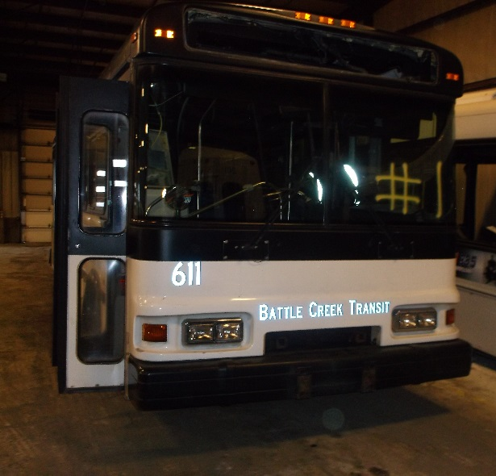

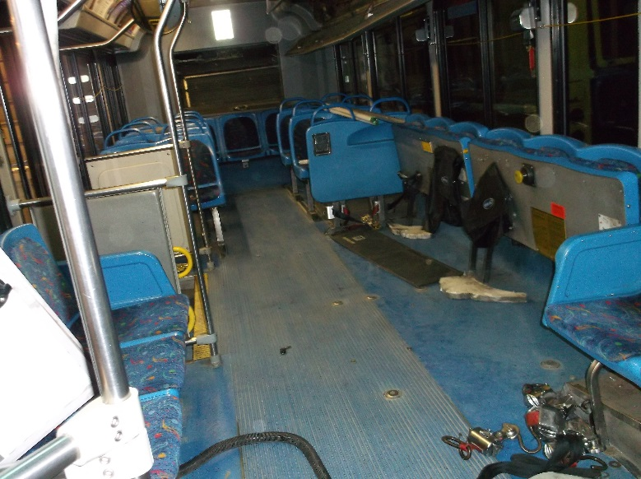

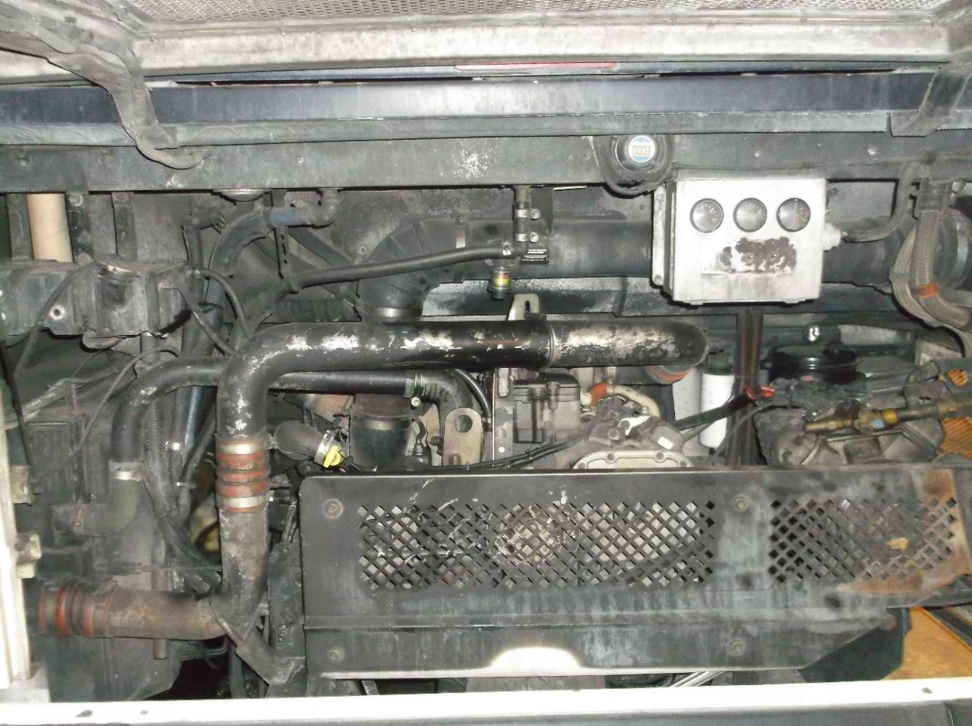

Vehicle #2 - Bus
2006 Bluebird Excell, 29ft. Mileage: 325,000

This bus is a rolling chassis missing engine, transmission, driveshaft, radiator, CAC, lift, HVAC components, interior pieces, bumpers, windshield and drivers seat.

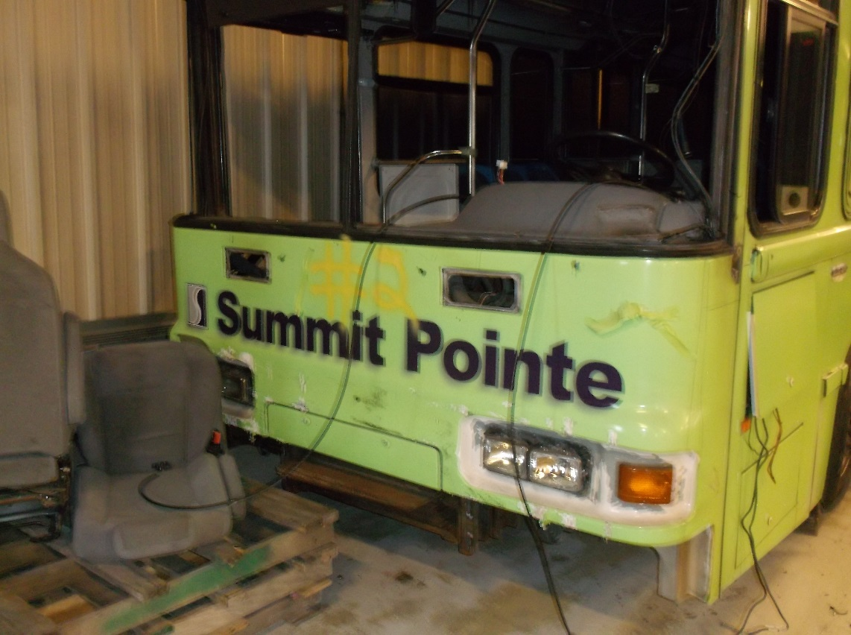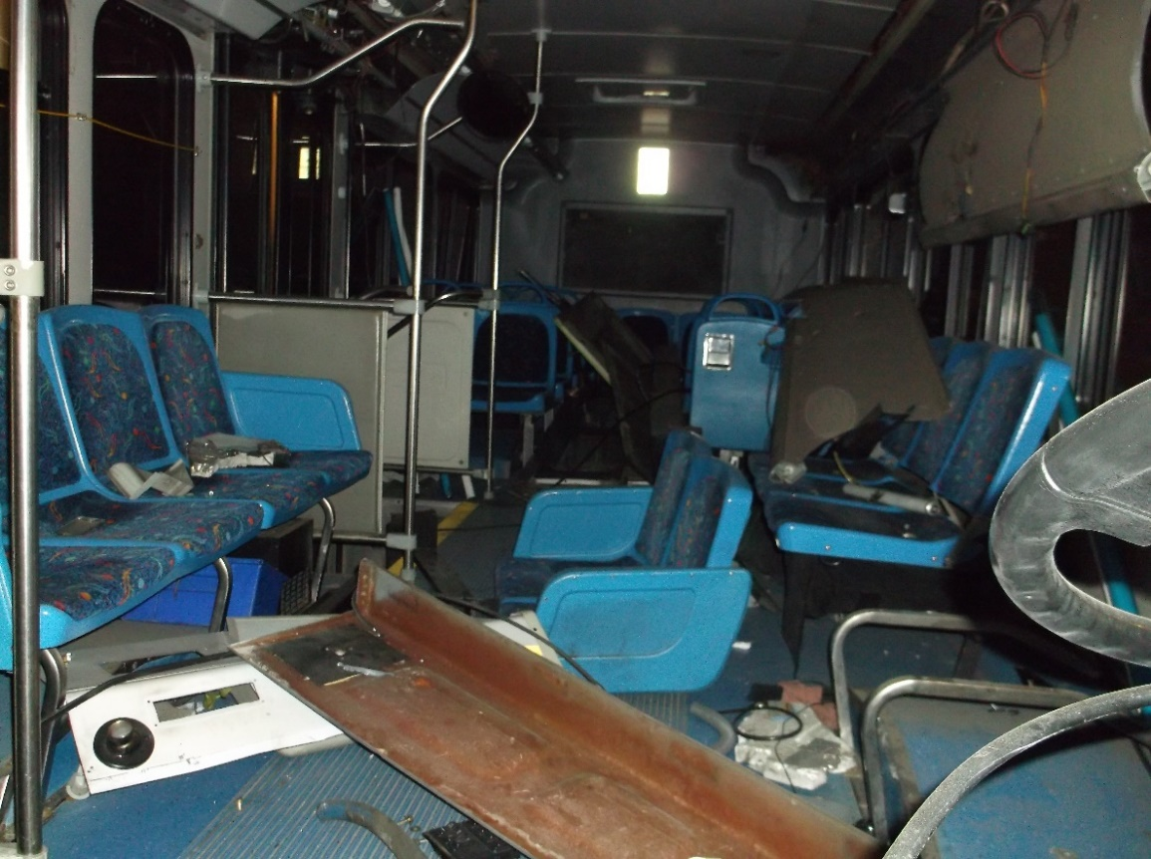
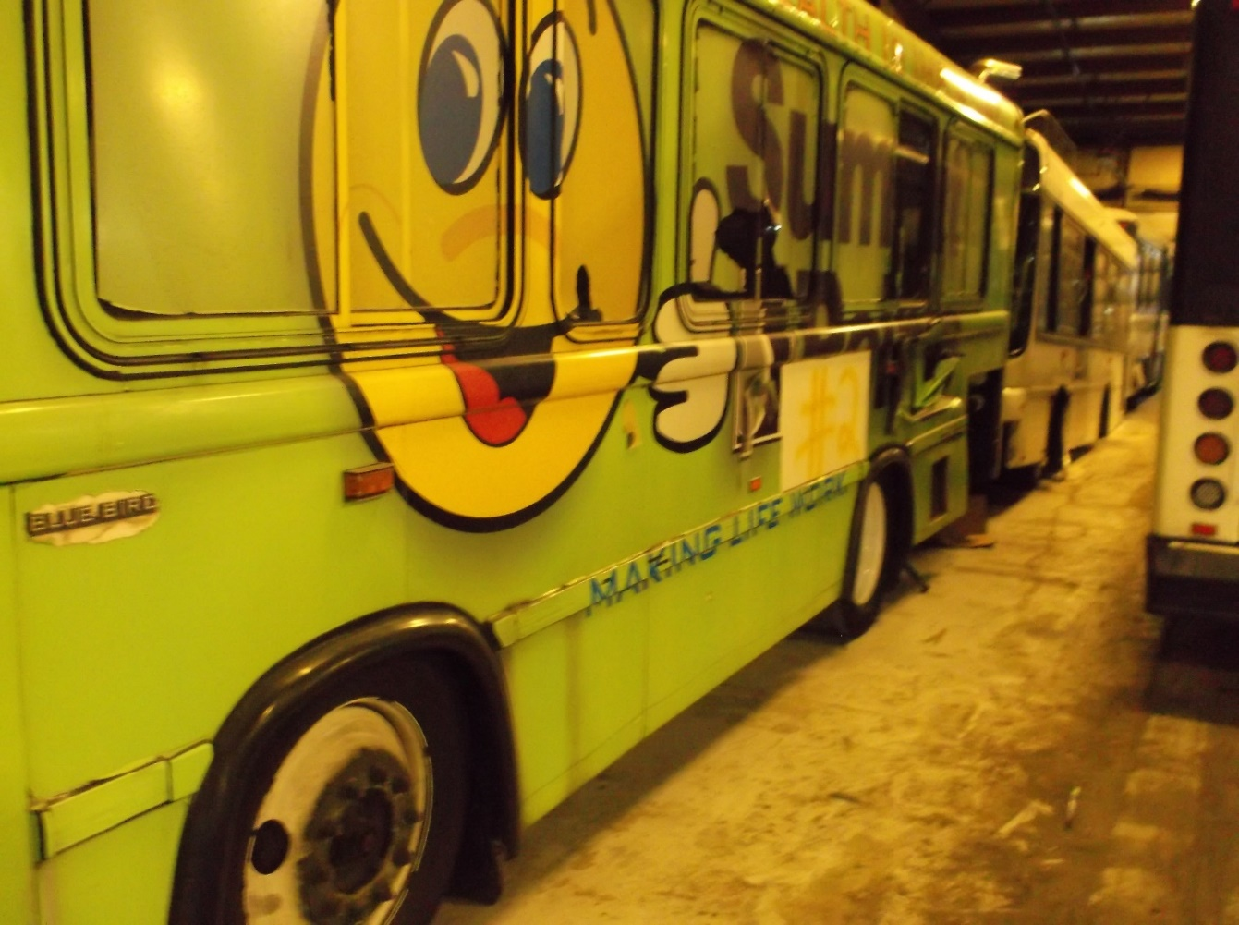
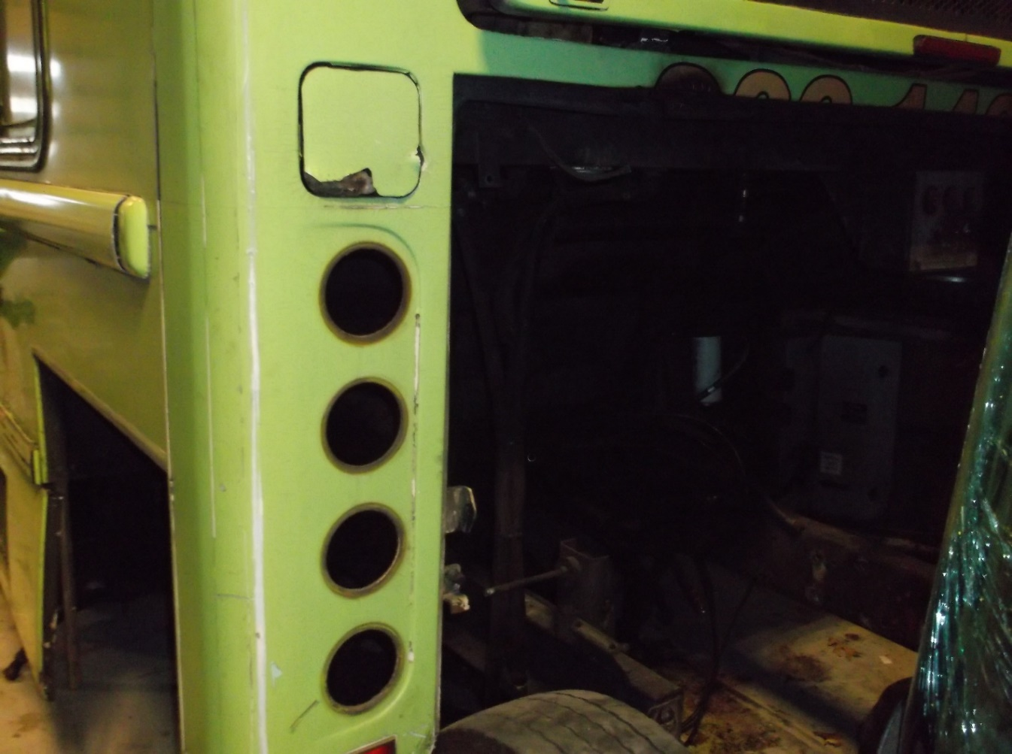

Vehicle #3 - Bus
2006 Bluebird Excell, 29ft. Mileage: 340,000

Engine 8.3 Cummins ISC, Allison BR400 transmission are complete. HVAC system and wheelchair lift are missing some components. Also missing driver’s seat, mirror’s, and some interior components.

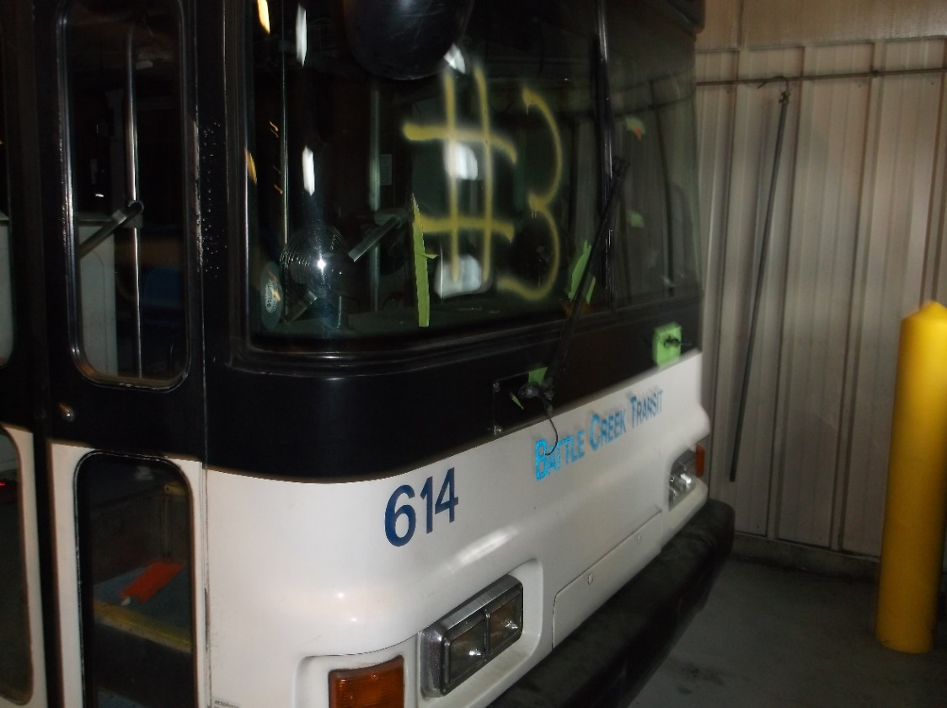
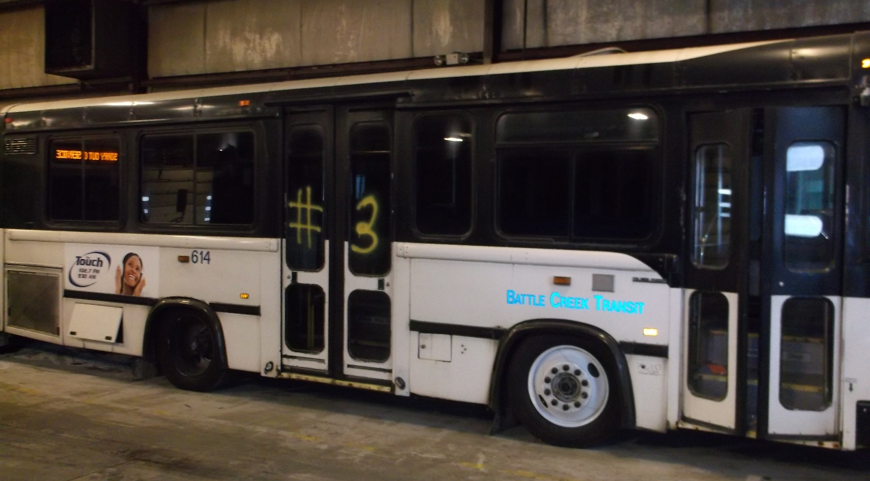
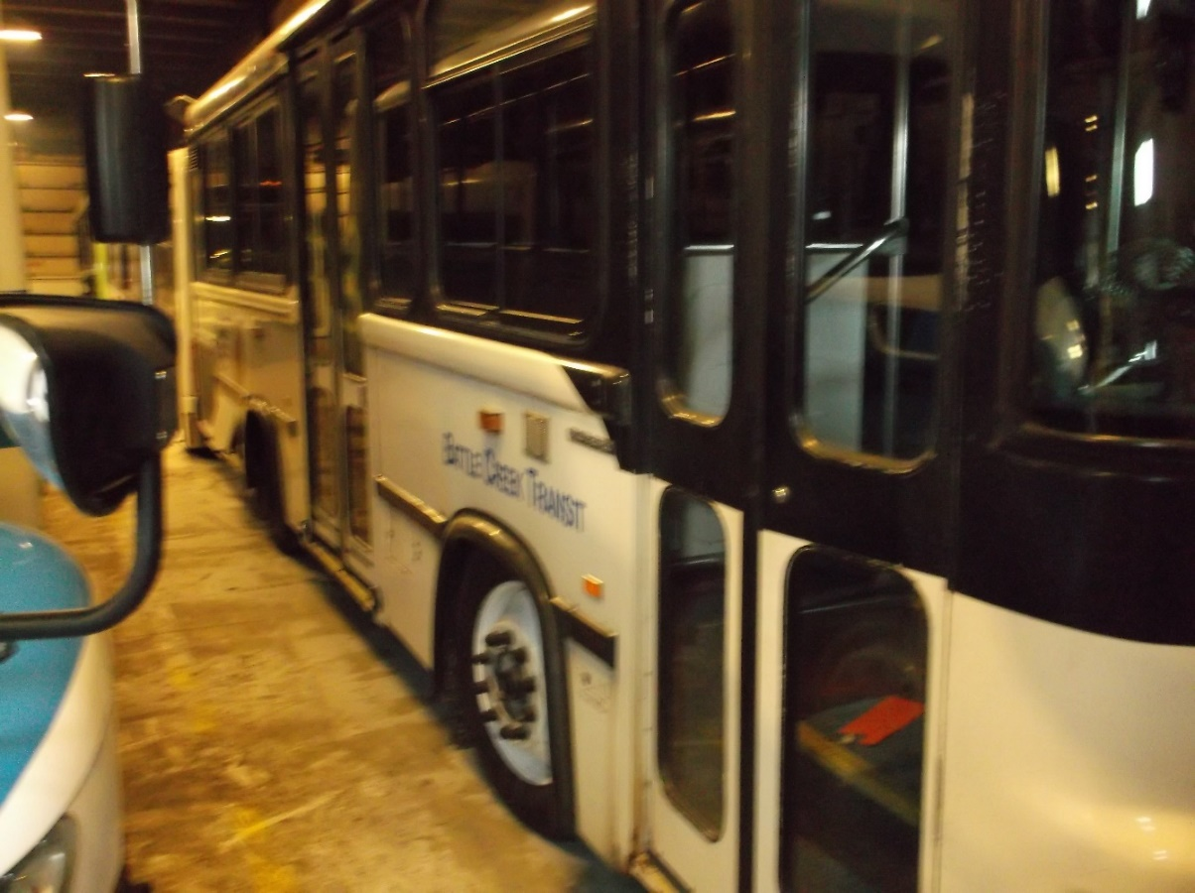
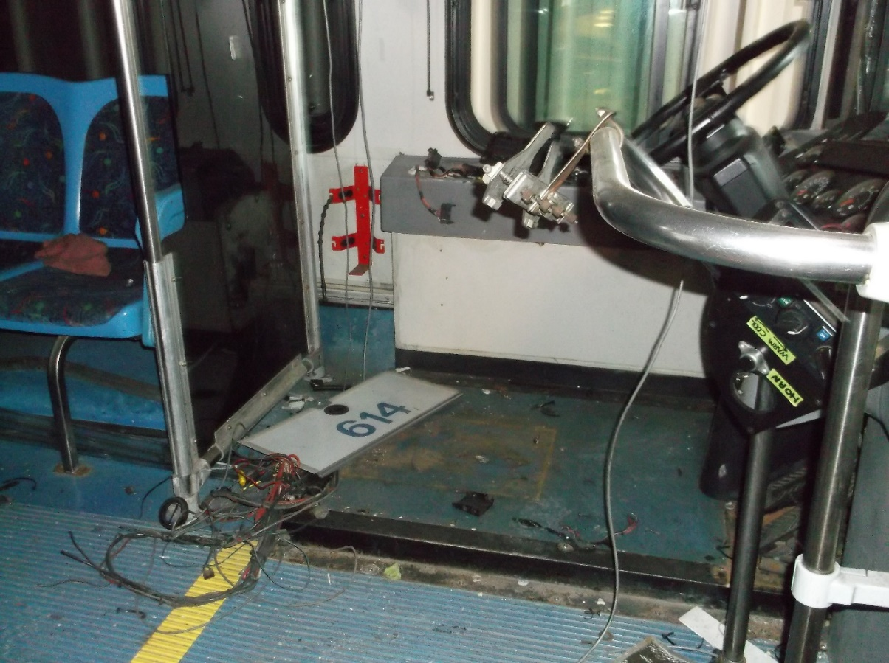
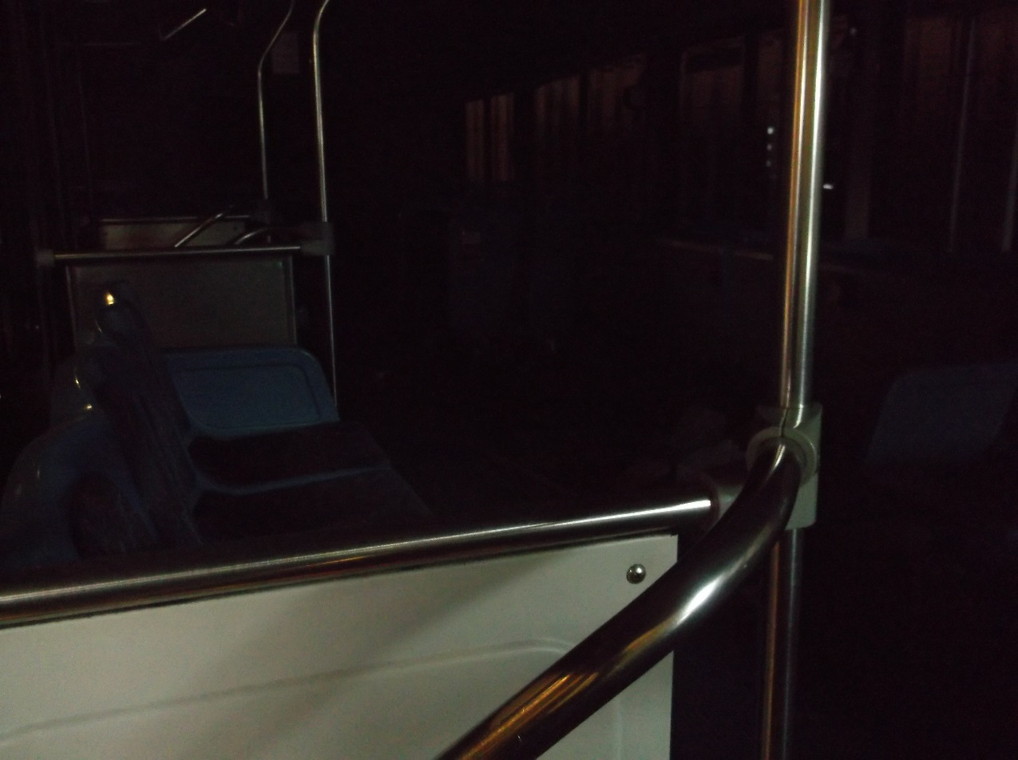

Vehicle #4 - Bus
2005 Bluebird Ultra Excell LF, 29ft. Mileage: 290,000

This bus is just a shell. Missing engine, transmission, drive shaft, rear axle and suspension, front steering and suspension, wheels and tires, front HVAC system, lift, glass, and components missing from overhead HVAC system.

