Request for Proposals

Solicitation Name | Custodial Service for KCDC’s Main Office Building
Solicitation Number | Q1921
Must Arrive by | 11:00 a.m. EST on January 24, 2019
Deliver Responses to: |   Knoxville’s Community Development Corporation  Procurement Division  901 N. Broadway  Knoxville, TN 37917  Procurement is located behind the main office building.
Electronic Copies | Electronic copies are available on KCDC’s webpage or by email at purchasinginfo@kcdc.org. Use the MS Word version to prepare your proposal.
Responses may be Emailed to KCDC | ☒ Yes ☐ No
Printed Responses Required | ☐ Yes ☒ No
Solicitation Meeting | ☒ Yes ☐ No
Solicitation Meeting is Mandatory | ☒ Yes ☐ No ☐ Not Applicable
Solicitation Meeting Date | January 14, 2019
Solicitation Meeting Time | 10:00 a.m.
Solicitation Meeting Location | KCDC’s Training Room in the Main Office Building.
Questions About This Solicitation | Submit questions to purchasinginfo@kcdc.org  KCDC will not accept questions via telephone.
Award Results | KCDC posts both a summary of the quotes received and the award decision to its web page at: http://www.kcdc.org/procurement/
Open Records/Public Access to Documents | All document provided to KCDC are subject to the Tennessee Open Meetings Act (TCA 8-44-101) and open records requirements.

Check KCDC’s webpage for addenda and changes before submitting your response

General Information

1. Background and Intent

a. Knoxville's Community Development Corporation (KCDC) is the public housing and redevelopment agency for the City of Knoxville and for Knox County in Tennessee. KCDC’s affordable housing property portfolio includes 20 sites with approximately 3,525 dwelling units. KCDC also oversees approximately 3958 Section 8 Vouchers, 82 Moderate Rehabilitation units and 20 Redevelopment areas. Several of the properties have transformed to the Project Based Rental Assistance program (PBRA) and KCDC is the management company for those sites. The properties for which KCDC is the management company include the Five Points 1, 2,3 LPs; Lonsdale Homes, LP; North Ridge Crossing, LP and The Vista at Summit Hill, LP.

b. KCDC desires the services of a highly qualified supplier to provide custodial services for its Main Office building located at 901 N. Broadway in Knoxville, Tennessee. The main building houses KCDC administrative staff (approximately 35 persons). Periodically there are meetings in KCDC’s Board Room and Training Room that will involve more than 35 persons.

c. KCDC wants suppliers to ask questions and provide suggestions to keep costs as low as possible while providing excellent service.

d. As an option, KCDC wants a bid on cleaning its Procurement Office area (separate building behind the
main office building as detailed herein. Understand that this option may or may not be exercised.

2. Changes after Award
It is possible that after award KCDC will need to revise the service needs or requirements specified in this document. KCDC reserves the right to make such changes after consultation with the supplier. Should additional costs arise, the supplier must document increased costs. KCDC reserves the right to accept and negotiate these charges.

3. Codes and Ordinances
All work covered is to be done in full accord with national, state and local codes and ordinances and orders that are in effect at the time the work is performed.

4. Contact Policy
The supplier may not contact an officer, agent or employee of KCDC other than the KCDC’s Procurement Division about matters pertaining to this solicitation, from the issuance of this solicitation until its award. Information obtained from an unauthorized officer, agent or employee of KCDC will not affect the risks or obligations assumed by the supplier or relieve the supplier from fulfilling any of the conditions of the project. Such contact can disqualify the supplier from participation in the solicitation process.

5. Damage
The supplier is responsible for all damage to buildings, equipment, premises and all other types of potential damage resulting from the provision of the services requested herein.
6. Evaluation

a. KCDC alone determines (using NIGP’s definition and other relevant sources as appropriate) the supplier’s “responsive” and “responsible” status prior to award. Responsible means a business with the financial and technical capacity to perform the requirements of the solicitation and subsequent contract. A responsive bid/proposal is one that fully conforms in all material respects to the solicitation document and all of its requirements, including all form and substance.

b. KCDC reserves the right to request additional information to assist in the evaluation process. This includes references and business capacity information.

c. KCDC will review all proposals and reserves the right to request necessary modifications, waive minor technicalities, reject all proposals, reject any proposal that does not meet mandatory requirement(s) or cancel this RFP, according to KCDC’s best interests.

d. KCDC’s Evaluation Team may elect to interview one or more suppliers before making an award. KCDC shall not reimburse the supplier for the costs associated with the interview process.

e. KCDC evaluates responses on a weighted evaluation system. The categories and points assigned for each category are below.

Factors | Maximum Points
Cost | 50
Supplier’s Staff Experience and Training | 30
Supplier’s Resources and References | 20
Total | 100

7. General Instructions
KCDC does not insert “General Instructions to Suppliers” in solicitation documents. These instructions are at www.kcdc.org. Click on “Procurement” and the link to the instructions. The supplier’s submittal means acceptance of the terms and conditions set forth in KCDC’s “General
Instructions to Suppliers.”

8. Insurance
Please see Appendix 1.

9. Invoicing/Ordering

a. Until a purchase order is in place, work is not to be performed nor are goods to be delivered. KCDC does not have a legal obligation to pay for the work performed prior to the issuance of a purchase order.

b. Suppliers must submit invoices within 90 days of the delivery of goods or services. KCDC may deny invoices submitted after the 90 day threshold. KCDC prefers invoices arrive within 10 days following the end of the month in which goods or services were supplied.

c. KCDC pays by electronic transfer (ACH) only. Supplier’s accounts receivable staff must use KCDC’s
portal to ascertain payments made and to which invoices they apply. Supplier’s may set up KCDC’s portal so that they receive an email with each payment detailing the amount and invoice paid.

d. Invoices must:

1. Be numbered
2. List a date on them that is after the work is completed or goods delivered
3. List the purchase order number
4. Breakdown pricing according to the award structure

e. KCDC requires that invoices be submitted via email.

10. Length of Award
The length of the contract will be twelve months with four optional annual renewals that KCDC may exercise at its discretion. KCDC will determine the need to exercise the option prior to the end of the executed award year.

11. Price Structure

a. At the end of each twelve month period, the awarded supplier may request a change to the percentage and/or specific item charged to KCDC. The supplier must provide proof of increased cost, in the form of Producer Price Index (PPI) increase for Knoxville to the Procurement Division. KCDC will decide whether to accept a price increase. If the price increase is accepted, the bid file will be so noted. If the price increase is not accepted, the supplier may:

1. Continue with the existing pricing.
2. Suggest an alternative price increase.
3. End the award.

b. Suppliers may decrease prices at any time with or without notice.

12. Questions
Direct questions to purchasinginfo@KCDC.org with “Custodial Services” in the subject line, at least five business days prior to the due date.

13. Safety/OSHA Guideline Compliance

a. The safety of staff and the public is of prime concern to KCDC and all costs associated are the supplier’s responsibility.

b. Supplier shall comply with all applicable OSHA and TOSHA rules.

c. The supplier shall ensure that its employees exercise all necessary caution and discretion to avoid injury to persons or damage to property.

d. The supplier is responsible for providing and placing barricades, tarps, plastic, flag tape and other safety/traffic control equipment to protect the public, surrounding areas, equipment and vehicles.

e. The supplier will protect all buildings, appurtenances and furnishings from damage. The supplier shall, at his expense, repair such damages (or replace the items) by approved methods to restore the damaged areas to their original condition.

f. Supplier shall use caution signs as required by OSHA Regulation 1910.144 and 1910.145.

g. Supplier shall comply with the OSHA Standard 29 CFR 1910.1030 Blood Borne Pathogens as it pertains to the training, safety and equipment needed for all employees engaged in custodial service. Supplier shall be responsible for compliance on date of contract acceptance and shall provide proof to KCDC.

h. The supplier shall verify that all floor finishes, seals, spray buff solutions and other such chemicals applied to non-carpeted floors provide adequate protection against slippery floors. Supplier shall correct any observed instances of slippery or slick floors immediately upon discovery.

i. Supplier will leave Safety Data Sheets (SDS) when installing, storing or using covered items. Suppliers must be certain the manufacturer properly labels (including the appropriate hazardous material symbols) all products.

j. The supplier shall purchase and issue all chemicals in their original containers. Materials requiring precautionary warnings shall have such notices affixed to all containers as prescribed by law, regulatory agencies or this contract. Markings or labeling of materials containing hazardous or toxic substance or wastes shall be in accordance with all Federal, State and County laws, ordinances, rules and regulations.

k. The supplier shall use only germicidal disinfectants that bear an Environmental Protection Agency (EPA) Registration Number.

l. Each year, supplier shall supply documentation that assigned staff have completed requisite safety
training.

14. Section 3 of the HUD Act of 1968
Section 3 is a provision of the Housing and Urban Development Act of 1968 which requires that programs of direct financial assistance administered by the U.S. Department of Housing and Urban Development (HUD) provide, to the greatest extent feasible, opportunities for job training and employment to lower income residents in connection with projects in their neighborhoods. Further, to the greatest extent feasible, contracts in connection with these projects are to be awarded to local businesses. Section 3 is a tool for fostering local economic development, neighborhood economic improvement and individual self-sufficiency.

a. Recipients and suppliers must make a good faith effort to utilize Section 3 area residents as trainees and employees in connection with the project.
Targeted recruitment and the selection of Section 3 area residents for available positions are two examples of good faith efforts to meet this requirement.
b. Recipients and suppliers must make a good faith effort to award contracts to Section 3 business concerns for work in connection with the project. An example of a good faith effort to meet this requirement is the implementation of an affirmative action plan, which includes targets for the number and dollar value for awarding contracts to Section 3 business concerns.

c. Recipients and suppliers must keep records and submit reports to HUD documenting the good faith efforts taken and the results of these actions. Examples of such documentation include letters to community organizations, employment development and business development centers, copies of solicitations for bids or proposals; and copies of affirmative action plans.

d. How can businesses find Section 3 residents to work for them? This can be accomplished by recruiting in the neighborhood and public housing developments to tell about available training and job opportunities. Distributing flyers, posting signs, placing ads, and contacting resident organizations and local community development and employment agencies to find potential workers are a few effective ways of getting jobs and people together.

e. All contracts awarded are subject to Section 3 requirements. Supplier shall seek to fill any and all position that are needed and unfilled with residents of KCDC communities. For additional information, please go to http://www.hud.gov/offices/fheo/section3/Section3.pdf. The successful supplier will supply KCDC with job announcements for any position that must be filled as a result of the award of KCDC work. Additionally the successful supplier will supply the same job announcement to the Knoxville-Knox County Committee Action Committee’s Workforce Connections group. These can be faxed to 544-5269.

f. A Section 3 resident is one who lives within a public housing authority’s site. It is also people who live in an area with a HUD assisted program and whose income is below HUD’s low income requirements.

g. A Section 3 business is one that:

- Is at least 51% owned by a Section 3 resident; or
- Employs Section 3 residents for at least 30% of its employee base; or
3. Makes a commitment to sub contract at least 25% of the project’s dollars to a Section 3 business.

h. Upon award, the successful supplier will supply two documents to KCDC:

- A Section 3 Business determination provided one is not already on file.

2. A Section 3 Business plan for this work.

15. Security
The successful supplier is responsible for ensuring that all doors at the complex are kept secured at all times and are properly locked when leaving the facility.

16. Site Examination

a. Suppliers are required to visit the site and become fully acquainted and familiar with conditions, as they exist and the required operations. The supplier shall make such investigations as necessary so that they may fully understand the scope of the work and related facilities and possible complexities when executing the work.

b. The failure or omission of the supplier to receive or examine the solicitation document or any part of the specifications, or to visit the site(s) and acquaint themselves as to the nature and location of the work, the general and local conditions and all matters which may in any way affect performance shall not relieve the supplier of any obligation to perform as specified herein. Supplier understands the intent and purpose hereof and its obligations hereunder and that it shall not make any claim for, or have any right to damages resulting from any misunderstanding or misinterpretation of the resulting agreement, or because of any lack of information.

c. By submitting a response to this solicitation, each supplier is certifying that they have inspected the site and have read the solicitation and all appendices and addenda. The failure or omission of any supplier to receive or examine any form, instrument, or document shall in no way relieve the supplier from any obligation in respect to its bid.

17. Smoking Policy
KCDC has a Smoke Free policy that applies to you, your employees and all subcontractors. Specifically, the policy (which is HUD required) mandates:

- No smoking on owner’s property
- No e-vape or similar usage on owner’s property
- The Smoke Free policy applies in personal or corporate vehicles on owner’s property

HUD definitions include:

- “Smoking” means inhaling, exhaling, burning or carrying any lighted or heated cigar, cigarette or pipe, or any other lighted or heated tobacco or plant product intended for inhalation, including hookahs and marijuana, whether natural or synthetic, in any manner or in any form.
“Smoking” also includes the use of an electronic smoking device which creates an aerosol or vapor, in any manner or in any form.

- “Electronic Smoking Device” means any product containing or delivering nicotine or any other substance intended for human consumption that can be used by a person in any manner for the purpose of inhaling vapor or aerosol from the product. The term includes any such device, whether manufactured, distributed, marketed or sold as an e-cigarette, e-cigar, e-pipe, e-hookah or vape pen or under any other product name or descriptor.

- Property means all buildings, parking lots, streets, structures and land owned by owners.

Should supplier staff be observed violating these requirements, KCDC’s Procurement Division will notify the corporate level contact about the problem. Should there be recurrences; owners may ask the supplier to not send the employee to owner’s property. Repeated offenses may result in forfeiture of your awarded “contract.”

18. Submittal Instructions
Submit your information in the order indicated below:

Document Number | Title | Form Provided by
Solicitation Document A | General Response Section | KCDC
Solicitation Document B | Affidavits | KCDC
Solicitation Document C | HUD Form 5369A | KCDC
Solicitation Document D | Supplier’s Cost Information | Supplier
Solicitation Document E | Supplier’s Business Qualification & Plan | Supplier
Solicitation Document F | Supplier’s References | Supplier

a. Place your company’s name on each page and number all pages consecutively.

b. The use of tables in presenting information facilitates the evaluation team’s review.

c. Do not use phrases such as “See the attached” or “Will be provided upon award.”

d. Bind proposals simply since KCDC ultimately scans documents into electronic format. Acceptable binding methods include paper clips, staples and three ring binders.

Scope of Work

19. Building Description

a. The building’s total gross size is 28,000 square feet.

b. There are four floors serviced by four sets of stairs and a four-stop elevator.

c. There is approximately 23,275 square feet of carpet.

d. There is approximately 3,725 square feet of hard tile floor.

e. There is approximately 1,000 square feet of restroom space. The restrooms have a total of three urinals and sixteen commodes.

f. There is a kitchen with a sink and stove as well as other accessories such as:

1. Two Refrigerators
2. One Microwave
3. One Range Hood
4. One Dishwasher
5. One Ice Maker
6. One Water Dispenser
7. Two Toaster Ovens
8. One Coffee Maker

g. The building has seventy-two windows and twenty-eight of those have mini-blinds, which the supplier will clean. There are eight storefront areas with glass doors. One of these is very large-the main entrance.

h. A copy of the building floor plan is in Appendix 2.

i. This information provided is not a substitute for site inspection and verification of scope and difficulty of the required work.

20. Environmental Protection
KCDC wants suppliers to be environmentally responsible in the purchase and usage of chemicals and supplies for this work. The successful supplier will minimize resource consumption and negative impacts on the environment and human health to the greatest degree possible, consistent with good business practices. KCDC encourages suppliers to consider the following factors when purchasing supplies:

- Environmentally friendly products
- Green Seal approved products and services
- Energy Star certified equipment
- Products supplied in concentrate
- Products dispensed through automatic metering and mixing equipment
- Products with high recycled material and post-consumer waste content
- Non-flammable products
- Other characteristics that can be shown to:
    - Minimize waste
    - Minimize consumption of energy and resources
    - Minimize release of toxic compounds

21. Equipment

a. The supplier shall provide all necessary, commercial grade, cleaning equipment (including power driven floor scrubbing machines, back pack vacuum, high dusting equipment, waxing and polishing machines, industrial floor and upholstery vacuum cleaners, et cetera) for the performance of specified work. Such equipment shall be of the size and type customarily used in work of this kind and no equipment shall be used which is harmful to the building or its contents.

b. All equipment such as brooms, mops and vacuums shall be available for use by the KCDC staff during the day. KCDC shall assume responsibility when using the equipment.

c. KCDC provides electrical power at existing power outlets for the supplier to operate such equipment as is necessary for the work. The supplier is responsible for any damage caused to the electrical outlets and their covers caused by the improper disconnection of equipment. KCDC supplies hot and cold water as necessary for cleaning.

d. Adequate deodorizers, paper supplies and hand soap shall be stored in locked housekeeping closets on each floor. Designated KCDC employees will have keys to these closets in the event supplies become short during the day and need replenishment. KCDC also wants a two day supply under the cabinets.

22. Inclement Weather
KCDC’s Executive Director determines whether or not to delay opening or to close or to remain open. When KCDC closes or delays opening, there is a text and email chain to employees and KCDC will add the successful supplier to the chain. If KCDC closed due to inclement weather, the supplier will not charge KCDC for service that day.

23. Keys
The supplier is responsible for any lost keys, card keys and any inherent damages (i.e., re-keying of whole facility) and KCDC may withhold the costs for such from supplier payment(s). The decision to re-key the whole facility is solely KCDC’s.

24. Leap Year
KCDC pays the calculated daily rate for the extra day.

25. Personnel
Supplier will:

a. Allow only personnel thoroughly trained and skilled to work on the job.

b. Have sufficient personnel to complete the work in a timely manner.

c. Enforce strict discipline and good order among employees.

d. Provide at least one employee on every job assignment with the ability to speak, read, write and understand English so KCDC’s staff can communicate effectively with them.

e. Employ the quantity and quality of supervision necessary for both effective and efficient management at all times.

f. Ensure that employees have proper identification displayed while on the job site. Employees must wear a company uniform or have photo identification badges at all times.

g. Employees parking vehicles (whether corporately or privately owned) must ensure that company identification is on the vehicles. This may be placards on the vehicle’s side, laminated paper with the company name placed on the dashboard or other means.

h. Ensure that acquaintances, family members, assistants, or any person not working on KCDC’s behalf do not accompany employees on KCDC sites.

i. The supplier shall fully staff the building on the first day of work under the award. All personnel shall receive close and continuing first-line supervision by the supplier.

j. Custodians shall be employees of the supplier. Day laborers are not acceptable.

k. Custodians employed by the supplier shall be fully trained and skilled in safe and proper housekeeping techniques. The supplier shall provide sufficient documentation to demonstrate adequate provision training. Supplier shall submit statement outlining their training program and method of verifying employee competency. Failure to do so may be cause for rejection of the bid.

l. Supplier shall provide KCDC with a current list of all employees that will perform work. Supplier shall have each employee adequately trained for the work. If the supplier uses employees not on the list, KCDC may order that person(s) off the property and deduct the cost of a full eight hours labor from the monthly invoice. Repeated use of employees not on the list may be grounds for termination of the contract.

m. The supplier shall obtain criminal background checks on all personnel assigned to KCDC’s building working in any capacity including supervision. Supplier must complete the background check and provide it to KCDC before the employee can work on KCDC property. The supplier must remove any employee from KCDC service upon their conviction of a felony crime during employment.
Supplier must conduct background checks annually for any person working at KCDC sites. Failure to obtain background checks as specified can result in termination of the contract.

n. KCDC reserves the right to require immediate removal of any employee from KCDC service it deems unfit for service for any reason.

This right is non-negotiable, and the supplier agrees to this condition by accepting this contract. The supplier should have enough qualified people with current background checks to be able to provide a replacement within twenty-four hours. Should a replacement take longer than twenty-four hours, this may be cause for termination of the contract.

o. All employees shall wear uniforms (or at a minimum a corporate photo ID) that bears the company name/logo. Uniforms must not be exceptionally dirty, stained or torn.

p. The supplier shall provide identification badges for all employees and all employees must wear the badges while they are on KCDC premises. The badge shall have the employee's picture and name at a minimum.

q. An authorized KCDC representative will designate restricted areas and supplier’s employees may not enter any such areas.

r. The supplier shall not allow employees, at any time, to open desk drawers, cabinets or to use office equipment, including the use of non-pay telephones for any purpose other than a local emergency call.

s. Employees must be bonded and proof of such submitted to KCDC prior to work commencement.

26. Room Preparation
On occasion, the successful supplier will prepare meeting rooms as directed the night before meetings. This primarily includes re-arranging tables and chairs. It may include other minor tasks such as providing extra chairs, tables and trashcans from other areas of the building.

These descriptions are examples and are not all-inclusive. KCDC staff will email such needs to the supplier’s contact person at least 24 hours in advance. If KCDC gives less notice, the supplier will attempt to provide the requested service but is not obligated to do so.

27. Supplies
The supplier furnishes all supplies necessary for this work. They include but are not limited to:

a. Toilet paper shall be double ply such as Fort Howard or approved equivalent.

b. Multi-fold dispenser paper towels may be white or brown, such as Fort Howard, or other existing style. KCDC will consider approved equivalents.

c. Roll paper towels for the Georgia Pacific enMotion Automatic Touchless Dispenser.

d. Wax, such as Johnson's or equivalent.

e. The supplier provides all deodorizers, paper goods, soaps, cleaners, strippers, waxes, et cetera currently in use in the building bathrooms, kitchen, the Executive Conference Room (roll paper towels only), et cetera or equivalent substitutions approved by KCDC. The supplier also provides batteries for all dispensers.

f. Supplies shall not be used that KCDC or the manufacturer of the product determines harmful to the surfaces to which applied or to any other part of the building, their occupants, contents or equipment. KCDC may require samples of the products offered.

g. Supplies will be of a type that do not leave behind a sticky or oily residue on surfaces and does not have a strong, lingering scent.

28. Task Schedule

a. Daily Tasks:

- Common Areas, Private Offices, Lobby Areas (1st & 2nd Floor), Break Area near Gym, Board
Room, Gym, Training Room, Small Conference Room (2nd Floor), Admissions Meeting Room
(1st Floor), Mailroom, Elevator and Stairwells:
- Empty wastebaskets.

b. Clean and sanitize the drinking fountains.

- Spot clean cabinet doors, countertops and desktops (unless a staff member declines
service).

d. Spot clean reception lobby glass, including the front door and any other partition or door
glass.

e. Sweep/dust mop the VCT floors, as well as the two interior stairwells, and any carpet protectors under office chairs.

f. Spot clean spills and stains on the floors.

g. Vacuum carpeted areas.

h. Spot clean stainless steel and wood paneling in elevator.

2. Restrooms:

a. Clean, sanitize and polish all vitreous fixtures, including toilet bowls, urinals and hand basins including cabinet doors and countertops.

b. Clean all glass and mirrors.

c. Empty all trash containers and disposals. Insert liners as required. Spot clean and sanitize containers as needed.

d. Spot clean all walls, doors, stainless steel partitions, frames, light switches, kick and push plates and handles.

e. Refill all dispensers to their normal limits. This includes soap, toilet tissue, paper towels and liners.

f. Sweep, damp mop and sanitize ceramic tile floors.

3. Kitchen and Executive Management Conference Room and Copier Room

- Damp clean and sanitize cabinet doors, countertops, tabletops, seats and the backs of
chairs.

b. Refill paper towel holders.

c. Empty all trash containers and wash as necessary.

d. Spot clean doors, frames, light switches, kick and push plates, handles, walls and interior glass.

e. Vacuum carpeted areas.

f. Sweep/dust mop and damp mop VCT and ceramic tile and laminate floors.

g. Clean sinks (provided it is not cluttered with dishes) and faucets.

h. Clean the exterior of the toaster ovens.

i. Clean the interior and exterior of the microwave.

- Clean exterior of the coffeemaker and make sure it is turned off.

- Check the dishwasher to determine if it needs to be cleaned inside or out.

4. Exterior Cleaning

- Sweep and pick-up trash and debris on, in or around, dumpsters, flowerbeds, parking lots,
porches, steps, sidewalks, lawn, et cetera, up to the City’s sidewalks.

- Sweep off outside mats at exterior entrances.

b. Weekly

- Common Areas, Private Offices, Lobby Areas (1st & 2nd Floor), Break Area near Gym, Board
Room, Gym, Training Room, Small Conference Room (2nd Floor), Admissions Meeting Room
(1st Floor), Mailroom, Elevator and Stairwells:

a. Dust all furnishings including desks, chairs, tables and gym equipment and racks.

b. Dust all exposed filing cabinets, bookcases, shelves, cabinet doors and countertops.

c. Dust all telephones, printers and copiers. Sanitize telephones.

d. Dust the Venetian blinds.

e. Damp clean the surfaces of major gym equipment where hands touch.

f. Dust all low (at or below seventy-two inches) horizontal and vertical surfaces.

This includes sills, ledges, handrails, moldings, shelves, picture frames, lamps, ducts, radiators, baseboards, behind doors, under desks, chair legs, et cetera.

g. Clean interior glass in windows and doors. When desired, KCDC hires a window-cleaning supplier to clean windows above eight feet high (i.e. the Main Lobby area).

h. Sweep/vacuum and damp mop inlaid floor mat at Main Lobby entrance and the catch area underneath it.

2. Restrooms

a. Dust all low (at or below seventy-two inches) horizontal and vertical surfaces. This includes sills, moldings, ledges, shelves, frames, ducts, baseboards, heating outlets, et cetera.

3. Kitchen and Executive Management Conference Room and Copier Room

a. Dust all low (at or below seventy-two inches) horizontal and vertical surfaces. This includes sills, moldings, ledges, shelves, picture frames, ducts, baseboards, cabinet doors, counter tops, behind doors, under tables & counters, heating outlets, chair legs, et cetera.

b. Clean interior glass in windows and doors.

c. Dust the Venetian blinds.

4. Exterior Cleaning

a. Check the outside trash can and empty if needed.

5. Provide a chart showing the dates of the month in which scheduled services are accomplished to KCDC’s designated staff members (currently Joy Russell and Jim Barker) via email.

c. Monthly

- Common Areas, Private Offices, Lobby Areas (1st & 2nd Floor), Break Area near the Gym, Board
Room, Gym, Training Room, Small Conference Room (2nd Floor), Admissions Meeting Room (1st Floor), Mailroom, Elevator and Stairwells:

a. High dust (above seventy-two inches) all horizontal and vertical surfaces including shelves, molding, doorframes and ledges. The supplier is to wipe and dust molding that is up to 12 feet above the floor.

b. Damp clean the Venetian blinds.

c. Remove dust and cobwebs from ceiling areas and corners.

d. Vacuum the furniture and damp clean plastic & vinyl chair seats and backs.

e. Clean the various artificial plants in the building.

f. Provide and replace the Time Mist 30-day refill (item 764699 from Staples) that goes inside the Time Mist Plus GY dispensers in the identified locations (see appendix 1). Use the scent: Clean & Fresh.

2. Restrooms

- High dust, (above seventy-two inches), all horizontal and vertical surfaces including shelves,
ledges, doorframes and molding.

- Provide and replace the Non-Slip Urinal Screens (Scent: Country Berry or Mango) with
Brighton BPR28631 or equal in the three men’s restrooms.

- Provide and replace the Time Mist 30-day refill (item 764699 from Staples) that goes inside
the Time Mist Plus GY dispensers in restrooms. Use the scent: Clean & Fresh.

3. Kitchen and Executive Management Conference Room and Copier Room

a. High dust, (above seventy-two inches), all horizontal and vertical surfaces including shelves, ledges, doorframes, molding, et cetera.

- Vacuum the furniture as appropriate.

- Damp clean the Venetian blinds.

4. Exterior Cleaning and Other/Miscellaneous

a. Hose off building sidewalks and exterior doormats.

- Report burned out light bulbs when observed.

5. Provide a chart showing the dates of the month in which scheduled services are accomplished
to KCDC’s designated staff members (currently Joy Russell and Jim Barker) via email.

d. Quarterly

1. Carpet and Floor Cleaning Services include steam cleaning carpet, grout cleaning and scrubbing of all ceramic tile floors. Carpet should be vacuumed prior to carpet cleaning services.

2. Provide a chart showing the dates of the month in which scheduled services are accomplished to KCDC’s designated staff members (currently Joy Russell and Jim Barker) via email.

e. Yearly

1. Strip and Wax all VCT tile floors.

2. Provide a chart showing the dates of the month in which scheduled services are accomplished to KCDC’s designated staff members (currently Joy Russell and Jim Barker) via email.

f. As Needed:

- Change the batteries in all dispensers yearly or as otherwise needed.

- Adjust non-digital clocks when daylight saving time changes and replace the batteries.

- Respond to special job assignments.

KCDC staff will email such needs to the supplier’s contact person at least 24 hours in advance. If KCDC gives less notice, the supplier will attempt to provide the requested service but is not obligated to do so.

- Maintain janitor closet/room in an orderly condition and in compliance with City Safety and Fire
regulations.

- Provide a chart showing the dates of the month in which scheduled services are accomplished
to KCDC’s designated staff members (currently Joy Russell and Jim Barker) via email. (See
Appendices 4 to 8).

29. Task Description

a. Receptacle Emptying and Cleaning

1. Supplier shall empty all trash receptacles according to schedule. Line all receptacles with clean plastic liners. Supplier shall notify KCDC when a trash receptacle requires repair or replacement. Supplier shall keep receptacles clean and odor free. Supplier shall not allow trash and paper to accumulate in hallways or overflow receptacles.

2. The supplier shall keep the dumpster site clean and orderly. Supplier shall not allow trash to blow around grounds. The supplier shall promptly clean up spills resulting from the collection process.

3. Miscellaneous Trash and Paper Collection
Supplier shall collect and remove all trash and paper left in corridors, hallways or near trash receptacles and obviously intended as trash. Supplier shall verify any questionable item before removing it.

4. The supplier shall clean and disinfect trash receptacles to include any rigid liners within receptacles and in compliance with the cleaning schedule. Supplier shall thoroughly dry metal parts to prevent rust. Receptacles shall be free from dirt, food or beverage spoilage and odors.

5. KCDC’s staff will empty the large trash can in the IT Division office area.

b. Restroom Cleaning and Servicing – Including Floors & Fixture Cleaning and Disinfecting
- Supplier shall clean restrooms with the proper dilutions of disinfectant/detergent cleaning
products to control disease-causing organisms and to prevent odors. Service must be often enough to assure adequacy of supplies and hygienic condition of restrooms.

2. Supplier shall clean fixtures (including toilet bowls, hand basins and urinals), according to the specified schedule. Supplier will pay special care to baseboards, floor and wall mounting brackets and sealants so as not to allow accumulations of dirt, urine and other soils.

3. Fixtures shall present a clean shining appearance free from dust, spots, stains, rust, mildew, soap residues, mineral deposits, organic material, et cetera. Wall and floor brackets and other fixture junctures shall be free of accumulations of dirt and urine.

4. Supplier shall clean stall partitions and partitions between urinals according to the schedule. Supplier shall scrub or wipe off graffiti as soon after detection as possible.

Supplier shall report to KCDC graffiti, which the normal cleaning procedures do not remove. Stall and urinal partitions shall present a clean appearance free from water streaks, stains, soil, or other unsightly blemishes and free from dust on top edges. Cleaning agents should not leave behind an oily or sticky residue or lingering strong scents.

5. Supplier shall clean and polish mirrors, stainless steel, chrome and other metal trim according to the schedule. Included shall be metal supply dispensers, hand dryers, metal door pushes, handles and metal light switches. Do not use abrasive cleaners.

Mirrors, chrome and other metal trim shall be free from watermarks, streaks, soil, stains, graffiti and other omissions and shall present a high shine.

6. Clean according to the schedule ceramic tile floors, stalls, et cetera in restrooms of all scale, mineral deposits and soap residues with an appropriate chemical cleaning solution. Exercise extreme care to avoid damaging fixtures, metal pipes, chrome, et cetera.

Clean tile floors and walls of all scale, mineral deposits and soap residues and thoroughly rinse and dry to present a uniformly clean appearance without residue or a tacky feel.

7. Grouting and sealants shall be cleaned according to the schedule with an appropriate chemical cleaning agent. Exercise care to prevent damage to tile and any loose or broken grouting. Report any such damage to KCDC. Grout and other sealants shall be scrubbed clean and present a uniformly clean and hygienic appearance.

8. Scrub ceramic tile floors and walls with a heavy-duty disinfectant/detergent solution according to the schedule. Exercise extreme care to avoid excessive wetting of the area. Ceramic tile floors and walls shall be thoroughly cleaned, rinsed and dried to present a uniformly clean appearance.

9. Service restrooms according to the schedule, but as frequently as necessary to ensure sufficiency of supplies and hygienic condition. Leave extra supplies when necessary to assure sufficiency between cleaning and servicing.
Stock hand towels, soap, toilet issues, toilet seat covers, sanitary napkins and deodorant air fresheners in appropriate dispensers in quantities adequate to ensure sufficiency between cleanings.

c. Floor Maintenance

1. Sweep or dust mop floors according to the schedule to present a clean and orderly appearance at all times. Do not use sweeping compounds on finished floors. Floors shall present a clean and orderly appearance with no loose dirt or debris in evidence including in corners, expansion joints and other places accessible to the broom or dust mop.

2. Scrape and remove surface accumulations of chewing gum, tar, hardened dirt and other spoilage not removed by other means such as mopping, sweeping and/or dust mopping. Take care to avoid damage to floor tiles or finish. Remove all gum, tar and other soils when discovered.

3. According to the schedule and as needed, spills, spots and stains shall be damp mopped to assure a uniformly clean appearance. Spilled materials may result in stains, which penetrate floor finishes. In these instances, floors shall receive a light coat of finish to repair the damage and present a uniform appearance. Mop up spills, spots and stains to assure a uniformly clean appearance.

4. Floors shall be damp or wet mopped according to the schedule to maintain a uniformly clean appearance. Take care to avoid splashing walls, baseboards, furnishings, et cetera.

Place disks of cardboard or plastic under or around furniture legs to prevent rust stains. Mopped floors shall be free from streaks, spots, stains, smears, mop strands and other unsightly appearance.

5. Supplier shall maintain a high gloss, non-slippery finish on all VCT tile floors; repair and refinish worn areas of finish and remove heel and scuff marks. Exercise extreme care to prevent hitting or otherwise damaging walls, baseboards and furnishings with the floor machine.

When the supplier moves furniture to clean, replace all moved furniture. Floors shall have a uniform high shine and be free of streaks, scuffmarks and other unsightly appearance.

6. Supplier shall remove accumulations of dirt, finish, discoloration, stains and rust spots from finished floors. Avoid the flooding of floors with stripping solution or rinse water at all times. Exercise extreme caution to prevent splashing of walls, baseboards or furnishings.

Replace any furnishings moved in order to accomplish this work to its proper position when work is completed.

Re-wax floors according to the schedule with a sealer and two coats of slip-resisting floor finish. Floors shall be clean and free from scuffmarks, stains, rust, dirt, gum, tar, old finish, et cetera before the finish is applied. Apply coats with adequate time for drying allowed between coats.

7. Strip floors of layers of soiled finish, heel marks and scuffs, discolorations and stains. After thorough rinsing, floors shall be ready for application of new or additional finish. Properly apply sealer and finish coats to the floor. Finished or refinished floors shall present a uniform shine and shall not have buildups or finish along edges or in corners. Overlapping finish marks shall not be apparent and blend all blemishes in with additional coatings to assure uniformity.

d. Carpet Care

- Suppliers shall vacuum all carpets (as well as spot clean and shampoo them to remove accumulations of dust, dirt, stains and soil) according to the schedule.

Carpets shall present a uniformly clean appearance at all times free from spots, stains, chewing gum, tar, grease, litter, et cetera. Report any tears, rips, burns or indelible stains to KCDC so repairs or replacement can occur.

2. Vacuum carpets according to the schedule. Pay close attention to corners, edges and areas that are inaccessible to the machine. Employ the appropriate hand tools to assure the proper cleaning of these areas.

Exercise care to prevent hitting or otherwise damaging walls, baseboards, or furnishings with the vacuum or attachments. Empty or clean the bags regularly. Vacuum walk-off mats and any furniture moved or replaced.

Vacuumed carpets shall present a uniformly clean appearance both in open spaces and in inaccessible areas under and around furnishings, in corners and along edges. Carpets shall be free from lint, debris strings, loose carpet strands and the pile shall stand erect.

3. Carpets shall be spot cleaned as necessary to remove gum, tar, grease, spills, spots, stains, et cetera. If it is safe, and does not cause fading or discoloration a solvent cleaner may be used. The supplier may use an aerosol chewing gum remover with a putty knife, but pay careful attention to avoid damaging carpet fibers.

- Keep carpets free from chewing gum, candy spills, spots, grease, food and beverage stains,
watermarks, et cetera. Report to KCDC all indelible stains, not removable by spotting and shampooing procedures. Clean up water leaks or beverage spills as soon as discovered. Remove gum and tar as soon as discovered.

5. The supplier will steam clean these areas once per quarter all carpeted areas in the Main Office Building including:
- Elevator
- Hallways
- Second Floor Lobby
- The Board Room
- The Gym
- The Stairway in the Lobby
- Training Room
- Private Offices
- All Common Areas

6. Service Hours

a. The supplier shall clean all areas after KCDC closes at 4:00 p.m. (except as noted). The supplier shall perform all work during the normal workweek.

b. KCDC prefers that cleaning be on Fridays to allow for weekend drying.

7. Specifications

a. Cleaning requires the movement of small items such as chairs and small tables. Place these items on cleaning risers and leave them in their original position when the job is completed.

b. The supplier shall not move large items such as desks, file cabinets and “in-place” furniture for cleaning.

c. The supplier is to use a hot steam, exterior system (truck mount system) with cleaning fluid in the water. The minimum extraction rate will be 96%. KCDC will consider alternatives if the supplier provides details that convince staff of the effectiveness of the method.

d. The supplier will apply Scotchgard™ (or equal) product by pump spray.

e. Cleaning shall not cause shrinkage to carpets or affect their appearance or durability. The cleaning process shall remove all traces of dirt, grime and soil leaving carpets free from all residual or foreign matter.

f. All heavy traffic areas or spots shall be pre-treated.

g. Supplier is to protect exposed metal to prevent rust marks on flooring. KCDC will not accept rust marks.

h. The supplier will notify KCDC of damaged carpet prior to carpet cleaning.

e. Horizontal Surface Cleaning

Horizontal surface means those surfaces and objects not high enough to require the use of a ladder (at or below seventy-two inches) that comprise the furnishings and structures of the facility including, but not limited to office furniture (desks, chairs, tables, file cabinets), counter tops, ledges, rails, display cases and the tops of those cases, typewriters, telephones, printers, copiers, picture frames and other wall hangings, et cetera.

- Supplier shall clean baseboards according to the schedule and after all stripping, scrubbing and
refinishing procedures as necessary. Baseboards shall be free from splashes, dirt, cobwebs, finish buildups, streaks, crevice accumulations of dirt, et cetera.
2. This procedure is a form of policing areas for dirt, smudges, smears, graffiti, fingerprints, spills, splashes, et cetera. Suppliers perform this work according to the schedule and as a matter of good housekeeping practice, on a continuing basis. Surfaces which have been spot cleaned shall be free from smudges, fingerprints, dirt, splashes, graffiti, smears, spills, et cetera and shall present a uniformly clean appearance.

3. Supplier shall dust according to the schedule. Supplier shall exercise care to avoid damaging painted or wooden surfaces and "lighting" of the cleaned areas.

The supplier shall use the appropriate cleaning agents. The supplier shall test these in inconspicuous areas before general use.

4. The supplier shall use the appropriate cleaning agents, polishes, cloths, et cetera appropriate to the type and composition of the structure or object. The supplier shall move any items or furnishings moved during the procedure to the proper position. The supplier shall take care to keep dust dispersion to a minimum. Dusted surfaces shall be free from dust, lint, paper shreds, grime, cobwebs, hair and other unsightly omissions. The supplier shall not allow oil streaks to remain if treated dust cloths are used.

5. The supplier shall damp wipe or wash horizontal surfaces according to the schedule. The supplier shall use appropriate cleaning agents for the type and composition of the structure or object.

The supplier shall move any items or furnishings moved during the procedure to the proper position. The supplier shall take care to avoid damage to wood or painted surfaces.

Surfaces that have been damp wiped shall be free from dirt, streaks, spots, stains, cobwebs, smudges, fingerprints, smears, et cetera and shall present a uniformly clean appearance. The supplier shall remove watermarks or spots.

f. Vertical Surface Cleaning

Vertical surface cleaning means those surfaces not high enough to require the use of a ladder (at or below seventy-two inches) that comprise the furnishings and structure of the facility and shall include, but not limited to walls, doors, door frames, gates, table and desk legs and sides, sides of file cabinets, ventilation louvers, et cetera.

1. Spot cleaning, dusting and damp wiping as defined above.

2. Wall Scrubbing shall be according to the schedule. Supplier shall apply the appropriate cleaning agents shall be employed according to the type and composition of the wall. The supplier shall use disinfectant agents on restroom walls.

Walls shall be totally cleaned and well rinsed and shall be free from graffiti, dirt, splashes, soap residues, fingerprints, et cetera and shall present a uniformly clean appearance. The supplier may employ either manual or machine scrubbing, but in either case, flooding of floors may not occur. The supplier shall protect floors and floor finishes during the procedure.
3. The supplier shall clean drinking fountains according to the schedule. The supplier shall clean all surfaces with an appropriate disinfectant/detergent solution, wiped thoroughly dry and polished. The supplier shall remove trash and debris (gum wrappers, cigarette butts, et cetera). The supplier shall report plumbing problems to KCDC’s maintenance staff for corrective action. Drinking fountains shall be free from trash and debris (gum wrappers, cigarette butts, et cetera.), dirt, fingerprints, smudges, streaks, spots and stains. Wall areas around the fountains shall be free from water spots and streaks.

g. High Dusting/Cleaning

“High surfaces” means those surfaces and objects high enough to require the use of a ladder (above seventy-two inches up to 12 feet) which comprise the structure and furnishing of the facility and shall include, but are not limited to wall/ceiling junctures, light fixtures, ventilation louvers, overhead signs, sills, ledges, et cetera.

High surfaces and objects shall be free from dirt lint, cobwebs, grease, grime, streaks, spots, stains, insects, et cetera and shall present an overall clean appearance.

1. Ventilation louvers, grills, panels, et cetera shall be cleaned according to the schedule by damp wiping, dusting, washing or vacuuming as appropriate and with the appropriate cleaning agents. Cleaned vents, grill, et cetera shall be free from dirt, accumulated dust, cobwebs and shall present an overall clean appearance.

2. The supplier shall take down, clean and then replace removable light filters (egg crates, diffusers, et cetera) according to schedule using appropriate cleaning agents.

The supplier shall take care to prevent cracking or breaking these somewhat delicate structures. Same standards as in paragraph h (1).

h. Cleaning Venetian Blinds

The supplier shall clean venetian blinds according to the schedule by any of the industry-accepted methods - dusting, damp wiping, vacuuming, hand washing or washing by use of an ultrasonic cleaning machine.

The supplier shall take care to prevent damages to either the slats or the tapes that support them. Cleaned Venetian blinds, especially the slats and tapes that support them, shall be free from dirt, accumulated dust, cobwebs, et cetera and shall present an overall clean appearance.

i. Elevator/Stairway Cleaning
The supplier shall clean elevators and stairways according to the schedule for all floors, walls, et cetera given herein. Cleaned elevator and stairway shall present a uniformly clean appearance.

j. Hand Rail Cleaning
The supplier shall clean handrails of elevators and stairways. Handrails shall be free from fingerprints, dirt and smears.
k. Special Jobs

Special cleaning for special functions, cleaning of an area after repairs or refurbishing, restocking soap/towel dispensers in kitchens, break areas, waiting/reception rooms, et cetera.

- The supplier shall notify KCDC’s designated staff members (currently Joy Russell and Jim
Barker) seventy-two hours prior to any major cleaning activity such as carpet shampooing or floor stripping and finishing so they may e-mail office staff. As additional notification, the supplier should also post typewritten notices placed in prominent locations.

Affixing the notices to walls, doors et cetera, must not damage the surface finishes. The notice must describe the activity, time and date, anticipated tenant disruptions and a phone number if there are any questions. The supplier shall remove the notices promptly after the cleaning activity.

l. Exterior Cleaning

Sweep and pick-up trash and debris on, in or around, dumpsters, flowerbeds, parking lots, porches, steps, sidewalks, yards, et cetera, up to the City’s sidewalks according to the schedule. When necessary, water should be used to clean spills or stains that cannot be removed by sweeping alone.

30. Hours/Days of Work

a. KCDC’s plan is for afterhours cleaning. However, KCDC may consider plans that call for cleaning during the normal KCDC workday hours of 7:30 a.m. to 4:00 p.m.

b. Currently the incumbent supplier begins work around 4:00 p.m.

c. KCDC holidays include:

  - New Year’s Day
  - Martin Luther King Day
  - Good Friday
  - Memorial Day
  - Independence Day (4th of July)
  - Labor Day (1st Monday in September)
  - Thanksgiving Day
  - The Day After Thanksgiving
  - Christmas Eve
  - Christmas Day

d. While very rare, KCDC does reserve the right to close in the event of inclement weather. When KCDC closes for inclement weather, the supplier’s employees will not report to work. The supplier will not bill for those hours.

e. Each Memorial Day Weekend Friday, KCDC closes at 11:30 a.m. for Employee Appreciation Day.
31. Other Notes

a. The Boardroom is cleaned monthly and more often if needed. This room typically does not have a lot of usage. The KCDC Board meets there at 5:00 (currently) on the last Thursday of the month. There are periodic meetings in addition to the Board meeting but overall the room is not generally heavily used. However, the successful supplier will check the room daily for evidence of use and clean as appropriate.

b. Meeting room tables are to be wet cleaned weekly.

c. The supplier will clean the glass on the stairwell on the backside of the building weekly.

d. The supplier will pick up the recycling bins and dump them into the larger recycling container under the stairs on the backside of the building.

32. Special Access Areas
Certain office areas have limited access and the following comments detail access requirements:

a. Accounting Office Area (BOC and Payroll):
- They lock their offices at 4:00 and place the trashcans outside their doors.
- One day a week, the cleaning service will arrive before 4:00 p.m. to vacuum and dust.
- Once a month clean the file room while Accounting personnel are present. The supplier is responsible for this coordination.

b. Human Resources Office Area:
- In the Human Resources office area, four days a week they lock their offices at 4:00 and place the trashcans outside their doors.
- One day a week, the cleaning service will arrive before 4:00 p.m. to vacuum and dust.
- Clean the Human Resources office area according to the published schedule everyday but not in the file room.
- Once a month clean the file room while Human Resources personnel are present. The supplier is responsible for this coordination.
- Once per month, while cleaning the file room empty the shredder. The supplier provides the bags.

c. Information Technology (IT) Office Area:
- In the IT office area, cleaning must finish before 4:00 p.m..
- Clean the IT office area according to the published schedule every day.
- The sink does not have to be cleaned.
- You will not enter the “control room.”
- In the work room, the supplier will primarily empty the trash and sweep in the workroom.
- The supplier may ask KCDC for assistance moving the large trashcan if it is too heavy to transport.

33. Option 1: Cleaning the Procurement Office Area:
KCDC desires a bid to clean its Procurement Building office area as detailed below. KCDC may choose
to accept this option or it may not. The task descriptions above apply. Notes:

a. This is for the lobby, two offices, conference room, restrooms and kitchen areas only.

b. Services include:

Item | Frequency
Sweeping Non-Carpeted Floors | Monthly
Mopping Non-Carpeted Floors | Monthly
Vacuuming Carpeted Floors | Monthly
Cleaning Restrooms | Monthly
Cleaning Toilets
Cleaning Mirrors
Cleaning Floors
Re-stocking Supplies
Emptying Waste Baskets and Recycling Bids | Monthly
Emptying and Cleaning the Trash Can in the Kitchen area | Monthly
Cleaning the Windows and Door | Monthly
Cleaning the Kitchen | Monthly
Counters
Stove
Microwave (interior and exterior)
Refrigerator (exterior)
Dusting/Cleaning Desks, Tables, Pictures, Work Surfaces et cetera | Monthly

c. Facts include:

Item | Note
Offices | 2
Lobby/Reception Area | 1
Restrooms (Single Person) | 2
Kitchen Area | 1
Flooring: Tile | Yes
Flooring: Carpet | Yes
Employees | 3
Hours | 7:30-4:00
Service Time Desired | Before 4:00
Square Footage | +/- 1,110

This and the Previous Pages Do Not Need to be Returned

Custodial Services Q1921

Solicitation Document A General Response Section

General Information about the Supplier
Sign Your Name to the Right of the Arrow
By signing, you indicate you read and agree to “KCDC’s General Instructions to Suppliers” on www.kcdc.org.
Printed Name and Title
Company Name
Street Address
City/State/Zip
Contact Person (Please Print Clearly)
Telephone Number
Cell Number
Supplier’s E-Mail Address (Please Print Clearly)
Addenda
Addenda are at www.kcdc.org. Click on “Procurement” and then on “Open Solicitations” to find addenda. Please check for addenda prior to submitting a proposal.
Acknowledge addenda have been issued by checking below as appropriate:
None ☐ | Addendum 1 ☐ |  |  | Addendum 2 ☐ |  | Addendum 3 ☐ |  |  | Addendum 4 ☐ | Addendum 5 ☐
Statistical Information (Check all the apply)
This business is at least 51% owned and operated by a woman |  |  |  |  |  |  |  |  |  |  | Yes ☐ No ☐
This business qualifies as a small business by the State of Tennessee  (Gross receipts of $10,000,000 or less and employing less than 100 full time persons ) |  |  |  |  |  |  |  |  |  |  | Yes ☐ No ☐
This business qualifies as Section 3 business (as defined by HUD):  It is at least 51% owned by a Section 3 resident (lives in Public Housing) or it employs Section 3 residents for at least 30% of its employee base; or it commits to sub contract at least 25% of the project’s dollars to a Section 3 business. |  |  |  |  |  |  |  |  |  |  | Yes ☐ No ☐
This business is owned & operated by persons at least 51% of the following ethnic background:
Asian/Pacific ☐ |  | Black ☐ | Hasidic Jew ☐ |  | Hispanic ☐ |  |  | Native Americans ☐ |  |  | White ☐
Cooperative Procurement
Subject to additional location/delivery charges, the supplier agrees to extend the offered costs to other governments if the government so desires. Yes ☐ No ☐
Prompt Payment Discount
A prompt payment discount of ________% is offered for payment within ____ days of submission of an accurate and proper invoice.
MasterCard Acceptance
Mastercard is accepted for payment without additional fees. Yes ☐ No ☐
Mastercard is accepted for payment with a fee of _______. Yes ☐ No ☐

Custodial Services Q1921

Solicitation Document B Affidavits

Supplier: _____________________________________________________________________________

Conflict of Interest:
1. No commissioner or officer of KCDC or other person whose duty it is to vote for, let out, overlook or in any manner superintend any of the work for KCDC has a direct interest in the award or the supplier providing goods or services.

2. No employee, officer or agent of the grantee or sub-grantee will participate in selection, or in the award or administration of an award supported by Federal funds if a conflict of interest, real or apparent, would be involved. Such a conflict would arise when the employee, officer or agent, any member of his immediate family, his or her partner, or an organization, which employs, or is about to employ, any of the above, has a financial or other interest in the supplier selected for award.

3. The grantee's or sub-grantee's officers, employees or agents will neither solicit nor accept gratuities, favors or anything of monetary value from suppliers, potential supplier s, or parties to sub-agreements.

4. By submission of this form, the supplier is certifying that no conflicts of interest exist.

Drug Free Workplace Requirements:
5. Private employers with five or more employees desiring to contract for construction services attest that they have a drug free workplace program in effect in accordance with TCA 50-9-112.

Eligibility:
6. The supplier is eligible for employment on public contracts because no convictions or guilty pleas or pleas of nolo contender to violations of the Sherman Anti-Trust Act, mail fraud or state criminal violations with an award from the State of Tennessee or any political subdivision thereof have occurred.

General:
7. Supplier fully understands the preparation and contents of the attached offer and of all pertinent circumstances respecting such offer.

8. Such offer is genuine and is not a sham offer.

Iran Divestment Act:
9. Concerning the Iran Divestment Act (TCA 12-12-101 et seq.), by submission of this bid/quote/proposal, each supplier and each person signing on behalf of any supplier certifies, and in the case of a joint bid/quote/proposal, each party thereto certifies as to its own organization, under penalty of perjury, that to the best of its knowledge and belief that each supplier is not on the list created pursuant to § 12-12-106.

Custodial Services Q1921

Solicitation Document B Affidavits - continued

Non-Collusion:
10. Neither the said supplier nor any of its officers, partners, owners, agents, representatives, employees or parties interest, including this affiant, has in any way colluded, conspired, connived or agreed, directly or indirectly, with any other responder, supplier, or person to submit a collusive or sham offer in connection with the award or agreement for which the attached offer has been submitted or to refrain from making an offer in connection with such award or agreement, or collusion or communication or conference with any other supplier, or, to fix any overhead, profit, or cost element of the offer price or the offer price of any other supplier, or to secure through any collusion, conspiracy, connivance, or unlawful agreement any advantage against KCDC or any person interested in the proposed award or agreement.

11. The price or prices quoted in the attached offer are fair, proper and not tainted by any collusion, conspiracy, connivance or unlawful agreement on the part of the supplier or any of its agents, representatives, owners, employees, or parties in interest, including this affiant.

Accuracy of Electronic Copies:
12. If the supplier provides electronic copies of the bid/proposal/quote to KCDC, the supplier certifies that the information provided on paper and in the electronic format is identical unless specifically noted otherwise.

No Contact/No Advocacy Affidavit
13. After this solicitation is issued, any contact initiated by any supplier or proposer with any owner’s representative concerning this proposal is strictly prohibited-except for communication with the Procurement Division. My signature signifies that no unauthorized contact occurred.

14. To ensure the integrity of the review and evaluation process, respondents to this solicitation nor any firm representing them, may not lobby or advocate to owner’s staff or Board members. My signature signifies that no unauthorized advocacy occurred.

The undersigned hereby acknowledges receipt of these affidavits and certifies that the submittal in response to this solicitation is in full compliance with the listed requirements.

Signed by
Printed Name
Title
Subscribed and sworn to before me this date
By (Notary Public)
My Commission Expires on
Notary Stamp

Custodial Services Q1921
Solicitation Document C HUD Form 5369A

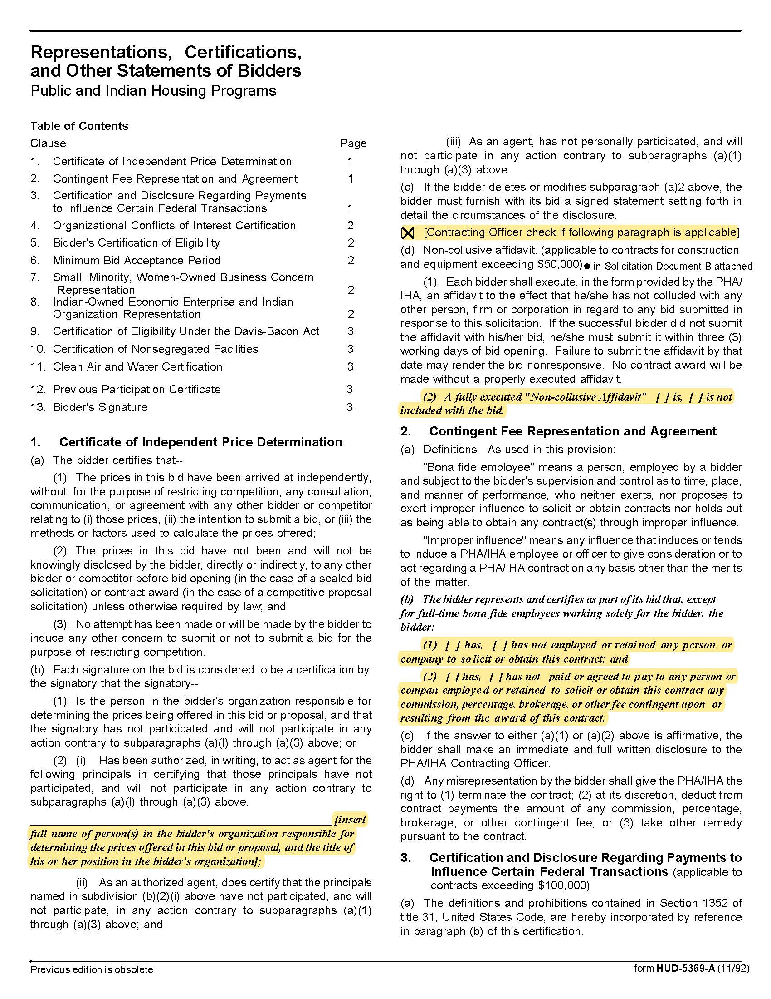

Custodial Services Q1921
Solicitation Document C HUD Form 5369A - Continued
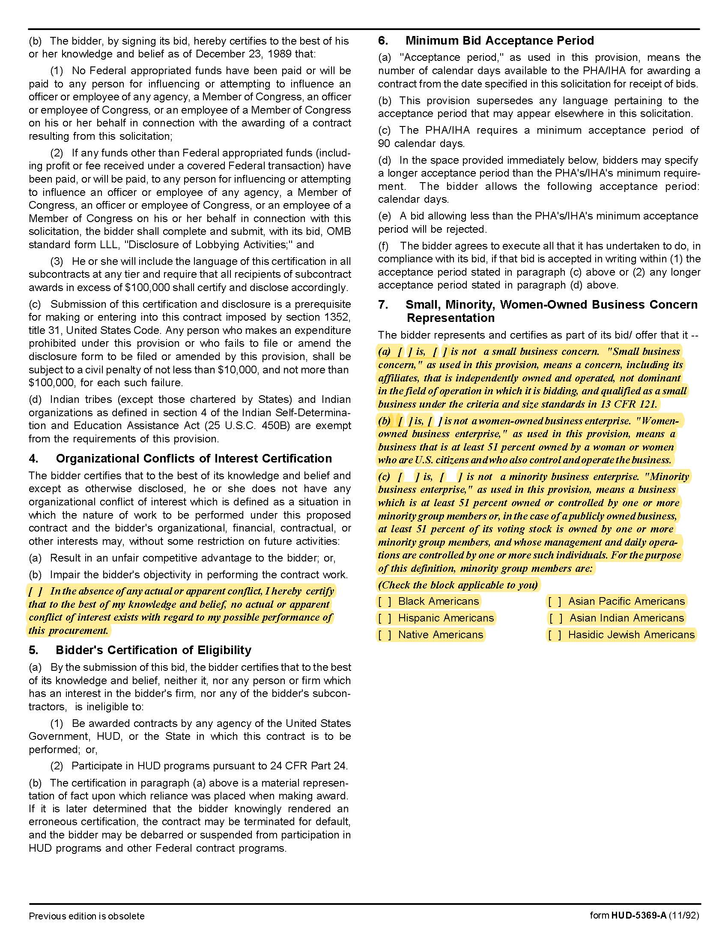

Custodial Services Q1921
Solicitation Document C HUD Form 5369A - Continued

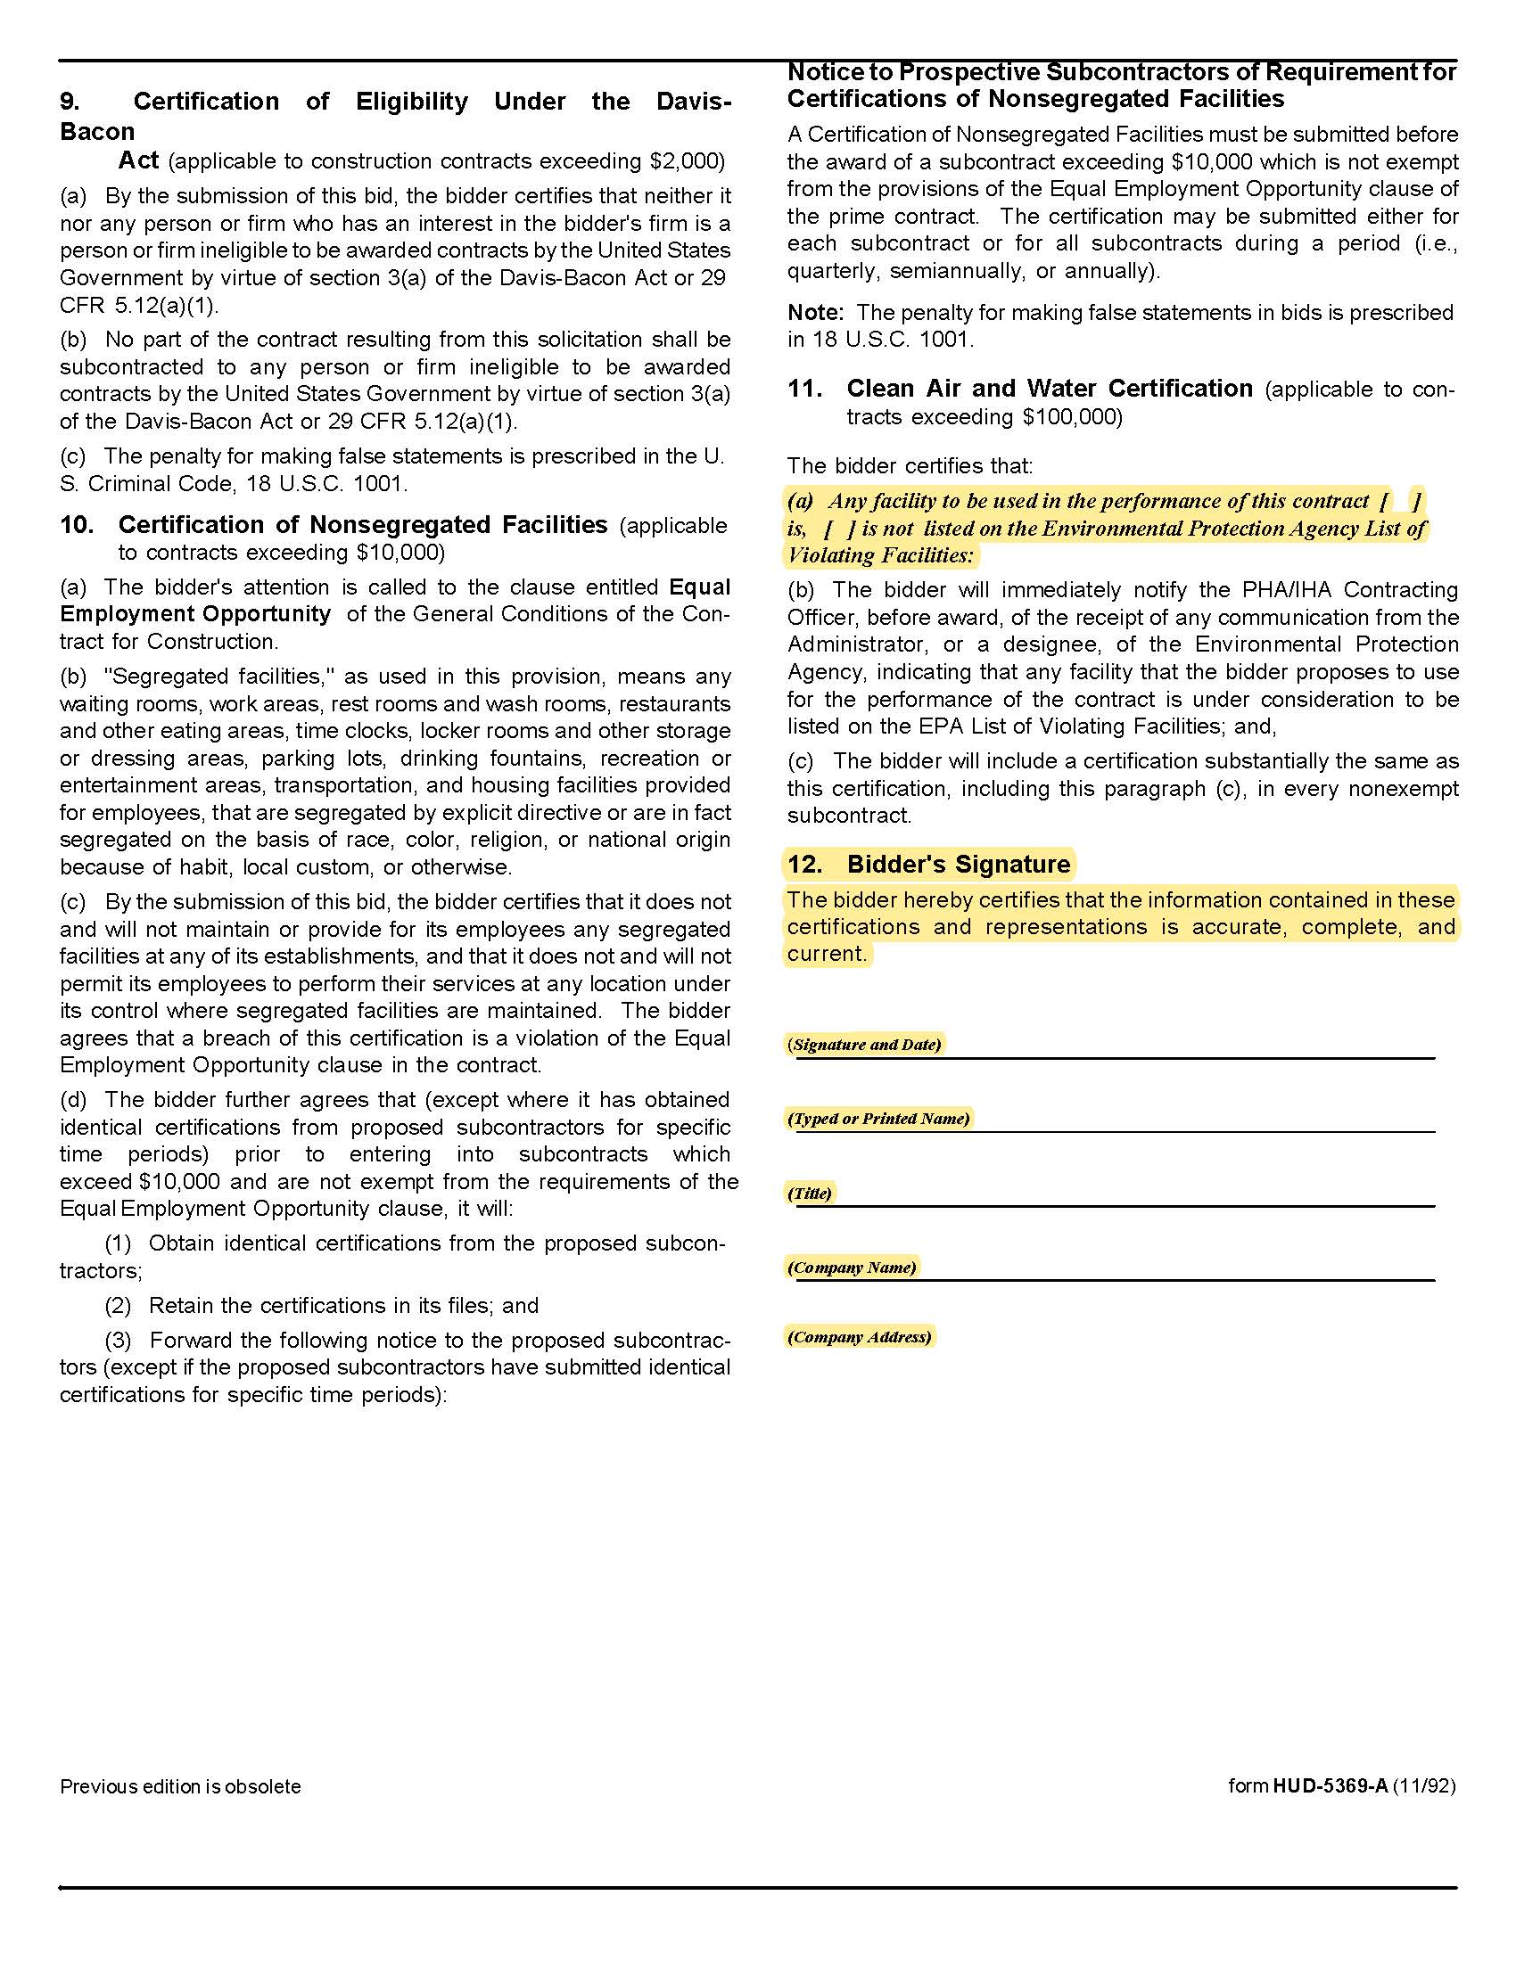

Custodial Services Q1921
Solicitation Document D Cost Information

A. Cost for the Main Office Building:
Suppliers are to present a cost effective service plan with maximum flexibility. There must be no hidden costs associated with this response. Full disclosure of the nature and amount of all fees and charges is mandatory.

- Per month cost
- Cost for cleaning upholstered chairs/furniture (as needed)
- Ideas to reduce cost (indicate service alteration and cost savings)
- Other

B. Cost for the Purchasing Office Area:
This is an option that KCDC may or may not accept at its discretion.

Suppliers are to present a cost effective service plan. There must be no hidden costs associated with this response. Full disclosure of the nature and amount of all fees and charges is mandatory.

- Per month cost
- Ideas to reduce cost (indicate service alteration and cost savings)
- Other

Custodial Services Q1921
Solicitation Document E Supplier’s Business Qualification and Plan

The supplier will demonstrate their business history, capabilities and plan specific to KCDC by including these factors in their response to this section.

1. EXPERIENCE:
- Years in business.
- Years in business under this name.
- Years performing this type of work.
- Total number of business clients.
- Value of work now under contract.
- Value of work in place last year.
- Percentage (%) of work usually self-performed (not sub-contracted).
- Has your firm failed to complete a contract?
- Has your firm been involved in bankruptcy or reorganization?
- Does your firm have pending judgment claims or suits against it?
- What company is used for pre-employment criminal background checks?

2. SAFETY:
- Have you had OSHA fines within the last three years?
- Have you had job-related fatalities within the last five years?
- If you answer YES to either of the above questions, you MUST provide details describing the circumstances surrounding each incident.

3. PERSONNEL, EQUIPMENT & MATERIALS:
- How many total employees does your company employ?
- How many full-time and how many part-time Clerical/Administrators?
- How many full-time and how many part-time Custodians?
- How many full-time and how many part-time Supervisors?
- Number of years of custodial experience for the person(s) proposed to work for KCDC.
- Are your employees bonded?
- Proposed daily work hours.
- Supplier provided equipment.
- Describe your company’s training program.
- Specify names and experience of staff proposed for this work.

Custodial Services Q1921
Solicitation Document F Supplier’s References

Part I Provide three references as similar as possible to this work. Suppliers may only list a firm as a reference once even if you have done multiple jobs for them.

- Name of the business serviced
- Contact person
- Contact person title
- Contact person’s telephone number
- Contact person’s email address
- Description of the service provided
- Contract began
- Contract ended
- Size of job

Part II Provide a list of all clients during the last three years as shown below.

Client Name/Contact Person | Still Providing Service

Custodial Services Q1921

Appendix 1 Insurance Requirements

INSURANCE
The Supplier shall maintain, at Supplier’s sole expense, on a primary and non‐contributory basis, at all times during the life of the contract insurance coverages, limits and endorsements described herein. All insurance must be underwritten by insurers with an A.M. Best rating of A :VIII or better. Upon award, the Supplier shall provide Certificate(s) of Insurance and amendatory endorsements to KCDC evidencing said insurance coverages.

The Supplier agrees the insurance requirements herein as well as KCDC’s review or acknowledgement, is not intended to and shall not in any manner limit or qualify the liabilities and obligations assumed by the Supplier under this contract. KCDC’s failure to require a certificate of insurance, acceptance of a non-conforming certificate, or allowing the Supplier to commence work shall not operate as a waiver of these minimum insurance requirements or the liabilities and obligations assumed by the Supplier under this contract.

  - Commercial General Liability and Umbrella/Excess Liability Insurance: with a minimum combined single limit of $1,000,000 per occurrence with $2,000,000 in the aggregate covering bodily injury, personal injury, property damage, and products and completed operations.

Such insurance shall contain or be endorsed to contain a provision that includes KCDC, its officials, officers, employees and volunteers as additional insureds providing coverage at least as broad as CG 20 10 07 04 and 20 37 07 04 endorsements. The coverage shall contain no special limitations on the scope of its protection afforded to the listed insureds.

If necessary, umbrella/excess liability insurance can be used in conjunction with the general liability insurance to meet these requirements. Unless the umbrella/excess liability insurance provides coverage on a pure/true follow-form basis, or KCDC its officials, officers, employees, and volunteers are automatically defined as an additional insured, the Supplier shall add by endorsement, KCDC, its officials, officers, employees, and volunteers as an additional insured for both ongoing and completed operations, providing coverage at least as broad as CG 20 10 07 04 and 20 37 07 04 endorsements.

See paragraph “d.1.” for exact naming of certificate holder and additional insured.

  - Commercial Automobile Liability Insurance: for all owned, hired, and non-owned vehicles utilized by contactor in connection with the Project. Coverage is to include coverage for loading and unloading hazards.

Such insurance shall contain or be endorsed to contain a provision that includes KCDC, its officials, officers, employees and volunteers as additional insureds.

See paragraph “d.1.” for exact naming of certificate holder and additional insured.

  - Workers’ Compensation Insurance and Employers Liability Insurance: Workers’ Compensation Insurance with statutory limits as required by the State of Tennessee or other applicable laws and Employers Liability coverage.

  - Other Insurance Requirements:
- Upon award, Supplier shall furnish KCDC with original Certificate(s) of Insurance and amendatory
endorsements effecting coverage required by this section.

Custodial Services Q1921

Appendix 1 Insurance Requirements

The certificate holder and additional insured shall be:

Knoxville’s Community Development Corporation (KCDC), its officials, officers, employees, and volunteers
901 N Broadway
Knoxville, TN 37917

- Provide a waiver of subrogation for each required policy herein. When required by the insurer, or should
a policy condition not permit Supplier to enter into a pre‐loss agreement to waive subrogation without an endorsement, the policy should be endorsed with a Waiver of Transfer of Rights of Recovery Against Others, or its equivalent. This waiver of subrogation requirement shall not apply to any policy which includes a condition specifically prohibiting such an endorsement, or voids coverage should Supplier enter into such an agreement on a pre‐loss basis.

- A minimum 30‐day cancellation notice for all insurances (by endorsement if necessary) is required.

- Provide certified copies of endorsements and policies if requested by KCDC in lieu of or in addition to
Certificates of Insurance.

- Replace certificates, policies and endorsements for any such insurance expiring prior to completion of
services.

- Maintain such insurance from the time services commence until services are completed or through such
extended discovery/reporting/tail period as required. Failure to maintain or renew coverage or to provide evidence of renewal may be treated by KCDC as a material breach of contract.

- Any deductibles and/or self‐insured retentions greater than $50,000 must be disclosed to and approved
by KCDC prior to the commencement of services. Use of large deductibles and/or self‐insured retentions will require proof of financial ability as determined by KCDC.

- All policies must be written on an occurrence basis.

9. Require all subcontractors to maintain during the term of the resulting contract commercial general
liability insurance, automobile liability insurance and workers’ compensation/employers liability insurance (unless subcontractor’s employees are covered by Supplier’s insurance) in the same manor and limits as specified for the Supplier.

e. Right to Revise or Reject: KCDC reserves the right, but not the obligation, to review or revise any
insurance requirement, not limited to limits, coverages and endorsements based on insurance market conditions affecting the availability or affordability of coverage; or changes in the scope of work / specifications affecting the applicability of coverage.

Custodial Services Q1921

Appendix 1 Insurance Requirements

f. No Representation of Coverage Adequacy: The coverages, limits or endorsements required herein protect the primary interests of KCDC, and the Supplier agrees in no way should these coverages, limits or endorsements required be relied upon when assessing the extent or determining appropriate types and limits of coverage to protect the Supplier against any loss exposures, whether as a result of the project or otherwise

Term Sheet - Insurance Requirements

Certificate Holder &  Additional Insureds | Knoxville’s Community Development Corporation (KCDC), its officials, officers, employees, and volunteers
GL (Supplier & Subs) | $1M / $2M
Auto (Supplier & Subs) | Required
WC & Employers Liability (Supplier & Subs) | Statutory Limits
30-day cancellation | Required– must indicate on COI
Primary non-contributory | Required – must indicate on COI
Waiver of Subrogation | Required – must indicate on COI

Custodial Services Q1921

Appendix 2 Fixtures, Automatic Odor Control Systems and Paper Towels

Executive Management Team (EMT) Area Restrooms - Men and Women
Total of 6 toilets and 2 urinals
Paper Towels are fold-type in 4 dispensers

Housing Department Restroom - Women
Total of 2 toilets
One Time Mist Plus GY dispenser
Paper Towels are the roll-type in 1 Georgia Pacific enMotion Automatic Touchless Dispenser

Accounting Department Restroom - Men
Total of 2 Toilets and 1 urinal
One Time Mist Plus GY dispenser
Paper Towels are the roll-type in 1 Georgia Pacific enMotion Automatic Touchless Dispenser

Gym Area Restroom - Women
Total of 3 toilets
Paper Towels are the fold-type in 2 dispensers

Gym Area Restroom - Men
Total of 1 toilet
Paper Towels are the fold-type in 1 dispenser

Main Lobby Restrooms - Men and Women
Total of 2 toilets
There are 2 Time Mist Plus GY dispensers (one in each restroom)
Paper Towels are the fold-type in 2 dispensers (one is each restroom)

Other Areas
Gym: Paper Towels are the roll-type in 1 Georgia Pacific enMotion Automatic Touchless Dispenser
Kitchen: Paper Towels are the fold-type in a basket on the counter
EMT Conference Room: Paper Towels are regular household roll-type in 1 holder on counter

Custodial Services Q1921

Appendix 3 First Floor Plan
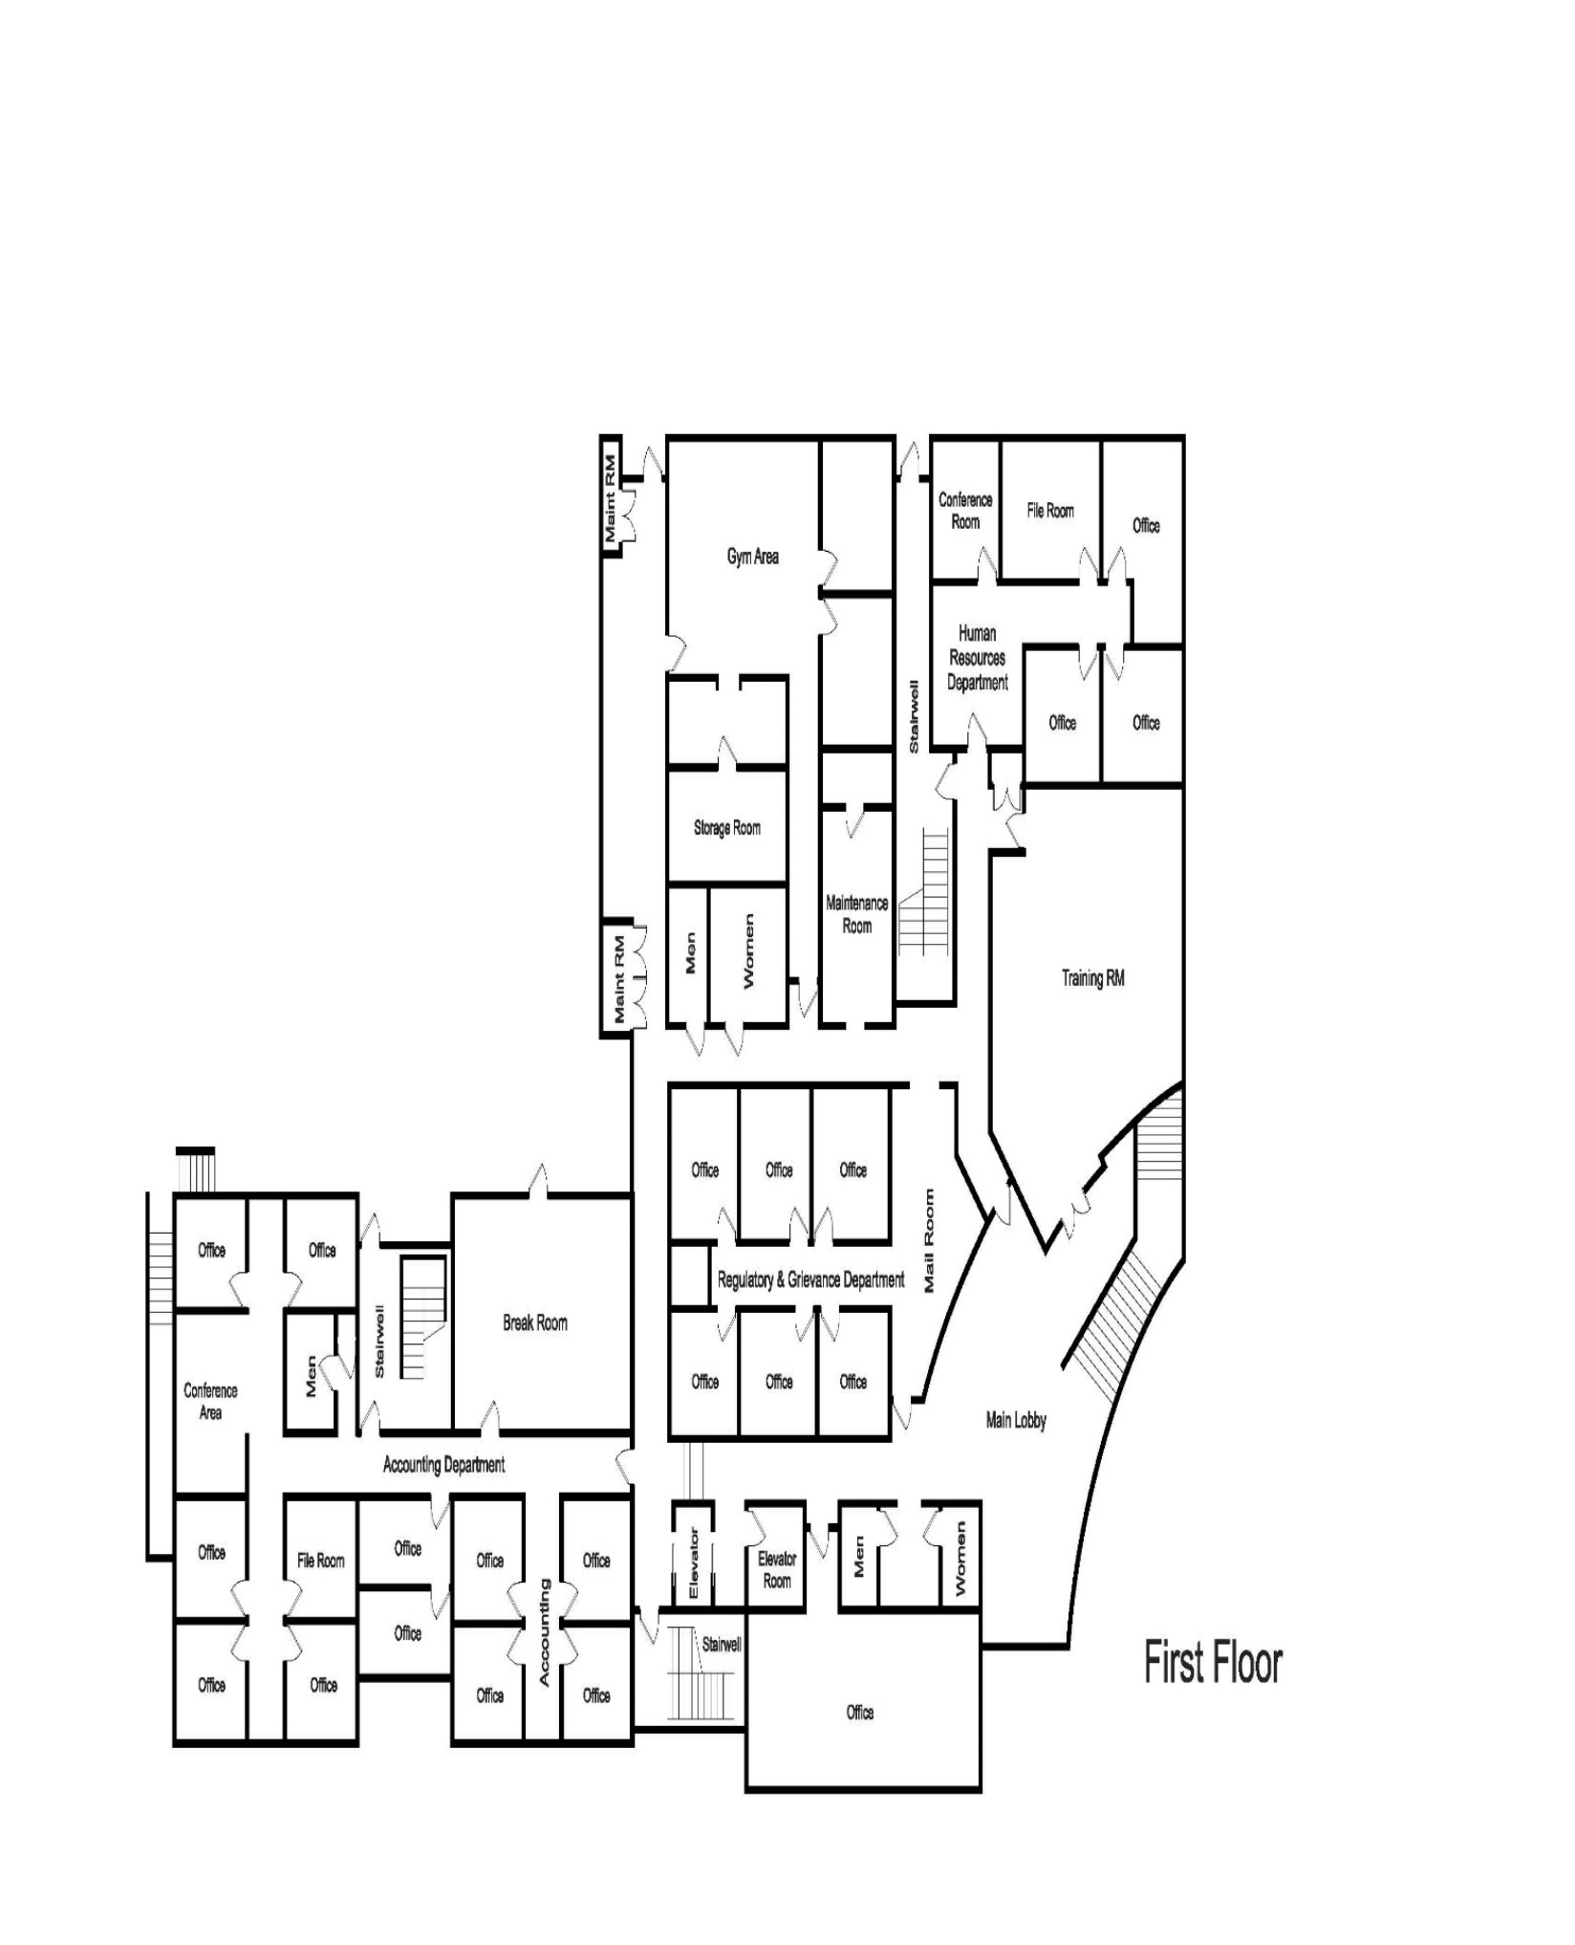

Custodial Services Q1921

Appendix 4 Second Floor Plan
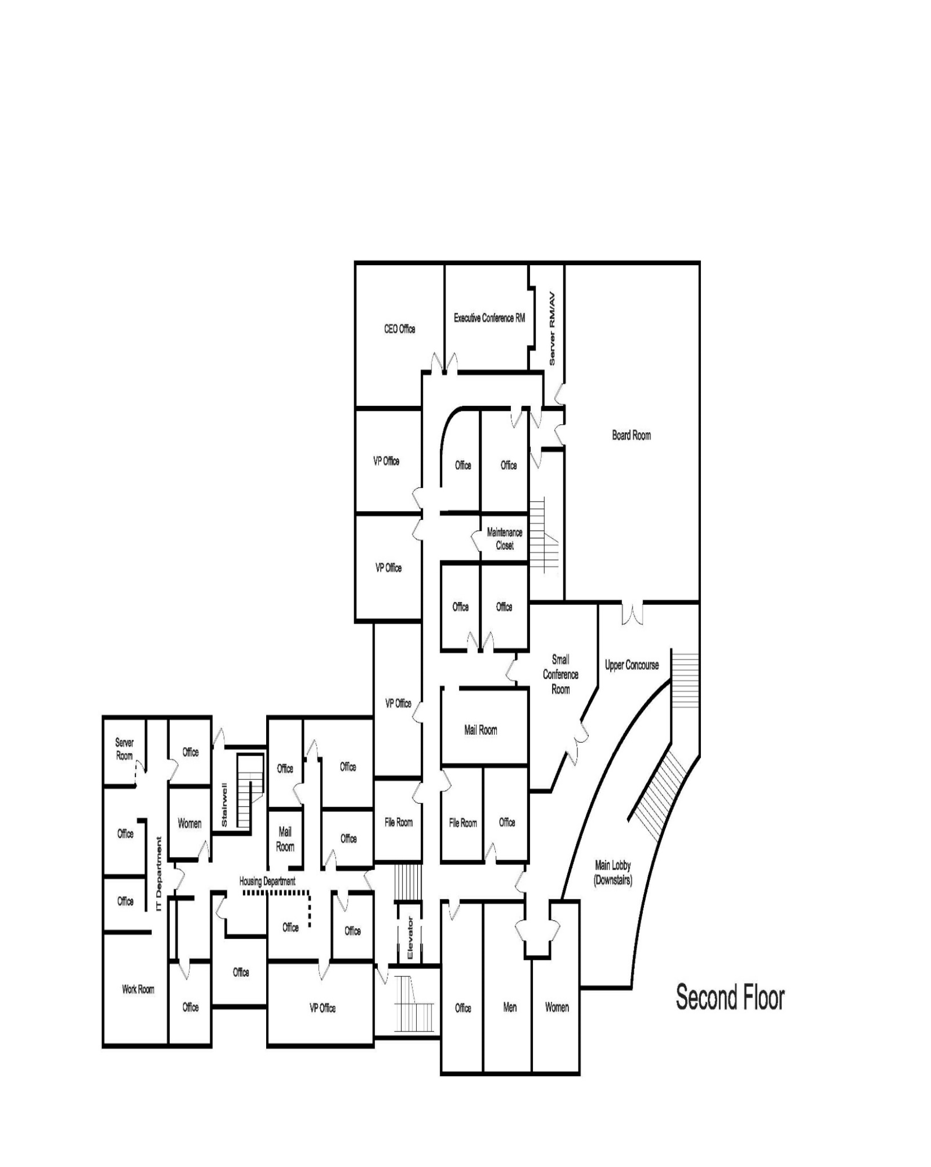

Custodial Services Q1921

Appendix 5 Daily Service Checklist

Form Completed by
Item | Work was Completed on (enter the date below)
Item | Monday | Tuesday | Wednesday | Thursday | Friday
Common Areas, Private Offices, Lobby Areas (1st & 2nd Floor), Break Area near Gym, Board Room, Gym, Training Room, Small Conference Room (2nd Floor), Admissions Meeting Room (1st Floor), Mailroom, Elevator and Stairwells:
Empty wastebaskets | ☐ | ☐ | ☐ | ☐ | ☐
Clean and sanitize the drinking fountains | ☐ | ☐ | ☐ | ☐ | ☐
Spot clean cabinet doors, countertops and desktops (unless a staff member declines service) | ☐ | ☐ | ☐ | ☐ | ☐
Spot clean reception lobby glass, including the front door and any other partition or door glass | ☐ | ☐ | ☐ | ☐ | ☐
Sweep/dust mop the VCT floors, (including the interior stairwells) and any carpet protectors under office chairs | ☐ | ☐ | ☐ | ☐ | ☐
Spot clean spills and stains on the floors | ☐ | ☐ | ☐ | ☐ | ☐
Vacuum carpeted areas | ☐ | ☐ | ☐ | ☐ | ☐
Spot clean stainless steel & wood in the elevator | ☐ | ☐ | ☐ | ☐ | ☐
Restrooms
Clean, sanitize and polish all vitreous fixtures, including toilet bowls, urinals and hand basins plus cabinet doors and countertops | ☐ | ☐ | ☐ | ☐ | ☐
Clean all glass and mirrors | ☐ | ☐ | ☐ | ☐ | ☐
Empty all trash containers and disposals. Insert liners as required. Spot clean and sanitize containers as needed | ☐ | ☐ | ☐ | ☐ | ☐
Spot clean all walls, doors, stainless steel partitions, frames, light switches, kick and push plates and handles | ☐ | ☐ | ☐ | ☐ | ☐
Refill all dispensers (soap, toilet tissue, paper towels and liners) to their normal limits | ☐ | ☐ | ☐ | ☐ | ☐
Sweep, damp mop and sanitize ceramic tile floors | ☐ | ☐ | ☐ | ☐ | ☐
Kitchen and Executive Management Conference Room and Copier Room
Damp clean and sanitize cabinet doors, countertops, tabletops, seats and chair backs | ☐ | ☐ | ☐ | ☐ | ☐
Refill paper towel holders | ☐ | ☐ | ☐ | ☐ | ☐
Empty all trash containers and wash as necessary | ☐ | ☐ | ☐ | ☐ | ☐
Spot clean doors, frames, light switches, kick and push plates, handles, walls and interior glass | ☐ | ☐ | ☐ | ☐ | ☐
Vacuum carpeted areas. | ☐ | ☐ | ☐ | ☐ | ☐
Sweep/dust mop and damp mop VCT and ceramic tile and laminate floors | ☐ | ☐ | ☐ | ☐ | ☐
Clean sinks (provided it is free of dishes) and faucets | ☐ | ☐ | ☐ | ☐ | ☐
Clean the exterior of toaster ovens | ☐ | ☐ | ☐ | ☐ | ☐
Clean the interior and exterior of the microwave | ☐ | ☐ | ☐ | ☐ | ☐
Clean exterior of the coffeemaker and make sure it is turned off | ☐ | ☐ | ☐ | ☐ | ☐
Check the dishwasher to determine if it needs to be cleaned inside or out | ☐ | ☐ | ☐ | ☐ | ☐
Exterior Cleaning
Sweep and pick-up trash and debris on, in or around, dumpsters, flowerbeds, parking lots, porches, steps, sidewalks, lawn, et cetera, up to the City’s sidewalks | ☐ | ☐ | ☐ | ☐ | ☐
Sweep off outside mats at exterior entrances | ☐ | ☐ | ☐ | ☐ | ☐

Custodial Services Q1921

Appendix 6 Weekly Service Checklist

Form Completed by
Work was Completed on the Week Ending
 | Common Areas, Private Offices, Lobby Areas (1st & 2nd Floor), Break Area near Gym, Board Room, Gym, Training Room, Small Conference Room (2nd Floor), Admissions Meeting Room (1st Floor), Mailroom, Elevator and Stairwells:
☐ | Dust all furnishings including desks, chairs, tables and gym equipment and racks
☐ | Dust all exposed filing cabinets, bookcases, shelves, cabinet doors and countertops
☐ | Dust all telephones, printers and copiers. Sanitize telephones
☐ | Dust the Venetian blinds
☐ | Damp clean the surfaces of major gym equipment where hands touch
☐ | Dust all low (at or below 72 inches) horizontal and vertical surfaces. This includes sills, ledges, handrails, moldings, shelves, picture frames, lamps, ducts, radiators, baseboards, behind doors, under desks, chair legs, et cetera
☐ | Clean interior glass in windows and doors.
☐ | Sweep/vacuum and damp mop inlaid floor mat at Main Lobby entrance and the catch area underneath it
☐ | Restrooms
☐ | Dust all low (at or below 72 inches) horizontal and vertical surfaces. This includes sills, moldings, ledges, shelves, frames, ducts, baseboards, heating outlets, et cetera
☐ | Kitchen and Executive Management Conference Room and Copier Room
☐ | Dust all low (at or below 72 inches) horizontal and vertical surfaces. This includes sills, moldings, ledges, shelves, picture frames, ducts, baseboards, cabinet doors, counter tops, behind doors, under tables & counters, heating outlets, chair legs, et cetera
☐ | Clean interior glass in windows and doors
☐ | Dust the Venetian blinds
☐ | Exterior Cleaning
☐ | Check the outside trash can and empty if needed

Custodial Services Q1921

Appendix 7 Monthly Service Checklist

Form Completed by
Work was Completed on the Month Ending
Common Areas, Private Offices, Lobby Areas (1st & 2nd Floor), Break Area near Gym, Board Room, Gym, Training Room, Small Conference Room (2nd Floor), Admissions Meeting Room (1st Floor), Mailroom, Elevator and Stairwells:
☐ | High dust (above 72 inches) all horizontal and vertical surfaces including shelves, molding, doorframes and ledges. The supplier is to wipe and dust molding that is up to 12 feet above the floor.
☐ | Damp clean the Venetian blinds
☐ | Remove dust and cobwebs from ceiling areas and corners
☐ | Vacuum the furniture and damp clean plastic & vinyl chair seats and backs
☐ | Provide and replace the Time Mist 30-day refill (item 764699 from Staples) that goes inside the Time Mist Plus GY dispensers in the identified locations (see appendix 1). Use the scent: Clean & Fresh.
☐ | Clean the various artificial plants in the building
Restrooms
☐ | High dust, (above seventy-two inches), all horizontal and vertical surfaces including shelves, ledges, doorframes and molding.
☐ | Provide and replace the Non-Slip Urinal Screens (Scent: Country Berry or Mango) with Brighton BPR28631 or equal in the three men’s restrooms.
☐ | Provide and replace the Time Mist 30-day refill (item 764699 from Staples) that goes inside the Time Mist Plus GY dispensers in restrooms. Use the scent: Clean & Fresh.
Kitchen and Executive Management Conference Room and Copier Room
☐ | High dust, (above 72 inches), all horizontal and vertical surfaces including shelves, ledges, doorframes, molding, et cetera
☐ | Vacuum the furniture as appropriate
☐ | Damp clean the Venetian blinds
Exterior Cleaning and Other/Miscellaneous
☐ | Hose off building sidewalks and exterior doormats
☐ | Report burned out light bulbs when observed.

Custodial Services Q1921

Appendix 8 Quarterly Service Checklist

Form Completed by
Work was Completed on the Month Ending
☐ | Carpet and Floor Cleaning Services include steam cleaning carpet, grout cleaning and scrubbing of all ceramic tile floors. Carpet should be vacuumed prior to carpet cleaning services.

Custodial Services Q1921

Appendix 9 Yearly Service Checklist

Form Completed by
Work was Completed on the Month Ending
☐ | Strip and Wax all VCT tile floors

Custodial Services Q1921

Appendix 10 As Needed Service Checklist

Form Completed by
Work was Completed on the Month Ending
☐ | Change the batteries in all dispensers yearly or as otherwise needed.
☐ | Adjust non-digital clocks when daylight saving time changes and replace the batteries
☐ | Respond to special job assignments. KCDC staff will email such needs to the supplier’s contact person at least 24 hours in advance. If KCDC gives less notice, the supplier will attempt to provide the requested service but is not obligated to do so.
☐ | Maintain janitor closet/room in an orderly condition and in compliance with City Safety and Fire  regulations

