Request for Proposals
Solicitation name and number | Public Relations Services Q2306
Upload responses by | 11:00 a.m. on 05/31/23
Upload your response document to | https://vrapp.vendorregistry.com/Account/LogOn  (Can also be accessed via KCDC’s webpage)
Questions about this solicitation | KCDC will not accept questions via telephone.  Submit questions to procurementinfo@kcdc.org by 6:00 p.m. on 05/24/23.
Opening | There is no public opening since this is a request for proposals solicitation. However, the scoring tabulation is posted to KCDC’s webpage shortly after an award decision is made.
Award results | KCDC posts the award decision to its web page at: http://www.kcdc.org/procurement/.
Open Records/Public Access to Documents | All document provided to KCDC are subject to the Tennessee Open Meetings Act (TCA 8-44-101) and open records requirements.
Check KCDC’s webpage for addenda and changes before submitting your response

General Information

1. Definitions

a. “KCDC” is inclusive of Knoxville’s Community Development Corporation and its various corporations, partnerships entities and subsidiaries.

b. “Supplier” is inclusive of various words describing interested parties often called “vendor,” “bidders,” “contractors” and “proposers.”

2. Background and Intent

a. Knoxville's Community Development Corporation (“KCDC”) is the public housing authority for the City of Knoxville and for Knox County in Tennessee. KCDC’s affordable housing property portfolio includes more than 26 properties with approximately 3,600 dwelling units. In addition to operating its public housing apartments, KCDC oversees approximately 4,097 Section 8 Vouchers and 76 Moderate Rehabilitation units. Additionally, KCDC serves as the redevelopment agency for the City of Knoxville, managing redevelopment areas, TIFs, and PILOTs.

b. KCDC’s existing “contract” for public relations services has reached its maximum award length (five years) and with this solicitation, KCDC intends to secure the cost-effective services of a strategically oriented, highly creative agency to meet its public relations needs. KCDC’s primary objective is to create a proactive marketing strategy for the agency, utilizing both traditional and social media to get original content to our customers and the broader community, while reducing public relations service costs. Suppliers are encouraged to be creative in their suggested approach to meeting KCDC’s needs.

c. The selected firm must have the ability to move quickly from one project to the next. KCDC expects prime attention from senior account service/creative personnel. KCDC wants a partnership with a firm so that united, KCDC and the firm, reach set goals.

d. The award will include routine services (typically on a retainer arrangement) as well as services needed on an “as needed” basis (priced on a project basis).

e. KCDC anticipates this award commencing on or about July 1, 2023.

3. Changes after Award
It is possible that after award KCDC will need to revise the requirements specified herein. KCDC reserves the right to make such changes after consultation with the supplier. Should additional costs arise, the supplier must document increased costs. KCDC reserves the right to accept or reject and negotiate these charges. Such changes will not be of a “cardinal” nature.
4. Contract Administrator/Technical Point of Contact
The following employees are the main points of contact for the successful supplier.

a. Contractual Issues: Terry McKee, Procurement Director

b. Day to Day Needs: KCDC’s Executive Management team:

Title | Person
Chief Executive Officer | Ben Bentley
Executive Assistant to the CEO | Joy Russell Patrick
Redevelopment | Jim Hatfield
Vice President of Housing | Sabrina Draplin
Vice President of Strategic Partnerships & Policy | Marisa Moazen

5. Contact Policy
Only contact KCDC’s Procurement Division about this solicitation from the issuance of this solicitation until award. Information obtained from an unauthorized officer, agent, or employee will not affect the risks or obligations assumed by the supplier or relieve the supplier from fulfilling any of the conditions of the resulting award for this project. Such contact can disqualify the supplier from the solicitation process.

6. Evaluation

a. KCDC alone determines (using NIGP’s definition and other relevant sources as appropriate) the supplier’s “responsive” and “responsible” status prior to award. Responsible means a business with the financial, technical, relevant experience and capacity to perform the requirements of the solicitation and subsequent contract. A responsive proposal is one that fully conforms in all material respects to the solicitation document and all its requirements, including all form and substance.

b. KCDC will review all proposals and reserves the right to request additional necessary information, modifications, waive minor technicalities, reject all proposals, reject any proposal that does not meet mandatory requirement(s) or cancel this RFP, according to KCDC’s best interests. KCDC further reserves the right to adjust its evaluation scenario if they are in KCDC’s best interest and consistent with good business practices.

c. KCDC may require oral presentations as part of the evaluation process. Typically, this will be for the firms that are shortlisted. KCDC will provide details about the meeting to the firms that are selected. Generally, these meetings are approximately 60 minutes.

d. KCDC reserves the right to ordinally rank proposals as a first step and then only detail score the top tier of proposals if determined to be in KCDC’s best interest.

e. KCDC plans to award to the best overall supplier presenting the most advantageous proposal (in its entirety) with the maximum points available and based on the following evaluation scale:

Factors | Maximum Points
Fee Schedule | 30
Business Capabilities  (Size, staff composition, report capabilities, et cetera) | 25
Assigned Personnel  Knowledge, expertise & qualifications of personnel assigned to KCDC’s project | 25
Proactive Marketing Plan  (Provide outline of a strategy with goals, timeline, and steps for implementation for both social and traditional media) | 15
References | 5
Total | 100

7. General Instructions to Suppliers
KCDC’s General Instructions to Suppliers are at www.kcdc.org . Click on “Procurement” and the link to the instructions. The supplier’s submittal means acceptance of the terms and conditions found in KCDC’s “General Instructions to Suppliers.” The following paragraphs in the General Instructions to Suppliers do not apply: 16, 30, 46a, 46b, 46d, 463 and 71.

8. Insurance
The supplier agrees to maintain at its sole expense on a primary and non-contributory basis during the term of this resulting contract insurance coverages and limits in accordance with the supplier’s standard business practices and acceptable to KCDC. Such insurance shall contain or be endorsed to contain a provision that includes KCDC, its officials, officers, employees, and volunteers as additional insureds with respect to liability arising out of work and/or operations performed by or on behalf of the supplier. Such insurance shall provide waiver(s) of subrogation. The supplier shall provide KCDC with Certificates of Insurance evidencing such insurance prior to contract execution.

9. Invoicing/Ordering

a. Until a purchase order is in place, work is not to be performed nor are goods to be delivered.

b. Suppliers must submit invoices within 90 days of the delivery of goods or services. KCDC may deny invoices submitted after the 90-day threshold. KCDC prefers invoices arrive within 10 days following the end of the month in which goods or services were supplied.

c. Most KCDC purchases of goods are exempt from Tennessee sales and use tax pursuant to Tennessee Code Annotated 67-6-329(a) (4). However, suppliers are subject to Tennessee sales and use tax on all materials and supplies used for KCDC’s assignments, whether such materials and supplies are purchased by the supplier, produced by the supplier, or provided to the supplier by KCDC, pursuant to Tennessee Code Annotated 67-6-209.

d. KCDC pays by electronic transfer (ACH) only. Supplier’s accounts receivable staff must use KCDC’s portal to find payments made and to which invoices they apply.

e. Invoices must:
- Be numbered
- Show a date that is after the work is complete or goods delivered
- List the purchase order number
- Breakdown pricing according to the award structure
- Reference the bid number

f. KCDC wants all invoices emailed to apadmin@kcdc.org . Do not send invoices by any other means.

10. Length of Award
The initial award will be for 12 months. The award has four one-year optional renewals that KCDC may choose to exercise.

11. Price Structure

a. At the end of each twelve-month period, the awarded supplier may request a change to the percentage and/or specific item charged to KCDC. Such increases must be supported by changes to the PPI for Knoxville or by other benchmarks approved by KCDC. The supplier must provide proof of the necessity of the increase to the Procurement Division. KCDC will decide whether to accept a price increase. If the price increase is accepted, the bid file will be so noted. If the price increase is not accepted, the supplier may:

1. Continue with the existing pricing.
2. Suggest an alternative price increase.
3. End the award.

b. KCDC does not pay fuel surcharges.

c. Suppliers may decrease prices at any time with or without notice.

12. Section 3 of the HUD Act of 1968 as amended and as enacted
All awards are subject to Section 3 requirements. Supplier shall seek to all positions that are needed and unfilled with residents of KCDC communities. Additional information is at http://www.hud.gov/offices/fheo/section3/Section3.pdf.
Upon award, the successful supplier will complete a Section 3 project plan for KCDC. The successful supplier will supply KCDC with job announcements for any positions that must be filled because of the award of KCDC work. Additionally, the successful supplier will supply the same job announcement to the Knoxville-Knox County Committee Action Committee’s Workforce Connections group. These can be faxed to 865-544-5269.

13. Small Business Outreach
KCDC requires the successful supplier to reach out to small businesses, minority owned businesses, veteran owned businesses and woman owned businesses for goods and subcontracted services to fulfill this award. In addition to the successful supplier reporting on dollars spent with such businesses each January, KCDC expects outreach that results in actual subcontracting arrangements with such suppliers.

14. Smoke Free Policy
KCDC’s Smoke Free policy is applicable to you, your employees and subcontractors. The policy mandates:

- No smoking on any KCDC property
- No e-vape or similar usage on any KCDC property
- The Smoke Free policy applies in personal or corporate vehicles on owner’s property

15. Solicitation Requirements
Caution: Requirements in the solicitation are not optional. If you have concerns or issues with any of the stated requirements, raise them before the solicitation due date. Examples of past issues where suppliers made faulty assumptions include bonds, insurance requirements and payment expectations.

16. Subcontracting
Subcontractors must:

a. Be approved by KCDC prior to beginning work.

b. Carry the insurance coverages as outlined herein.

c. Not be on the federal government, HUD’s nor the State of Tennessee’s debarment lists.

d. Not be changed without KCDC’s permission.

Description of Work

17. General Comments
KCDC desires cost effective, routine services and “as needed” public relations services. The selected firm will perform important routine services for KCDC as well as periodic special projects. Both types of services are detailed below.

a. Routine services include such services as:

- Developing, implementing and evaluating a proactive marketing and media strategy for KCDC, incorporating both traditional and social media outlets.

- Establishing, monitoring, updating, and creating content for KCDC’s social media sites including Facebook, LinkedIn, Twitter, and Instagram. This includes posting notices and solicitations for KCDC’s Procurement Division.

- Social Media Communications services such as meeting notices and construction project updates via social media including Facebook, Twitter and E-blasts. This includes posting notices and solicitations for KCDC’s Procurement Division.

- Issuing press releases on KCDC’s behalf and working with media to build interest in KCDC related content.

- Monitoring local media outlets for stories involving KCDC, providing KCDC with such information and then guiding KCDC’s response if applicable.

- Monitoring Knoxville City Council meetings and Knox County Commission meetings (including committees) for issues involving KCDC, providing KCDC with such information, and then guiding KCDC’s response if applicable.

  - These services mean that your firm reviews the meeting agendas to determine if there are agenda items relevant to KCDC. If so, your firm will monitor those items either in person or through meeting minutes, community television broadcasts or other methods as appropriate for KCDC’s efforts and needs.

- Maintaining KCDC’s website including basic updates to ensure correct content.

- Ensuring KCDC presents unified brand messaging across all platforms including providing a brand guidelines kit.

- Crisis Communications. In the event of a crisis, the selected firm may support KCDC by way of informational materials, messaging, social media and other communication materials to assist with the crisis at hand.
- Media Placement (except for third party costs).

- Press Conferences (except for third party costs and supplies).

- Research.

- Solicit for free media time and/or space for public service announcements.

- Social media (such as Facebook, Instagram LinkedIn, Twitter, YouTube et cetera) campaigns for specific projects.

- Event planning (except for third party costs).

b. As needed services could include:

- Annual Progress Reports

- Brochures

- Creative Development

- Media Development

- Newsletters

- Photography/Videography

- Print Advertising

This is not an all-inclusive list and many “as needed” services are not products from the supplier but rather creative content about items. Specific “as needed” items from the past include:

- A video concerning KCDC’s HOPE VI project.

- A flyer about the Residences at Eastport.

- A multifold booklet about “Changing the Face of Public Housing.”

18. Changes in Work
If KCDC finds it necessary to require corrections to completed work due to errors made by the supplier, the supplier shall correct the work at no additional cost to KCDC.
If KCDC requires changes for previously accepted work, the supplier shall make such changes as directed by KCDC. The supplier’s compensation is at the established rate between the supplier and KCDC.

19. Confidentiality
The supplier agrees to use information related to KCDC only as needed and approved by KCDC. Such information will be kept confidential for the duration of the contract and beyond, except when release is authorized by KCDC.

20. Copyright Information
Supplier shall not assert rights of common law, or equity or establish any claim to statutory copyright in any material or information developed in performance of the services authorized. KCDC has the right to use, reproduce, or distribute any or all such information and other materials without the necessity of obtaining any permission from the supplier and without expense and charge. All work products are the property of and owned by KCDC. Supplier shall secure duplication and distribution rights for KCDC from all suppliers and subcontractors. The supplier will supply all documents, recordings, et cetera to KCDC in two formats:

a. Original high-quality master formats.

b. Formats compatible with existing KCDC hardware, software and equipment.

21. Core Messages

a. KCDC’s overarching messages are: the importance of increasing the quantity and quality of affordable housing in Knox County through redevelopment of existing KCDC properties and the development of new affordable housing; and the importance of continued investment in redevelopment activities - including KCDC’s work with the City of Knoxville on planning and execution of redevelopment plans to spur growth in the urban core and surrounding neighborhoods.

b. The overall core message is presenting a positive picture of KCDC. There is plenty of negative publicity and KCDC wants to combat that with a positive message. KCDC believes this will generally assist efforts in meeting our strategic objectives.

22. KCDC Communications Capacity
KCDC has limited internal resources for Communications. Most internal communication falls to our Strategic Partnerships team, since they are working to create much of the content that accompanies any messaging or outreach. Strategic partnerships work closely with our Executive Department and public relations firm. Additionally, one member of our IT Division is a skilled graphic artist, and is used for some newsletters, posters and other such items.

23. KCDC’s General Responsibilities
KCDC will

a. Schedule periodic meetings with the supplier to monitor the progress of work.

c. Provide any necessary reports, formats, and forms.

d. Approve or deny approval of all finished products provided by the supplier prior to release or implementation of any material developed within 10 calendar days of receipt.

b. Approve or deny approval of Schedules of Work and Activities within 10 calendar days of receipt.

24. KCDC Materials
In the past, KCDC has published strategic planning materials and annual reports for public dissemination. While KCDC still creates most content associated with these documents, due to funding constraints stemming from federal budget cuts, KCDC has not published these materials the last several years. KCDC has primarily relied on traditional media to get the word out, though that is changing. Our fundraising/development efforts are small in scope. While probably not a point of emphasis, KCDC is open to ideas for expansion in this area.

25. Methods
Most of KCDC’s current communications occur through traditional media (print, radio, television), supplemented with some content delivered directly to residents of our properties.

26. Payment
KCDC will make monthly payments to the supplier for the “retainer” and for additional approved costs that are not part of the retainer.

a. The supplier will bill all media by activity at the actual flat fee rate. Progress payments are made on a percentage of completion basis.

b. The cost of services rendered, or materials produced by organizations on KCDC’s behalf and not a part of the supplier’s organization shall be approved by KCDC and billed at actual cost by activity (i.e., long-distance telephone calls, mailing, shipping and photocopying). Billing for allowable in-state travel expenses shall not exceed Tennessee Statute state rates for in-state travel. Out-of-state travel is reimbursed at approved General Services Administration (GSA) out-of-state travel rates.

c. Supplier must request payment for all required printing with an itemized invoice. Supplier must competitively bid printing services (3 or more) to provide best price and quality for KCDC. The supplier must provide copies of the competitive bids upon submission of estimates.
d. The supplier must submit requests for payment which include the following information:

1. Actual hours worked by employees and the rate of pay extended to a monthly total.

2. Itemized invoices for all charges with copies of supporting documentation for charges for purchases of items.

3. Itemized invoices for all charges with copies of supporting documentation for charges for out-of-pocket expenditures.

4. Itemized invoices for all charges with copies of supporting documentation for charges for other direct costs.

27. Supplier Reports and Meetings
The supplier must submit reports every quarter and a comprehensive final report at the end of the year to document the results of the work performed. The supplier shall recommend a format for KCDC approval for the quarterly reports and the comprehensive annual report.

a. The supplier must promptly notify KCDC in writing of events, which have a significant impact on contract, work, including:

1. Problems, delays, or adverse conditions, which will prevent the meeting of time or work schedules.

2. Favorable developments that will enable meeting time or work schedules earlier than anticipated.

b. KCDC may require meetings each month between the supplier and KCDC personnel to discuss assigned projects. The meetings are at a location to be specified but typically this will be at KCDC’s offices. Supplier is paid the hourly rate only for time spent in the meeting.

28. Public Gatherings
KCDC has groundbreakings and ribbon cuttings approximately 4 to 6 times per year, which might involve media, government officials, residents, businesses, and the broader Knoxville community. Periodically there are other meetings that occur for specific purposes that the supplier may need to attend.

29. Statements of Work Required for Ad Hoc Projects

a. The supplier must submit a Statement of Work to KCDC for written approval prior to performing as needed tasks. In addition to identification and scheduling of projected activities, each work schedule must include measurable objectives and estimated costs. Costs not approved by KCDC will not be reimbursed.

b. Upon approval by KCDC, each Statement of Work shall become a part of the purchase order. A Statement of Work may be amended as necessary and agreed upon by KCDC and the agency.

30. Staff Replacement
KCDC understands that over time supplier’s employees may leave or have other assignments to which they are dedicated. KCDC will allow this with the following provisions:

a. Replacement personnel must have credentials equivalent to the individuals they replace.
Resumes of replacement personnel will be submitted to KCDC for review. KCDC reserves the right to interview replacement personnel.

b. The supplier briefs the replacement personnel as to the status of KCDC’s project(s) and ongoing work at no expense to KCDC.

31. Target Audience
KCDC’s Internal target audience includes the Board and employees. External audience varies depending on the communication, but includes members of the community, current and future KCDC residents, developers, contractors, as well as HUD and local government officials.

32. Travel Exclusion
KCDC will not reimburse the supplier for travel expenses incurred in travel to and from meetings. Hourly rates for services shall start at the beginning of the meeting and end at the conclusion of the meeting.

33. Submit your information in this order:

Document Number | Title | Form Provided by
Solicitation Document A | General Response Section | KCDC
Solicitation Document B | Affidavits | KCDC
Solicitation Document C | HUD Form 5369A | KCDC
Solicitation Document D | Executive Summary | Supplier
Solicitation Document E | Capabilities and History | Supplier
Solicitation Document F | Staff Capabilities and Experience | Supplier
Solicitation Document G | General Approach to Service Provision | Supplier
Solicitation Document H | References | Supplier
Solicitation Document I | Cost Schedule | Supplier

Do not return this and the preceding pages to KCDC.
Solicitation Document A |  |  |  | General Information about the Supplier
Note: Complete all cells even if the answer is “Does not apply”
Sign Your Name in the column to the right
If completing this document in Adobe, an electronic signature is acceptable to KCDC.
Your signature indicates you read and agree to “KCDC’s General Instructions to Suppliers” (www.kcdc.org) and that you are authorized to bind the supplier or are submitting the response on behalf of and at the direction of the suppliers’ representative authorized to contractually bind the supplier. I represent that the supplier or its applicable representatives has reviewed the information contained in this Solicitation Package and that the information submitted is accurate.
Item |  |  |  |  |  |  | Response
Printed Name and Title
Legal Corporate Name
Street Address
City/State/Zip
Contact Person
Telephone Number
Cell Number
Supplier’s E-Mail Address
Addenda
Addenda are at www.kcdc.org. Click on “Procurement” and then on “Open Solicitations” to find addenda. Be sure to check for addenda prior to submitting a proposal.
Acknowledge addenda have been issued by checking below as appropriate:
None ☐ | 1 ☐ |  |  | 2 ☐ |  | 3 ☐ |  | 4 ☐ |  | 5 ☐
Statistical Information (Check a box in each of the next four lines)
1. This business is at least 51% owned and operated by a woman |  |  |  |  |  |  |  |  |  | Yes ☐ No ☐
2. This business qualifies as a small business by the State of Tennessee  Total gross receipts of not more than $10,000,000 average over a three-year  period OR employs no more than 99 persons on a full-time basis |  |  |  |  |  |  |  |  |  | Yes ☐ No ☐
3. This business is at least 51% owned and operated by a veteran |  |  |  |  |  |  |  |  |  | Yes ☐ No ☐
4. This business is owned & operated by persons at least 51% of the following ethnic background:
Asian/Pacific  ☐ |  | Black  ☐ | Hasidic Jew  ☐ |  | Hispanic  ☐ |  | Native American ☐ |  | White  ☐ | Publicly Owned ☐
Prompt Payment Discount
A ____% prompt payment discount applies if KCDC pays within ____ days of accurate invoicing.
Insurance Statement
I have reviewed the insurance requirements and will comply without exception. Yes ☐ No ☐

Solicitation Document B | Affidavits

Conflict of Interest
1. No commissioner or officer of KCDC or other person whose duty it is to vote for, let out, overlook or in any manner superintend any of the work for KCDC has a direct interest in the award or the supplier providing goods or services.

2. No employee, officer or agent of the grantee or sub-grantee will participate in selection, or in the award or administration of an award supported by federal funds if a conflict of interest, real or apparent, would be involved. Such a conflict would arise when the employee, officer or agent, any member of his immediate family, his or her partner, or an organization, which employs, or is about to employ, any of the above, has a financial or other interest in the supplier selected for award.

3. The grantee's or sub-grantee's officers, employees or agents will neither solicit nor accept gratuities, favors or anything of monetary value from suppliers, potential suppliers, or parties to sub-agreements.

4. By submission of this form, the supplier is certifying that no conflicts of interest exist.

Drug Free Workplace Requirements
5. Private employers with five or more employees desiring to contract for construction services attest that they have a drug free workplace program in effect in accordance with T.C.A. 50-9-112.

Eligibility
6. The supplier is eligible for employment on public contracts because no convictions or guilty pleas or pleas of nolo contender to violations of the Sherman Anti-Trust Act, mail fraud or state criminal violations with an award from the State of Tennessee or any political subdivision thereof have occurred.

General
7. Supplier fully understands the preparation and contents of the attached offer and of all pertinent circumstances respecting such offer.

8. Such offer is genuine and is not a sham offer.

Iran Divestment Act
9. Concerning the Iran Divestment Act (TCA 12-12-101 et seq.), by submission of this bid/quote/proposal, each supplier and each person signing on behalf of any supplier certifies, and in the case of a joint bid/quote/proposal, each party thereto certifies as to its own organization, under penalty of perjury, that to the best of its knowledge and belief that each supplier is not on the list created pursuant to § 12-12-106.

Accuracy of Electronic Copies
10. If the supplier provides electronic copies of the bid/proposal/quote to KCDC, the supplier certifies that the information provided on paper and in the electronic format is identical unless specifically noted otherwise.

General
11. Neither the said supplier nor any of its officers, partners, owners, agents, representatives, employees or parties interest, including this affiant, has in any way colluded conspired, connived or agreed, directly or indirectly, with any other responder, supplier, or person to submit a collusive or sham offer in connection with the award or agreement for which the attached offer has been submitted or to refrain from making an offer in connection with such award or agreement, or collusion or communication or conference with any other supplier, or, to fix any overhead, profit, or cost element of the offer price or the offer price of any other supplier, or to secure through any collusion, conspiracy, connivance, or unlawful agreement any advantage against KCDC or any person interested in the proposed award or agreement.

12. The prices quoted in the attached offer are fair, proper and not tainted by any collusion, conspiracy, connivance, or unlawful agreement on the part of the supplier or any of its agents, representatives, owners, employees, or parties in interest, including this affiant.

No Contact/No Advocacy Affidavit
13. Any contact initiated by any supplier with any KCDC representative concerning this solicitation is strictly prohibited-except for communication with the Procurement Division. My signature signifies that no unauthorized contact occurred.

14. To ensure the integrity of the review and evaluation process, respondents to this solicitation nor any firm representing them, may not lobby or advocate to KCDC staff or Board members. My signature signifies that no unauthorized advocacy occurred.

Non-Boycott of Israel Affidavit
15. Concerning the Non-Boycott of Israel Act (TCA 12-4-1 et seq.), by submission of this bid/quote/proposal, each supplier and each person signing on behalf of any supplier certifies, and in the case of a joint bid/quote/proposal, each party thereto certifies as to its own organization, under penalty of perjury, that to the best of its knowledge and belief that each supplier is not boycotting Israel pursuant to § 12-4-1 and will not during the term of any award. Note: Applicable only to contracts of $250,000 or more and to suppliers with 10 or more employees.

The undersigned hereby acknowledges receipt of these affidavits and certifies that the submittal in response to this solicitation is in full compliance with the listed requirements. Failure to properly acknowledge issues concerning the above is grounds for bid/proposal rejection and may subject the signer to penalties as directed by the appropriate laws.

Signed by
Printed Name
Title

Solicitation Document C | HUD Form 5369A
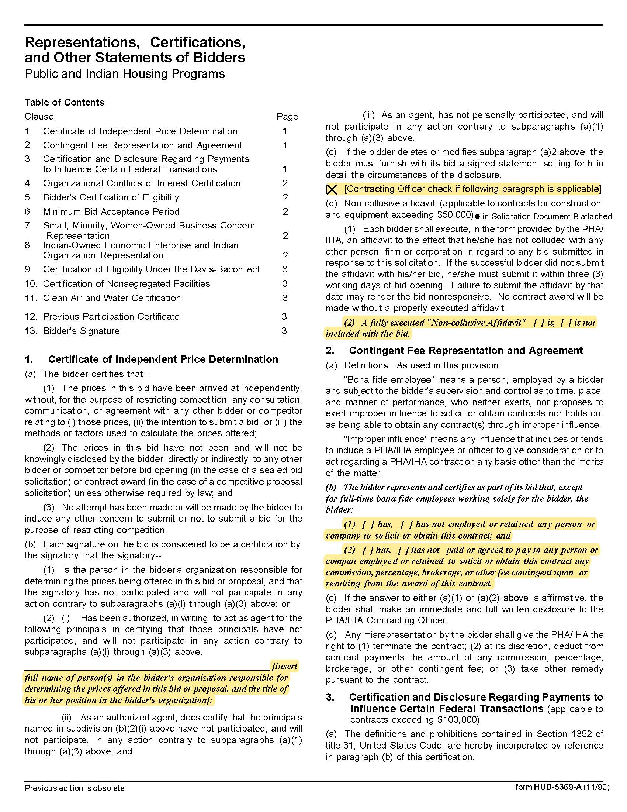

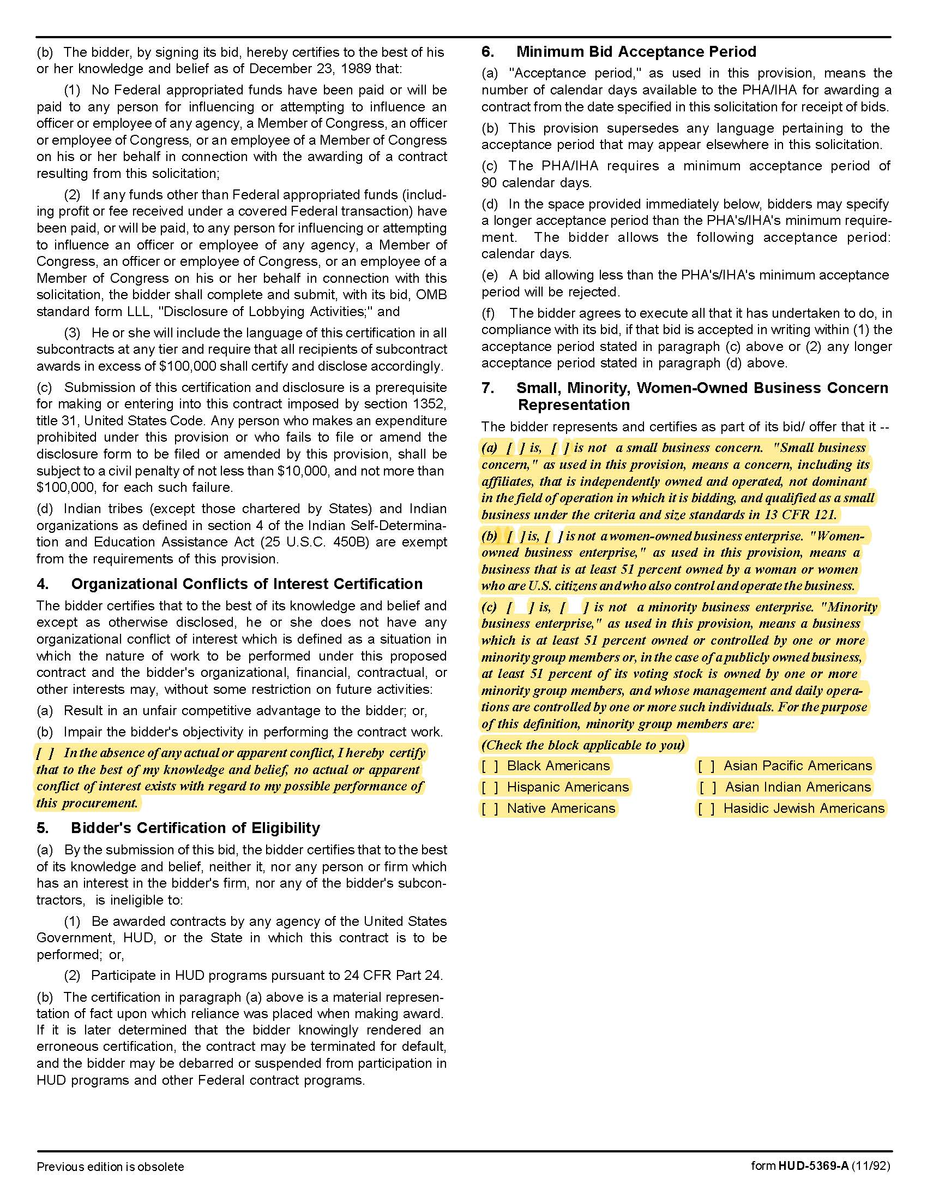

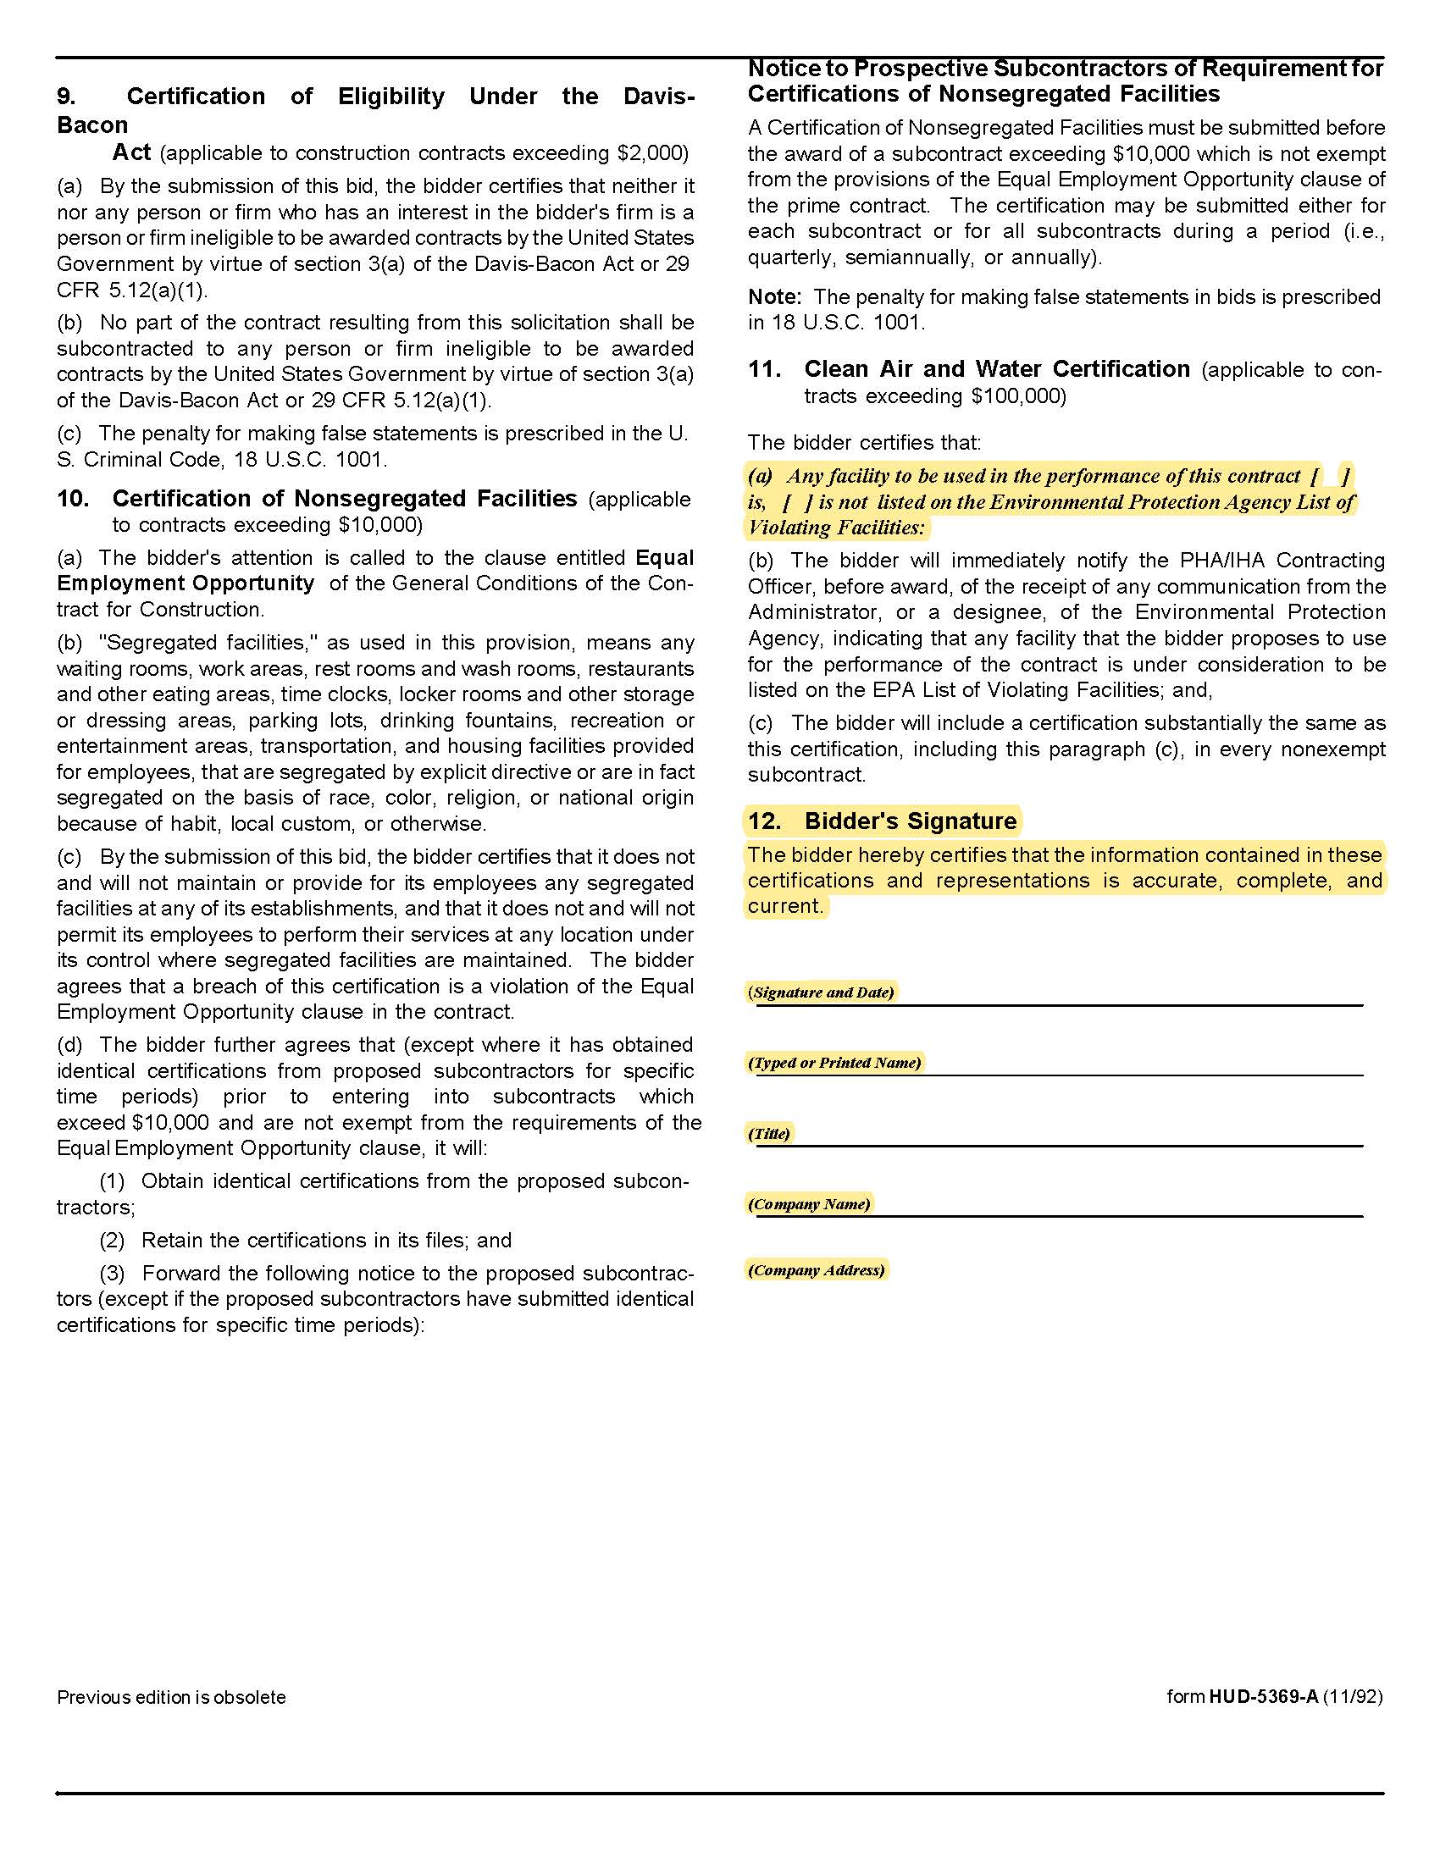

Solicitation Document D | Executive Summary

Provide a summary level description of the contents of the proposal, your firm, its capabilities and provide an overview of its history. Include summary information about your firm’s innovative and creative abilities. Answer the question: “Why should KCDC hire your firm?” The summary is limited to a maximum of two pages.

Solicitation Document E | Capabilities and History

1. A narrative history of your company.
2. Indicate the number of years your firm has been in this business.
3. Describe any advantages that KCDC will have due to synergies created from contracts with other organizations in the community.
4. Indicate the number of clients your firm serves.
5. Has your firm failed to complete a project? If yes, provide details.
6. Are there any judgments, claims or suits pending or outstanding by or against your firm. If yes, provide details.
7. A brief narrative describing why your firm is best qualified to perform the requested services.
8. Major work presently under contract.
9. List of projects for which your firm is a candidate for award:
10. Detail your firm’s past demonstrated ability to be innovative and creative. Provide examples of past products, demonstrated results and overall cost.
11. How and when do you solicit client input into the creative effort?
12. Describe the process for delivering maximum creative value while keeping the fee as low as possible.
13. Describe social media experience relevant to KCDC.

Solicitation Document F | Staff Capabilities and Experience

1. Provide an organizational chart for your firm.
2. Indicate your total number of employees.
3. Indicate your number of administrative employees.
4. Indicate your number of professional employees.
5. Provide information about each professional staff member including
a. Title
b. Professional Certifications
c. Their role with KCDC’s account
6. Indicate which member of your team will be KCDC’s main contact.
7. Indicate how much (as a percentage) of KCDC’s account representative’s time will be devoted to KCDC.
8. Describe the experience of your creative team.

Solicitation Document G | General Approach to Service Provision

1. Describe the process your firm uses for developing:
a. Strategic Initiatives
b. Marketing Plans
c. Media Plans
d. Promotional Plans
e. Research/Evaluation Plans
f. New Production Plans
g. Social media initiatives

2. Identify how you intend to monitor and report progress during the implementation.
3. Provide examples of reports that have been used in previous efforts.

Solicitation Document H | References

Provide information about experience with public entities to demonstrate the ability to execute the requirements of the RFP. The proposal must include five specific references of similar accounts. Present information in this format:

1. Name of the business serviced
2. Contact name
3. Address
4. Phone number
5. Email address
6. Amount of the contract
7. Description of the contract
8. Date the contract began and ended (if applicable)

Solicitation Document I | Cost Schedule

Proposers are to present a cost-effective contract plan with maximum flexibility. Proposers are strongly urged to quote one or more “retainer” type fee structures with a flat not to exceed monthly fee associated with a set number of hours devoted to KCDC each month. Indicate what is included in the fee and what is considered “extra” cost. KCDC may consider cost proposals with variations of this method. There must be no hidden costs associated with this response. Full disclosure of the nature and amount of all fees and charges is mandatory.

Retainer Arrangements:
1. Indicate the number of hours for each type of employee that is included.
2. Indicate “rollover” provisions of specified hours.
3. Indicate the cost for additional services on an hourly basis.

4. Clearly indicate additional costs such as supplies, mileage, and mark up on third party
services.

Hourly Rate Arrangements:
Provide a detailed statement of fees based on hourly rates by type of service:

1. Consulting with KCDC staff (includes per diem but travel to and from meetings is excluded).
2. Presentation to the KCDC Board and/or other committees (includes travel, et cetera).
3. Media Placement Services
4. Photography
5. Printing
6. Video Scripting
7. Video/DVD Production
8. Public Relations
9. Audio/Video/DVD Duplication
10. Audio Production
11. Print Media Scripting
12. Other Services Offered

