Request for Proposals

Public relations Services

Solicitation Number | Q1803
Due Date | February 23, 2018
Due Time | 11:00 a.m. eastern standard time
Deliver Responses to: |   Knoxville’s Community Development Corporation  Procurement Division  901 N. Broadway  Knoxville, TN 37917  Note: Procurement is in a separate building behind the main office building
Electronic Copies: | Proposers are encouraged to use the Adobe fillable or MS Word version to provide a typed.  Electronic copies are available on KCDC’s webpage or by emailing purchasinginfo@kcdc.org.
May responses be emailed to KCDC | ☒ Yes ☐ No  However, if the solicitation calls for written submittals, they must be provided as indicated.
Solicitation Meeting | ☐ Yes ☒ No
Solicitation Meeting is Mandatory | ☐ Yes ☒ No
Solicitation Meeting Date | NA
Solicitation Meeting Time | NA
Solicitation Meeting Location | NA
Questions About This Solicitation | Submit questions to purchasinginfo@kcdc.org

Check KCDC’s webpage for addenda and changes before submitting your response

General Information

1. BACKGROUND AND INTENT

a. Knoxville's Community Development Corporation (KCDC) is the public housing and redevelopment agency for the City of Knoxville and for the County of Knox in Tennessee. KCDC’s public housing property portfolio includes 20 sites with approximately 3,547 dwelling units. KCDC also administers approximately 3,958 vouchers and 82 moderate rehabilitation units through our Section 8 department.

b. KCDC’s existing “contract” for public relations services is nearing its maximum award length (five years) and with this solicitation, KCDC intends to secure the cost effective services of a strategically oriented, highly creative agency to meet its public relations needs. KCDC’s primary objective is to create a proactive marketing strategy for the Agency, utilizing both traditional and social media to get original content to our customers and the broader community, while reducing public relations service costs. Thus proposers are encouraged to be creative in their suggested approach to meeting KCDC’s needs.

c. The selected firm must have the ability to move quickly from one project to the next. KCDC expects prime attention from senior account service/creative personnel. KCDC wants a partnership with a firm so that united KCDC and the firm reach set goals.

c. The award will include routine services as well as services needed on an “as needed” basis.

d. KCDC anticipates this award commencing on or about March 1, 2018.

2. CHANGES AFTER AWARD
It is possible that after award KCDC will need to revise the service needs or requirements specified in this document. KCDC reserves the right to make such changes after consultation with the proposer. Should additional costs arise, the proposer must document the increased costs. KCDC reserves the right to accept and negotiate these charges.

3. CONTRACT ADMINISTRATOR/TECHNICAL POINT OF CONTACT
The following employees are the main points of contact for the successful proposer.

a. Contractual Issues: Terry McKee, IT & Procurement Director

b. Day to Day Needs: KCDC’s Executive Management team:

- CEO: Ben Bentley
- Senior Vice President of Housing: Sean Gilbert
- Executive Assistance to CEO: Joy Russell Patrick

4. CONTACT PERSONNEL
The proposer will have no more than two persons to handle billing inquiries and service related issues. In the event one or both contacts leave the KCDC account, the successful proposer will introduce the new contacts to KCDC personnel.

5. CONTACT POLICY
The proposer may not contact anyone about this solicitation, other than the KCDC’s Procurement Division from the issuance of this RFP until award. Information obtained from an unauthorized officer, agent, or employee will not affect the risks or obligations assumed by the proposer or relieve the proposer from fulfilling any of the conditions of the resulting award for the purpose of this project. Additionally, such contact can disqualify the proposer from participation in the solicitation process.

6. COPIES
The proposer will deliver three printed copies and one original printed copy (so marked) of your proposal by the due date and time. Additionally, the proposer will submit an electronic copy of the proposal.

7. EVALUATION
All responses are subject to a determination of “responsive” and “responsible” prior to award. KCDC is the sole judge as to proposer “responsiveness” and “responsibility.” KCDC reserves the right to request additional information to assist in the evaluation process. This includes references and business capacity information.

a. KCDC will evaluate responses with a weighted evaluation system. The categories and points assigned for each category are:

FACTORS | MAXIMUM POINTS
Fee Schedule | 30
Business Capabilities  (size, staff composition, report capabilities, et cetera) | 25
Assigned Personnel  Knowledge, expertise & qualifications of personnel assigned to KCDC’s project | 25
Proactive Marketing Plan  (Provide outline of a strategy with goals, timeline, and steps for implementation for both social and traditional media) | 15
References | 5
Total Points Possible | 100

b. KCDC will review all proposals and reserves the right to request necessary modifications, waive minor technicalities, reject all proposals, reject any proposal that does not meet mandatory requirement(s) or cancel this RFP, according to KCDC’s best interests.

c. KCDC’s Evaluation Team may elect to interview one or more proposers before making an award.

d. KCDC’s Evaluation Team may elect to first rank proposals with a simple numeric score and then detail score only the top tier of proposals.

KCDC reserves the right to waive technical irregularities in submissions or to reject any or all proposals if to do so is in the best interest of KCDC.

8. GENERAL INSTRUCTIONS
KCDC does not insert “General Instructions to Suppliers” in the solicitation document. These instructions are at www.kcdc.org. Click on “Procurement” and follow the link. By submitting a response to this solicitation, the proposer accepts the responsibility for downloading, reading and abiding by the terms and conditions set forth in KCDC’s “General Instructions to Suppliers.” Proposers may wish to review certain applicable HUD instructions also on KCDC’s webpage.

9. INSURANCE
Upon award, Certificates of Insurance must be provided to KCDC indicating that the proposer carries at least the following minimum levels of insurance. Proposer will at its sole expense obtain and maintain in full force and effect for the duration of the resulting award and any extension hereof at least the following types and amounts of insurance for claims which may arise from or in connection with this resulting award. All insurance must be underwritten by insurers with an A.M. Best rating of A-: VI or better.

The proposer will maintain, at proposer’s sole expense, on a primary and non-contributory basis, at all times during the life of the award insurance coverages, limits, and endorsements described herein. All insurance must be underwritten by insurers with an A.M. Best rating of A-: VI or better. Upon award, the proposer will provide Certificate(s) of Insurance to KCDC evidencing said insurance coverages.

The proposer agrees the insurance requirements herein as well as KCDC’s review or acknowledgement, is not intended to and will not in any manner limit or qualify the liabilities and obligations assumed by the proposer under this award

a. Commercial General Liability Insurance: occurrence version commercial general liability insurance with a limit of not less than $1,000,000 each occurrence for bodily injury, personal injury, property damage, and products and completed operations. If such insurance contains a general aggregate limit, it will apply separately to the work/location in this award or be no less than $2,000,000.

Such insurance will contain or be endorsed to contain a provision that includes KCDC, its officials, officers, employees, and volunteers as additional insureds with respect to liability arising out of work or operations performed by or on behalf of the proposer including materials, parts, or equipment furnished in connection with such work or operations. The coverage will contain no special limitations on the scope of its protection afforded to the above-listed insureds.

The Additional Insured will read “Knoxville’s Community Development Corporation (KCDC)”.

If necessary, umbrella/excess liability insurance can be used in conjunction with the general liability insurance to meet these requirements. Unless the umbrella/excess liability insurance provides coverage on a pure/true follow-form basis, or KCDC is automatically defined as an additional insured, the proposer will add by endorsement, KCDC, its officials, officers, employees, and volunteers as an additional insured.

b. Automobile Liability Insurance: including vehicles owned, hired, and non-owned, with a combined single limit of not less than $1,000,000 each occurrence. Such insurance will include coverage for loading and unloading hazards.

c. Workers’ Compensation Insurance and Employers Liability Insurance: with statutory limits as required by the State of Tennessee or other applicable laws.

d. Other Insurance Requirements: Proposer will:

- Upon award, furnish KCDC with original Certificates of Insurance and amendatory endorsements effecting coverage required by this section. Certificates of Insurance will provide a minimum 30-day endeavor to notify KCDC of cancellation when available by proposer’s insurance. If the proposer receives a non-renewal or cancellation notice from an insurance carrier affording the required coverage, or receives notice that coverage no longer complies with the insurance requirements herein, proposer will notify KCDC by email or fax within five (5) business days and provide a copy of the non-renewal for cancellation notice or written specifics as to which coverage is no longer in compliance.

The certificate holder address will read:
Knoxville’s Community Development Corporation
Attn: Contracting Officer
901 N. Broadway
Knoxville, TN 37917

2. Provide certified copies of endorsements and policies if requested by KCDC in lieu of or in addition to Certificates of Insurance.

3. Replace certificates, policies, and endorsements for any such insurance expiring prior to completion of services.

4. Maintain such insurance from the time services commence until services are completed. Failure to maintain or renew coverage or to provide evidence of renewal may be treated by KCDC as a material breach of award.

5. Require all subcontractors to maintain during the term of the resulting award commercial general liability insurance, automobile liability insurance, and workers’ compensation/employers liability insurance (unless subcontractor’s employees are covered by proposer’s insurance) in the same manor and limits as specified for the proposer. Proposer will furnish subcontractor(s)’ Certificates of Insurance to KCDC without expense prior to subcontractor(s) commencing work.
6. Any deductibles and/or self-insured retentions greater than $50,000 must be disclosed to and approved by KCDC prior to the commencement of services. Use of large deductibles and/or self-insured retentions will require proof of financial ability as determined by KCDC.

7. Provide a waiver of subrogation for each required policy herein. When required by the insurer, or should a policy condition not permit proposer to enter into a pre-loss agreement to waive subrogation without an endorsement, the policy should be endorsed with a Waiver of Transfer of Rights of Recovery Against Others, or its equivalent. This waiver of subrogation requirement will not apply to any policy which includes a condition specifically prohibiting such an endorsement, or voids coverage should proposer enter into such an agreement on a pre-loss basis.

8. All policies must be written on an occurrence basis.

e. Once KCDC sends the successful proposer the notification of intent to award, the proposer is required to provide a Certificate(s) of Insurance evidencing coverage as required above within the timeline detailed noted below. Failure to comply within the set timeframe may constitute unresponsiveness and KCDC reserves the right, at its sole discretion, to reconsider the award.

KCDC has determined the following timeline applies to this solicitation:

General Services: 7 calendar days ☒ Yes ☐ No
Construction Services 15 calendar days ☐ Yes ☐ No

10. INVOICING/ORDERING

a. Until a purchase order is in place, work is not to be performed nor are goods to be delivered. Purchase orders authorize work and obligate payment. KCDC does not have a legal obligation to pay for work or goods delivered prior to purchase order issuance.

b. Invoices must:

1. Be numbered

2. Have a date on them that is after the work is completed or goods delivered

3. Show the purchase order number.

4. Breakdown pricing according to the bid structure. For instance, if the award is priced by the hour, then the invoice needs to show the hours and rates. This is important so that KCDC can quickly compare the rates charged with the approved rates.

5. Be suitable for scanning since KCDC does not maintain paper records.

c. Proposers are required to submit invoices within 90 days following the delivery of the goods or services. KCDC may deny invoices submitted after the 90-day threshold.

d. KCDC’s purchases of goods are exempt from Tennessee sales and use tax pursuant to Tennessee Code Annotated 67-6-329(a) (4) and KCDC is generally exempt from the Federal Excise tax. Suppliers are subject to Tennessee sales and use tax on all materials and supplies used in the performance of a contract, whether such materials and supplies are purchase by the supplier, produced by the supplier, or provided to the supplier by KCDC, pursuant to Tennessee Code Annotated 67-6-209. The supplier will pay all taxes incurred in the performance of an awarded contract.

Upon the placement of a purchase order or the award of a contract, KCDC will provide a State of Tennessee Sales Tax Exemption form to the proposer. KCDC will not pay taxes on invoices.

e. KCDC pays by electronic transfer (ACH) only.

11. LENGTH OF AWARD
The initial award will be for 12 months. The award has four one-year optional renewals that KCDC may choose to exercise.

12. PRICE STRUCTURE

a. At the end of each award year, the successful proposer may request a price increase. Proof of increased cost to the successful proposer must accompany price increase requests. KCDC may, at its option:

1. Accept the proposed price increase.
2. Reject the proposed price increase.
3. Suggest an alternative price increase.

b. If KCDC rejects a proposed price, the successful proposer may:

1. Continue with the existing pricing.
2. Suggest an alternative price increase.
3. End the award.

13. QUESTIONS
Direct questions pertaining to this document to purchasinginfo@KCDC.org with “Public Relations Services” in the subject line, at least five days prior to the due date.

14. SECTION 3 OF THE HUD ACT OF 1968
Section 3 is a provision of the Housing and Urban Development Act of 1968, which requires that programs of direct financial assistance administered by the U.S. Department of Housing and Urban Development (HUD) provide, to the greatest extent feasible, opportunities for job training and employment to lower income residents in connection with projects in their neighborhoods. Further, to the greatest extent feasible, contracts in connection with these projects are to be awarded to local businesses. Section 3 is a tool for fostering local economic development, neighborhood economic improvement and individual self-sufficiency.

a. Recipients and vendors must make a good faith effort to utilize Section 3 area residents as trainees and employees in connection with the project. Targeted recruitment and the selection of Section 3 area residents for available positions are two examples of good faith efforts to meet this requirement.

b. Recipients and vendors must make a good faith effort to award contracts to Section 3 business concerns for work in connection with the project. An example of a good faith effort to meet this requirement is the implementation of an affirmative action plan, which includes targets for the number and dollar value for awarding contracts to Section 3 business concerns.

c. Recipients and vendors must keep records and submit reports to HUD documenting the good faith efforts taken and the results of these actions. Examples of such documentation include letters to community organizations, employment development and business development centers, copies of solicitations for proposals or proposals; and copies of affirmative action plans.

d. How can businesses find Section 3 residents to work for them? By recruiting in the neighborhood and public housing developments to tell about available training and job opportunities. Distributing flyers, posting signs, placing ads, and contacting resident organizations and local community development and employment agencies to find potential workers are a few effective ways of getting jobs and people together.

e. All contracts awarded are subject to Section 3 requirements. Proposer will seek to fill any and all position that are needed and unfilled with residents of KCDC communities. For additional information, please go to http://www.hud.gov/offices/fheo/section3/Section3.pdf. The successful proposer will supply KCDC with job announcements for any position that must be filled as a result of the award of KCDC work. Additionally the successful proposer will supply the same job announcement to the Knoxville-Knox County Committee Action Committee’s Workforce Connections group. These can be faxed to 544-5269.

f. A Section 3 resident is one who lives within a public housing authority’s apartment. It is also people who live in an area with a HUD assisted program and whose income is below HUD’s low income requirements.

g. A Section 3 business is one that:

1. Is at least 51% owned by a Section 3 resident; or

2. Employs Section 3 residents for at least 30% of its employee base; or

3. Makes a commitment to sub award at least 25% of the project’s dollars to a Section 3 business.

15. SUBCONTRACTORS
KCDC must approve subcontractors prior to them beginning work and the subcontractors must carry the insurance coverages outlined herein.

Scope of Work/Description of Minimums

16. GENERAL COMMENTS
KCDC desires cost effective, routine services and “as needed” public relations services. The selected firm will perform important routine services for KCDC as well as periodic special projects. Both types of services are detailed below.

a. Routine services include such things as:

- Developing, implementing, and evaluating a proactive marketing strategy for KCDC, incorporating both traditional and social media outlets.

- Establishing, monitoring, updating, and creating Content for KCDC’s social media sites including Facebook, LinkedIn, Twitter, and Instagram. This includes posting notices and solicitations for KCDC’s Procurement Division.

- Social Media Communications services such as meeting notices and construction project updates via social media including Facebook, Twitter and E-blasts. This includes posting notices and solicitations for KCDC’s Procurement Division.

- Issuing press releases on KCDC’s behalf, and working with media to build interest in KCDC related content.

- Monitoring local media outlets for stories involving KCDC, providing KCDC with such information and then guiding KCDC’s response if applicable.

- Monitoring Knoxville City Council meetings (including committees) for issues involving KCDC providing KCDC with such information and then guiding KCDC’s response if applicable.

- Monitoring Knox County Commission meetings (including committees) for issues involving KCDC providing KCDC with such information and then guiding KCDC’s response if applicable.

These services mean that your firm reviews the meeting agendas to determine if there are agendas items relevant to KCDC. If so, your firm will monitor those items either in person or through meeting minutes, community television broadcasts or other methods as appropriate for KCDC’s efforts and needs.
b. As needed services could include:

- Annual Progress Reports
- Brochures
- Creative Development
- Crisis Communications. In the event of a crisis, the selected firm may support KCDC by way of informational materials, messaging, social media and other communication materials to assist with the crisis at hand.
- Media Development
- Media Placement
- Newsletters
- Photography/Videography
- Press Conferences
- Print Advertising
- Research
- Solicit for free media time and/or space for public service announcements.
- Social media (such as Facebook, LinkedIn, Twitter, et cetera) campaigns for specific projects

This is not an all-inclusive list and many “as needed” services are not products from the proposer but rather press releases about items. Specific “as needed” items from the past include:

- A video concerning KCDC’s HOPE VI project
- A flyer about the Residences at Eastport
- A multifold booklet about “Changing the Face of Public Housing”

17. CHANGES IN WORK
If KCDC finds it necessary to require corrections to completed work due to errors made by the proposer, the proposer shall correct the work at no additional cost to KCDC. If KCDC requires changes for previously accepted work, the proposer shall make such changes as directed by KCDC. The supplier’s compensation is at the established rate between the proposer and KCDC.

18. CONFIDENTIALITY
The proposer agrees to use information related to KCDC only as needed and approved by KCDC. Such information will be kept confidential for the duration of the contract and beyond, except when release is authorized by KCDC.

19. COPYRIGHT
Proposer shall not assert rights of common law, or equity or establish any claim to statutory copyright in any material or information developed in performance of the services authorized. KCDC has the right to use, reproduce, or distribute any or all of such information and other materials without the necessity of obtaining any permission from the proposer and without expense and charge. All work products are the property of and owned by KCDC. Proposer shall secure duplication and distribution rights for KCDC from all suppliers and subcontractors. The proposer will supply all documents, recordings, et cetera to KCDC in two formats:

a. Original high quality master formats.

b. Formats compatible with existing KCDC hardware, software and equipment.

20. KCDC’s GENERAL RESPONSIBILITIES
KCDC will

a. Schedule periodic meetings with the proposer to monitor the progress of work.

c. Provide any necessary reports, formats, and forms.

d. Approve or deny approval of all finished products provided by the proposer prior to release or implementation of any material developed within 10 calendar days of receipt.

b. Approve or deny approval of Schedules of Work and Activities within 10 calendar days of receipt.

21. PAYMENT
KCDC will make monthly payments to the proposer for approved costs incurred in accordance with the following:

a. The proposer will bill all direction, artwork, public information, research, account service work, special event coordination and copy writing on an hourly basis by activity in accordance with the contractual rates.

b. The proposer will bill all media by activity at the actual flat fee rate. Progress payments are made on a percentage of completion basis.

c. The cost of services rendered or materials produced by organizations on KCDC’s behalf and not a part of the proposer’s organization shall be approved by KCDC and billed at actual cost by activity (i.e., long-distance telephone calls, mailing, shipping and photocopying). Billing for allowable in-state travel expenses shall not exceed Tennessee Statute state rates for in-state travel. Out-of-state travel is reimbursed at approved out-of-state travel rates.

d. Proposer must request payment for all required printing with an itemized invoice. Proposer must competitively bid printing services (3 or more) to provide best price and quality for KCDC. The proposer must provide copies of the competitive bids upon submission of estimates.

e. The proposer must submit requests for payment which include the following information:

1. Actual hours worked by employees and the rate of pay extended to a monthly total.

2. Itemized invoices for all charges with copies of supporting documentation for charges for purchases of items.
3. Itemized invoices for all charges with copies of supporting documentation for charges for out-of-pocket expenditures.

4. Itemized invoices for all charges with copies of supporting documentation for charges for other direct costs.

22. PROPOSER REPORTS AND MEETINGS
The proposer must submit reports every quarter and a comprehensive final report at the end of the year to document the results of the work performed. The proposer shall recommend a format for KCDC approval for the quarterly reports and the comprehensive annual report.

a. The proposer must promptly notify KCDC in writing of events, which have a significant impact on contract, work, including:

1. Problems, delays, or adverse conditions, which will prevent the meeting of time or work schedules

2. Favorable developments that will enable meeting time or work schedules earlier than anticipated.

b. KCDC may require meetings each month between the proposer and KCDC personnel to discuss assigned projects. The meetings are at a location to be specified but typically this will be at KCDC’s offices. Proposer is paid the hourly rate only for time actually spent in the meeting.

23. STATEMENT OF WORK

a. The proposer must submit a Statement of Work to KCDC for written approval prior to performing as needed tasks. In addition to identification and scheduling of projected activities, each work schedule must include measurable objectives and estimated costs. Costs not approved by KCDC will not be reimbursed.

b. Upon approval by KCDC, each Statement of Work shall become a part of the purchase order. A Statement of Work may be amended as necessary and agreed upon by KCDC and the agency.

24. STAFF REPLACEMENT
KCDC understands that over time proposer’s employees may leave or have other assignments to which they are dedicated. KCDC will allow this with the following provisions:

a. Replacement personnel must have credentials equivalent to the individuals they replace. Resumes of replacement personnel will be submitted to KCDC for review. KCDC reserves the right to interview replacement personnel.

b. The proposer briefs the replacement personnel as to the status of KCDC’s project(s) and ongoing work at no expense to KCDC.

25. TRAVEL EXCLUSION
The proposer will not be reimbursed for any travel expenses incurred in travel to and from meetings. Hourly rates for services shall start at the beginning of the meeting and end at the conclusion of the meeting.

Submittal Structure Instructions

1. Submit your information in the order indicated below:

Document Number | Title | Form Provided by
Solicitation Document A | General Response Section | KCDC
Solicitation Document B | Affidavits | KCDC
Solicitation Document C | HUD Form 5369A | KCDC
Solicitation Document D | Proposer’s Executive Summary | Proposer
Solicitation Document E | Proposer’s Capabilities and History | Proposer
Solicitation Document F | Proposer’s Staff Capabilities and Experience | Proposer
Solicitation Document G | Proposer’s General Approach to Service Provision | Proposer
Solicitation Document H | Proposer’s References | Proposer
Solicitation Document I | Proposer’s Cost Schedule | Proposer

2. Place your company’s name on each page and number all pages consecutively

3. The use of tables in presenting information facilitates the evaluation team’s review.

4. Submit one written original (with all pages marked “original”), three printed copies and one electronic copy (email or flash drive /CD) of your submittal).

5. Fancy brochures and advertisements are not necessary.

6. Do not use phrases such as “See the attached” or “Will be provided upon award.”

7. Bind proposals simply since KCDC ultimately scans documents into electronic format. Acceptable
binding methods include paper clips, staples and three ring binders.

8. Proposers are encouraged to use a typed version for their responses.

This and the previous pages do not need to be returned

Public Relations Services Q1803

Solicitation Document A General Response Section

General Information about the Proposer
Sign Your Name to the Right of the Arrow
Your signature indicates that you have read and agree to “KCDC’s General Instructions to Suppliers” on www.kcdc.org.
Printed Name and Title
Company Name
Street Address
City/State/Zip
Contact Person (Please Print Clearly)
Telephone Number
Cell Number
Proposer’s e-mail address (Please Print Clearly)
Addenda
Addenda are at www.kcdc.org. Click on “Procurement” and then on “Open Solicitations” to find addenda. Please check for addenda prior to submitting a proposal.
Acknowledge addenda have been issued by checking below as appropriate:
None ☐ | Addendum 1 ☐ |  |  | Addendum 2 ☐ |  |  | Addendum 3 ☐ |  |  | Addendum 4 ☐ |  |  | Addendum 5 ☐
Statistical Information
This business is owned & operated by persons at least 51% of the following ethnic background:
Asian/Pacific ☐ |  | Black ☐ | Hasidic Jew ☐ |  |  | Hispanic ☐ |  |  | Native ☐ Americans |  |  | White ☐
As defined on KCDC’s webpage (see the “General Instructions to Suppliers”), this business qualifies as:
Section 3 ☐ |  |  |  |  | Small Business ☐ |  |  |  |  |  | Woman Owned ☐
Cooperative Procurement by Other Governmental Entities
Subject to additional location/delivery charges, the proposer agrees to extend the offered costs to other governments if the government so desires. Yes ☐ No ☐
Insurance Requirements
I have reviewed the insurance requirements in this solicitation and will provide KCDC with a Certificate of Insurance adhering to these requirements within the stated number of days. Yes ☐ No ☐
Prompt Payment Discount
A discount of _____% is offered if payment is made within 30 days
Mastercard Acceptance
Mastercard is accepted for payment without additional fees. Yes ☐ No ☐
Mastercard is accepted for payment with a fee of _______. Yes ☐ No ☐

Solicitation Document B Affidavits

Proposer: _____________________________________________________________________________

Conflict of Interest:

1. No commissioner or officer of KCDC or other person whose duty it is to vote for, let out, overlook or in any manner superintend any of the work for KCDC has a direct interest in the award or the proposer providing goods or services.

2. No employee, officer or agent of the grantee or sub-grantee will participate in selection, or in the award or administration of an award supported by Federal funds if a conflict of interest, real or apparent, would be involved. Such a conflict would arise when the employee, officer or agent, any member of his immediate family, his or her partner, or an organization, which employs, or is about to employ, any of the above, has a financial or other interest in the proposer selected for award.

3. The grantee's or sub-grantee's officers, employees or agents will neither solicit nor accept gratuities, favors or anything of monetary value from proposers, potential proposers, or parties to sub-agreements.

4. By submission of this form, the proposer is certifying that no conflicts of interest exist.

Drug Free Workplace Requirements:

5. Private employers with five or more employees desiring to contract for construction services attest that they have a drug free workplace program in effect in accordance with TCA 50-9-112.

Eligibility:

6. The proposer is eligible for employment on public contracts because no convictions or guilty pleas or pleas of nolo contender to violations of the Sherman Anti-Trust Act, mail fraud or state criminal violations with an award from the State of Tennessee or any political subdivision thereof have occurred.

General:

7. proposer fully understands the preparation and contents of the attached offer and of all pertinent circumstances respecting such offer.

8. Such offer is genuine and is not a sham offer.

Solicitation Document B Affidavits-continued

9. Iran Divestment Act:
Concerning the Iran Divestment Act (TCA 12-12-101 et seq.), by submission of this bid/quote/quote, each proposer and each person signing on behalf of any proposer certifies, and in the case of a joint bid/quote/quote, each party thereto certifies as to its own organization, under penalty of perjury, that to the best of its knowledge and belief that each proposer is not on the list created pursuant to § 12-12-106.

Non-Collusion:

10. Neither the said proposer nor any of its officers, partners, owners, agents, representatives, employees or parties interest, including this affiant, has in any way colluded conspired, connived or agreed, directly or indirectly, with any other responder, proposer, or person to submit a collusive or sham offer in connection with the award or agreement for which the attached offer has been submitted or to refrain from making an offer in connection with such award or agreement, or collusion or communication or conference with any other proposer, or, to fix any overhead, profit, or cost element of the offer price or the offer price of any other proposer, or to secure through any collusion, conspiracy, connivance, or unlawful agreement any advantage against KCDC or any person interested in the proposed award or agreement.

11. The price or prices quoted in the attached offer are fair, proper and not tainted by any collusion, conspiracy, connivance, or unlawful agreement on the part of the proposer or any of its agents, representatives, owners, employees, or parties in interest, including this affiant.

The undersigned hereby acknowledges receipt of this Solicitation Document B and certifies that the submittal in response to this solicitation is in full compliance with the listed requirements.

Signed by
Printed Name
Title
Subscribed and sworn to before me this date
By (Notary Public)
My Commission Expires on
Notary Stamp

Solicitation Document C HUD Form 5369A
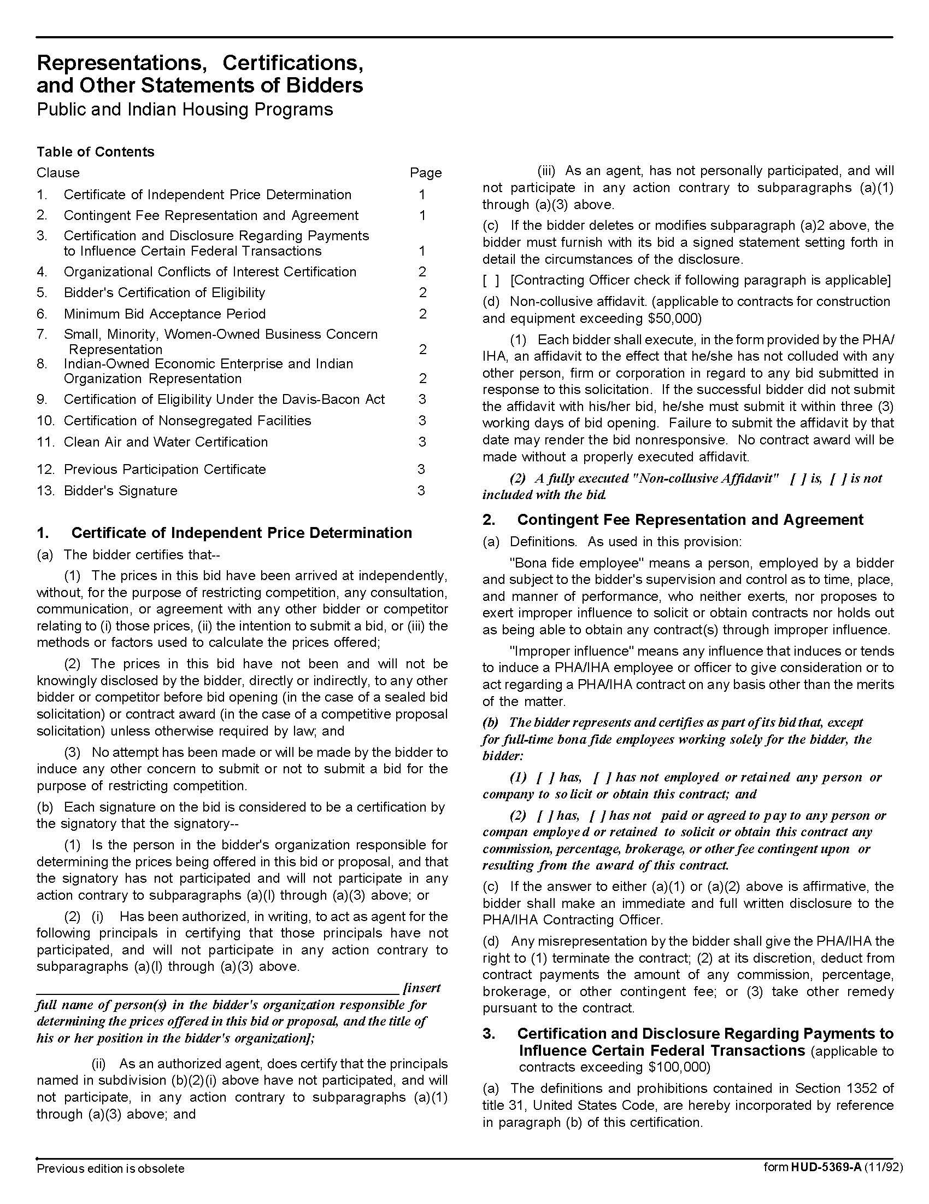

Solicitation Document C HUD Form 5369A-continued
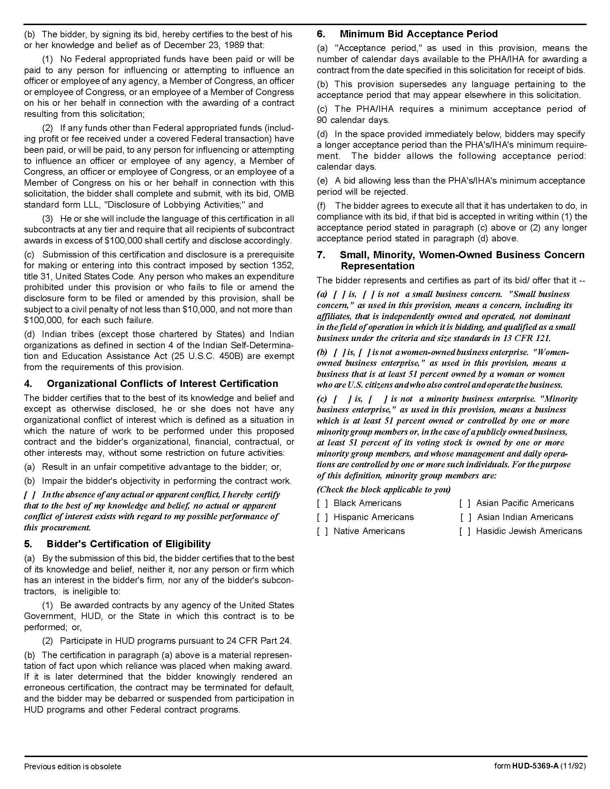

Solicitation Document C HUD Form 5369A-continued
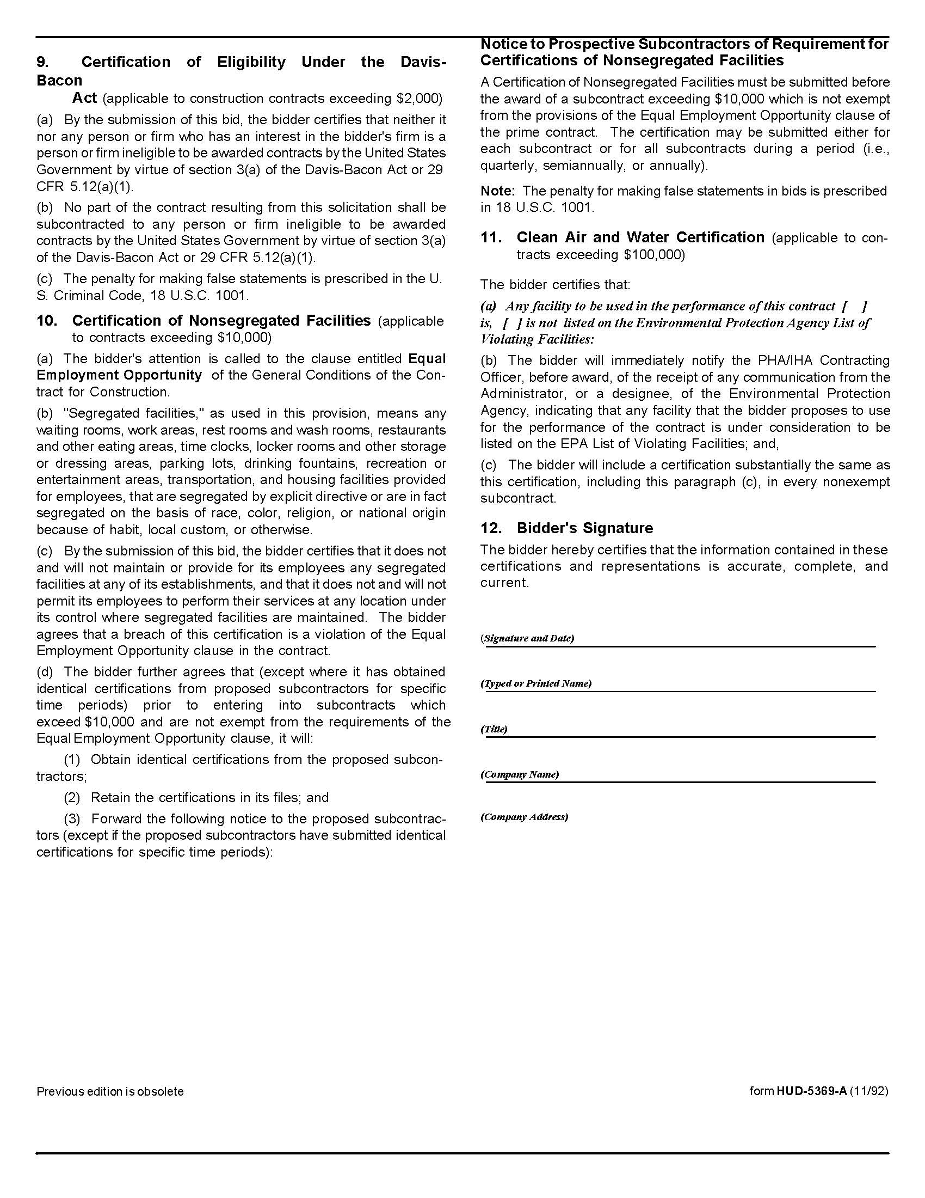

Solicitation Document D Proposer’s Executive Summary

Proposer: _____________________________________________________________________________

Provide a summary level description of the contents of the proposal, your firm, its capabilities and provide an overview of its history. Include summary information about your firm’s innovative and creative abilities. Answer the question: “Why should KCDC hire your firm?”
The summary must be limited to a maximum of two pages.

Solicitation Document E Proposer’s Capabilities and History

Proposer: _____________________________________________________________________________

1. A narrative history of your company.

2. Indicate the number of years your firm has been in this business.

3. Describe any advantages that KCDC will have due to synergies created from contracts with other organizations in the community.

4. Indicate the number of clients your firm serves.

5. Has your firm failed to complete a project? If yes, provide details.

6. Are there any judgments, claims or suits pending or outstanding by or against your firm. If yes, provide details.

7. A brief narrative describing why your firm is best qualified to perform the requested services.

8. Major work presently under contract:

Company | Description | % Complete

9. List of projects for which your firm is a candidate for award:

10. Detail your firm’s past demonstrated ability to be innovative and creative. Provide examples of past products, demonstrated results and overall cost.

11. How and when do you solicit client input into the creative effort?

12. Describe the process for delivering maximum creative value while keeping the fee as low as possible.

13. Describe social media experience relevant to KCDC.

Solicitation Document F Proposer’s Staff Capabilities and Experience

Proposer: _____________________________________________________________________________

1. Provide an organizational chart for your firm.

2. Indicate your total number of employees.

3. Indicate your number of administrative employees.

4. Indicate your number of professional employees.

5. Provide information about each professional staff member including

a. Title

b. Professional Certifications

c. Their role with KCDC’s account

6. Indicate which member of your team will be KCDC’s main contact.

7. Indicate how much (as a percentage) of KCDC’s account representative’s time will be devoted to KCDC.

8. Describe the experience of your creative team

Solicitation Document G Proposer’s General Approach to Service Provision

Proposer: _____________________________________________________________________________

1. Describe the process your firm uses for developing:

a. Strategic Initiatives

b. Marketing Plans

c. Media Plans

d. Promotional Plans

e. Research/Evaluation Plans

f. New Production Plans

g. Social media initiatives

2. Identify how you intend to monitor and report progress during the implementation.

3. Provide examples of reports that have been used in previous efforts.

Solicitation Document H Proposer’s References

Proposer: _____________________________________________________________________________

The proposer must provide information about experience with public entities to show proven and demonstrated ability to execute the requirements of the RFP. The proposal must include five specific references of similar accounts. Present information in this format:

1. Name of the business serviced

2. Contact name

3. Address

4. Phone number

5. Email address

6. Amount of the contract

7. Description of the contract

8. Date the contract began

9. Date the contract ended (if applicable)

Solicitation Document I Proposer’s Cost Schedule

Proposers are to present a cost effective contract plan with maximum flexibility. Proposers are strongly urged to quote one or more “retainer” type fee structures with a flat not to exceed monthly fee associated with a set number of hours devoted to KCDC each month. Indicate what is included in the fee and what is considered “extra” cost. KCDC may consider cost proposals with variations of this method. There must be no hidden costs associated with this response. Full disclosure of the nature and amount of all fees and charges is mandatory.

Retainer Arrangements:
1. Indicate the number of hours for each type of employee that is included.

2. Indicate “rollover” provisions of specified hours.

3. Indicate the cost for additional services on an hourly basis.

4. Clearly indicate additional costs such as supplies, mileage, and mark up on third party services.

Hourly Rate Arrangements:
Provide a detailed statement of fees based on hourly rates by type of service:

1. Consulting with KCDC staff (includes per diem but travel to and from meetings is excluded).

2. Presentation to the KCDC Board and/or other committees (includes travel, et cetera).

3. Media Placement Services

4. Photography

5. Printing

6. Video Scripting

7. Video/DVD Production

8. Public Relations

9. Audio/Video/DVD Duplication

10. Audio Production

11. Print Media Scripting

12. Other Services Offered

