Career Cluster Module Specs for Middle Schools

Vinyl Sign Making Module
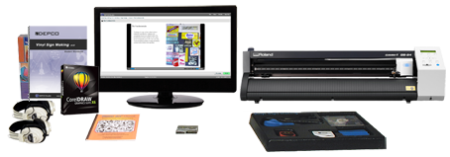
In this creative curriculum, students receive real-world experience by acquiring skills and performing tasks that are comparable to those found in the vinyl sign making industry. First, students become familiar with the sign-making software by exploring sample signs and working with basic text and graphics tools. Next, they are introduced to sign layout concepts such as proportion, balance, harmony, and symmetry, then they apply selected concepts to a variety of sign design projects. Finally, students operate advanced equipment to plot and cut two original vinyl signs.
Skills
- Create pleasing graphic layouts with the sign software
- Apply vinyl to the desired surface
- Demonstrate proper setup and use of the vinyl sign cutter
- Weed (remove cut vinyl) from the backing

Knowledge
- Cost of materials
- Basic elements of design
- Entrepreneurial aspects of a sign shop
- The role of signs in our society

Activities
- Activity 1 - Introduction
- Activity 2 - Sign Designs
- Activity 3 - The Sign Business
- Activity 4 - The Product
- Activity 5 - The Entrepreneur
- Activity 6 - The Market
- Activity 7 - Financing the Business
- Activity 8 - Managing the Business
- Activity 9 - Successful Business
- Activity 10 - Post-Test and Wrap-up
- Activity 11 - Bonus Activities
- Activity 12 - Challenge
- Activity 13 - Open-Ended Challenge
- Activity 14 - Careers
- Activity 15 - Internet
Standards
Math/Measure Problem Solving Reading

Module Equipment Includes
Student Workbook, Instructor's Manual, Installation CD, CorelDRAW Software, Vinyl Sign Making Tools, Organizer Storage Tray, Vinyl Sign Artwork CD, Headphones (2), Vinyl Sign Making Supply Kit for 24 Students, Roland CAMM-1 GS-24
Roland CAMM-1 GS-24 Desktop Vinyl Cutter, Roland CutStudio Software.
Computer and supplies are required and sold separately.

Part # and Description
MP6605 - Vinyl Sign Making

Specifications

Requirements
RS-232 Serial port for vinyl cutter
Module requires a computer workstation.

Curriculum Specifications
Format 2000. The Vinyl Sign Making curriculum consists of a well-illustrated student activity guide with 10 daily activities and 5 additional enrichment activities including careers, problem solving, challenge activities, vocabulary reinforcement, and Internet

Hospitality and Tourism Module
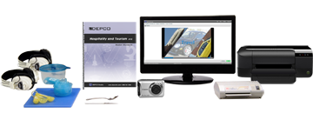
A good meal and sound nights sleep are things a traveler needs. What were once a few rooms over an old tavern have flourished into what we now see as mega resort complexes, towering skyscrapers, and thrilling theme parks. In this curriculum, students learn about the many facets the hospitality and tourism industry provides to not only consumers, but to those who choose to make hospitality and tourism a career.

Skills
- Discuss the history of hospitality and tourism.
- Create a fruit basket using an orange.
- Manipulate industry standard hotel management software.
- Discuss and calculate various exchange rates.

Knowledge
- Discuss the statistics and projected growth of the hospitality and tourism industry.
- Discuss various segments of the hospitality and tourism industry.
- Identify the many careers associated with hospitality and tourism

Activities
- Activity 1 - Introduction
- Activity 2 - Tourism
- Activity 3 - Lodging
- Activity 4 - Safety and Health Regulations
- Activity 5 - Resorts
- Activity 6 - Lodging Responsibilities
- Activity 7 - Lodging Reports
- Activity 8 - Travel Agens
- Activity 9 - Travel
- Activity 10 - Post-Test and Wrap-Up
- Activity 11 - Bonus Activities
- Activity 12 - Challenge
- Activity 13 - Open-Ended Challenge
- Activity 14 - Careers
- Activity 15 - Internet

Module Equipment Includes
Student Workbook, Instructor's Manual, Installation CD, Laminator, Paring Knife, Dinner Spoon, Atlas, Cutting Board, Digital Camera, Hi-Speed Reader, SD Memory Card, Module Box, Hospitality and Tourism Supply Kit for 100 Students, KW Hotel Free, Vacation Planner, Headphones

Part # and Description

MP4103 Hospitality and Tourism

Requirements
Module requires: computer workstation, printer

Curriculum Specifications
No information available.

Home Maintenance

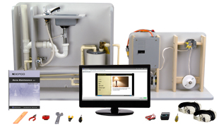
Home Maintenance refers to the basic, everyday repairs that are required in the home; many individuals choose to make these repairs themselves. Two areas are emphasized in the Home Maintenance curriculum, residential wiring and residential plumbing. This curriculum will briefly introduce students to the world of electricity and plumbing. Students gain experience completing simple repairs, such as assembling a lavatory faucet, rewiring a lamp cord, and they learn how to properly maintain a hot water heater. They learn to connect plumbing lines and to install an outside faucet.

Skills
- Gain general knowledge in minor home repairs
- Install plumbing pipes to connect a faucet, water heater, and outside faucet
- Install electrical wiring to connect switches, outlets, and light fixtures

Knowledge
- Identify and use terminology related to residential wiring and plumbing
- Explain how electricity and plumbing work
- Identify how technology affects residential wiring

Activities
- Activity 1 - Introduction
- Activity 2 - Electricity
- Activity 3 - Lighting
- Activity 4 - Wiring
- Activity 5 - Technological Trends
- Activity 6 - Household Plumbing
- Activity 7 - CPVC and Fixtures
- Activity 8 - Plumbing Pipes
- Activity 9 - Valves
- Activity 10 - Post-Test and Wrap-Up
- Activity 11 - Bonus Activities
- Activity 12 - Challenge
- Activity 13 - Open-Ended Challenge
- Activity 14 - Careers
- Activity 15 - Internet

Standards
Math/Measure
Problem Solving
Science

Module Equipment Includes
Student Workbook, Instructor's Manual, Installation CD, DEPCO Home Maintenance Plumbing Panel and Components, DEPCO Home Maintenance Wiring Panel and Components, DEPCO Home Maintenance Plumbing and Wiring Tool Kit, Headphones

Part # and Description
MP4072 Home Maintenance

Requirements
Allow for ample space when working with the Home Maintenance Plumbing and Wiring Panels.
Computer is required and sold separately.

Curriculum Specifications
No information available
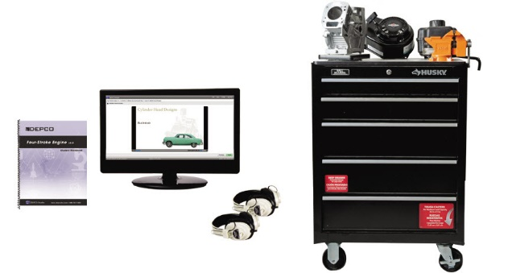
Four-Stroke Engine
After a solid introduction to the four strokes — intake, compression, power, and exhaust — students are ready to get their hands dirty and see how all of the components work together. They first identify the major and minor components of the cylinder block, and then assemble the internal and external parts such as the piston, crankshaft, camshaft, and flywheel. As the work gets more complex — building the cylinder head, adding a spark plug, mounting the carburetor and fuel tank, installing the muffler and air filter — students become increasingly involved in the intricate and delicate inner workings of the engine
Skills
• Illustrate the four-stroke sequence in the engine
• Describe the function of a piston
• Assemble a four-stroke engine piston and identify its components
• Assemble the crankshaft, camshaft, and flywheel of a four-stroke engine
Knowledge
• Explain the basic internal operation of a four-stroke engine
Activities
• Activity 1 - Introduction
• Activity 2 - Cylinder Block and Piston
• Activity 3 - Piston, Crank and Cam
• Activity 4 - Ignition Systems
• Activity 5 - Cylinder Head and Spark Plug
• Activity 6 - Intake, Exhaust, and Carburetion
• Activity 7 - Governor, Throttle, and Pull Starter
• Activity 8 - Disassembly
• Activity 9 - Disassembly and Lubrication
• Activity 10 - Post-Test and Wrap-Up
• Activity 11 - Bonus Activities
• Activity 12 - Challenge
• Activity 13 - Open-Ended Challenge
• Activity 14 - Careers
• Activity 15 - Internet
Standards
Mathematics/Measure
Science
Problem Solving
English Language Arts/Reading
DEPCO Unit Includes:
Student Workbook, Instructor’s Manual, Installation CD, Organizer Storage Tray (9), Small Engine Workstation, 3 in. Bench Vice, Tool Organizer Tray, Briggs & Stratton Overhead Valve Engine, Tool Chest, Headphones (2)
Computer is required and sold separately.
Part # and Description
TM8100 | Four-Stroke Engine Module (Complete)
TM8103 | Four-Stroke Engine - Additional engine class setup
TM8107 | Four-Stroke Engine Storage Cabinet (Optional)
Requirements
Optional Four-Stroke Storage Cabinets should be considered for each Four-Stroke Engine if storage is not available.
TV/DVD Player is recommended.
Four-Stroke Engine Module includes one class setup. An additional class setup must be purchased for each additional class period.
Curriculum Specifications
The student workbook contains concise, hands-on procedures, illustrations, screen captures, and photographs, which reinforce the multimedia content. Interesting and relevant graphics are used in the media to encourage visual learning. DEPCO Studio is an effective curriculum delivery system that uses interesting digital videos, full-color animations, professional quality narrations, challenging interactions, relevant photographs, and Computer Aided Instruction (CAI), to modernize the way subject matter is taught. Each Career and Technology module has one unit, which consists of 10 basic activity days with Pre-Test, Post-Test, and Activity Review Questions; 5 enrichment activities, which include vocabulary reinforcement, problem-solving, open-ended challenges, careers, and Internet activities; and an instructor's section, which includes lesson plan outlines, installation instructions, and answer keys.
Research and Design
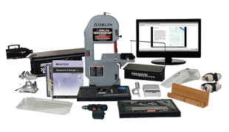
Students take a model race car from design to manufacturing. They study the factors that affect the speed of a vehicle, and then develop drawings using orthographic projection and exact measurements to minimize or capitalize on those factors. Next, they create a full-scale mock-up model of their car, then analyze and evaluate the model for aerodynamics. Lastly, the students apply all the information they have gathered by building, finishing, and racing their wooden race cars.
Skills
• Read specifications correctly
• Properly use basic woodworking and measurement tools
• Develop an end product based on design and testing
• Generate drawings for development of a product
Knowledge
• Explain the basic steps of design process
• Explain the major factors that affect performance
• Explain the importance of drawings in product development
Activities
• Activity 1 - Introduction
• Activity 2 - Design Drawings
• Activity 3 - Mock-Up
• Activity 4 - Mock-up Analysis
• Activity 5 - Layout
• Activity 6 - Carving I
• Activity 7 - Carving II
• Activity 8 - Carving III
• Activity 9 - Assembly
• Activity 10 - Post-Test and Wrap-up
• Activity 11 - Bonus Activities
• Activity 12 - Challenge
• Activity 13 - Open-Ended Challenge
• Activity 14 - Careers
• Activity 15 - Internet
Standards
Mathematics/Measure
Problem Solving
English Language Arts/Reading
Module Equipment Includes:
Student Workbook, Instructor’s Manual, Installation CD, DEPCO AeroWedge, Wind Generator, Drill Fixture, DEPCO Styrofoam Cutter, Band Saw, Vice, Cordless Power Drill, Dust Buster, Electronic Scale (grams), Drawing Templates, Drawing Tool Set, Cutting Tools, Organizer Trays (2), CO₂ Car Supply Kit for 24 Students
Part # and Description
TM8302 | Research and Design DEPCO Studio Module (Less band saw)
TM7708 | Airbrush Compressor (Optional)
TM7709 | Airbrush Compressor (Optional)
830100 | CO2 Car Supply Kit (24 students)
830400 | CO2 Car Supply Kit (100 students)
GT4000 | GT4000 Race Track (Sold separately)
TM8310 | Research and Design TLU - Complete (Race track not included)
ET20M | CO2 Raceway (Sold separately)
Requirements
Adequate ventilation for the airbrush painting. Recommend optional spray booth.
Adequate floor space should be allocated for the GT4000 Racetrack which is 30" tall x 15' 3" long x 18" wide, also allow for enough room to move around the track. In addition, a generous amount of work space is required for the module equipment.
GT4000 Gravity Test Track ships LTL freight.
ET20M CO2 Raceway requires a smooth surface and can be setup in a range of lengths up to 20 meters.
Curriculum Specifications
The student workbook contains concise, hands-on procedures, illustrations, screen captures, and photographs, which reinforce the multimedia content. Interesting and relevant graphics are used in the media to encourage visual learning. DEPCO Studio is an effective curriculum delivery system that uses interesting digital videos, full-color animations, professional quality narrations, challenging interactions, relevant photographs, and Computer Aided Instruction (CAI), to modernize the way subject matter is taught. Each Career and Technology module has one unit, which consists of 10 basic activity days with Pre-Test, Post-Test, and Activity Review Questions; 5 enrichment activities, which include vocabulary reinforcement, problem-solving, open-ended challenges, careers, and Internet activities; and an instructor's section, which includes lesson plan outlines, installation instructions, and answer keys.
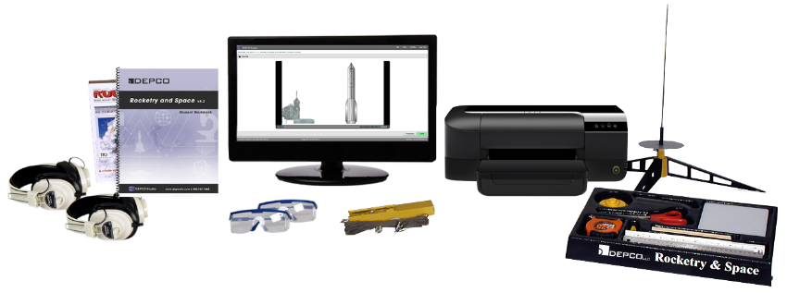
Rocketry and Space
From the fascinating history of rockets to the basic principles of rocket flight, students receive a thorough introduction to the field of rocketry and space in this exciting curriculum. Students draw upon Newton’s laws of motion and begin by making a paper rocket in order to obtain specific data to help project flight estimates and distances. As students learn more about rockets, including the role of centers of mass, pressure in rocket stability, and the functions of different model rocket parts, they build an actual model rocket and are able to launch it under direct supervision by the instructor. Also included in the Rocketry and Space curriculum is RockSim, a computer simulation program, through which students design, build, and launch a simulated rocket.
Skills
• Read and interpret drawings and plans
• Compute average distances traveled by a rocket
• Measure distances, lengths, and dimensions
• Construct a rocket
Knowledge
• Describe Newton's laws of motion
• Explain the effect of center of mass and center of pressure on rocket flight
• Identify factors in rocket performance
• Identify common parts and features of rockets
Activities
• Activity 1 - Introduction
• Activity 2 - Newton’s Law
• Activity 3 - Single Stage Design
• Activity 4 - Two Stage Design
• Activity 5 - Design Your Rocket
• Activity 6 - Rocket Controls
• Activity 7 - Preflight Activities
• Activity 8 - Rocket Assembly
• Activity 9 - RockSim Software
• Activity 10 - Post-Test and Wrap-Up
• Activity 11 - Bonus Activities
• Activity 12 - Challenge
• Activity 13 - Open-Ended Challenge
• Activity 14 - Careers
• Activity 15 - Internet
Standards
Mathematics/Measure
Science
Problem Solving
English Language Arts/Reading
DEPCO Unit Includes:
Student Workbook, Instructor’s Manual, Installation CD, Rocket Launch Controller, Rocket Launch Pad, Tape Measure – 25 ft, Safety Glasses (2), Cutting Board, Rocket Builders Marking Guide, Fin Placement Disc, Organizer Tray, Rocket Simulation Software, Headphones (2), Rocketry and Space Supply Kit for 24 Students
Part # and Description
MP8406 | Rocketry and Space DEPCO Studio Module (Less computer)
Call* | Rocketry and Space DEPCO Studio Module (Upgrade)
TM8410 | Rocketry and Space Supply Kit (24 students)
Requirements
Module requires a computer workstation.
Special supervision must be taken when students launch their rockets.
Curriculum Specifications
The student workbook contains concise, hands-on procedures, illustrations, screen captures, and photographs, which reinforce the multimedia content. Interesting and relevant graphics are used in the media to encourage visual learning. DEPCO Studio is an effective curriculum delivery system that uses interesting digital videos, full-color animations, professional quality narrations, challenging interactions, relevant photographs, and Computer Aided Instruction (CAI), to modernize the way subject matter is taught. Each Career and Technology module has one unit, which consists of 10 basic activity days with Pre-Test, Post-Test, and Activity Review Questions; 5 enrichment activities, which include vocabulary reinforcement, problem-solving, open-ended challenges, careers, and Internet activities; and an instructor's section, which includes lesson plan outlines, installation instructions, and answer keys.
Global Positioning System
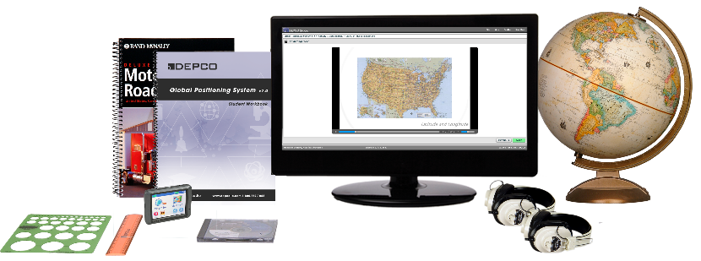
Global Positioning System (GPS) captures the vast circumference of the world and minimizes its size by enabling students to pinpoint target-specific areas. Today, GPS is used in the transportation industry to track everything from jumbo jets to 18-wheelers; in agriculture to accurately plant, fertilize, and harvest crops; for personal use in such activities as hiking, fishing, and boating; and, it is also used to help locate and track some of our precious natural resources. After completing this curriculum, students have a greater awareness of the world in which we live, as well as a working knowledge of the Global Positioning System through the use of actual GPS software and hardware.
Skills
• Analyze global positioning data
• Demonstrate global mapping techniques
• Demonstrate a working knowledge of Global Positioning Systems (GPS)
• Demonstrate the ability to relate GPS data to the world
• Demonstrate the ability to effectively manipulate GPS software and equipment
Knowledge
• Explain the history that prompted the development of GPS
• Demonstrate the use of the program and electronic mapping tools
Activities
• Activity 1 - Introduction
• Activity 2 - GPS Technology
• Activity 3 - Introduction to MapSource
• Activity 4 - The GPS Receiver
• Activity 5 - Precision Farming
• Activity 6 - Transportation and Recreation
• Activity 7 - Public Safety
• Activity 8 - Mapping
• Activity 9 - Communication
• Activity 10 - Post-Test and Wrap-Up
• Activity 11 - Bonus Activities
• Activity 12 - Challenge
• Activity 13 - Open-Ended Challenge
• Activity 14 - Careers
• Activity 15 - Internet
Standards
Mathematics/Measure
Problem Solving
Science
English Language Arts/Reading
DEPCO Unit Includes:
Student Workbook, Instructor’s Manual, Installation CD, GPS Personal Navigator, Navigational Software, Metric Circle Template, Ruler, Globe, Atlas, Headphones (2)
Part # and Description
MP1002 | Global Positioning System DEPCO Studio Module (Less computer)
Requirements
Module requires a computer workstation.
Curriculum Specifications
The student workbook contains concise, hands-on procedures, illustrations, screen captures, and photographs, which reinforce the multimedia content. Interesting and relevant graphics are used in the media to encourage visual learning. DEPCO Studio is an effective curriculum delivery system that uses interesting digital videos, full-color animations, professional quality narrations, challenging interactions, relevant photographs, and Computer Aided Instruction (CAI), to modernize the way subject matter is taught. Each Career and Technology module has one unit, which consists of 10 basic activity days with Pre-Test, Post-Test, and Activity Review Questions; 5 enrichment activities, which include vocabulary reinforcement, problem-solving, open-ended challenges, careers, and Internet activities; and an instructor's section, which includes lesson plan outlines, installation instructions, and answer keys.

Biotech and Genetics

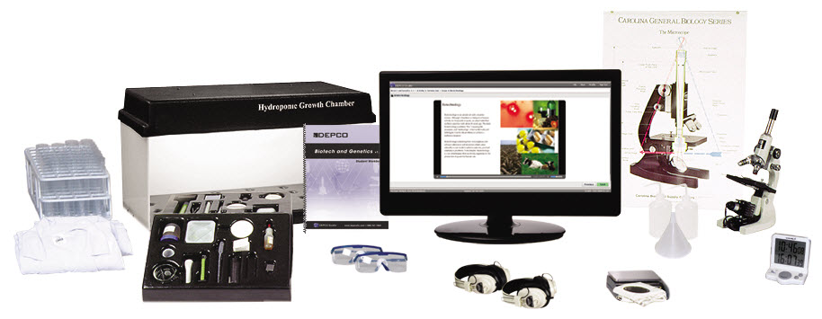
In this project-packed curriculum, students get a taste of a wide range of biotechnological concepts, processes, and uses. They set up and complete a hydroponics experiment and grapple with tough bioethics case studies. Students learn about basic genetics and how DNA works, to analyze biochemical compounds in materials using chromatography, and to use enzymes to cause biological reactions. In addition, they are asked to observe the fermentation process and explore common biological pharmaceutical products. Students also complete blood typing experiments. Plus, with the Biotech and Genetics curriculum, students receive valuable practice with a number of biotechnology tools, including a microscope.
Skills
• Prepare microscope slides and set up and use a compound microscope
• Run chromatography strip for chemical identification
• Interpret outcomes of experiments through reasoning
Knowledge
• How enzymes act as catalysts
• The role of DNA in genetics
• Ethical issues in biotechnology
• Blood types and blood typing techniques
Activities
• Activity 1 - Introduction
• Activity 2 - The Scientific Method
• Activity 3 - Fermentation
• Activity 4 - Enzymes
• Activity 5 - Blood-Typing
• Activity 6 - Genetics
• Activity 7 - The Microscope
• Activity 8 - DNA Extraction
• Activity 9 - Advanced Biotech
• Activity 10 - Post-Test and Wrap-up
• Activity 11 - Bonus Activities
• Activity 12 - Challenge
• Activity 13 - Open-Ended Challenge
• Activity 14 - Careers
• Activity 15 - Internet
Standards
Mathematics/Measure
Science
Problem Solving
English Language Arts/Reading
DEPCO Unit Includes:
Student Workbook, Instructor’s Manual, Installation CD, Microscope, Electronic Scale, Electronic Timer, Beaker Warmer, 25 ml Graduated Cylinder, 100 ml Graduated Cylinder, 150 ml Beaker, DEPCO Hydroponic Growth Chamber, Scoop, Tweezers, Prepared Slides, Ruler, Scissors, Thermometer, Funnel, Wash Bottle (2), Vial (50), Test Tube Rack, Storage Tray (2), Safety Glasses (2), Lab Coat (6), Microscope Poster, Headphones (2), Biotech and Genetics Supply Kit for 24 Students
Part # and Description
MP0202 | Biotech and Genetics DEPCO Studio Module (Less computer)
020100 | Biotech and Genetics Supply Kit (24 students)
020150 | Biotech and Genetics Supply Kit (100 students)
Requirements
Students will be required to have access to a water supply.
Module requires a computer workstation.
Curriculum Specifications
The student workbook contains concise, hands-on procedures, illustrations, screen captures, and photographs, which reinforce the multimedia content. Interesting and relevant graphics are used in the media to encourage visual learning. DEPCO Studio is an effective curriculum delivery system that uses interesting digital videos, full-color animations, professional quality narrations, challenging interactions, relevant photographs, and Computer Aided Instruction (CAI), to modernize the way subject matter is taught. Each Career and Technology module has one unit, which consists of 10 basic activity days with Pre-Test, Post-Test, and Activity Review Questions; 5 enrichment activities, which include vocabulary reinforcement, problem-solving, open-ended challenges, careers, and Internet activities; and an instructor's section, which includes lesson plan outlines, installation instructions, and answer keys.
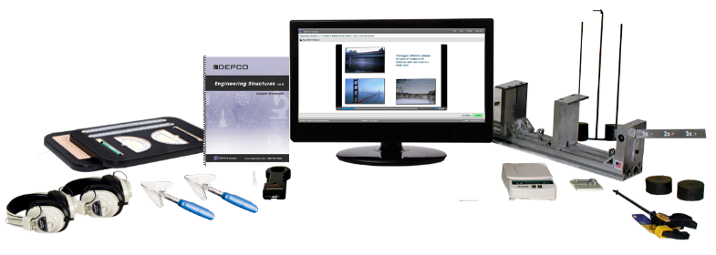
Engineering Structures
Engineers must ask many important questions before designing and building a bridge: What type of bridge is best suited for this project? What materials should be used? What safety features will the bridge have? In this extraordinary, hands-on curriculum, students are faced with a similar set of questions, only on a smaller scale. As they learn about everything from correctly placing abutments, piers, piles, and trusses to evaluating the effectiveness of a bridge, students are putting their engineering knowledge into practice by designing, building, and testing a balsa wood bridge. In addition, great engineering structures of the past and present are covered with interesting facts and histories, including descriptions of the geodesic dome, Hoover Dam, and the Brooklyn Bridge.
Skills
• Build and test a model bridge
• Design a bridge using correct procedures
• Illustrate proper use of selected tools
Knowledge
• Identify components of bridge construction
• Explain the features of correct bridge construction
• Practice safe tool procedures
• Explain the proper procedures for testing bridges
Activities
• Activity 1 - Introduction
• Activity 2 - Design and Test Bridge
• Activity 3 - Bridge Design
• Activity 4 - Design and Construct Sides
• Activity 5 - Building the Top Section
• Activity 6 - Building the Base Section
• Activity 7 - Start Assembly of the Bridge
• Activity 8 - Finish Assembly of the Bridge
• Activity 9 - Evolution of the Bridge Design
• Activity 10 - Post-Test and Wrap-Up
• Activity 11 - Bonus Activities
• Activity 12 - Challenge
• Activity 13 - Open-Ended Challenge
• Activity 14 - Careers
• Activity 15 - Internet
Standards
Mathematics/Measure
Problem Solving
English Language Arts/Reading
DEPCO Unit Includes:
Student Workbook, Instructor’s Manual, Installation CD, Bridge Building Software, Electronic Scale (grams), Weight Set, Stick Trimmer (2), DEPCO Engineering Structure Tester, DEPCO Engineering Structures Student Workpad (12), Measuring Tools, Digital Scale (50 lbs.), Headphones (2), Engineering Structures Supply Kit for 24 Students
Part # and Description
MP7502 | Engineering Structures DEPCO Studio Module (Less computer)
Call | Engineering Structures DEPCO Studio (Upgrade)
751100 | Engineering Structures Supply Kit (24 students)
751200 | Engineering Structures Supply Kit (100 students)
750025 | Student Work Pad (Optional)
Requirements
Module requires a computer workstation.
Curriculum Specifications
The student workbook contains concise, hands-on procedures, illustrations, screen captures, and photographs, which reinforce the multimedia content. Interesting and relevant graphics are used in the media to encourage visual learning. DEPCO Studio is an effective curriculum delivery system that uses interesting digital videos, full-color animations, professional quality narrations, challenging interactions, relevant photographs, and Computer Aided Instruction (CAI), to modernize the way subject matter is taught. Each Career and Technology module has one unit, which consists of 10 basic activity days with Pre-Test, Post-Test, and Activity Review Questions; 5 enrichment activities, which include vocabulary reinforcement, problem-solving, open-ended challenges, careers, and Internet activities; and an instructor's section, which includes lesson plan outlines, installation instructions, and answer keys.
Graphic Design
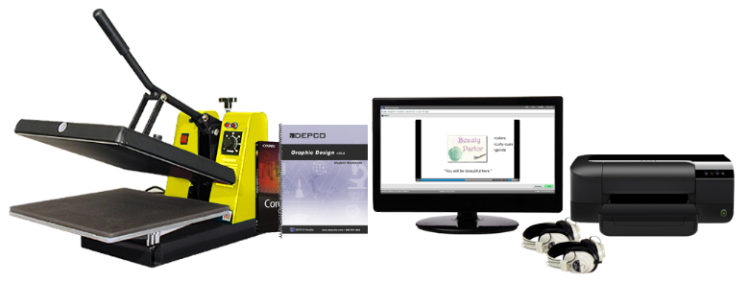
In this curriculum, students explore the fundamentals of graphic design and learn how to apply them in order to manufacture real-world projects produced in industry today. A solid foundation in audience analysis, color theory, typography, and design principles are taught to the students as they work on challenging design projects. Lastly, students apply their new knowledge of graphic design by producing a T-shirt, hat, or mouse pad with the assistance of a computer, graphic design software, printer, and transfer press.
Skills
• Create special effects with graphics software
• Operate a thermal transfer machine
• Create, edit, and manipulate text on the computer
• Modify clip art files to meet a specific need
• Draw basic shapes and objects on the computer
Knowledge
• Demonstrate basic layout techniques
• Explain color theory
• Explain the uses and purposes of graphic design
Activities
• Activity 1 - Introduction
• Activity 2 - Basic Tools
• Activity 3 - Working with Graphics
• Activity 4 - Color
• Activity 5 - Text and Text Effects
• Activity 6 - Special Effects
• Activity 7 - Importing and Editing
• Activity 8 - Applications
• Activity 9 - Completing Your Design
• Activity 10 - Post-Test and Heat Transfer
• Activity 11 - Bonus Activities
• Activity 12 - Challenge
• Activity 13 - Open-Ended Challenge
• Activity 14 - Careers
• Activity 15 - Internet
Standards
Mathematics/Measure
Problem Solving
English Language Arts/Reading
DEPCO Unit Includes:
Student Workbook, Instructor’s Manual, Installation CD, CorelDRAW Software, T-Shirt Transfer Press, Headphones (2)
Part # and Description
MP6017 | Graphic Design DEPCO Studio Module (Less computer and printer)
TM6008 | Hat Heat Transfer Press (Optional)
130235 | Inkjet HP5550 T-Shirt Supply Kit (100 students)
600101 | Inkjet T-Shirt Paper (100 sheets)
600150 | Inkjet T-Shirt Paper (500 sheets)
600175 | Mouse Pads (Pack of 25)
600180 | Mouse Pads (Pack of 100)
600144 | Hats - White (Case of 144)
Requirements
This transfer process is only compatible with white garments. Any other garment color will show through the transfer.
Power considerations: the T-shirt press is rated at 12.5 AMP, and Hat press is rated at 4.5 AMP. A dedicated 20 AMP circuit should be considered.
Module requires a computer workstation and printer.
This T-shirt transfer is an inkjet process and not permanent like screen-printing. Special consideration must be taken when laundering and wearing these garments.
Curriculum Specifications
The student workbook contains concise, hands-on procedures, illustrations, screen captures, and photographs, which reinforce the multimedia content. Interesting and relevant graphics are used in the media to encourage visual learning. DEPCO Studio is an effective curriculum delivery system that uses interesting digital videos, full-color animations, professional quality narrations, challenging interactions, relevant photographs, and Computer Aided Instruction (CAI), to modernize the way subject matter is taught. Each Career and Technology module has one unit, which consists of 10 basic activity days with Pre-Test, Post-Test, and Activity Review Questions; 5 enrichment activities, which include vocabulary reinforcement, problem-solving, open-ended challenges, careers, and Internet activities; and an instructor's section, which includes lesson plan outlines, installation instructions, and answer keys.
Robotics Engineering
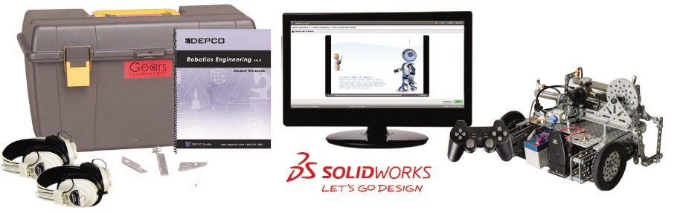
The Robotics Engineering Level I curriculum introduces students to the exciting field of robotics. Students learn the mechanical design and construction of robots through hands-on activities. Activities include the construction of a remote control robot and the use of SOLIDWORKS software.
Skills
• Construct a robot
• Read, interpret, and construct CAD drawings
• Test robotic mechanisms
• Develop problem solving skills
Knowledge
• Identify common components of pneumatic systems
• Explain engineering design principles
• Explain radio control system usages
• Describe robotic components and uses
• Demonstrate knowledge of physics
• Explain electronic wiring and implementation
Activities
• Activity 1 - Introduction
• Activity 2 - SOLIDWORKS
• Activity 3 - SOLIDWORKS – Assembly
• Activity 4 - Drive Train
• Activity 5 - Construct the Chassis
• Activity 6 - Introduction to Pneumatics
• Activity 7 - Pneumatics
• Activity 8 – Add the Controller Components
• Activity 9 – Robot Operation
• Activity 10 - Post-Test and Wrap-Up
• Activity 11 - Bonus Activities
• Activity 12 - Challenge
• Activity 13 - Open-Ended Challenge
• Activity 14 - Careers
• Activity 15 - Internet
Standards
Mathematics/Measure
Science
Problem Solving
English Language Arts/Reading
DEPCO Unit Includes:
Student Workbook, Instructor’s Manual, Installation CD, SolidWorks® Software, Gears-IDS™ kit, Headphones (2)
Part # and Description
MP2602 | Robotics Engineering DEPCO Studio Module (Less computer)
Requirements
Module requires a computer workstation.
Curriculum Specifications
The student workbook contains concise, hands-on procedures, illustrations, screen captures, and photographs, which reinforce the multimedia content. Interesting and relevant graphics are used in the media to encourage visual learning. DEPCO Studio is an effective curriculum delivery system that uses interesting digital videos, full-color animations, professional quality narrations, challenging interactions, relevant photographs, and Computer Aided Instruction (CAI), to modernize the way subject matter is taught. Each Career and Technology module has one unit, which consists of 10 basic activity days with Pre-Test, Post-Test, and Activity Review Questions; 5 enrichment activities, which include vocabulary reinforcement, problem-solving, open-ended challenges, careers, and Internet activities; and an instructor's section, which includes lesson plan outlines, installation instructions, and answer keys.
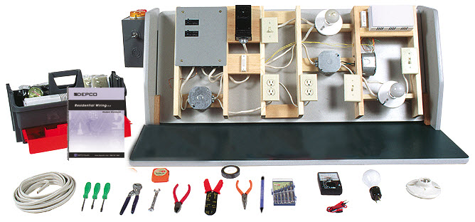
Residential Wiring
Students start this curriculum with a complete safety and hand tool orientation, and then they become familiar with the Student Wiring Panel, our specialized residential wiring kit. They begin by installing and wiring the service entrance, ground rod, and service panel before installing and wiring a dizzying array of items: circuits, breakers, junction boxes, convenience outlets, ceiling lights, wall switches, additional junction boxes, a 220-volt outlet, doorbell, and a 3-way switch. Lastly, National Electrical Code (NEC) information, units of electricity, and accurate calculation of electric usage are some of the final components that help to produce this exciting DEPCO curriculum.
Skills
• Ground wiring in a home
• Diagram the wiring in a home
• Properly wire electrical components
• Install a doorbell
• Wire a light switch and a convenience outlet
Knowledge
• Demonstrate safe residential wiring procedures
• Demonstrate proper installation of an electrical panel
• Demonstrate proper mounting of electrical components
• Identify different kinds of electrical components
Activities
• Activity 1 - Introduction
• Activity 2 - Service Entrance, Ground Rod, and Service Panel
• Activity 3 - Circuit Breakers and Junction Boxes
• Activity 4 - Convenience Outlets
• Activity 5 - Ceiling Light and Wall Switch
• Activity 6 - Wiring a Second Junction Box
• Activity 7 - 220 Volt Outlet
• Activity 8 - Wiring a Doorbell
• Activity 9 - Wiring a Three-Way Switch
• Activity 10 - Post-Test and Wrap-up
• Activity 11 - Bonus Activities
• Activity 12 - Challenge
• Activity 13 - Open-Ended Challenge
• Activity 14 - Careers
• Activity 15 - Internet
Standards
Mathematics/Measure
Problem Solving
English Language Arts/Reading
DEPCO Unit Includes:
Student Activity Guide, DEPCO Residential Wiring Workcenter, DEPCO Student Wiring Panel, Pre-Cut Wiring Kit, Instructor Wiring Supply Packet, Electrical Tool Kit, Residential Wiring Component Kit
Part # and Description
TM9700 | Residential Wiring Module (Complete)
TM9703 | Residential Wiring Student Panel and Wiring Kit (Each)
970002 | Residential Wiring Student Activity Guide (Only)
TM9707 | Residential Wiring Storage Cabinet (Optional)
Requirements
A student wiring panel will need to be purchased for each additional class. One wiring panel is included with Residential Wiring module.
The Residential Wiring storage cabinet must be shipped via LTL truck because of the crated size and weight.
The Residential Wiring storage cabinet must be shipped via LTL truck because of the crated size and weight.
Curriculum Specifications
Format 2000. The Residential Wiring curriculum consists of a well-illustrated student activity guide with 10 daily activities and 5 additional enrichment activities including careers, problem solving, challenge activities, vocabulary reinforcement, and Internet.

General Requirements

General Requirements
The following requirements are to ensure consistency of the products and services proposed will meet all requirements and standards. It is the prime intent of these conditions to show and define the essential minimum requirements regarding the scope and quality of the lab system.
- Module titles must be current shipping modules of the manufacturer supplying the proposal. Each module must have been available for at least one year. Modules that are not in manufacturer’s current product catalog will not be considered. Literature supporting this must be supplied with proposal.
- All vendors must be prepared to show the following proof of their ability to perform under this contract. Failure to meet any of the requirements and qualifications will be sufficient cause for rejection of any or all bids.
  - Minimum of five (5) years in business providing educational training equipment, curriculum and service.
  - Financial and technical resources of sufficient scope to assure prompt and satisfactory performance in the production and delivery of all equipment and workstations specified.
- A complete set of curriculum samples must be available within five (5) business days upon request.
- Bidders submitting “OR Equal” bids shall include descriptive and illustrative literature, specifications, and samples of all curriculum materials proposed.
- Manufacturer must have dedicated technical support and customer service department staffed with no fewer than four (4) trained and experienced members. Each department member to have at least one year experience installing and supporting modular career and technology labs. Department must be managed by a dedicated service manager with at least three (3) years of experience installing and supporting modular career and technology labs.
- Manufacturer must have a full-time application specialist on staff dedicated to support and training of the electronic classroom management software.
- Toll-free telephone support must be available during business hours by both the manufacturer and local representative.
- Local representative must supply local customer service and support.
- Repairs of all modular technology equipment proposed must be available at the manufacturer’s facility in the United States.
- Supply and consumable lists for each module must be available on-line via the manufacturer’s web site.
- Replacement parts lists for each module must be available on-line via the manufacturer’s web site.
- Specifications for every module must be available via manufacturer’s web site.
- Manufacturer must have on staff a full-time dedicated modular career and technology teacher trainer.
- Technology furniture and workstations must be manufactured in company owned and operated facility in the United States.
- Authorized reseller must be capable and willing to supply a “Turn-Key” system excluding computers and networking at the request of the school district.
- Proposal must be complete. No partial proposals will be accepted. All items requested must be supplied and supported by a single vendor.
- Service contracts must be available upon request. Service contracts may be activated after warranty period expires.
- Lab drawings must be submitted with the proposal indicating workstation placement. Location of student workstations must be ADA compliant.
- Instructor In-service
  - Factory training must be available and conducted in manufacturer’s facility. Dates and itineraries must be available on manufacturer’s web site. Factory training must include 1 hour of 700 level college credit included at no additional charge.
  - Onsite instructor orientation must be conducted immediately upon completion of lab setup.
- Installation and Delivery
  - Delivery of modular career and technology lab equipment, software, curriculum and workstations must be within 60 days of purchase order date.
  - Installation of modular career and technology labs must be complete within 120 days of purchase order date.

Module Requirements
The following elements are required for each module proposed.
- Any applications software included must be of the same type used in industry and must be the current shipping version.
- If required, startup supplies for at least 24 students must be included. Additional supplies must be available in 24 and 100 student kits.
- Computers shall not be required for every module. Should the module curriculum not require a computer, alternative methods of testing must be available.
- All student workbooks must be color printed with pages in sheet protectors and assembled in a heavy duty three ring binder.
- Interactive multimedia curriculum shall be included in each learning unit proposed.
- All module workstations must be capable of operating stand-alone (no network or management system) or connected to a network content server. Module workstations must not be required to be connected to the teacher server to operate the student lessons.

Computer Requirements

Computer Requirements
With the utilization of multimedia in today’s curriculum delivery systems, a multimedia computer is a necessary component an effective career and technology program. Use the descriptions below as a guide when purchasing computers for the interactive learning lab. NOTE: specifications subject to change.

Operating System specifications
Supported platforms include: Windows 7, Windows 8.1, and Windows 10.

Minimum computer specifications
Pentium 4, 1.3 GHz, 256 MB RAM, CD-ROM Drive, 10 GB Hard Disk, 4MB Video Card, Sound Card, Speakers, 1-Serial Port, 1-Parallel Printer Port, 1-USB Port, SVGA Monitor, Mouse, 100 Base-T Ethernet Network Port, Windows® 7 (some products require the use of a DVD-ROM drive due to third-party software).

Recommended computer specifications
Intel Core 2 Duo or AMD Phenom II processor; 64-bit support required, 4 GB or more RAM, DVD-ROM Drive, 10 GB Hard Disk, 256MB Video Card, Sound Card, Speakers, 1-Serial Port, 1-Parallel Printer Port, 1-USB Port, SVGA Monitor, Mouse, 100 Base-T Ethernet Network Port, Windows® 7 or Windows® 10 , 64-bit operating system, and the use of a DVD-ROM drive due to third-party software.

Network Requirements
The classroom management system requires an efficient local area network with internet connectivity to perform the necessary management functions.

Operating System specifications
Supported platforms include: Windows 7, Windows 10, and Linux. A browser capable of running Adobe® Flash® Player 10.1 or better is required.

Minimum network specifications
Local area network, peer-to-peer, internet connectivity, Network Protocol, 10BaseT, 250 kilobits/second or superior downstream bandwidth.

Recommended network specifications
Local area network, peer-to-peer, internet connectivity, Network Protocol, 100BaseT, CAT-5 cabling, 2 Megabits/second or superior downstream bandwidth.

Curriculum

Curriculum Framework

Curriculum is to consist of well-illustrated student workbooks/manuals, support materials, special tooling, fixtures and organizer trays. Curriculum is appropriate for and covers each of the 16 different career clusters.
- Manufacturer must develop every module student workbook/manual and project guide. No third party curriculum shall be acceptable.
- Every module curriculum guide must be provided in the following framework:
  - Introduction and table of contents.
  - Activity 1 must include a 20 question pretest and to be an orientation to the concepts and principles of the module content and activities.
  - Activity 2 – 9 must be identical in format. Each activity must include vocabulary, purpose, objectives, equipment and procedures. Each activity must include a 5-question daily response quiz.
  - Activity 10 must include a 20-question post-test and sufficient time to complete any projects unfinished.
  - Activity 11 must include vocabulary reinforcement, which must include crossword puzzle, word matching and problem solving.
  - Activity 12 must include challenge activities, which may also include problem-solving activities.
  - Activity 13 must include instructions for an open-ended project utilizing the knowledge and skills developed with this module.
  - Activity 14 must be information about careers specific to the module topics.
  - Activity 15 must include instructions to complete an Internet activity.
  - Student Reference Section must include a glossary and special instructions to a variety of hardware configurations.
  - Instructor Section must include module installation instructions, student evaluation suggestions, worksheets, answer keys and pages to copy.
- Each student activity guide must be packaged in three-ring notebook with sheet protector pages allowing for easy revisions and updates.
- Each student activity must include support icons which indicate to the students: Instructor Checkpoints, Safety Glasses Required, Caution, Video Used, Careers, Mathematics Principles, Science Principles, Communications, Technology, and Creativity.
- Each student activity must be written to accommodate one or two students for a 45 to 50 minute class period. Must also be compatible with block scheduling.
- Specific self-directed step-by-step instructions written for the exact hardware and software supplied with the learning unit described in each module specification sheet.
- All technology topics must be developed specifically for grades 7 to 12.
- Each curriculum topic to contain a minimum of one daily written student activity with illustrations, photographs and screen captures and at least 5 daily response questions.
- Curriculum shall have specific learner outcomes, which shall be the basis for the curriculum.
- The curriculum shall be student directed to allow the student to take responsibility for their learning.
- The curriculum shall be developed according to the 10-activity format with 5 enrichment activities containing careers, problem solving, challenge activities, crossword puzzle, word matching and Internet.
- Evaluation of student progress to include pre-test, post test, vocabulary, five daily response questions for each lesson, crossword puzzle, word matching, and journal entry. Self-directed curriculum instructions: A detailed instructional delivery system for the learner and instructor shall be provided and must include the following sections:
  - Overview - The overview shall give a basic instruction to the daily activity of the student and include description of all equipment used during that activity. Instruction on video produced by the manufacturer provides reinforcement of daily written materials.
  - Outcomes - Outcomes and objectives to be defined to assist student with individual accomplishments for that daily activity.
  - Purpose - Written description to the students to focus the student’s attention to the daily activity.
  - Equipment - A list of equipment required for each daily activity to be provided as part of the written instruction.
  - Vocabulary - A list of new terms to be included for each daily activity.
  - Procedures - Step-by-step instructions with illustrations, photographs and screen captures guide students through the daily hands-on activities.
- Written Content - All content required for instruction to be included in the student workbook/manual as either part of daily activity or supplemental sections in back of workbook/manual. External content material such as textbooks shall not be required.
- Written Instruction - Each activity to included sequential step-by-step student instruction to assist in the learning process. All instructions to be well illustrated with detailed diagrams and photographs of specific equipment used.
- Video Instruction - All instructional videos produced by the manufacturer to be cataloged with ID numbers to correspond with written instruction or supplied in digital format and installed on workstation hard drive. CD must not be required to be present in CD-ROM drive to operate module curriculum.
- Instructor Section - provides written assistance for Installation, Reference Materials, a letter to the instructor, classroom suggestions, single page lesson plan outline, daily response answer key, pre-test answer key and post-test answer key, word matching answer key, and problem solving answer key.
- Pages to Copy - Pages in which the instructor shall reproduce for use by students during daily activities to include:
  - Journal entry sheet,
  - Daily response sheet,
  - Vocabulary sheet,
  - Crossword puzzle sheet.
  - Must include a single response sheet used by students to record daily responses documented in daily student lessons as a backup to the electronic management system.
- Glossary - Vocabulary and terminology available to the students used during the daily activities.
- Career Activity - Provides examples of typical occupations and careers for the specific technology-learning unit.
- Internet Activity – Directions to the manufacturer’s on-line database of Internet activities specific to each module title. On-line activities must include
  - Common search terms specific to each module topic,
  - Relevant links to web sites specific to each module topic,
  - Direct links to the US Department of Labor Occupational Outlook Handbook web site to introduce students to careers specific to each module topic.
  - Examples and suggestions for practical applications of the Internet.
- Installation of student template files, examples, applications software and custom software must be installed by an automated setup from CD-ROM.

Interactive Multimedia

DEPCO Studio Media Player – Stand-alone interactive multimedia curriculum delivery system produced by DEPCO Enterprises, LLC.
- Content must retrieve curriculum elements from a single xml document, which facilitates easy updating of content.
- Variable Media Content Presentation Components
- Application specific media components designed to deliver presentations in a variety of formats.
  - Text and Photo Media Content Components
  - Movie Media Content Components
  - Animation Media Content Components
  - Interactive Media Content Components
- Adobe AIR
- Restricted Page Advance - Page advance button is disabled until pages containing multimedia presentations completed. Prevents student ability to advance without viewing multimedia content such as digital videos, presentations and animations. This feature may be disabled via the password protected control panel.
- Scalable Interface
- Student may resize and scale DEPCO Studio Media Player interface to any desired size including full-screen.
- Full Screen Movie Viewer
- Media formats (audio, video, and graphics) supported must include: .mp3, .flv, .swf, .gif, .jpeg, .png, .svg

Electronic Lab Management System

Electronic Lab Management

Online Lab Management System

DEPCO Studio

Description
The new DEPCO Studio online content delivery and classroom management system improves the performance and efficiency in any learning setting. With a DEPCO Studio subscription, every educator has the ability to not only manage their classroom with current DEPCO ENTERPRISES, LLC curriculum but also gain the ability to upload their own curriculum into the delivery system! Because DEPCO Studio is so simplistic in delivering e-Learning, facilities ranging from early childhood through workforce development programs are able to easily integrate the system into everyday activities. Contact your DEPCO ENTERPRISES, LLC representative for more information on this innovative product.

DEPCO Studio LMS Features
- Student and Course Setup and Editing Capabilities
- Group and Individual Communication via Messaging
- Student Scheduling
- Gradebook and Reporting Options
- And More!

DEPCO Studio Content Delivery System Features
- Attention Capturing Interactive Media Content Including Theory, Principles, and Instruction
- Multiple Assessment Options
- Supporting Course Documentation and Demonstrational Videos
- Individual Student Progress Tracking
- And More!

DEPCO Studio Media Player™ Interactive Learning
- Effective, hybrid multimedia curriculum delivery system
- Utilizes computers and DEPCO Student Workbooks
- Digital videos, animations, and narrated text
- Database-driven allowing immediate content updates
- Concise hands-on procedures
- Illustrations, screen captures, and photographs

Managing the Lab
Scheduling, grading, and communicating with students is no longer a complicated process. DEPCO Studio assists instructors by simplifying the classroom management experience. Creating a student, class, or course is accomplished with only a few clicks of the mouse. Sending a message to a student or class and announcing new curriculum schedules can easily be accomplished using DEPCO Studio.

Class Setup
- Assign student members to your class
- Customize your classroom with selecting specific curriculum titles
- Customize your curriculum by selecting the number of students per title per rotation
- Flexible enough for a rotational schedule or an instructor led project based curriculum

Gradebook
- Completely customizable grade periods allow grade reporting by year, semester (or trimester), or nine weeks
- Completely customizable grade scales
- Gradebook report showing grades
- All reports can be exported to Adobe Acrobat® documents (.pdf), HTML Web pages, Microsoft® Excel spreadsheets (.xls), Rich Text Format (.rtf), or plain text (.txt)

Scheduling
- Automatic scheduler handles scheduling conflicts, student preferences, grouping, etc.
- Color-coded, drag-and-drop schedule customization
- Schedules an unlimited number of students

Student Evaluation
DEPCO Studio incorporates many instructor friendly features that allow students to learn what you want emphasized. DEPCO Studio enables instructors to modify current DEPCO ENTERPRISES, LLC curriculum or create their own curriculum for students to view. Instructors completely control the content, tests, and grading scale in DEPCO Studio.
The content delivery system tracks students’ progress and logins while guiding them through multimedia curriculum. Instructors can also attach documents such as manuals and supporting files to the curriculum for the students to view and download. Because DEPCO Studio is an online platform, multiple students can login to view the same curriculum independently or simultaneously, and their progress is still tracked.
Test Development
- Student tests are delivered electronically, graded, and recorded automatically
- Four different test question types: Multiple Choice, True/False, Free Form, Matching
- Randomized questions and answers
Curriculum Development
- Modify DEPCO ENTERPRISES, LLC curriculum
- Upload audio, video, graphics, and text
- Create a variety of examinations
- Preview curriculum
- View available modules
- Add/Remove curriculum in classes
Student Portfolio
- Student grade viewer allows students to track their own progress
- Student profile editor allows students to enter and update personal information
Content Delivery
- View seamless multimedia curriculum
- Multiple student login
- Track students’ progress with linear tracking
- Take tests with individual logins
- Attach workbooks and support materials
- View grades with secured logins
Computer Specifications
Windows PC
- Intel Pentium 4 2.33GHz, AMD Athlon 64 2800+ processor (or equivalent); 128MB RAM
- Adobe Flash Player 10.1 or newer
Macintosh
- PowerPC G5 1.8GHz; Intel Core Duo 1.33 GHz or faster; 256MB or RAM
- Adobe Flash Player 10.1 or newer
Linux
- Intel Pentium 4 2.33 GHz, AMD Athlon 64 2800+ processor (or equivalent); 512MB RAM
- Adobe Flash Player 10.1 or newer

