Invitation for Sealed Bids


WATER HEATERS (as needed)

Solicitation Number | Q1727
Due Date | June 2, 2017
Due Time | 11:00 a.m. eastern standard time
Deliver Responses to: |   Knoxville’s Community Development Corporation  Procurement Division  901 N. Broadway  Knoxville, TN 37917  Note: Procurement is in a separate building behind the main office building
Electronic Copies: | KCDC urges suppliers to use the MS Word version of this document to provide a typed submission. That version is available on KCDC’s webpage or by emailing purchasinginfo@kcdc.org.
May responses be emailed to KCDC | ☒ Yes ☐ No  Paper copies must also be provided, if the solicitation narrative so indicates.
Solicitation Meeting | No
Solicitation Meeting is Mandatory | ☐ Yes ☒ No
Solicitation Meeting Date | Not applicable
Solicitation Meeting Time | Not applicable
Solicitation Meeting Location | Not applicable
Questions About This Solicitation | Submit questions to purchasinginfo@kcdc.org
Award Results | KCDC posts both a summary of the quotes received and the award decision to its web page at: http://www.kcdc.org/procurement/

Check KCDC’s webpage for addenda and changes before submitting your response

General Information

1. BACKGROUND AND INTENT

a. Knoxville's Community Development Corporation (KCDC) is the public housing and redevelopment agency for the City of Knoxville and for the County of Knox in Tennessee. KCDC’s public housing property portfolio includes 20 sites with approximately 3,547 dwelling units. KCDC also administers approximately 3,958 vouchers and 82 moderate rehabilitation units through our Section 8 department.

b. KCDC issued this solicitation on behalf of the Tennessee Association Housing & Redevelopment Authorities (TAHRA). Hereafter the terms “KCDC” and “TAHRA” are used interchangeably.

c. The various public housing authorities (PHAs) in the State of Tennessee often purchase common items while furnishing their units. The common items include water heaters of various sizes. Realizing that there are often discounts for quantity purchases, TAHRA agreed to coordinate one solicitation that any or all housing agencies (plus any other governmental entity that so desires) in the state may use.

d. Once the award is made, the successful supplier will honor orders, at the specified prices, from any TAHRA member agency, city, county or state agency, or any other municipality or political subdivision choosing to participate.

e. However, no agency or governmental entity is required to participate and may conduct separate procurements for items contained in this solicitation. Additionally, TAHRA does not guarantee any orders will be placed and assures no responsibility, financial or otherwise, for purchases made under this contract.

f. This solicitation is to provide thirty (30) gallon, thirty-eight (38), forty (40) gallon and fifty (50) gallon Energy Star-rated (as applicable) water heaters for use by Public Housing Authorities across the State of Tennessee.

g. Upon award, the successful suppliers will need to market the program to the TAHRA membership. For such purposes, TAHRA will work with the suppliers to communicate award notice and materials.

h. Successful suppliers are strongly encouraged to consider active participation in TAHRA including attendance at its spring and fall meetings. Additionally, the supplier may want to consider becoming an affiliate member of TAHRA. Details are on TAHRA’s webpage at http://tahranet.org/.

2. CHANGES AFTER AWARD
It is possible that after award the KCDC may need to revise the service needs or requirements specified in this document. KCDC reserves the right to make such changes after consultation with the supplier(s). Should additional costs arise, KCDC reserves the right to consider accepting these charges provided the supplier(s) can document the increased costs. KCDC reserves the right to make such changes after consultation with the supplier(s).

KCDC also reserves the right to accept proposed service changes from the supplier if they will lower the cost to KCDC and/or provide improved service.

3. EVALUATION
KCDC will arrive at the “lowest and best” solution for the final award; this may not entail simply awarding to the supplier quoting the lowest cost. All responses are subject to a determination of “responsive” and “responsible” prior to award. KCDC is the sole judge as to supplier “responsiveness” and “responsibility.” KCDC reserves the right to request additional information to assist in the evaluation process.

4. GENERAL INSTRUCTIONS
KCDC does not insert “General Instructions to Vendors” in the solicitation document. These instructions are at www.kcdc.org. Click on “Procurement” and follow the link. By submitting a response to this solicitation, the supplier accepts the responsibility for downloading, reading and abiding by the terms and conditions set forth in KCDC’s “General Instructions to Vendors.” Suppliers may wish to review certain applicable HUD instructions on KCDC’s webpage.

5. INVOICING/ORDERING
This section is germane to KCDC only.

a. Until a purchase order is in place, work is not to be performed nor are goods to be delivered. As purchase orders authorize work and obligate payment, if suppliers provide goods and services without a purchase order in place, KCDC does not have a legal obligation to pay for said goods and services.

b. Invoices must:

1. Be numbered.
2. Have a date on them that is after the work is completed or goods delivered.
3. Show the purchase order number.
4. Breakdown pricing according to the bid structure. For instance, if the agreed to pricing is by the hour, then the invoice needs to show the hours and rates. This is important so that KCDC can quickly compare the rates charged with the approved rates.
5. Be suitable for scanning since KCDC does not maintain paper records.

c. Suppliers are required to submit invoices within ninety (90) days after the delivery of the goods or services. KCDC may deny invoices submitted after the ninety (90) day threshold.

d. KCDC is exempt from all taxes levied by the State of Tennessee, its cities and counties, as well as most federally imposed taxes. Upon the placement of a purchase order KCDC will provide a State of Tennessee Sales Tax Exemption form to the supplier. KCDC will not pay taxes on invoices.

e. KCDC pays by electronic transfer (ACH) only. KCDC does not issue checks.

6. LENGTH OF AWARD
The initial award is for twelve (12) months. The award has four (4) - one (1) year optional renewals that KCDC may choose to exercise.

7. PRICE STRUCTURE

a. At the end of each award year, the successful supplier may request a price increase. Proof of increased cost to the successful supplier must accompany price increase requests. KCDC may, at its option:

1. Accept the proposed price increase.
2. Reject the proposed price increase.
3. Suggest an alternative price increase.

b. If KCDC rejects a proposed price, the successful supplier may:

1. Continue with the existing pricing.
2. Suggest an alternative price increase.
3. End the award.

c. While the supplier may offer other goods, only those specifically awarded are “on contract.” Other goods offered are not covered by the award and can only be procured through specific purchase orders identifying the special goods to be offered and the price for them. KCDC’s and other entities normal procurement thresholds will apply.

d. If one supplier elects to not renew or KCDC/TAHRA elects to not renew with a supplier, the remaining suppliers may continue with the entire award or the solicitation may be re-issued.

e. If Energy Star requirements change during this award or contract, KCDC/TAHRA reserve the right to renegotiate the award or contract with the successful supplier(s) to meet the new standards without going out for new bids, if so desired.

8. QUANTITIES
While this is an “As Needed” solicitation and no specific quantities are guaranteed and while this solicitation is intended for all members of TAHRA (see Appendix I for a listing), the following quantities are known to have been purchased in 2016 by KCDC, Metropolitan Development and Housing Authority (MDHA) and the Chattanooga Housing Authority (CHA).

Item | Total Units Purchased
30 gallon water heaters | 197
38 gallon water heaters | 6
40 gallon water heaters | 220
50 gallon water heaters | 24

9. QUESTIONS
Direct questions pertaining to this document to purchasinginfo@KCDC.org with “Water Heaters” in the subject line, at least five days prior to the due date.

10. USE OF SOLICITATION FORMS
Suppliers are to complete the solicitation forms contained in the solicitation package. Failure to complete these forms may result in rejection of your response. Do not alter the solicitation forms without KCDC’s approval. Vendors are asked to use the MS Office version of the pricing pages to eliminate difficulties in reading handwritten text.

Specifications

11. GENERAL REQUIREMENTS
The supplier shall furnish all equipment and material, and it shall be commercial quality from a regular product line. This request for bid is not intentionally written around any one manufacturer and is to indicate the general size, type and description of equipment needed.

12. ENERGY STAR
KCDC/TAHRA is very interested in energy efficiency. Energy Star certified water heaters are required unless there are no such models currently so certified.

13. DELIVERY:

a. Delivery shall be F.O.B. Destination, freight paid by the supplier, to the ordering entity. Delivery charges are included in the per unit cost. The driver will, at the minimum, assist PHA staff with unloading appliances to the tailgate of the delivery truck.

b. Agencies shall have the right to mix sizes and types of products to obtain quantity pricing. Prices given are for delivery F.O.B. to any point within Tennessee for purchases made by any participating entity. Should a governmental entity outside of Tennessee desire to use this award/contract, the supplier and the entity will negotiate shipping charges.

c. KCDC’s delivery needs have changed and now deliveries are directly to KCDC sites. While some sites can easily accommodate large trucks, many cannot accept trucks longer than fourteen (14) feet. Most KCDC sites do not have docks and the supplier will have to arrange lift gate delivery.

14. MODEL AND PRICE CHANGE NOTIFICATION
After award, if models change and/or prices increase (see above concerning price increases), the supplier(s) must notify KCDC. Upon approval, notification will be sent to other TAHRA members.

15. PACKING AND MARKING
Packaging, packing and marking shall be in accordance with standard commercial practices and be specified in the contract or order. KCDC encourages environmentally friendly packaging and the general reduction of packaging materials.

THIS AND THE PREVIOUS PAGES DO NOT NEED TO BE RETURNED

Water Heaters (as needed) Q1727

Solicitation Document A General Response Section

General Information about the Supplier
Sign Your Name to the Right of the Arrow
Your signature indicates that you have read and agree to “KCDC’s General Instructions to Vendors” on www.kcdc.org.
Printed Name and Title
Company Name
Street Address
City/State/Zip
Contact Person (Please Print Clearly)
Telephone Number
Cell Number
Supplier’s e-mail address (Please Print Clearly)
Addenda
Addenda are at www.kcdc.org. Click on “Procurement” and then on “Open Solicitations” to find addenda. Please check for addenda prior to submitting a bid.
Acknowledge addenda have been issued by checking below as appropriate:
None ☐ | Addendum 1 ☐ |  |  | Addendum 2 ☐ |  |  | Addendum 3 ☐ |  |  | Addendum 4 ☐ |  |  | Addendum 5 ☐
Statistical Information
This business is owned & operated by persons at least 51% of the following ethnic background:
Asian/Pacific ☐ |  | Black ☐ | Hasidic Jew ☐ |  |  | Hispanic ☐ |  |  | Native ☐ Americans |  |  | White ☐
As defined on KCDC’s webpage (see the “General Instructions to Vendors”), this business qualifies as:
Section 3 ☐ |  |  |  |  | Small Business ☐ |  |  |  |  |  | Woman Owned ☐
Cooperative Procurement by Other Governmental Entities
Subject to additional location/delivery charges, the supplier agrees to extend the offered costs to other governments if the government so desires. Yes ☐ No ☐
Prompt Payment Discount
A prompt payment discount of ________% is offered for payment within ____ days of submission of an
accurate and proper invoice.

Water Heaters (as needed) Q1727

Solicitation Document B Affidavits

Supplier: _____________________________________________________________________________

Conflict of Interest:

1. No commissioner or officer of KCDC or other person whose duty it is to vote for, let out, overlook or in any manner superintend any of the work for KCDC has a direct interest in the award or the supplier providing goods or services.

2. No employee, officer, or agent of the grantee or sub-grantee will participate in selection, or in the award or administration of an award supported by Federal funds if a conflict of interest, real or apparent, would be involved. Such a conflict would arise when the employee, officer or agent, any member of his immediate family, his or her partner, or an organization, which employs, or is about to employ, any of the above, has a financial or other interest in the supplier selected for award.

3. The grantee's or sub-grantee's officers, employees or agents will neither solicit nor accept gratuities, favors or anything of monetary value from suppliers, potential suppliers, or parties to sub-agreements.

4. By submission of this form, the supplier is certifying that no conflicts of interest exist.

Drug Free Workplace Requirements:

5. Private employers with five or more employees desiring to contract for construction services attest that they have a drug free workplace program in effect in accordance with TCA 50-9-112.

Eligibility:

6. The supplier is eligible for employment on public contracts because no convictions or guilty pleas or pleas of nolo contender to violations of the Sherman Anti-Trust Act, mail fraud or state criminal violations with an award from the State of Tennessee or any political subdivision thereof have occurred.

General:

7. Supplier fully understands the preparation and contents of the attached offer and of all pertinent circumstances respecting such offer.

8. Such offer is genuine and is not a sham offer.

Water Heaters (as needed) Q1727

Solicitation Document B Affidavits-continued

9. Iran Divestment Act:
Concerning the Iran Divestment Act (TCA 12-12-101 et seq.), by submission of this bid/proposal/quote, each supplier and each person signing on behalf of any supplier certifies, and in the case of a joint bid/proposal/quote, each party thereto certifies as to its own organization, under penalty of perjury, that to the best of its knowledge and belief that each supplier is not on the list created pursuant to § 12-12-106.

Non-Collusion:

10. Neither the said supplier nor any of its officers, partners, owners, agents, representatives, employees or parties interest, including this affiant, has in any way colluded, conspired, connived or agreed, directly or indirectly, with any other responder, supplier, or person to submit a collusive or sham offer in connection with the award or agreement for which the attached offer has been submitted or to refrain from making an offer in connection with such award or agreement, or collusion or communication or conference with any other supplier, or, to fix any overhead, profit, or cost element of the offer price or the offer price of any other supplier, or to secure through any collusion, conspiracy, connivance, or unlawful agreement any advantage against KCDC or any person interested in the proposed award or agreement.

11. The price or prices quoted in the attached offer are fair, proper and not tainted by any collusion, conspiracy, connivance, or unlawful agreement on the part of the supplier or any of its agents, representatives, owners, employees, or parties in interest, including this affiant.

The undersigned hereby acknowledges receipt of this Solicitation Document B and certifies that the submittal in response to this solicitation is in full compliance with the listed requirements.

Signed by
Printed Name
Title
Subscribed and sworn to before me this date
By (Notary Public)
My Commission Expires on

Water Heaters (as needed) Q1727

Solicitation Document C HUD Form 5369A
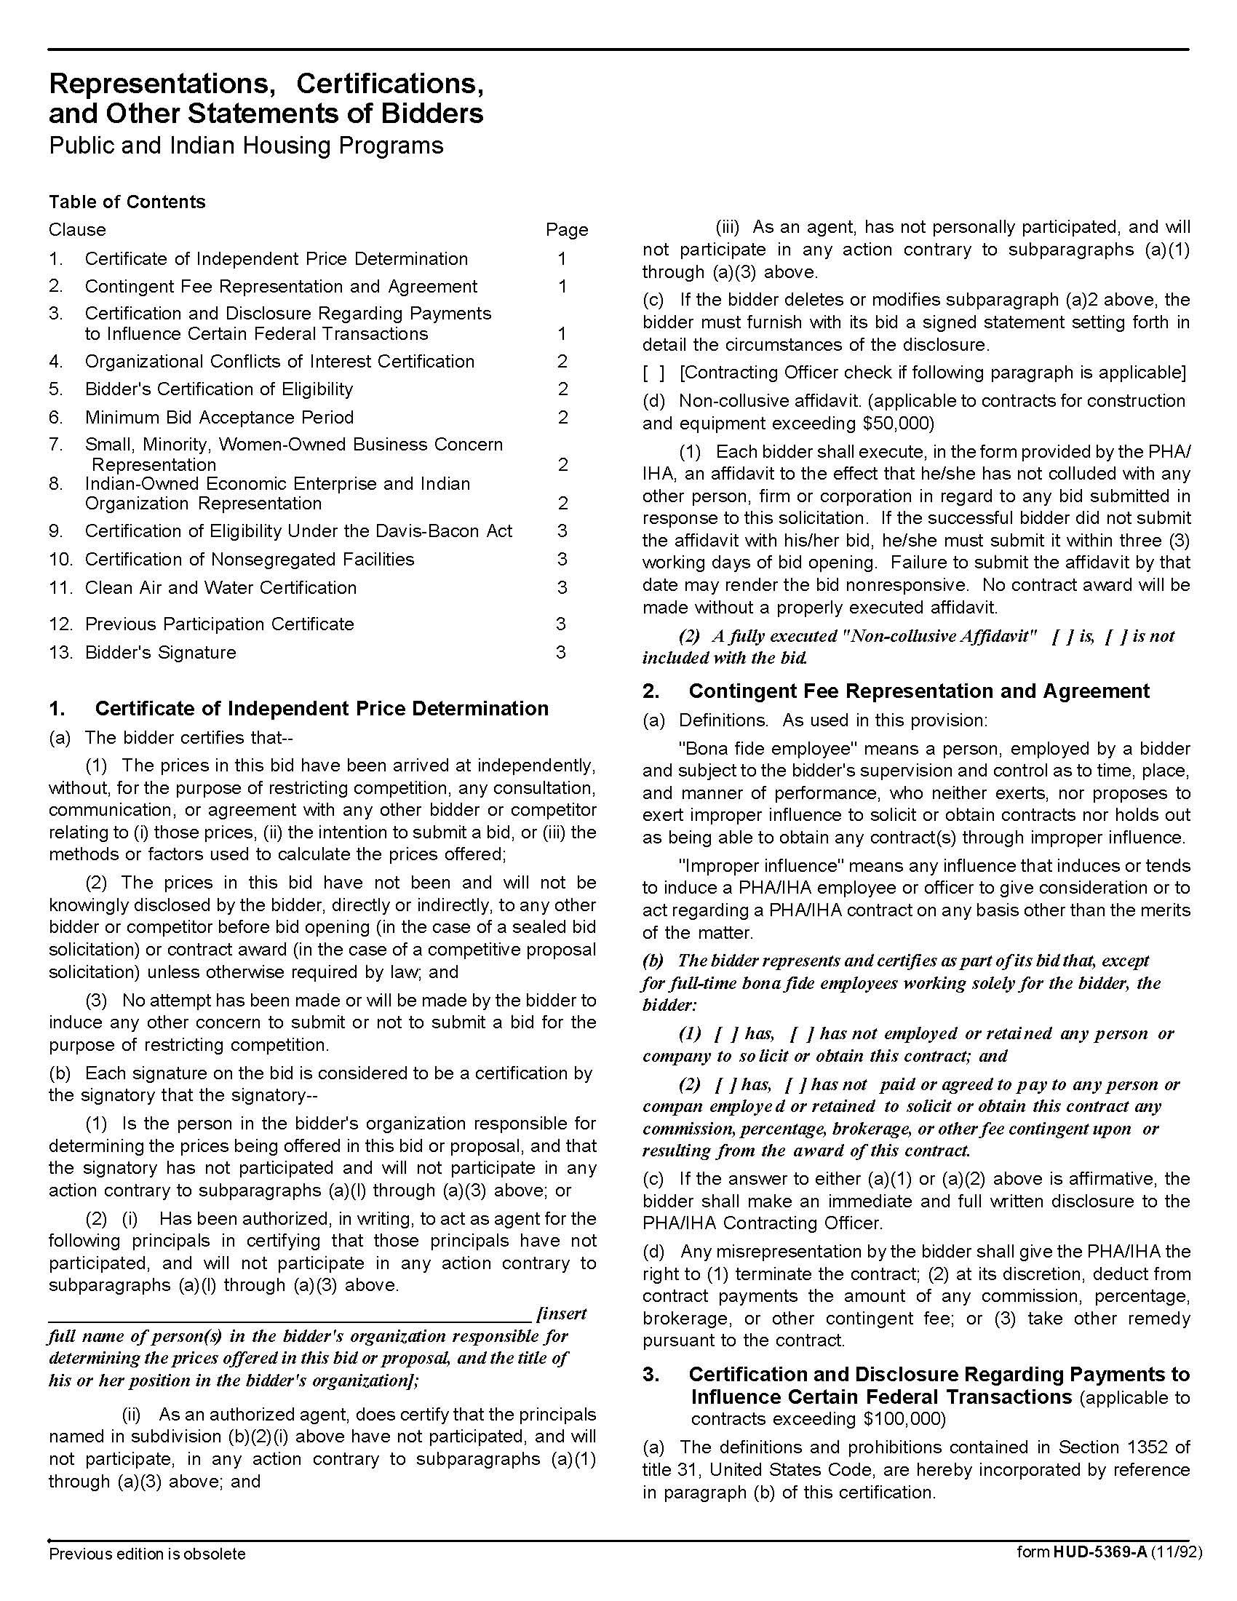

Water Heaters (as needed) Q1727

Solicitation Document C HUD Form 5369A-continued
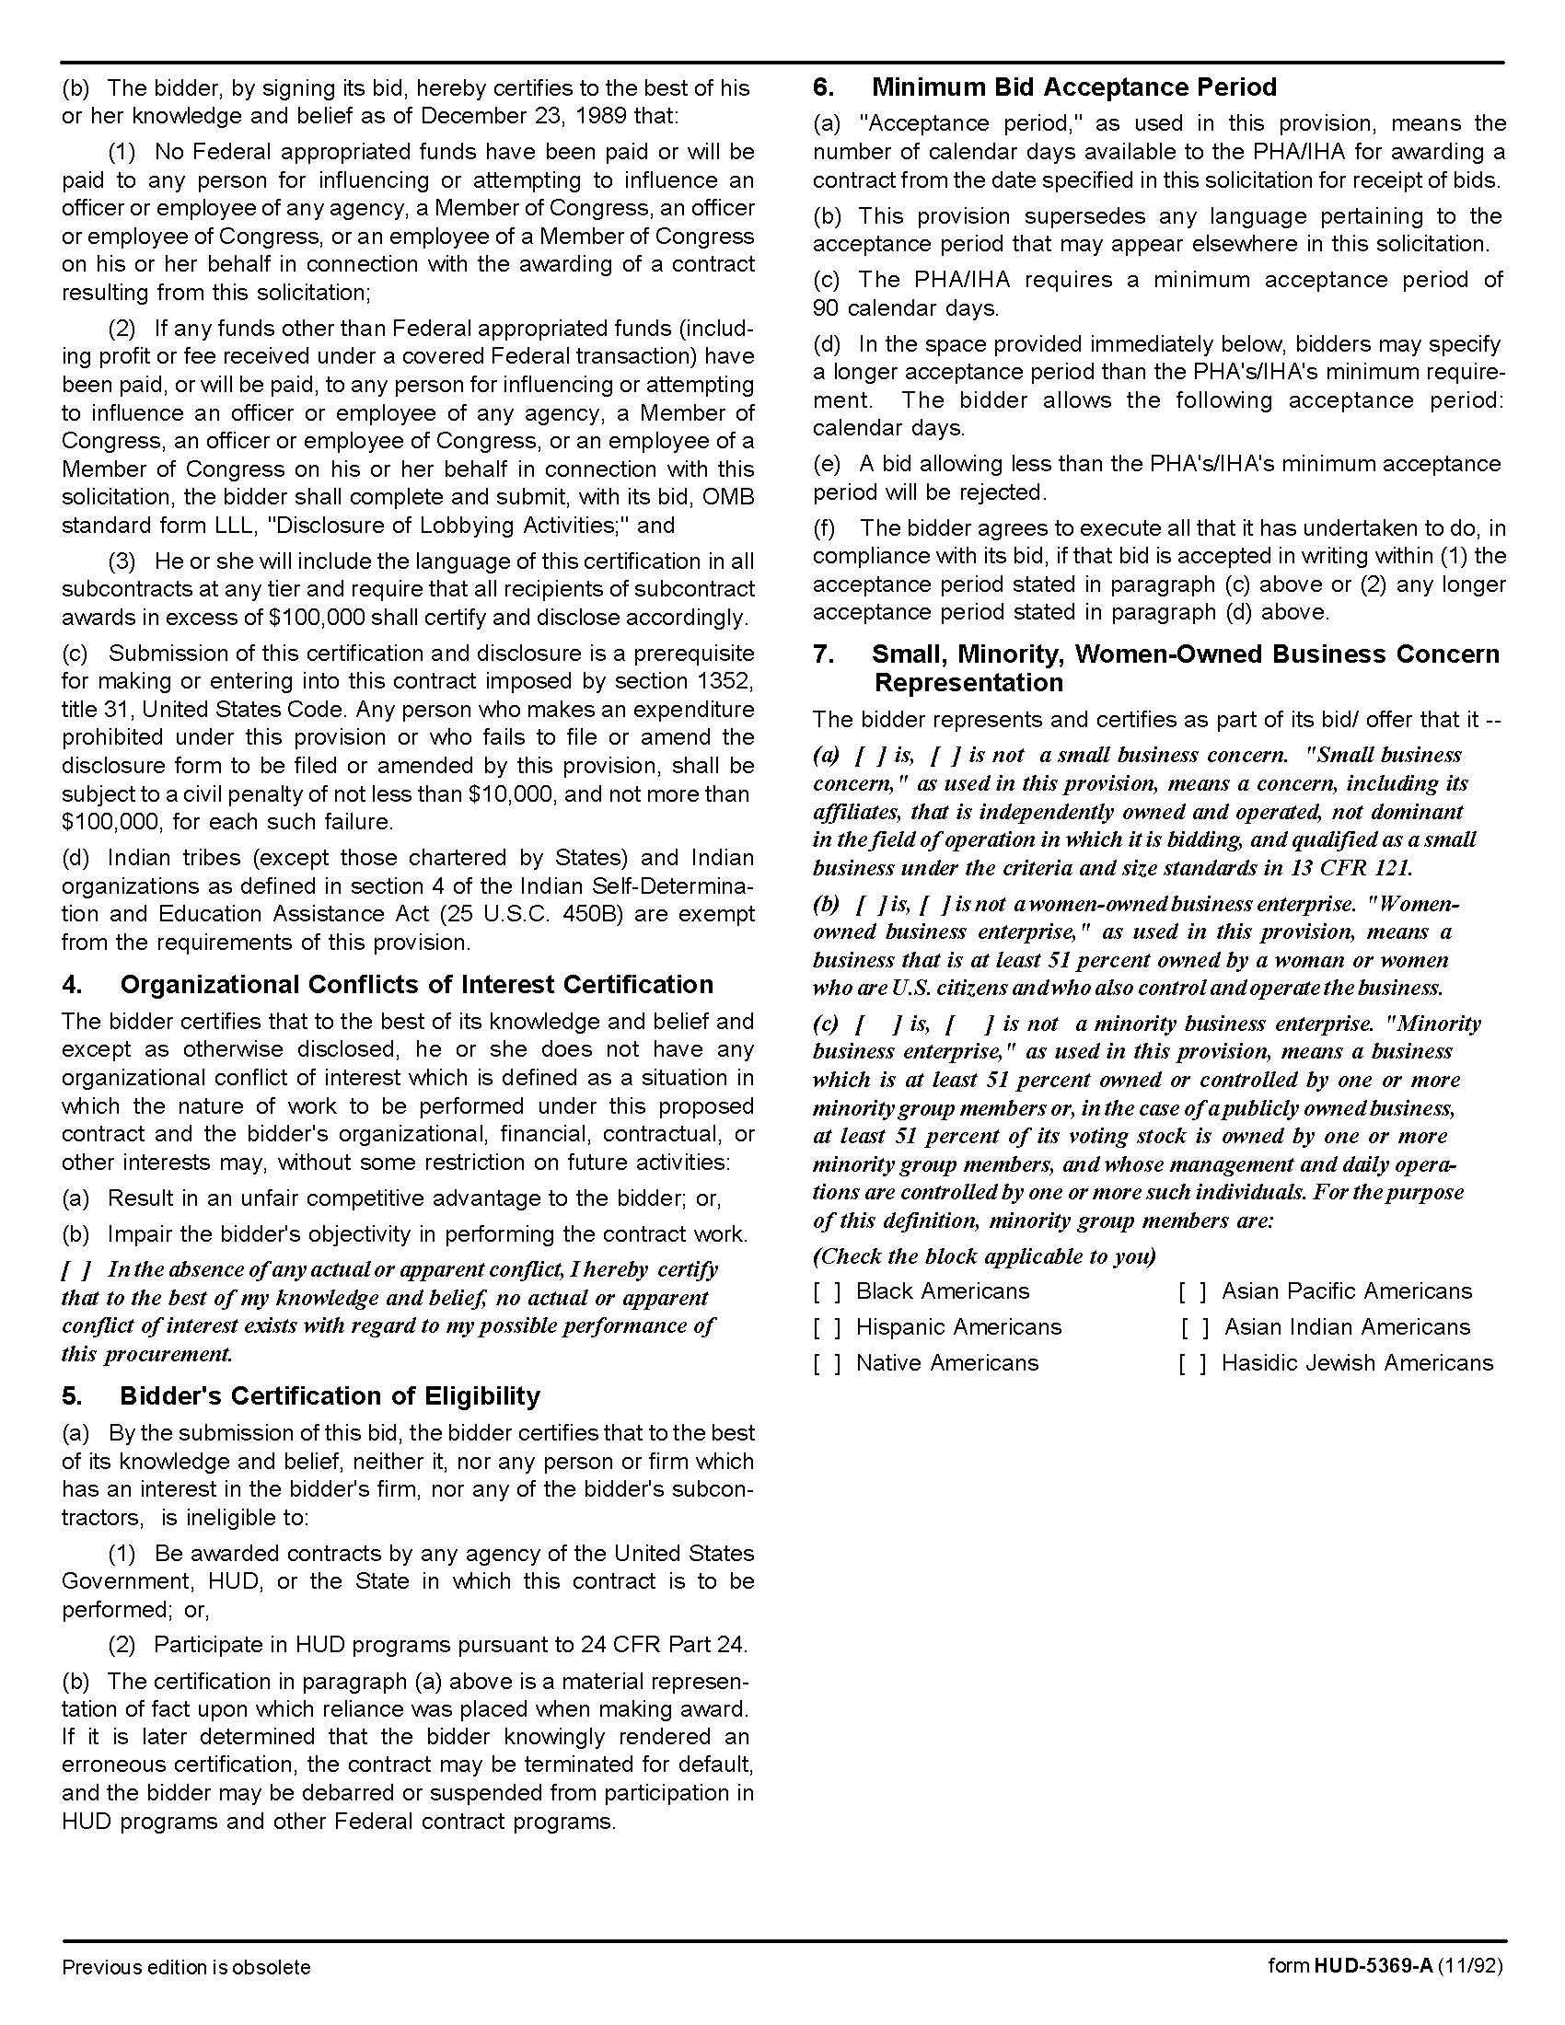

Water Heaters (as needed) Q1727

Solicitation Document C HUD Form 5369A-continued
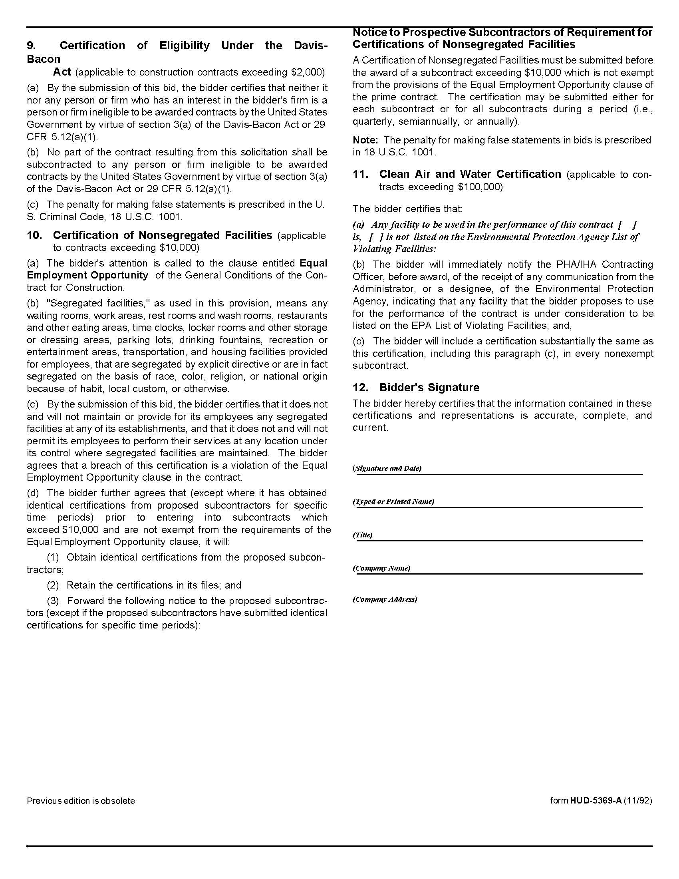

Water Heaters (as needed) Q1727

Solicitation Document D Pricing

Supplier: _________________________________________________________________________

Suppliers are to submit specification sheets for the models bid.

ITEM | UOM | DESCRIPTION  BID ITEMS  ‘BID SAME AS OR EQUAL TO’ | ITEM BID | ENERGY  STAR  COMPLIANT | PRICE  EACH
1. | EACH | Electric Water Heater  30 gallon – SHORT  ENS 30 – 22Wx39 ¾H |  | Yes  No  NA | $
2. | EACH | Electric Water Heater  30 gallon – Side Valve - SHORT  ENJB 30 – 22Wx30H |  | Yes  No  NA | $
3. | EACH | Electric Water Heater  30 gallon – LOWBOY  ENLB 30 – 20W x 30H |  | Yes  No  NA | $
4. | EACH | Electric Water Heater  30 gallon – LOWBOY  PROE30 S2 RU95 B  19 ¾ W x 32H |  | Yes  No  NA | $
5. | EACH | Electric Water Heater  30 gallon – TALL  ENT 30 – 19W x 46 ½H |  | Yes  No  NA | $
6. | EACH | Electric Water Heater  38 gallon – LOWBOY  ENLB 40 – 23W x 32H |  | Yes  No  NA | $
7. | EACH | Electric Water Heater  40 gallon – MEDIUM  ENS 40 – 20W x 49 ¾H |  | Yes  No  NA | $
8. | EACH | Electric Water Heater  40 gallon – TALL  ENT 40 – 18W x 61¼ H |  | Yes  No  NA | $
9. | EACH | Electric Water Heater  50 gallon – SHORT  ENS 50 – 23W x 49¼ H |  | Yes  No  NA | $
10. | EACH | Electric Water Heater  50 gallon – LOWBOY  ENL 50 – 26½ W x 36H |  | Yes  No  NA | $
11. | EACH | Electric Water Heater  50 gallon – TALL  PROE50 T2 RU95  20 ¼ W x 61 5/8 H |  | Yes  No  NA | $
12. | EACH | Gas Water Heater  30 gallon  GCR 30 – 18W x 61½H |  | Yes  No  NA | $
13. | EACH | Gas Water Heater  40 gallon – TALL  GCR 40 – 20W x 61¾H |  | Yes  No  NA | $

Water Heaters (as needed) Q1727

Solicitation Document D Pricing-Continued

14. | EACH | Gas Water Heater  40 gallon  DIRECT VENT MODEL  GDV 40 – 22W x 64H |  | Yes  No  NA | $

 |  |  |  |  |  | Revised 04/17/2017

Water Heaters (as needed) Q1727

Appendix I TAHRA Member Listing
ENTITY |  | EXECUTIVE DIRECTOR | EMAIL | ADDRESS | PHONE | NO. OF UNITS  (Section 8  Not Included)
Athens Housing  Authority |  | Ross Dodson | ross@athenstnha.com | P. O. Box 928  Athens, TN 37301 | 423.745.0341 | 441
Bolivar Housing  Authority |  | Michael A. Miller | bhahhs@bellsouth.net | 621 Hatchie Haven  Bolivar, TN 38008 | 731.658.3419 | 119
Bristol Housing  Authority |  | Steve Scyphers | jss@bthra.org | 204 Bluff City Hwy.  Bristol, TN 37621 | 423.274.8150 | 354
Brownsville  Housing Authority |  | Brenda Lonon | blonon@brownsvilleha.org | P. O. Box 194  254 Anderson Ave.  Brownsville, TN 38012 | 731.772.0274 | 135
Chattanooga  Housing Authority |  | Betsy McCright | ed@chahousing.org | P. O. Box 1486  801 N. Holtzclaw Ave. (37404)  Chattanooga,TN 37401 | 423.668.2374 | 2,672
Clarksville  Housing Authority |  | Wanda B. Mills | wmills@clarksvillehousing.org | P. O. Box 603, 721 Richardson St.  Clarksville, TN 37041 | 931.647.2303 | 508
Cleveland  Housing Authority |  | Paul A. Dellinger | paul@clevelandhousingauthority.org | P. O. Box 2846  450 Walker St., NE  Cleveland, TN 37320 | 423.479.9659  EXT 109 | 420
Clinton  Housing Authority |  | John H. Greer | clintonha@bellsouth.net | 825 McAdoo St.  Clinton, TN 37716 | 865.457.9692 | 150
Columbia Housing &  Redev. Corp. |  | Trent Ogilvie | trent@chrc-tn.org | 101 Penny Ave.  Columbia, TN 38401 | 931.388.5203  EXT 224 | 296
Covington  Housing Authority |  | Christi Billings | covhouse@bellsouth.net | P. O. Box 88  1701 Shoaf St.  Covington, TN 38019 | 901.476.6135 | 246
Crossville  Housing Authority |  | Don Alexander | dra@crossvillehousing.org | P. O. Box 425  67 Irwin Ave.  Crossville, TN 38557 | 931.484.2990 | 757
Dayton  Housing Authority |  | Lisa Bonadio | lbonidao@daytonhousingauthority.org | P. O. Box 257  270 Railroad St.  Dayton, TN 37321 | 423.775.1871  EXT 227 | 342
Dickson  Housing Authority |  | Buford Reed, Jr. | booty@dichsonhousing.com | 333 Martin Luther King Jr. Blvd.  Dickson, TN 37055 | 615.446.4708 | 164
Ducktown  Housing Authority |  | Sheryl Miller | ducktownhousing@gmail.com | P. O. Box 214  Ducktown, TN 37326 | 423.496.3546
Dyersburg  Housing Authority |  | Paula Ledford | dhapl@ecsis.net | P. O. Box 824  541 Hike Ave.  Dyersburg, TN 38025 | 731.285.6771 | 502
Elizabethton  Housing Authority |  | Kelly Geagley | ehdatn@gmail.com | P. O. Box 637  Elizabethton, TN 37644 | 423.543.3571 | 326
Erin  Housing Authority |  | Melinda Deason | erinha@peoplestel.net | P. O. Box 384  44 Griffin Dr.  Erin, TN 37061 | 931.289.4261 | 60
Erwin Housing Authority |  | Lori Rice | lori@erwinhousing.comcastbiz.net | 750 Carolina Ave., Building 100  Erwin, TN 37650 | 423.743.5231 | 73
Etowah  Housing Authority |  | Carolyn Jonnson | cjeha@comcast.net | 400 Sunset Dr.  Etowah, TN 37331 | 423.263.2674 | 136
Fayetville  Housing Authority |  | Jimmy Bills | fayhous@fpunet.com | P. O. Box 999  Fayetville, TN 37334 | 931.433.1587 | 276
Franklin Co. Consolidated Housing  Authority |  | Lydia McBee | lmfccha@bellsouth.net | P. O. Box 502  Winchester, TN 37398 | 931.967.0344 | 248
Franklin  Housing Authority |  | Derwin Jackson | djackson@franklinhousingauthority.com | 200 Spring St.  Franklin, TN 37064 | 615.794.1247 | 273
Gallatin  Housing Authority |  | Michael Bates | gallhsg@comcast.net | 401 N. Boyers Ave.  Gallatin, TN 37066 | 615.452.1661 | 389
Gallaway  Housing Authority |  | Brian Harris | brian@martinhousing.org | 200 Jackson St.  Arlington, TN 38002 | 901.867.8101 | 60
Greeneville  Housing Authority |  | Rebecca Moyer | grneha@comcast.net | P. O. Box 279  100 Cox Circle  Greeneville, TN 37743 | 423.638.3111 | 325
Grundy  Housing Authority |  | Derryl Graham | dgraham@blomand.net | 187 Raulston St.  Monteagle, TN 37356 | 931.924.2496 | 110
Harriman  Housing Authority |  | Amy Hall | ahall@harrimanhsg.org | 924 Sewanee St.  Harriman, TN 37748 | 865.882.9636 | 324
Hartsville  Housing Authority |  | Kim Satterfield | hartsvha@bellsouth.net | P. O. Box 44  212 Rogers St.  Hartsville, TN 37074 | 615.374.3959 | 34
Highland Residential  Services (formerly Cookeville HA |  | Chris Cassetty  Director of Operations | ccassetty@highlandsrs.com | P. O. Box 400  Cookeville, TN 38501 | 931.526.9793 | 529
Hohenwald  Housing Authority |  | Terry Bunch | terry@hohenwaldhousing.com | 107 Allison Ave.  Hohenwald, TN 38462 | 931.796.3642 | 116
Humboldt  Housing Authority |  | Patricia Taylor | humhouse@bellsouth.net | 3532 Seymour Loop  Humboldt, TN 38343 | 731.784.9722 | 232
Huntingtondon  Housing Authority |  | Denelda Price | director@huntingdonhousing.org | 433 Hillcourt Circle  Huntingdon, TN 38344 | 731.986.4442 | 148
Jackson  Housing Authority |  | C. Winston Henning | whenning@jacksonha.com | P. O. Box 3188 125 Preston St.  Jackson, TN 38303 | 731.422.1671  EXT 103 | 982
Jefferson City  Housing Authority |  | Keith Godwin | 1jcha@bellsouth.net | 942 East Ellis St.  Jefferson City, TN 37760 | 865.475.2064 | 199
Jellico  Housing Authority |  | Crystal Creekmore | jellicoha@bellsouth.net | P. O. Box 240  Jellico, TN 37762 | 423.784.8809 | 122
Johnson City  Housing Authority |  | Richard McClain | richardm@jchousing.org | 901 Pardee St.  Johnson City, TN 37601 | 423.232.4784 | 752
Kingsport Housing & Redevelopment Authority |  | Terry W. Cunningham | kingsporthousing.org | P. O. Box 44  906 E. Sevier Ave.  Kinsgport, TN 37662 | 423.392.2513 | 529
Knoxville's Community  Development Corp.  KCDC |  | Benjamin M. Bentley | bentley@kcdc.org | 901 N. Broadway  Knoxville, TN 37917 | 865.403.1100 | 3,870
Lafayette  Housing Authority |  | Lisa Gentry | lafhouse@nctc.com | 613 Dycus Circle  Lafayette, TN 37083 | 615.666.2140 | 102
LaFollette  Housing Authority |  | John Snodderly | john@lafollettehousing.org | P. O. Box 392  LaFollette, TN 37766 | 423.562.2261 | 1,116
Lawrenceburg  Housing Authority |  | Eddy Casteel | houseaut@lawrenceburgha.org | P. O. Drawer C 1020 Smith Ave.  Lawrenceburg, TN 38464 | 931.762.7532 | 303
Lebanon  Housing Authority |  | Patrick Johnson | pjohnson@lhatn.org | 49 Upton Heights  Lebanon, TN 37087 | 615.444.1872  EXT 117 | 354
Lenoir City  Housing Authority |  | Mary Sue Jordan | msjordan@lcityha.org | 101 Oakwood Dr.  Lenoir City, TN 37771 | 865.986.8707 | 170
Lewisburg  Housing Authority |  | Ronald Robinson | lha@tnweb.com | 744 Bark St.  Lewisburg, TN 37091 | 931.359.4517 | 220
Lexington  Housing Authority |  | Melba J. Johnson | melbalha@gmail.com | 100 Willow Court  Lexington, TN 38351 | 731.968.7506 | 120
Livingston  Housing Authority |  | Ken Mabry | livhouseauth@twlakes.net | P. O. Box 98  Livingston, TN 38570 | 931.823.6423 | 65
Loudon  Housing Authority |  | Lori Everett | lhalori@bellsouth.net | P. O. Box 425  124 Pathkiller Trail  Loudon, TN 37774 | 865.458.2061 | 121
Manchester  Housing Authority |  | Nancy Huddleston | mha@cafes.net | 710 Butler Circle  Manchester, TN 37355 | 931.728.2596 | 166
Martin  Housing Authority |  | Brian Harris | brian@martinhousing.org | 134 E. Heights Dr.  Martin, TN 38237 | 731.587.3186 | 433
Maryville  Housing Authority |  | Nancy Burnette | nburnette@mhatn.com | 311 Atlantic Ave.  Maryville, TN 37801 | 865.983.4958 | 517
McKenzie  Housing Authority |  | Barbara Cooper | coopermha@bellsouth.net | 22 McDonald Ave.  McKenzie, TN 38201 | 731.352.5335 | 148
McMinnville  Housing Authority |  | Patricia Basham | mmha@blomand.net | 301 Hardaway St.  McMinnville, TN 37110 | 931.473.3286 | 422
Memphis  Housing Authority |  | Dorian Jenkins | swilkins@mhanewday.com | P. O. Box 3664 700 Adams Ave.  Memphis, TN 38103 | 901.544.1102 | 2,990
Metropolitan (Nashville)  Development & Housing  Agency (MDHA) |  | Rita  James | rjames@nashville-mdha.org | 712 South 6th St.  Nashville, TN 37206 | 615.252.8432 | 6129
Milan  Housing Authority |  | Mark A. Dodson | tn31@milanhousing.org | 1000 Northside Terrace  Milan, TN 38358 | 731.686.8571 | 100
Millington  Housing Authority |  | Tanya Martchek | themha@rittermail.com | P. O. Box 55  4888 Bill Knight Ave.  Millington, TN 38083 | 901.872.3677 | 90
Morristown  Housing Authority |  | Jeff  Green | jgreen@morristownpha.org | P. O. Box 497  600 Sulphur Springs Rd.  Morristown, TN 37815 | 423.586.5115  EXT 8004 | 676
Mt. Pleasant  Housing Authority |  | Dawn Hudson | mphauth@bellsouth.net | 138 Thomas Circle  Mt. Pleasant, TN 38474 | 931.379.5811 | 116
Murfreesboro  Housing Authority |  | Thomas Rowe | trowe@mha-tn.org | 415 N. Maple St.  Murfreesboro, TN 37130 | 615.893.9414 | 430
Newbern  Housing Authority |  | Jane Norsworthy | jnorsworthy@aeneas.net | P. O. Box 100  Newbern, TN 38059 | 731.627.2142 | 145
Newport  Housing Authority |  | Charlie Boggan | cwbogan4nha@newporttnhousing.com | 440 Lennon Circle  Newport, TN 37821 | 423.623.1575 | 400
Oak Ridge  Housing Authority |  | James A. Carson | jacarson@orha.net | 10 Van Hicks Lane  Oak Ridge, TN 37830 | 865.482.1006 | 128
Oliver Springs  Housing Authority |  | Karen Leffew | oshousing@aol.com | 131 Brittain Village  Oliver Springs, TN 37840 | 865.435.1711 | 113
Paris  Housing Authority |  | Lisa Wimberley | parhsing@bellsouth.net | 917 Minor St.  Paris, TN 38242 | 731.642.4451 | 196
Parsons-Decaturville  Housing Authority |  | Mecca Derre | meccapdha@gmail.com | 155 Miller St.  Unit 301C  Parsons, TN 38363 | 731.847.2638 | 68
Portland  Housing Authority |  | Sabrina Woodard | ptldhsgdirector@gmail.com | P. O. Box 37  107 Potts Ave.  Portland, TN 37148 | 615.325.4559 | 120
Pulaski  Housing Authority |  | Vivian Gordon | viviango@pulaskihousing.com | 2006 Garden Meadow Dr.  Pulaski, TN 38478 | 931.363.6525 | 209
Ripley  Housing Authority |  | Justin Jones | jjones@ripleyha.net | 101 Northcrest  Ripley, TN 38063 | 731.635.1901  EXT 28 | 265
Rockwood  Housing Authority |  | Jill Jiles-Everhart | jjeverhart@bellsouth.net | 320 Carpenter St.  Rockwood, TN 37854 | 865.354.9841 | 159
Rogersville  Housing Authority |  | Rebecca Wolf | rhabecky@rogersvillehousing.net | 902 Locust St.  Rogersville,TN 37857 | 423.272.8540 | 204
Savannah  Housing Authority |  | C. Hardin Hughes | hardin@savhousing.com | 80 Jefferson St.  Savannah, TN 38372 | 731.925.2020
Sevierville  Housing Authority |  | Ronald Franklin | sevshng@bellsouth.net | 500 Leo Sharp Rd.  Sevierville, TN 37862 | 865.453.8500 | 245
Shelbyville  Housing Authority |  | William Hershel Thrasher | whthrashersha@bellsouth.net | P. O. Box 560  316 Templeton St.  Shelbyville, TN 37160 | 931.684.1341  EXT 20 | 422
Smithville  Housing Authority |  | Sharon Prater | smthvhou@dtccom.net | P. O. Box 117  415 Jackson St.  Smithville, TN 37166 | 615.597.4140  EXT 3 | 182
Smyrna  Housing Authority |  | Sean Lee | sean_lee@comcast.net | 701 Stan Circle  Smyrna, TN 37167 | 615.459.8866 | 736
South Carthage  Housing Authority |  | Michael Bates |  | P. O. Box 197  109 Hazel Dr.  Carthage, TN 37030 | 615.735.1940 | 70
South Pittsburg  Housing Authority |  | Lisa Bradford | sphalb@bellsouth.net | P. O. Box 231  214 Elm Ave.  South Pittsburg, TN 37380 | 423.837.6600 | 202
Sparta  Housing Authority |  | Jim Payne | jim@spartahousing.com | 300 Cragrock Dr. Sparta, TN 38583 | 931.836.3357 | 162
Springfield  Housing Authority |  | Seth Hudson | springfield101@comcast.net | 808 Rose Hill Circle  Springfield, TN 37172 | 615.384.4591
Sweetwater  Housing Authority |  | Vicki Barnes | vbarnes@sweetwaterhousing.com | P. O. Box 88  #3 Valley View Village Dr.  Sweetwater, TN 37874 | 423.337.6224 | 158
Trenton  Housing Authority |  | Doug Lockard | doug@trentonhousing.org | 128 Burnett Dr.  Trenton, TN 38382 | 731.855.1231 | 210
Tullahoma  Housing Authority |  | James H. (Jim) Rock | tn024@bellsouth.net | 2401 Cedar Lane Village Dr.  Tullahoma, TN 37388 | 931.455.9319  EXT 225 | 310
Union City  Housing Authority |  | Gena Burden | gena@uchousing.org | 1409 E. Main St.  Union City, TN 38261 | 731.885.1971 | 286
Waverly  Housing Authority |  | Buford Reed | booty@dicksonhousing.com | 35 W. Brookside Dr.  Waverly, TN 37185 | 931.296.2256 | 70
Woodbury  Housing Authority |  | Pam P. Cunningham | whatn@dtccom.net | 401 McFerrin St.  Woodbury, TN 37190 | 615.563.5276 | 100

