Request for Proposals

Solicitation Name | Wait List Analysis Services
Solicitation Number | Q1914
Due Date | December 21 , 2018
Due Time | 11:00 a.m. EST
Deliver Responses to: | Knoxville’s Community Development Corporation    Procurement Division  901 N. Broadway  Knoxville, TN 37917  Procurement is behind the main office building.
Electronic Copies | Electronic copies are available on KCDC’s webpage or by email at purchasinginfo@kcdc.org.
Responses may be Emailed to KCDC | ☒ Yes ☐ No
Printed Responses Required | ☐ Yes ☒ No
Questions About This Solicitation | Submit questions to purchasinginfo@kcdc.org  KCDC will not accept questions via telephone.
Award Results | KCDC posts both a summary of the proposals received and the award decision to its web page at: http://www.kcdc.org/procurement/
Open Records/Public Access to Documents | All document provided to KCDC are subject to the Tennessee Open Meetings Act (TCA 8-44-101) and open records requirements.

Check KCDC’s webpage for addenda and changes before submitting your response

General Information

1. Background and Intent

a. Knoxville's Community Development Corporation (KCDC) is the public housing and redevelopment agency for the City of Knoxville and for Knox County in Tennessee. KCDC’s affordable housing property portfolio includes 20 sites with approximately 3,525 dwelling units. KCDC also oversees approximately 3,958 Section 8 Vouchers, 82 Moderate Rehabilitation units and 20 Redevelopment areas. As of the date of the Request for Proposal, 13 properties have transformed to the Project Based Rental Assistance program (PBRA) and KCDC is the management company for those sites. The properties for which KCDC is the management company include Five Points 1, LP; Lonsdale Homes, LP; Northridge Crossing, LP and The Vista at Summit Hill, LP.

b. KCDC is seeking proposals for independent testing of its Site-Based Wait Lists in accordance with applicable federal regulation (See 24 CFR 903.7 (V)(B)).

c. KCDC has many more applicants seeking housing than it is able to accommodate in its housing developments and Section 8 vouchers. Because the demand for housing greatly exceeds the supply of available units and vouchers, individuals and families seeking housing wait for periods ranging from months to years to be housed. The U.S. Department of Housing and Urban Development (HUD) allows Public Housing Authorities (PHA’s) to adopt Site-Based Waiting Lists in accordance with 24 CFR 903.7(b) (see Appendix D). KCDC maintains Site-Based Wait Lists for all Low Income Public Housing, Project-Based Rental Assistance properties as well as all Section 8 programs. As designed, the site-based waiting lists allow applicants to select the particular developments where they would like to live.

d. HUD regulation 24 CFR 903.7(V)(B) requires “At least every three years the PHA uses independent testers or other means satisfactory to HUD, to assure that the site-based waiting list is not being implemented in a discriminatory manner, and that no patterns or practices of discrimination exist, and provide the results to HUD.”

e. KCDC intends to utilize means satisfactory to HUD to assure that its site-based waiting lists are not being implemented in a discriminatory manner. In pursuit of that goal, KCDC is seeking statisticians/analysts to review population data from both our site-based waitlists and overall portfolio and compare them with KCDC’s Admissions and Continued Occupancy Policies (ACOP), Tenant Selection and Assignment Plan (TSAP), Affirmative Fair Housing Marketing Plan(s) and Section 8 Administrative Plan to determine whether the composition of our waitlist and KCDC-housed population reflects the unbiased implementation of our policies. Furthermore, KCDC seeks review of the same data pertaining to our waitlist and housed population to establish if any patterns or trends emerge from their composition relative to the income-eligible general population in the Knoxville census track data. The methods and findings of the study must be recorded in a report provided to KCDC, to be reviewed by HUD. The analysis and resulting report must be completed and furnished to KCDC within 60 days of award.

f. For further clarification, some variables/fields KCDC anticipates proposers may wish to utilize are: Entity ID (a unique identifier for each applicant), Ethnicity, Race, National Origin, Gender, bedroom size, desired bedroom size as required by PBRA guidelines, Reasonable Accommodation requirement, number of household members, elderly head or co-head of household, disabled head or co-head of household, original Application date, waiting list(s) selected. Further, the data set is rather large. There are roughly 18,165 applicants active on Low Income Public Housing and Project-Based Rental Assistance waiting lists. There are roughly 22,559 applicants active on Section 8 waiting lists.

g. KCDC’s objectives for this work are to:

- Ensure that the Site-Based Wait Lists administered by KCDC are not being implemented in a
discriminatory manner and have not resulted in the development of any patterns of discrimination, and
- Assist KCDC in meeting its regulatory requirements related to Site-Based Wait Lists, and
- Complete testing in a manner consistent with KCDC’s Admissions and Continued Occupancy
policies (ACOP), Tenant Selection and Assignment Plan (TSAP), Affirmative Fair Housing Marketing Plan(s) and Section 8 Administrative Plan.

h. Scope of Services:

- Analyze the Site-Based Wait Lists administered by KCDC to assess whether the site-based
waiting lists are being implemented in a discriminatory manner, and ensure that no patterns or practices of discrimination exist.

2. Review population data from both our site-based waitlists and overall portfolio and compare them with KCDC’s Admissions and Continued Occupancy Policies (ACOP), Tenant Selection and Assignment Plan (TSAP), Affirmative Fair Housing Marketing Plan(s), and Section 8 Administrative Plan to determine whether the composition of our waitlist and KCDC housed population reflects the unbiased implementation of our policies.

3. Analyze Site-Based Wait Lists of all KCDC’s housing portfolios.

4. Review population data in both site-based waitlists and overall portfolio and compare with population data in the Knoxville census track.

5. Compare the data to establish trends or patterns that are revealed by the review.

6. Prepare written report and recommendations for KCDC and HUD of the findings, methodology,
and trends or patterns from the review.

7. Periodic evidence that preparer is working towards completion must be submitted to KCDC’s Regulatory & Compliance Division.

8. A detailed written report must be submitted within 60 days of award.

2. Changes after Award
It is possible that after award KCDC will need to revise the service needs or requirements specified in this document. KCDC reserves the right to make such changes after consultation with the supplier. Should additional costs arise, the supplier must document increased costs. KCDC reserves the right to accept and negotiate these charges.

3. Codes and Ordinances
All work covered is to be done in full accord with national, state and local codes and ordinances and orders that are in effect at the time the work is performed.

4. Contact Policy
The supplier may not contact an officer, agent or employee of KCDC other than the KCDC’s Procurement Division about matters pertaining to this solicitation, from the issuance of this solicitation until its award. Information obtained from an unauthorized officer, agent or employee of KCDC will not affect the risks or obligations assumed by the supplier or relieve the supplier from fulfilling any of the conditions of the project. Such contact can disqualify the supplier from participation in the solicitation process.

5. Evaluation

a. KCDC alone determines (using NIGP’s definition and other relevant sources as appropriate) the supplier’s “responsive” and “responsible” status prior to award. Responsible means a business with the financial and technical capacity to perform the requirements of the solicitation and subsequent contract. A responsive bid/proposal is one that fully conforms in all material respects to the solicitation document and all of its requirements, including all form and substance.

b. KCDC reserves the right to request additional information to assist in the evaluation process. This includes references and business capacity information.

c. KCDC will review all proposals and reserves the right to request necessary modifications, waive minor technicalities, reject all proposals, reject any proposal that does not meet mandatory requirement(s) or cancel this RFP, according to KCDC’s best interests.

KCDC plans to award to the best overall proposal on the following evaluation scale:

Factors | Maximum Points
Cost | 60
Qualifications | 30
References | 10
Total | 100

6. General Instructions
KCDC does not insert “General Instructions to Suppliers” in solicitation documents. These instructions are at www.kcdc.org. Click on “Procurement” and the link to the instructions. The supplier’s submittal means acceptance of the terms and conditions set forth in KCDC’s “General Instructions to Suppliers.”
7. Insurance

a. The supplier agrees to obtain and maintain at its sole expense during the term of this agreement insurance coverages and limits in accordance with the supplier’s standard business practices and acceptable to KCDC. Such insurance shall contain or be endorsed to contain a provision that includes KCDC, its officials, officers, employees, and volunteers as additional insureds with respect to liability arising out of work or operations performed by or on behalf of the supplier including materials, parts, or equipment furnished in connection with such work or operations. The coverage shall contain no special limitations on the scope of its protection afforded to the above-listed insureds.

b. Certificate Holder and Owner Entities:
The certificate holder shall be:

Knoxville’s Community Development Corporation (KCDC)
Attn: Contracting Officer
901 N. Broadway
Knoxville, TN 37917

Owner Entities include:
  - KCDC, its officials, officers, employees, and volunteers
  - Eastport Development, LP
  - Five Points 1 LP
  - Five Points 2 LP
  - Five Points 3 LP
  - Five Points 4 LP
  - Lonsdale, LP
  - North Ridge Crossing, LP
  - Vista at Summit Hill, LP

Note: Only one certificate needs to be provided. Certificate must reflect KCDC as the Certificate Holder and specify all coverages and terms apply to all Owner Entities.

8. Invoicing/Ordering

a. Until a purchase order is in place, work is not to be performed nor are goods to be delivered. KCDC does not have a legal obligation to pay for the work performed prior to the issuance of a purchase order.

b. Suppliers must submit invoices within 90 days of the delivery of goods or services. KCDC may deny invoices submitted after the 90 day threshold. KCDC prefers invoices arrive within 10 days following the end of the month in which goods or services were supplied.

c. KCDC pays by electronic transfer (ACH) only.

d. Since KCDC is the managing partner for four separate corporations under the KCDC umbrella, those separate corporations must receive separate invoices. Thus the supplier will generally:

- Bill each specific site for work performed or goods delivered
- With KCDC’s permission, generate one monthly master invoice showing all locations and
their individual costs (except for those listed below)
- Create separate invoices for Five Points I, Lonsdale Homes, North Ridge Crossing and The Vista.

e. Invoices must:

1. Be numbered
2. List a date on them that is after the work is completed or goods delivered
3. List the purchase order number
4. Breakdown pricing according to the award structure

f. KCDC requires that invoices be submitted via email.

9. Length of Award
The length of the contract will be twelve months with four optional annual renewals that KCDC may exercise at its discretion.

10. Price Structure

- At the end of each twelve month period, the awarded supplier may request a change to the
percentage and/or specific item charged to KCDC. The supplier must provide proof of increased Producer Price Index (Knoxville) to the Procurement Division. Suppliers may lower prices at any time with or without notice. KCDC will decide whether to accept a price increase. If the price increase is accepted, the solicitation file will be so noted. If the price increase is not accepted, the supplier may:

1. Continue with the existing pricing.
2. Suggest an alternative price increase.
3. End the award.

b. KCDC does not pay fuel surcharges.

11. Questions
Send direct questions pertaining to this document to purchasinginfo@KCDC.org with “Wait List Services” in the subject line, at least five business days prior to the due date. KCDC does not accept questions via telephone.

12. Submittal Instructions
Submit your information in the order indicated below:

Document Number | Title | Form Provided by
Solicitation Document A | General Response Section | KCDC
Solicitation Document B | Affidavits | KCDC
Solicitation Document C | HUD Form 5369A | KCDC
Solicitation Document D | Qualifications Statement | Proposer
Solicitation Document E | Service Plan | Proposer
Solicitation Document F | Cost Proposal | Proposer

a. Place your company’s name on each page and number all pages consecutively

b. The use of tables in presenting information facilitates the evaluation team’s review.

c. Do not use phrases such as “See the attached” or “Will be provided upon award.”

d. Bind proposals simply since KCDC ultimately scans documents into electronic format. Acceptable binding methods include paper clips, staples and three ring binders.

This and the Previous Pages Do Not Need to be Returned

Wait List Analysis Services Q1914

Solicitation Document A General Response Section

General Information about the Supplier
Sign Your Name to the Right of the Arrow
By signing, you indicate you read and agree to “KCDC’s General Instructions to Suppliers” on www.kcdc.org.
Printed Name and Title
Company Name
Street Address
City/State/Zip
Contact Person (Please Print Clearly)
Telephone Number
Cell Number
Supplier’s E-Mail Address (Please Print Clearly)
Addenda
Addenda are at www.kcdc.org. Click on “Procurement” and then on “Open Solicitations” to find addenda. Please check for addenda prior to submitting a proposal.
Acknowledge addenda have been issued by checking below as appropriate:
None ☐ | Addendum 1 ☐ |  |  | Addendum 2 ☐ |  | Addendum 3 ☐ |  |  | Addendum 4 ☐ | Addendum 5 ☐
Statistical Information (Check all the apply)
This business is at least 51% owned and operated by a woman |  |  |  |  |  |  |  |  |  |  | Yes ☐ No ☐
This business qualifies as a small business by the State of Tennessee  (Gross receipts of $10,000,000 or less and employing less than 100 full time persons ) |  |  |  |  |  |  |  |  |  |  | Yes ☐ No ☐
This business qualifies as Section 3 business (as defined by HUD):  It is at least 51% owned by a Section 3 resident (lives in Public Housing) or it employs Section 3 residents for at least 30% of its employee base; or it commits to sub contract at least 25% of the project’s dollars to a Section 3 business. |  |  |  |  |  |  |  |  |  |  | Yes ☐ No ☐
This business is owned & operated by persons at least 51% of the following ethnic background:
Asian/Pacific ☐ |  | Black ☐ | Hasidic Jew ☐ |  | Hispanic ☐ |  |  | Native Americans ☐ |  |  | White ☐
Cooperative Procurement
Subject to additional location/delivery charges, the supplier agrees to extend the offered costs to other governments if the government so desires. Yes ☐ No ☐
Prompt Payment Discount
A prompt payment discount of ________% is offered for payment within ____ days of submission of an accurate and proper invoice.
MasterCard Acceptance
Mastercard is accepted for payment without additional fees. Yes ☐ No ☐
Mastercard is accepted for payment with a fee of _______. Yes ☐ No ☐

Wait List Analysis Services Q1914

Solicitation Document B Affidavits

Supplier: _____________________________________________________________________________

Conflict of Interest:
1. No commissioner or officer of KCDC or other person whose duty it is to vote for, let out, overlook or in any manner superintend any of the work for KCDC has a direct interest in the award or the supplier providing goods or services.

2. No employee, officer or agent of the grantee or sub-grantee will participate in selection, or in the award or administration of an award supported by Federal funds if a conflict of interest, real or apparent, would be involved. Such a conflict would arise when the employee, officer or agent, any member of his immediate family, his or her partner, or an organization, which employs, or is about to employ, any of the above, has a financial or other interest in the supplier selected for award.

3. The grantee's or sub-grantee's officers, employees or agents will neither solicit nor accept gratuities, favors or anything of monetary value from suppliers, potential supplier s, or parties to sub-agreements.

4. By submission of this form, the supplier is certifying that no conflicts of interest exist.

Drug Free Workplace Requirements:
5. Private employers with five or more employees desiring to contract for construction services attest that they have a drug free workplace program in effect in accordance with TCA 50-9-112.

Eligibility:
6. The supplier is eligible for employment on public contracts because no convictions or guilty pleas or pleas of nolo contender to violations of the Sherman Anti-Trust Act, mail fraud or state criminal violations with an award from the State of Tennessee or any political subdivision thereof have occurred.

General:
7. Supplier fully understands the preparation and contents of the attached offer and of all pertinent circumstances respecting such offer.

8. Such offer is genuine and is not a sham offer.

Iran Divestment Act:
9. Concerning the Iran Divestment Act (TCA 12-12-101 et seq.), by submission of this bid/quote/proposal, each supplier and each person signing on behalf of any supplier certifies, and in the case of a joint bid/quote/proposal, each party thereto certifies as to its own organization, under penalty of perjury, that to the best of its knowledge and belief that each supplier is not on the list created pursuant to § 12-12-106.

Wait List Analysis Services Q1914

Solicitation Document B Affidavits - continued

Non-Collusion:
10. Neither the said supplier nor any of its officers, partners, owners, agents, representatives, employees or parties interest, including this affiant, has in any way colluded conspired, connived or agreed, directly or indirectly, with any other responder, supplier, or person to submit a collusive or sham offer in connection with the award or agreement for which the attached offer has been submitted or to refrain from making an offer in connection with such award or agreement, or collusion or communication or conference with any other supplier, or, to fix any overhead, profit, or cost element of the offer price or the offer price of any other supplier, or to secure through any collusion, conspiracy, connivance, or unlawful agreement any advantage against KCDC or any person interested in the proposed award or agreement.

11. The price or prices quoted in the attached offer are fair, proper and not tainted by any collusion, conspiracy, connivance, or unlawful agreement on the part of the supplier or any of its agents, representatives, owners, employees, or parties in interest, including this affiant.

Accuracy of Electronic Copies:
12. If the supplier provides electronic copies of the bid/proposal/quote to KCDC, the supplier certifies that the information provided on paper and in the electronic format is identical unless specifically noted otherwise.
No Contact/No Advocacy Affidavit
13. After this solicitation is issued, any contact initiated by any proposer with any KCDC representative concerning this proposal is strictly prohibited-except for communication with the Procurement Division. My signature signifies that no unauthorized contact occurred.

14. To ensure the integrity of the review and evaluation process, respondents to this solicitation nor any firm representing them, may not lobby or advocate to KCDC staff or Board members. My signature signifies that no unauthorized advocacy occurred.

The undersigned hereby acknowledges receipt of these affidavits and certifies that the submittal in response to this solicitation is in full compliance with the listed requirements.

Signed by
Printed Name
Title
Subscribed and sworn to before me this date
By (Notary Public)
My Commission Expires on
Notary Stamp

Wait List Analysis Services Q1914
Solicitation Document C HUD Form 5369A
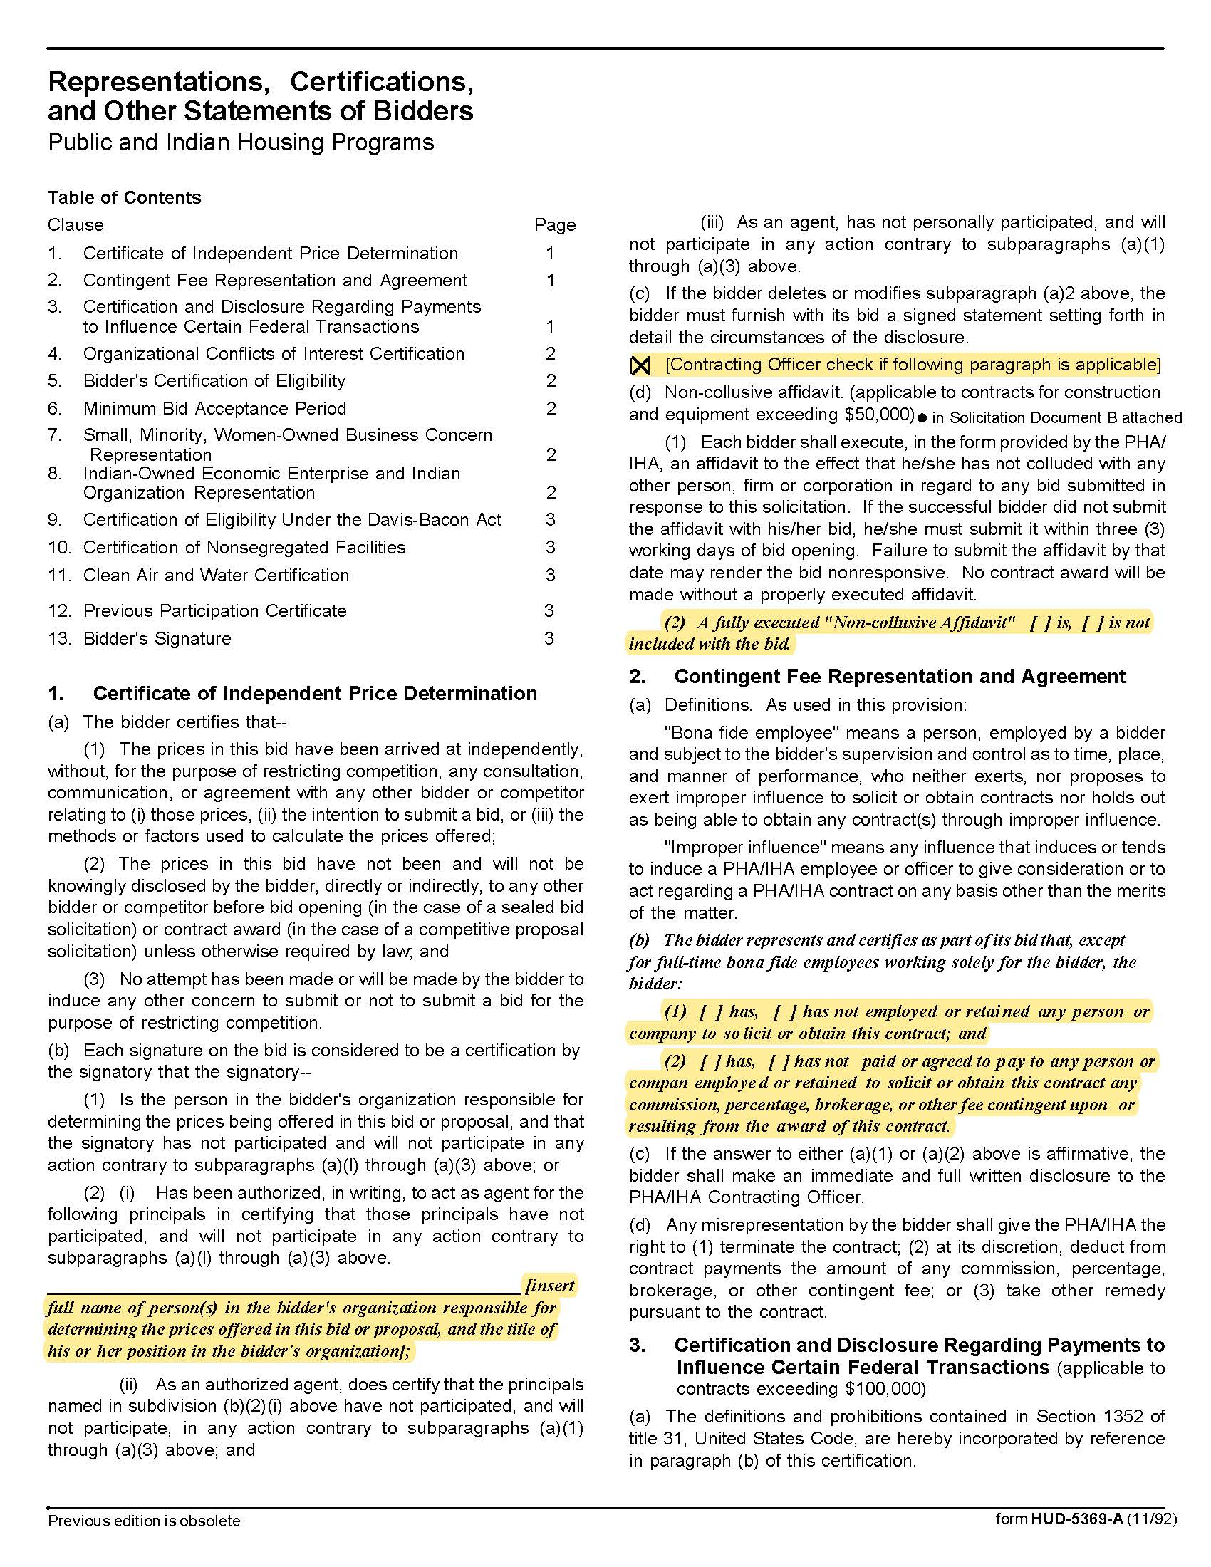

Wait List Analysis Services Q1914
Solicitation Document C HUD Form 5369A - Continued
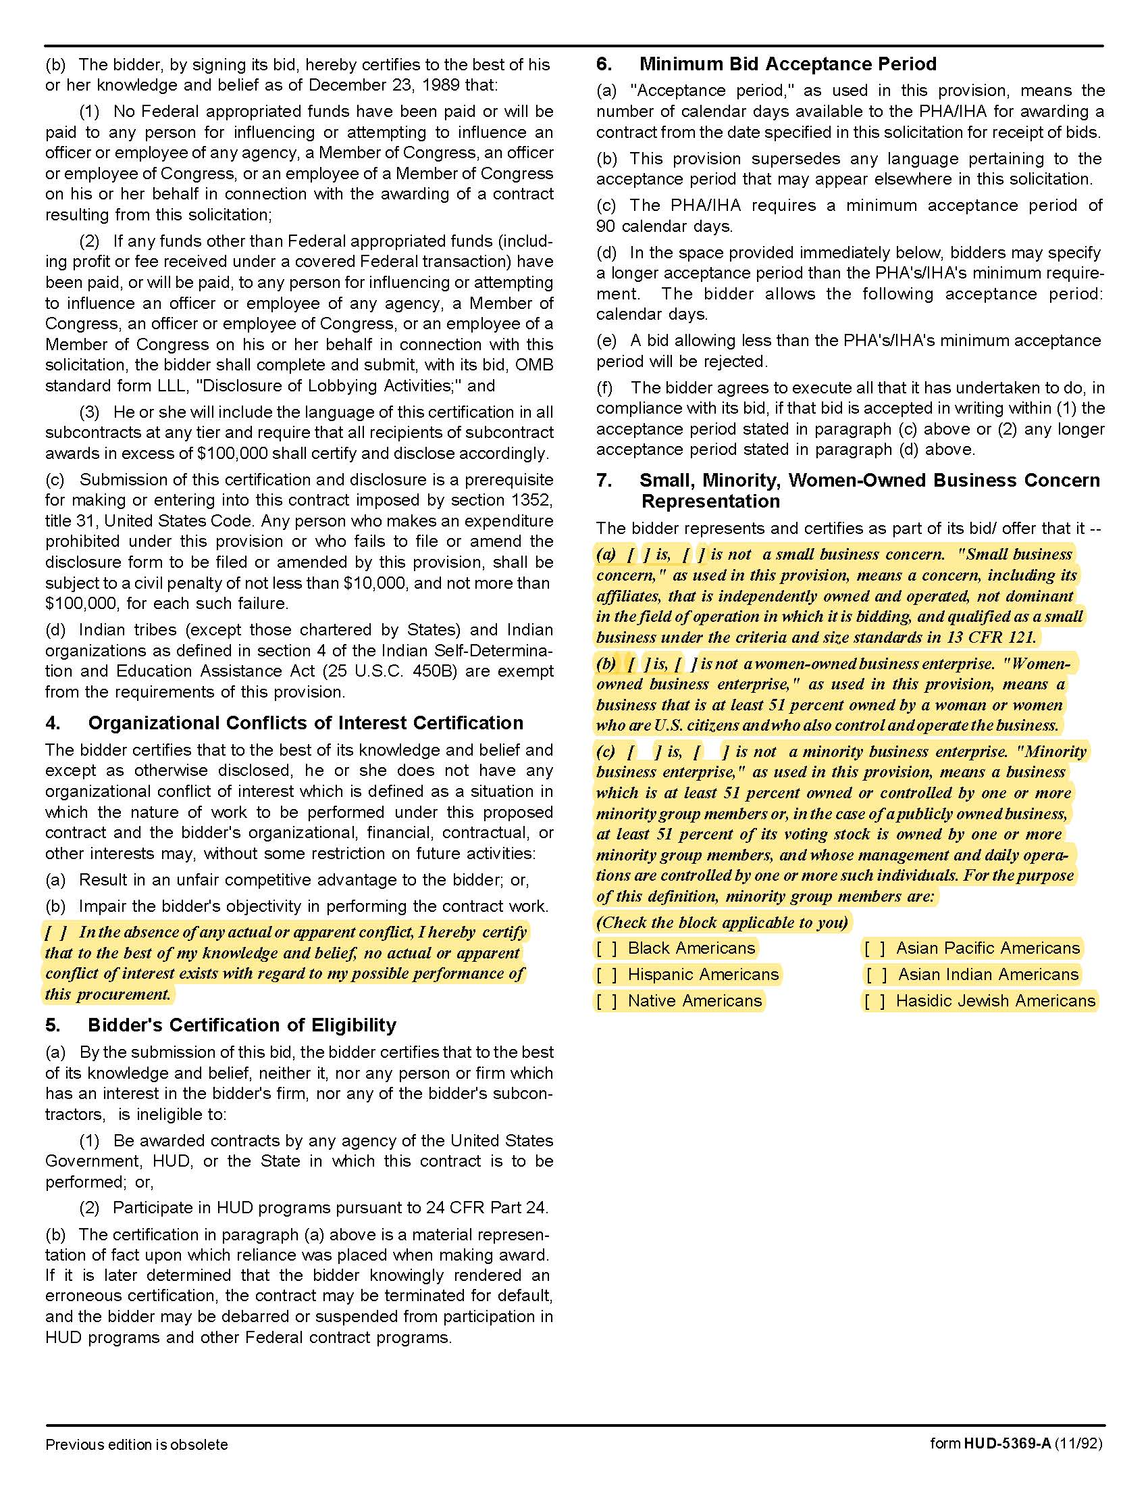

Wait List Analysis Services Q1914
Solicitation Document C HUD Form 5369A - Continued
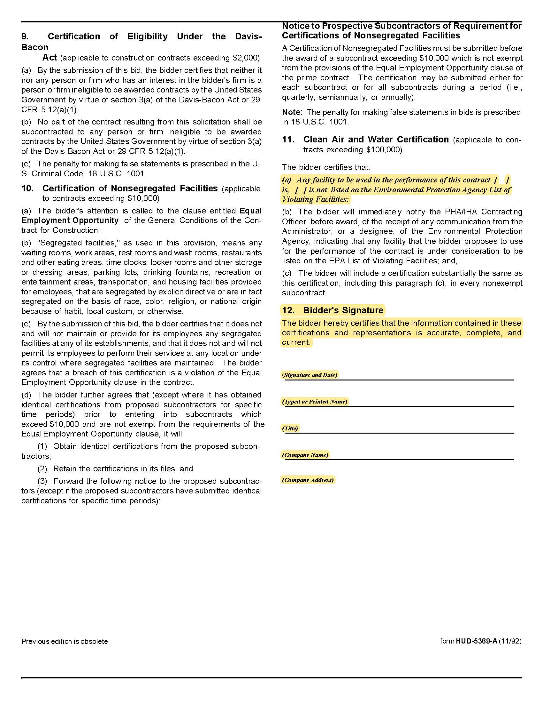

Wait List Analysis Services Q1914
Solicitation Document D Supplier Qualifications Statement

Use this section of your response to detail your company’s qualifications. Include such information as:

1. A narrative description of the company
- Years in Business
- Staff Size
- Resources available to complete this work

2. Staff Resources
- Certifications
- KCDC’s primary contact
- The individual with day-to-day responsibility for the services
- Provide information about the capabilities and experience of these individual in the areas of fair housing and independent testing.

3. Provide a list of recently completed projects of a similar nature and scope. For each identify:
- Housing Authority served
- Size of wait lists
- Contact person
- Contact person’s email

4. Indicate plans to partner with Section 3, small, minority, or woman owned firms to complete this work.
- If any

Wait List Analysis Services Q1914
Solicitation Document E Service Plan

1. Describe the approach you would recommend to meet the program objectives and for undertaking the
scope of services described herein:

- To review population data from both our site-based waitlists and overall portfolio and compare them with KCDC’s Admissions and Continued Occupancy Policies (ACOP) and Affirmative Fair Housing Marketing Plan(s) to determine whether the composition of our waitlist and KCDC-housed population reflects the unbiased implementation of our policies;
- Compare them with population trends in both our site-based waitlists and overall portfolio
- Compare them with population trends found in Knoxville Census data to establish if the Site-Based Wait Lists administered by KCDC are not being administered in a discriminatory manner and have not resulted in the development of any patterns of discrimination.

2. Describe the materials that would be produced for KCDC under the contract.

3. Describe the manner in which you propose to work with KCDC.

4. Describe the challenges, opportunities and obstacles you anticipate in implementing the services.

Wait List Analysis Services Q1914
Solicitation Document F Cost

Proposers shall submit a Fee Schedule in this format:

A. Compensation for the services shall be based on an hourly rate. Provide the hourly rates for all personnel classifications that may be assigned to the services. Hourly rates shall include all direct and indirect costs of providing the services, including overhead, but not including reimbursables. Furthermore, in order to provide a cost comparison in evaluating the hourly rate fee component of the RFP responses, please provide your anticipated personnel and time allocations for the services out of an estimated total time of 350 hours. Your responses are not intended to limit the scope of the RFP.

Personnel | Time/tasks | x Rate | = Sub-Totals
e.g. Investigator | ____ hours | $_____/hour | $______
 | Total Time: 350 hrs.
SUB-TOTAL FEE:
(if applicable)

B. Reimbursables. Please list all anticipated reimbursables together with their estimated costs.

Reimbursables | x Costs | = Sub-Totals
 | SUB-TOTAL FEE:

C. Total Fee

Part A | + Part B | = Total Fee

