Request for Proposals

Solicitation Name | Dental Insurance Q2003
Responses Must Arrive No Later Than  (As KCDC’s Procurement Office clocks indicate) | 2:00 p.m. on August 5, 2019
Deliver Responses to: | Knoxville’s Community Development Corporation    Procurement Division  901 N. Broadway  Knoxville, TN 37917  Procurement is behind the main office building.
Electronic Copies | Electronic copies are available on KCDC’s webpage or by email at purchasinginfo@kcdc.org.
Responses may be Emailed to KCDC | ☐ Yes ☒ No
Printed Responses Required | ☒ Yes ☐ No
Solicitation Meeting | ☐ Yes ☒ No
Solicitation Meeting is Mandatory | ☐ Yes ☐ No ☒ Not Applicable
Solicitation Meeting Date and Time | Not Applicable
Solicitation Meeting Location | Not Applicable
Solicitation Meeting via Telephone | Not Applicable
Site Visit Schedule | Not Applicable
Questions About This Solicitation | Submit questions to purchasinginfo@kcdc.org  KCDC will not accept questions via telephone.
Award Results | KCDC posts the award decision to its web page at: http://www.kcdc.org/procurement/
Open Records/Public Access to Documents | All document provided to KCDC are subject to the Tennessee Open Meetings Act (TCA 8-44-101) and open records requirements.
Check KCDC’s webpage (https://www.kcdc.org/procurement/) for addenda and changes before submitting your response

General Information

1. Background and Intent

a. Knoxville's Community Development Corporation (KCDC) is the public housing and redevelopment agency for the City of Knoxville and for Knox County in Tennessee. KCDC’s affordable housing property portfolio includes 20 sites with approximately 3,525 dwelling units. Several of the properties include Low Income Housing Tax Credits units and KCDC is both the General Partner and the management company for those sites. Those properties include Eastport Development, LP; Five Points 1, LP; Five Points 2, LP; Five Points 3, LP; Lonsdale, LP; North Ridge Crossing, LP; and Vista at Summit Hill, LP. KCDC also oversees approximately 3,958 Section 8 Vouchers, 82 Moderate Rehabilitation units and 20 Redevelopment areas.

b. KCDC is seeking proposals for dental plans offering benefits equal to or better than our current plan to be effective on 01-01-20. See Exhibit B on KCDC’s webpage for a summary of the current dental plan benefits. KCDC benefits program also includes the following:

- High Deductible Health Plan with a Health Reimbursement Account
- Wellness Plan
- Dental Insurance
- Group Life Insurance with AD&D
- Voluntary Supplemental Life Insurance
- Group Long Term Disability
- Group Short Term Disability
- Post‐Employment Health Plan‐‐VEBA 501(c)(9)
- Retirement Plans (401a and 457b)
- Employee Assistance Program

c. Cancelation
The successful vendor and KCDC shall agree that the contract will be in effect for not less than 12 months commencing January 1, 2021 and shall not be canceled by either party without 60 days written notice unless mutually agreed to by both parties.

d. Eligibility

1. All regular, full-time employees working 30 or more hours per week are eligible for benefits.

2. Dependents of “a” including:

a. Legal spouse, and

b. Dependent children to age 26

3. Former employees who elect to continue their coverage under COBRA provisions.

2. Changes after Award
It is possible that after award KCDC will need to revise the service needs or requirements specified in this document. KCDC reserves the right to make such changes after consultation with the supplier. Should additional costs arise, the supplier must document increased costs. KCDC reserves the right to accept and negotiate these charges.

3. Codes and Ordinances
All work covered is to be done in full accord with national, state and local codes and ordinances and orders that are in effect at the time the work is performed.

4. Contact Policy
Only contact KCDC’s Procurement Division about this solicitation from the issuance of this RFP until award. Information obtained from an unauthorized officer, agent, or employee will not affect the risks or obligations assumed by the proposer or relieve the proposer from fulfilling any of the conditions of the resulting award for the purpose of this project. Such contact can disqualify the proposer from the solicitation process.

5. Exhibits
All exhibits are posted on KCDC’s webpage.

- Exhibit A Census - employee listing including date of birth, sex, zip code and election tier.
- Exhibit B KCDC Summary of Benefits
- Exhibit C Summary of current and proposed plan design
- Exhibit D Claims Data

6. Evaluation

a. KCDC alone determines (using NIGP’s definition and other relevant sources as appropriate) the supplier’s “responsive” and “responsible” status prior to award. Responsible means a business with the financial and technical capacity to perform the requirements of the solicitation and subsequent contract. A responsive bid/proposal is one that fully conforms in all material respects to the solicitation document and all of its requirements, including all form and substance.

b. KCDC reserves the right to request additional information to assist in the evaluation process. This includes references and business capacity information.

c. KCDC will review all proposals and reserves the right to request necessary modifications, waive minor technicalities, reject all proposals, reject any proposal that does not meet mandatory requirement(s) or cancel this RFP, according to KCDC’s best interests.

KCDC plans to award to the best overall proposal on the following evaluation scale:

Factors | Maximum Points
Administration/Experience | 20
Cost of Product | 35
Benefit Design/Provider Network | 35
Employee Education and Wellness Benefits | 10
Total | 100

7. General Instructions
KCDC does not insert “General Instructions to Suppliers” in solicitation documents. These instructions are at www.kcdc.org. Click on “Procurement” and the link to the instructions. The supplier’s submittal means acceptance of the terms and conditions set forth in KCDC’s “General Instructions to Suppliers.”

8. Insurance Brokers
KCDC will not accept proposals from insurance brokers. KCDC will only accept proposals from insurance companies who can provide the services as stated in this RFP. Cowan, a division of HUB International is KCDC’s broker and any commissions are payable to Cowan if included. Cowan will assist KCDC in the analysis of the proposals.

9. Invoicing

a. Suppliers are asked to email invoices with 10 days following work completion and are required to submit invoices within 90 days following the delivery of the goods or services. KCDC may deny invoices submitted after the 90-day threshold.

b. KCDC normally pays by electronic transfer (ACH). Suppliers set up their access to KCDC’s Supplier Portal to track actual payments made. KCDC is not able to routinely offer payment history assistance and so if the supplier is unable or unwilling to use KCDC’s Supplier Portal to track payments, consider whether or not to submit a response to this solicitation.

10. Length of Award
The length of the award will initially be 12 months. KCDC is requesting a 3-year rate guarantee with the option to extend for an additional 2 years.

11. Licensure
All insurance companies proposed for usage must be properly licensed to perform those services in the State of Tennessee.

12. Price Structure
At the end of each award period, the awarded supplier may request a price change. The supplier must provide proof of increased Producer Price Index (Knoxville) to the Procurement Division. Suppliers may lower prices at any time with or without notice. KCDC will decide whether to accept a price increase. If the price increase is accepted, the solicitation file will be so noted. If the price increase is not accepted, the supplier may continue with the existing pricing, suggest an alternative price increase or end the award.

Scope of Work/Description of Work

13. Goals
KCDC’s goals are to:

a. Provide the most cost beneficial-comprehensive dental plan available.

b. Offer a quality benefit plan, large provider network, accurate and timely claims processing, effective plan administration and excellent customer service.

c. Be compliant with all legal and regulatory requirements pertaining to the benefits and wellness programs.

14. Services Desired

a. Maintain on-line eligibility including employee and dependent data, and special notes to file.

b. Provide direct certification of eligibility.

c. Maintain fully automated claims adjustment: dedicated claim adjuster, benefit plan on-line, HIPAA reasonable and customary guidelines; duplicate bill and specific information on the provider or claimant; provider compensation payment; three-year rolling claims history.

d. Provide explanation of benefits (EOB) to claimants.

e. Provide information to providers about the plan of benefits.

f. Inform covered participants in a timely fashion of lapse or termination of their eligibility to receive covered services.

g. Provide accurate and timely adjudication of claims (e.g., claims should be adjudicated within ten business days of receipt of all information necessary to adjudicate; correction of errors should be made within 5 working days; follow-up to requests to providers for additional information should occur within 7 working days.)

h. Provide direct claim processing.

i. Prepare and send payments to providers and participants in a timely and accurate manner, within 5 working days of completion of adjudication.

j. Provide claim forms in a format acceptable to KCDC.

k. Provide participant identification cards.

l. Prepare reports as may be required by a regulatory agency. KCDC is not subject to ERISA which will affect the number of reports required.

m. Provide required statistical reports that are accurate, complete, and timely.

n. Provide a toll-free Customer Service Number for claim inquiries if claims office is outside the local service area.

o. Provide assistance on case law concerning litigation involving COBRA, adjudication or claims, or other related matters.

p. Provide timely, accurate and courteous claim adjudication information to plan participants and to KCDC’s Human Resources staff.

q. Dedicated customer relations representative who is available to discuss and resolve issues as needed.

r. Notify participants in writing of denial of claim within 14 days of denial.

s. Provide an appeal process, which shall be completed within 30 days of carrier’s receipt of written notice of appeal.

t. Disclosure of components of dental care service costs (i.e., capitation, administration, taxes, network fees, printing, membership services, et cetera).

u. On-line access for KCDC for eligibility changes, additions and deletions. If not available, please provide a written description of the method for making eligibility changes (adding and deleting members).

v. Carrier agrees to issue drafts of the Summary Plan Description (SPD) to HUB International for review within 30 calendar days of the effective date. Once the SPD draft has been reviewed, carrier agrees to print and deliver booklets to HUB International or the company locations within 30 calendar days of the approval date.

w. Full management reports as needed including monthly accounting reports and monthly claim reports.

x. Will notify KCDC of renewal action or any change within 120 days of renewal date. Will provide with the renewal, annual claims experience, which will include paid claim, income, enrollment, and utilization information.

y. Dental carriers will agree to administer the dental plan according to KCDC’s IRC Code Section 125 plan and allow changes mid-year for the following life events:

i. Change in legal marital status (marriage, divorce, annulment, legal separation, death of spouse)
ii. Commencement or termination of employment of spouse
iii. Termination of employee’s employment
iv. Dependent ceases to meet dependent eligibility status
v. Change in number of tax dependents (birth, adoption, placement for adoption, death)
vi. Change in work schedule (reduction or increase in hours worked by employee, spouse or dependent; changing from part-time to full-time or vice versa)
vii. Significant change in you or your spouse’s health coverage, attributable to loss of eligibility for spouse’s group insurance
Election change must be consistent to life event.

15. Confidentiality

a. All reports, information, or data prepared or assembled by the selected firm are confidential and the selected firm agrees that said reports, information or data will not be available to any individual or organization without the prior written approval of KCDC.

b. In addition, KCDC may disclose certain information to the selected firm and the selected firm may have access to certain information not generally known to others and is confidential. The selected firm agrees not to use or disclose to any third party except in the performance of services hereunder any such confidential information. The selected firm further agrees to cause its employees and any subcontractors to undertake the same obligations of confidentiality. These provisions shall survive the termination of the contract.

16. Plan Design

a. KCDC is seeking proposals for fully insured dental insurance products. Proposal should include plan design and provisions.

b. All proposals should include standard commissions based on KCDC’s size and must be disclosed in your RFP.

17. Submittal Instructions
Submit your information in the order indicated below:

Document | Title | Provided by
 | Table of Contents | Proposer
Solicitation Document A | General Response Section | KCDC
Solicitation Document B | Affidavits | KCDC
Solicitation Document C | HUD Form 5369A | KCDC
Solicitation Document D | Proposer’s Response to Questionnaire | KCDC
Solicitation Document E | Proposer’s Cost Proposal | KCDC
Solicitation Document F | Proposer’s References | KCDC
Solicitation Document G | Proposer’s Exceptions to Criteria Herein | KCDC
Solicitation Document H | Proposer’s Additional Information | Proposer
Solicitation Document I | Required Documents supplied by the Proposer | Proposer

a. Place your company’s name on each page and number all pages consecutively

b. This document is available in MS Word format and can be downloaded from KCDC’s webpage. KCDC’s Adobe copy of the document will remain the “official” version of the document.

This and the Previous Pages Do Not Need to be Returned

Dental Insurance Q2003

Solicitation Document A General Response Section

General Information about the Supplier
Sign Your Name to the Right of the Arrow
By signing, you indicate you read and agree to “KCDC’s General Instructions to Suppliers” on www.kcdc.org.
Printed Name and Title
Company Name
Street Address
City/State/Zip
Contact Person (Please Print Clearly)
Telephone Number
Cell Number
Supplier’s E-Mail Address (Please Print Clearly)
Addenda
Acknowledge addenda have been issued by checking below as appropriate:
None ☐ | Addendum 1 ☐ |  |  | Addendum 2 ☐ |  | Addendum 3 ☐ |  |  | Addendum 4 ☐ | Addendum 5 ☐
Statistical Information (Check all the apply)
This business is at least 51% owned and operated by a woman |  |  |  |  |  |  |  |  |  |  | Yes ☐ No ☐
This business qualifies as a small business by the State of Tennessee  Total gross receipts of not more than $10,000,000 average over a three-year period OR employs no more than 99 persons on a full-time basis |  |  |  |  |  |  |  |  |  |  | Yes ☐ No ☐
This business qualifies as Section 3 business (as defined by HUD):  It is at least 51% owned by a Section 3 resident (lives in Public Housing) or it employs Section 3 residents for at least 30% of its employee base; or it commits to subcontract at least 25% of the project’s dollars to a Section 3 business. |  |  |  |  |  |  |  |  |  |  | Yes ☐ No ☐
This business is owned & operated by persons at least 51% of the following ethnic background:
Asian/Pacific ☐ |  | Black ☐ | Hasidic Jew ☐ |  | Hispanic ☐ |  |  | Native Americans ☐ |  |  | White ☐
Cooperative Procurement
Subject to additional location/delivery charges, the supplier agrees to extend the offered costs to other governments if the government so desires. Yes ☐ No ☐
Prompt Payment Discount
A prompt payment discount of ________% is offered for payment within ____ days of submission of an accurate and proper invoice.
MasterCard Acceptance
Mastercard is accepted for payment without additional fees. Yes ☐ No ☐
Mastercard is accepted for payment with a fee of _______. Yes ☐ No ☐

Dental Insurance Q2003

Solicitation Document B Affidavits

Supplier: _____________________________________________________________________________

Conflict of Interest:
1. No commissioner or officer of KCDC or other person whose duty it is to vote for, let out, overlook or in any manner superintend any of the work for KCDC has a direct interest in the award or the supplier providing goods or services.

2. No employee, officer or agent of the grantee or sub-grantee will participate in selection, or in the award or administration of an award supported by federal funds if a conflict of interest, real or apparent, would be involved. Such a conflict would arise when the employee, officer or agent, any member of his immediate family, his or her partner, or an organization, which employs, or is about to employ, any of the above, has a financial or other interest in the supplier selected for award.

3. The grantee's or sub-grantee's officers, employees or agents will neither solicit nor accept gratuities, favors or anything of monetary value from suppliers, potential suppliers, or parties to sub-agreements.

4. By submission of this form, the supplier is certifying that no conflicts of interest exist.

Eligibility:
5. The supplier is eligible for employment on public contracts because no convictions or guilty pleas or pleas of nolo contender to violations of the Sherman Anti-Trust Act, mail fraud or state criminal violations with an award from the State of Tennessee or any political subdivision thereof have occurred.

General:
6. Supplier fully understands the preparation and contents of the attached offer and of all pertinent circumstances respecting such offer.

7. Such offer is genuine and is not a sham offer.

Iran Divestment Act:
8. Concerning the Iran Divestment Act (TCA 12-12-101 et seq.), by submission of this bid/quote/proposal, each supplier and each person signing on behalf of any supplier certifies, and in the case of a joint bid/quote/proposal, each party thereto certifies as to its own organization, under penalty of perjury, that to the best of its knowledge and belief that each supplier is not on the list created pursuant to § 12-12-106.
Non-Collusion:
9. The price or prices quoted in the attached offer are fair, proper and not tainted by any collusion, conspiracy, connivance, or unlawful agreement on the part of the supplier or any of its agents, representatives, owners, employees, or parties in interest, including this affiant.

Dental Insurance Q2003

Solicitation Document B Affidavits - continued

10. Neither the said supplier nor any of its officers, partners, owners, agents, representatives, employees or parties interest, including this affiant, has in any way colluded conspired, connived or agreed, directly or indirectly, with any other responder, supplier, or person to submit a collusive or sham offer in connection with the award or agreement for which the attached offer has been submitted or to refrain from making an offer in connection with such award or agreement, or collusion or communication or conference with any other supplier, or, to fix any overhead, profit, or cost element of the offer price or the offer price of any other supplier, or to secure through any collusion, conspiracy, connivance, or unlawful agreement any advantage against KCDC or any person interested in the proposed award or agreement.

Accuracy of Electronic Copies:
11. If the supplier provides electronic copies of the bid/proposal/quote to KCDC, the supplier certifies that the information provided on paper and in the electronic format is identical unless specifically noted otherwise.
No Contact/No Advocacy Affidavit
12. After this solicitation is issued, any contact initiated by any proposer with any KCDC representative concerning this proposal is strictly prohibited-except for communication with the Procurement Division. My signature signifies that no unauthorized contact occurred.

13. To ensure the integrity of the review and evaluation process, respondents to this solicitation nor any firm representing them, may not lobby or advocate to KCDC staff or Board members. My signature signifies that no unauthorized advocacy occurred.

The undersigned hereby acknowledges receipt of these affidavits and certifies that the submittal in response to this solicitation is in full compliance with the listed requirements.

Signed by
Printed Name
Title
Subscribed and sworn to before me this date
By (Notary Public)
My Commission Expires on
Notary Stamp

Dental Insurance Q2003

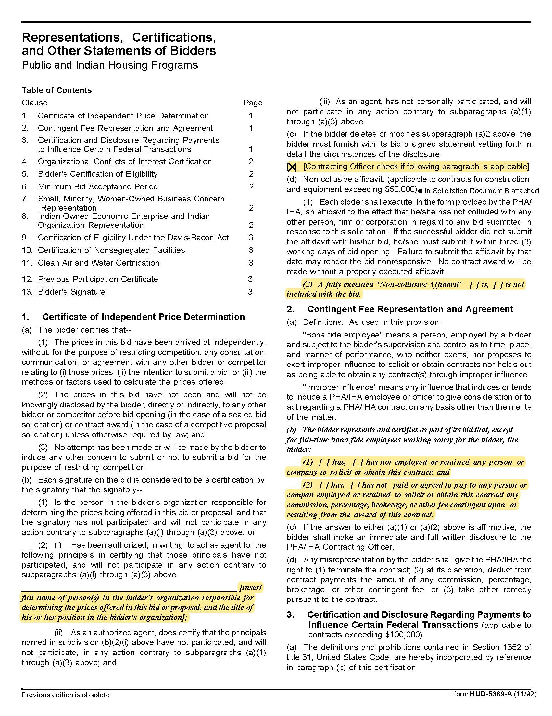
Solicitation Document C HUD Form 5369A

Dental Insurance Q2003
Solicitation Document C HUD Form 5369A - Continued
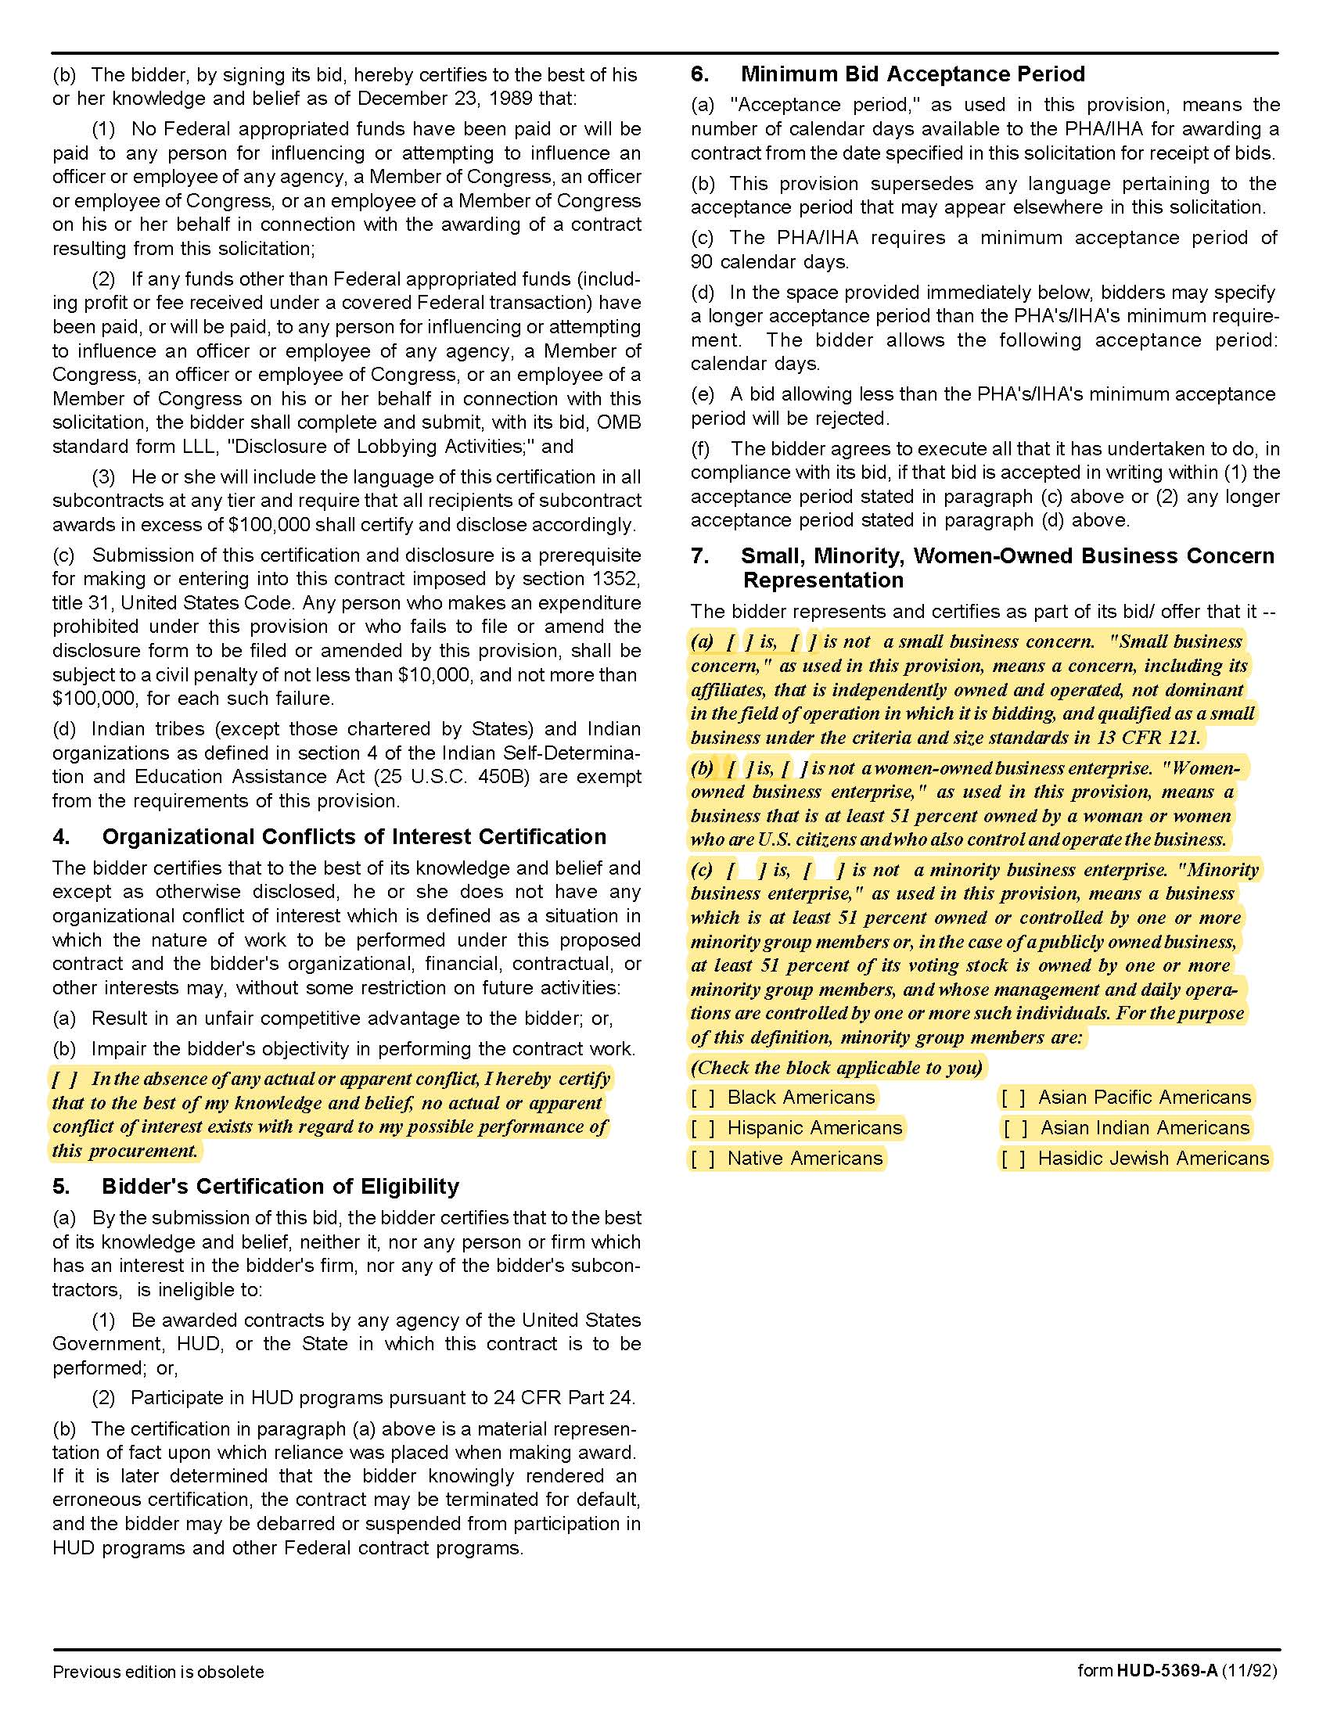

Dental Insurance Q2003
Solicitation Document C HUD Form 5369A - Continued
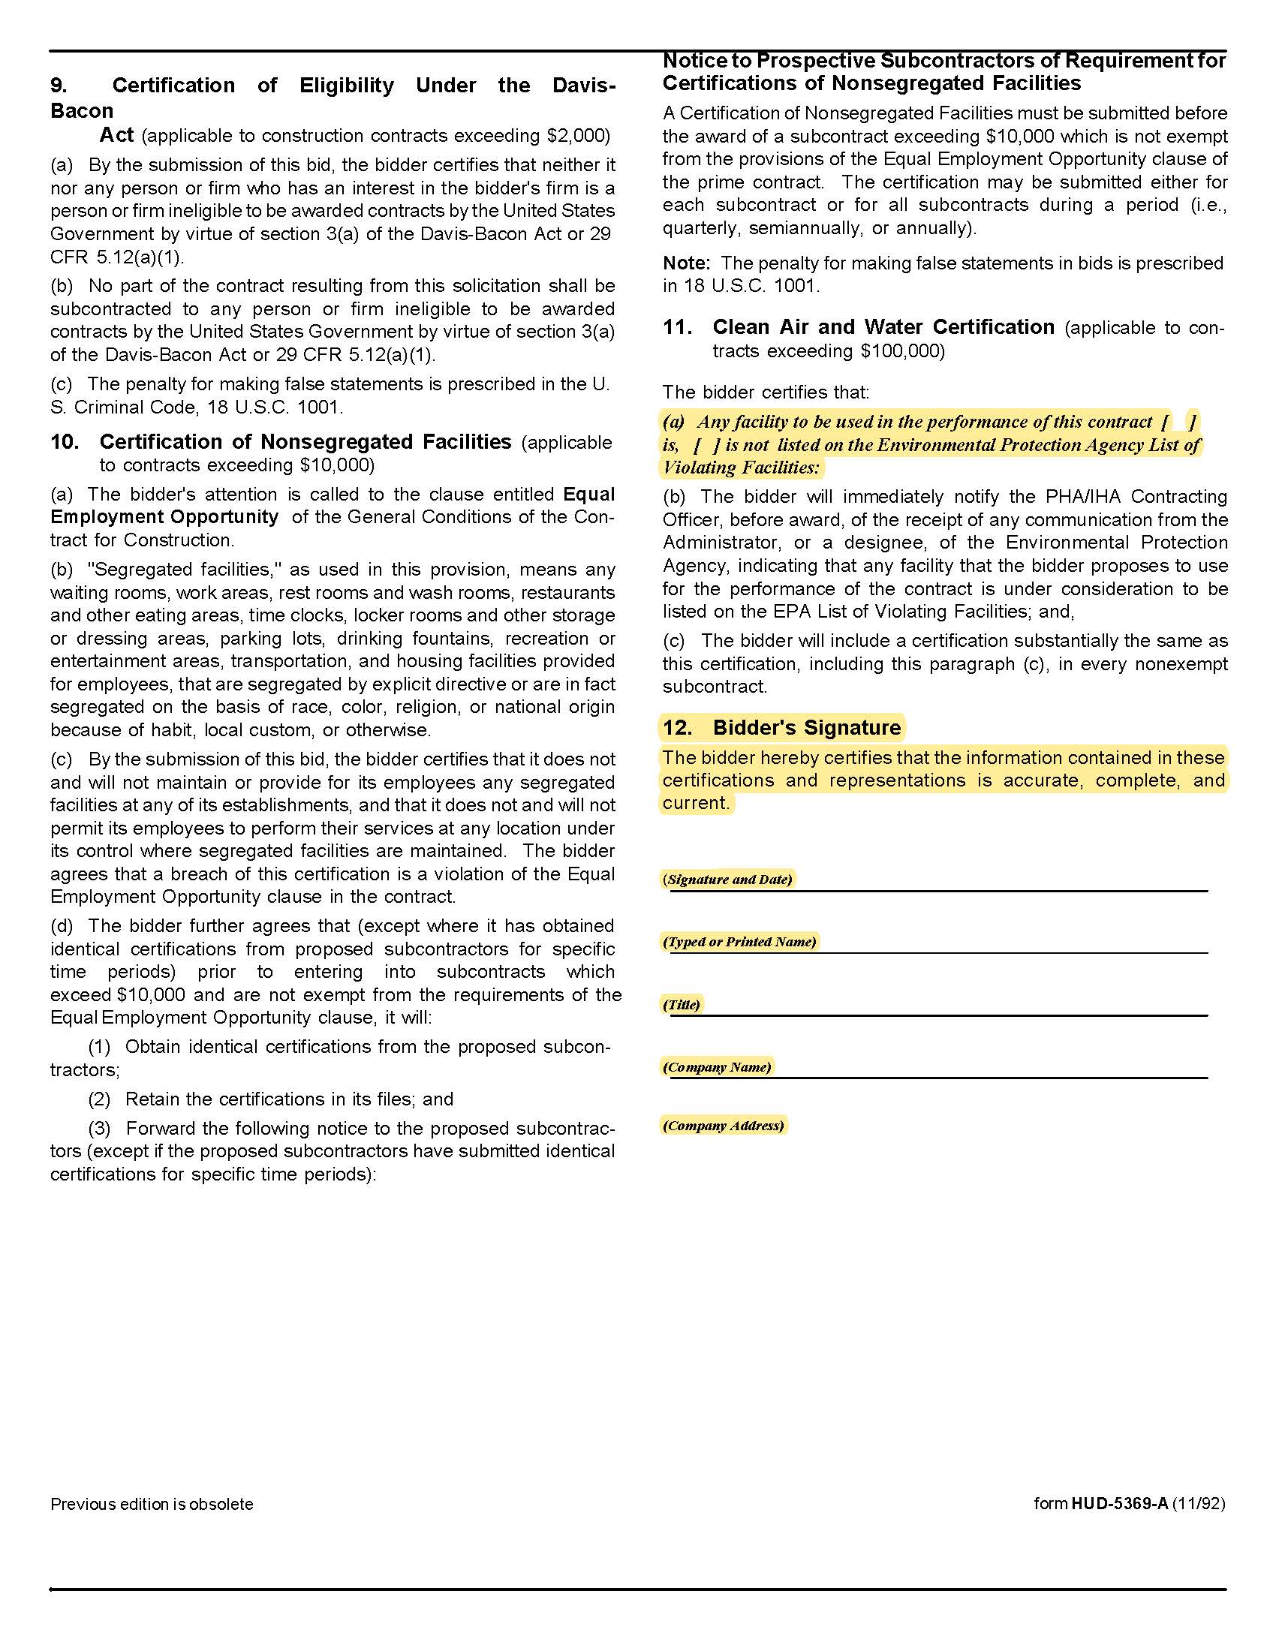

Dental Insurance Q2003
Solicitation Document D Proposer’s Response to Questionnaire

All questions must be answered directly and completely. Attach information to fully explain your approach to a particular question as needed. Incomplete answers will not be given consideration in the evaluation process.

Section A. Administrative Capability/Management Experience

1. Provide the legal name and address of your firm.

2. Provide the name of any parent company or sponsoring entity with majority ownership in the firm.

3. How long has your firm been in operation?

4. How many years have you offered dental insurance in operation in the Knoxville area?

5. Provide your current enrollment figures (number of members) of your firm for the coverage you are offering.

6. How many employers are represented in this number?

7. What are your 2017 enrollment figures in the Knoxville Service Area for the coverage(s) you are offering?

8. Provide the current number of participating employers and participation for each of the last 2 years.

9. Provide the number of employers who have terminated in each of the last 2 years for the type(s) of plans you are proposing.

10. Please provide a brief biographical sketch of all individuals in management positions with the provider and include similar information for the account executive(s) who will be working with KCDC. Include:

- Names
- Qualifications
- Years of relevant experience
- Services they will provide to KCDC

11. Does your agreement with participating providers guarantee a specified time for turnaround of claims?

12. Who is the contact person for the following areas?

- Initial plan set up
- Billing problems
- Claim problems
- Enrollment issues

Dental Insurance Q2003
Solicitation Document D Questionnaire-continued

13. What is the average hold time for customer service calls?

a. Do you have a “back line phone number” or “direct support phone number” for Plan Administrators?

b. What is the average hold time for your Plan Administrator line?

c. How many employees staff the Plan Administrator line during normal business hours?

14. What are your minimum participation requirements?

15. Describe plan materials available to members.

16. How do you communicate changes regarding benefit design and administrative procedures to employers and participants?

17. Is information regarding changes to benefit design and administrative procedures passed onto employers and employees prior to enacting the change?

18. How do you ensure plan administrators are aware of the changes before notification is sent to members?

19. What specific claim data on KCDC employees and dependents can be provided?

- Monthly
- Quarterly
- Annually

20. During the past 5 years, have any plan participants filed a lawsuit against your company?

Section B. Availability of Services
21. What services are you able to provide employees via the phone and what are their days and hours of operation? Please include hours of operation and time zone for your toll-free numbers for members and employers (if separate) for:

- Customer service
- Provider service

a. What support do you provide to plan administrators?

b. Describe on-line services available to plan administrators?

22. Describe procedures for members to access dental care providers.

a. How often do you update the information on your website (i.e., provider directories, etc.)?
Dental Insurance Q2003
Solicitation Document D Questionnaire-continued

23. Give an estimate of the number of participants your provider network could adequately service.

a. List any anticipated deletions from your provider network during the next twelve months. You may also provide a list of anticipated additions at your discretion.

Section C. Costs of Product

24. Give the average rate increase percentage for 2018 and the past three years in Knoxville Service Area.

Section D. Benefit Design

25. List all optional benefits you currently offer including cost and requirements for all.

Section E. Financial Information

26. Provide profit/loss amount expressed per participant as of 1/1/19. Do not vary from this request.

27. Provide profit/loss at the end of the last 2 fiscal years. Do not vary from this request.

28. Describe the process to protect KCDC and enrollees in the event of insolvency.

Section F. Quality of Providers & Facilities

29. Describe programs to monitor and evaluate quality of care.

30. Who conducts these programs?

31. Have changes been adopted because of quality reviews?

32. If so, what?

33. Describe procedures for handling employee suggestions and grievances concerning network providers.

Section G. Employee Education and Wellness Benefits

34. What services/programs do you offer to assist members in getting necessary care for major dental issues?

a. List the program

b. Provide a brief description of the program

c. Describe the criteria for participation.

Dental Insurance Q2003
Solicitation Document D Questionnaire-continued

Section H. Open Enrollment Meetings

35. KCDC will hold Open Enrollment Meetings during mid-October. The selected vendor may commit to provide account representatives during this time to present plan information and answer questions about benefits.

Dental Insurance Q2003

Solicitation Document E Cost Proposal

Proposers are to complete the following cost information tables.

Option A Dental Insurance

 | Employee Only Contract | Employee + spouse | Employee + Child(ren) | Family Contract
Year One | $ |  |  | $
Year Two | $ |  |  | $
Year Three | $ |  |  | $
Estimate Enrollment Year One
Estimate Enrollment Year Two
Estimate Enrollment Year Three

Option B Dental Insurance

 | Employee Only Contract | Employee + spouse | Employee + Child(ren) | Family Contract
Year One | $ |  |  | $
Year Two | $ |  |  | $
Year Three | $ |  |  | $
Estimate Enrollment Year One
Estimate Enrollment Year Two
Estimate Enrollment Year Three

Dental Insurance Q2003

Solicitation Document F References

The proposer must include at least 5 specific references of similar accounts. KCDC prefers references from
“affordable housing, not for profit, governmental agencies” companies but will accept other references at its
discretion.

While you may have had numerous separate contracts with a particular company, a company can only be 1 reference. Provide the following information:

- Business Name
- Contact Person
- Contact Person Email Address
- Contact Person Telephone Number
- Date Contract Began
- Date Contract Ended
- Number of Employees

Dental Insurance Q2003

Solicitation Document G Exceptions Taken

Clearly relate the section and item number of the criteria that is in question. Detail your exception.

Dental Insurance Q2003

Solicitation Document H Additional Information

This is the place to provide any additional information that the proposer desires to supply.

Dental Insurance Q2003

Solicitation Document I Required Documents (to be submitted with the proposal)

1. Provide an administration manual to be used by KCDC.
2. Provide sample copies of your billing.
3. Provide a sample packet of plan materials to be distributed to employees.
4. Provide a sample of your employer contract.
5. Provide current provider directories and instructions for viewing current providers on-line.
6. Provide a copy of your current contract.
7. Provide a copy of benefit contract/booklet describing benefits and all limitations and/or restrictions.
8. Provide a copy of the current audited financial statement.
9. Provide a statement of current financial reserves.
10. Provide a detailed benefit summary that specifies the services included in each coverage category. Specify
the services that are subject to co-pays, deductible and co-insurance.

