City of Myrtle Beach
Invitation for Bid
IFB 17-B0058

Thermal Imager

Issue Date: April 27, 2017



First in Service

Issued By:
Ann Sowers
Purchasing Division
3231 Mr. Joe White Avenue
Myrtle Beach, SC 29577
Phone: 843-918-2170
www.cityofmyrtlebeach.com

City of Myrtle Beach Purchasing Division
3231 Mr. Joe White Avenue
Myrtle Beach, SC 29577

INVITATION FOR BID
IFB # 17-B0058 Thermal Imager

Buyer Contact: | Ann Sowers  (843) 918-2172  asowers@cityofmyrtlebeach.com
Mandatory Pre-Bid Conference:  Attendance is required for bid consideration. | N/A
Opening Date & Time: | Thursday, May 11, 2017 at 2:00pm
Bid Opening Location: | City of Myrtle Beach  3231 Mr. Joe White Avenue  Myrtle Beach, SC 29577

Please note the following required condition (if indicated by an X below):

_____ Bid for a service $20,000.00 or greater must be accompanied by a bidder’s bond in the amount of five
percent (5%) of the total dollar amount of the bid submitted, payable to the City of Myrtle Beach.

No bids will be accepted unless submitted on the forms furnished herein. All pages of the bid must be in a sealed envelope and delivered in accordance with these instructions:
- The envelope must be marked with the name of bidder, bid number/name, and time/date of bid opening.
- Bid packages shall be delivered to the address listed above. The City of Myrtle Beach is not responsible for late or misdirected mail.
If the above criteria are not met, your bid shall be rejected. Bids will be opened and read publicly at the time and date specified above.

Bidders are advised that from the date of issue of this solicitation until award of the contract, no contact with City personnel related to this solicitation is permitted. All communications/requests for clarification are to be directed to the Buyer listed above.

It is the intent and purpose of the City of Myrtle Beach that this Invitation for Bid promotes competitive bidding. It shall be the Bidder’s responsibility to advise the Purchasing Division if any language, requirements, etc., or any combination thereof, inadvertently restricts or limits the requirements stated in this Invitation to Bid to a single source. Such notification must be submitted in writing and must be received by the Purchasing Division no later than three (3) City of Myrtle Beach business days prior to the bid opening date.

Bidder to complete this section:

Name of Bidder: ________________________________________________________________________

Address: ______________________________________________________________________________

Phone Number: ________________________________________________________________________

E-mail: ______________________________________________________________________________

Please note: Signature is required on page 14.

CITY OF MYRTLE BEACH – GENERAL INSTRUCTIONS
MUST BE SIGNED AS PART OF INVITATION FOR BID PACKAGE

1.0 SUMMARY

  - DOCUMENT INCLUDES:

2.0 Authority
2.01 Equal Weight and Force
2.02 Written Explanations
2.03 Disputes with Written Explanations
2.04 Written Addenda

3.0 Requirements for Written Bid Documents
3.01 Availability of Documents
3.02 Non-Responsive Bids
3.03 Document Completion
3.04 Contents of Bid Packet
3.05 Single Package Requirement
3.06 Bid Submission
3.07 Bid Delivery/Opening
3.08 Document Ownership

4.0 Full Examination
4.01 Thorough Investigation
4.02 Pre-Bid Meetings
4.03 Evidence of Examination

5.0 Pricing
5.01 Unit Pricing
5.02 Cash Discounts
5.03 Changes in Cost

6.0 Tax Information
6.01 Sales Tax/Federal Tax
6.02 Payment of Taxes

7.0 Material Assessment
7.01 Product Documentation
7.02 MSDS
7.03 Evidence of Work/Product
7.04 Sample Submission
7.05 Sample Ownership
7.06 Furnished Items
7.07 Quality of Items

8.0 Changes in Specifications
8.01 Authority of Specifications
8.02 Equipment
8.03 Deviation from Specifications
8.04 Material Preference
8.05 Changes after Award
8.06 Equivalent Items

9.0 Modifications
9.01 Additional Work
9.02 Adjustments to Items/Work

10.0 Bond Requirements
10.01 Bid/Performance/Payment Bonds

11.0 Delivery
11.01 Warehouse Deliveries
11.02 Dates
11.03 Delivery Price
11.04 Documentation
11.05 Wrong Deliveries

12.0 Award Criteria/Timeline
12.01 Award Criteria
12.02 Contract Issuance
12.03 Contract Timeline
12.04 Notification

13.0 Bidder Responsibilities
13.01 Duration of Bid
13.02 Transfer of Responsibilities
13.03 Subcontractors
13.04 Coordination and Contact
13.05 Liquidated Damages

14.0 Indemnity Clause
14.01 Hold Harmless

15.0 Federal and State Laws
15.01 Employment Regulations

16.0 Financial Accounting
16.01 Representation
16.02 Payment

17.0 Bid Rejection/Withdrawal
17.01 Reasons for Rejection
17.02 Best Interest
17.03 Withdrawal Timeline

18.0 Protest Procedures/Timelines
18.01 Bid Specifications/Contract Terms
18.02 Intent to Award

19.0 City Reserved Rights
19.01 Reserved Right
19.02 Final Judgment
19.03 Clarification
19.04 Price Increase
19.05 Loss/Damage
19.06 Performance Failure
19.07 Negotiation

20.0 ADA Compliance
20.01 Contact Information

21.0 Signatures
21.01 Accuracy and Completeness
21.02 Compliance

  - DEFINITIONS:

- City of Myrtle Beach – herein referred to as “City.”
B. IFB – Invitation for Bid
C. Bidder – any vendor, proprietor, business, company, service provider, or
corporation who submits a bid to the City.
D. Bid – the collection of documents that includes these general instructions, the
scope of work and/or specifications, a written offer, and signature
page to be used for consideration in negotiations and/or contract
development.
E. Addendum – a written change, addition, alteration, correction, or revision to a
bid document.
F. Bond – provides financial assurance that the bid has been submitted in good
faith, that a bidder will enter into a contract at the amount bid, and
will provide the appropriate performance and payment bonds.
G. Bid Bond – an insurance agreement, accompanied by a monetary commitment,
by which a third party accepts liability and guarantees that the bidder
will not withdraw from the bid.
H. Performance Bond – guarantees execution of the terms of a contract.
I. Payment Bond – covers payment of subcontractors, laborers, and materials
suppliers associated with the project.

2.0 AUTHORITY:

2.01 Equal Weight and Force. The instructions herein contained are given for the
purpose of guidance in properly preparing an applicable bid. These directions
have equal weight and force with the specifications and strict compliance is
required with all of the provisions. Unless otherwise stated in the special
instructions of the bid, these general instructions will apply.

2.02 Written Explanations. Only written information from the procurement manager
or an authorized representative of the purchasing division is binding; therefore no
verbal instructions or verbal information from any other source will be binding on
the City. The City will not be responsible for any other explanation or interpretation
and the decision of the procurement manager or an authorized representative of the
purchasing division shall be final and binding upon each Bidder.

2.03 Disputes with Written Explanations. The written specifications are considered
clear and complete. Failure of the Bidder to call attention in writing to any disputes,
definitions, discrepancies, inconsistencies or incompleteness before the opening of
the bid in the time and manner set forth herein is a waiver of right to do so upon
opening of the bids. Clarifications requested by Bidders must be in writing not less
than three (3) City of Myrtle Beach business days before date and time set for
receipt of bids.

2.04 Written Addenda. Should the procurement manager deem it necessary to alter bid
specifications, those alterations will be made in the form of written addenda that
will be posted on the City website. The Bidder is responsible for monitoring the
website. These addenda shall then be considered as part of these specifications.

3.0 REQUIREMENTS FOR WRITTEN DOCUMENTS:

3.01 Availability of Documents. Bid documents shall be obtained through the City of
Myrtle Beach website (www.cityofmyrtlebeach.com), or in person at the City of
Myrtle Beach Purchasing Office, 3231 Mr. Joe White Avenue, Myrtle Beach, SC
29577, Monday through Friday (excluding City holidays), from 8:00 AM to 5:00
PM. Bid documents may be mailed or sent via e-mail by vendor request only.

3.02 Non-Responsive Bids. Bids that are incomplete, unsigned, improperly signed or
sealed, conditional, illegible, obscure, contain arithmetical errors, erasures without
initials, alterations or irregularities of any kind, shall be declared non-responsive.

3.03 Document Completion. Bid and signature document are provided as part of the
solicitation. This form must be used in submitting a bid and all pages of the bid
document must be completely filled out and signed by the Bidder. No bids will be
accepted unless submitted on the forms furnished herein. Erasures or corrections
made on the bid documents prior to submission must be initialed by the Bidder.

3.04 Contents of Bid Packet. The general instructions, scope of work and/or
specifications, and the bid and signature document constitute the bid packet. By
submitting a bid, the Bidder is deemed to have accepted all of the terms and
conditions set forth in the bid packet documents. All bid packet documents, after
completion by the Bidder, must be returned with the bid in the same order as
received by the Bidder.

3.05 Single Package Requirement. Unless otherwise stated in the special instructions
section of this bid request, submit one complete bid package using the attached
form(s), if applicable, for bid pricing.

3.06 Bid Submission. Each bid must be enclosed in a sealed envelope, clearly marked
on the outside with information as stated on the cover page and delivered to the
procurement buyer. If the required information is not clearly stated on the outside
of the envelope, the bid is considered non-responsive. Bids submitted after the date
and time set for receipt will be returned to the Bidder unopened and shall be
considered non-responsive.

3.07 Bid Delivery/Opening. All bids must be sealed, marked and delivered in
accordance with these instructions to Purchasing Division, City of Myrtle Beach,
3231 Mr. Joe White Avenue, Myrtle Beach, SC 29577. Bids will be opened and
read publicly at the time so specified on the front cover sheet.

3.08 Document Ownership. All documents, reports, bids, submittals, working
papers or other material submitted to the City from the Bidder shall become the
sole and exclusive property of the City, in the public domain, and are not the
property of the Bidder. The Bidder shall not copyright, or cause to be copyrighted,
any portion of any of said documents submitted to the City as a result of this
solicitation.

4.0 FULL EXAMINATION:

4.01 Thorough Investigation. Bidders shall make all investigations necessary to
thoroughly inform themselves regarding plant and facilities for delivery of material
and equipment and/or service to be performed as required by the bid conditions.
No plea of ignorance by the Bidder of conditions that exist or that may hereafter
exist as a result of failure or omission on the part of the Bidder to make the
necessary examination and investigations, or failure to fulfill in every detail the
requirements of the contract documents, will be accepted as a basis for varying the
requirements of the City or the compensation.

4.02 Pre-Bid Meetings. When Bidders are required to make site visits or attend
pre-bid meetings, all expenses shall be paid for by the Bidder, unless previous
written arrangements are made with the City. No bidder will be admitted to a pre-
bid meeting after the specified start time, otherwise the bid will be considered non-
responsive.

4.03 Evidence of Examination. Submission of a bid will be considered as
conclusive evidence of the Bidder’s complete examination, understanding, and
acceptance of the specifications.

5.0 PRICING:

5.01 Unit Pricing. Unit pricing will govern over extended prices unless otherwise stated
in special instructions in this bid request. All prices quoted should be firm. In those
cases where a firm bid cannot be made, consideration will still be given to all
Bidders. Also, maximum or ceiling prices should be quoted where possible when
bid contain non-firm prices.

5.02 Cash Discounts. Cash discounts, if allowed, should be so stated on the bid form.
Prices must, however, be based upon payment thirty (30) calendar days after
delivery.

5.03 Changes in Cost. If during the term of the contract entered into as a result of this
bid, the cost of material(s) is/are increased through no act on the part of the
contractor other than to comply with any prevailing rise in the market price(s) of
material(s) used, it shall be the contractor’s responsibility to notify the City of
Myrtle Beach Purchasing Office in writing of the price increase(s) and the effective
date of the increase(s). Price(s) shall be increased only to the point of absorbing
additional cost(s) of material(s) paid for by the contractor. At any time during the
term of the contract, the City may request that the contractor provide written
documentation from the manufacturer/supplier of the material(s) to substantiate
price increase(s). If during the term of the contract, the cost of material(s) to the
contractor is reduced, then the contractor shall reduce the contract price(s) and
notify the procurement buyer in writing.

6.0 TAX INFORMATION:

6.01 Sales Tax/Federal Tax. The City of Myrtle Beach pays South Carolina State Sales
Tax. The City is exempt from Federal Excise Tax and will issue exemption
certificates if required. All applicable taxes should be shown as separate line items
unless otherwise indicated.

6.02 Payment of Taxes. The contractor agrees to pay all taxes and license fees of
whatever nature applicable to conduct business and furnish the City of Myrtle
Beach, if requested, with duplicate receipts or other satisfactory evidence showing
the prompt payment of all taxes and fees when referred to and showing that all
licenses are in effect.

7.0 MATERIAL ASSESSMENT:

7.01 Product Documentation. Bid shall include adequate brochures, latest printed
specification and advertising literature describing the product(s) offered in such a
fashion as to permit ready comparison with the specifications on an item-by-item
basis where applicable.

7.02 Materials Data Safety Sheet (MSDS). If so requested in the bid documents, a
completed MSDS for the item(s) indicated must be provided with the bid
documents. Failure to submit this form upon request shall result in rejection of
bid.

7.03 Evidence of Work/Product. All Bidders must be prepared to present suitable
evidence of similar work recently completed or goods supplied. Products are to be
brand name or equal unless otherwise specified. If submitting an equal product,
supporting documents must be provided with bid.

7.04 Sample Submission. When samples are required with a bid, they must be
submitted with the bid unless approved by the purchasing manager or purchasing
manager’s authorized representative, or the bid shall be considered non-responsive.

7.05 Sample Ownership. Samples submitted will become the property of the City of
Myrtle Beach. The entire cost of the sample(s) shall be paid for by the Bidder
unless previous written arrangements are made with the City.

7.06 Furnished Items. Bidders are required to state exactly what they intend to furnish;
otherwise, they shall be required to furnish the items as specified.

7.07 Quality of Items. Bidders will submit, with their bid, data necessary to evaluate
and determine the quality of the item(s) they are bidding.

8.0 CHANGES IN SPECIFICATIONS:

8.01 Authority of Specifications. It shall be understood that in all cases the terms and
conditions, as detailed in the specifications, shall supersede terms and conditions,
as detailed in the general instructions.

8.02 Equipment. If this bid is for the purchase of equipment, the Bidder guarantees that
the equipment offered is standard new equipment, latest model or regular stock
product, with parts regularly used for the type of equipment offered; also that no
attachment or part has been substituted or applied contrary to the manufacturer’s
recommendations and standard practices.

8.03 Deviation from Specifications. Any deviation from specifications must be noted
in detail and submitted in writing with this bid. Complete specifications should be
attached for any substitutions offered, or when amplifications are desirable or
necessary. The absence of a specification deviation statement and accompanying
specifications will hold the Bidder strictly accountable to the specifications as
written herein.

8.04 Material Preference. The specifications, as listed herein, represent our preference
in material; however, we are fully cognizant that no two pieces of comparable
material are identical and/or same in size, function, and operation; and some of the
specifications will not completely coincide with ours as listed. Please list your
exceptions and explanations separately. It is not our intent to write specifications
for any project on which only one proponent can submit a bid.

8.05 Changes after Award. Any changes in specifications, after the purchase
order/contract has been awarded, must be with the written consent of the purchasing
division; otherwise, the responsibility for such changes shall be with the Bidder.

8.06 Equivalent Items. When brand names or trade names and model numbers
followed by the words "or equivalent" or "or other approved equal" are used, it is
for the quality, style and features of those brands and models. Bids on equivalent
items of substantially the same quality, style and features are then invited.
However, to receive consideration, such equivalent bids must be accompanied by
sufficient descriptive literature and/or specifications to clearly identify the units and
provide for competitive evaluation with the brands or models.

9.0 MODIFICATIONS:

9.01 Additional Work. No extras or additional work will be allowed or paid for unless
such extras or additional work are/is ordered in writing by the purchasing division
and with the price for such established and agreed upon before such extras are
delivered or work is performed.

9.02 Adjustments to Items/Work. The City of Myrtle Beach shall have the right,
without invalidating the contract, to make additions to or deductions from the items
or work covered by the specifications. In case such deductions or additions are
made, an equitable price adjustment shall be made between the City and the
contractor. Any such adjustments in price shall be made in writing.

10.0 BOND REQUIREMENTS:

10.01 Bid/Performance/Payment Bonds. If required, Bidder shall supply a bid bond of
5% of the total bid amount. The successful Bidder at its own cost and expense shall
furnish, if required, a valid performance and payment bond (payable to the City of
Myrtle Beach) in the full amount of this agreement conditioned on the full and
faithful performance of the work under this agreement in accordance with the
specifications and contract documents. Bonds are required if the contract work is
valued at $20,000.00 or more for construction and/or any type of service related
requirement. The performance and payment bonds shall be executed by the
contractor and a bonding company authorized to do business in the State of South
Carolina and approved by the State of South Carolina to issue such performance
and payment bonds. Only the forms provided by the City for the performance and
payment bonds will be accepted.

11.0 DELIVERY:

11.01 Warehouse Deliveries. Unless otherwise stated in the special instructions section
of this bid request, deliveries will be accepted during the hours between 8:00 AM
and 4:00 PM Monday through Friday, excluding City holidays.

11.02 Dates. The delivery date as stated in the bid shall be the time required to deliver
the complete item(s) after the receipt of the order or award of the contract. Where
multiple items appear on a bid request, the Bidder shall, unless otherwise stated by
the City, show delivery date for each item separately. If only a single delivery date
is shown, it will be assumed to mean that all items included in the bid can and will
be delivered on or before the specified date. The Bidder certifies that the delivery
will be completed in the time the Bidder states, starting at the time the order is
placed, provided that the time between the bid opening and the placing of the order
does not exceed the number of days stipulated in the bid. The right is reserved to
reject any bid on which the delivery time indicated is considered sufficient to delay
the operation for which the commodity is intended. Successful Bidder will be
responsible for making any and all claims against carriers for missing or damaged
items.

11.03 Delivery Price. Bid prices are to be Delivered Price (FOB Destination). Bid
prices must include all delivery costs, including but not limited to, loading and
unloading cost(s), transportation charge(s) and fuel surcharge(s). The City of
Myrtle Beach will not be responsible for any demurrage charge(s).

11.04 Documentation. Invoice(s), certificates of origin, warranties and guarantees must
be submitted at the time of delivery of the item(s).

11.05 Wrong Deliveries. In the event that materials, supplies, etc. are delivered which
do not comply with specifications and have not been approved by the purchasing
division, the contractor, upon notification, shall immediately remove from the
premises any such materials, supplies, etc. and replace them with materials,
supplies, etc. in full accordance with the specifications.

12.0 AWARD CRITERIA/TIMELINE:

12.01 Award Criteria. The award will be made within the time specified to the
responsible Bidder meeting the specifications and having the lowest possible cost
consistent with the quality and service needed for effective use. The following
criteria will be used in making this determination:
A. Superior quality and specification adherence
B. Adequate maintenance and service
C. Delivery and/or completion time
D. Guarantees and warranties
E. Company’s reputation and financial status
F. Past experience and cost with similar or like equipment or service
G. Anticipated future cost and experience
H. Performance of proponent’s equipment by other agencies, plants, and
firms
Evaluation factors, if required, shall be stated in either a percent basis or a
numerical format.

12.02 Contract Issuance. The award of a contract is accomplished by executing a
written agreement that incorporates the entire bid, Bidder’s response, clarifications,
addenda, and additions. All such materials constitute the contract documents. The
Bidder agrees to accept the contract terms unless substantive changes are made
without the approval of the Bidder. The procurement office is the sole point of
contact for the issuance of the contract.

12.03 Contract Timeline. In the event the successful Bidder fails or refuses to execute
a formal written contract with the City of Myrtle Beach in form and content
acceptable to the City, within ten (10) City business days after notice of acceptance
of the bid, the bid shall be revoked, and all obligations of the City in connection
with the bid shall be canceled.

12.04 Notification. Bid tabulations will be available on-line at
www.cityofmyrtlebeach.com/purchasing.html. Winning Bidder will be notified
five (5) City business days after bid tabulations are posted.

13.0 BIDDER RESPONSIBILITIES:

13.01 Duration of Bid. Bid prices, terms and conditions shall be firm for a period of at
least one hundred twenty (120) calendar days from the deadline for receipt of
submittal, or until such time as established in the bid. The successful bid shall not
be subject to future price escalation or changes of terms if accepted during the one
hundred twenty (120) day period, or the specified bid time. Price decreases or
changes in terms by others after the acceptance of a bid will not be considered.

13.02 Transfer of Responsibilities. The contractor shall not assign or otherwise transfer
any of its responsibilities or obligations under the contract to any other person or
entity without prior written consent of the City.

13.03 Subcontractors. The contractor shall be wholly responsible for the performance
of all subcontractors and for their acts and omissions, and those of persons either
directly or indirectly employed by the contractor, and the fact that subcontractors
are subject to the approval of the City of Myrtle Beach shall not affect the
contractor’s responsibility in this regard. The Bidder shall bind every subcontractor
to all terms and conditions anywhere contained in the contract documents as far as
applicable to the work of such subcontractor so that the subcontractor assumes
toward the contractor and toward the work all the obligations and responsibilities
that the contract assumes toward the City as to the performance of the
subcontractor’s portion of the work.

13.04 Coordination and Contact. The selected Bidder will be required to assume
responsibility for coordination, engineering, delivery, installation, and maintenance
of all equipment, software and services offered in their bid, whether they are the
manufacturer or producer of them. Further, the City of Myrtle Beach will consider
the selected Bidder to be the sole point of contact with regard to contractual matters,
including payment of any and all charges resulting from the lease or purchase of
the entire service equipment and software configuration, when applicable. Only
service and equipment offered by Bidders who have installed similar systems of
comparable size will be considered. All service and equipment offered will be in
current standard production and of the latest design.

13.05 Liquidated Damages. If the Bidder fails to deliver the supplies or perform the
services within the time specified in the contract, the Bidder shall, in place of
actual damages, pay to the City of Myrtle Beach liquidated damages of
$__________ per calendar day of delay. If the City terminates the contract, in
whole or in part, the contractor is liable for liquidated damages accruing until the
City reasonably obtains delivery or performance of similar supplies or services
from an alternate bidder. These liquidated damages are in addition to excess
costs of repurchase due to contract termination. The Bidder will not be charged
with liquidated damages when the delay in delivery or performance is
documented to be beyond the control and without the fault or negligence of the
Bidder.

14.0 INDEMNITY CLAUSE:

14.01 Hold Harmless. The contractor agrees to indemnify and save harmless the City of
Myrtle Beach, its representatives, employees and agents, from all claims, demands,
actions, suits and liabilities arising from the contractor’s own fault or negligence or
through the negligence or fault of the manufacturer of goods supplied by the
contractor. This obligation shall extend to and include, all litigation costs and
reasonable attorney fees incurred by the City in response to such claims, demands,
actions or liabilities, provided it is ultimately determined that such claims result
from the contractor’s or manufacturer’s fault or negligence.

15.0 FEDERAL AND STATE LAWS:

15.01 Employment Regulations. Bidders shall comply with all local, state, and federal
directives, orders, and laws as applicable to this bid and subsequent contract(s)
including, but not limited to Equal Employment Opportunity (EEO), in compliance
with executive Order 11246, Minority Business Enterprise (MBE), and
Occupational Safety and Health Act (OSHA), as applicable to this contract and
Immigration Bill H4400 which states that every contractor doing business with the
City of Myrtle Beach for the physical performance of services with the total value
of the contract to be performed in a twelve month period exceeding fifteen thousand
dollars ($15,000.00) must agree to the following:
- Register and participate in the federal work authorization program to
verify the employment authorization of all new employees; and require
agreement from its sub-contractors to do the same; or
B. To employ only workers who:
1. Possess a valid South Carolina Driver’s License or ID issued by
the South Carolina Department of Motor Vehicles;
2. Are eligible to obtain a South Carolina Driver’s License or ID
card in that they meet the requirements.
3. Possess a valid Driver’s License or ID card from another state
where the requirements are at least as strict as those in South
Carolina.

16.0 FINANCIAL ACCOUNTING:

16.01 Representation. The selected Bidder shall assign a competent account
representative acceptable to the City of Myrtle Beach who will represent the
Bidder in providing contracted services to the City. If the account representative
is removed by the Bidder, the new representative must be acceptable to the City.

16.02 Payment. Payments shall be made to the contractor within thirty (30) calendar
days of receipt of invoice after inspection by and acceptance of the material, goods
and/or service by an authorized representative of the City.

17.0 BID REJECTION/WITHDRAWAL:

17.01 Reasons for Rejection. The City of Myrtle Beach shall reject a bid if:
A. The Bidder misstates or conceals any material fact in the bid; or if,
B. The bid does not strictly conform to the law or requirements of the bid;
or if,
C. The bid is conditional, except that the Bidder may qualify his/her bid for
acceptance by the City on an “all or none” basis, or a “low item”
basis. An “all or none” basis bid must include all items upon which
bids are invited.

17.02 Best Interest of City of Myrtle Beach. The City may, however, reject all bids
whenever it is deemed in the best interest of the City to do so, and may reject any
part of a bid unless the bid has been qualified as provided in statement.

17.03 Withdrawal Timeline. Bids may be withdrawn on a written request, received
from Bidders prior to the bid closing date and time. Negligence on the part of the
Bidder in preparing the bid creates no right for withdrawal of the bid after the bid
has been opened. No modifications, clarifications, or explanations of any bids will
be allowed after the date and time of closing.

18.0 PROTESTS:

18.01 Procedures/Timelines. Protest of Bid Specifications and/or Contract Terms:
- Specifications and contract terms shall be made available for inspection
and copying. Unless a different deadline is specified in the IFB,
protests of the bid specifications or contract terms shall be presented to
the City in writing within five (5) City of Myrtle Beach business days
prior to bid closing.
- Such protest or request for change shall include the reasons for protest
or request, and any proposed changes to specifications or terms.
- Envelopes containing protests of specifications shall be marked and
mailed, or hand delivered within five (5) city of Myrtle Beach business
days to the procurement buyer.
- No protest against award because of the content of bid specifications or
contract terms shall be considered after the deadline established for
submitting such protest in paragraph A above.
- Submission of a bid without the timely submission of protest of
specifications or contract terms is deemed a waiver to the right to protest
specifications or contract terms.
- A decision by the procurement buyer shall be given in writing in each
of such cases at least one (1) City of Myrtle Beach business day before
the time set for the opening of bids. A copy of the decision may be
obtained at the procurement manager’s office.
- If, in the judgment of the procurement manager, the previously
mentioned inquiry requires explanation or interpretation, any such
explanation or interpretation of said plans, specifications, or other
contract documents will be made by written addendum duly issued with
copies mailed or delivered to each person or firm receiving a set of
contract documents.

18.02 Procedures/Timelines. Intent to Award:
A. The written purchase order shall constitute a final decision of the City
of Myrtle Beach to award the contract if no written protest is filed with
the City within five (5) City of Myrtle Beach business days of the
posting of the bid tab. If a protest is timely filed, the purchase order is
a final decision of the City only upon issuance of a written decision
denying the protest and affirming the award.
B. Purchasing buyer shall notify winning Bidder five (5) City days after
bid tab is posted on the City website. It is the responsibility of the
Bidder to check the website. Any actual Bidder who is adversely
affected or aggrieved by the award of the contract to another Bidder on
the same solicitation shall have five (5) City business days after the
posting of bid tab to submit to the City a written protest of the award.
The written protest shall specify the grounds upon which the protest is
based. The city shall not entertain a protest submitted after the time
period established in this rule or such different period as may be
provided in the City’s request for bids.
C. Bidders must submit written protests of the intent to award to the
procurement manager within five (5) business days. The written protest
must include name and contact information of the protestor, solicitation
title and number, the grounds upon which the protest is based, and relief
expected.

19.0 CITY RESERVED RIGHTS:

19.01 Reserved Rights. The City of Myrtle Beach expressly reserves the following
rights:
A. To reject any and/or all irregularities in the bids submitted
B. To reject any and all bids, or parts thereof, as deemed in the best interest
of the City.
C. To base awards due with regard on quality of services, experiences,
compliance with specifications, and other such factors as may be
necessary in the circumstances.
D. To make the award to any Bidder who, in the opinion of senior
management, is in the best interest of the City.

19.02 Final Judgment. If any doubt or difference of opinion arises between the City of
Myrtle Beach and the Bidder as to the interpretation of this request for bid, the
decision of the City will be final and binding upon all parties.

19.03 Clarification. The City of Myrtle Beach reserves the right to obtain clarification
on any point in the Bidder’s bid. The failure of the Bidder to make additional
information available could result in the rejection of the response. Such
clarification might involve the delivery of demonstration equipment to the City for
evaluation purposes. Such hardware will be provided at no cost to the City. The
City is not obliged to evaluate any or all products.

19.04 Price Increase. The City of Myrtle Beach reserves the right to accept or reject any
price increase(s) and to cancel any and all item(s) under the contract for which price
increase(s) is/are considered unacceptable.

19.05 Loss/Damage. The City of Myrtle Beach will not be responsible for the loss or
damage of any items during the IFB process.

19.06 Performance Failure. In the event that the Bidder fails to perform any material
obligations, the City of Myrtle Beach reserves the right to give the Bidder written
cure notice of such failure. The Bidder will then have five (5) calendar days to
resolve the failure. If the failure is not resolved within five (5) calendar days, the
City reserves the right to withhold all money that is due and payable to the Bidder.
Such a remedy is in addition to other remedies that might be available to the City.
Moreover, the City reserves the right to terminate the contract if the Bidder exceeds
the five (5) calendar days of non-performance without the approval of the purchasing manager.

19.07 Negotiation. After determining the lowest responsive Bidder(s), but prior to the
notice of award to any bidder, the City of Myrtle Beach may elect to open
negotiations with the selected responsive and responsible Bidder(s) in an effort to
improve the bid for a period of five (5) days. In these negotiations, the City
may address scope of work, unit pricing, or any other contractual requirements
fairly contained within the bid documents. In the event that the apparent
responsive and responsible low Bidder(s) should decline to negotiate, or should
negotiations commence but fail, the City shall reject any or all bids.

20.0 ADA COMPLIANCE:

20.01 Contact Information. Questions concerning the bid requirements or
specifications should be directed in writing to the procurement buyer shown on the
front page of this bid package. If you need disability-related accommodations,
please contact (843) 918-2170.

21.0 SIGNATURES:

21.01 Accuracy and Completeness. The authorized signer of the bid shall represent and
warrant that they have been sufficiently informed in all matters relating to the
specified products; that they have checked their bid for errors and omissions; that
the prices stated in their bid are correct and as intended are a complete and correct
statement of prices.

21.02 Compliance. By Signature below the Bidder affirms that they have examined,
understands and accepts all instructions, specifications and conditions, and will
provide for appropriate insurance, deposits, and performance bonds if required, and
will comply fully with specifications as attached for the agreed contract, especially
where materials and work are involved, and that any and all registration
requirements where required for Bidders as set forth in law are met.

________________________ _____________________________________________________
Signature of Bidder Date of Signing

______________________________________________________________________________
Print Name of Bidder

If more convenient, tabulations are available for pick-up after final award. No bid tabulations will be faxed.

Specifications:

The City of Myrtle Beach would like to obtain thermal imagers for use by our Fire Department.

Listed below is the item we would like to obtain. This item needs to be received with two (2) weeks after notification of award.

All prices to include sales tax and delivery, or any other charges.

Item # | Description  NO SUBSTITUTIONS | Qty | Unit of measure | Unit Price | Total Price
1 | Argus 320Mi-TIC S 3 Button 30Hz Thermal Imager  - 3.5 inch display  - 1.8 pounds  - Extended dynamic temperature range up to 2000degrees Fahrenheit  - Laser pointer, electronic compass, heat/cold seeker  Features to include:  - Image and video recording  - Dynamic Scene Enhancement (DSE) technology  - Image Freeze  - Software configuration tool  - Space-saving truck mountable charger  Outfitted with:  - Fire Mode – high dynamic range and imaging for interior structural firefighting  - Size Up Mode – easy colorization for size up from outside of the fire scene  - Overhaul Mode – easily identify hottest spots identified with red colorization  - Missing Person Mode – optimized contrast and blue colorization used to enhance search efforts in non-fire applications (wilderness/automobile accidents/etc.)  - White Hot (grey scale only) Mode – White hot for general applications with no heat colorization  - Inspection Mode – full color scheme for preventative maintenance applications  Price to include:  - New equipment only; no remanufactured or “grey market” items. All items must be covered by the manufacturer’s standard warranty of 24 months. | 2 | ea | $________ | $_______
See Attachment 001 for additional specifications.

Company Name: _______________________________________________________________

Authorized Signature:__________________________________________________________

Email Address:________________________________________________________________
Basis of Award
Sellers understand that the City of Myrtle Beach ranks all bids by price; however, pursuant to applicable terms and conditions of this bid, buyers may use criteria other than price to evaluate offers. Accordingly, please note that the award will be made to the responsible seller whose bid conforms to the solicitation that is most advantageous to the buyer on basis of price, technical capability, and delivery. No partial bids allowed.

ADDITIONAL TERMS AND CONDITIONS

- Include with your bid at least three (3) references of similar products provided by your company. Telephone number and person to contact must be included for bid consideration.

1) | __________________________________________________________________
 | __________________________________________________________________
 | __________________________________________________________________
2) | __________________________________________________________________
 | __________________________________________________________________
 | __________________________________________________________________
3) | __________________________________________________________________
 | __________________________________________________________________
 | __________________________________________________________________

- List any exceptions to specifications:

_______________________________________________________________________
_______________________________________________________________________
_______________________________________________________________________
_______________________________________________________________________
_______________________________________________________________________

BID AND SIGNATURE DOCUMENT

Bid Number: 17-B0058

The undersigned, as bidder, declare that we have examined all bid documents contained herein and will contract, thereon, with the City of Myrtle Beach (hereinafter referred to as the "City")
to do everything necessary for the fulfillment of this contract. We agree any addenda received are part of the bid documents. (If no addenda has been received, please place a zero in the space provided.)

In addition, we propose to furnish the following services in strict conformance to the bid specifications and bid invitation issued by the City of Myrtle Beach for this bid. Any exceptions are clearly noted as required.

We understand that any false statements made to meet any requirements may result in contract cancellation or initiation of action under Federal or State laws or both.

_________________________________  Bidder-Company Name |  |  | _________________________________  Addenda Numbers Received
_________________________________  City Business License Number |  |  | _________________________________  Telephone Number
_________________________________  Authorized Signature |  |  | _________________________________  Fax Number
_________________________________  Printed Name |  |  | _________________________________  Email
South Carolina Sales Tax Registration No.: ___________________________________________
If SC Sales Tax No. not supplied, please state reason: ___________________________________
Federal Tax ID No. (FEIN): _______________________________________________________
_________________________________  Mailing Address |  |  | ____________________  Date
_________________________________
City, State, Zip
_________________________________
Remittance Address (If different from mailing address)

_________________________________
City, State, Zip

Attachment 001
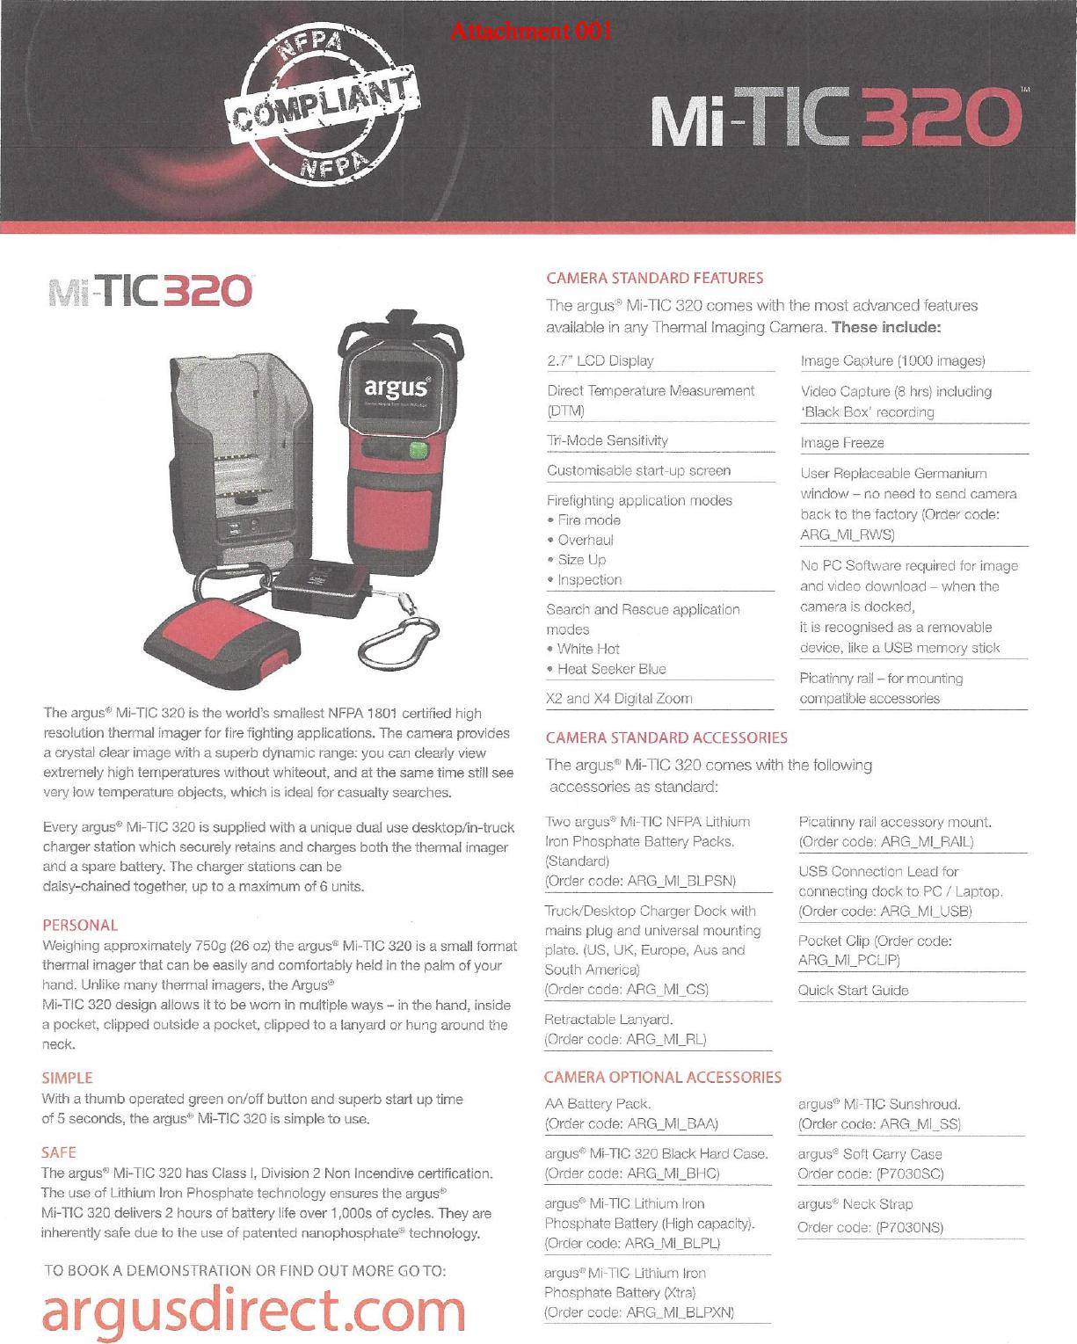
TIC 320
The argue Mi-TIC 320 is the world's smallest NFPA 1801 certified high resolution thermal imager for fire fighting applications. The camera provides a crystal clear image with a superb dynamic range: you can clearly view extremely high temperatures without whiteout, and at the same time still see very low temperature objects, which is ideal for casualty searches.
Every argus® Mi-TIC 320 is supplied with a unique dual use desktop/in-truck charger station which securely retains and charges both the thermal imager and a spare battery. The charger stations can be
daisy-chained together, up to a maximum of 6 units.
PERSONAL
Weighing approximately 750g (26 oz) the argus® Mi-TIC 320 is a small format thermal imager that can be easily and comfortably held in the palm of your hand. Unlike many thermal imagers, the Argus®
Mi-TIC 320 design allows it to be worn in multiple ways - in the hand, inside a pocket, clipped outside a pocket, clipped to a lanyard or hung around the neck.
SIMPLE
With a thumb operated green on/off button and superb start up time
of 5 seconds, the argue Mi-TIC 320 is simple to use.
CAMERA STANDARD FEATURES
Tri-Mode Sensitivity
Customisable start-up screen
Firefighting application modes
- Fire mode
- Overhaul
- Size Up
- Inspection
Search and Rescue application modes
- White Hot
- Heat Seeker Blue
X2 and X4 Digital Zoom
CAMERA STANDARD ACCESSORIES
Two argus® Mi-TIC NFPA Lithium Iron Phosphate Battery Packs. (Standard)
(Order code: ARG_MI_BLPSN)
Truck/Desktop Charger Dock with mains plug and universal mounting plate. (US, UK, Europe, Aus and South America)
(Order code: ARG_MI_CS)
Retractable Lanyard. (Order code: ARG_MI_RL)
CAMERA OPTIONAL ACCESSORIES
AA Battery Pack.
(Order code: ARG_Ml_BAA)
Image Freeze
User Replaceable Germanium window - no need to send camera back to the factory (Order code: ARG_MI_RVVS)
No PC Software required for image and video download - when the camera is docked,
it is recognised as a removable device, like a USB memory stick
Picatinny rail - for mounting compatible accessories
Picatinny rail accessory mount. (Order code: ARG_M1_RAIL)
USB Connection Lead for connecting dock to PC / Laptop. (Order code: ARG_M1_USB)
Pocket Clip (Order code: ARG_MI_PCLIP)
Quick Start Guide
argue Mi-11C Sunshroud. (Order code: ARG_MI_SS)
The argue' Mi-TIC 320 comes with the following accessories as standard:
SAFE
The argue Mi-TIC 320 has Class I, Division 2 Non Incendive certification. The use of Lithium Iron Phosphate technology ensures the argus® Mi-TIC 320 delivers 2 hours of battery life over 1,000s of cycles. They are inherently safe due to the use of patented nanophosphate® technology.
TO BOOK A DEMONSTRATION OR FIND OUT MORE GO TO:
argusdirectcom
The argus® Mi-TIC 320 comes with the most advanced features available in any Thermal Imaging Camera. These include:
2.7" LCD Display Image Capture (1000 images)
Direct Temperature Measurement Video Capture (8 hrs) including
(DTM) 'Black Box' recording
argue Mi-TIC 320 Black Hard Case. (Order code: ARG_M1_BHC)
argue Mi-TIC Lithium Iron Phosphate Battery (High capacity). (Order code: ARG_MI_BLPL)
argue Mi-TIC Lithium Iron Phosphate Battery (Xtra) (Order code: ARG_MI_BLPXN)
arguse Soft Carry Case Order code: (P7030SC)
argus® Neck Strap Order code: (P703ONS)

Attachment 001
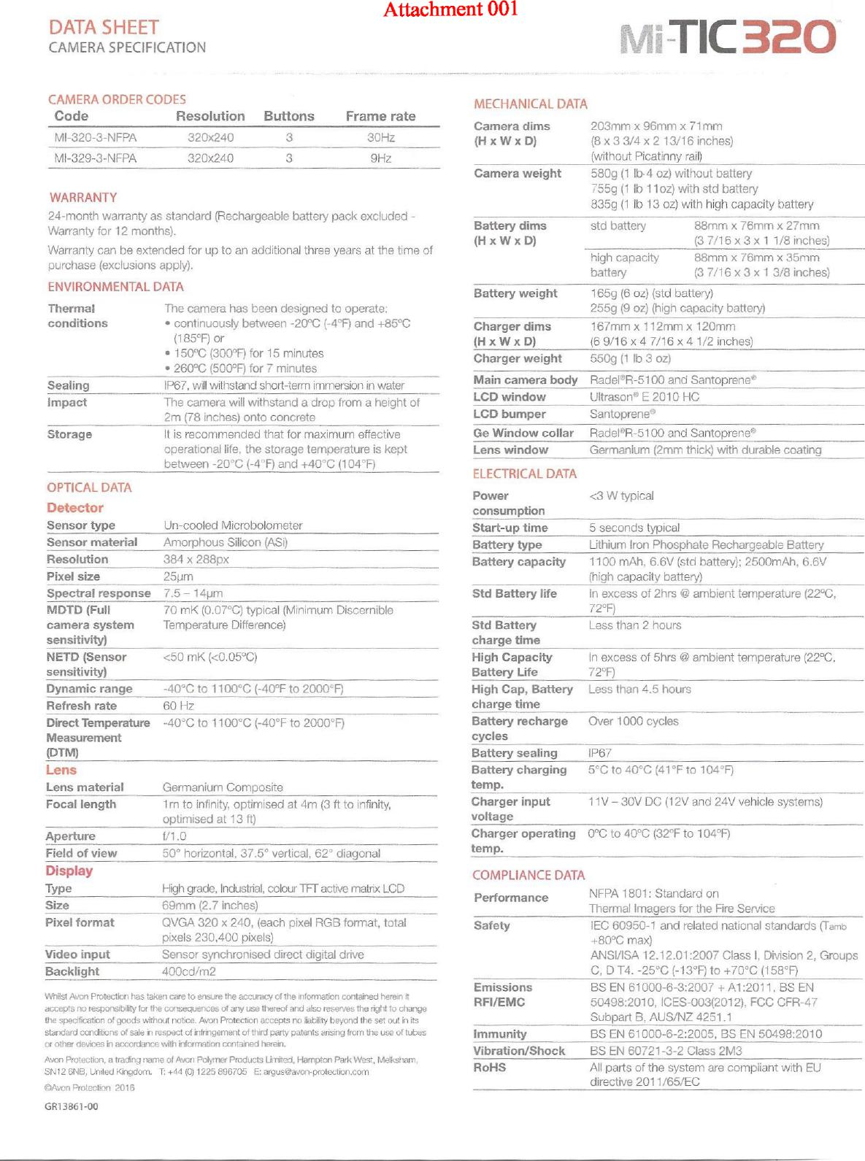
TIC 320
Camera dims (H x W x D)
203mm x 96mm x 71mm (8 x 3 ³/₄ x 2 13/16 inches) (without Picatinny rail)
Camera weight
580g (1 lb-4 oz) without battery
755g (1 lb lloz) with std battery
835g (1 lb 13 oz) with high capacity battery
Battery dims (H x W x D)
std battery 88mm x 76mm x 27mm
(3 7/16 x 3 x 1 1/8 inches)
high capacity 88mm x 76mm x 35mm
battery (3 7/16 x 3 x 1 3/8 inches)
Thermal conditions
The camera has been designed to operate:
- continuously between -20°C (-4°F) and +85°C (185°F) or
- 150°C (300°F) for 15 minutes
- 260°C (500°F) for 7 minutes
It is recommended that for maximum effective operational life, the storage temperature is kept between -20°C (-4°F) and +40°C (104°F)
Storage
Display Type Size
High grade, Industrial, colour II- I active matrix LCD 69mm (2.7 inches)
Safety
1EC 60950-1 and related national standards (iamb +80°C max)
ANSI/ISA 12.12.01:2007 Class I, Division 2, Groups C, D T4. -25°C (-13°F) to +70°C (158°F)
Emissions RFI/EMC
BS EN 61000-6-3:2007 + A1:2011, BS EN 50498:2010, 10ES-003(2012). FCC CFR-47 Subpart B, AUS/NZ 4251.1
Immunity Vibration/Shock
BS EN 61000-6-2:2005, BS EN 50498:2010
BS EN 60721-3-2 Class 2M3
RoHS
All parts of the system are compliant with EU directive 2011/65/EC
Attachment 001
DATA SHEET
CAMERA SPECIFICATION
CAMERA ORDER CODES
Code Resolution Buttons Frame rate
MI-320-3-NFPA 320x240 3 30Hz
MI-329-3-NFPA 320x240 3 9Hz
WARRANTY
24-month warranty as standard (Rechargeable battery pack excluded - Warranty for 12 months).
Warranty can be extended for up to an additional three years at the time of purchase (exclusions apply).
MECHANICAL DATA
Whilst Avon Protection has taken care to ensure the accuracy of the information contained herein it accepts no responsibility for the consequences of any use thereof and also reserves the right to change the specification of goods without notice. Avon Protection accepts no liability beyond the set out in its standard conditions of sale in respect of infringement of third party patents arising from the use of tubes or other devices in accordance with information contained herein.
Avon Protection, a trading name of Avon Polymer Products United, Hampton Park West, Melksham. SN12 6NB, United Kingdom. T: +44 10) 1225 896705 E: argus@avon-protoction.com
0Avon Protection 2016
GR13861-00
Battery capacity 1100 mAh, 6.6V (std battery): 2500mAh, 6.6V
(high capacity battery)
Std Battery life In excess of 2hrs @ ambient temperature (22°C,
72°F)
Std Battery Less than 2 hours
charge time
High Capacity In excess of 5hrs @ ambient temperature (22°C.
Battery Life 72°F)
High Cap, Battery charge time
Battery recharge cycles
Less than 4.5 hours
Over 1000 cycles
Battery sealing 1P67
Battery charging 5°C to 40°C (41°F to 104°F)
temp.
Charger input 11V - 30V DC (12V and 24V vehicle systems)
voltage
Charger operating 0°C to 40°C (32°F to 104°F)
temp.
ENVIRONMENTAL DATA
Sealing IP67, will withstand short-term immersion in water
Impact The camera will withstand a drop from a height of
2m (78 inches) onto concrete
Lens
Lens material
Germanium Composite
1m to infinity, optimised at 4m (3 ft to infinity, optimised at 13 ft)
Focal length
OPTICAL DATA
Detector Sensor type
Un-cooled Microbolometer
Amorphous Silicon (ASi)
Sensor material
Resolution Pixel size
384 x 288px 25pm
Spectral response
7.5 - 14pm
Refresh rate
60 Hz
Direct Temperature Measurement (DTM)
-40°C to 1100°C (-40°F to 2000°F)
MDTD (Full camera system sensitivity)
NETD (Sensor
sensitivity)
Dynamic range
70 mK (0.07°C) typical (Minimum Discernible Temperature Difference)
<50 mK (<0.05°C)
-40°C to 1100°C (-40°F to 2000°F)
Aperture f/1.0
Field of view 50° horizontal, 37.5° vertical, 62° diagonal
Pixel format QVGA 320 x 240, (each pixel RGB format, total
pixels 230,400 pixels)
Video input Sensor synchronised direct digital drive
Backlight 400cd/m2
165g (6 oz) (std battery)
255g (9 oz) (high capacity battery)
Battery weight
Charger dims (H x W x D)
167mm x 112mm x 120mm
(6 9/16 x 4 7/16 x 4 1/2 inches)
Charger weight
550g (1 lb 3 oz)
RaderR-5100 and Santoprene
UltrasorP⁾ E 2010 HC
Santoprene®
Main camera body LCD window LCD bumper
RaderR-5100 and Santoprene®
Germanium (2mm thick) with durable coating
Ge Window collar Lens window
Power
consumption
<3 W typical
Start-up time
5 seconds typical
Lithium Iron Phosphate Rechargeable Battery
Battery type
ELECTRICAL DATA
COMPLIANCE DATA
Performance NFPA 1801: Standard on
Thermal Imagers for the Fire Service

