Sink:
Regency 64 1/2" 16 Gauge Stainless Steel Two Compartment Commercial Sink with Stainless Steel Legs, Cross Bracing, and 1 Drainboard - 18" x 24" x 14" Bowls (webstaurantstore.com)
Item #: 60S2182424XL

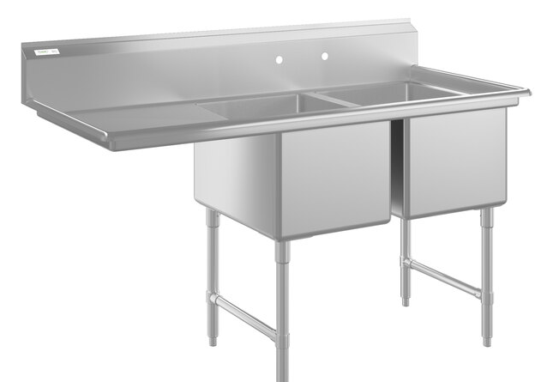

6’ table (right of stove):
Regency 30" x 72" 16-Gauge 304 Stainless Steel Commercial Open Base Work Table with 4" Backsplash (webstaurantstore.com)
Item numberItem #: 600WT30X72BS
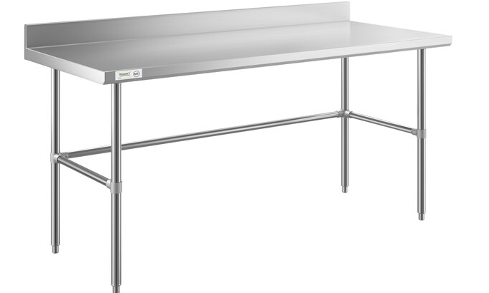

6’ shelf (18” wide, above 6’ table)
Regency 16 Gauge Stainless Steel 18" x 72" Heavy Duty Wall Shelf (webstaurantstore.com)
Item #: 600WS1872HD
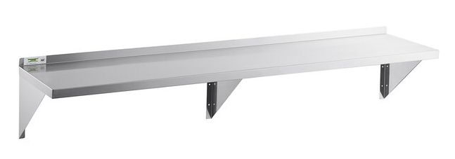

5 ft. table (right of sink):
Regency 30" x 60" 16-Gauge Stainless Steel Commercial Work Table with 4" Backsplash and Undershelf (webstaurantstore.com)
Item #: 600TSB3060S
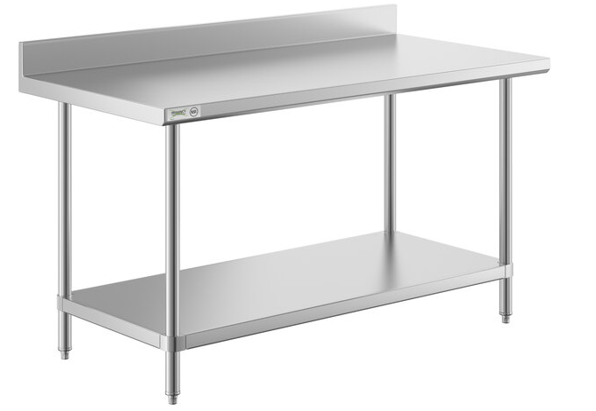

5 Ft. Shelf (above 5’ table):
Regency 16 Gauge Stainless Steel 18" x 60" Heavy Duty Wall Shelf (webstaurantstore.com)
Item numberItem #: 600WS1860HD
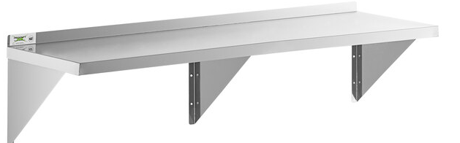

2 ft. shelf (above 24’ drain board/sink):
Regency 16 Gauge Stainless Steel 18" x 24" Heavy Duty Wall Shelf (webstaurantstore.com)
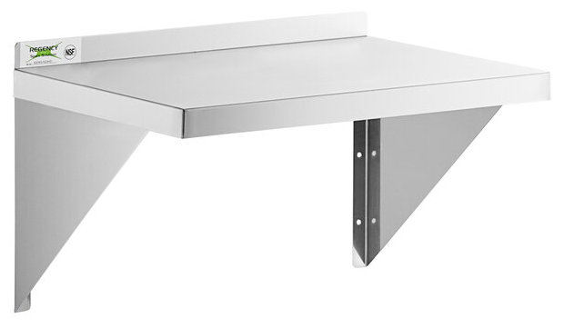

Ice maker (under 6’ table):
Avantco Ice UC-F-160-A 26" Air Cooled Undercounter Full Cube Ice Machine - 152 lb. (webstaurantstore.com)
Item #: 194UCF160A
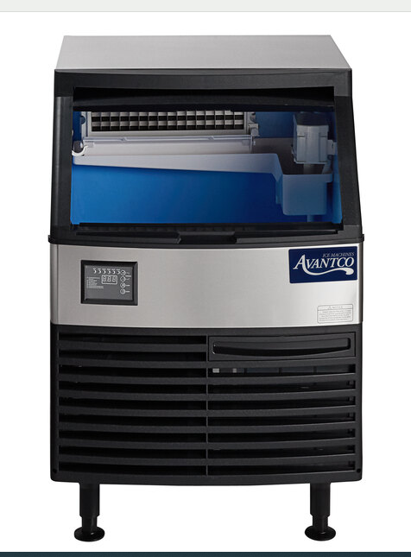

Island:
Regency 30" x 60" 18-Gauge 304 Stainless Steel Commercial Work Table with Undershelf and Overshelf, Drawer, Pot Rack, and Bun Pan Rack (webstaurantstore.com)
Item #: 600WT3060KIT
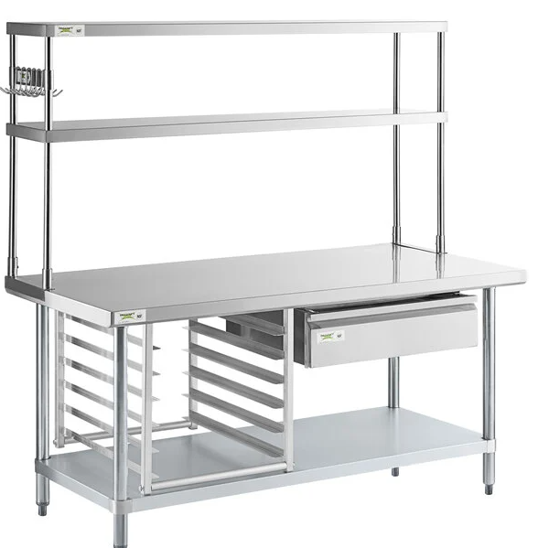

Drawer set (under mount to 6’ table):
Regency 25" x 24" x 7" Drawer with Stainless Steel Front (webstaurantstore.com)
Item #: 600DR2020
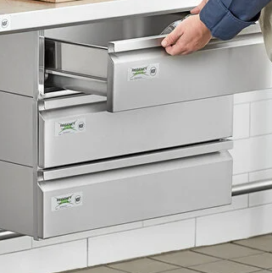

Faucet/sprayer:
Item #: 5105PR8W14
Equip by T&S 5PR-8W14 Wall Mounted 35 3/4" High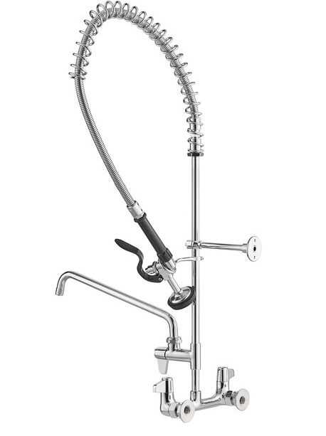 Pre-Rinse Faucet with 8" Adjustable Centers, 44" Hose, 14" Add-On Faucet, and 6" Wall Bracket (webstaurantstore.com)

Stove:
MoTak MR10-RGB24 60" 6 Burner Gas Range w/ Griddle & (2) Standard Ovens, Convertible (katom.com)
KaTom #: 895-CR10RGB24N • MPN: MR10RGB24-N-C-S
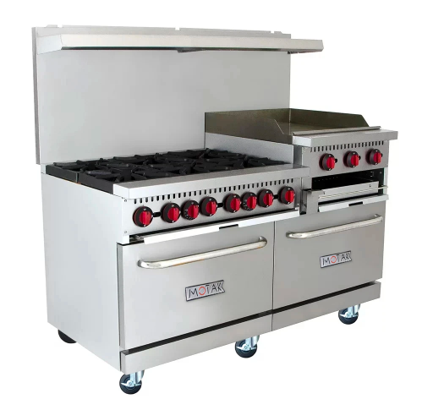

Regency 30&quot; x 15&quot; 18-Gauge 304 Stainless Steel Equipment Filler Table with Backsplash and Galvanized Undershelf

Regency 30" x 15" 18-Gauge 304 Stainless Steel Equipment Filler Table with Backsplash and Galvanized Undershelf (webstaurantstore.com)

