Proposed Limerock Stockpile
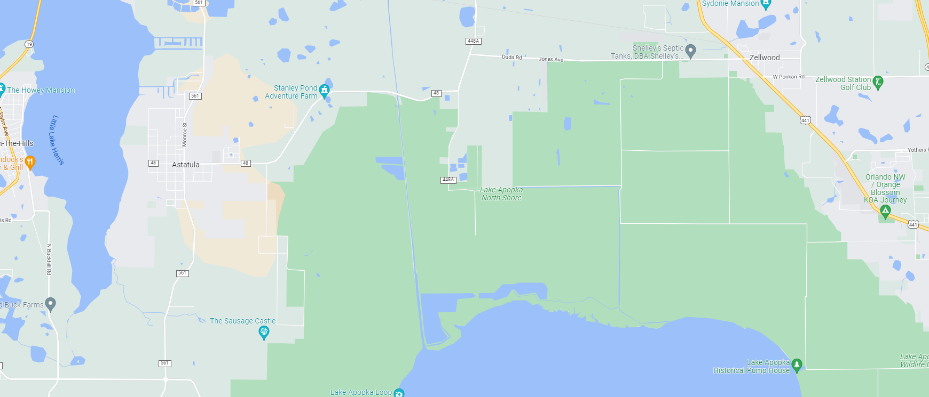
Limerock Delivery – Apopka
Limerock is to be delivered to the end of Ranch Road in Astatula, FL. The lat., long. for this location is 28.674074, -81.706010 .

