City of Myrtle Beach
Invitation for Bid

IFB 20-B0010
Withers Swash Renovations

Issue Date: August 2, 2019



First in Service

Issued By:

Purchasing Division
3231 Mr. Joe White Avenue
Myrtle Beach, SC 29577
Phone: 843-918-2170
www.cityofmyrtlebeach.com

City of Myrtle Beach Purchasing Division
3231 Mr. Joe White Avenue
Myrtle Beach, SC 29577

INVITATION FOR BID
IFB # 20-B0010 Withers Swash Renovations
Buyer Contact: | Tina Causey  843-918-2184  tcausey@cityofmyrtlebeach.com
Mandatory Pre-Bid Conference:  On-time attendance/sign-in is required for bid consideration. | Monday, August 13, 2019 @ 9:00AM at site:  Family Kingdom Parking Lot  300 S Ocean Blvd., Myrtle Beach, SC
Opening Date & Time: | Monday, August 20, 2019 @ 2:00PM
Bid Opening Location: | City of Myrtle Beach Purchasing Office  3231 Mr. Joe White Avenue  Myrtle Beach, SC 29577

Please Note: Bids for a service $25,000.00 or greater must be accompanied by a bidder’s bond in the amount of five percent (5%) of the total dollar amount of the bid submitted, payable to the City of Myrtle Beach.

No bids will be accepted unless submitted on the forms furnished herein. All pages of the bid must be in a sealed envelope and delivered in accordance with these instructions:
- The envelope must be marked with the name of bidder, bid number/name, and time/date of bid opening.
- Bid packages shall be delivered to the address listed above. The City of Myrtle Beach is not responsible for late or misdirected mail.
If the above criteria are not met, your bid shall be rejected. Bids will be opened and read publicly at the time and date specified above.

Bidders are advised that from the date of issue of this solicitation until award of the contract, no contact with City personnel related to this solicitation is permitted. All communications/requests for clarification are to be directed to the Buyer listed above.

It is the intent and purpose of the City of Myrtle Beach that this Invitation for Bid promotes competitive bidding. It shall be the Bidder’s responsibility to advise the Purchasing Division if any language, requirements, etc., or any combination thereof, inadvertently restricts or limits the requirements stated in this Invitation to Bid to a single source. Such notification must be submitted in writing and must be received by the Purchasing Division no later than three (3) City of Myrtle Beach business days prior to the bid opening date.

Bidder to complete this section:

Name of Bidder: ________________________________________________________________________

Address: ______________________________________________________________________________

Phone Number: ________________________________________________________________________

E-mail: ______________________________________________________________________________

Please note: Signature is required on page 21.

CITY OF MYRTLE BEACH – GENERAL INSTRUCTIONS
MUST BE SIGNED AS PART OF INVITATION FOR BID PACKAGE

1.0 SUMMARY

  - DOCUMENT INCLUDES:

2.0 Authority
2.01 Equal Weight and Force
2.02 Written Explanations
2.03 Disputes with Written Explanations
2.04 Written Addenda

3.0 Requirements for Written Bid Documents
3.01 Availability of Documents
3.02 Responsive Bids
3.03 Non-Responsive Bids
3.04 Document Completion
3.05 Contents of Bid Packet
3.06 Single Package Requirement
3.07 Bid Submission
3.08 Bid Delivery/Opening
3.09 Document Ownership

4.0 Full Examination
4.01 Thorough Investigation
4.02 Pre-Bid Meetings
4.03 Evidence of Examination

5.0 Pricing
5.01 Unit Pricing
5.02 Cash Discounts
5.03 Changes in Cost
5.04 Price Evaluation

6.0 Tax Information
6.01 Sales Tax/Federal Tax
6.02 Payment of Taxes

7.0 Material Assessment
7.01 Product Documentation
7.02 SDS
7.03 Evidence of Work/Product
7.04 Sample Submission
7.05 Sample Ownership
7.06 Furnished Items
7.07 Quality of Items

8.0 Changes in Specifications
8.01 Authority of Specifications
8.02 Equipment
8.03 Deviation from Specifications
8.04 Material Preference
8.05 Changes after Award
8.06 Equivalent Items

9.0 Modifications
9.01 Additional Work
9.02 Adjustments to Items/Work

10.0 Bond Requirements
10.01 Bid Bonds
10.02 Performance/Payment Bonds

11.0 Delivery
11.01 Warehouse Deliveries
11.02 Dates
11.03 Delivery Price
11.04 Documentation
11.05 Wrong Deliveries

12.0 Award Criteria/Timeline
12.01 Award Criteria
12.02 Contract Issuance
12.03 Commencement of Work
12.04 Contract Timeline
12.05 Notification
12.06 City Business License

13.0 Bidder Responsibilities
13.01 Duration of Bid
13.02 Transfer of Responsibilities
13.03 Drug-Free Workplace
13.04 Subcontractors
13.05 Coordination and Contact
13.06 Liquidated Damages
13.07 Force Majeure

14.0 Indemnity Clause
14.01 Hold Harmless
14.02 Failure to Enforce

15.0 Federal and State Laws
15.01 Employment Regulations
15.02 Employment Discrimination
15.03 Compliance with Laws

16.0 Financial Accounting
16.01 Representation
16.02 Payment

17.0 Bid Rejection/Withdrawal
17.01 Reasons for Rejection
17.02 Best Interest of the City
17.03 Determination of Responsibility
17.04 Disqualification
17.05 Withdrawal Timeline

18.0 Disputes and Protests
18.01 Informal Dispute Resolution
18.02 Formal Dispute Resolution
18.03 Procedures/Timelines
18.04 Stay of the Procurement
18.05 Confidentiality of Information
18.06 Post-Filing Formal Protest Process
18.07 Formal Protest Decision Timeline and Notification
18.08 Appeals

19.0 City Reserved Rights
19.01 Reserved Right
19.02 Final Judgment
19.03 Clarification
19.04 Price Increase
19.05 Loss/Damage
19.06 Performance Failure
19.07 Termination for Convenience
19.08 Termination for Default
19.09 Correction of Minor Informalities

20.0 ADA Compliance
20.01 Contact Information

21.0 Signatures
21.01 Accuracy and Completeness
21.02 Non-Collusion
21.03 Compliance

  - DEFINITIONS:

- City of Myrtle Beach – herein referred to as “City.”
B. IFB – Invitation for Bid
C. Bidder – any vendor, proprietor, business, company, service provider, or corporation
who submits a bid to the City.
D. Bid – the collection of documents that includes these general instructions, the scope
of work and/or specifications, a written offer, and signature page to be
used for consideration in negotiations and/or contract development.
E. Addendum – a written change, addition, alteration, correction, or revision to a bid
document.
F. Bond – provides financial assurance that the bid has been submitted in good faith, that
a bidder will enter into a contract at the amount bid, and will provide the
appropriate performance and payment bonds.
G. Bid Bond – an insurance agreement, accompanied by a monetary commitment, by
which a third party accepts liability and guarantees that the bidder will not
withdraw from the bid, must be submitted with bid package if over
$25,000.00
H. Performance Bond – guarantees execution of the terms of a contract, required for
work valued at $25,000.00 or more for construction and/or any type of
service, must be received within ten (10) calendar days from date/time of
notification of award.
I. Payment Bond – covers payment of subcontractors, laborers, materials, and suppliers
associated with the project, required for work valued at $25,000.00 or
more for construction and/or any type of service, must be received within
ten (10) calendar days from date/time of notification of award.

2.0 AUTHORITY:

2.01 Equal Weight and Force. The instructions herein contained are given for the purpose of
guidance in properly preparing an applicable bid. These directions have equal weight and
force with the specifications and strict compliance is required with all of the provisions.
Unless otherwise stated in the special instructions of the bid, these general instructions
shall apply.

2.02 Written Explanations. Only written information from the procurement manager or an
authorized representative of the purchasing division is binding; therefore no verbal
instructions or verbal information from any other source shall be binding on the City.
The City shall not be responsible for any other explanation or interpretation and the
decision of the procurement manager or an authorized representative of the purchasing
division shall be final and binding upon each Bidder.

2.03 Disputes with Written Explanations. The written specifications are considered clear
and complete. Failure of the Bidder to call attention in writing to any disputes,
definitions, discrepancies, inconsistencies or incompleteness before the opening of the
bid in the time and manner set forth herein is a waiver of right to do so upon opening of
the bids. Clarifications requested by Bidders must be in writing not less than three (3)
days before date and time set for receipt of bids.

2.04 Written Addenda. Should the procurement manager deem it necessary to alter bid
specifications, those alterations shall be made in the form of written addenda that shall be
posted on the City website, and may be advertised in the South Carolina Business
Opportunities (SCBO) online publication and the local newspaper. The Bidder is
responsible for monitoring all of these sources and should not rely on a single source for
updates. These addenda shall then be considered as part of these specifications. No
interpretations of the meaning of the bid specifications shall be made orally.

3.0 REQUIREMENTS FOR WRITTEN DOCUMENTS:

3.01 Availability of Documents. Bid documents may be obtained through the City of Myrtle
Beach website (www.cityofmyrtlebeach.com), or in person at the City of Myrtle Beach
Purchasing Office, 3231 Mr. Joe White Avenue, Myrtle Beach, SC 29577, Monday
through Friday (excluding City holidays), from 8:00 AM to 5:00 PM. Bid documents may
be mailed or sent via e-mail by vendor request only.

3.02 Responsive Bids. The City of Myrtle Beach will review bids on a pass/fail basis to
determine whether the bid is “responsive” to this IFB. A responsive bid will contain all
required documents and forms that are completed in their entirety. Documents and forms
must be unaltered, legible, signed, sealed appropriately, and free from errors without
noted corrections. The City reserves the right (at its sole discretion) to determine whether
a bid is responsive.

3.03 Non-Responsive Bids. Bids that are incomplete, unsigned, improperly signed or sealed,
conditional, illegible, obscure, contain arithmetical errors, corrections without initials,
ambiguities, alterations, and/or irregularities of any kind, may be declared non-responsive.

3.04 Document Completion. A bid and signature document is provided as part of the
solicitation. This form must be used in submitting a bid and all pages of the bid
document must be completely filled out in blue ink and signed by the Bidder. No bid
shall be accepted unless submitted on the forms furnished herein. The format of the bid
documents shall not be altered in any way. Written errors made on the bid documents
prior to submission must be corrected by marking through the entry in blue ink and
making the correct entry adjacent to the written error and initialed by the Bidder in blue
ink.

3.05 Contents of Bid Packet. The general instructions, scope of work and/or specifications,
and the bid and signature document constitute the bid packet. By submitting a bid, the
Bidder is deemed to have accepted all of the terms and conditions set forth in the bid
packet documents. Alternative bids shall not be considered. All bid packet documents,
after completion by the Bidder, must be returned with the bid in the same order as
received by the Bidder.

3.06 Single Package Requirement. Unless otherwise stated in the special instructions section
of this bid request, submit one complete bid package using the attached form(s), if
applicable, for bid pricing.

3.07 Bid Submission. Each bid must be enclosed in a sealed envelope, clearly marked on the
outside with the company name/address in the upper left-hand corner and bid
number/name and time/date of opening in the lower left-hand corner. This sealed
envelope must be delivered to the procurement buyer. If the required information is not
clearly stated on the outside of the envelope, the bid is considered nonresponsive. It is
the Bidder’s responsibility to ensure that the bid is delivered by the official opening date
and time. Bids submitted after the date and time set for receipt shall be considered late,
regardless of the degree of lateness or the reason related thereto, including causes beyond
the control of the Bidder. Late bids shall not be opened and will be returned to the
Bidder unopened. The City of Myrtle Beach is not responsible for late or misdirected
mail.

3.08 Bid Delivery/Opening. All bids must be sealed, marked and delivered in accordance with
these instructions to Purchasing Division, City of Myrtle Beach, 3231 Mr. Joe White
Avenue, Myrtle Beach, SC 29577. Bids received prior to the advertised hour of opening
shall be securely kept sealed. Bids shall be opened and read publicly at the time so
specified on the front cover sheet.

3.09 Document Ownership. All documents, reports, bids, submittals, working papers or
other material submitted to the City from the Bidder shall become the sole and exclusive
property of the City, in the public domain, and are not the property of the Bidder. The
Bidder shall not copyright, or cause to be copyrighted, any portion of any of said
documents submitted to the City as a result of this solicitation.

4.0 FULL EXAMINATION:

4.01 Thorough Investigation. Bidders shall make all investigations necessary to thoroughly
inform themselves regarding plant and facilities for delivery of material and equipment
and/or service to be performed as required by the bid conditions. No plea of ignorance
by the Bidder of conditions that exist or that may hereafter exist as a result of failure or
omission on the part of the Bidder to make the necessary examination and investigations,
or failure to fulfill in every detail the requirements of the contract documents, shall in no
way relieve the Bidder from any obligation in respect to the bid.

4.02 Pre-Bid Meetings. When Bidders are required to make site visits or attend mandatory
pre-bid meetings, all expenses shall be paid for by the Bidder, unless previous written
arrangements are made with the City. Bidder must be physically present at the sign-
in location with the Buyer at the start of the scheduled meeting time. The official start of
each pre-bid meeting will be determined by the Buyer with an announcement of the time
and the final closing for contractors to sign-in. Any contractor arriving after the declared
time announcement and closing of sign-in shall not be admitted to the pre-bid meeting,
and any bid received shall be considered non-responsive.

4.03 Evidence of Examination. Submission of a bid shall be considered as conclusive
evidence of the Bidder’s complete examination, understanding and acceptance of the
specifications.

5.0 PRICING:

5.01 Unit Pricing. Unit pricing shall govern over extended prices unless otherwise stated in
the special instructions in this bid request. All prices quoted should be firm. In those
cases where a firm bid cannot be made, consideration shall still be given to all Bidders.
Also, maximum or ceiling prices should be quoted where possible when bid contains
non-firm prices.

5.02 Cash Discounts. Cash discounts, if allowed, should be so stated on the bid form. Prices
must, however, be based upon payment thirty (30) calendar days after delivery.

5.03 Changes in Cost. If during the term of the contract entered into as a result of this bid,
the cost of material(s) is/are increased through no act on the part of the contractor other
than to comply with any prevailing rise in the market price(s) of material(s) used, it shall
be the contractor’s responsibility to notify the City of Myrtle Beach Purchasing Office in
writing of the price increase(s) and the effective date of the increase(s). Price(s) shall be
increased only to the point of absorbing additional cost(s) of material(s) paid for by the
contractor. At any time during the term of the contract, the City may request that the
contractor provide written documentation from the manufacturer/supplier of the
material(s) to substantiate price increase(s). If during the term of the contract, the cost of
material(s) to the contractor is reduced, then the contractor shall reduce the contract
price(s) and notify the procurement buyer in writing.

5.04 Price Evaluation. The City of Myrtle Beach shall evaluate the Bidder’s price proposal
for completeness, price reasonableness, price realism, and unbalanced pricing. Price
reasonableness shall be established by competition and determined primarily by
comparison with other bids submitted. Price realism shall be established by analysis of
the unit price submitted to determine whether the bid price reflects a clear understanding
of the requirements, are realistic for the work to be performed, and are consistent with the
methods of performance and materials described in the bid response. Unbalanced pricing
exists when, despite an acceptable total evaluated price, the price of one or more contract
line items is significantly overstated or understated and poses an unacceptable risk to
the City. The City may determine that a bid is unacceptable if the proposed price is
materially unbalanced between line items.

6.0 TAX INFORMATION:

6.01 Sales Tax/Federal Tax. The City of Myrtle Beach pays South Carolina State Sales Tax.
The City is exempt from Federal Excise Tax and shall issue exemption certificates if
required. All applicable taxes should be shown as separate line items unless otherwise
indicated.

6.02 Payment of Taxes. The contractor agrees to pay all taxes and license fees of whatever
nature applicable to conduct business and furnish the City of Myrtle Beach, if requested,
with duplicate receipts or other satisfactory evidence showing the prompt payment of all
taxes and fees when referred to and showing that all licenses are in effect.

7.0 MATERIAL ASSESSMENT:

7.01 Product Documentation. Bid shall include adequate brochures, latest printed
specification and advertising literature describing the product(s) offered in such a fashion
as to permit ready comparison with the specifications on an item-by-item basis where
applicable.

7.02 Safety Data Sheet (SDS). If so requested in the bid documents, a completed SDS for the
item(s) indicated must be provided with the bid documents. Failure to submit this form
upon request may result in rejection of bid.

7.03 Evidence of Work/Product. All Bidders must be prepared to present suitable evidence
of similar work recently completed or goods supplied. Products are to be brand name or
equal unless otherwise specified. If submitting an equal product, supporting documents
must be provided with bid.

7.04 Sample Submission. When samples are required with a bid, they must be submitted
with the bid unless approved by the purchasing manager or purchasing manager’s
authorized representative.

7.05 Sample Ownership. Samples submitted shall become the property of the City of Myrtle
Beach. The entire cost of the sample(s) shall be paid for by the Bidder unless previous
written arrangements are made with the City.

7.06 Furnished Items. Bidders are required to state exactly what they intend to furnish;
otherwise, they shall be required to furnish the items as specified.

7.07 Quality of Items. Bidders shall submit, with their bid, data necessary to evaluate and
determine the quality of the item(s) they are bidding. Unless otherwise specified, the
Bidder shall unconditionally guarantee the items and workmanship being bid. If any
defects or signs of deterioration are noted which, in the City’s opinion, are due to faulty
workmanship or material, the Bidder, upon notification and at the expense of the Bidder,
shall replace the items to the complete satisfaction of the City. Upon the Bidder’s failure
to replace items, the City may return the rejected items to the Bidder at the Bidder’s risk
and expense, or the City may dispose of them as its own property.

8.0 CHANGES IN SPECIFICATIONS:

8.01 Authority of Specifications. It shall be understood that in all cases the terms and
conditions, as detailed in the specifications, shall supersede terms and conditions, as
detailed in the general instructions. No verbal agreement or conversation with any
officer, agent, or employee of the City shall affect or modify any of the terms and
conditions.

8.02 Equipment. If this bid is for the purchase of equipment, the Bidder guarantees that the
equipment offered is standard new equipment, latest model or regular stock product, with
parts regularly used for the type of equipment offered; also that no attachment or part has
been substituted or applied contrary to the manufacturer’s recommendations and standard
practices.

8.03 Deviation from Specifications. Any deviation from specifications must be noted in
detail and submitted in writing with this bid. Complete specifications should be attached
for any substitutions offered, or when amplifications are desirable or necessary. The
absence of a specification deviation statement and accompanying specifications shall
hold the Bidder strictly accountable to the specifications as written herein.

8.04 Material Preference. The specifications, as listed herein, represent our preference in
material; however, we are fully cognizant that no two pieces of comparable material are
identical and/or same in size, function, and operation; and some of the specifications will
not completely coincide with ours as listed. Please list your exceptions and explanations
separately. It is not our intent to write specifications for any project on which only one
proponent can submit a bid.

8.05 Changes after Award. Any changes in specifications, after the purchase order/contract
has been awarded, must be with the written consent of the purchasing division; otherwise,
the responsibility for such changes shall be with the Bidder.

8.06 Equivalent Items. For items identified in this bid as “brand name or equal,” the
Bidder’s offer must indicate each product that is being offered as an “equal” product by
providing the following information:
A. A description reflecting the characteristics and level of quality that will satisfy
the salient physical, functional, or performance characteristics of “equal”
products specified in the bid
B. A clear identification of the item by brand name and make/model number (if
any)
C. Descriptive literature such as illustrations, drawings, photographs, or a clear
reference to previously furnished descriptive data or information that is
readily available to the purchasing buyer
D. A clear description of any modifications the Bidder plans to make in a product
so that it conforms to the bid requirements
Compliance verification is performed by the City purchasing buyer and their requestor(s).
The purchasing buyer is required to evaluate “equal” products on the basis of information
furnished by the Bidder, or identified in the bid. The buyer is not responsible for
locating, obtaining, or researching any information that is not provided. A Bidder’s
product shall not be considered as an “equal” product if there is an inadequate description
of how the “equal” product meets the salient characteristics specified in the bid.

9.0 MODIFICATIONS:

9.01 Additional Work. The bid shall not contain any unauthorized additions. No additional
work shall be allowed or paid for unless such extra or additional work is ordered in
writing by the purchasing division and with the price for such established and agreed
upon before such extras are delivered or work is performed.

9.02 Adjustments to Items/Work. The City of Myrtle Beach shall have the right, without
invalidating the contract, to make additions to or deductions from the items or work
covered by the specifications. In case such deductions or additions are made, an
equitable price adjustment shall be made between the City and the contractor. Any such
adjustments in price shall be made in writing.

10.0 BOND REQUIREMENTS:

10.01 Bid Bonds. If required, Bidder shall supply a bid bond of 5% of the total bid amount to
be submitted with the bid package. Bonds are required if the contract work is valued at
$25,000.00 or more for construction and/or any type of service related requirement.

10.02 Performance/Payment Bonds. The successful Bidder at its own cost and expense shall
furnish, if required, a valid performance and payment bond (payable to the City of Myrtle
Beach.) The bond shall be in the full amount of this agreement conditioned on the full
and faithful performance of the work under this agreement in accordance with the
specifications and contract documents. Bonds are required if the contract work is valued
at $25,000.00 or more for construction and/or any type of service related requirement.
The performance and payment bonds shall be executed by the contractor and a bonding
company authorized to do business in the State of South Carolina and approved by the
State of South Carolina to issue such performance and payment bonds. Bonds must be
received within ten (10) calendar days from the date and time of notification of award.
Only the forms provided by the City for the performance and payment bonds shall be
accepted.

11.0 DELIVERY:

11.01 Warehouse Deliveries. Unless otherwise stated in the special instructions section of this
bid request, deliveries shall be accepted during the hours between 8:00 AM and 4:00 PM
Monday through Friday, excluding City holidays.

11.02 Dates. The delivery date as stated in the bid shall be the time required to deliver the
complete item(s) after the receipt of the order or award of the contract. Where multiple
items appear on a bid request, the Bidder shall, unless otherwise stated by the City, show
delivery date for each item separately. If only a single delivery date is shown, it shall be
assumed to mean that all items included in the bid can and will be delivered on or before
the specified date. The Bidder certifies that the delivery shall be completed in the time the
Bidder states, starting at the time the order is placed, provided that the time between the
bid opening and the placing of the order does not exceed the number of days stipulated in
the bid. The right is reserved to reject any bid on which the delivery time indicated is
considered sufficient to delay the operation for which the commodity is intended.
Successful Bidder(s) shall be responsible for making any and all claims against carriers
for missing or damaged items.

11.03 Delivery Price. Bid prices are to be Delivered Price (FOB Destination). Bid prices must
include all delivery costs, including but not limited to, loading and unloading cost(s),
transportation charge(s) and fuel surcharge(s). The City of Myrtle Beach shall not be
responsible for any demurrage charge(s).

11.04 Documentation. Invoice(s), certificates of origin, warranties and guarantees must be
submitted at the time of delivery of the item(s).

11.05 Wrong Deliveries. In the event that materials, supplies, etc. are delivered which do not
comply with specifications and have not been approved by the purchasing division, the
contractor, upon notification, shall immediately remove from the premises any such
materials, supplies, etc. and replace them with materials, supplies, etc. in full accordance
with the specifications.

12.0 AWARD CRITERIA/TIMELINE:

12.01 Award Criteria. For service and supply-related requirements, the award shall be made
within the time specified to the responsible Bidder meeting the specifications and having
the lowest possible cost consistent with the quality and service needed for effective use.
The following criteria may also be used in making this determination:
A. Superior quality and specification adherence
B. Adequate maintenance and service
C. Delivery and/or completion time
D. Guarantees and warranties
E. Company’s reputation and financial status
F. Past experience and cost with similar or like equipment or service
G. Anticipated future cost and experience
H. Performance of proponent’s equipment by other agencies, plants, and firms
Evaluation factors, if required, shall be stated in either a percent basis or a numerical
format.

12.02 Contract Issuance. The award of a contract is accomplished by executing a written
agreement that incorporates the entire bid, Bidder’s response, clarifications, addenda, and
additions. All such materials constitute the contract documents. The Bidder agrees to
accept the contract terms unless substantive changes are made without the approval of the
Bidder. Bidder shall not add any provisions reserving the right to accept or reject an
award. The procurement office is the sole point of contact for the issuance of the
contract.

12.03 Commencement of Work. Upon execution and delivery of the contract and insurance
certificates, the Bidder shall be notified to proceed with the work of the contract. The
work of the contract shall be commenced within one (1) City business day following such
notification, or as otherwise specified in the Notice to Proceed. The performance period
shall be from date of issuance of Notice to Proceed through __________ calendar days.
Contract prices shall remain firm for the duration of the contract period. The City of
Myrtle Beach reserves the right to adjust the performance period to meet the best interests
of the City. Any such adjustment will be made in writing through the Purchasing Office.

12.04 Contract Timeline. In the event the successful Bidder fails or refuses to execute a
formal written contract with the City of Myrtle Beach in form and content acceptable to
the City, within ten (10) City business days after notice of acceptance of the bid, the bid
may be revoked, and all obligations of the City in connection with the bid may be
canceled.

12.05 Notification. Bid tabulations shall be available on-line at
www.cityofmyrtlebeach.com/purchasing.html. Winning Bidder shall be notified five (5)
City business days after bid tabulations are posted.

12.06 City Business License. The successful Bidder must obtain a City of Myrtle Beach
business license in order to conduct business within our city. A business license is not
required to submit a bid; however, any bidder that receives an award under this bid shall
be required to obtain a City business license before work can begin. For further
information on obtaining a city business license, contact the City Business License Office
at 843-918-1200.

13.0 BIDDER RESPONSIBILITIES:

13.01 Duration of Bid. Bid prices, terms and conditions shall be firm for a period of at least
one hundred twenty (120) calendar days from the deadline for receipt of submittal, or
until such time as established in the bid. The successful bid shall not be subject to future
price escalation or changes of terms if accepted during the one hundred twenty (120) day
period, or the specified bid time. Price decreases or changes in terms by others after the
acceptance of a bid shall not be considered.

13.02 Transfer of Responsibilities. The contractor shall not assign or otherwise transfer any
of its responsibilities or obligations under the contract to any other person or entity
without prior written consent of the City.

13.03 Drug-Free Workplace. In accordance with the provisions of the Drug-Free Workplace
Act, the City of Myrtle Beach shall promote a drug-free workplace. Illegal drugs or
narcotics in the workplace are strictly prohibited. The manufacture, possession, use,
and/or distribution of a controlled substance of any kind while working on City property
is subject to disciplinary action up to and including immediate discharge. As such,
Bidders are required to insure that a drug-free workplace is provided in the performance
of any City contracts. By submitting a bid, Bidder certifies that, if awarded the contract,
they and their subcontractors shall comply with the City’s Drug-Free Workplace Policy.
The failure of any Bidder to uphold and enforce this policy is subject to termination of
contract.

13.04 Subcontractors. The contractor shall be wholly responsible for the performance of all
subcontractors and for their acts and omissions, and those of persons either directly or
indirectly employed by the contractor, and the fact that subcontractors are subject to the
approval of the City of Myrtle Beach shall not affect the contractor’s responsibility in this
regard. The Bidder shall bind every subcontractor to all terms and conditions anywhere
contained in the contract documents as far as applicable to the work of such subcontractor
so that the subcontractor assumes toward the contractor and toward the work all the
obligations and responsibilities that the contract assumes toward the City as to the
performance of the subcontractor’s portion of the work.

13.05 Coordination and Contact. The selected Bidder shall be required to assume
responsibility for coordination, engineering, delivery, installation, and maintenance of all
equipment, software and services offered in their bid, whether they are the manufacturer
or producer of them. Bidder shall not assign, transfer, convey, sublet, or otherwise
dispose of the contract or their right, title, or interest therein without prior written consent
of the City. Further, the City of Myrtle Beach shall consider the selected Bidder to be the
sole point of contact with regard to contractual matters, including payment of any and all
charges resulting from the lease or purchase of the entire service equipment and software
configuration, when applicable. Only service and equipment offered by Bidders who
have installed similar systems of comparable size shall be considered. All service and
equipment offered shall be in current standard production and of the latest design.

13.06 Liquidated Damages. If the Bidder fails to deliver the supplies or perform the services
within the time specified in the contract, the Bidder shall, in place of actual damages, pay
to the City of Myrtle Beach liquidated damages of $__________ per calendar day of
delay. If the City terminates the contract, in whole or in part, the contractor is liable for
liquidated damages accruing until the City reasonably obtains delivery or performance of
similar supplies or services from an alternate bidder. These liquidated damages are in
addition to excess costs of repurchase due to contract termination. The Bidder shall not
be charged with liquidated damages when the delay in delivery or performance is
documented to be beyond the control and without the fault or negligence of the Bidder.

13.07 Force Majeure. The Bidder shall not be held responsible for failure to perform the
responsibilities imposed by this bid due to legal strikes, fires, riots, rebellions, and acts of
God beyond the control of the Bidder, unless otherwise specified in the bid.

14.0 INDEMNITY CLAUSE:

14.01 Hold Harmless. The contractor agrees to indemnify and save harmless the City of
Myrtle Beach, its officers, representatives, departments, agencies, employees, and agents,
from all claims, loss, damage, injury, fines, penalties, demands, actions, suits, and
liabilities arising from the contractor’s own fault or negligence or through the negligence
or fault of the manufacturer of goods supplied by the contractor. This obligation shall
extend to and include, all litigation costs, court costs, and reasonable attorney fees
incurred by the City in response to such claims, provided it is ultimately determined that
such claims result from the contractor’s or manufacturer’s fault or negligence.

14.02. Failure to Enforce. Failure by the City at any time to enforce the provisions of the bid
shall not be construed as a waiver of any provisions. The failure to enforce shall not
affect the validity of any part of the bid.

15.0 FEDERAL AND STATE LAWS:

15.01 Employment Regulations. Bidders shall comply with all local, state, and federal
directives, orders, and laws as applicable to this bid and subsequent contract(s)
including, but not limited to Equal Employment Opportunity (EEO), in compliance with
executive Order 11246, Minority Business Enterprise (MBE), and Occupational Safety
and Health Act (OSHA), as applicable to this contract and Immigration Bill H4400 which
states that every contractor doing business with the City of Myrtle Beach for the physical
performance of services with the total value of the contract to be performed in a twelve-
month period exceeding fifteen thousand dollars ($15,000.00) must agree to the
following:
- Register and participate in the federal work authorization program to verify
the employment authorization of all new employees; and require
agreement from its sub-contractors to do the same; or
B. To employ only workers who:
1. Possess a valid South Carolina Driver’s License or ID issued by the
South Carolina Department of Motor Vehicles; or
2. Are eligible to obtain a South Carolina Driver’s License or ID card in
that they meet the requirements; or
3. Possess a valid Driver’s License or ID card from another state where
the requirements are at least as strict as those in South Carolina.

15.02 Employment Discrimination. During the performance of this bid, the Bidder agrees not
to discriminate against any employee or applicant for employment because of race,
religion, color, sex, orientation, age, disability, or national origin; however, some
conditions may be a bona fide occupational qualification reasonably necessary for the
completion of this bid. Furthermore, the Bidder agrees that this non-discriminatory
agreement shall be incorporated by the Bidder in all contracts entered into with suppliers,
subcontractors, and all labor organizations furnishing skilled, unskilled, and craft union
skilled labor, or who may perform any such labor or services.

15.03 Compliance with Laws. The Bidder shall, in the performance of work under this bid,
fully comply with all applicable federal, state, county, or municipal laws, rules,
regulations, or ordinances, and shall hold the City harmless from any liability resulting
from failure of such compliance.

16.0 FINANCIAL ACCOUNTING:

16.01 Representation. The selected Bidder shall assign a competent account representative
acceptable to the City of Myrtle Beach who shall represent the Bidder in providing
contracted services to the City. The account representative shall maintain accurate and
detailed records, correspondence, and accounts relating all parts of the bid. Records shall
be kept in accordance with sound, generally accepted accounting principles. The City
shall have the right to audit all records pertaining to the costs incurred under this bid. If
the account representative is removed by the Bidder, the new representative must be
acceptable to the City.

16.02 Payment. Inspection and acceptance of the material, goods, and/or service by an
authorized representative of the City shall be required prior to any payment. After
acceptance by the City, payments shall be made to the contractor within thirty (30)
calendar days of receipt of invoice.

17.0 BID REJECTION/DISQUALIFICATION/WITHDRAWAL:

17.01 Reasons for Rejection. The City of Myrtle Beach may reject a bid if:
A. The Bidder misstates or conceals any material fact in the bid; or if,
B. The bid does not strictly conform to the law or requirements of the bid; or if,
C. The bid is conditional, except that the Bidder may qualify his/her bid for
acceptance by the City on an “all or none” basis, or a “low item” basis. An
“all or none” basis bid must include all items upon which bids are invited.

17.02 Best Interest of City of Myrtle Beach. The City may, however, reject all bids
whenever it is deemed in the best interest of the City to do so, and may reject any part of a
bid unless the bid has been qualified as provided in statement. The City may also waive
any minor informalities or irregularities in any bid.

17.03 Determination of Responsibility. The City may make such investigation as it deems
necessary to determine the ability of a Bidder to furnish the required goods/services, and
the Bidder shall furnish to the City any requested information and data for this purpose at
the Bidder’s expense. Information requested may include, but not be limited to: financial
statements, credit ratings, criminal histories, references, records of past performance,
and/or on-site inspections. The City reserves the right to reject any Bidder if the evidence
fails to satisfy the City that such Bidder is properly qualified to carry out the terms of this
bid.

17.04 Disqualification. Any of the following factors may be considered just cause to
disqualify a bid without further consideration: evidence of either direct or indirect
collusion among bidders in regard to the amount, terms, or conditions of the bid; attempts
to improperly influence any member of the evaluation team; evidence of bidder’s
inability to successfully complete required responsibilities and obligations of the bid;
existence of any lawsuit, unresolved contractual claim, or dispute between the bidder and
the City; and/or default under any previous agreement with the City that resulted in the
termination of the agreement.

17.05 Withdrawal Timeline. Bids may be withdrawn on a written request, received from
Bidders prior to the bid closing date and time. Negligence on the part of the Bidder in
preparing the bid creates no right for withdrawal of the bid after the bid has been opened.
No modifications, clarifications, or explanations of any bids shall be allowed after the date
and time of closing.

18.0 DISPUTES AND PROTESTS:

18.01 Informal Dispute Resolution. A Bidder who has a concern with a decision made by the
Purchasing Agent or designee, shall first inform the Purchasing Agent, or designee, within
five (5) calendar days after the date the City posts a bid tab on the City’s website stating
its intention to make a contract award, or the contract is awarded, whichever occurs first,
unless the bid document specified a shorter time period. The Purchasing Agent or designee
shall discuss the issue(s) with the Bidder in an attempt to resolve the dispute.

18.02 Formal Dispute Resolution. A Bidder who has a dispute that cannot be resolved by
informal efforts may file a written protest with the City of Myrtle Beach in connection with
any of the following:
A. A solicitation or other request for a contract or agreement for the acquisition of
materials, supplies, equipment, and/or services.
B. An award of a contract or agreement for the acquisition of materials, supplies,
equipment, and/or services.
C. A termination or cancellation of the award of a contract or agreement for the
acquisition of materials, supplies, equipment, and/or services if the objection is
based, in whole or in part, on the allegation that the award of the contract or
agreement was improper.

18.03 Procedures/Timelines. A formal protest may be filed in the following manner:
A. A protest must be submitted in writing, filed by an Interested Party, and
addressed to the Purchasing Agent or designee. An e-mail is not acceptable as
a written protest.
B. The protest must be signed by an authorized agent or representative of the
Interested Party.
C. An administrative fee shall be submitted with the written protest and shall be
made in the form of a certified check or money order made payable to the City
of Myrtle Beach. The administrative fee will be calculated as five percent (5%)
of the protestor’s bid amount. In a case where the protestor did not submit a
bid, the administrative fee will be calculated as five percent (5%) of the lowest
responsive and responsible bid received by the City. The Administrative fee
shall be returned if the protest is upheld; otherwise the fee is non-refundable.
D. Within five (5) calendar days of discussing the dispute with the Purchasing
Agent or designee, the written protest and administrative fee must be received
by the Purchasing Agent or designee. A protest received after the five (5)
calendar days, or without the appropriate administrative fee, will not be
considered.
E. The written protest shall include:
1. The name and address to which certified mail is received on behalf of
the protestor.
2. An appropriate identification of the solicitation, and if a contract has
been awarded, the contract number.
3. A complete statement of the reasons for the protest, including exhibits,
documents, or other evidence in support of the reasons for the protest.
4. A request for a remedy sought by the protestor.
F. Upon receipt of the protest, the Purchasing Agent or designee shall promptly
deliver a copy of the protest to the City Attorney, and notify the Director of
Financial Services and any/all other representatives of City departments
associated with the solicitation.

18.04 Stay of the Procurement. When a protest has been timely and appropriately filed before
the award of a contract or agreement, the contract or agreement shall not be awarded unless
the Purchasing Agent or designee determines that the award of the contract or agreement
during the pendency of the protest is necessary to protect substantial interests of the City.

When a protest has been timely and appropriately filed after the award of a contract or
agreement, the Purchasing Agent or the designee shall direct the contractor not to engage
in any further performance of the contract or agreement, unless the Purchasing Agent or
designee determines that the performance under the contract or agreement during the
pendency of protest is necessary to protect substantial interest of the City.

18.05 Confidentiality of Information. The Purchasing Agent or designee shall, upon written
request, make available to any other interested party information submitted that bears on
the substance of the protest, except where information is proprietary, confidential, or
otherwise permitted or required to be withheld from disclosure by law or regulation.
Persons or other entities that are involved in the protest that want to keep information
submitted by them as confidential should request that the information not be disclosed by
specifically identifying the confidential information within the documents submitted by
indicating on the front page of each document that it contains confidential information.

18.06 Post-Filing Formal Protest Process. Once a protest has been filed appropriately, the
Purchasing Agent or designee may, in its sole discretion, may engage in any or all of the
following:
A. Hold a conference between all parties to the protest in which resolution options
are explored.
B. Conduct an investigation of the merits of the protest allegations.
C. Order the parties to the protest to engage in certain methods of discovery and
set limits in terms of discovery scope and time.
D. Schedule and conduct a protest hearing.
The Purchasing Agent or designee will render a decision on the merits of the protest after
engaging in some or none of the activities listed above.

18.07 Formal Protest Decision Timeline and Notification. A decision on a protest shall be
made by the Purchasing Agent or designee as expeditiously as possible, but no later than
ten (10) City of Myrtle Beach business days after receiving the protest. In determining the
protest, the Purchasing Agent or designee may terminate the contract or agreement, issue
a new solicitation or other request for contract or agreement, or award a contract or
agreement. The protest decision shall be mailed to the protester by certified mail, return
receipt requested.

18.08 Appeals. To the extent permitted by law or court rules regarding appeals, an appeal of the
decision regarding the protest may be made to a court of competent jurisdiction within the
time set forth in the Rules.

19.0 CITY RESERVED RIGHTS:

19.01 Reserved Rights. The City of Myrtle Beach expressly reserves the following rights:
A. To reject any and/or all irregularities in the bids submitted
B. To reject any and all bids, or parts thereof, as deemed in the best interest of the
City.
C. To base awards due with regard on quality of services, experiences,
compliance with specifications, and other such factors as may be
necessary in the circumstances.
D. To make the award to any Bidder who, in the opinion of senior management,
is in the best interest of the City.
E. To make award based on negotiations conducted in accordance with this
solicitation or on the basis of a best and final offer by the Bidder.
F. Only the evaluation factors specified in this solicitation shall be used as a basis
for award.

19.02 Final Judgment. If any doubt or difference of opinion arises between the City of Myrtle
Beach and the Bidder as to the interpretation of this request for bid, the decision of the
City shall be final and binding upon all parties.

19.03 Clarification. The City of Myrtle Beach reserves the right to obtain clarification on any
point in the Bidder’s bid. The failure of the Bidder to make additional information
available could result in the rejection of the response. Such clarification might involve
the delivery of demonstration equipment to the City for evaluation purposes. Such
hardware shall be provided at no cost to the City. The City is not obliged to evaluate any
or all products.

19.04 Price Increase. The City of Myrtle Beach reserves the right to accept or reject any price
increase(s) and to cancel any and all item(s) under the contract for which price increase(s)
is/are considered unacceptable.

19.05 Loss/Damage. The City of Myrtle Beach shall not be responsible for the loss or damage
of any items during the IFB process.

19.06 Performance Failure. In the event that the Bidder fails to perform any material
obligations, the City of Myrtle Beach reserves the right to give the Bidder written cure
notice of such failure. The Bidder shall then have five (5) calendar days to resolve the
failure. If the failure is not resolved within five (5) calendar days, the City reserves the
right to withhold all money that is due and payable to the Bidder. Such a remedy is in
addition to other remedies that might be available to the City. Moreover, the City reserves
the right to terminate the contract if the Bidder exceeds the five (5) calendar days of non-
performance without the approval of the purchasing manager.

19.07 Termination for Convenience. The City of Myrtle Beach reserves the right to terminate
the contract with the Contractor when it is in the best interest of the City. If the contract
is so terminated, the City shall provide the Contractor with thirty (30) calendar days
written notice and shall compensate the Contractor for all necessary and reasonable direct
costs of performing the services actually accomplished as of the date of termination. No
other costs shall be allowed for a termination for convenience. No damages shall be
allowed for a termination of convenience.

19.08 Termination for Default. The performance of work under this bid may be terminated
by the City in whole, or in part, upon non-performance, violation of contract terms,
delivery failure, bankruptcy or insolvency, or whenever the City determines that
termination is in the City’s best interest. Any such termination shall be communicated by
a written notice of default, delivered to the Bidder, at least fifteen calendar (15) days
before the date of termination, specifying the extent to which performance of the work is
terminated, and the date upon which such termination becomes effective. The City of
Myrtle Beach shall be entitled to recover all fees, costs, claims, or damages incurred as a
result of the Contractor’s breach of this Agreement, including reasonable attorney’s fees
and costs of legal action instituted by the City to collect such fees, costs, claims, or
damages.

19.09 Correction of Minor Informalities. Prior to the notice of award to any bidder, the City
of Myrtle Beach may elect to waive minor informalities or allow the bidder to correct
them. Minor informalities are matters of form rather than substance. They are
insignificant mistakes that can be waived or corrected without prejudice to the other
bidders and have little or no effect on price, quantity, quality, delivery, or contractual
conditions. If minor informalities or bid mistakes are noted, the bidder shall have no
more than five (5) City business days to make necessary corrections. In the event that
corrections are not acceptable or not received, the City may reject the bid.

20.0 ADA COMPLIANCE:

20.01 Contact Information. Questions concerning the bid requirements or specifications
should be directed in writing to the procurement buyer shown on the front page of this
bid package. If you need disability-related accommodations, please contact (843) 918-
2170.

21.0 SIGNATURES:

21.01 Accuracy and Completeness. The authorized signer of the bid shall represent and
warrant that they have been sufficiently informed in all matters relating to the specified
products; that they have checked their bid for errors and omissions; that the prices stated
in their bid are correct and as intended are a complete and correct statement of prices.

21.02 Non-Collusion. The authorized signer of the bid certifies that the bid is made without
collusion or fraud, and that they have not offered or received any kickbacks or
inducements from any other bidder, supplier, manufacturer, or subcontractor in
connection with their bid. Furthermore, the authorized signer certifies that they have not
conferred on any public employee having official responsibility for this procurement
transaction any payment, loan, subscription, advance, deposit of money, services, or
anything of more than nominal value, present or promised, unless consideration of
substantially equal or greater value was exchanged. Prior compensated consulting shall
not preclude a Bidder from making a bid.

21.03 Compliance. By signature below the Bidder affirms that they have examined,
understands and accepts all instructions, specifications and conditions, and shall provide
for appropriate insurance, deposits, and performance bonds if required, and shall comply
fully with specifications as attached for the agreed contract, especially where materials
and work are involved, and that any and all registration requirements where required for
Bidders as set forth in law are met.

____________________________________________________________________________________
Signature of Bidder Date of Signing

____________________________________________________________________________________
Print Name of Bidder

If more convenient, tabulations are available for pick-up after final award. No bid tabulations will be faxed.

Withers Swash Renovations – Ocean Blvd. to Atlantic Ocean

PROJECT DISCRIPTION: New concrete Boardwalk with Aluminum Railings for The City of Myrtle Beach – Withers Swash Boardwalk – located between Ocean Boulevard and The Atlantic Ocean. The new Boardwalk is a Nature environment along the Withers Swash channel.
SCOPE of Work: The project consists of approximately 2750 feet of New Concrete Boardwalk. Demolition of the existing wooden boardwalk and 2 wooden steps. Replace with 6” of concrete and 42” high aluminum black railings. The ends of the Boardwalk the slope of the concrete must meet ADA requirements and all local and State codes. The General Contractor is responsible for visiting the projects site and for measurements and quantities. All work with be coordinated with the City of Myrtle Beach.
Schedule: September 15, 2019 to November 15, 2019 – These dates may be adjusted a pond request.
Plans & Specifications: The Contractor MUST submit to the OWNER the required submittals for APROVAL prior to proceeding. All plans and work related items MUST meet all current Local, State and Federal Code and Requirements and Law. See Attached pictures and sketch sheet.
Occupancy: The contractor will be responsible for all building inspections. The building permit will be at NO FEE; the contractor will be responsible for all Business License Fees.
Cleaning: The Contractor at all times during the construction period of the Boardwalk renovation WILL conduct a daily cleaning at all times. Provide final-cleaning operations when indicated. Employ experienced workers for the final cleaning. Clean all concrete surfaces and the concrete Boardwalk and Railing prior to the Owner accepting the overall project.
Selective Demolition: Remove attached and detach items from the existing wooden Boardwalk construction and legally dispose of them off-site, unless indicated to be removed and salvaged or removed and reinstalled. The Contractor shall be careful of all existing electrical and water mains during the demolition. Any utilities damage during the demolition will be at the Contractor expense to fix and replace.
Backfilling: Select clean backfill areas at the locations needed throughout the Boardwalk construction limits. Fill areas shall conform to the shape of the typical sections indicated or shall meet the requirements of the particular case. Systematically backfill to allow maximum time for natural settlement. Do not backfill over porous, wet, frozen or spongy subgrade surfaces. Place and compact material in continuous layers not exceeding six (6) inches compacted depth. Employ and store a placement method that does not disturb or damage property, utilities and or Swash area.
Concrete: The work included under this project consist of furnishing all materials, forms, transportation and equipment and performing all necessary labor to do all the plain and reinforced concrete work as shown on attached sheet. Concrete shall be composed of cement, fine aggregate, and water, so proportioned and mixed as to produce a plastic workable mixture in accordance with all requirements of ASTM Designation C 150 Type 1, Type II or Type III, cement will 3000PSI with fiber and six inches (6”) thick minimum with a 16” inches by 8” inches 3000PSI, #5 rebar reinforced concrete fiber cap as shown on attached sheet. Control joints will be tooled and approximately ten (10) feet apart. The finished will be a light broom finish.
Aluminum Railings: The Contractor will supply approximately 460 linear feet of railing including 2 steps. The railings will powder coated by a certify Company that can do this kind of work and must be approved by the Owner prior to the installation. The bid submittal the Contractor will supply to the OWNER the Sub Contractors name and welding certifications. SEE ATTACHED SECTION 05 5200 ALUMINUM HANDRAILS AND RAILINGS specifications.
Stormwater Drains: The Contractor will install one (1) Stormwater drain at the new location of the shower on the Boardwalk. Stormwater drains to be approximate 12” X 12” PVC box and grate with a 4” min outlet PVC pipe to the swash. Location by OWNER.
Existing Wooden Ramp:
Replace the existing wooden ramp (56’SF) at the end of the existing Boardwalk.

Withers Swash Boardwalk
Ocean Blvd. to Ocean

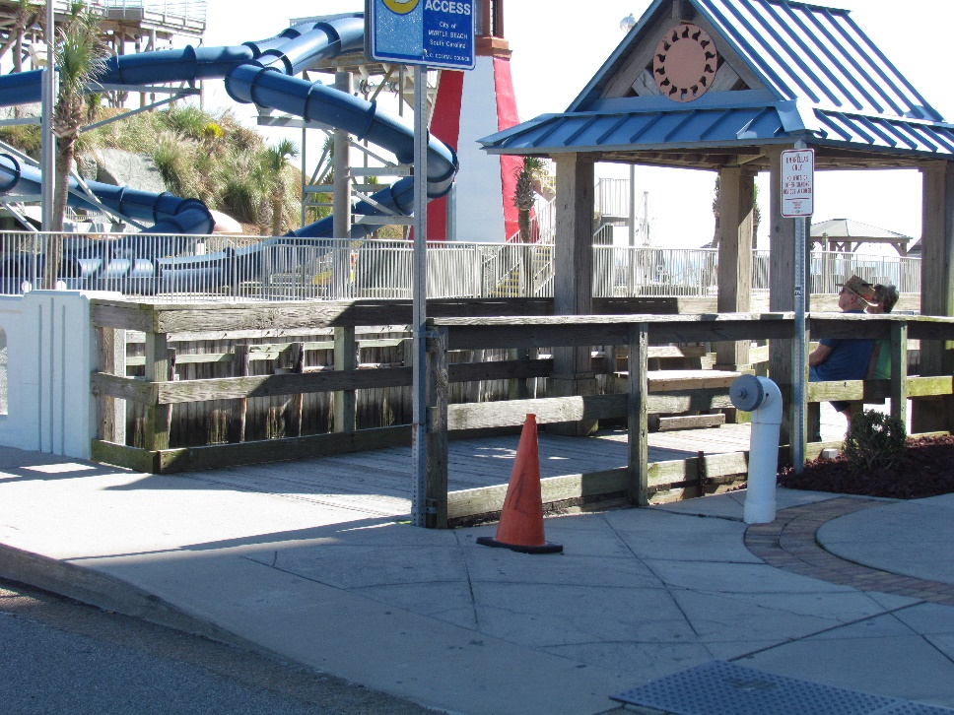
Existing Entrance from Ocean Blvd.

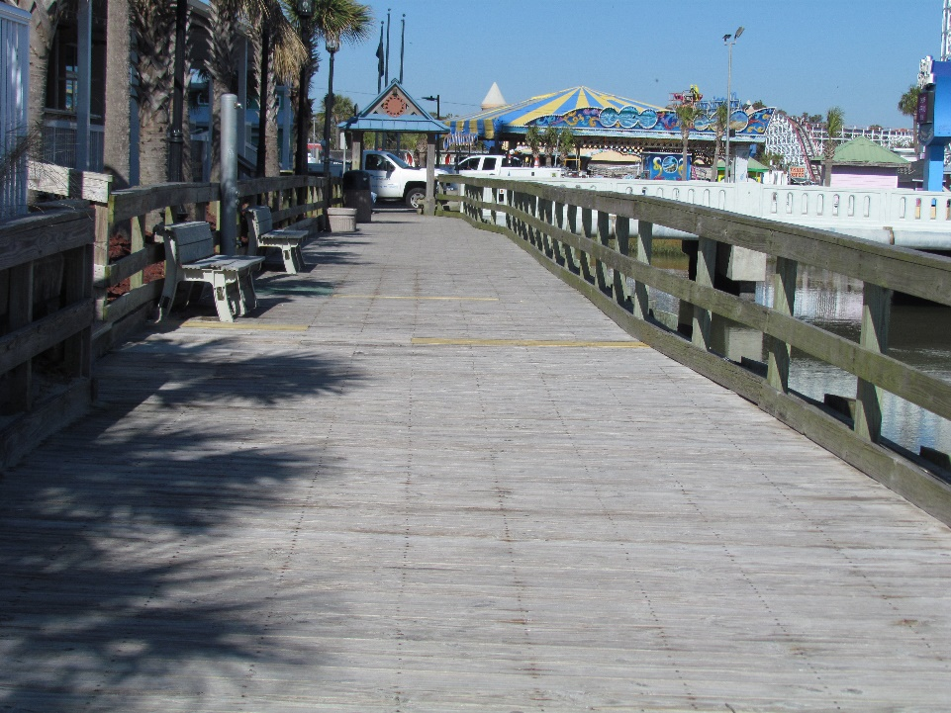
Existing Wood Decking

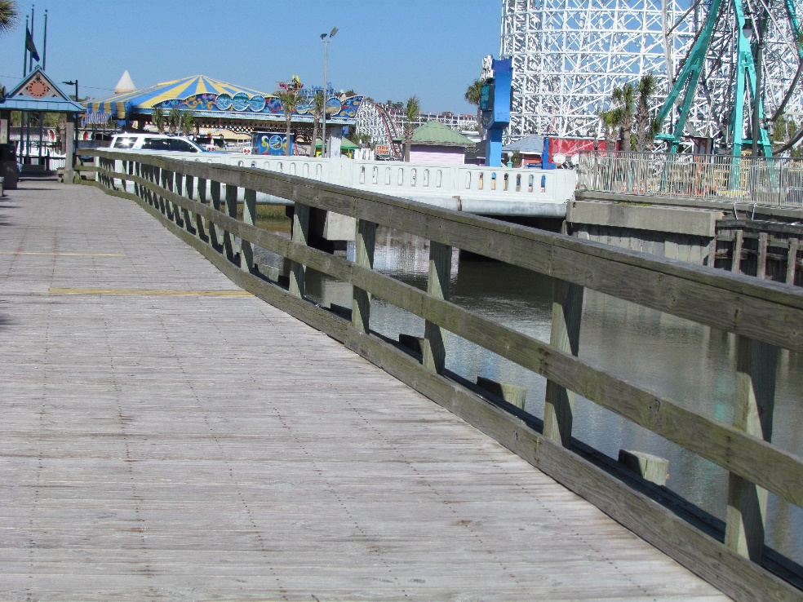
Existing Wood Railing

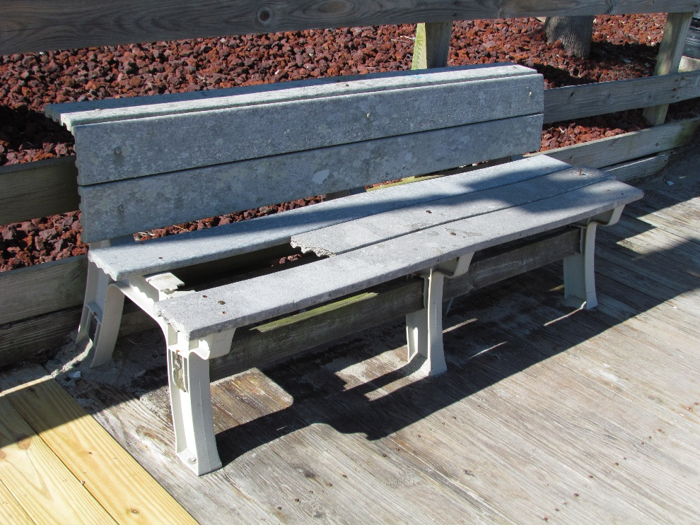
Existing Beach

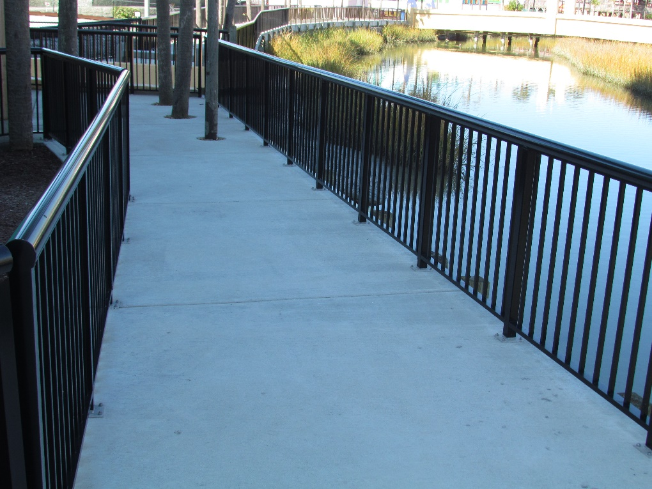
Proposed New Design for Replacement

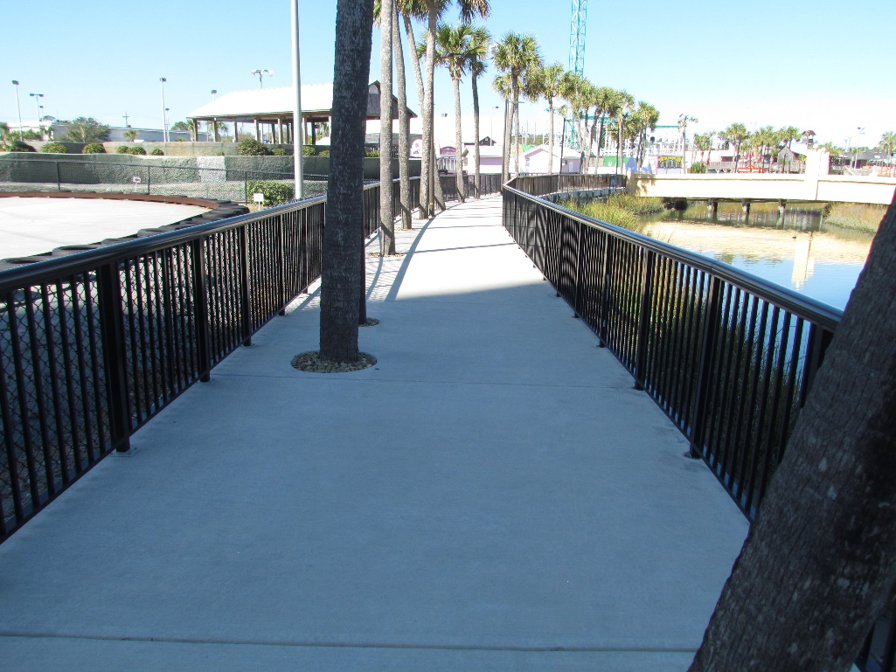
Proposed Concrete Boardwalk

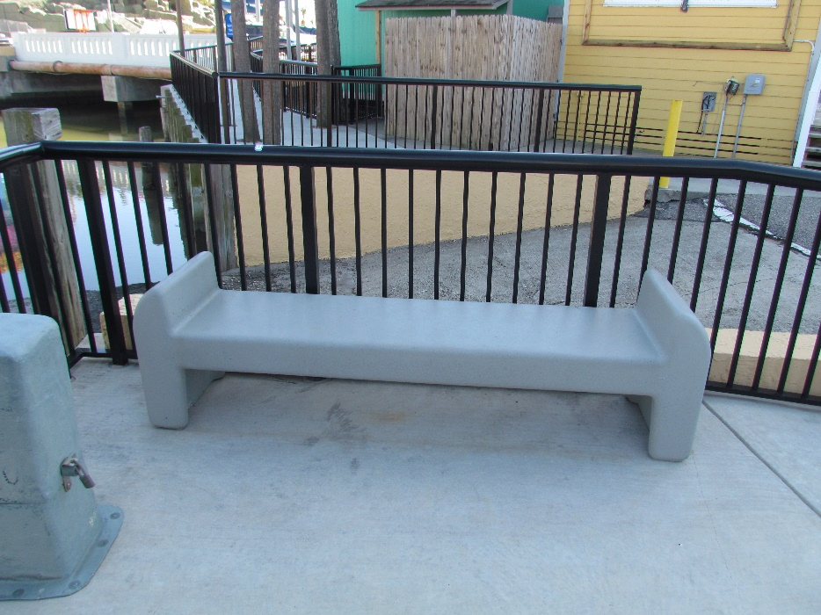
Proposed Concrete Beach

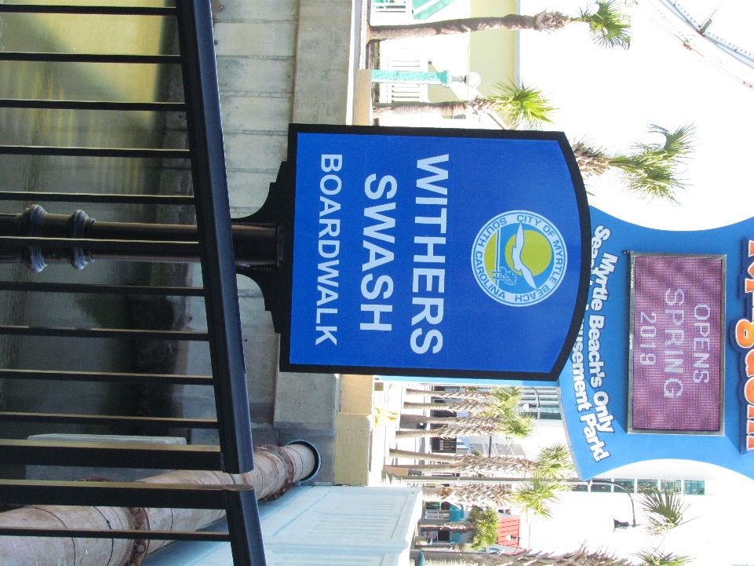
Proposed New Signage
SECTION 05 5200

ALUMINUM HANDRAILS AND RAILINGS

PART 1 – GENERAL

  - SECTION INCLUDES

A. The work specified in this Section includes, but shall not be limited to, the following:

1. Aluminum handrails.
2. Aluminum railings.

B. Related Sections:
1. Section 05 70 00 - Ornamental Metal: Adjacent or adjoining handrails and railings fabricated from steel pipe and tube components.

1.2 REFERENCES

- ESR-3269 ICC-ES Evaluation Report, International Code Council Standards for Glass Balustrade Guard Rail Applications

B. General: The publications listed below form a part of this Specification to the extent referenced. The publications are referred to in the text by the basic designation only. The edition/revision of the referenced publications shall be the latest date as of the date of the Contract Documents, unless otherwise specified.

C. Aluminum Association, Inc. (AA): 1. AA SAS-30, "Specifications for Aluminum Structures."

D. American Architectural Manufacturers Association (AAMA):
1. AAMA 611, "Voluntary Specifications for Anodized Architectural Aluminum (Revised).”
2. AAMA 2604, "Voluntary Specification, Performance Requirements, and Test Procedures for High Performance Organic Coatings on Aluminum Extrusions and Panels."
3. AAMA 2605, "Voluntary Specification, Performance Requirements, and Test Procedures for Superior Performing Organic Coatings on Aluminum Extrusions and Panels."
4. AAMA Aluminum Curtain Wall Series No. 12, "Structural Properties of Glass."

E. American Iron and Steel Institute (AISI):
1. AISI SG-673, Part I, "Specification for the Design of Cold-Formed Steel Structural Members."

F. American Welding Society (AWS):
1. AWS D1.2, "Structural Welding Code – Aluminum."

G. ASTM (ASTM):
1. ASTM B26/B26M,”Standard Specification for Aluminum-Alloy Sand Castings.”
2. ASTM B209/B209M,”Standard Specification for Aluminum and Aluminum-Alloy Sheet and Plate.”
3. ASTM B210/B210M, “Standard Specification for Aluminum and Aluminum-Alloy Drawn Seamless Tubes.”
4. ASTM B221/B221M, “Standard Specification for Aluminum and Aluminum-Alloy Extruded Bars, Rods, Wire, Profiles, and Tubes.” 2 052311 / CRL 05 5200 Aluminum Handrails and Railings 5. ASTM B247/B247M, “Standard Specification for Aluminum and Aluminum-Alloy Die Fo Hand Forgings, and Rolled Ring Forgings.”
6. ASTM B429/B429M, “Standard Specification for Aluminum-Alloy Extruded Structural Pipe and Tube.”
7. ASTM C1048, “Standard Specification for Heat-Treated Flat Glass - Kind HS, Kind FT Coated and Uncoated Glass.”
8. ASTM C1107, “Standard Specification for Packaged Dry, Hydraulic Cement Grout (Non-Shrink).”
9. ASTM E488, “Standard Test Methods for Strength of Anchors in Concrete and Masonry Elements.”
10. ASTM E985, "Standard Specification for Permanent Metal Railing Systems and Rails for Buildings."

H. Code of Federal Regulation (CFR):
1. 16 CFR Part 1201, "Safety Standard for Architectural Glazing Material" (Consumer Products Safety Commission).
I. National Association of Architectural Metal Manufacturers (NAAMM): 1. NAAMM MFM, "Metal Finishes Manual."

1.3 DEFINITIONS

A. See definitions in ASTM E985 for railing-related terms that apply to this Section.

1.4 PERFORMANCE REQUIREMENTS

A. General: Handrails and railings shall withstand structural loading as determined by allowable design working stresses of materials based on the following standards.
1. Aluminum: AA SAS-30.
2. Cold-Formed Structural Steel: AISI SG-673, Part I.
3. Glass: Fully tempered glass in glass-supported handrails and railings require a design with a safety factor of three applied to the applicable modulus of rupture listed in "Mechanical Properties" in AAMA Aluminum Curtain Wall Series No. 12.

B. Structural Performance: Provide handrails and railings capable of withstanding the following structural loads without exceeding allowable design working stress of materials for handrails, railings, anchors, and connections:

1. Top Rail: Shall withstand the following loads: a. Concentrated load of 200 lbf (0.89 kN) applied at any point and in any direction. b. Uniform load of 50 lbf-ft. (0.07 kN-m) applied horizontally and concurrently with uniform load of 100 lbf-ft. (0.14 kN-m) applied vertically downward. c. Concentrated and uniform loads above need not be assumed to act concurrently.

2. Handrails Not Serving As Top Rails: Shall withstanding the following loads: a. Concentrated load of 200 lbf (0.89 kN) applied at any point and in any direction. b. Uniform load of 50 lbf-ft. (0.07 kN-m) applied in any direction. c. Concentrated and uniform loads above need not be assumed to act concurrently.

3. Guard Infill Area: Shall withstand the following loads:
a. Concentrated horizontal load of 200 lbf (0.89 kN) applied to 1 square foot (0.09 m2 ) at any point in system, including panels, intermediate rails, balusters, or other elements composing infill area. Loads need not be assumed to act concurrently with loads on top rails in determining stress on guard.

- Thermal Movements: Handrails and railings shall allow for movements resulting from 120 deg F (49 deg C) changes in ambient and 180 deg F (82 deg C) surface temperatures. Base engineering calculation on surface temperatures of materials due to both solar heat gain and nighttime-sky heat loss.
D. Corrosion Resistance: Separate incompatible materials to prevent galvanic corrosion.

1.5 SUBMITTALS
A. General: Submit under provisions of Section 01 33 00 - Submittal Procedures.
B. Product Data: Submit manufacturer’s data sheets on each product to be used, including, but not limited to, the following:
1. Preparation instructions and recommendations.
2. Storage and handling requirements and recommendations.
3. Installation methods.

C. Product Data: Submit product data for manufacturers product lines of handrails and railings assembled from standard components, including, but not limited to, the following:
1. Grout, anchoring cements and paint products.

D. Shop Drawings: Submit shop drawings showing fabrication and installation of handrails and railings. Include plans, elevations, sections, details, and attachments to other work.

E. Samples:
1. Color Selection: Submit manufacturer's color charts showing the full range of colors available for products with factory-applied color finishes.

2. Finish Selection: Provide sections of railing or flat sheet metal which depict available mechanical surface finishes.

3. Verification Samples: For each type of exposed finish required, prepared on components indicated below and of same thickness and metal indicated for the work. If finishes involve normal color and texture variations, include sample sets showing the full range of variations expected.

a. 6 inch (152 mm) long sections of each different linear railing member, including handrails and top rails.

F. Quality Control Submittals:

1. Design Data: For installed handrails and railing systems indicated to comply with certain design loadings, include structural analysis data signed and sealed by the professional engineer who was responsible for their preparation.

2. Certificates: Submit certification by the manufacturer that products supplied comply with local regulations controlling use of volatile organic compounds (VOC's).

G. LEED Submittals: Submittals that are required to comply with requirements for LEED certification include, but shall not be limited to, the following:
1. Recycled Content: Provide product data and certification letter indicating percentages by weight of post-consumer and pre-consumer recycled content for products having recycled content.
2. Regional Materials: Provide product data for regional materials indicating location and distance from the Project of material manufacturer and point of extraction, harvest, or recovery for each raw material. Distance shall be within 500 miles (805 Km) of the Project Site.

1.6 QUALITY ASSURANCE
A. Qualifications:

- Manufacturer Qualifications: Manufacturer shall be a firm engaged in the manufacture of aluminum handrails and railings of types and sizes required, and whose products have been in satisfactory use in similar service for a minimum of 10 years.
B. Regulatory Requirements: Comply with applicable requirements of the laws, codes, ordinances, and regulations of Federal, State, and local authorities having jurisdiction. Obtain necessary approvals from such authorities.

C. Welding Standards: Comply with applicable provisions of AWS D1.2.

D. Supply sample submittals to demonstrate aesthetic effects as well as qualities of materials and execution.
1.7 DELIVERY, STORAGE, AND HANDLING

A. Store products in manufacturer's unopened packaging until ready for installation.

B. Store and dispose of solvent-based materials, and materials used with solvent-based materials, in accordance with requirements of local authorities having jurisdiction.

1.8 PROJECT CONDITIONS A. Environmental Requirements: Maintain environmental conditions (temperature, humidity, and ventilation) within limits recommended by manufacturer for optimum results. Do not install products under environmental conditions outside manufacturer's absolute limits.

1.9 WARRANTY
A. General: See Section 01 77 00 - Closeout Procedures.
B. Special Warranty: Provide manufacturer's standard form outlining the terms and conditions of their standard Limited Warranty: 1. Surface Finish Warranty: Five year limited warranty.
2. Material Integrity Warranty: One year.

C. Additional Owner Rights: The warranty shall not deprive the Owner of other rights the Owner may have under other provisions of the Contract Documents and shall be in addition to and run concurrent with other warranties made by the Contractor under requirements of the Contract Documents.

1.10 EXTRA MATERIALS
A. All supplemental materials not expressly specified in this section shall be approved by the Architect prior to installation.

PART 2 – PRODUCTS

2.1 MANUFACTURERS

A. Basis of Design: Items specified are to establish a standard of quality for design, function, materials, and appearance. Equivalent products by other manufacturers are acceptable. The Architect will be the sole judge of the basis of what is equivalent.

2.2 MATERIALS
A. LEED Requirements:
1. Recycled Content: Provide building materials with recycled content such that post-consumer recycled content plus one-half of pre-consumer recycled content shall constitute a minimum of [10 percent] [20 percent], based on cost, of the total value of materials in the Project. 2. Regional Materials: Provide a minimum of [10 percent] [20 percent], based on cost, of building materials that are regionally extracted, processed, and manufactured. B. Application/Scope of Work: 1. Architectural railing.

2. Structural glass railing.
3. Fencing and pool surround.
4. Vehicle and pedestrian gate.
5. Glass wall system.

C.Basis of Design: C.R. Laurence Co., Inc. (CRL)
Tel: (800) 421-6144 Fax: (800) 587-7501
Email: railings@crlaurence.com
www.crlaurence.com

D. Metals: Provide metal free from pitting, seam marks, roller marks, stains, discolorations, and other imperfections where exposed to view on finished units.
1. Aluminum: Provide alloy and temper recommended by aluminum producer and finisher for type of use and finish indicated, and with not less than strength and durability properties of alloy and temper designated below for each aluminum form required.
a. Extruded Bar and Tube: ASTM B221/B221M, Alloy 6063-T5/T52.
b. Extruded Structural Pipe and Tube: ASTM B429/B429M, Alloy 6063-T832.
c. Drawn Seamless Tube: ASTM B210/B210M, Alloy 6063-T832.
d. Plate and Sheet: ASTM B209/B209M, Alloy 6061-T6.
e. Die and Hand Forgings: ASTM B247/B247M, Alloy 6061-T6.
f. Castings: ASTM B26/B26M, Alloy A356-T6.

2. Brackets, Flanges, and Anchors: Provide cast or formed metal of same type of material and finish as supported rails, unless otherwise indicated.

a. Provide cast brackets with flange tapped for concealed anchorage to threaded hanger bolt.
b. Provide formed or cast brackets with predrilled hole for exposed bolt anchorage.
c. Provide formed steel brackets with predrilled hole for bolted anchorage and with snap-on cover that matches rail finish and conceals bracket base and bolt head.
d. Provide brackets with interlocking pieces that conceal anchorage. Locate set screws on bottom of bracket.

E. Railing Components:
1. Extruded Aluminum Components: Provide manufacturer’s standard extruded aluminum components as follows:
a. Standard Post: 2.376 inches (60.35 mm) by 2.376 inches (60.35 mm) with radiused corner, 0.100 inch (2.54 mm) wall thickness.
b. Bottom Rail: 1.6926 inches (42.99 mm) high by 1.676 inches (43.57 mm) high with a 0.765 inch (19.43 mm) wide pocket on the top and an open bottom.
c. Picket: 0.750 inches (19.05 mm) by 0.750 inches (19.05 mm), 0.062 inch (1.57 mm) wall thickness.
d. Top Rail: Circular cross section, radius as indicated on the Drawings or, if not indicated, as selected by the Architect from the manufacturer’s standards with an open bottom, 0.0866 inch (2.20 mm) wall thickness.

G. Fasteners:
1. Handrail Anchors: Select fasteners of type, grade and class required to produce connections suitable for anchoring handrails and railings to other types of construction indicated and capable of withstanding design loads.
2. Handrail and Railing Component Anchors: Use fasteners fabricated from same basic metal, unless otherwise indicated. Do not use metals that are corrosive or incompatible with materials joined.
a. Provide concealed fasteners for interconnecting railing components and for attaching them to other work, unless exposed fasteners are unavoidable or are standard fastening method for handrail and railing indicated.
b. Provide Phillips flat-head machine screws for exposed fasteners, unless otherwise indicated. 3. Cast-in-Place and Post Installed Anchors: Provide anchors of type indicated below, fabricated from corrosion-resistant materials with capability to sustain, without failure, a load equal to six times the load imposed when installed in unit masonry and equal to four items the load imposed when installed in concrete, as determined by testing per ASTM E488 conducted by a qualified independent testing agency.
a. Cast-in-place anchors.
b. Chemical anchors.
c. Expansion anchors.
H. Grout and Anchoring Cement:
1. Non-Shrink, Non-Metallic Grout: Provide premixed, factory-packaged, non-staining, non-corrosive, non-gaseous grout complying with ASTM C1107. Provide grout specifically recommended by manufacturer for interior and exterior applications.

2. Interior Anchoring Cement: Provide factory-packaged, non-shrink, non-staining, hydraulic-controlled expansion cement formulation for mixing with water at project site to create pourable anchoring, patching and grouting compound. Use for interior applications only.

2.3 FABRICATION

A. Assemble handrails and railings in shop to greatest extent possible to minimize filed splicing and assembly. Disassemble units only as necessary for shipping and handling limitations. Clearly mark units for reassembly and coordinated installation. Use connections that maintain structural value of joined pieces.

B. Form changes in direction of railing members as shown on the Drawings.

C. Fabricate handrails and railings by connecting members with railing manufacturer's standard concealed mechanical fasteners and fittings, unless otherwise indicated. Fabricate members and fittings to produce flush, smooth, rigid, hairline joints.

D. Provide manufacturer's standard wall brackets, flanges, miscellaneous fittings, and anchors to connect handrail and railing members to other construction.

E. Tempered glass shall be cut to final size and shape before heat treatment; provide for proper edge clearance and bite on glass. Provide thickness indicated on the Drawings, not less than required to support structural loads.

F. Provide inserts and other anchorage devices to connect handrails and railings to concrete or masonry. Fabricate anchorage devices capable of withstanding loads imposed by handrails and railings. Coordinate anchorage devices with supporting structure.

G. Shear and punch metals cleanly and accurately. Remove burrs from exposed cut edges.

H. Cut, reinforce, drill, and tap components as indicated on the Drawings to receive finish hardware, screws, and similar items.

I. Close exposed ends of railing members with prefabricated end fittings.

J. Provide mounted handrail wall returns at wall ends unless otherwise indicated. Close ends of returns, unless clearance between end of railing and wall is 1/4 inch (6 mm) or less.

2.4 FINISHES

A. General: Comply with NAAMM MFM for recommendations for applying and designating finishes. 1. Appearance of Finished Work:
a. Variations in appearance of abutting or adjacent units are acceptable if they are within one-half of the range of final samples. Noticeable variations in the same unit are not acceptable.
b. Variations in appearance of other components are acceptable if they are within the range of final samples and are assembled or installed to minimize contrast.

B. Aluminum Finish: Finish designations prefixed by AA comply with the system established by the Aluminum Association for designating aluminum finishes.

1. Powder Coat Finish: AA-C12-C42-R1x (Chemical Finish: cleaned with inhibited chemicals; Chemical Finish: acid chromate-fluoride-phosphate conversion coating; Organic Coating: as specified below). Prepare, pretreat, and apply manufacturer's standard baked powder coat finish. Comply with coating manufacturer's written instructions for cleaning, surface preparation, pretreatment, and application.
a. Material: Polyester powder coating, 3.0 mil (0.076 mm). Comply with AAMA 2604, including, but not limited to, average film thickness. Subject to compliance with requirements, provided by the following product:
1) “ARC 2001™,” Spraylat Powder Coatings b. Color: [_____________]. c. Gloss: [_____________].
2. Class I Clear Anodized Finish: AA-M12-C22-A41 (Mechanical Finish: as fabricated, non-specular; Chemical Finish: etched, medium matte; Anodic Coating: Architectural Class I, clear film thicker than 0.7 mil [0.018 mm]) complying with AAMA 611.
3. Class I Color Anodized Finish: AA-M21-C22-A42/A44 (Mechanical Finish: as fabricated, non-specular; Chemical Finish: etched, medium matte; Anodic Coating: Architectural Class I, film thicker than 0.7 mil [0.018 mm] with integral color or electrolytically deposited color) complying with AAMA 611. Provide color to match the Architect’s sample, or, if no sample, as selected by the Architect from within full range of industry colors and color density range.

PART 3 - EXECUTION

3.1 EXAMINATION

A. Verification of Conditions: Examine areas and conditions under which the work is to be installed, and notify the Contractor in writing, with a copy to the Owner and the Architect, of any conditions detrimental to the proper and timely completion of the work. Do not proceed with the work until unsatisfactory conditions have been corrected.
1. Examine substrates to receive anchors verifying that locations of concealed reinforcements have been clearly marked for the Installer. Locate reinforcements and mark locations if not already done.
2. Beginning of the work shall indicate acceptance of the areas and conditions as satisfactory by the Installer. 3.2 PREPARATION A. Coordinate setting drawings, diagrams, templates, instructions, and directions for installing anchors, such as sleeves, concrete inserts, anchor bolts, and miscellaneous items having integral anchors, that are to be embedded in concrete or masonry construction. Coordinate delivery of such items to the Project site.

3.3 INSTALLATION
A. General:
1. Fitting: Fit exposed connections together to form tight, hairline joints.
2. Cutting and Placement: Set handrails and railings accurately in location, alignment, and elevation measured from established lines and levels and free from rack.
a. Do not weld, cut, or abrade coated or finished surfaces of railing components that are intended for field connection by mechanical or other means without further cutting or fitting.
b. Align rails so variations from level or parallel alignment do not exceed 1/4 inch in 12 feet (1.6 mm per m).
c. Provide manufacturer’s proprietary system to evacuate entrapped water in hollow sections of railing members that are exposed to exterior or to moisture from condensation or other sources, in order to prevent water from entering the concrete slab. In lieu of the manufacturer’s proprietary system, if acceptable to the Architect, provide another means to evacuate the entrapped water, i.e., a weephole and epoxy fill system (“drill-and-fill”).
d. Anchor posts in concrete with pipe sleeves preset and anchored into concrete. After posts have been inserted into sleeves, solidly fill annular space between post and sleeve with non-metallic, non-shrink grout, mixed and placed to comply with anchoring material manufacturer's directions.
e. Anchor posts in concrete by forming or core drilling holes not less than 5 inches (127 mm) deep and 3/4 inch (19 mm) greater than outside diameter of post. Clean holes of loose material, insert posts, and fill annular space between post and concrete with non-metallic, non-shrink grout, mixed and placed to comply with anchoring material manufacturer's directions.

1) Cover anchorage joint with a round steel flange attached to post by welding to post after placement of anchoring material.
2) Cover anchorage joint with a round steel flange attached to post by set screws. 3) Leave anchorage joint exposed, wipe off surplus anchoring material, and leave 1/8 inch (3 mm) buildup, sloped away from post.
3. Corrosion Protection: Coat concealed surfaces of aluminum that will be in contact with grout, concrete, masonry, wood, or dissimilar metals, with a heavy coat of bituminous paint.
4. Adjusting: Adjust handrails and railings before anchoring to ensure alignment at abutting joint's space posts at interval indicated, but not less than required to achieve structural loads.
5. Fastening to In-Place Construction: Use anchorage devices and fasteners where necessary for securing handrails and railings and for properly transferring loads to in-place construction.

B. Non-Welded Railings Connections: Use mechanical joints for permanently connecting railing components. Use wood blocks and padding to prevent damage to railing members and fittings.

- Installing Glass Panels in Glass Handrails and Railings: Install assembly to comply with railing manufacturer's written instructions. Attach base channel to building structure, then insert and connect factory-fabricated and factory-assembled glass panels. 1. Erect glass handrails and railings under direct supervision of manufacturer's authorized technical personnel. 3.4

- ADJUSTING AND CLEANING
A. Touch-Up Painting: Immediately after erection, clean field welds, bolted connections, and abraded areas of shop paint, and appoint exposed areas with same material.
B. Cleaning: Restore finishes damaged during installation and construction period so no evidence remains of correction work. Return items that cannot be refinished in field to shop; make required alterations and refinish entire unit, or provide new units.

3.5 PROTECTION
A. Provide final protection and maintain conditions in a manner acceptable to the Installer that shall ensure that the aluminum handrails and railings shall be without damage at time of Substantial Completion.

B. Protect finishes of handrails and railings from damage during construction period with temporary protective coverings approved by railing manufacturer. Remove protective coverings at the time of Substantial Completion.

END OF SECTION

DELIVERY: Bid prices shall be Delivered Prices (FOB Destination). Shipping and handling is to include all costs, including but not limited to: taxes, loading/unloading costs(s), fuel charge(s), fuel surcharge(s), energy surcharge(s), and environmental fee(s). The City will not be responsible for any demurrage charge(s).

BID AWARD: Sellers understand that the City of Myrtle Beach ranks all bids by price; however, pursuant to applicable terms and conditions of this bid, buyers may use criteria other than price to evaluate offers. This includes, but is not limited to: Section 3.02 - Responsive Bids; Section 3.03 – Non-Responsive Bids; Section 5.04 – Price Evaluation; Section 12.01 – Award Criteria. Accordingly, please note that the award will be made to the responsible seller whose bid conforms to the solicitation that is most advantageous to the buyer on basis of price, technical capability, and delivery.

INVOICING: Invoicing shall be submitted upon completion of shipment. All invoices must reference the purchase order number, quantity, unit price, and extended price of each item purchased. Invoices shall be submitted to: City of Myrtle Beach
Finance Department/Accounts Payable
PO Box 2468
Myrtle Beach, SC 29578-2468

Price Schedule

In accordance with the project scope, plans, specifications in the contract, the Contractor shall provide all plant, supervision, labor, materials, equipment, supplies, and transportation necessary to complete this scope of work. Prices to include all taxes and costs, including (but not limited to): supplies, tools, equipment, labor, supervision, delivery, loading/unloading, truck charges, mileage, travel time, per diem, fuel, fuel surcharges, energy surcharges, hazardous material handling fees, environmental impact fees, and waste disposal fees.
All work shall comply with all federal, state, and local laws and regulations, industry and construction codes and standards, manufacturer’s specifications and recommendations, all contract special provisions, and terms and conditions. FOB: Destination

Item # | Description | Qty. | Unit of Issue | Total Bid Price
1 | Withers Swash Boardwalk Renovations | 1 | LS | $____________

Company Name: ___________________________

Contact Person:_________________________________________

Phone: ________________________________________________

Email Address: _________________________________________

ADDITIONAL TERMS AND CONDITIONS

- Include with your bid at least three (3) references of similar products provided by your company. Telephone number and person to contact must be included for bid consideration.

1) | __________________________________________________________________
 | __________________________________________________________________
 | __________________________________________________________________
2) | __________________________________________________________________
 | __________________________________________________________________
 | __________________________________________________________________
3) | __________________________________________________________________
 | __________________________________________________________________
 | __________________________________________________________________

- List any exceptions to specifications:

_______________________________________________________________________
_______________________________________________________________________
_______________________________________________________________________
_______________________________________________________________________
_______________________________________________________________________

City of Myrtle Beach
INSURANCE REQUIREMENTS

PUBLIC LIABILITY AND PROPERTY DAMAGE
The Contractor shall purchase and thereafter maintain for the term of this agreement, and any subsequent extensions hereto, public liability insurance to protect Contractor from claims for bodily injury and/or property damage which may result from Contractor’s performance of this agreement. The policy shall provide a combined single limit of liability of $1,000,000 per occurrence for bodily injury and property damage with an aggregated limit of not less than $1,000,000.

AUTOMOBILE LIABILITY
The Contractor shall purchase and thereafter maintain for the term of this agreement and any subsequent extensions hereto, comprehensive automobile liability insurance to protect the Contractor from claims for bodily injury and property damage which may arise from Contractor’s use of motor vehicles in the performance of this agreement. The policy shall provide for a combined single limit of $1,000,000 per occurrence for bodily injury and property damage.

WORKERS’ COMPENSATION INSURANCE
Prior to beginning the work, the Contractor shall take out full compensation insurance for all persons which may be employed directly or indirectly in the performance of this agreement, coverage is to apply to all employees for statutory limits in compliance with the applicable state and federal laws. The policy must provide Employers Liability coverage in the amount of $500,000 each accident; $500,000 bodily injury by disease each employee and $500,000 bodily injury by disease policy limit and shall be maintained in full force and effect during the term and any subsequent extensions hereto.

EXCESS LIABILITY POLICY
At the option of the Contractor, the limits of the primary general liability, automobile liability and employer’s liability policies may be less than stipulated herein, with an excess policy providing the additional limits needed. This form of coverage must be approved by the City and will only be acceptable when both the primary and excess policies include the coverage and endorsements required herein.

POLICY ENDORSEMENTS
The following requirements shall apply to the policy(s) indicated below:

- General Liability and Automobile Liability

It is understood and agreed that the City of Myrtle Beach, its officials, agents and employees are recognized as additionally named insureds under the policy and, as such, will be provided thirty (30) days written notice by registered mail of non-renewal, exhaustion of aggregate limit, modification of coverage or cancellation for any reason, and the company hereby agrees to provide such notice. Failure of the company to provide the required notice shall cause the coverage to continue in force for the benefit of the City, its officials, agents and employees until proper notification, as required herein, is provided, the provisions of the policy or any Certificate of Insurance to the contrary notwithstanding.

- Workers’ Compensation

The cancellation provision is hereby amended to provide that the City of Myrtle Beach will be provided thirty (30) days written notice via certified mail, return receipt required, in the event of coverage cancellation.

NOTIFICATION OF INSURANCE COMPANIES
It is the responsibility of the Contractor to notify all insurance companies to familiarize themselves with all the terms and conditions of this agreement. The insurance companies shall waive their right of

INSURANCE REQUIREMENTS continued

notification by the City of any change or modification of this contract, or of decreased or increased work, or of the cancellation of this agreement or of any other acts by the City or its authorized employees or agents under the terms of this agreement. The waiver by the insurance companies shall in no way relieve them of their obligations under this agreement.

CERTIFICATES OF INSURANCE
Contractor shall file with the City a Certificate of Insurance, which shall be approved by the City prior to the inception of any work. Renewal certificates shall be sent to the City thirty (30) days prior to any expiration date.

INSURER LICENSING AND RATING
All insurance companies providing coverage to the City, shall be licensed to do business in the State and have an A.M. Best rating of “A-“ or better.

INSURANCE COVERAGE ADJUSTMENTS
In response to changing circumstance of loss exposures, the City reserves the right to modify the insurance coverage, limits of liability, policy endorsements and policy terms required in this contract. The City will provide written notice to the Contractor, which outlines such changes and allow Contractor a reasonable period of time in which to comply with the new requirements. However, in no event shall Contractor compliance period be longer than thirty (30) days.
COVERAGE CANCELLATION OR UNSATISFACTORY COVERAGE
If at any time any of the foregoing policies shall be or become unsatisfactory to the City, as to form or substance, or if a company issuing any such policy shall be or become unsatisfactory to the City, the Contractor shall, upon notice to that effect from the City, promptly obtain a new policy and submit the same for approval to the City. Upon failure of the Contractor to furnish, deliver and maintain the insurance coverage’s required herein, this agreement, at the sole discretion of the City, may be forthwith declared suspended, discontinued or terminated. Failure of the Contractor to take out and/or maintain any required insurance shall not relieve the Contractor from any liability under this agreement, nor shall the insurance requirements be construed to conflict with or otherwise limit the obligations of the Contractor concerning indemnification.

HOLD HARMLESS
Contractor agrees to protect, defend, indemnify and hold the City, its officers, employees and agents free and harmless from and against any and all losses, penalties, damages, settlements, cost, charges, professional fees or other expenses and liabilities of every kind and character arising out of, or relating to, any and all claims, liens, demands, obligations, actions, proceedings or causes of action of every kind in connection with or arising out of this agreement, and/or the performance hereof, that are due to the negligence of the Contractor, its officers, employees or agents. The Contractor further agrees to investigate, handle, respond to, provide defense for and defend the same at its sole expense and agrees to bear all other costs and expenses related thereto.

INSURANCE REQUIREMENTS continued

SAMPLE

CERTIFICATE OF INSURANCE |  |  |  |  |  |  |  | CERTIFICATE NUMBER
PRODUCER  Insurance Agent Name  4000 Insurance Pkwy  Anytown, USA 99999 |  |  | THIS CERTIFICATE IS ISSUED AS A MATTER OF INFORMATION ONLY AND CONFERS NO RIGHTS UPON THE CERTIFICATE HOLDER OTHER THAN THOSE PROVIDED IN THE POLICY. THIS CERTIFICATE DOES NOT AMEND, EXTEND OR ALTER THE COVERAGE AFFORDED BY THE POLICIES DESCRIBED HEREIN.
 |  |  |  |  | COMPANIES AFFORDING COVERAGE
INSURED  Bidding Firm’s Name  1000 Any Street  Anytown, USA 99999 |  |  | COMPANY A ABC INSURANCE COMPANY  COMPANY B  COMPANY C  COMPANY D

COVERAGES-THIS CERTIFICATE SUPERCEDES AND REPLACES ANY PREVIOUSLY ISSUED CERTIFICATE FOR THE POLICY NOTED BELOW

This is to certify that policies of insurance described herein have been issued to the insured named herein for the policy indicated. Notwithstanding any requirement, term or condition of any contract or other document with respect to which the certificate may be issued or may pertain, the insurance afforded by the policies described herein is subject to all the terms, conditions and exclusions of such policies. Aggregate limits shown may have been reduced by paid claims.

CO LTR | TYPE OF INSURANCE | POLICY NUMBER |  | POLICY EFFECTIVE DATE (MM/DD/YY) |  | POLICY EXPIRATION DATE (MM/DD/YY) | LIMITS
A | General Liability  X Commercial General  Liability  _ Claims Made X Occur  _ Owners & Contractor’s  Prot  ________________ | XYZ1234 |  | 00/00/00 |  | 00/00/00 | General Aggregate  Products-Comp/Op Agg  Personal & Adv Injury  Each Occurrence  Fire Damage (any 1 fire) |  | $ 1,000,000  $ 1,000,000  $ 1,000,000  $ 1,000,000  $ 50,000
A | Automobile Liability  X Any Auto  _ All Owned Autos  _ Scheduled Autos  X Hired Autos  X Non-Owned Autos  ________________ | XYZ1234 |  | 00/00/00 |  | 00/00/00 | Combined Single Limit  Bodily Injury  (Per person)  Bodily Injury  (Per accident)  Property Damage |  | $ 1,000,000  $  $  $
 | Garage Liability  _ Any Auto  ________________ |  |  | 00/00/00 |  | 00/00/00 | Auto Only-Ea Accident  Other than auto only:  Each Accident  Aggregate |  | $  $  $
 | Excess Liability  _ Umbrella Form  _ Other than Umbrella Form |  |  | 00/00/00 |  | 00/00/00 | Each Occurrence  Aggregate |  | $  $
A | Workers Compensation  (and Employer’s Liability)  The Proprietor/Partners  Executive Officers Are:  X Inc _ Excl | XYZ1234 |  | 00/00/00 |  | 00/00/00 | X WC Statutory Limits  _ Other  EL Each Accident  EL Disease-Policy Ltd  EL Disease-Ea Employee |  | $ 500,000  $ 500,000  $ 500,000
 | Other
Description of Operations/Locations/Vehicles/Special Items:
City of Myrtle Beach is named as additional insured with respect to General and Automobile Liability

CERTIFICATE HOLDER |  |  |  | CANCELLATION
City of Myrtle Beach  Attn: Purchasing Division  Drawer 2468  Myrtle Beach, SC 29578-2468 |  |  |  | Should any of the policies described herein be cancelled before the expiration date thereof, the insurer affording coverage will endeavor to mail 30 days written notice to the certificate holder named herein, but failure to mail such notice shall impose no obligation or liability of any kind upon the insurer affording coverage, its agents or representatives, or the issuer of this certificate.
 |  |  |  | INSURANCE AGENT SIGNATURE

BID BOND
IFB 20-B0010

KNOW ALL MEN BY THESE PRESENTS, that we the undersigned,

_____________________________________________________________ as Principal, and

___________________________________________ as SURETY are hereby held and firmly bound unto

_______________________________________ as OWNER, in the penal sum of

_____________________________________________________________________ for the payment of which, well and truly to be made, we hereby jointly and severally bind ourselves, successors and assigns.

THE CONDITION OF THE ABOVE OBLIGATION IS SUCH, that whereas the PRINCIPAL has submitted to the City of Myrtle Beach a certain BID, attached hereto and hereby made a part hereof to enter into a contract in writing for the _____________________________.

NOW, THEREFORE,

(a) If said BID shall be rejected, or

(b) If said BID shall be accepted and the PRINCIPAL shall execute and deliver a contract in the Form of Contract attached hereto (properly completed in accordance with said BID) and shall furnish BOND for his faithful performance of said contract, and for the payment of all persons performing labor or furnishing materials in connection therewith, and shall in all other respects perform the agreement created by the acceptance of said BID,

then this obligation shall be void, otherwise the same shall remain in force and effect; it being expressly understood and agreed that the liability of the Surety for any and all claims hereunder shall, in no event, exceed the penal amount of this obligation as herein stated.

The SURETY, for value received, hereby stipulates and agrees that the obligations of said SURETY and its BOND shall be in no way impaired or affected by any extension of the time within which the OWNER may accept such BID; and said SURETY does hereby waive notice of any such extension.

IN WITNESS WHEREOF, the PRINCIPAL and the SURETY have hereunto set their hands and seals and such of them as are corporations have caused their corporate seals to be hereto affixed and these to be signed by their proper officers, the day and year first set forth above.

_____________________________(L.S.) ______________________________
Principal Surety

_____________________________ By____________________________

IMPORTANT: Surety companies executing BONDS must appear on the Treasury Department’s most current list (Circular 570 as amended) and be authorized to transact business in the State where the project is located.

PERFORMANCE BOND

KNOW ALL MEN BY THESE PRESENTS: that

___________________________________________________________________________________________
(Name of Contractor)

___________________________________________________________________________________________
(Address of Contractor)

a ________________________________________________________ hereinafter called Principal, and
(Corporation, Partnership, or Individual)

___________________________________________________________________________________________
(Name of Surety)

___________________________________________________________________________________________
(Address of Surety)

Hereinafter called SURETY, are held and firmly bound unto __________________________________________

___________________________________________________________________________________________
(Name of Owner)

___________________________________________________________________________________________
(Address of Owner)

Hereinafter called OWNER, in the penal sum of ____________________________________________________

_______________________________ Dollars, ($________________________) in lawful money of the United
States, for the payment of which sum well and truly to be made, we bind ourselves, successors, and assigns, jointly and severally, firmly by these presents.

THE CONDITION OF THIS OBLIGATION is such that whereas, the Principal entered into a certain contract with the OWNER, dated the ______ day of ___________________, 20 ____, a copy of which is hereto attached and made a part hereof for the construction of:

___________________________________________________________________________________________

___________________________________________________________________________________________

___________________________________________________________________________________________

NOW, THEREFORE, if the Principal shall well, truly and faithfully perform its duties, all the undertakings, covenants, terms, conditions, and agreements of said contract during the original term thereof, and any extensions thereof which may be granted by the OWNER, with or without notice to the Surety and during the one year guaranty period, and if he shall satisfy all claims and demands incurred under such contract, and shall fully indemnify and save harmless the OWNER from all costs and damages which it may suffer by reason of failure to do so, and shall reimburse and repay the OWNER all outlay and expense which the OWNER may incur in making good any default, then this obligation shall be void; otherwise to remain in full force and effect.
PERFORMANCE BOND continued

PROVIDED, FURTHER, that the said Surety, for value received hereby stipulates and agrees that no change, extension of time, alteration or addition to the terms of the contract or to WORK to be performed thereunder or the SPECIFICATIONS accompanying the same shall in any way affect its obligation on this BOND, and it does hereby waive notice of any such change, extension of time, alteration or addition to the terms of the contract or to the WORK or to the SPECIFICATIONS.

PROVIDED, FURTHER, that no final settlement between the OWNER and the CONTRACTOR shall abridge the right of any beneficiary hereunder, whose claim may be unsatisfied.

IN WITNESS WHEREOF, this instrument is executed in four (4) counterparts, each one of which shall be deemed an original, this the ______ day of ____________________ , 20 ____ .

ATTEST: ___________________________________
Principal

__________________________________
Principal Secretary

[SEAL]

__________________________________ By _______________________________(s)
(Witness as to Principal)

__________________________________ ____________________________________
(Address) (Address)
__________________________________ ____________________________________

____________________________________
Surety
ATTEST:

__________________________________
(Surety) Secretary

[SEAL]

___________________________________ By _________________________________
Witness as to Surety Attorney-in-Fact

___________________________________ ____________________________________
(Address) (Address)
___________________________________ ____________________________________

PERFORMANCE BOND continued

NOTE: Date of Bond must be prior to date of Contract. If CONTRACTOR is Partnership, all partners should execute BOND.

IMPORTANT: Surety companies executing BONDS must appear on the Treasury Department’s most current list (Circular 570 as amended) and be authorized to transact business in the state where the PROJECT is located.

PAYMENT BOND

KNOW ALL MEN BY THESE PRESENTS: that
______________________________________________________________________________
(Name of Contractor)
______________________________________________________________________________
(Address of Contractor)
a _________________________________________________ hereinafter called Principal, and
(Corporation, Partnership or Individual)
______________________________________________________________________________
(Name of Surety)
______________________________________________________________________________
(Address of Surety)
hereinafter called Surety, are held and firmly bound unto ________________________________
______________________________________________________________________________
(Name of Owner)
______________________________________________________________________________
(Address of Owner)
hereinafter called OWNER, in the penal sum of _________________________________ Dollars, ($ ______________) in lawful money of the United States, for payment of which sum well and truly to be made, we bind ourselves, successors, and assigns, jointly and severally, firmly by these presents.

THE CONDITION OF THIS OBLIGATION is such that whereas, the Principal entered into a certain contract with the OWNER, dated the _____________ day of ______________, 20 ___,
a copy of which is hereto attached and made a part hereof for the construction of:
______________________________________________________________________________
______________________________________________________________________________
______________________________________________________________________________

NOW, THEREFORE if the Principal shall promptly make payment to all persons, firms, SUBCONTRACTORS, and corporations furnishing materials for or performing labor in the prosecution of the WORK provided for in such contract, and any authorized extension or modification thereof, including all amounts due for materials, lubricants, oil, gasoline, coal and coke, repairs on machinery, equipment and tools, consumed or used in connection with the construction of such WORK whether by SUBCONTRACTOR or otherwise, then this obligation shall be void; otherwise to remain in full force and effect.

PROVIDED, FURTHER, that the said Surety for value received hereby stipulates and agrees that no change, extension of time, alteration or addition to the terms of the contract or to the WORK to be performed thereunder or the SPECIFICATIONS accompanying the same shall in any way affect its obligation on this BOND, and it does hereby waive notice of any such change, extension of time, alteration or addition to the terms of the contract or to the WORK or to the SPECIFICATIONS.

PROVIDED, FURTHER, that no final settlement between the OWNER and the CONTRACTOR shall abridge the right of any beneficiary hereunder, whose claim may be unsatisfied.

PAYMENT BOND continued

IN WITNESS WHEREOF, this instrument is executed in four (4) counterparts, each one of which shall be deemed an original, this the __________ day of _________________________ , 20 ____ .

ATTEST: ________________________________
Principal
________________________________
(Principal) Secretary

[SEAL] By ________________________________ (S)

________________________________
(Address)
________________________________ ________________________________
Witness as to Principal

________________________________
(Address)
________________________________

ATTEST: ________________________________
Surety
________________________________
Surety Secretary

[SEAL]

________________________________ By ________________________________
Witness as to Surety Attorney-in-Fact

________________________________ ________________________________
(Address) (Address)
________________________________ ________________________________

NOTE: Date of BOND must be prior to date of contract. If CONTRACTOR is Partnership, all partners should execute BOND.

IMPORTANT: Surety companies executing BONDS must appear on the Treasury Department’s most current list (Circular 570 as amended) and be authorized to transact business in the State where the PROJECT is located.
BID AND SIGNATURE DOCUMENT
Bid Number: 20-B0010

The undersigned, as bidder, declare that we have examined all bid documents contained herein and will contract, thereon, with the City of Myrtle Beach (hereinafter referred to as the “City”) and do everything necessary for the fulfillment of this contract. We agree any addenda received are part of the bid documents. (If no addenda have been received, please place a zero in the space provided.)

In addition, we propose to furnish the following services in strict conformance to the bid specifications and bid invitation issued by the City of Myrtle Beach for this bid. Any exceptions are clearly noted as required.

We understand that any false statement made to meet any requirements may result in contract cancellation or initiation of action under federal or state laws, or both.

____________________________________________________________________________________
Bidder – Company Name

____________________________________________________________________________________
Mailing Address

____________________________________________________________________________________
Remittance Address (if different from mailing address)

____________________________________________________________________________________
Telephone Number Fax Number

____________________________________________________________________________________
E-mail

____________________________________________________________________________________
Authorized Signature Date

Addenda Numbers Received: ___________________________________________________________

Printed Name: _______________________________________________________________________

City Business License Number: _________________________________________________________

South Carolina Sales Tax Registration Number: ____________________________________________

If no SC Sales Tax Number, please give reason: ____________________________________________

Federal Tax ID Number (FEIN): ________________________________________________________
 | CITY OF MYRTLE BEACH  LOCAL VENDOR PREFERENCE  TO QUALIFY FOR LOCAL PREFERENCE  FORM MUST BE SUBMITTED WITH BID
First in Service
APPLICATION OF ELIGIBILITY TO QUALIFY FOR LOCAL VENDOR PREFERENCE WITHIN THE DEFINED BOUNDARIES: MYRTLE BEACH CITY LIMITS, HORRY COUNTY, NESA AREA (NESA area is comprised of Horry, Georgetown, Williamsburg, Florence, Marion, Darlington, Dillon, Chesterfield, and Marlboro Counties).

City of Myrtle Beach Business License: (To qualify for Local Vendor Preference vendor must have had a City of Myrtle Beach Business License a minimum of ninety (90) days prior to the request for bid/ proposal being made public)
City of MB Business License Number: ______________  *NOT Horry County License Number | Date issued: ______________

Complete all areas below. Incomplete forms may be rejected.

 | 1. | LEGAL NAME OF BUSINESS: |  |  | __________________________________________
 |  | Mailing Address: |  |  |  |  | ________________________________________  ________________________________________
 |  | Physical Address:  (To qualify vendor must have maintained  a physical address and office as a principal place of business within the defined boundaries of the category sought for at least one (1) year, and during that time have had a majority of full-time employees, chief officers and managers regularly conducting work and business from this office.) |  |  |  |  | ________________________________________  ________________________________________
 | 2. | Year business was established in the City of Myrtle Beach / Horry County / NESA area:
 |  | Year: | ______________ |  |  |  |  | County: |  | ______________
 |  |  |  |  |  | (Name of County)
************************************************************************************
Under penalty of perjury, the undersigned states that the foregoing statements are true and correct.
The undersigned also acknowledges that any person, firm, corporation or entity intentionally submitting false information to the City in an attempt to qualify for local preference shall be prohibited from bidding on City of Myrtle Beach products and services for a period of one (1) year.
 | Authorized Signature: |  |  | ____________________________________ |  |  |  |  |  |  | Date: | ______________
 | Printed Name & Title: |  |  | ____________________________________ |  |  |  |  |  |  | Phone: | ______________
LOCAL VENDOR PREFERENCE continued

Bid Amount | Within City Limits | Within Horry County | Within NESA Area
From $7,500.01 to $25,000.00 | 5% of Bid | 4% of Bid | 3% of Bid
$25,000.01 and up | $500.00 plus 4% of amount above $25,000.00 with the maximum being $2,000.00 including the $500.00 | $400.00 plus 3% of amount above $25,000.00 with the maxium being $1,800.00 including the $400.00 | $300.00 plus 2% of amount above $25,000.00 with the maxium being $1,600.00 including the $300.00

If company/individual performs services on City property a Certificate of Insurance must be provided prior to commencement of work meeting requirements of the City.

The vendor must submit this copy of the Local Vendor Preference Certificate with their bid.

An eligible business shall maintain such status throughout the term of any contract with the City. Failure to maintain such status or to keep current on all fees and taxes owed the City shall be grounds to terminate the contract.

