Invitation for Sealed Bids

Solicitation name | Fire Sprinkler Services Q2508
Upload responses by | 11:00 a.m. on December 12th, 2024
Upload your response at | Upload your Quote by clicking this link  - All proposals must be submitted through the Vendor Registry platform as ONE document.  - Proposals delivered by email, fax, USPS or in person will be rejected.
Post Questions to | Post questions by clicking this link  by 6:00 p.m. on December 4th, 2024  KCDC will not accept questions via email or telephone.
Award results | KCDC posts the award decision to its web page at: http://www.kcdc.org/procurement/.
Open Records/Public Access to Documents | All document provided to KCDC are subject to the Tennessee Open Meetings Act (TCA 8-44-101) and open records requirements.
Check KCDC’s webpage for addenda and changes before submitting your response.

General Information

1. Background and Intent

a. Knoxville's Community Development Corporation (“KCDC”) is the public housing authority for the City of Knoxville and for Knox County in Tennessee. KCDC’s affordable housing property portfolio includes more than 26 properties with approximately 3,600 dwelling units. In addition to operating its public housing apartments, KCDC oversees approximately 4,097 Section 8 Vouchers and 76 Moderate Rehabilitation units. Additionally, KCDC serves as the redevelopment agency for the City of Knoxville, managing redevelopment areas, TIFs, and PILOTs.

b. Definition/Clarification: KCDC uses “suppliers” as inclusive of various words describing interested parties often called “bidders,” “contractors,” “firms,” “proposers” and “vendors.”

c. From time to time KCDC’s properties require fire sprinkler maintenance and repairs. The intent of this specification is to have those services under contract so that when the needs arise, KCDC may rapidly obtain the services needed.

2. Changes after Award
It is possible that after award KCDC will need to revise the requirements specified herein. KCDC reserves the right to make such changes after consultation with the supplier. Should additional costs arise, the supplier must document increased costs. KCDC reserves the right to accept or reject and negotiate these charges. Generally, such changes will not be of a “cardinal” nature.

3. Codes and Ordinances
All work covered is to be performed in full accord with national, state and local codes, ordinances and orders that are in effect at the time the work is performed.

4. Contact Policy
Only contact KCDC’s Procurement Division about this solicitation from the issuance of this solicitation until award. Information obtained from an unauthorized officer, agent, or employee will not affect the risks or obligations assumed by the supplier or relieve the supplier from fulfilling any of the conditions of the resulting award for this project. Such contact can disqualify the supplier from the solicitation process.

5. Damage
The supplier is responsible for all damage to buildings, equipment, grounds, premises and all other types of potential damage resulting from the provision of the services requested herein.

6. Employees
Supplier will:

a. Provide at least one employee on every job assignment with the ability to speak, read, write and understand English so owner’s staff can communicate effectively with them.

b. Ensure that employees have proper identification displayed while on the job site. Employees, while on site, must wear a company uniform or have photo identification displayed.

c. Ensure employees parking vehicles (whether corporately or privately owned) must ensure that company identification is on the vehicles. This may be by placards on the vehicle’s side, laminated paper with the company name placed on the dashboard or other means.

d. Allow only personnel thoroughly trained and skilled to work on the job.

e. Provide sufficient employees to complete the work in a timely manner.

f. Not allow employees to be on KCDC premises unless they are working on a KCDC project. Acquaintances, family members, assistants or any person not working on KCDC’s behalf will not accompany employees on KCDC sites.

7. Equipment
Supplier shall provide all necessary equipment, materials, supplies, et cetera needed for the work. Include the cost for such equipment, materials and supplies in the price quoted. KCDC staff is not to be asked for the loan of equipment.

8. Evaluation

a. KCDC will evaluate this as a formal sealed bid and the award is to the “lowest and best” bidders. KCDC alone determines (using the National Institute of Governmental Procurement’s definition and other relevant sources as appropriate) the supplier’s “responsive” and “responsible” status prior to award. Responsible means a business with the financial and technical ability to perform the requirements of the solicitation and subsequent contract.

9. General Instructions to Suppliers
KCDC’s General Instructions to Suppliers are at www.kcdc.org. Click on “Procurement” and the link to the instructions. The supplier’s submittal means acceptance of the terms and conditions found in KCDC’s “General Instructions to Suppliers.” The following paragraphs in the General Instructions to Suppliers do not apply: 17, 18, 20, 46a, 46c, 46d, 46e, and 46f.

10. Insurance

a. See Appendix 1. These insurances and levels are required and not optional. If you or your insurance agent have concerns or believe that some coverages are not necessary, email procurementinfo@kcdc.org detailing any requested changes before this solicitation’s due date. The supplier will include all insurance costs in the base bid.

b. Note that KCDC’s Insurance Appendix has changed and now requires your signature as well as that of your insurance agent(s).

c. Upon notice of intent to award, your insurance agent will email questions and the proposed Certificate of Insurance (COI) to dmartin@kcdc.org for review.

11. Invoicing/Ordering
KCDC’s Invoicing Standards are at www.kcdc.org. Click on “Procurement” and the link to the Invoicing Standards. The supplier’s submittal means acceptance of KCDC’s invoicing standards.

12. Length of Award
The length of the contract will be twelve months with four optional annual renewals that KCDC may exercise at its discretion.

13. Licensure
Suppliers must possess and maintain proper licensure from the State of Tennessee and all other authorities having jurisdiction throughout the term of this award. If City and County licenses are required-it is your responsibility to obtain such required licenses.

14. Permits
The supplier shall obtain and pay for all permits required to complete the required scope of work. In addition, supplier shall arrange, schedule, and pay for all required final inspections by state, local, or independent certified inspecting authorities necessary for issuance of all required KCDC utilization permits concerning completed work.

15. Price Structure

a. At the end of each twelve-month period, the awarded supplier may request a change to the percentage and/or specific item charged to KCDC. Such increases must be supported by changes to the PPI for Knoxville or other such benchmark acceptable to KCDC. The supplier must provide proof of the necessity of the increase to the Procurement Division. KCDC will decide whether to accept a price increase. If the price increase is accepted, the bid file will be so noted. If the price increase is not accepted, the supplier may:

1. Continue with the existing pricing.
2. Suggest an alternative price increase.
3. End the award.

b. KCDC does not pay fuel surcharges.

c. Suppliers may decrease prices at any time with or without notice.

16. Service Contract
KCDC requires the successful supplier to send a copy of any contracts, agreements, or service agreements that will need KCDC’s signature for our review and comment at time of award.

17. Small Business Outreach
KCDC requires the successful supplier to reach out to small businesses, minority owned businesses and woman owned businesses for goods and subcontracted services to fulfill this award. In addition to the successful supplier reporting on dollars spent with such businesses each January, KCDC expects outreach that results in actual subcontracting arrangements with such suppliers.

18. Smoke Free Policy
KCDC’s Smoke Free policy is applicable to you, your employees and subcontractors. The policy mandates:

- No smoking on any KCDC property
- No e-vape or similar usage on any KCDC property
- The Smoke Free policy applies in personal or corporate vehicles on KCDC’s property

19. Work Hours
KCDC’s work hours are Monday through Friday from 7:30 a.m. until 4:00 p.m. and supplier work is normally performed during these hours. Afterhours work or work on Saturdays, Sundays or holidays requires KCDC’s advance approval since KCDC staff is normally not present at those times.

Scope of Work

20. Introduction
The purpose of this solicitation is to arrive at a contract with one supplier for both routine system maintenance and for repairs as they are needed.

21. Dry Systems
The supplier shall:

a. Test the alarms, both water flow and air if so provided.

b. Perform a water flow test through the drain connection when facilities and conditions permit.

c. Check:
- Accelerators or exhausters (including dry pipe valve rooms or enclosures)
- Air pressures
- Automatic drip connectors
- Latching arrangements
- Open condensation drains on drum drip connections
- Priming water level
- The general condition of the dry pipe valves

d. Drain low points during fall and winter inspections.

22. Emergency Response Time
Supplier must have twenty-four hour emergency response capability. When contacted for an emergency, the supplier must have staff on KCDC’s premises within two hours.

23. Field Service Adjustments
The supplier shall perform minor adjustments while inspecting the sprinklers (at no additional cost to KCDC) whenever possible.

24. Fire Pumps
Quarterly Services include:

a. Checking for drip pockets under packing glands for proper drainage.

b. Checking the packing adjustment for proper functioning.

c. Checking the suction and discharge gauges to ascertain proper system operation.

d. Start the pumps.

e. Run electric pumps at least 10 minutes and diesel engine pumps 30 minutes.

f. Check the pumping housing conditions to determine that the heat is adequate and that the ventilating louvers operate freely.

g. Check the pump system conditions including that the valves are fully open; system is leak free, suction line pressure is proper, system line reading is proper, wet pit suction screens are unobstructed and the pressure relief value is discharging some water.

h. Check the electrical system conditions including: the controller pilot light, transfer switch pilot light, the isolating switch, the reverse phase alarm pilot light and the oil level in the vertical motor sight glass is within the normal range.

i. Check the diesel engine system conditions:
- Fuel tank is two-thirds full
- Controller selector switch is in auto position
- Battery voltage readings are within the normal range
- Battery charging current readings are acceptable
- Battery pilot lights are on
- All alarm pilot lights are off
- Engine running time meter is reading
- Oil levels are in the acceptable range
- Cooling water level is in the acceptable range
- Electrolyte levels in the batteries are acceptable
- Battery terminals are corrosion free
- The water jacket heater is operating
- Observe the time for the engine to crank
- Observe the time for the engine to reach running speed
- Observe the engine gauges while the engine is running
- Record any abnormalities
- Check the heat exchanger for cooling water flow

j. Observations
- Check for unusual noise or vibrations
- Check packing boxes, bearings and pump casings for overheating
- Record the pump starting pressure
- Record the time the controller is on the first step (for reduced voltage or reduced starting)
- Record the time pumps run after starting (for automatic stop controllers)

k. Make a thorough visual inspection of all system components to verify that the pump assembly appears to be in normal operating condition and free from physical damage.

l. Verify pump housing conditions.

m. Check adequacy of suction supply pressure.

n. Verify that the controller is in the proper position.

o. If appropriate, verify the transfer switch position and the reverse phase alarm and diesel fuel.

p. Perform a no-flow test.

q. Test all local and supervisory alarms.

r. Test all control valves with electric tamper switches.

s. Check the condition and position of all sealed control valves. If needed, install new seals.

Yearly Services include:

t. Those listed in the quarterly section.

u. Test for the proper operation of the mechanical condition of the system components.

v. Fully operate control valves-test and lubricate for proper operation.

w. Test each pump assembly under minimum (no flow), rated (100%) and peak (150%) flow. Supplier will document pertinent visual observations.

25. Pricing Scenarios
KCDC desires two sets of pricing to allow staff to determine the service level best suited for KCDC at this time.

a. Annual Test including “Trip Tests” of the dry valves and “Fire Pump Flow Testing.”

b. Annual Test and Quarterly Inspections (as recommended by NFPA)

26. Reporting Requirements
The awarded supplier will provide a semi-annual inspection report to Supportive Maintenance for all fire sprinklers covered by this award. The report will include:

a. The date and time of each inspection.

b. The findings of the inspection sorted by site.

c. The suggested corrective actions.

d. The name of the technician providing the service.

e. Location, brand, model, et cetera

f. Other documentation as requested.

All reports will be in compliance with NFPA “Care and Maintenance of Fire Sprinkler Systems NO-13 A” and the American Insurance Association Publication “Recommended method for Reporting Dry Pipe Valve Tests NO. 13 C.”

27. Special Systems-Water Deluge
The supplier shall:

a. Test the alarms

b. Test detection or actuation system

c. Test accessory equipment

d. Conduct all tests in accordance with procedures suggested by the manufacturer and all authorities having jurisdiction.

28. Wet Systems
The supplier shall quarterly:

a. Test the alarms by opening the inspector’s test connection and/or the bypass test connection.

b. Conduct a full water flow test when facilities and conditions permit.

c. Check the cold weather valves and drain in the fall.

d. Record the static and residual flow pressures.

e. Test for proper operation of the mechanical portions of the system including the alarm valve clapper, pilot valve and retard chamber.

f. Test all sprinkler system control valves that are equipped with electric tamper switches by operating the control valve sufficiently to operate the switch.

g. Check the condition and position of all sealed control valves and, if necessary, install new seals and record such.

h. Check the condition of the Fire Department Siamese connection including caps, gaskets, clappers and ball drips.

i. Verify the availability of spare sprinkler heads and wrenches.

j. Check all gauges to ensure proper pressure appears to be available.

The supplier shall annually (In addition to the above):

k. Make a thorough visual inspection of all system components from the floor level including checking distribution piping for damage, loose hangers and leaks.

l. Visually check sprinkler heads for obvious damage, leaks, corrosion, loading, obstruction, proper position and other obvious factors that impair its function.

m. Inspect all sprinkler system control valves including full operation and lubrication.

n. Check anti-freeze systems for the freezing point of the solution-provided weather conditions permit.
Replacement anti-freeze is at additional cost to KCDC.

o. Every five years, internally inspect check valves as to their ability to move freely and operate properly. Inspect, clean or replace valve strainers/filters.

p. Check gauges against a calibrated gauge or replace existing gauges. A sampling of any extra high temperature sprinkler heads will be removed, replaced and tested.

q. Inspect, replace and rebuild backflow systems as needed in the event of failure or leakage.

This and the preceding pages do not need to be returned to KCDC.

Solicitation Document A |  |  |  | General Information about the Supplier and Cost
Note: Complete all cells even if the answer if “Does not apply”
Sign Your Name in the field to the right
If completing this document in Adobe, an electronic signature is acceptable to KCDC.
Your signature indicates you, reviewed Solicitation Package, agree to “KCDC’s General Instructions to Suppliers” (www.kcdc.org), the information you provided is accurate and you are authorized to contractually bind the supplier.
Printed Name and Title
Legal Corporate Name
Street Address
City/State/Zip
Contact Person (Please Print Clearly)
Telephone Number
Cell Number
Supplier’s E-Mail Address (Please Print Clearly)
Addenda and Questions
Questions raised during the bidding process are posted and answered on KCDC’s portal. Suppliers must review these before uploading responses. Once these have been reviewed, certify so below:
I have read all the posted Questions and Answers: Yes ☐
Addenda are at www.kcdc.org. Click on “Procurement” and then on “Open Solicitations” to find addenda. Please check for addenda prior to submitting a bid.
Acknowledge addenda have been issued by checking below as appropriate:
None ☐ | 1 ☐ |  |  |  | 2 ☐ |  | 3 ☐ |  |  | 4 ☐ |  | 5 ☐
Statistical Information (Check a box in each of the next four lines)
1. This business is at least 51% owned and operated by a woman |  |  |  |  |  |  |  |  |  |  |  | Yes ☐ No ☐
2. This business qualifies as a small business by the State of Tennessee  Total gross receipts of not more than $10,000,000 average over a three-year  period OR employs no more than 99 persons on a full-time basis |  |  |  |  |  |  |  |  |  |  |  | Yes ☐ No ☐
3. This business is at least 51% owned and operated by a veteran |  |  |  |  |  |  |  |  |  |  |  | Yes ☐ No ☐
4. This business is owned & operated by persons at least 51% of the following ethnic background:
Asian/Pacific  ☐ |  | Black  ☐ | Hasidic Jew  ☐ |  |  | Hispanic  ☐ |  |  | Native American ☐ |  | White  ☐ | Publicly Owned ☐
Prompt Payment Discount Statement
A ____% prompt payment discount applies when KCDC makes payment in ____ days of accurate invoicing.

Solicitation Document B | Addenda

Conflict of Interest
1. No commissioner or officer of KCDC or other person whose duty it is to vote for, let out, overlook or in any manner superintend any of the work for KCDC has a direct interest in the award or the supplier providing goods or services.

2. No employee, officer or agent of the grantee or sub-grantee will participate in selection, or in the award or administration of an award supported by federal funds if a conflict of interest, real or apparent, would be involved. Such a conflict would arise when the employee, officer or agent, any member of his immediate family, his or her partner, or an organization, which employs, or is about to employ, any of the above, has a financial or other interest in the supplier selected for award.

3. The grantee's or sub-grantee's officers, employees or agents will neither solicit nor accept gratuities, favors or anything of monetary value from suppliers, potential suppliers, or parties to sub-agreements.

4. By submission of this form, the supplier is certifying that no conflicts of interest exist.

Drug Free Workplace Requirements
5. Private employers with five or more employees desiring to contract for construction services attest that they have a drug free workplace program in effect in accordance with TCA 50-9-112.

Eligibility
6. The supplier is eligible for employment on public contracts because no convictions or guilty pleas or pleas of nolo contender to violations of the Sherman Anti-Trust Act, mail fraud or state criminal violations with an award from the State of Tennessee or any political subdivision thereof have occurred.

General
7. Supplier fully understands the preparation and contents of the attached offer and of all pertinent circumstances respecting such offer.

8. Such offer is genuine and is not a sham offer.

Iran Divestment Act
9. Concerning the Iran Divestment Act (TCA 12-12-101 et seq.), by submission of this bid/quote/proposal, each supplier and each person signing on behalf of any supplier certifies, and in the case of a joint bid/quote/proposal, each party thereto certifies as to its own organization, under penalty of perjury, that to the best of its knowledge and belief that each supplier is not on the list created pursuant to § 12-12-106.
Accuracy of Electronic Copies
10. If the supplier provides electronic copies of the bid/proposal/quote to KCDC, the supplier certifies that the information provided on paper and in the electronic format is identical unless specifically noted otherwise.

General
11. Neither the said supplier nor any of its officers, partners, owners, agents, representatives, employees or parties interest, including this affiant, has in any way colluded conspired, connived or agreed, directly or indirectly, with any other responder, supplier, or person to submit a collusive or sham offer in connection with the award or agreement for which the attached offer has been submitted or to refrain from making an offer in connection with such award or agreement, or collusion or communication or conference with any other supplier, or, to fix any overhead, profit, or cost element of the offer price or the offer price of any other supplier, or to secure through any collusion, conspiracy, connivance, or unlawful agreement any advantage against KCDC or any person interested in the proposed award or agreement.

12. The price or prices quoted in the attached offer are fair, proper and not tainted by any collusion, conspiracy, connivance, or unlawful agreement on the part of the supplier or any of its agents, representatives, owners, employees, or parties in interest, including this affiant.

No Contact/No Advocacy Affidavit
13. After this solicitation is issued, any contact initiated by any supplier with any KCDC representative concerning this solicitation is strictly prohibited-except for communication with the Procurement Division. My signature signifies that no unauthorized contact occurred.

14. To ensure the integrity of the review and evaluation process, respondents to this solicitation nor any firm representing them, may not lobby or advocate to KCDC staff or Board members. My signature signifies that no unauthorized advocacy occurred.

Non-Boycott of Israel Affidavit
15. Concerning the Non-Boycott of Israel Act (TCA 12-4-1 et seq.), by submission of this bid/quote/proposal, each supplier and each person signing on behalf of any supplier certifies, and in the case of a joint bid/quote/proposal, each party thereto certifies as to its own organization, under penalty of perjury, that to the best of its knowledge and belief that each supplier is not boycotting Israel pursuant to § 12-4-1 and will not during the term of any award. Note: Applicable only to contracts of $250,000 or more and to suppliers with 10 or more employees.

The undersigned hereby acknowledges receipt of these affidavits and certifies that the submittal in response to this solicitation is in full compliance with the listed requirements. Failure to properly acknowledge issues concerning the above is grounds for bid rejection and may subject the signer to penalties as directed by the appropriate laws.

Signed by
Printed Name
Title

Solicitation Document C | HUD Form 5369A

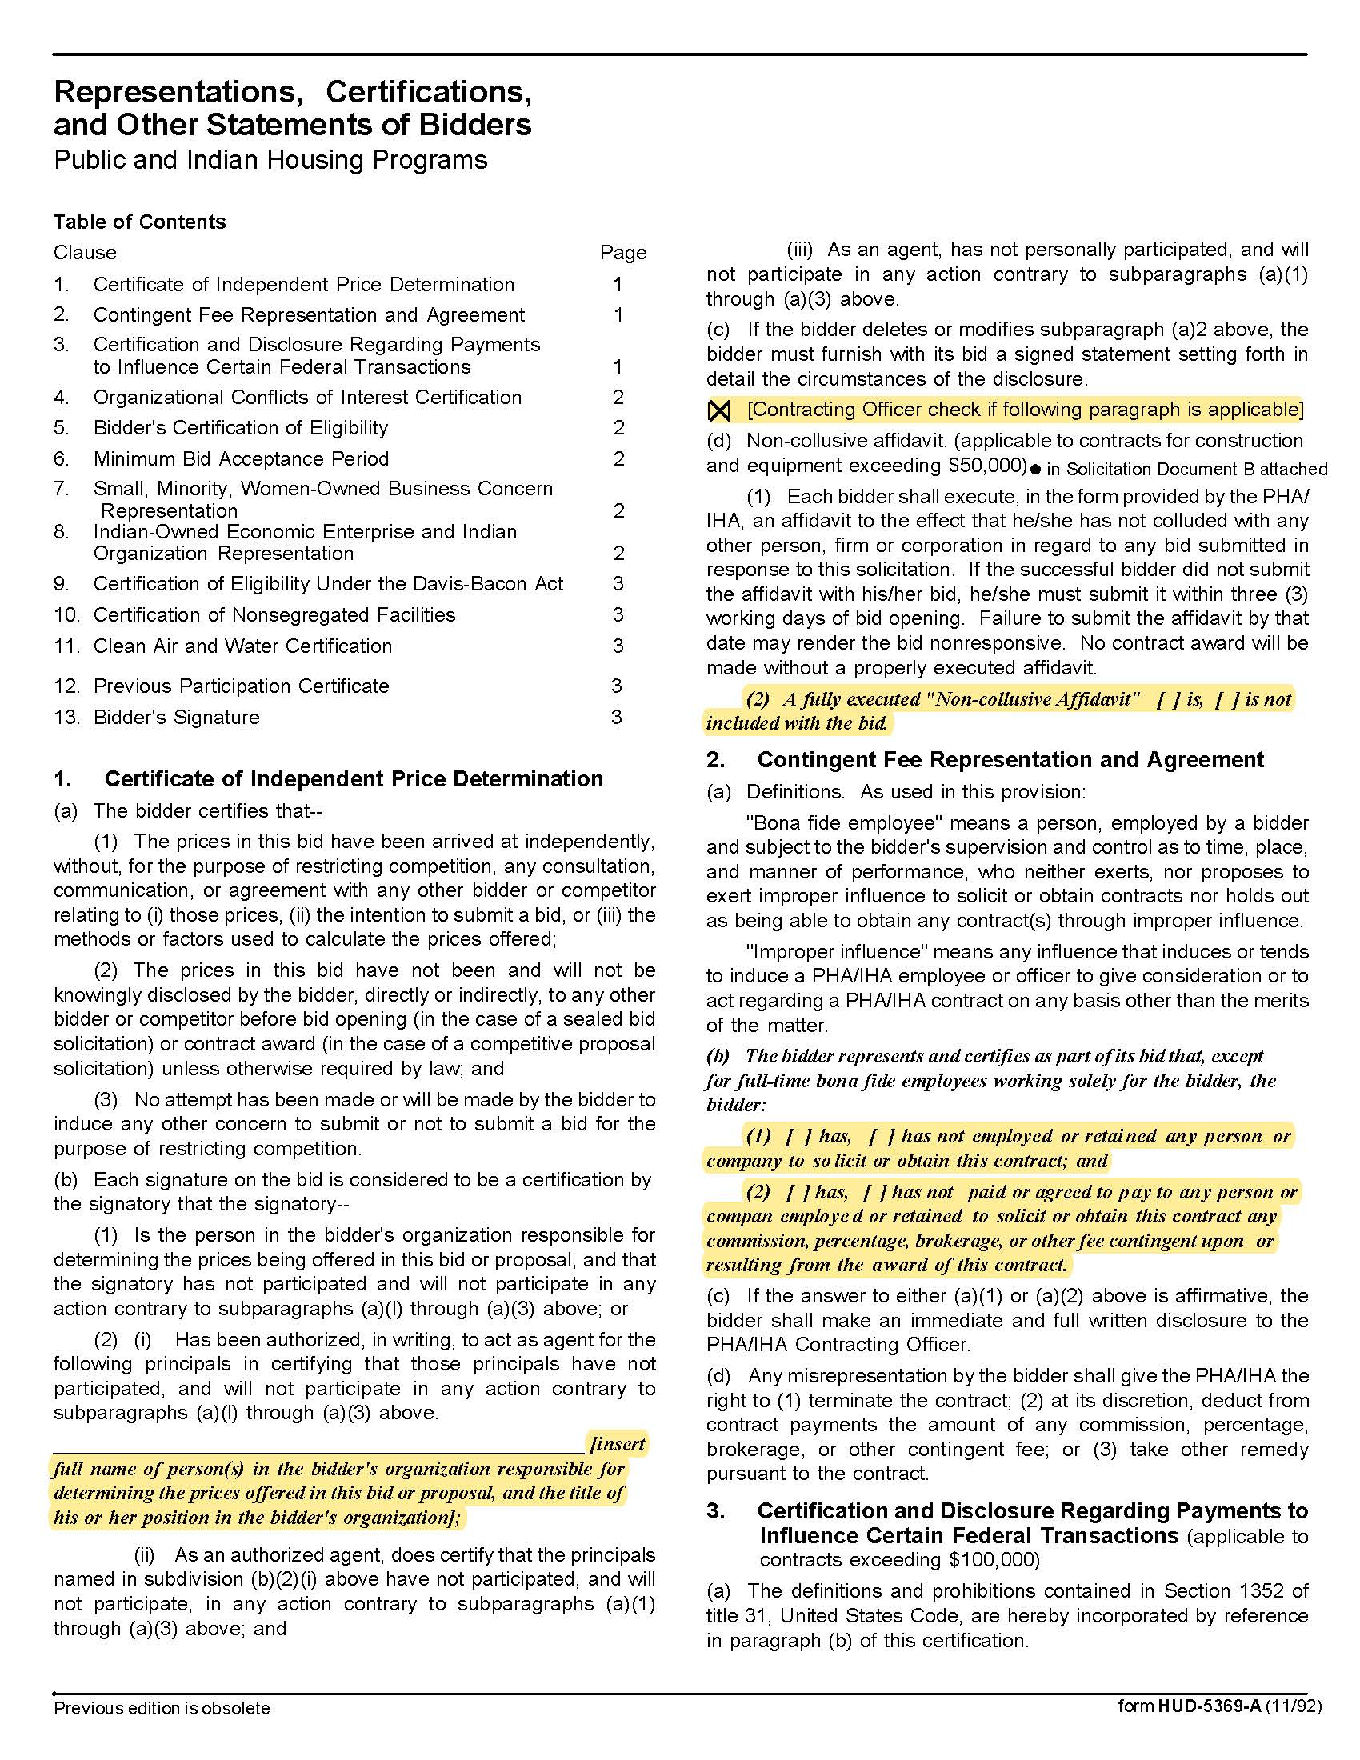

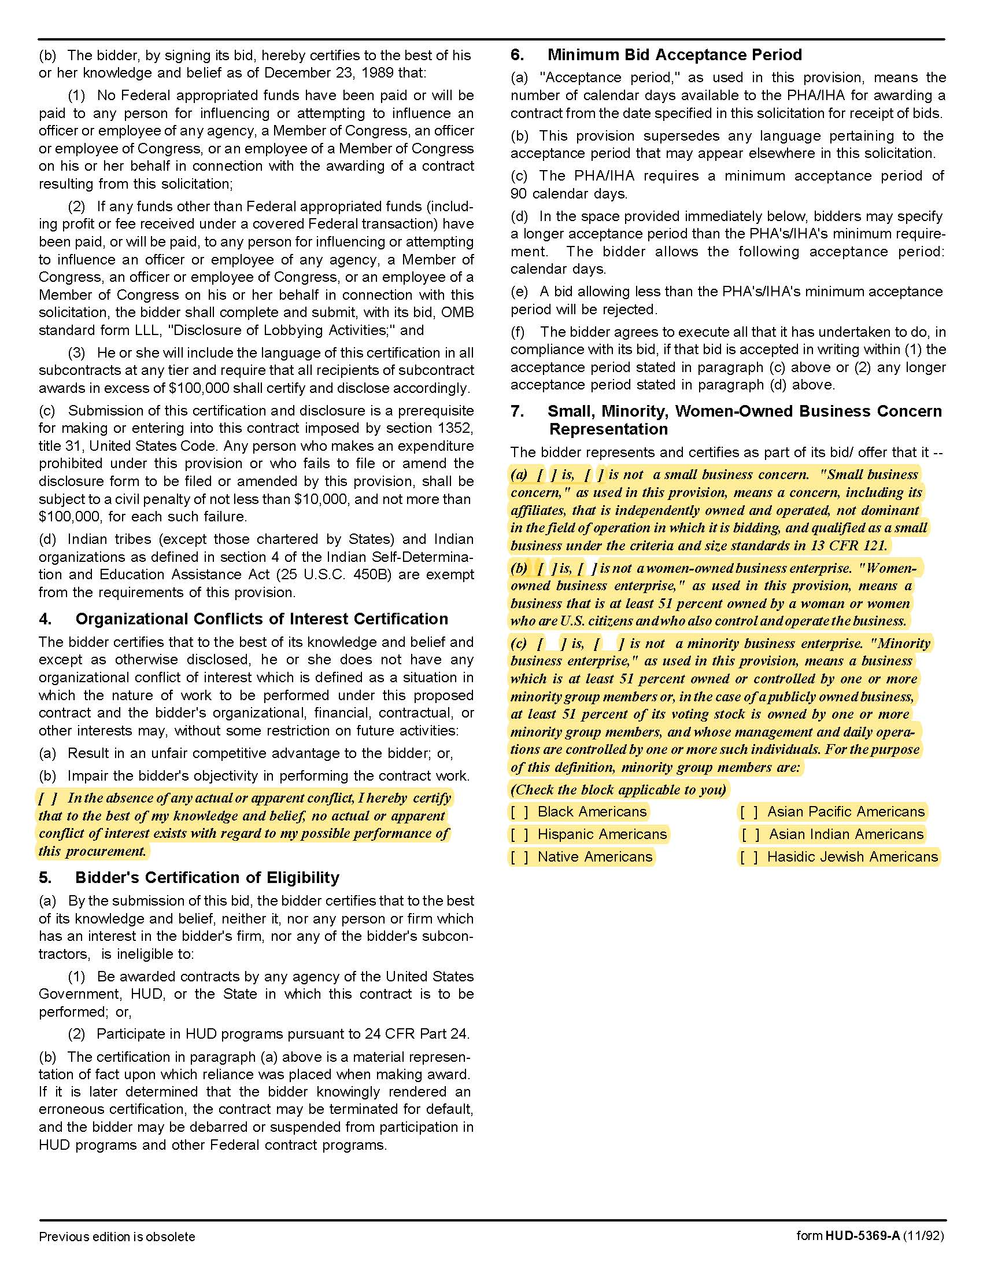

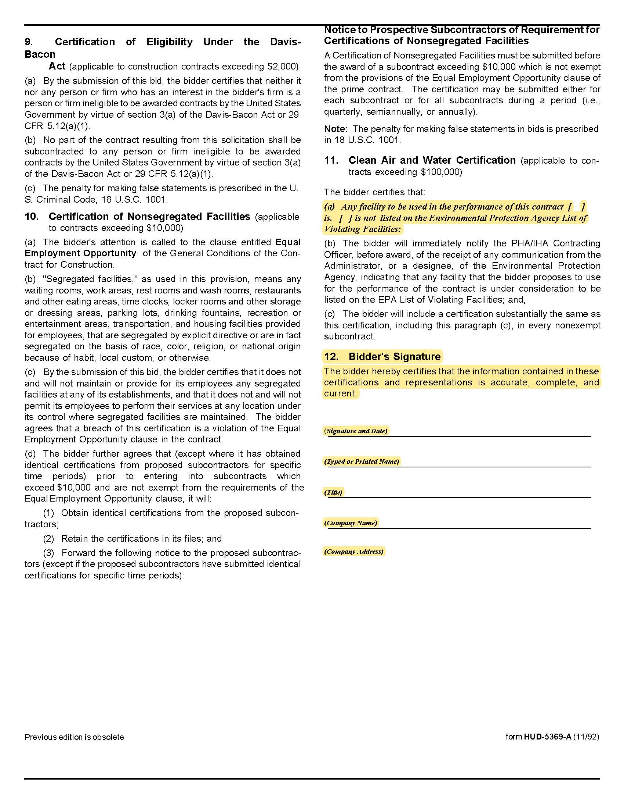

Solicitation Document D | Cost

Scenario A: Once per Year
Yearly Cost for Maintenance at Cagle Terrace | $
Yearly Cost for Maintenance at Eastport | $
Yearly Cost for Maintenance at the Five Points Multiplexes | $
Yearly Cost for Maintenance at Isabella Towers | $
Yearly Cost for Maintenance at Love Towers | $
Yearly Cost for Maintenance at Northgate Terrace | $
Yearly Cost for Maintenance at the Main Office | $
Yearly Cost for Maintenance at Residences at Five Points Phase I | $
Yearly Cost for Maintenance at Residences at Five Points Phase II | $
Yearly Cost for Maintenance at Supportive Maintenance | $
Yearly Cost for Maintenance at The Verandas | $
Yearly Cost for Maintenance at First Creek Phase I | $
Yearly Cost for Maintenance at First Creek Phase II
(Will be added to serviceable sites after warranty expires)
Yearly Cost for Maintenance at Liberty Place
(Will be added to serviceable sites after warranty expires)
Total Yearly Cost | $
Scenario B: Once per Year with Quarterly Inspections
Yearly Cost for Maintenance at Cagle Terrace | $
Yearly Cost for Maintenance at Eastport | $
Yearly Cost for Maintenance at the Five Points Multiplexes | $
Yearly Cost for Maintenance at Isabella Towers | $
Yearly Cost for Maintenance at Love Towers | $
Yearly Cost for Maintenance at Northgate Terrace | $
Yearly Cost for Maintenance at the Main Office | $
Yearly Cost for Maintenance at Residences at Five Points Phase I | $
Yearly Cost for Maintenance at Residences at Five Points Phase II | $
Yearly Cost for Maintenance at Supportive Maintenance | $
Yearly Cost for Maintenance at The Verandas | $
Yearly Cost for Maintenance at First Creek Phase I | $
Yearly Cost for Maintenance at First Creek Phase II
(Will be added to serviceable sites after warranty expires)
Yearly Cost for Maintenance at Liberty Place
(Will be added to serviceable sites after warranty expires)
Total Yearly Cost | $

Cost for Repairs/Service Outside of Routine Maintenance (as needed)
Title | Regular Work Hours | Overtime Hours
Plumber, Master | $ | $
Plumber, Journeyman | $ | $
Mechanic, Master | $ | $
Mechanic, Journeyman | $ | $
Helper | $ | $
Parts/electrical supplies, cost plus/minus from the list price |  | %
Five Year Inspection Wet Pipe Sprinkler Systems |  | $
Five Year Inspection Fire Pump Sprinkler Systems |  | $
Generator Test |  | $
Automatic Transfer Switch Testing |  | $
Backflow Inspection |  | $
Backflow Replacement |  | $
Backflow Rebuild |  | $
Diesel Fuel Test for Degradation |  | $

Solicitation Document D | Cost

Solicitation Document E | Contract/Agreement Sales Quote Forms for KCDC’S Review and Edit
Please insert here a copy of any contracts, agreements, or service agreements that your company uses and KCDC would sign upon award so that KCDC’s can review and comment before awarding.

Solicitation Document F | Insurance Agent’s Statement and Certification
I have reviewed the insurance requirements Appendix with the bidder/proposer named below and have told the bidder/proposer that the required coverage will be available and have advised the bidder/proposer of any additional costs that may be entailed with the coverages.

Insurance Agency 1 Name: ________________________________________________________

Authorizing Signature: ________________________________________________________

Insurance Agency 2 Name: ________________________________________________________

Authorizing Signature: ________________________________________________________

Insurance Agency 3 Name: ________________________________________________________

Authorizing Signature: ________________________________________________________

Bidder’s/Proposer’s Statement and Certification:
I certify that:

1. I have reviewed these requirements with my insurance agent(s).

2. If awarded the contract, I and my subcontractors (if any) will comply with the insurance requirements herein.

3. I/my insurance agency take no exceptions to the listed insurance requirements.

4. My subcontractors (if any) take no exceptions to the listed insurance requirements.

Bidder’s Name: ________________________________________________________

Authorizing Signature: ________________________________________________________

Note: Falsification of information on this page can result in bid rejection and debarment from KCDC
business for three years as well as a recommendation for debarment from receiving any federally funded work for three years.

- INSURANCE
Appendix 1 | Insurance Requirements

The Supplier shall maintain, at Supplier’s sole expense, on a primary and non‐contributory basis, at all times during the life of the contract insurance coverages, limits, and endorsements described herein. All insurance must be underwritten by insurers with an A.M. Best rating of A-: VI or better. Upon award, the Supplier shall provide Certificate(s) of Insurance and amendatory endorsements to KCDC evidencing said insurance coverages. See paragraph “e” for exact naming of certificate holder and additional insureds (Owner Entities).

The Supplier agrees the insurance requirements herein as well as KCDC’s review or acknowledgement, is not intended to and shall not in any manner limit or qualify the liabilities and obligations assumed by the Supplier under this contract. KCDC’s failure to require a certificate of insurance, acceptance of a non-conforming certificate, or allowing the Supplier to commence work shall not operate as a waiver of these minimum insurance requirements or the liabilities and obligations assumed by the Supplier under this contract.

a. Commercial General Liability Insurance: occurrence version general liability insurance including contractual liability with a minimum combined single limit of $1,000,000 per occurrence with $2,000,000 in the aggregate covering the following perils: bodily injury, personal injury, and broad form property damage including products/completed operations for one year after completion of the Project(s). Limits must apply separately to the work/location in this contract.

Such insurance shall contain or be endorsed to contain a provision that includes the Owner Entities (paragraph “e”) as additional insureds with respect to the Supplier’s ongoing and completed operations, providing coverage at least as broad as CG 20 10 07 04 and 20 37 07 04 endorsements. The coverage shall contain no special limitations on the scope of its protection afforded to the listed insureds.

b. Commercial Automobile Liability Insurance: in an amount not less than $1,000,000 (combined single limit) for all owned, hired, and non-owned vehicles utilized by Supplier in connection with the Project. Coverage is to include coverage for loading and unloading hazards.

Such insurance shall contain or be endorsed to contain a provision that includes the Owner Entities (paragraph “e”) as additional insureds.

c. Workers’ Compensation Insurance and Employers Liability Insurance: Workers’ Compensation Insurance with statutory limits as required by the State of Tennessee or other applicable laws.
d. Other Insurance Requirements:

- Upon award, Supplier shall furnish KCDC with original Certificate(s) of Insurance and amendatory endorsements effecting coverage required by this section.

- Provide a waiver of subrogation for each required policy herein. When required by the insurer or should a policy condition not permit Supplier to enter into a pre‐loss agreement to waive subrogation without an endorsement, the policy should be endorsed with a Waiver of Transfer of Rights of Recovery Against Others, or its equivalent. This waiver of subrogation requirement shall not apply to any policy which includes a condition specifically prohibiting such an endorsement, or voids coverage should supplier enter into such an agreement on a pre‐loss basis.

- A minimum 30‐day cancellation notice for all insurances (by endorsement if necessary) is required.

- Replace certificates, policies, and endorsements for any such insurance expiring prior to completion of services.

- Maintain such insurance from the time services commence until services are completed or through such extended discovery/reporting/tail period as required. Failure to maintain or renew coverage or to provide evidence of renewal may be treated by KCDC as a material breach of contract.

- Any deductibles and/or self‐insured retentions greater than $50,000 must be disclosed to and approved by KCDC prior to the commencement of services. Use of large deductibles and/or self‐insured retentions will require proof of financial ability as determined by KCDC.

- All policies must be written on an occurrence basis with the exception of Errors and Omissions Liability (E & O) / Professional Liability and Pollution Liability which may be claims made coverage.

8. Require all subcontractors to maintain during the term of the resulting contract commercial general liability insurance, automobile liability insurance, and workers’ compensation/employers liability insurance (unless subcontractor’s employees are covered by contractor’s insurance) in the same manor and limits as specified for the Supplier.

e. Certificate Holder and Additional Insureds:

The Certificate Holder shall be: KCDC
901 N Broadway
Knoxville, TN 37917

Additional Insureds: Owner Entities are defined as those entities listed below and shall be provided all insurance
coverages, limits, and endorsements included herein including additional insured status. Provided Supplier’s insurer(s)
permits, the entities listed below can be identified collectively as “Owner Entities”:

KCDC, its officials, officers, employees, and volunteers
Eastport Development, LP
Five Points 1 LP
Five Points 2 LP
Five Points 3 LP
Five Points 4 LP
Lonsdale, LP
North Ridge Crossing, LP
Vista at Summit Hill, LP
Western Heights LP
Liberty Place Knoxville LP
Cagle Terrace Corporation
Montgomery Village Corporation

(Note: Only one (1) certificate needs to be provided. Certificate must reflect KCDC as the Certificate Holder and specify all coverages and terms apply to all Owner Entities.)

f. Right to Revise or Reject: KCDC reserves the right to revise any insurance requirement, including but not limited to, limits, coverages, and endorsements based on changes in scope of work/specifications, insurance market conditions affecting the availability or affordability of coverage.

g. No Representation of Coverage Adequacy: The coverages, limits or endorsements required herein protect the primary interests of the Owner Entities, and the Supplier agrees in no way should these coverages, limits or endorsements required be relied upon when assessing the extent or determining appropriate types and limits of coverage to protect the Supplier against any loss exposures, whether as a result of the project or otherwise.

Certificate Holder | KCDC  901 N Broadway  Knoxville, TN 37917
Additional Insureds (Owner Entities)  (can be identified collectively as Owner Entities) | KCDC, its officials, officers, employees, and volunteers  Eastport Development, LP  Five Points 1 LP  Five Points 2 LP  Five Points 3 LP  Five Points 4 LP  Lonsdale, LP  North Ridge Crossing, LP  Vista at Summit Hill, LP  Western Heights LP  Liberty Place Knoxville LP  Cagle Terrace Corporation  Montgomery Village Corporation
GL (Supplier & Subcontractors) | $1M / $2M (including contractual liability)
Auto (Supplier & Subcontractors) | $1M (owned, hired, & non-owned)
WC & Employers Liability (Supplier & Subcontractors) | statutory limits
30-day cancellation (Supplier & Subcontractors) | Required– must indicate on COI
Primary non-contributory (Supplier & Subcontractors) | Required – must indicate on COI
Waiver of Subrogation (Supplier & Subcontractors) | Required – must indicate on COI

(Note: Only one (1) certificate needs to be provided. Certificate must reflect KCDC as the Certificate Holder and specify all coverages and terms apply to all Owner Entities.)

