Request for Proposals
Solicitation name/number | Legal Services Q2401
Upload responses by | 11:00 a.m. on August 30, 2023 (as KCDC’s clocks show)
Upload your response to | https://vrapp.vendorregistry.com/Account/LogOn  (Can also be accessed via KCDC’s webpage)
Questions | KCDC will not accept questions via telephone.  Post questions to https://vrapp.vendorregistry.com/Account/LogOn  by 6:00 p.m. on August 23, 2023.
Award results | KCDC posts the award decision to its web page at: http://www.kcdc.org/procurement/.
Open Records/Public Access to Documents | All document provided to KCDC are subject to the Tennessee Open Meetings Act (TCA 8-44-101) and open records requirements.
Check KCDC’s webpage for addenda and changes before submitting your response

General Information

1. Background and Intent

a. Knoxville's Community Development Corporation (“KCDC”) is the public housing authority for the City of Knoxville and for Knox County in Tennessee. KCDC’s affordable housing property portfolio includes more than 26 properties with approximately 3,600 dwelling units. In addition to operating its public housing apartments, KCDC oversees approximately 4,097 Section 8 Vouchers and 76 Moderate Rehabilitation units. Additionally, KCDC serves as the redevelopment agency for the City of Knoxville, managing redevelopment areas, TIFs, and PILOTs.

b. KCDC’s existing “contract” for legal services has reached its maximum award length (five years) and with this solicitation, KCDC intends to secure the cost-effective services of one or more firms to meet its needs for legal services.

c. The City of Knoxville’s Mayor appoints KCDC’s Board of Commissioners. The Board of Commissioners serve as the governing body and authorize subsidy contracts with the United States Department of Housing and Urban Development (HUD) pursuant to the latter agency's regulations and statutory authorizations. These contracts allow KCDC to construct, own and operate public/affordable housing and to receive payments for eligible individuals and families.

d. KCDC’s Chief Executive Officer (CEO) is known as the “Executive Director.” An “Executive Management” staff supports the Executive Director. The Executive Management staff consists of the:

- Chief Financial Officer
- Vice President of Policy & Strategic Partnerships
- Vice President of Administration
- Vice President of Housing
- Vice President of Redevelopment
- Vice President of Rental Assistance

Below these positions are the various directors, supervisors, managers, and employees.

e. KCDC periodically needs legal services including such areas as Fair Housing, General Counsel, Human Resources, Real Estate and Public Finance/Incentives issues. This solicitation is to result in the hiring of one or more qualified firms to provide legal services on an “as needed” basis by KCDC and its affiliates. KCDC is under no obligation to exclusively use the services of any selected firm.

f. KCDC has several affiliated corporations for which the firm(s) may also provide services as needed. These include:

Name | Type | Purpose
Bell Street Corporation | Section 115 | Created for ownership and financing activities related to KCDC's Austin Homes redevelopment.
Bell Street 2 Corporation | Section 115 | General partner in a limited partnership for the development of affordable housing units through RAD initiatives
Bell Street 3 Corporation | Section 115 | General partner in a limited partnership for the development of affordable housing units through RAD initiatives
Bell Street Corporation (BSC) | Section 115 | General partner in a limited partnership for the development of affordable housing units through RAD initiatives
Cagle Terrace Corporation | Section 115 | To own and facilitate the renovation of Cagle Terrace.
Eastport Development LP | Section 42 | To acquire, own, develop, lease, and operate The Residences at Eastport, Phase II.
Family Investment Foundation, Inc | 501(c) (3) | For charitable, social, vocational, recreational and health purposes, and related business ventures
Five Points 1 Corporation | Section 115 | General partner in a limited partnership for the development of the Five Points Senior Building
Five Points 2 Corporation | Section 115 | General partner in a limited partnership for the development of Five Points Phase 2 Apartments
Five Points 3 Corporation | Section 115 | General partner in a limited partnership formed in conjunction with low-income housing tax credits for the development of the Five Points Phase 3 Apartments
Five Points 4 Corporation | Section 115 | General partner in a limited partnership for the development of the Five Points Phase 4 Apartments
Greater Tennessee Housing Assistance Corporation | Section 115 | Established for the purpose of funding the construction of six Section 8 New Construction housing projects
Hollywood GP Corporation | Section 115 | Created for ownership and financing activities related to 817 Hollywood Road and for similar properties and activities as determined beneficial
Knoxville Housing Development Corporation (KHDC) | Section 115 | Established to acquire, rehab, or develop affordable housing projects in the Knoxville area for KCDC. KHDC is the owner of Passport Homes and Clifton Road Apartments.
Liberty Place Knoxville LP |  | To acquire, own, develop, lease, and operate Liberty Place Knoxville, (the Property).
Lonsdale LP |  | Created to acquire, own, develop, lease, and operate The Lonsdale (the "Property") l
Montgomery Village Housing Corporation | Section 115 | To own and facilitate the renovation of Montgomery Village Apartments. These apartments are a part of KCDC’s multifamily portfolio, but have a federal loan guarantee, which necessitates the Corporation.
Moss Grove GP Corporation | Section 115 | Created for ownership and financing activities related to Moss Grove and for similar properties and activities as determined beneficial
North Ridge Crossing LP |  | Formed under the laws of the State of Tennessee on March 23, 2016, to acquire, own, develop, lease, and operate North Ridge Crossing Apartments (the "Property").
Passport Development Corporation | Section 115 | KCDC’s general partner to limited partnerships. Currently is the General Partner for Eastport Development LP., owner of The Residences at Eastport Phase 2.
Passport Housing Corporation | Section 115 | General partner in a limited partnership for the rehabilitation and operation of apartment units at Residences at Lonsdale, North Ridge Crossing, and The Vista at Summit Hill.
Western Heights Corporation | Section 115 | Created for ownership and financing activities related to KCDC's Western Heights Phase I redevelopment. P
Western Heights LP |  | To acquire, own, develop, lease, and operate Western Heights LP, (the Property).
Western Heights 1 LP |  | To acquire, own, develop, lease, and operate Western Heights LP, (the Property).
Vista at Summit Hill LP |  | Formed under the laws of the State of Tennessee on March 23, 2016, to acquire, own, develop, lease, and operate The Vista at Summit Hill (the "Property").
Young High GP Corporation | Section 115 | Created for ownership and financing activities related to Young High and for similar properties and activities as determined beneficial

2. Changes after Award
It is possible that after the award KCDC will need to revise the requirements specified herein. KCDC reserves the right to make such changes after consultation with the firm. Should additional costs arise, the firm must document increased costs. KCDC reserves the right to accept or reject and negotiate these charges. Any changes will not be of a “cardinal” nature.

3. Contact Policy
Only contact KCDC’s Procurement Division about this solicitation from the issuance of this solicitation until award. Information obtained from an unauthorized officer, agent, or employee will not affect the risks or obligations assumed by the firm or relieve the firm from fulfilling any of the conditions of the resulting award for this project. Such contact can disqualify the firm from the solicitation process.

4. Contract Approval
Awards resulting from this RFP are subject to the approval of KCDC’s Board, HUD, and the State of Tennessee.

5. Errors and Deficiencies
The successful firm will revise any material prepared under an agreement resulting from this RFP without additional compensation if it is determined that the firm is responsible for errors or deficiencies.

6. Evaluation

a. KCDC alone determines (using NIGP’s definition and other relevant sources as appropriate) the firm’s “responsive” and “responsible” status prior to award. Responsible means a business with the financial, technical, relevant experience and capacity to perform the requirements of the solicitation and subsequent contract. A responsive proposal is one that fully conforms in all material respects to the solicitation document and all its requirements, including all form and substance.

b. KCDC will review all proposals and reserves the right to request additional necessary information, modifications, waive minor technicalities, reject all proposals, reject any proposal that does not meet mandatory requirement(s) or cancel this RFP, according to KCDC’s best interests. KCDC further reserves the right to adjust its evaluation scenario if deemed in KCDC’s best interest and consistent with good business practices.

c. KCDC may require oral presentations as part of the evaluation process. Typically, this will be for the firms that are shortlisted. KCDC will provide details about the meeting for the oral presentations to the firms that are selected. Generally, these meetings are approximately 60 minutes.

d. KCDC reserves the right to ordinally rank proposals as a first step and then only detail score the top tier of proposals if determined to be in KCDC’s best interest.
e. KCDC plans to award to the best overall firms presenting the most advantageous proposal (in its entirety) with the maximum points available and based on the following evaluation scale:

Factors | Maximum Points
Firm’s Qualifications and Experience | 40
Professional Staff to be assigned | 40
Cost | 20
Total | 100

f. KCDC may negotiate the fees initially requested in the proposal. The fees proposed by the top-rated firm(s) may be the beginning of negotiations.

g. Separate contracts may be awarded for each area of legal services or for a combination of areas of legal services, or multiple contracts may be recommended for award within the same area of legal services in case one firm has a conflict of interest and cannot represent KCDC in specific matters.

h. KCDC will evaluate the proposals received for each service type independently.

7. General Instructions to Suppliers
KCDC’s General Instructions to Suppliers are at www.kcdc.org . Click on “Procurement” and the link to the instructions. The firm’s submittal means acceptance of the terms and conditions found in KCDC’s “General Instructions to Suppliers.” The following paragraphs in the General Instructions to Suppliers do not apply: 9, 12, 13, 17, 18, 20, 31, 44, 47a, 47b, 47d, 47e, 53, 60 and 72.

8. Insurance
The Firm agrees to maintain at its sole expense on a primary and non-contributory basis during the term of the resulting contract insurance coverages and limits in accordance with the firm’s standard business practices and acceptable to KCDC. Such insurance shall contain or be endorsed to contain a provision that includes KCDC, its officials, officers, employees, and volunteers as additional insureds with respect to liability arising out of work and/or operations performed by or on behalf of the firms. Such insurance shall provide waiver(s) of subrogation. The Firms shall provide KCDC with Certificates of Insurance evidencing such insurance prior to contract execution.

9. Invoicing/Ordering

a. Until a purchase order is in place, work is not to be performed nor are goods to be delivered.

b. Firms must submit invoices within 90 days of the delivery of goods or services. KCDC may deny invoices submitted after the 90-day threshold. KCDC prefers invoices arrive within 10 days following the end of the month in which goods or services were supplied.

c. KCDC pays by electronic transfer (ACH) only. Firms’ accounts receivable staff must use KCDC’s portal to find payments made and to which invoices they apply. Firms may set up KCDC’s portal so that they receive an email with each payment detailing the amount and invoice paid.
. Invoices must:

- Be numbered
- Show a date that is after the work is complete or goods delivered
- List the purchase order number
- Breakdown pricing according to the award structure
- Reference the bid number

e. KCDC wants all invoices emailed to apadmin@kcdc.org . You may copy the service requestor on the email. Do not send invoices by any other means.

10. Length of Award
The initial award will be for 12 months. The award has four one-year optional renewals that KCDC may choose to exercise.

11. Price Structure

a. At the end of each twelve-month period, the awarded Firm(s)s may request a change to rates charged to KCDC. Such increases must be supported by changes to the PPI for Knoxville or by other benchmarks approved by KCDC. The Firms must provide proof of the necessity of the increase to the Procurement Division. KCDC will decide whether to accept a price increase. If the price increase is accepted, the bid file will be so noted. If the price increase is not accepted, the Firms may:

1. Continue with the existing pricing.
2. Suggest an alternative price increase.
3. End the award.

b. Firms may decrease prices at any time with or without notice.

12. Solicitation Requirements
Caution: Requirements in the solicitation are not optional. If you have concerns or issues with any of the stated requirements, raise them before the solicitation due date. Examples of past issues where Firms made faulty assumptions include bonds, insurance requirements and payment expectations.

Conditions and Work Description

13. General Requirements
These legal services are a necessary supplement to KCDC’s daily operation and are divided into these general categories:

- General Counsel and Litigation
- Housing (Landlord/Tenant)
- Real Estate (Acquisition/Construction/Environmental)
- Employment Law
- Public Finance and Incentives ((Tax Increment Financing (TIFs) and Payment In Lieu of Taxes (PILOTS))

14. Group A General Counsel and Litigation

a. These services include but are not limited to such items as review of Board of Commissioners (BOC) meeting agendas; compliance with the Tennessee Open Meeting Law; governance requirements contained in the relevant Code of Federal Regulations (CFR), KCDC policies, procedures, bylaws, and actions that will put KCDC at risk for liability exposure.

b. KCDC may, on an as-needed basis, require the successful firm(s) to provide services
pertaining to related matters within the following areas, to applicable federal, state, and local regulations, statutes, laws, and codes:

- Accounting/Finance
- Development and Modernization
- Information Technology
- Maintenance
- Operations
- Procurement
- Public Housing Programs
- Section 8/Housing Choice Voucher Program (HCVP)
- U.S. Department of Housing and Urban Development (HUD)

d. The selected firm will serve as outside counsel and represent KCDC in any legal matters for which they are engaged.

e. The selected firm will provide written legal opinions as requested.

f. The selected firm will attend meetings as requested (e.g. KCDC staff meetings, Ribbon Cuttings, site events.

g. Prepare or assist in preparing correspondence or other documents to federal, state, and local government officials, vendors, agents, et cetera, as requested.

h. Assist and advise KCDC concerning contracts and leases, contract provisions and negotiations of such contracts and other related documents.

i. Represent KCDC and its affiliate entities, in negotiations, arbitration, mediation, court proceedings and actions on other such matters as required.

j. Provide guidance on various types of incorporation, entity formation insurance, civil procedure, building and construction law and other commercial matters.

k. Serve as bond counsel for KCDC if the need arises.

l. Other matters as requested.

15. Group B Housing (Landlord/Tenant)

a. As requested, assist KCDC staff with compliance with state and federal housing laws including, but not limited to the Tennessee Landlord Tenant Act, Title VIII of the Civil Rights Act of 1968, Title VI of the Civil Rights act of 1964, and other federal acts and executive orders related to and discrimination.

b. Represent KCDC before agencies, boards and other entities concerning Fair Housing issues including representing KCDC in court.

c. Represent KCDC concerning Unlawful Detainer Services in connection with the management and operation of the low-income public housing programs, the firm will represent KCDC for scheduled court appearances. The housing “community managers” will appear in court with the attorney.

d. Represent KCDC in bankruptcy matters concerning residents and others as needed.

e. Other matters as requested.

16. Group C Real Estate (Acquisition/Construction/Environmental)

a. Services required include legal counsel for needs involving the acquisition of land required to conduct KCDC’s mission, including relocation activities associated therewith. Use of the eminent domain power is occasionally required in KCDC projects.

Counsel retained for this purpose are expected to have considerable experience in this as well as other areas of real estate law. This function may also involve representation of the agency in litigation arising out of its real estate activities.
b. Participate, as necessary, in negotiations and provide services in connection with acquisition of land from various owners, including all improvements thereon.

c. Prepare petitions and prosecute to completion all condemnation proceedings which may be necessary in connection with acquisition of parcels with the project areas.

d. Participate, as necessary, in negotiations and provide services in connection with disposition of property to potential developers.

e. As requested, review, assist in developing, or prepare sales contract documents, lease agreements, development agreements, et cetera, to ensure conformance with all applicable local, state, and federal legal requirements.

f. Assist KCDC staff in matters pertaining to redevelopment plans, including amendments as required, and enforcement of said plans.

g. Provide Tax Credit (Low income and new market) guidance and advice.

h. Provide real estate development guidance.

i. Assist and advise KCDC concerning contracts, contract provisions and negotiations of such contracts and other related documents/matters when needed.

j. Represent KCDC and its affiliate entities in negotiations, arbitration, mediation, court proceedings and actions on other matters as required.

k. Provide expertise and guidance in the review of title issues and real property encumbrances.

l. Provide expertise and guidance in the review of Eminent Domain issues.

m. Provide expertise and guidance in the review of Environmental issues.

n. Provide expertise and guidance in the review of other matters as requested.

17. Group D Employment Law
Provide services such as s specialized legal counsel on matters involving employee relations including but not limited to FLSA and EEOC issues; review of KCDC’s Personnel Policy for compliance with all federal, state, and local statutory requirements; consultation with the KCDC Board and staff on employee issues and problems. This function may also involve representation of the agency in litigation concerning employer/employee relationships.

18. Group E Public Finance and Incentives

a. The service includes assisting KCDC in securing and utilizing Low Income Housing Tax Credits and other resources which are or may become available to implement the housing objectives of the agency. This may include the innovative utilization of public housing and housing choice voucher funds, HOME Investment Partnership funds, and other federal and state funding which may be applicable to the agency’s housing plans and objectives.

b. This service also includes investigating, documenting, and making recommendations about Tax Increment Financing (TIFs).

c. This service also includes investigating, documenting, and making recommendations about Payments in Lieu of Taxes (PILOT).

d. Other matters as requested.

19. General Comments

a. None of the preceding information is intended to be an all-inclusive listing of all the legal services that KCDC may retain the successful firm(s) to provide.

b. KCDC reserves the right to approve whether any additional staff may be brought in to consult on matters already under review, and the successful firm(s) must declare beforehand whether inclusion of the additional staff would incur additional staff hours and the applicable rate as proposed on the Fixed Fee Schedule.

c. If the firm(s) does not have a qualified person in-house to provide any services required, the firm(s) may retain another counsel who has such a qualified person. Such retention must have KCDC’s prior written approval. Any billing/payment for such additional counsel will be at the same hourly rate listed within the resulting contract unless KCDC gives prior approval otherwise.

d. KCDC reserves the right to, at any time during the ensuing contract period, and without penalty to the legal counsel retained because of this RFP, to retain additional legal counsel when it is in KCDC’s best interest to do so.

20. Authorized KCDC Contacts
KCDC authorizes the following persons to request legal services from the selected firm(s).

- Board Chair
- Chief Financial Officer
- Executive Director/CEO
- Redevelopment Administrator
- Risk Manager
- Vice President of Administration
- Vice President of Housing
- Vice President of Redevelopment

21. Confidentiality

a. During the term of this appointment, as well as thereafter, the firm(s) will keep all information pertaining to KCDC confidential unless such information is open to the public under local, state, and federal law. The firm(s) shall not at any time use any such information to the detriment of KCDC, its officers, or employees.

b. The firm(s) shall immediately communicate any inquiries from the media concerning KCDC or matters for which KCDC engages the firm to one of the above-authorized KCDC contacts. The firm shall work with KCDC to develop an appropriate response, if warranted.

22. Conflict of Interest
By submitting a response to this Request for Proposal, in addition to complying with any applicable professional conduct standards relating to conflicts of interest, the signer affirms and agrees that he/she has not represented any client in any matter pending against KCDC during the six month period preceding the resulting contract and that he/she/the Firm shall not represent any client in any capacity concerning any matter pending against KCDC during the existence of this contract, nor for a six month period following the termination of this contract.

23. Minimum Qualifications

a. Each attorney on the proposed team shall possess a Juris Doctorate degree and have graduated from a law school accredited by the American Bar Association.

b. The Tennessee Bar must have admitted each attorney in the proposed team to practice and each attorney must maintain a Tennessee law license in good standing.

c. The proposed designated Lead Attorney shall have a minimum of ten years’ experience as an attorney. The attorney’s resume shall show experience in specialized fields.

d. Adherence to the Tennessee Code of Professional Responsibility is required.

24. Records
The firm under contract to provide legal services shall maintain proper records and files. Such records and files shall be furnished to KCDC upon completion if requested.

25. Retainer and Non-Retainer Options
KCDC has asked for a retainer option and KCDC also asked for hourly rates. KCDC will determine which model best meets its needs. KCDC understands that there may be various “retainer” options and proposers may detail those in the costing section for KCDC’s consideration.

26. Submit your information in this order:

Document Number | Title | Form Provided by
Solicitation Document A | General Response Section | KCDC
Solicitation Document B | Affidavits | KCDC
Solicitation Document C | HUD Form 5369A | KCDC
Solicitation Document D | Executive Summary | Firm
Solicitation Document E | Capabilities and History | Firm
Solicitation Document F | Staff Capabilities and Experience | Firm
Solicitation Document G | General Approach to Service Provision | Firm
Solicitation Document H | References | Firm
Solicitation Document I | Cost Schedule | Firm

a. Your entire submittal must not exceed 20 printed pages (not counting Solicitation Document A, B, C and G). A page is one 8.5 x 11 sheet of paper (can be double sided). Use a standard font no smaller than 11 in size to complete the documents.

b. Your submittal’s first page is KCDC’s Solicitation Document A.

Do not return this and the preceding pages to KCDC.

Solicitation Document A |  |  |  | General Information about the Firm
Note: Complete all cells even if the answer is “Does not apply”
Sign Your Name in the column to the right
If completing this document in Adobe, an electronic signature is acceptable to KCDC.
Your signature indicates you read and agree to “KCDC’s General Instructions to Firms” (www.kcdc.org) and that you are authorized to bind the Firms or are submitting the response on behalf of and at the direction of the Firms’ representative authorized to contractually bind the Firms. I represent that the Firms or its applicable representatives has reviewed the information contained in this Solicitation Package and that the information submitted is accurate.
Item |  |  |  |  |  |  | Response
Printed Name and Title
Legal Corporate Name
Street Address
City/State/Zip
Contact Person
Telephone Number
Cell Number
Supplier’s E-Mail Address
Addenda
Addenda are at www.kcdc.org. Click on “Procurement” and then on “Open Solicitations” to find addenda. Be sure to check for addenda prior to submitting a proposal.
Acknowledge addenda have been issued by checking below as appropriate:
None ☐ | 1 ☐ |  |  | 2 ☐ |  | 3 ☐ |  | 4 ☐ |  | 5 ☐
Statistical Information (Check a box in each of the next four lines)
1. This business is at least 51% owned and operated by a woman |  |  |  |  |  |  |  |  |  | Yes ☐ No ☐
2. This business qualifies as a small business by the State of Tennessee  Total gross receipts of not more than $10,000,000 average over a three-year  period OR employs no more than 99 persons on a full-time basis |  |  |  |  |  |  |  |  |  | Yes ☐ No ☐
3. This business is at least 51% owned and operated by a veteran |  |  |  |  |  |  |  |  |  | Yes ☐ No ☐
4. This business is owned & operated by persons at least 51% of the following ethnic background:
Asian/Pacific  ☐ |  | Black  ☐ | Hasidic Jew  ☐ |  | Hispanic  ☐ |  | Native American ☐ |  | White  ☐ | Publicly Owned ☐
Prompt Payment Discount
A ____% prompt payment discount applies if KCDC pays within ____ days of accurate invoicing.

Solicitation Document B | Affidavits

Conflict of Interest
1. No commissioner or officer of KCDC or other person whose duty it is to vote for, let out, overlook or in any manner superintend any of the work for KCDC has a direct interest in the award or the firm providing goods or services.

2. No employee, officer or agent of the grantee or sub-grantee will participate in selection, or in the award or administration of an award supported by federal funds if a conflict of interest, real or apparent, would be involved. Such a conflict would arise when the employee, officer or agent, any member of his immediate family, his or her partner, or an organization, which employs, or is about to employ, any of the above, has a financial or other interest in the firm selected for award.

3. The grantee's or sub-grantee's officers, employees or agents will neither solicit nor accept gratuities, favors or anything of monetary value from firms, potential firms, or parties to sub-agreements.

4. By submission of this form, the firm is certifying that no conflicts of interest exist.

Eligibility
5. The firm is eligible for employment on public contracts because no convictions or guilty pleas or pleas of nolo contender to violations of the Sherman Anti-Trust Act, mail fraud or state criminal violations with an award from the State of Tennessee or any political subdivision thereof have occurred.

General
6. Firm fully understands the preparation and contents of the attached offer and of all pertinent circumstances respecting such offer.

7. Such offer is genuine and is not a sham offer.

Iran Divestment Act
8. Concerning the Iran Divestment Act (TCA 12-12-101 et seq.), by submission of this bid/quote/proposal, each firm and each person signing on behalf of any firm certifies, and in the case of a joint bid/quote/proposal, each party thereto certifies as to its own organization, under penalty of perjury, that to the best of its knowledge and belief that each firm is not on the list created pursuant to § 12-12-106.

Accuracy of Electronic Copies
9. If the firm provides electronic copies of the bid/proposal/quote to KCDC, the firm certifies that the information provided on paper and in the electronic format is identical unless specifically noted otherwise.

General
10. Neither the said firm nor any of its officers, partners, owners, agents, representatives, employees or parties interest, including this affiant, has in any way colluded conspired, connived or agreed, directly or indirectly, with any other responder, firm, or person to submit a collusive or sham offer in connection with the award or agreement for which the attached offer has been submitted or to refrain from making an offer in connection with such award or agreement, or collusion or communication or conference with any other firm, or, to fix any overhead, profit, or cost element of the offer price or the offer price of any other firm, or to secure through any collusion, conspiracy, connivance, or unlawful agreement any advantage against KCDC or any person interested in the proposed award or agreement.

11. The prices quoted in the attached offer are fair, proper, and not tainted by any collusion, conspiracy, connivance, or unlawful agreement on the part of the firm or any of its agents, representatives, owners, employees, or parties in interest, including this affiant.

No Contact/No Advocacy Affidavit
12. Any contact initiated by any firm with any KCDC representative concerning this solicitation is strictly prohibited-except for communication with the Procurement Division. My signature signifies that no unauthorized contact occurred.

13. To ensure the integrity of the review and evaluation process, respondents to this solicitation nor any firm representing them, may not lobby or advocate to KCDC staff or Board members. My signature signifies that no unauthorized advocacy occurred.

Non-Boycott of Israel Affidavit
14. Concerning the Non-Boycott of Israel Act (TCA 12-4-1 et seq.), by submission of this bid/quote/proposal, each firm and each person signing on behalf of any firm certifies, and in the case of a joint bid/quote/proposal, each party thereto certifies as to its own organization, under penalty of perjury, that to the best of its knowledge and belief that each firm is not boycotting Israel pursuant to § 12-4-1 and will not during the term of any award. Note: Applicable only to contracts of $250,000 or more and to firms with 10 or more employees.

The undersigned hereby acknowledges receipt of these affidavits and certifies that the submittal in response to this solicitation is in full compliance with the listed requirements. Failure to properly acknowledge issues concerning the above is grounds for bid/proposal rejection and may subject the signer to penalties as directed by the appropriate laws.

Signed by
Printed Name
Title

Solicitation Document C | HUD Form 5369A
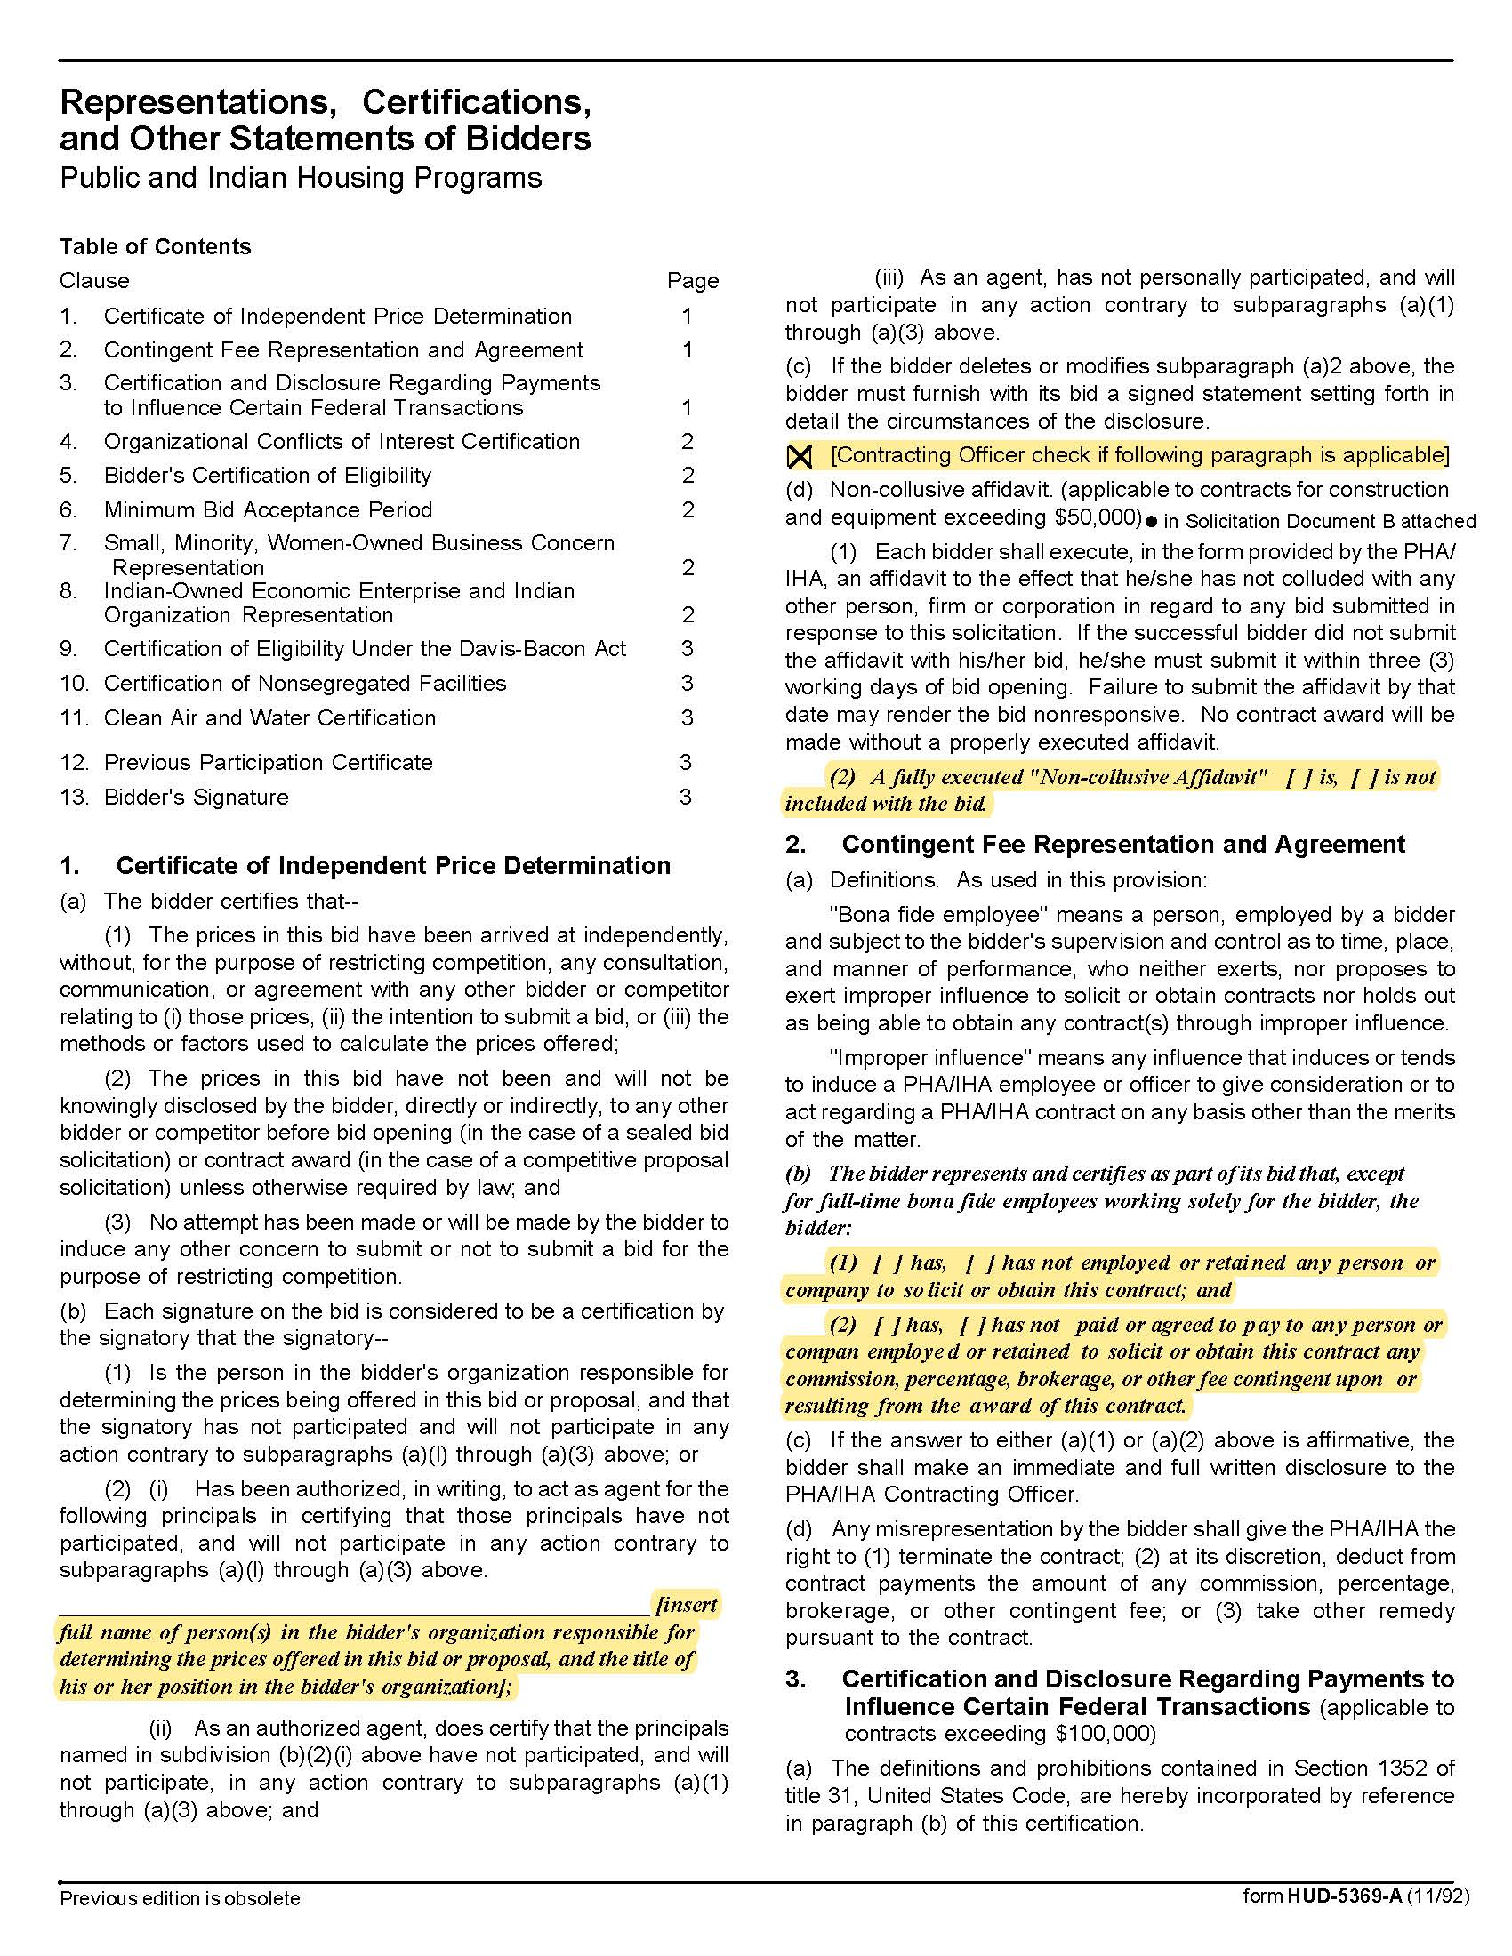

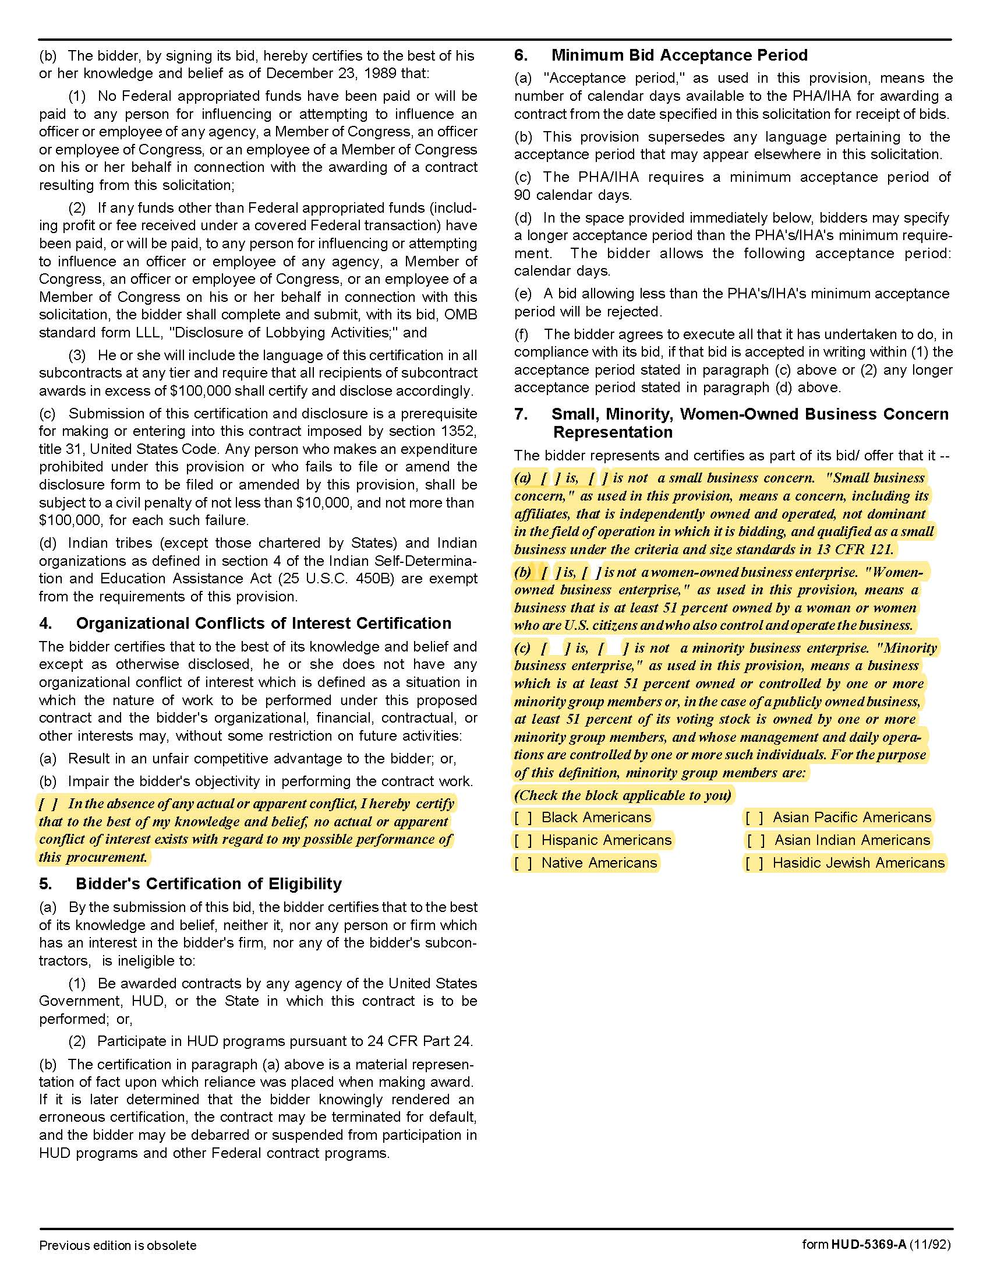

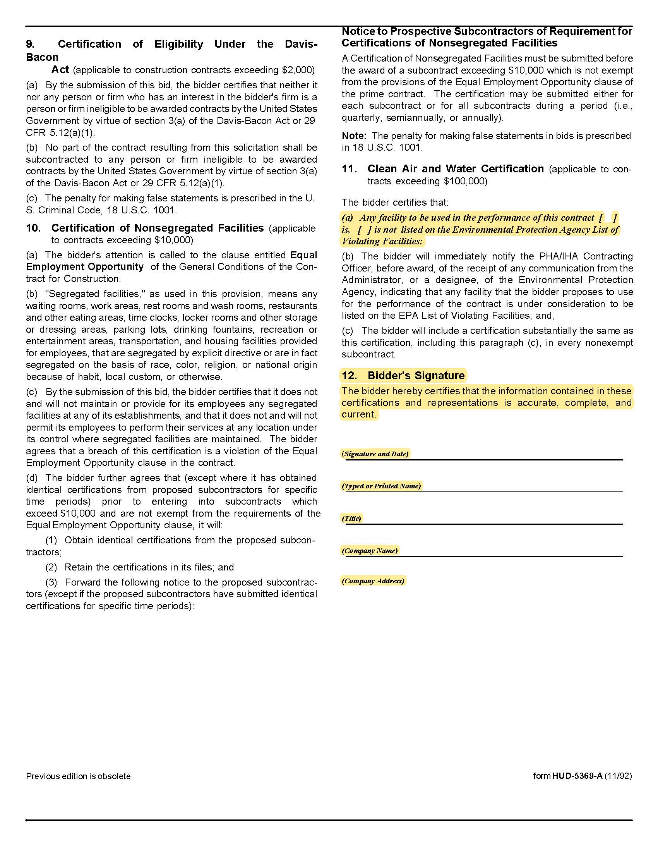

Solicitation Document D | Firm Qualifications

Provide the information requested below so that KCDC can determine your capacity to perform the required work. You may provide additional relevant information as desired-subject to maximum submittal size detailed herein.

Required with all submittals:

1. Outline why KCDC should select your firm to provide the required services.

2. Narrative about the firm’s history.

3. History of the firm and key management/partners.

4. Narrative about the firm’s resources available to complete the work.

5. Number of overall staff available for KCDC.

6. Expectations regarding adequate notice for meetings with KCDC personnel.

7. Any potential conflicts of interest in representing KCDC.

8. Evidence of prior relevant experience with regulations and policies of the United States Department of Housing and Urban Development.

9. Submitting for General Counsel Services? Yes ☐ No ☐ If yes:
Provide examples and/or evidence of prior relevant experience concerning:

- Litigation
- Contract law
- Tennessee Open Meeting Laws/rules
- HUD related work
- Incorporation, insurance, civil procedure, building and construction law and other commercial matters.
- Bond counsel

10. Submitting for Housing Services? Yes ☐ No ☐ If yes:
Provide examples and/or evidence of prior relevant experience concerning:

- State and federal housing laws
- Landlord and tenant law
- Tennessee’s Landlord Tenant Act
- Title VIII of the Civil Rights Act of 1968
- Title VI of the Civil Rights act of 1964
- Other federal acts and executive orders related to discrimination.
- Bankruptcy matters concerning residents and others.

11. Submitting for Real Estate Law Services? Yes ☐ No ☐ If yes:
Provide examples and/or evidence of prior relevant experience concerning:

- Litigation
- Real estate law
- Redevelopment issues such as, but not limited to condemnation, eminent domain, disposition of property to potential developers, TIF’s, et cetera.
- Construction law
- Land/property acquisition
- Sales contract documents, lease agreements, development agreements, et cetera, to ensure conformance with all applicable local, state, and federal legal requirements.
- Tax Credit (Low income and new market) requirements

12. Submitting for Employment Law Services? Yes ☐ No ☐ If yes:
Provide examples and/or evidence of prior relevant experience concerning:

  - Employment law
  - FLSA
  - EEOC issues
  - Personnel Policies review (compliance with all federal, state, and local statutory requirements)
  - Consultation with the Board and staff on employee issues and problems
  - Representing KCDC in litigation concerning employer/employee relationships

13. Submitting for Public Finance and Incentives? Yes ☐ No ☐ If yes:
Provide examples and/or evidence of prior relevant experience concerning:

- Redevelopment issues
- Eminent domain
- TIF’s
- Construction law
- Low Income Housing Tax Credits
- Housing Choice Voucher funds
- HOME Investment Partnership funds
- Other federal and state funding

Solicitation Document E | Qualifications and Experience of Staff Assigned to KCDC’s Project

1. Provide an organizational chart identifying the key individuals and their proposed roles.

2. Identify the individual(s) that will function as project manager and any other supervisory personnel that will work on project; attach a brief resume for each.

Name | Title

3. Provide resumes of each professional staff member that may be assigned to KCDC showing
this information.

- Name
- Title
- Years with Firm
- Years in Practice
- Education
- Experience (duties/roles)
- Expertise Area
- Professional affiliations/credentials
- Litigation experience: Jury/Non-Jury
- Tennessee State Bar Number
- Date of Admission to the federal bar

4. Identify the accessibility of the proposed designated Lead Attorney and the response time that the individual offers to KCDC. Specifically, identify the lead-time required for attending scheduled or specially called meetings. Identify how quickly the Lead Attorney can arrive in person to attend an unscheduled, urgent meeting. Identify the same for any assisting attorneys.

5. Provide the number of current clients for the firm as a whole and for the attorney(s) assigned to KCDC.

Solicitation Document F | References

1. Provide information regarding the firm’s experience, specifically identifying any public housing authorities, affordable housing entities, municipalities, real estate company, redevelopment agencies, or other public agencies for which the firm has performed similar work in the State of Tennessee.

2. One client is one reference-not matter how many contracts or services performed for the client.

3. KCDC reserves the right to contact and interview the listed references via electronic survey means.

4. Provide three references in the following format.

This reference is applicable to | General Counsel  Housing  Real Estate  Employment Law  Public Finance and Incentives | Yes ☐  Yes ☐  Yes ☐  Yes ☐  Yes ☐
Name of the business receiving services
Contact person
Contact person title
Contact person’s telephone number
Contact person’s email address
Description of the service provided
Service began
Service ended

Solicitation Document G | Cost Proposal

Complete this form and submit it separately as detailed earlier in this document. Note that you may insert additional lines into each chart if necessary.

1. Proposing on General Counsel services Yes ☐ No ☐

Monthly Retainer | $
The monthly retainer includes how many hours?
If the monthly retainer option is not chosen, rates are: | Hourly Rate
Director/President | $
Managers | $
Shareholder/Attorney | $
Associate | $
Law Clerks | $
Paralegal/Legal Assistant | $
Clerical | $

2. Proposing on Housing services Yes ☐ No ☐

Monthly Retainer | $
The monthly retainer includes how many hours?
If the monthly retainer option is not chosen, rates are: | Hourly Rate
Monthly Retainer | $
Director/President | $
Managers | $
Shareholder/Attorney | $
Associate | $
Law Clerks | $
Paralegal/Legal Assistant | $
Clerical | $

3. Proposing on Real Estate services Yes ☐ No ☐

Monthly Retainer | $
The monthly retainer includes how many hours?
If the monthly retainer option is not chosen, rates are: | Hourly Rate
Director/President | $
Managers | $
Shareholder/Attorney | $
Associate | $
Law Clerks | $
Paralegal/Legal Assistant | $
Clerical | $

4. Proposing on Employment Law services Yes ☐ No ☐

Monthly Retainer | $
The monthly retainer includes how many hours?
If the monthly retainer option is not chosen, rates are: | Hourly Rate
Director/President | $
Managers | $
Shareholder/Attorney | $
Associate | $
Law Clerks | $
Paralegal/Legal Assistant | $
Clerical | $

5. Proposing on Public Finance and Incentives services Yes ☐ No ☐

Monthly Retainer | $
The monthly retainer includes how many hours?
If the monthly retainer option is not chosen, rates are: | Hourly Rate
Director/President | $
Managers | $
Shareholder/Attorney | $
Associate | $
Law Clerks | $
Paralegal/Legal Assistant | $
Clerical | $

6. Other cost notes:

a. The firm will bear all local travel and miscellaneous expenses. Any costs for travel more than 50 miles away from KCDC will be based on per diem rates for the area published by the U.S. General Services Administration. Payment will be made only for actual expenses and copies of receipts are required.

b. All non-local travel must be pre-approved by KCDC.

c. Reimbursable expenses including, but not limited to, Courier, Postage, Overnight Mail, Filing Fees, Faxes, Telephone Calls, Mileage, Reproduction/copying will be reimbursed at cost.

d. Reproduction/copying costs will only be reimbursed if the volume exceeds typical and normal amounts associated with the work being performed. Such cases require KCDC’s approval.

e. Fractions of billable hours shall be charged to the nearest 10th of an hour.

