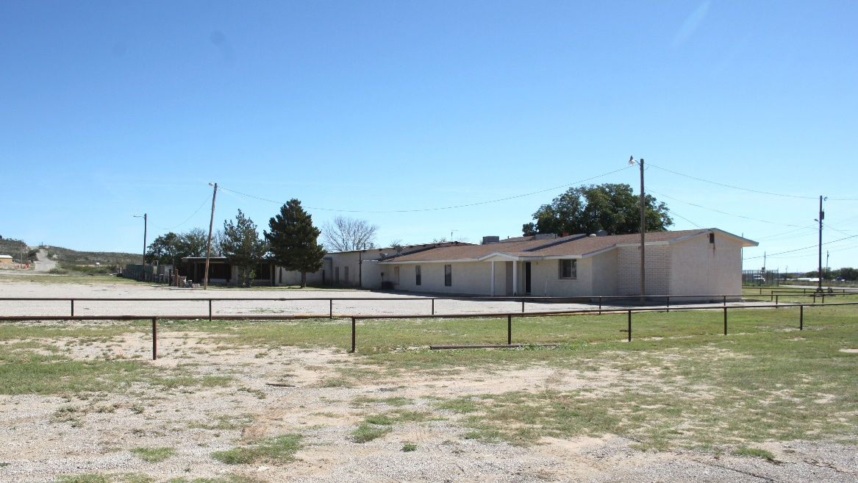
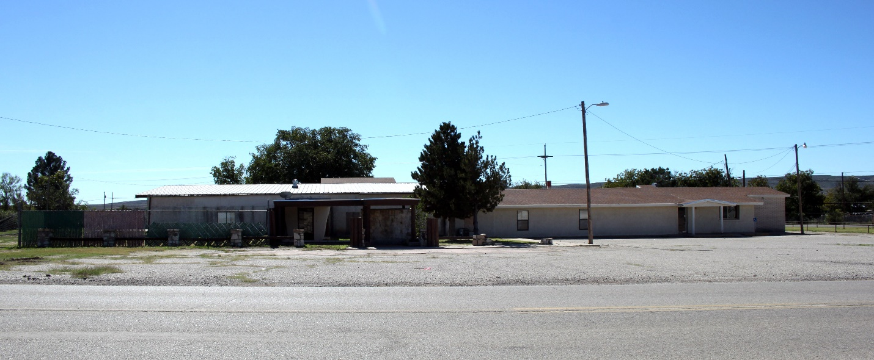
PROPERTY FOR SALE: The City of Carlsbad is soliciting formal sealed bids for the sale of property currently owned by the City. This property is located at 5000 West Church Street, Carlsbad, NM 88220 and consists of 94,384.65 square feet or 2.167 acres of property. Zoned Commercial-1, it was previously known as the Fountain Restaurant as well as the Crossroads Treatment Center. This corner lot is connected to City water. The building is approximately 10,000 square feet.
Bids must be received by the City of Carlsbad, Purchasing Manager, Room 115, Carlsbad Municipal Building, 101 N. Halagueno, Carlsbad, NM 88220, by Monday, December 31, 2018, no later than 3 p.m. local time.
Bid documents and all related information is available at the City of Carlsbad website at www.cityofcarlsbadnm.com/purchasing.cfm
For more information, please contact the Purchasing Manager- Matt Fletcher, at PO Box 1569, Carlsbad NM 88221-1569, (575) 234-7905 or by email request to msfletcher@cityofcarlsbadnm.com

