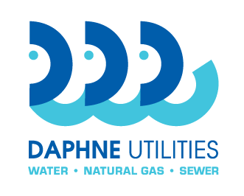
Daphne Utilities
Zinc Orthophosphate
RFB 20-06

Bid Specifications

The scope of work shall consist of supplying zinc orthophosphate to Daphne Utilities at five specified locations within the Daphne Utilities service area. Daphne Utilities will provide access to the delivery sites. Vendor shall deliver the products to the specified location and unload products at no additional costs. Vendor shall provide corrosion testing coupons at multiple corrosion testing sites. The zinc orthophosphate shall be formulated as follows:
Appearance clear liquid, odorless
Density 13.43 - 14.34 lbs. / gallon
Specific Gravity 1.57 – 1.77
pH < 2.0
Zn 11.0%
PO₄ 44% - 52.0%

It is the intent of Daphne Utilities to award this contract based on unit prices, provided the products are of an acceptable quality and delivery can be made in an acceptable manner.
All prices must include delivery and set in place at point of storage. Daphne Utilities will only accept delivery in bulk, usually by tanker truck. Daphne Utilities will not be responsible for assisting with unloading or placing products in storage place. Vendor must accommodate certain days of delivery requested by each department. Delivery are to be made between 7AM and 7PM Mondays through Fridays.
Delivered items will not be considered “accepted” until an authorized agent of Daphne Utilities has determined they fully comply with the specifications. All materials shall be made available for inspection by Daphne Utilities at the point of destination before receiving approval to offload the material. Any items not compliant will be returned for a full credit at no expense to Daphne Utilities.
The vendor must comply with standard record keeping and reporting requirements. Payment will be made by Daphne Utilities after the goods and services have been received, accepted, and properly invoiced with the purchase order number. Any defects in the work performed or product delivered must be corrected before invoices are eligible for payment. Payment terms shall be net 30 days.

Daphne Utilities
Zinc Orthophosphate
RFB 20-06

Bid Form

Zinc Orthophosphate (per above specifications) $___________per________

I have read and understood the terms and conditions and the bid specifications of this bid. I also understand, and have provided or will provide at the appropriate time, all documentation required. Omission of any required documentation may result in the bid being deemed unresponsive by Daphne Utilities.

Submitted by: __________________________________________________________ Company name of bidder

_________________________________________________________________________________________
By: company officer name

_________________________________________________________________________________________
Signature

__________________________________________ ________________________________ Title Date

_________________________________________________________________________________________
Company address, city, state, zip

___________________________________________ ________________________________
Phone EIN / tax id number

___________________________________________ ________________________________
Point of contact name Point of contact phone

___________________________________________
Point of contact email

