Request for Proposals
Solicitation name | Heat Treatment for Bedbugs Q2400
Upload responses by | 11:00 a.m. on December 21, 2023 (as KCDC’s clocks show)
Upload your response at | https://vrapp.supplierregistry.com/Account/LogOn  - All bids/proposals must be submitted through the Vendor Registry platform as one document.  - When uploading bids/proposals, be sure to upload all required solicitation documents.  - Bids/proposals delivered by email, fax, USPS or in person will be rejected.
Post Questions to | https://vrapp.supplierregistry.com/Account/LogOn  by 6:00 p.m. on December 14, 2023.  KCDC will not accept questions via email or telephone.
Award results | KCDC posts the award decision to its web page at: http://www.kcdc.org/procurement/.
Open Records/Public Access to Documents | All document provided to KCDC are subject to the Tennessee Open Meetings Act (TCA 8-44-101) and open records requirements.
Check KCDC’s webpage for addenda and changes before submitting your response.

General Information

1. Background and Intent

a. Knoxville's Community Development Corporation (“KCDC”) is the public housing authority for the City of Knoxville and for Knox County in Tennessee. KCDC’s affordable housing property portfolio includes more than 26 properties with approximately 3,600 dwelling units. In addition to operating its public housing apartments, KCDC oversees approximately 4,097 Section 8 Vouchers and 76 Moderate Rehabilitation units. Additionally, KCDC serves as the redevelopment agency for the City of Knoxville, managing redevelopment areas, TIFs, and PILOTs.

b. Definition/Clarification: KCDC uses “suppliers” as inclusive of various words describing interested parties often called “bidders,” “contractors,” “firms,” “proposers” and “vendors.”

c. KCDC wants to establish an award for bedbug thermal remediation services as a part of its overall pest control strategy. Due to the expense, disruption and potential risks to property, whole‐unit heat treatments must be reserved as an option for severely infested units which conventional treatment strategies have failed to remediate.

2. Bonding
The proposer’s employees must be bonded as they will be alone in the residents’ apartments. Proof of the bond must be supplied to KCDC prior to work commencement.

3. Changes after Award
It is possible that after award KCDC will need to revise the requirements specified herein. KCDC reserves the right to make such changes after consultation with the supplier. Should additional costs arise, the supplier must document increased costs. KCDC reserves the right to accept or reject and negotiate these charges. Generally, such changes will not be of a “cardinal” nature.

4. Codes and Ordinances
All work covered is to be performed in full accord with national, state and local codes, ordinances and orders that are in effect at the time the work is performed.

5. Contact Policy
Only contact KCDC’s Procurement Division about this solicitation from the issuance of this solicitation until award. Information obtained from an unauthorized officer, agent, or employee will not affect the risks or obligations assumed by the supplier or relieve the supplier from fulfilling any of the conditions of the resulting award for this project. Such contact can disqualify the supplier from the solicitation process.

6. Damage
The supplier is responsible for all damage to buildings, equipment, grounds, premises and all other types of potential damage resulting from the provision of the services requested herein.

7. Employees
Supplier will:

a. Provide at least one employee on every job assignment with the ability to speak, read, write and understand English so owner’s staff can communicate effectively with them.

b. Ensure that employees have proper identification displayed while on the job site. Employees, while on site, must wear a company uniform or have photo identification displayed.

c. Employee’s parking vehicles (whether corporately or privately owned) must ensure that company identification is on the vehicles. This may be by placards on the vehicle’s side, laminated paper with the company name placed on the dashboard or other means.

8. Entrance to Sites
Supplier’s employees are not to be on KCDC premises unless they are working on a KCDC project. Acquaintances, family members, assistants or any person not working on KCDC’s behalf will not accompany employees on KCDC sites.

9. Equipment
Supplier shall provide all necessary equipment, materials, supplies, et cetera needed for the work. Include the cost for such equipment, materials and supplies in the price quoted. KCDC staff is not to be asked for the loan of equipment.

10. Evaluation

a. KCDC alone determines (using NIGP’s definition and other relevant sources as appropriate) the supplier’s “responsive” and “responsible” status prior to award. Responsible means a business with the financial, technical, relevant experience and capacity to perform the requirements of the solicitation and subsequent contract. A responsive proposal is one that fully conforms in all material respects to the solicitation document and all its requirements, including all form and substance.

b. KCDC will review all proposals and reserves the right to request additional necessary information, modifications, waive minor technicalities, reject all proposals, reject any proposal that does not meet mandatory requirement(s) or cancel this RFP, according to KCDC’s best interests. KCDC further reserves the right to adjust its evaluation scenario if they are in KCDC’s best interest and consistent with good business practices.

c. KCDC may require oral presentations as part of the evaluation process. Typically, this will be for the firms that are shortlisted. KCDC will provide details about the meeting to the firms that are selected.

d. KCDC reserves the right to ordinally rank proposals as a first step and then only detail score the top tier of proposals if determined to be in KCDC’s best interest.

e. KCDC plans to award to the best overall supplier presenting the most advantageous proposal (in its entirety) with the maximum points available and based on the following evaluation scale:

Factors | Maximum Points
Firm’s Qualifications to Complete the Work | 20
Staff Qualifications to Complete the Work | 20
Cost | 30
Client References | 10
Treatment Plan | 20
Total | 100

11. General Instructions to Suppliers
KCDC’s General Instructions to Suppliers are at www.kcdc.org. Click on “Procurement” and the link to the instructions. The supplier’s submittal means acceptance of the terms and conditions found in KCDC’s “General Instructions to Suppliers.” The following paragraphs in the General Instructions to Suppliers do not apply: 17, 46a, 46b, 46d and 46e.

12. Insurance

a. See Appendix 1. These insurances and levels are required and not optional. If you or your insurance agent have concerns or believe that some coverages are not necessary, email procurementinfo@kcdc.org detailing any requested changes before this solicitation’s due date. The supplier will include all insurance costs in the base bid.

b. Note that KCDC’s Insurance Appendix has changed and now requires your signature as well as that of your insurance agent(s).

c. Upon notice of intent to award, your insurance agent will email the Certificate of Insurance (COI) to tmckee@kcdc.org for review.

13. Invoicing/Ordering

a. Until a purchase order is in place, work is not to be performed nor are goods to be delivered. KCDC does not have a legal obligation to pay for the work performed prior to the issuance of a purchase order.

b. Suppliers must submit invoices within 90 days of the delivery of goods or services. KCDC may refuse invoices submitted after the 90-day threshold. KCDC prefers invoices arrive within 10 days following the end of the month in which goods or services were supplied.

c. Most KCDC purchases of goods are exempt from Tennessee sales and use tax pursuant to Tennessee Code Annotated 67-6-329(a) (4) and KCDC is exempt from the Federal Excise tax. However, suppliers are subject to Tennessee sales and use tax on all materials and supplies used in the performance of a contract, whether such materials and supplies are purchased by the supplier, produced by the supplier, or provided to the supplier by KCDC, pursuant to Tennessee Code Annotated 67-6-209.

d. Certain KCDC properties are not exempt from taxation and their invoices should include applicable taxes. These are: Eastport LP, First Creek (Bell Street) LP, First Creek (Bell Street) 2 LP, First Creek (Bell Street) 3 LP, Five Points 1, LP; Five Points 2, LP; Five Points 3, LP; Five Points 4, LP; Lonsdale Homes, LP; Northridge Crossing, LP, The Vista at Summit Hill, LP and Western Heights, LP.

e. The supplier pays all taxes incurred in the performance of an awarded contract. Upon the placement of a purchase order or the award of a contract, KCDC will provide a State of Tennessee Sales Tax Exemption form to the supplier. KCDC will not pay taxes on invoices.

f. KCDC pays by electronic transfer (ACH) only. Suppliers’ accounts receivable staff must use KCDC’s portal to find payments made and to which invoices they apply. Suppliers may set up KCDC’s portal so that they receive an email with each payment detailing the amount and invoice paid.

g. Invoices must:

- Be numbered
- Show a date that is after the work is complete or goods delivered
- List the purchase order number
- Breakdown pricing according to the award structure
- Reference the bid number

h. KCDC wants all invoices emailed to apadmin@kcdc.org . You may copy the requestor on the email. Do not send invoices by any other means.

14. Length of Award
The length of the contract will be twelve months with four optional annual renewals that KCDC may exercise at its discretion.

15. Licensure
Suppliers must be properly licensed by the State of Tennessee and all other authorities having authority. Throughout the term of this contract, the supplier shall keep the required licensure.

16. Price Structure

a. At the end of each twelve-month period, the awarded supplier may request a change to the percentage and/or specific item charged to KCDC. Such increases must be supported by changes to the PPI for Knoxville or other such benchmark acceptable to KCDC. The supplier must provide proof of the necessity of the increase to the Procurement Division. KCDC will decide whether to accept a price increase. If the price increase is accepted, the bid file will be so noted. If the price increase is not accepted, the supplier may:

1. Continue with the existing pricing.
2. Suggest an alternative price increase.
3. End the award.

b. KCDC does not pay fuel surcharges.

c. Suppliers may decrease prices at any time with or without notice.

17. Safety/OSHA Guideline Compliance

a. The safety of the public is of prime concern to KCDC, and all costs associated are the responsibility of the supplier. The supplier shall ensure that its employees exercise all necessary caution and discretion to avoid injury to persons or damage to property.

b. The supplier will provide and place barricades, tarps, plastic, flag tape and other safety/traffic control equipment to protect the public, surrounding areas, equipment and vehicles as appropriate. This includes taking the necessary steps to exclude persons (residents, visitors, other suppliers) from entering work areas.

c. The supplier shall ensure that the flow of vehicular traffic is impeded as little as possible during projects.

d. If work is conducted in an area (such as sidewalks providing entrance/exit to a residence, office or other similar area) an alternate access plan must be provided for handicapped persons. For instance, if gravel is placed as a temporary solution, there must be an acceptable alternate route for those in wheelchairs.
e. The supplier will protect all buildings, appurtenances and furnishings from damage. The supplier shall, at his expense, repair such damages (or replace the items) by approved methods to restore the damaged areas to their original condition.

f. Supplier shall use caution signs as required by OSHA Regulation 1910.144 and 1910.145 at no cost to KCDC. Caution signs shall be on-site on commencement of contract.

g. Supplier shall comply with all other OSHA and TOSHA safety standards that apply.

18. Security
The successful supplier is responsible for providing all security for equipment, materials, personnel and tools required for this work. KCDC is not responsible for damage or losses to equipment, materials, personnel or tools.

19. Small Business Outreach
KCDC requires the successful supplier to reach out to small businesses, minority owned businesses and woman owned businesses for goods and subcontracted services to fulfill this award. In addition to the successful supplier reporting on dollars spent with such businesses each January, KCDC expects outreach that results in actual subcontracting arrangements with such suppliers.

20. Smoke Free Policy
KCDC’s Smoke Free policy is applicable to you, your employees and subcontractors. The policy mandates:

- No smoking on any KCDC property
- No e-vape or similar usage on any KCDC property
- The Smoke Free policy applies in personal or corporate vehicles on owner’s property

21. Subcontractors
Subcontractors must:

a. Be approved by KCDC prior to beginning work.

b. Carry the insurance coverages as outlined herein.

c. Not be on the federal government, HUD’s nor the State of Tennessee’s debarment lists.

d. Not be changed without owner’s permission.

22. Utilities

a. When work is at its office areas and other non-resident locations, KCDC will normally provide utilities for suppliers if they are currently available at the area.

b. The supplier must ascertain the availability of utilities for this work prior to submitting a bid.

23. Work Hours
KCDC’s work hours are Monday through Friday day from 7:30 a.m. until 4:00 p.m. and supplier work is normally performed during these hours. Afterhours work or work on Saturdays, Sundays or holidays requires KCDC’s advance approval since KCDC staff is normally not present at those times.

Work Description

24. Introduction

a. KCDC has 3,600 apartments which have a planned routine pest control service. The services include chemical treatment for bedbugs but at times KCDC needs heat treatments to expedite bedbug control measures. The awarded supplier(s) will be under contract to provide these services, as they are needed and at the pre-determined cost structure.

b. The awarded supplier shall furnish all materials, equipment, labor, supervision and other incidentals that may be required to satisfactorily perform Bed Bug Heat Treatment Services.

25. General Requirements

a. The technician will check in and sign the logbook in the building office.

b. Heat treatment will not occur until the area or areas needing treatment have been prepared as detailed in the “Heat Treatment Preparation Instruction for Occupants” document agreed to by the success supplier and KCDC.

c. After treatment, the Site Manager will sign both copies of the work ticket verifying the work was competed to their satisfaction. All work tickets shall be legible and have the building name and room numbers treated, the type of treatment that was used, the date and signature of the Site Manager or their designee at the time of treatment.

d. Supplier must provide a copy of pre‐treatment preparation instructions to site management and site maintenance staff at prior to treatment.

e. Supplier must provide specific details regarding total time required from set up to take down, maximum and minimum temperatures, total holding time at target temperature, and estimated cool‐down time.

f. All pest management applicators must be properly trained and certified to work in these high temperature environments.

g. At least one day prior to the Heat Treatment, Supplier must visit the site to work out the logistics of properly performing the treatment including:

- Parking for trailers and treatment vehicles.

- Inspection of problem unit to determine if unit is ready for treatment.

- Inspection of all adjacent units and common areas to determine if bed bug activity has spread from the problem unit and to speak to residents of adjacent units about the pending follow up visits.

- Becoming familiar with the space and the particular items that may affect the process including vents, doors, windows, sprinkler heads and heat sensors.
- Determine how and where heat equipment will be used during the treatment.

26. Requirements Specific to Heat Treatment

a. The treatment shall generate 30,000 BTU’s (British Thermal Units) or more while running on a 50-amp circuit.

b. The supplier must have enough equipment to heat all living spaces within the unit (living room, bedrooms, kitchens, bathrooms, et cetera) simultaneously.

c. The following temperatures must be reached and maintained for a minimum of 90 minutes:

- Ambient temperature must be 135 degrees Fahrenheit.

- The core temperature must be 125 degrees Fahrenheit.

- Temperatures need to be tracked and recorded by the minute using wireless probes.

- All data needs to be captured, graphed, and provided to KCDC at the end of each treatment.

- Sprinkler heads need to be insulated against the high temperatures and monitored via a wireless probe during treatment.

- During the treatment the technician shall move and rearrange clothing and items in the unit to maximize heat distribution.

- The technician must rearrange furniture, open drawers, closets, wardrobes, desks, et cetera and rearrange the items contained within as well as rearrange items such as laundry baskets, books, papers, clothing, or anything that is piled up to ensure good heat distribution.

- Once the temperature requirements are met, the heaters may be shut down.

d. Once the heaters are shut down, a registered technician should apply a residual insecticide (both liquid and dust) to key areas to minimize future infestations, per current industry best practices. Key areas include but are not limited to, base boards, switch plates, wall sockets, bed frames, and other furniture in the room as needed. All treatment must be applied in accordance to the label of the product.

e. KCDC uses sprinkler heads that have a threshold of 155 degrees Fahrenheit before activation. The supplier shall use a device constructed of highly insulated foam to insulate the sprinkler heads from the elevated ambient room temperature.
The supplier shall have on hand, in the unit being treated, a wedge designed to be inserted into an activated sprinkler head to limit the flow of water.

The supplier shall cover all sprinkler heads in the treatment area with insulated covers. Each cover should contain a wet cloth and wireless temperature monitor to track and record the temperature next to the sprinkler head during the entire treatment. If the temperature inside the insulated cover reaches 130 degrees Fahrenheit, the supplier will immediately turn off the heaters and ventilate the room to ensure that the sprinkler heads do not go off. The supplier shall reinsulate the affected head and continue the treatment. In the unlikely event a sprinkler head is activated, the supplier shall do the following:

- Insert wedge into sprinkler head immediately to limit water flow.

- Shut off the sprinkler system isolation valve for the area being treated immediately.

- Notify the area Site Manager.

27. Organize your proposal in this structure

Document Number | Title | Form Provided by
Solicitation Document A | General Response Section | KCDC
Solicitation Document B | Affidavits | KCDC
Solicitation Document C | HUD Form 5369A | KCDC
Solicitation Document D | Corporate Qualifications | Supplier
Solicitation Document E | Staff Qualifications | Supplier
Solicitation Document F | Cost | Supplier
Solicitation Document G | References | Supplier
Solicitation Document H | Treatment Plan | Supplier
Solicitation Document I | Insurance Agent’s Certifications | KCDC

Note: Your submittal’s first page is KCDC’s Solicitation Document A.

This and the preceding pages do not need to be returned to KCDC.

Solicitation Document A |  |  |  | General Information about the Supplier
Note: Complete all cells even if the answer if “Does not apply”
Sign Your Name to the right
If completing this document in Adobe, an electronic signature is acceptable to KCDC.
Your signature means you read and agree to “KCDC’s General Instructions to Suppliers” (www.kcdc.org) and KCDC’s Invoicing Expectations. Further, it means that you are authorized to bind the supplier to your offer. Your signature certifies that you and any other required representative has reviewed the information contained in Solicitation Package and that the information submitted is accurate.
Printed Name and Title
Legal Corporate Name
Street Address
City/State/Zip
Contact Person
Telephone Number
Cell Number
Supplier’s E-Mail Address
Addenda
Addenda are at www.kcdc.org. Click on “Procurement” and then on “Open Solicitations” to find addenda. Please check for addenda prior to submitting a proposal.
Acknowledge addenda have been issued by checking below as appropriate:
None ☐ | 1 ☐ |  |  |  | 2 ☐ |  |  | 3 ☐ |  | 4 ☐ |  | 5 ☐
Statistical Information (Check a box in each of the next four lines)
1. This business is at least 51% owned and operated by a woman |  |  |  |  |  |  |  |  |  |  |  | Yes ☐ No ☐
2. This business qualifies as a small business by the State of Tennessee  Total gross receipts of not more than $10,000,000 average over a three-year  period OR employs no more than 99 persons on a full-time basis |  |  |  |  |  |  |  |  |  |  |  | Yes ☐ No ☐
3. This business is at least 51% owned and operated by a veteran |  |  |  |  |  |  |  |  |  |  |  | Yes ☐ No ☐
4. This business is owned & operated by persons at least 51% of the following ethnic background:
Asian/Pacific  ☐ |  | Black  ☐ | Hasidic Jew  ☐ |  |  |  | Hispanic  ☐ |  | Native American ☐ |  | White  ☐ | Publicly Owned ☐
Prompt Payment Discount Statement
A ____% prompt payment discount applies when KCDC makes payment in ____ days of accurate invoicing.
Cooperative Procurement
Subject to additional location/delivery charges, the supplier agrees to extend the offered costs to other governments if the government so desires. Yes ☐ No ☐

Solicitation Document B | Affidavits

Conflict of Interest
1. No commissioner or officer of KCDC or other person whose duty it is to vote for, let out, overlook or in any manner superintend any of the work for KCDC has a direct interest in the award or the supplier providing goods or services.

2. No employee, officer or agent of the grantee or sub-grantee will participate in selection, or in the award or administration of an award supported by federal funds if a conflict of interest, real or apparent, would be involved. Such a conflict would arise when the employee, officer or agent, any member of his immediate family, his or her partner, or an organization, which employs, or is about to employ, any of the above, has a financial or other interest in the supplier selected for award.

3. The grantee's or sub-grantee's officers, employees or agents will neither solicit nor accept gratuities, favors or anything of monetary value from suppliers, potential suppliers, or parties to sub-agreements.

4. By submission of this form, the supplier is certifying that no conflicts of interest exist.

Drug Free Workplace Requirements
5. Private employers with five or more employees desiring to contract for construction services attest that they have a drug free workplace program in effect in accordance with TCA 50-9-112.

Eligibility
6. The supplier is eligible for employment on public contracts because no convictions or guilty pleas or pleas of nolo contender to violations of the Sherman Anti-Trust Act, mail fraud or state criminal violations with an award from the State of Tennessee or any political subdivision thereof have occurred.

General
7. Supplier fully understands the preparation and contents of the attached offer and of all pertinent circumstances respecting such offer.

8. Such offer is genuine and is not a sham offer.

Iran Divestment Act
9. Concerning the Iran Divestment Act (TCA 12-12-101 et seq.), by submission of this bid/quote/proposal, each supplier and each person signing on behalf of any supplier certifies, and in the case of a joint bid/quote/proposal, each party thereto certifies as to its own organization, under penalty of perjury, that to the best of its knowledge and belief that each supplier is not on the list created pursuant to § 12-12-106.

Accuracy of Electronic Copies
10. If the supplier provides electronic copies of the bid/proposal/quote to KCDC, the supplier certifies that the information provided on paper and in the electronic format is identical unless specifically noted otherwise.

General
11. Neither the said supplier nor any of its officers, partners, owners, agents, representatives, employees or parties interest, including this affiant, has in any way colluded conspired, connived or agreed, directly or indirectly, with any other responder, supplier, or person to submit a collusive or sham offer in connection with the award or agreement for which the attached offer has been submitted or to refrain from making an offer in connection with such award or agreement, or collusion or communication or conference with any other supplier, or, to fix any overhead, profit, or cost element of the offer price or the offer price of any other supplier, or to secure through any collusion, conspiracy, connivance, or unlawful agreement any advantage against KCDC or any person interested in the proposed award or agreement.

12. The price or prices quoted in the attached offer are fair, proper and not tainted by any collusion, conspiracy, connivance, or unlawful agreement on the part of the supplier or any of its agents, representatives, owners, employees, or parties in interest, including this affiant.

No Contact/No Advocacy Affidavit
13. After this solicitation is issued, any contact initiated by any supplier with any KCDC representative concerning this solicitation is strictly prohibited-except for communication with the Procurement Division. My signature signifies that no unauthorized contact occurred.

14. To ensure the integrity of the review and evaluation process, respondents to this solicitation nor any firm representing them, may not lobby or advocate to KCDC staff or Board members. My signature signifies that no unauthorized advocacy occurred.

Non-Boycott of Israel Affidavit
15. Concerning the Non-Boycott of Israel Act (TCA 12-4-1 et seq.), by submission of this bid/quote/proposal, each supplier and each person signing on behalf of any supplier certifies, and in the case of a joint bid/quote/proposal, each party thereto certifies as to its own organization, under penalty of perjury, that to the best of its knowledge and belief that each supplier is not boycotting Israel pursuant to § 12-4-1 and will not during the term of any award. Note: Applicable only to contracts of $250,000 or more and to suppliers with 10 or more employees.

The undersigned hereby acknowledges receipt of these affidavits and certifies that the submittal in response to this solicitation is in full compliance with the listed requirements. Failure to properly acknowledge issues concerning the above is grounds for bid rejection and may subject the signer to penalties as directed by the appropriate laws.

Signed by
Printed Name
Title

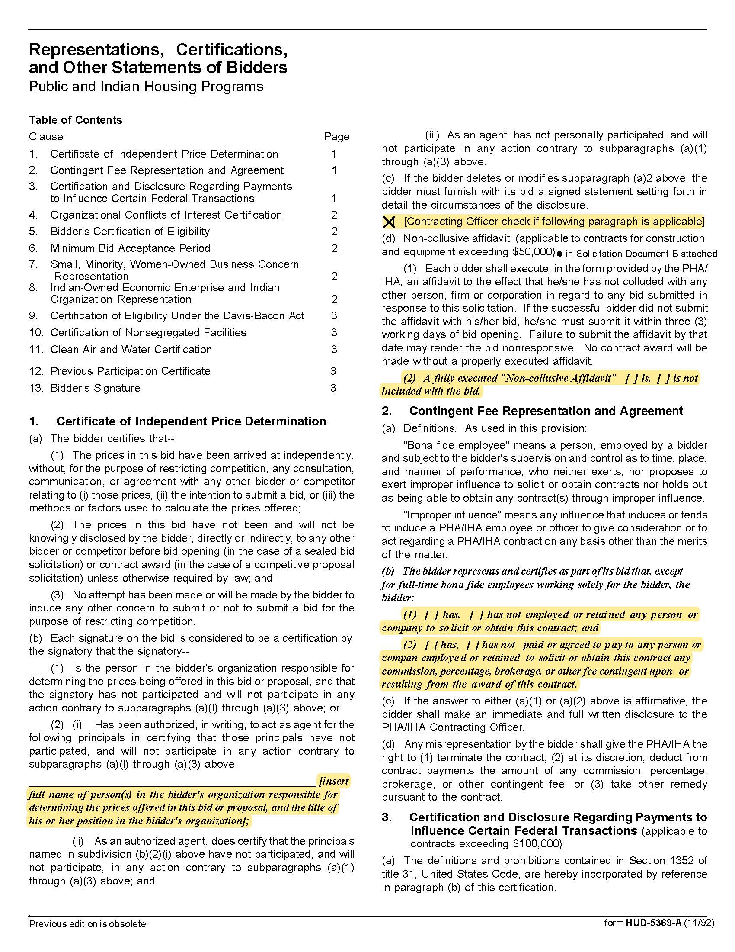
Solicitation Document C | HUD Form 5369A

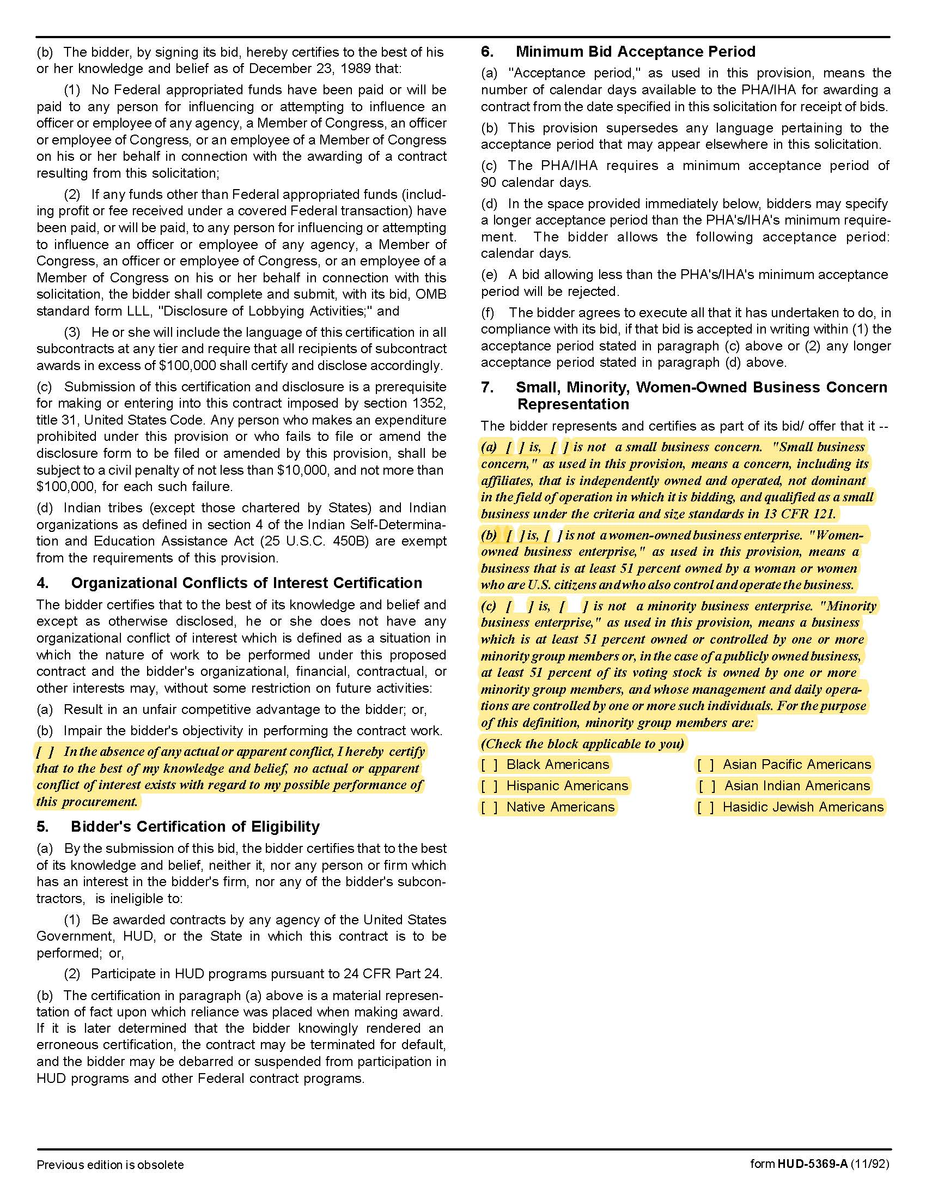

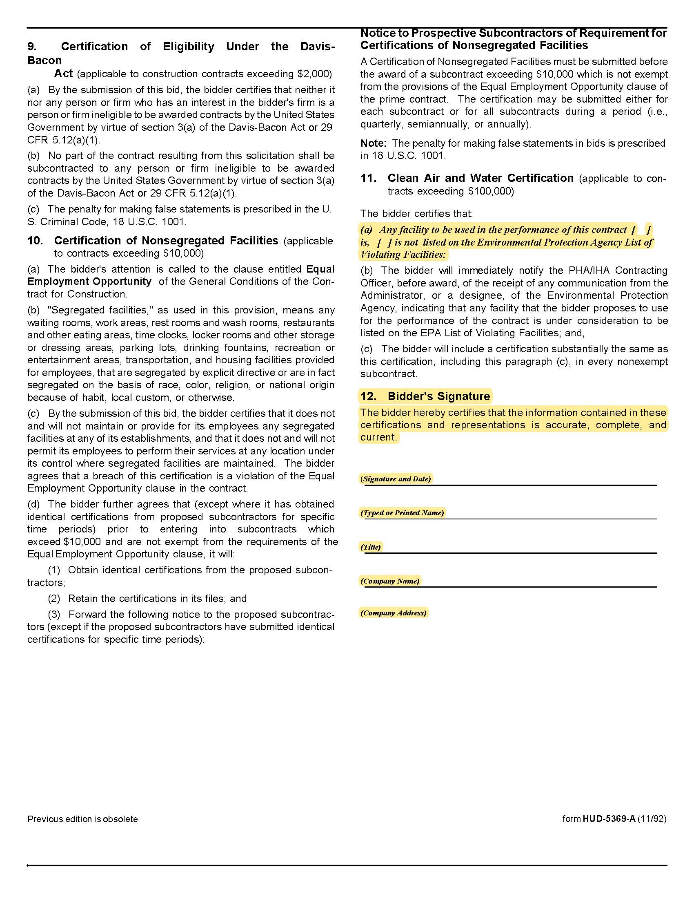

Solicitation Document D | Corporate Qualifications

Provide a detailed narrative outlining your corporate experience in providing heat treatment for bed bug control. Include information such as:

1. A narrative history of your company.

2. A brief narrative describing why your firm is best qualified to perform the requested services.

3. The length of time it has been providing such services.

4. Staff size (broken down by type of work performed).

5. Information about the number of vehicles owned relative to the ability to schedule various pest control services for multiple properties simultaneously.

6. Evidence that is has sufficient financial ability to undertake this ongoing service. This may include copies of most recent financial statements and more recent audit if available or balance sheet, income cash flow and lines of credit.

Solicitation Document E | Staff Qualifications for those to be assigned to KCDC

Provide a detailed narrative outlining your proposed staffs’ experience in providing heat treatment for bed bug control. Include information such as:

1. Names

- Certifications

- Training in the use of thermal remediation equipment.

- Years of experience in pest control services and years of experience with heat treatments.

2. Total number of personnel to be used with a heat treatment assignment.

3. Indicate which member of your team will be KCDC’s main contact.

Solicitation Document F | Cost

Use the table below to provide firm fixed costs for the desired services. Use the other fields to detail any other charges or optional charges.

Heat Treatment Service per Incident
0 Bedroom | $ each
1 Bedroom | $ each
2 Bedroom | $ each
3 Bedroom | $ each
4 Bedroom | $ each
5 Bedroom | $ each
Other: | $
Other: | $
Other: | $
Other: | $
Other: | $

Solicitation Document G | Corporate References

Provide two types of information:

1. Five specific references of similar past work. Include:

- Contact name
- Contact email
- Description of Work performed
- Date the service was provided

2. A client list that demonstrates that services have been provided to other clients of similar size and scope with an emphasis on providing services to other housing authorities and/or apartment complexes, if applicable.

Solicitation Document H | Treatment Plan

Provide a detailed narrative outlining your proposed heat treatment plan. Include information such as:

1. A sample of an “Apartment Heat Treatment Instructions” form.

2. The processes and procedures used by their staff to reduce or prevent cross‐contamination from infested units to adjacent areas.

3. Describe what (if any) measures must be taken to protect unit fixtures such as overhead fire sprinkler systems, toilet wax rings, et cetera from heat damage.

4. Steps used to collect and dispose of active bedbugs during heat treatment process.

5. The methodology used to insure even heating of large or heavy furniture pieces (mattresses, box springs, sofas, cushions, chairs, et cetera).

6. Specify the type of heating units to be used (propane, natural gas, electric, et cetera).

7. Specify the number and frequency of follow‐up inspections after heat treatment.

8. Specify the duration and terms of any guarantee(s) provided after services are completed.

Appendix 1 | Insurance Requirements

INSURANCE

The Supplier shall maintain, at Supplier’s sole expense, on a primary and non‐contributory basis, at all times during the life of the contract insurance coverages, limits, and endorsements described herein. All insurance must be underwritten by insurers with an A.M. Best rating of A-: VI or better. Upon award, the Supplier shall provide Certificate(s) of Insurance and amendatory endorsements to KCDC evidencing said insurance coverages. See paragraph “e” for exact naming of certificate holder and additional insureds (Owner Entities).

The Supplier agrees the insurance requirements herein as well as KCDC’s review or acknowledgement, is not intended to and shall not in any manner limit or qualify the liabilities and obligations assumed by the Supplier under this contract. KCDC’s failure to require a certificate of insurance, acceptance of a non-conforming certificate, or allowing the Supplier to commence work shall not operate as a waiver of these minimum insurance requirements or the liabilities and obligations assumed by the Supplier under this contract.

a. Commercial General Liability Insurance: occurrence version general liability insurance including contractual liability with a minimum combined single limit of $1,000,000 per occurrence with $2,000,000 in the aggregate covering the following perils: bodily injury, personal injury, and broad form property damage including products/completed operations for one year after completion of the Project(s). Limits must apply separately to the work/location in this contract.

Such insurance shall contain or be endorsed to contain a provision that includes the Owner Entities as additional insureds with respect to the Supplier’s ongoing and completed operations, providing coverage at least as broad as CG 20 10 07 04 and 20 37 07 04 endorsements. The coverage shall contain no special limitations on the scope of its protection afforded to the listed insureds.

b. Commercial Automobile Liability Insurance: in an amount not less than $1,000,000 (combined single limit) for all owned, hired, and non-owned vehicles utilized by Supplier in connection with the Project. Coverage is to include coverage for loading and unloading hazards.

Such insurance shall contain or be endorsed to contain a provision that includes the Owner Entities as additional insureds.

c. Workers’ Compensation Insurance and Employers Liability Insurance: Workers’ Compensation Insurance with statutory limits as required by the State of Tennessee or other applicable laws.
d. Pollution Liability Insurance: Supplier shall maintain pollution liability coverage, ISO CG 0039, or equivalent. If the coverage is written on a claims-made form:

1. The “Retro Date” must be shown and must be before the date of the contract or the beginning of contract work.

2. Insurance must be maintained and evidence of insurance must be provided for at least five (5) years after completion of the contract work and acceptance by KCDC.

3. If coverage is cancelled or non-renewed and not replaced with another claims-made policy form with a “Retro Date” prior to the contract effective date, Supplier must purchase “extended reporting” coverage for a minimum of five (5) years after completion of contract work

e. Other Insurance Requirements:

- Upon award, Supplier shall furnish KCDC with original Certificate(s) of Insurance and amendatory endorsements effecting coverage required by this section.

- Provide a waiver of subrogation for each required policy herein. When required by the insurer, or should a policy condition not permit Supplier to enter into a pre‐loss agreement to waive subrogation without an endorsement, the policy should be endorsed with a Waiver of Transfer of Rights of Recovery Against Others, or its equivalent. This waiver of subrogation requirement shall not apply to any policy which includes a condition specifically prohibiting such an endorsement, or voids coverage should supplier enter into such an agreement on a pre‐loss basis.

- A minimum 30‐day cancellation notice for all insurances (by endorsement if necessary) is required.

- Replace certificates, policies, and endorsements for any such insurance expiring prior to completion of services.

- Maintain such insurance from the time services commence until services are completed or through such extended discovery/reporting/tail period as required. Failure to maintain or renew coverage or to provide evidence of renewal may be treated by KCDC as a material breach of contract.

- Any deductibles and/or self‐insured retentions greater than $50,000 must be disclosed to and approved by KCDC prior to the commencement of services. Use of large deductibles and/or self‐insured retentions will require proof of financial ability as determined by KCDC.

- All policies must be written on an occurrence basis with the exception of Errors and Omissions Liability (E & O) / Professional Liability and Pollution Liability which may be claims made coverage.

8. Require all subcontractors to maintain during the term of the resulting contract commercial general liability insurance, automobile liability insurance, and workers’ compensation/employers liability insurance (unless subcontractor’s employees are covered by contractor’s insurance) in the same manor and limits as specified for the Supplier.

f. Certificate Holder and Additional Insureds:

The Certificate Holder shall be: KCDC
901 N Broadway
Knoxville, TN 37917
Additional Insureds:

Owner Entities are defined as those entities listed below and shall be provided all insurance coverages, limits, and endorsements included herein including additional insured status. Provided Supplier’s insurer(s) permits, the entities listed below can be identified collectively as “Owner Entities”:

KCDC, its officials, officers, employees, and volunteers
Eastport Development, LP
Five Points 1 LP
Five Points 2 LP
Five Points 3 LP
Five Points 4 LP
Bell Street LP
Bells Street 2 LP
Bell Street 3 LP
Lonsdale, LP
North Ridge Crossing, LP
Vista at Summit Hill, LP
Montgomery Village Corporation
Cagle Terrace Corporation

(Note: Only one (1) certificate needs to be provided. Certificate must reflect KCDC as the Certificate Holder and specify all coverages and terms apply to all Owner Entities.)

g. Right to Revise or Reject: KCDC reserves the right to revise any insurance requirement, including but not limited to, limits, coverages, and endorsements based on changes in scope of work/specifications, insurance market conditions affecting the availability or affordability of coverage.

h. No Representation of Coverage Adequacy: The coverages, limits or endorsements required herein protect the primary interests of the Owner Entities, and the Supplier agrees in no way should these coverages, limits or endorsements required be relied upon when assessing the extent or determining appropriate types and limits of coverage to protect the Supplier against any loss exposures, whether as a result of the project or otherwise.

Certificate Holder | KCDC  901 N Broadway  Knoxville, TN 37917
Additional Insureds (Owner Entities)  (can be identified collectively as Owner Entities) | KCDC, its officials, officers, employees, and volunteers  Knoxville’s Housing Development Corporation (KHDC)  Eastport Development, LP  Five Points 1 LP  Five Points 2 LP  Five Points 3 LP  Five Points 4 LP  Bell Street LP  Bell Street 3 LP  Lonsdale, LP  North Ridge Crossing, LP  Vista at Summit Hill, LP  Montgomery Village Corporation  Cagle Terrace Corporation
GL (Supplier & Subcontractors) | $1M / $2M (including contractual liability)
Auto (Supplier & Subcontractors) | $1M (owned, hired, & non-owned)
WC & Employers Liability (Supplier & Subcontractors) | Statutory limits
30-day cancellation (Supplier & Subcontractors) | Required– must indicate on COI
Primary non-contributory (Supplier & Subcontractors) | Required – must indicate on COI
Waiver of Subrogation (Supplier & Subcontractors) | Required – must indicate on COI

(Note: Only one (1) certificate needs to be provided. Certificate must reflect KCDC as the Certificate Holder and specify all coverages and terms apply to all Owner Entities.)

This and the preceding 3 pages do not need to be returned to KCDC.
Solicitation Document I | Insurance Agent’s Statement and Certification

I have reviewed these insurance requirements with the bidder/proposer named below and have told the bidder/proposer that the required coverage will be available and have advised the bidder/proposer of any additional costs that may be entailed with the coverages.

Insurance Agency 1 Name: ________________________________________________________

Authorizing Signature: ________________________________________________________

Insurance Agency 2 Name: ________________________________________________________

Authorizing Signature: ________________________________________________________

Insurance Agency 3 Name: ________________________________________________________

Authorizing Signature: ________________________________________________________

Bidder’s/Proposer’s Statement and Certification:
I certify that:

1. I have reviewed these requirements with my insurance agent(s).

2. If awarded the contract, I and my subcontractors (if any) will comply with the insurance requirements herein.

3. I/my insurance agency take no exceptions to the listed insurance requirements.

4. My subcontractors (if any) take no exceptions to the listed insurance requirements.

Bidder’s Name: ________________________________________________________

Authorizing Signature: ________________________________________________________
Return this page with your proposal.

