Greenwood County, SC
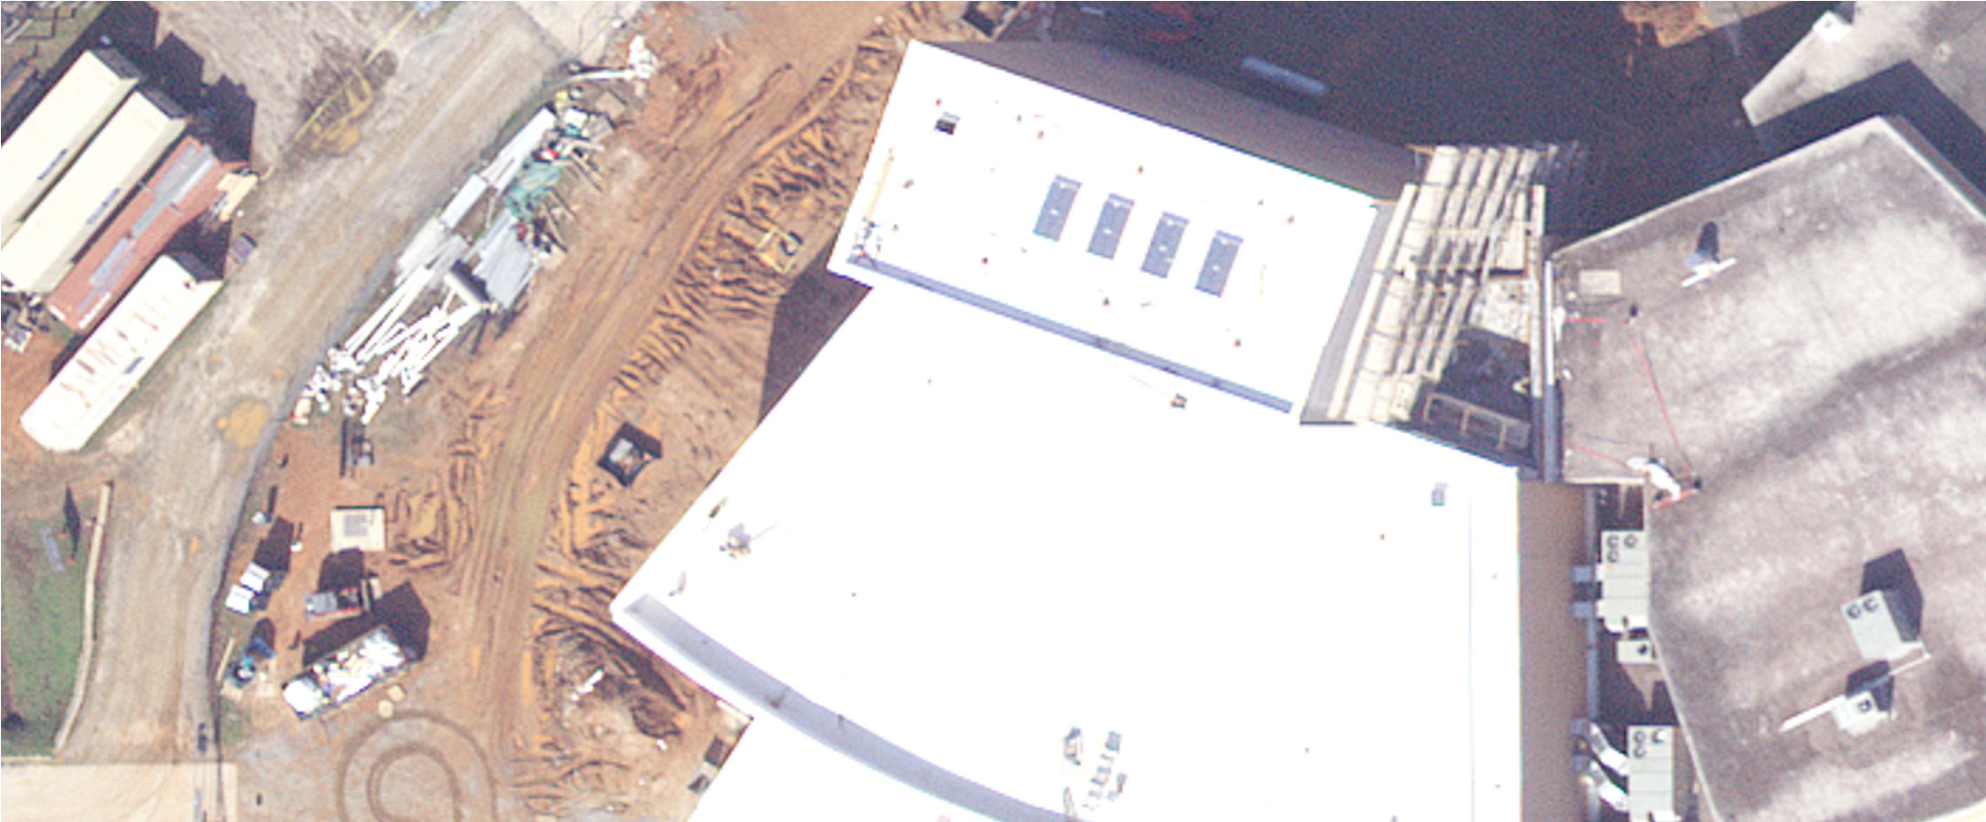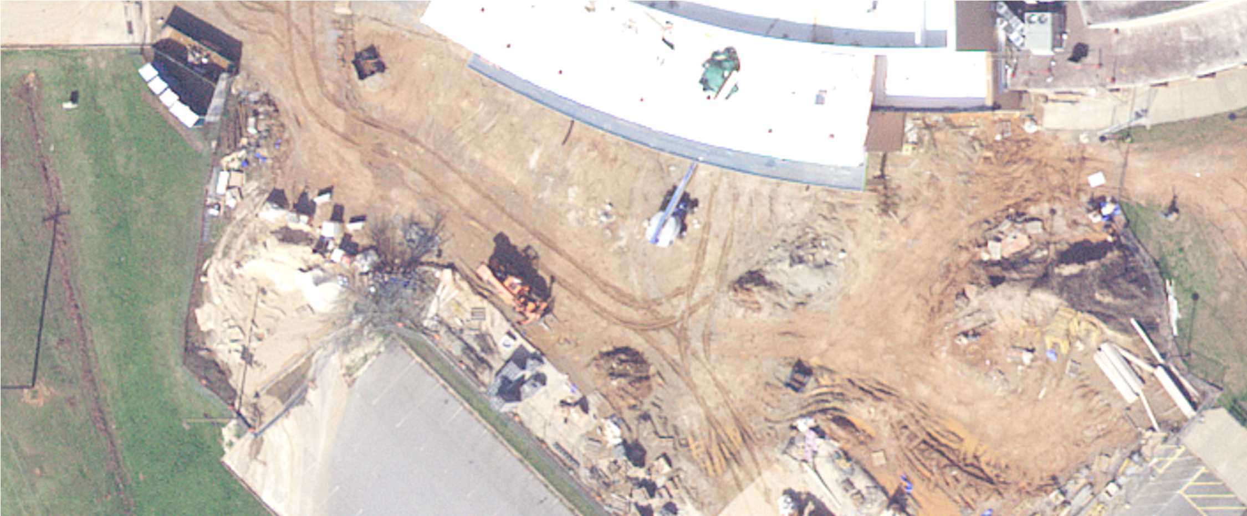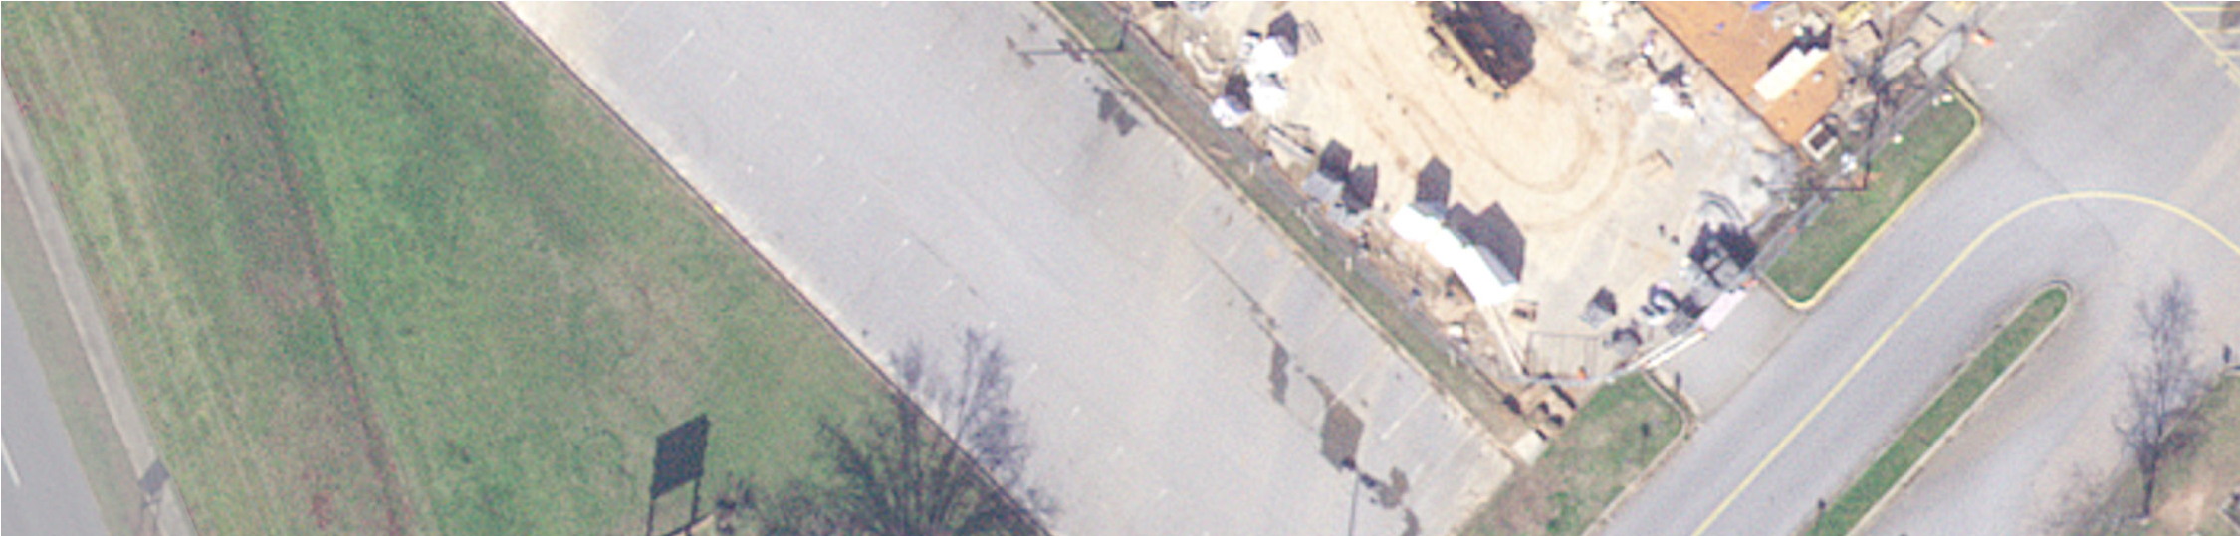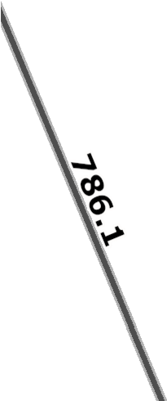
New Sign
August 22, 2022 1:564
0 25 50 100ft

0 5 10 20m
Map Layers, Greenwood County
Disclaimer: Map and parcel data are believed to be accurate, but accuracy is not guaranteed. This is not a legal document and should not be substituted for a title search,appraisal, survey, or for

