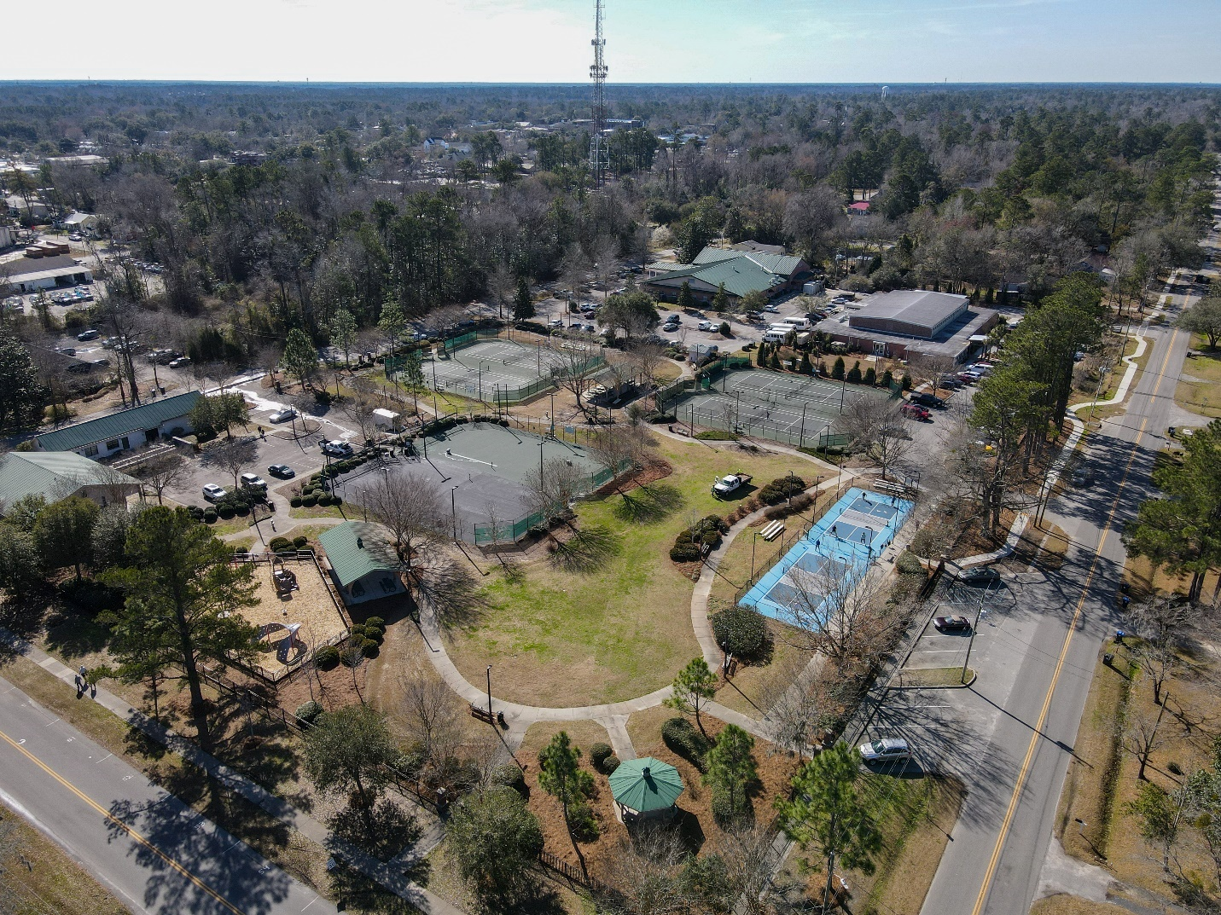

REQUEST FOR PROPOSAL

Splash Pad Design and Cost Estimate

Town of Summerville

Proposals are due:

Tuesday, August 1, 2023

1:00pm

REQUEST FOR PROPOSAL

July 10, 2023

The contact for this project is Amy Evans, Parks & Recreation Director. Contact information is 843-510-6014 or aevans@summervillesc.gov

Notice is hereby given that the Town of Summerville is seeking to hire a consultant to prepare a design, specifications and cost estimate for the addition of a splash pad at Doty Park located at 320 N Laurel St, Summerville SC 29483.

A non-mandatory site walk-thru will take place on July 20 at 10:00 a.m. at Doty Park.

An electronic proposal and three hard copies of the proposal must be submitted. All hard copies of proposals must be in a sealed envelope and marked in the lower left-hand corner: “RFP Splash Pad Design and Cost Estimate.”

Proposals shall be addressed to Purchasing Agent, Town of Summerville – 200 S Main St, Summerville SC 29483 . If shipped, please retain the proof of delivery by the deadline. All proposals must be received by 1:00 pm, EST, on Tuesday, August 1, 2023.

All submittals must be in 8-1/2"x11" format and the entire submittal package, excluding the introductory letter, shall not exceed fifteen (15) pages

Introduction
The Town of Summerville Parks and Recreation Department is seeking to hire a consultant to prepare a design, specifications and cost estimate for the addition of a splash pad in Doty Park.

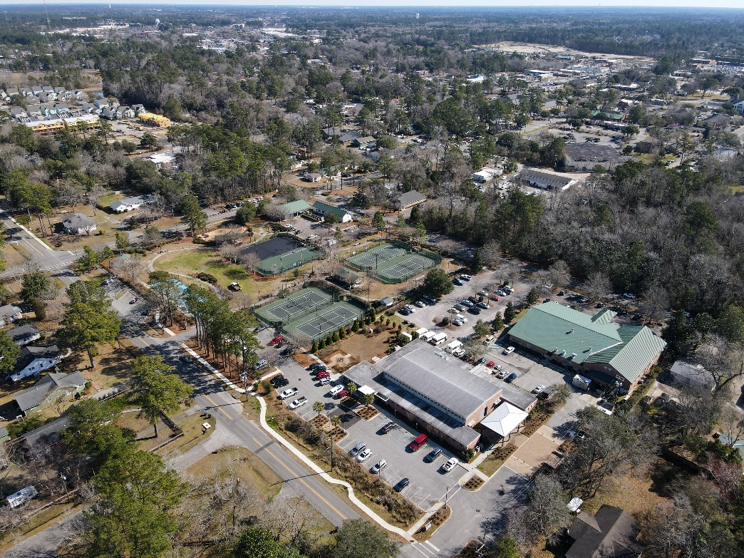
Doty Park is adjacent to the Rollins Edwards Community Center which serves as the hub for the Department’s summer camps. Doty Park is a free public park that is utilized by many within the community. The splash pad will be located near the existing playground and expand the opportunities currently offered at the site.

This project needs to be financially feasible and include a realistic timeline and budget for implementation.

Tentative Schedule

The Design and Cost Estimate must be completed no later than December 1, 2023.

• August 1 – Proposals Due by 1:00 p.m.
• August 1 – August 6 - Evaluation of submittals and interviews if deemed necessary
• August 7 – Contract Awarded by Council

Project Scope and Deliverables

The scope of the project includes, but may not be limited to:
- Design a zero-water depth spray area to meet age-appropriate needs for children under the age of 12. Touch activation should be included in the design.
- Design landscape and surrounding areas to include a seating area along the perimeter utilizing natural shade.
- Splash pad should be designed as a drain-to-waste system
- Meet all safety, health, and design standards, as well as applicable codes

Process
- Engineering Design – Complete research and analysis to design project including, but not limited to: site survey for use in preliminary and final design; compliance with structural code requirements; plumbing; electrical design needs.
- Permitting - the consultant will identify all permitting requirements and provide a cost estimate which includes permitting fees for all relevant agencies
- Construction cost estimate
- Development of design plans based on engineering research, analysis, and data suitable for submittal to regulatory agencies for permit review
- Preparation of bid documents for construction of the project

RFP Submission Requirements

An electronic proposal and three hard copies of the proposal must be submitted. All hard copies of proposals must be in a sealed envelope and marked in the lower left-hand corner: “RFP Splash Pad Design and Cost Estimate.” Electronic copies can be emailed to Parks and Recreation Director, Amy Evans, at aevans@SummervilleSC.gov

Proposals shall be addressed to the Purchasing Agent, Town of Summerville – 200 S Main St, Summerville SC 29483. If shipped, please retain the proof of delivery by the deadline. All proposals must be received by 1:00 pm, EST, on Tuesday, August 1, 2023.

All submittals must be in 8-1/2"x11" format and the entire submittal package, excluding the introductory letter, shall not exceed fifteen (15) pages.

Consultant Qualifications

Consultant qualifications should include detailed information regarding the Consultant’s experience on similar projects. A statement to the effect that the consultant’s project lead and key team members, as well as sub consultants (which will not be replaced without the prior approval of the Town) shall be included. The Consultant’s qualifications should include the following information:
- List projects of similar complexity and magnitude undertaken in the past five (5) years and provide references with a phone number for each reference
- Of the listed reference projects, list the involvement of proposed project team members for who resumes have been submitted
- Describe familiarity with relevant codes, environmental laws and ability to coordinate projects with multiple jurisdictional agencies
- List sub consultants and specify their involvement on the project. List no more than two (2) projects of similar complexity and magnitude undertaken by the sub consultant in the past five (5) years, and provide references and phone numbers for each project.
- The proposal should be accompanied by a brief introductory letter stating your firm’s interest in the project.

Consultant Selection Criteria

The selection of the successful company will be made based upon the qualifications, experience and ability of the company as detailed in the proposals submitted.
Consultants will be evaluated on the below items:
- Approach – Consultant’s understanding of the Town’s desires, goals, and general approach to the project as demonstrated in the project description and scope of work – 30 points
- Experience – Consultant’s experience with projects of similar complexity and function involving the public sector – 30 points
- Qualifications – Consultant’s staff qualifications being assigned to this project. Specialized project experience or technical competence relating to the Study Area for each person proposed to work on this project – 10 points
- Past performance – Demonstrated ability of the Consultant to perform high quality work, and meet schedules. Evaluation will include communication measures. A proposed schedule should be included with the Statement of Qualifications – 15 points
- Understanding – Demonstrated understanding of relevant duties and ability to coordinate projects with jurisdictional agencies and municipality projects – 15 points

If desired, top firms may be invited to interview with the Town selection team.

Contact & Question Period

For additional information concerning this RFP, any other aspect of the selection process, or the general project, contact Amy Evans, Parks and Recreation Director, aevans@summervillesc.gov.

No communication shall occur regarding this RFP, including requests for information or speculation between consultants or any of their members and any Town elected official or employees other than those named above. Failure to comply with this provision may result in the Consultant's proposal being removed from consideration. Any cost incurred by the Consultant in preparation, transmittal, or presentation of any information or material submitted in response to the RFP shall be borne solely by the Consultant.

Confidentiality
Responses to the RFP will become public records and, therefore, will be subject to public disclosure. However, South Carolina Statutes provide a method for protecting some documents from public disclosure. If the company designates a document as confidential or a trade secret, the Town will withhold the document from public disclosure to the extent that is entitled or required to do so by applicable law, and will return the document after selection.

Affirmative Action/Equal Employment: The Town of Summerville is an Affirmative Action/Equal Employment Opportunity Employer. Further, the Town of Summerville and the Company warrants that in the performance of this project, it will not discriminate or permit discrimination against any person or group of persons on the grounds of race, color, religion, national origin, sex or physical disability, including, but not limited to blindness, unless it is shown to be that such disability prevents performance of the work involved in any manner prohibited by the laws of the United States and the State of South Carolina.

Equal Employment Opportunity: The Town of Summerville does not discriminate in administering any of its programs and activities. The consultant awarded the contract for work will be required to ensure that no person shall be denied employment, fair treatment or be discriminated against on the basis of race, sex, religion, age, national origin, or handicap.

General Terms and Conditions:

- Respondents to this request shall be responsible for the accuracy of the information provided.
- The Town of Summerville reserves the right to reject any submittals, to waive minor irregularities in any submittal, to issue additional requests, and to substantially modify or terminate the project at any time before the final execution of a contract. The Town also reserves the right to choose not to proceed with this project or re-issue the Request for Proposals.
- The Town of Summerville shall not be responsible for any costs incurred by the respondent(s) in preparing, submitting, or presenting its response to the RFP or the interview process.
- Nothing contained herein shall require the Town of Summerville to enter into exclusive negotiations;
- The Town of Summerville reserves the right to request clarification of information submitted and request additional information from any respondent.
- The Town of Summerville will not accept any submittal after the time and date specified on the RFP.
- The qualifications of each member of the team are essential criteria in the selection process. The selected team will not be allowed to substitute any members without prior approval by the Town of Summerville.
- In the interest of a fair and equitable process, the Town of Summerville retains the sole responsibility to determine the timing, arrangement, and method of proposal presentations throughout the selection process.
- All submittals and accompanying documentation will become the property of the Town of Summerville; materials will not be returned, and they become public documents subject to public disclosure.

