REQUEST FOR PROPOSAL
Water Line usage

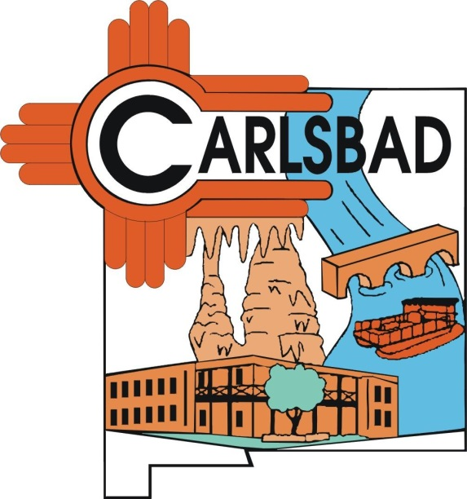

RFP 2019-11

Release Date
5/31/19

Contact: Matt Fletcher, Purchasing Manager
Phone – 575-234-7905
Email – msfletcher@cityofcarlsbadnm.com

PROPOSAL DUE DATE: June 21, 2019 by 5:00 p.m. (MDT)

SUBMIT TO: Purchasing Manager
Carlsbad Municipal Building
101 N. Halagueno Street
Room 114
Carlsbad, NM 88220

The City of Carlsbad owns an 8 mile section water line in the Loco Hills area.

Line Location:
The line begins as T17S R32E Section 2 and runs for approximately 8 miles and terminates at T18S R31E Section 1.
(A detailed map has been provided for reference)

The City is seeking proposals from parties interested in entering into an agreement with the City for the usage of the above referenced water line under the following terms and conditions:

1. The term of the agreement shall be 5 years.

2. Payment shall be on a per barrel basis. The rate is subject to
negotiation.

3. Payments shall be made to the City on a monthly basis.

4. Line shall be repaired and restored to AWWA standards at the
Applicant’s expense.

5. Cost of repairs to the line will not be refundable at termination
of the contract by either party.

7. The City will not supply water.

8. Agreement will be subject to BLM approval.

9. The applicant shall provide a water meter and make meter
accessible to City personnel.

10. The applicant agrees to indemnify, save, and hold harmless,
the City, its officers, and employees against all liability,
claims, damages, losses, or expenses of every kind,
including reasonable attorneys’ fees together with costs and
expenses of litigation, arising out of, from, or associated in
any manner with the acts or omissions of the applicant, its
officers, agents, or employees. A certificate of liability
insurance in the minimum amount of $1 million shall be
provided with the proposal and must be maintained
throughout the duration of the lease.

11. The agreement may be terminated by either party with
written 30 day notice.

- Offers shall be submitted in a sealed envelope to the Purchasing Manager, Room 115, Municipal Building, 101 N. Halagueno, Carlsbad, NM 88220 by 5:00 p.m. (MDT) on or before June 21, 2019. Proposals sent by email or fax will not be accepted.

- Late proposals will not be accepted.

- The City will consider offers that are in the best interest of the City.

- The City has the right to reject any and all offers.

Offer Form
RFP 2019-11

By signing this form, the offeror agrees to all terms and conditions as described in items 1 – 11.

Any exceptions taken to these terms should be detailed and provided with the offer submitted. Attach additional pages if necessary.

Offer Submitted by: ____________________________
Company Name

Individual Representing Company _____________________
Printed Name

Offer Price per barrel $ ____________________

Additional Conditions to Offer (if any) ____________________________________________________________________________________________________________________________________________________________________________________________________________________________________________________________________

Exceptions to terms (if any) : ____________________________________________________________________________________________________________________________________________________________________________________

Signature __________________ Date: __________

