Request for Proposals

Solicitation Name and Number | Owner’s Representative Services C21011
KCDC’s Procurement Division must receive your response no later than | 11:00 a.m. on March 11, 2021 (as KCDC’s clocks indicate)
Deliver Responses to | procurementinfo@kcdc.org
Electronic Copies | Use the MS Word version posted on KCDC’s website (or other electronic means) to provide a typed response. The final proposal is to be submitted in Adobe format.
Questions About This Solicitation | Submit questions to procurementinfo@kcdc.org by 6:00 p.m. on March 8, 2021.  KCDC will not accept questions via telephone.
Open Records/Public Access to Documents | All document provided to KCDC are subject to the Tennessee Open Meetings Act (TCA 8-44-101) and open records requirements.
Check KCDC’s webpage (https://www.kcdc.org/procurement/) for addenda and changes before submitting your response

General Information

1. Background and Intent
a. Knoxville's Community Development Corporation (KCDC) is the public housing and redevelopment agency for the City of Knoxville and for Knox County in Tennessee. KCDC’s housing property portfolio includes 17 properties with approximately 3,500 dwelling units. KCDC also administers approximately 3,958 Section 8 Vouchers and 82 Moderate Rehabilitation units. Other activities of KCDC include management of 9 LIHTC properties, administration of development and redevelopment projects for local governments and several related business activities.

b. KCDC uses “supplier” as inclusive of various words describing interested parties often called “supplier,” “bidders,” “contractors” and “suppliers.”

c. KCDC is seeking Owner Representative services for the construction of a new 20,000 square foot Head Start educational facility (“Project”) at the Western Heights development in Knoxville. The construction will take place on vacant land at the northwest corner of Oldham Avenue and McSpaddin Street. The selected Owner Representative should have: (i) significant project management and/or owner representative experience; (ii) construction experience with schools, educational facilities or other related civic buildings; and (iii) familiarity with projects involving federal funding and experience with monitoring and tracking Certified Payrolls and Davis Bacon requirements.

d. Project architect, McCarty, Holsaple, McCarty (MHM), is currently completing the Design Development (DD) drawings. Preliminary DD plans are expected to be completed by mid-March as well as a construction cost estimate. The construction cost estimate will be done by a third-party construction estimating firm engaged by MHM. Construction is expected to start in the summer of 2021 and last approximately 12 months.

e. The selected owner representative is expected to assist KCDC during the remaining predevelopment stage as well as manage and oversee the construction process. The selected Owner Representative is expected to coordinate with the various parties including KCDC staff, architects, engineers, general contractors, subcontractors, community stakeholders, regulatory authorities, utility providers and others. The selected Owner Representative is expected to serve as an advocate for KCDC and protect the best interests of KCDC.

f. KCDC intends for this solicitation to result in the selection of one company to provide owner representative services for the construction of the Head Start facility at Western Heights. However, note that KCDC may award all, none or some of this work.

g. Additionally, KCDC may establish a pool of up to five proposers responding to this solicitation as our pool for future Owner’s Representation services. If KCDC elects to do so, in the future when needs arise, KCDC may simply contact those firms to obtain proposals for such needs. Award will be based on expertise, availability, cost and other factors as may be prudent. The pool may remain in place for up to five years.

h. This solicitation is not an engagement for architectural services, nor is it a request for a turnkey construction nor development program.

i. Owner Representative tasks include, but are not limited to, these:

- Predevelopment work remaining until closing, (i) provide construction expertise to KCDC and MHM relating to the constructability of the current Project design, (ii) review the DD cost estimates provided by the third party and assist in value engineering, if necessary, (iii) assist in utility coordination with KUB (iv) assist KCDC and MHM in re-platting and permitting, (v) develop a comprehensive project budget that includes all Project-related hard and soft costs, and (vi) selection of contractor which will include preparing general contractor bid documents (e.g. scope of work, bid requirements, labor and wage assumptions, et cetera), reviewing bids and providing a recommendation on the lowest, qualified bid

- Provide complete project management services including phasing and scheduling; establishing project milestones/reporting schedules; reviewing and monitoring progress against budget; tracking potential cost changes and change orders; and monitoring compliance with all contract terms

- Visit the site approximately 3-4 times a week during construction to perform inspections of work in progress and notify the owner, architect and general contractor(s) of any defective work or other issues under the construction contract

- Inspect completed projects along with the architect, coordinate with the general contractor to facilitate the satisfactory completion of all work

- Working with general contractors, engineers, architects, et cetera on permitting issues and obtaining certificates of occupancy

- Project oversight

- Analyze alternative courses of action for unforeseen conditions such as materials shortages, work stoppages and accidents if they occur

- Manage and adhere to all Davis Bacon requirements, certified payroll reviews, Section 3 and any other requirements associated with projects receiving federal funds

- Assist with the evaluation/selection process and assist in awarding contracts to general contractors

- Facilitate biweekly project meeting with contractor, architect, and owner, and attend other meetings about the project as needed

- Evaluate the performance of the general contractor, subcontractors, architects and engineers as needed and as appropriate

- Review and approve monthly payment requests from architects, engineers, general contractors, etc. and provide recommendations to the owner

- Review and approve requests for change orders and recommend them (when appropriate) to KCDC.

- Prepare monthly construction reports and address to (i) KCDC and (ii) project lender (if requested).

j. KCDC anticipates spending approximately $50,000-$80,000 for Owner Representative services. The actual cost will be negotiated with the selected supplier.

k. A schematic picture is provided in Appendix A.

2. Changes After Award
It is possible that after award KCDC will need to revise the service needs or requirements specified in this document. KCDC reserves the right to make such changes after consultation with the supplier. Should additional costs arise, the supplier must document increased costs. KCDC reserves the right to accept and negotiate these charges.

3. Contact Policy
Contact only KCDC’s Procurement Division about this solicitation from the issuance of this RFP until its award. Information obtained from any other person will not affect the risks or obligations assumed by the supplier or relieve the supplier from fulfilling any of the conditions of the resulting award. Such contact can disqualify the supplier from the solicitation process.

4. Codes and Ordinances
All work covered is to be done in full accord with the current codes, laws, regulations and statutes of all national, state and local authorities having jurisdiction.

5. Confidentiality
a. All reports, information, or data, prepared, assembled or communicated verbally to or by the selected supplier are confidential and the selected supplier agrees that reports, information or data shall not be made available to any individual or organization without KCDC’s prior approval.

b. KCDC may disclose information to the selected supplier and the selected supplier may have access to information that is not generally known to others and is confidential. The selected supplier agrees not to use or disclose to third parties except in the performance of services hereunder any confidential information. The selected supplier agrees its employees and subcontractors have the same confidentiality requirements. These provisions shall survive the termination of the contract.

6. Evaluation
a. KCDC alone determines (using NIGP’s definition and other relevant sources as appropriate) the supplier’s “responsive” and “responsible” status prior to award.

Responsible means a business with the financial and technical capacity to perform the requirements of the solicitation and subsequent contract. A responsive proposal is one that fully conforms in all material respects to the solicitation document and all its requirements, including all form and substance.

b. KCDC will review all proposals and reserves the right to request necessary modifications, request additional information, waive minor technicalities, reject all proposals, reject any proposal that does not meet mandatory requirement(s) or cancel this RFP, according to KCDC’s best interests. KCDC further reserves the right to adjust its evaluation scenario if this is in KCDC’s best interest and consistent with good business practices.

c. KCDC may require oral presentations as part of the evaluation process.

d. KCDC plans to award to the best overall proposal on the following evaluation scale:

Item | Maximum Points
Firm’s Professional Competence and Experience of Project team proposed | 40
Cost | 35
Ability to provide full scope of services to KCDC (no or few exclusions to scope listed) | 25
Total Points | 100

7. General Instructions
KCDC does not insert “General Instructions to Suppliers” in solicitation documents. These instructions are at www.kcdc.org. Click on “Procurement” and then follow the link to the instructions. The supplier’s submittal means acceptance of the terms and conditions set forth in KCDC’s “General Instructions to Suppliers.” Paragraphs in the “General Instructions” document that do not apply to this solicitation: 16, 18, 39, 50, 52, 57, 65 and 69.

8. Insurance
The supplier agrees to maintain at its sole expense on a primary and non-contributory basis during the term of this resulting contract insurance coverages and limits in accordance with the supplier’s standard business practices and acceptable to KCDC. Such insurance shall contain or be endorsed to contain a provision that includes KCDC, its officials, officers, employees, and volunteers as additional insureds with respect to liability arising out of work or operations performed by or on behalf of the supplier. Such insurance shall provide waiver(s) of subrogation. Upon request, the supplier will provide KCDC with Certificates of Insurance evidencing such insurance.

9. Smoking Policy
KCDC’s Smoke Free policy is applicable to you, your employees and subcontractors.

a. The policy mandates:
- No smoking on KCDC’s property
- No e-vape or similar usage on KCDC’s property
- The Smoke Free policy applies in personal or corporate vehicles on KCDC’s property
b. Should your employees be observed violating these requirements, KCDC’s Procurement Division will
notify the supplier for resolution. Should there be recurrences, KCDC may ask the supplier to not send the employee to KCDC’s property. Repeated offenses may result in forfeiture of your awarded “contract.”

10. Submittal Instructions
Submit your information in the order indicated below:

Document Number | Title
Solicitation Document A | General Response Section
Solicitation Document B | Affidavits
Solicitation Document C | HUD Form 5369A
Solicitation Document D | Executive Summary
Solicitation Document E | Firm’s Professional Competence and Experience
Solicitation Document F | Proposed Staff Experience and Qualifications

Solicitation Document A: General Response Section
Sign Your Name to the Right of the Arrow
If completing this document in Adobe, an electronic signature is acceptable to KCDC.
Your signature indicates you read and agree to “KCDC’s General Instructions to Suppliers” (www.kcdc.org) and that you are authorized to bind the supplier or are submitting the response on behalf of and at the direction of the suppliers’ representative authorized to contractually bind the supplier. I represent that the supplier or its applicable representative(s) has reviewed the information contained in this Solicitation Package and that the information submitted is accurate.
Printed Name and Title
Company Name
Street Address
City/State/Zip
Contact Person (Please Print Clearly)
Telephone Number
Cell Number
Supplier’s E-Mail Address (Please Print Clearly)
Addenda
Addenda are at www.kcdc.org. Click on “Procurement” and then on “Open Solicitations” to find addenda. Please check for addenda prior to submitting a proposal.
Acknowledge addenda have been issued by checking below as appropriate:
None ☐ | Addendum 1 ☐ |  |  | Addendum 2 ☐ |  | Addendum 3 ☐ |  |  | Addendum 4 ☐ | Addendum 5 ☐
Statistical Information (Check all the apply)
This business is at least 51% owned and operated by a woman |  |  |  |  |  |  |  |  |  |  | Yes ☐ No ☐
This business qualifies as a small business by the State of Tennessee  Total gross receipts of not more than $10,000,000 average over a three-year period OR employs no more than 99 persons on a full-time basis |  |  |  |  |  |  |  |  |  |  | Yes ☐ No ☐
This business qualifies as Section 3 business (as defined by HUD):  It is at least 51% owned by a Public Housing resident or it employs Section 3 residents for at least 30% of its employee base; or it commits to subcontract at least 25% of the project’s dollars to a Section 3 business. |  |  |  |  |  |  |  |  |  |  | Yes ☐ No ☐
This business is owned & operated by persons at least 51% of the following ethnic background:
Asian/Pacific ☐ |  | Black ☐ | Hasidic Jew ☐ |  | Hispanic ☐ |  |  | Native Americans ☐ |  |  | White ☐

Solicitation Document B: Affidavits

Conflict of Interest
1. No commissioner or officer of KCDC or other person whose duty it is to vote for, let out, overlook or in any manner superintend any of the work for KCDC has a direct interest in the award or the supplier providing goods or services.

2. No employee, officer or agent of the grantee or sub-grantee will participate in selection, or in the award or administration of an award supported by Federal funds if a conflict of interest, real or apparent, would be involved. Such a conflict would arise when the employee, officer or agent, any member of his immediate family, his or her partner, or an organization, which employs, or is about to employ, any of the above, has a financial or other interest in the supplier selected for award.

3. The grantee's or sub-grantee's officers, employees or agents will neither solicit nor accept gratuities, favors or anything of monetary value from suppliers, potential suppliers or parties to sub-agreements.

4. By submission of this form, the supplier is certifying that no conflicts of interest exist.

Drug Free Workplace Requirements
5. Private employers with five or more employees desiring to contract for construction services attest that they have a drug free workplace program in effect in accordance with TCA 50-9-112.

Eligibility
6. The supplier is eligible for employment on public contracts because no convictions or guilty pleas or pleas of nolo contender to violations of the Sherman Anti-Trust Act, mail fraud or state criminal violations with an award from the State of Tennessee or any political subdivision thereof have occurred.
General
7. Supplier fully understands the preparation and contents of the attached offer and of all pertinent circumstances respecting such offer.

8. Such offer is genuine and is not a sham offer.

Iran Divestment Act
9. Concerning the Iran Divestment Act (TCA 12-12-101 et seq.), by submission of this bid/quote/proposal, each supplier and each person signing on behalf of any supplier certifies, and in the case of a joint bid/quote/proposal, each party thereto certifies as to its own organization, under penalty of perjury, that to the best of its knowledge and belief that each supplier is not on the list created pursuant to § 12-12-106.

Accuracy of Electronic Copies
10. If the supplier provides electronic copies of the bid/proposal/quote to KCDC, the supplier certifies that the information provided on paper and in the electronic format is identical unless specifically noted otherwise.

Non-Collusion
11. Neither the said supplier nor any of its officers, partners, owners, agents, representatives, employees or parties interest, including this affiant, has in any way colluded conspired, connived or agreed, directly or indirectly, with any other responder, supplier, or person to submit a collusive or sham offer in connection with the award or agreement for which the attached offer has been submitted or to refrain from making an offer in connection with such award or agreement, or collusion or communication or conference with any other supplier, or, to fix any overhead, profit, or cost element of the offer price or the offer price of any other supplier, or to secure through any collusion, conspiracy, connivance, or unlawful agreement any advantage against KCDC or any person interested in the proposed award or agreement.

12. The price or prices quoted in the attached offer are fair, proper and not tainted by any collusion, conspiracy, connivance, or unlawful agreement on the part of the supplier or any of its agents, representatives, owners, employees, or parties in interest, including this affiant.

No Contact/No Advocacy Affidavit
13. After this solicitation is issued, any contact initiated by any supplier with any KCDC representative concerning this proposal is strictly prohibited-except for communication with the Procurement Division. My signature signifies that no unauthorized contact occurred.

14. To ensure the integrity of the review and evaluation process, respondents to this solicitation nor any firm representing them, may not lobby or advocate to KCDC staff or Board members. My signature signifies that no unauthorized advocacy occurred.

The undersigned hereby acknowledges receipt of these affidavits and certifies that the submittal in response to this solicitation is in full compliance with the listed requirements.

Signed by
Printed Name
Title
Subscribed and sworn to before me this date
By (Notary Public)
My Commission Expires on
Notary Stamp

C: HUD Form 5369A
Solicitation Document C: HUD Form 5369A
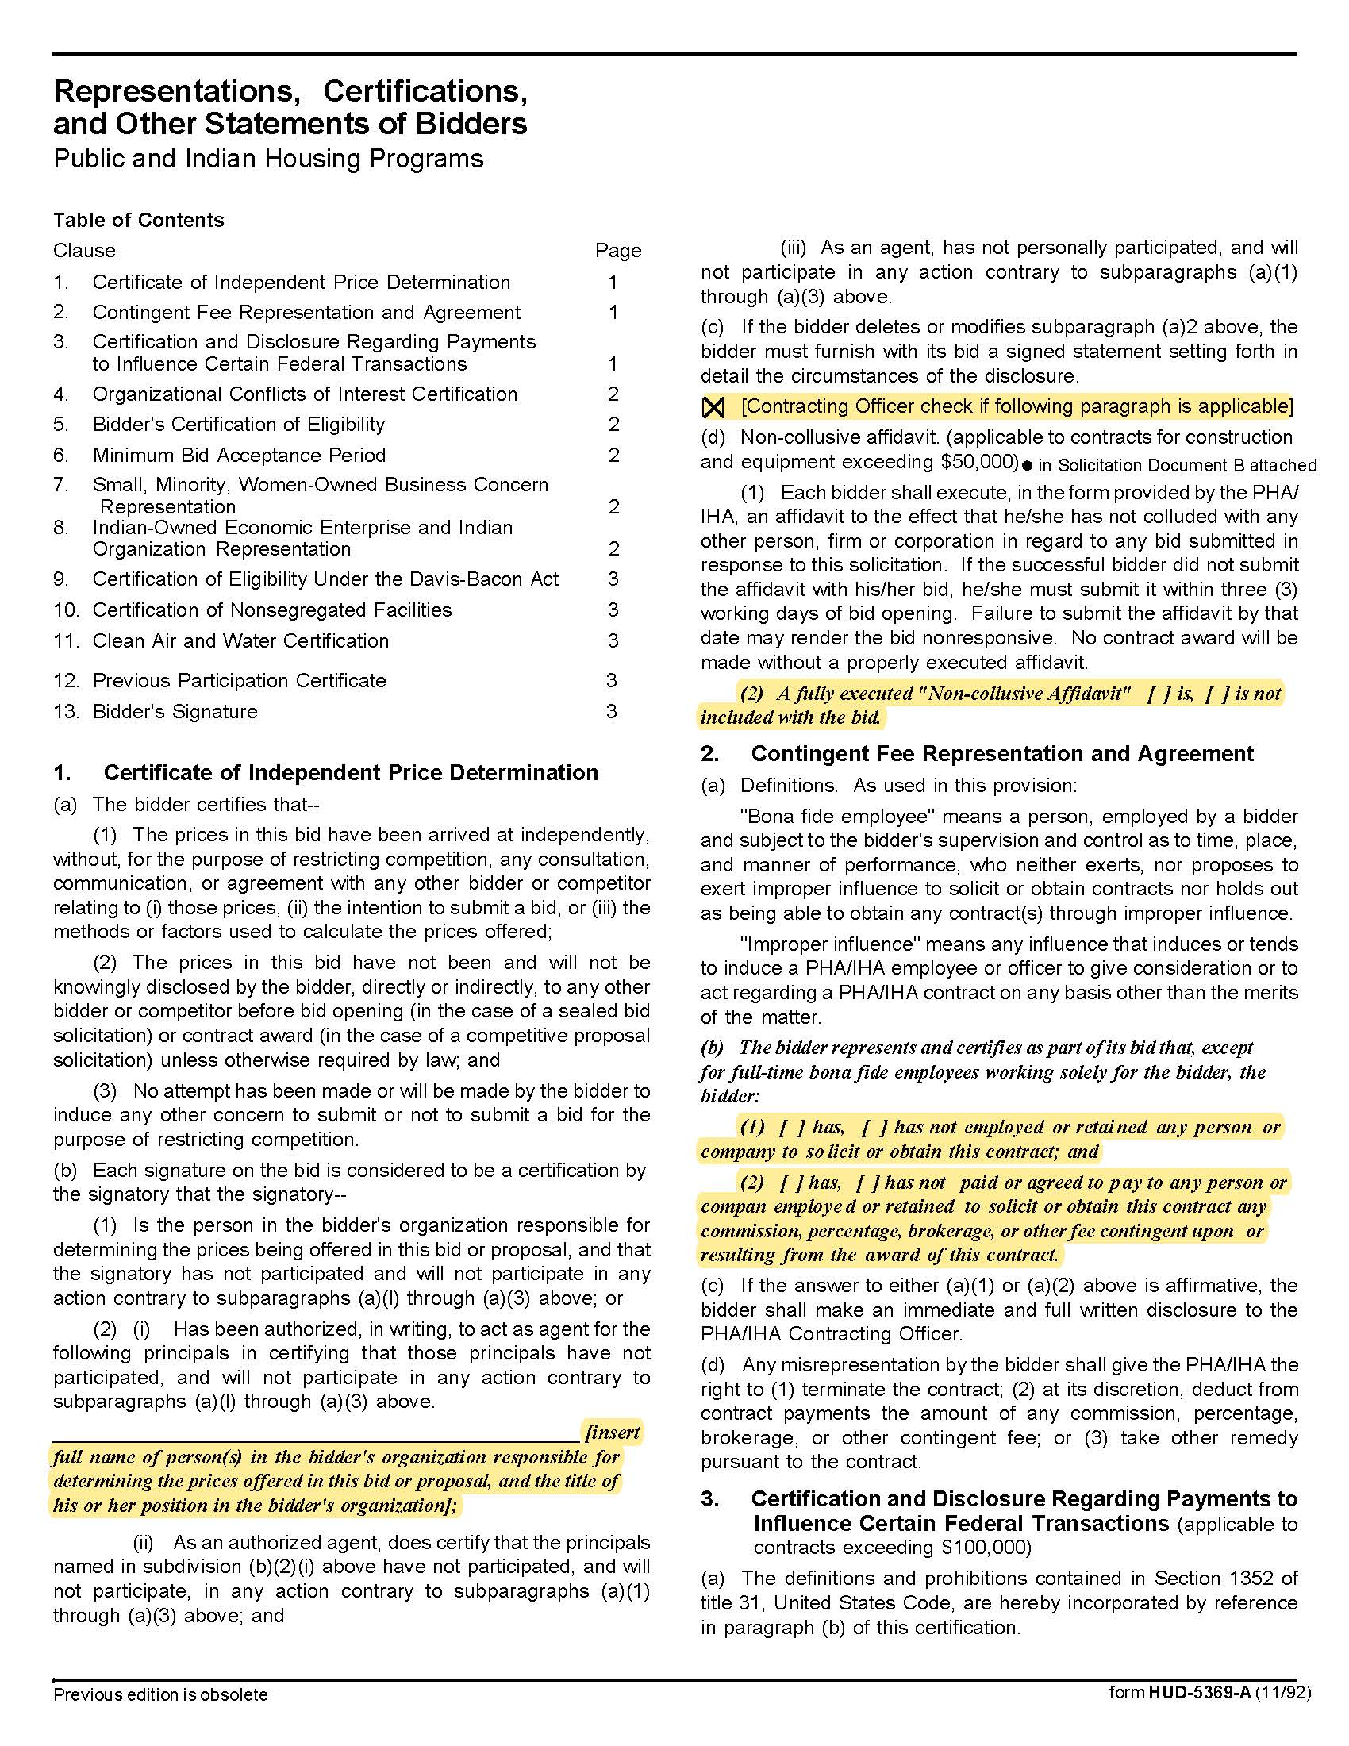

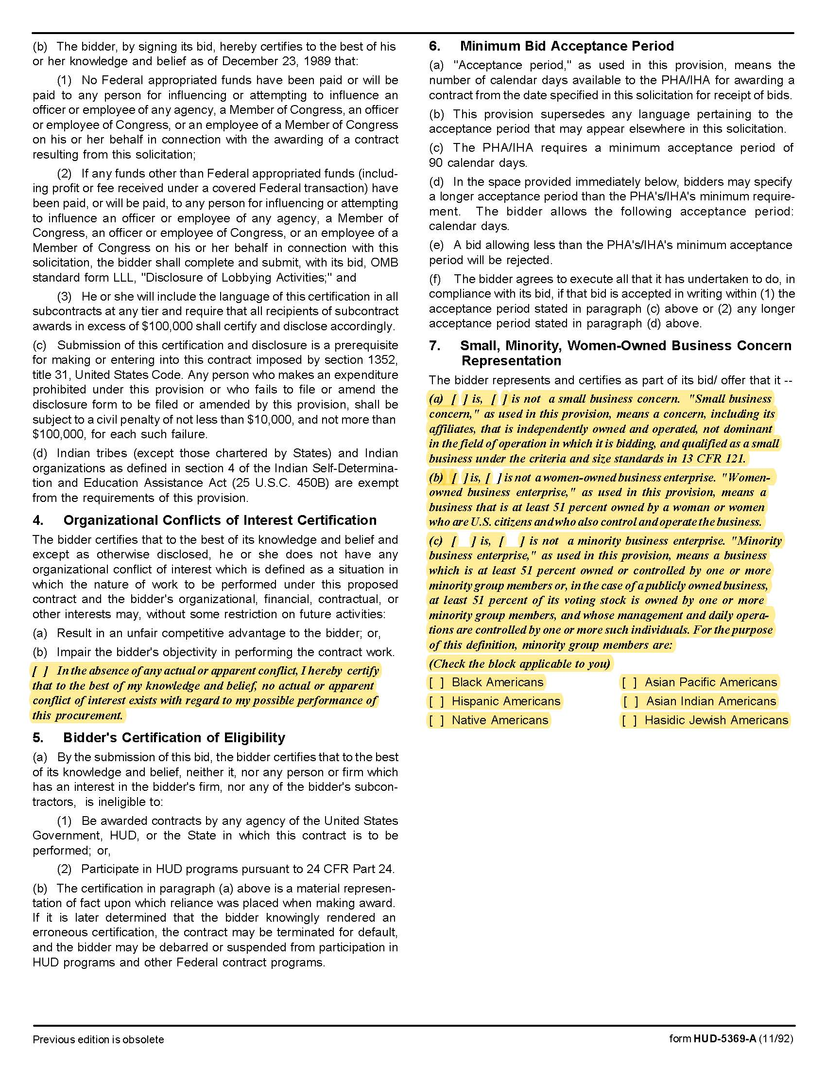

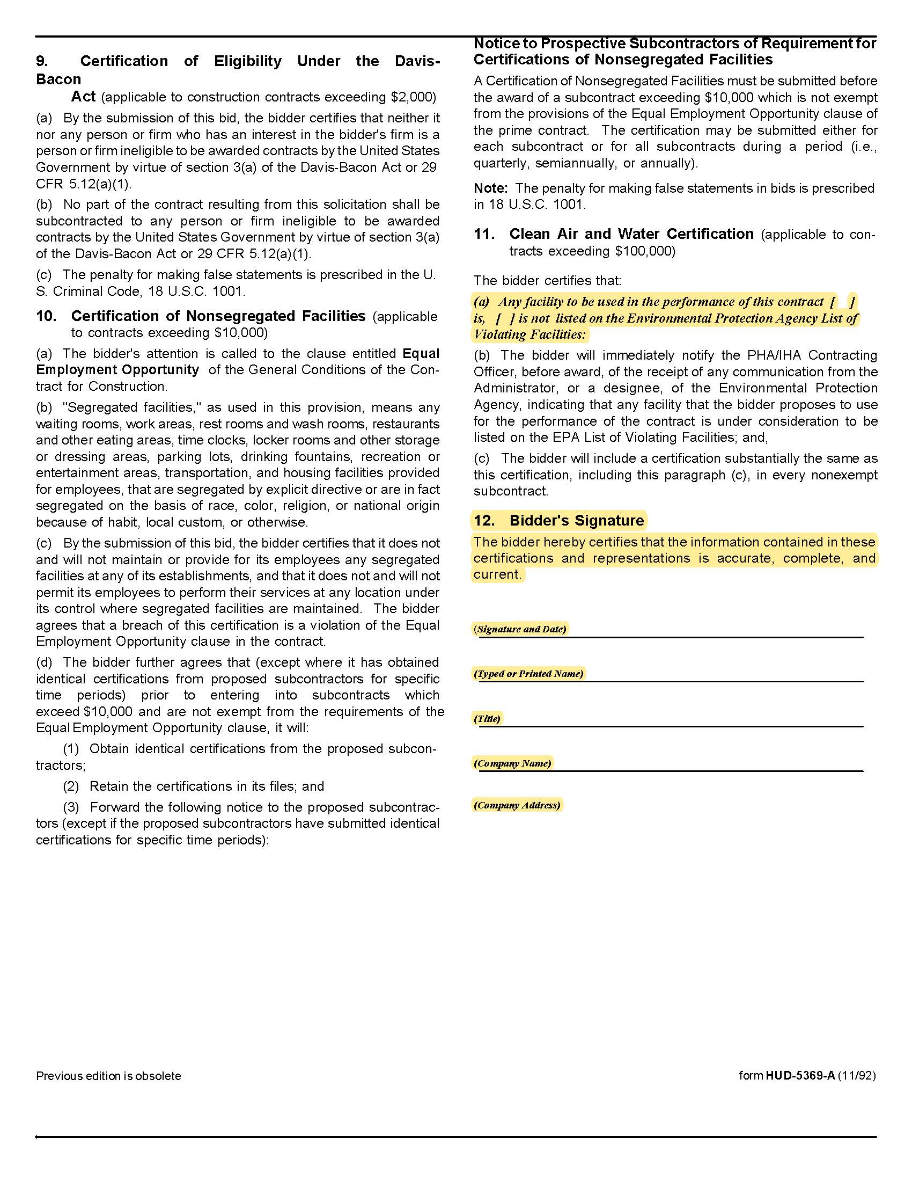

Solicitation Document D Executive Summary

Provide an Executive Summary Cover Letter (two pages or less) that includes:

- A statement explaining your interest in the project

- An overview of the proposed project team

- An explanation of why the team is best qualified for the work

- A statement that the supplier agrees to and accepts the terms and conditions of the RFP

- List any deviations from KCDC’s list of services to be provided (should your firm not be able to provide the services or not able to provide the services within the stated budget).

- A cost proposal for the listed services.

- Other information as desired

Solicitation Document E Firms’ Professional Competence and Experience

Using as many pages as needed, provide the following information about the proposer:

1. A narrative history of the proposer’s organization including the date of inception or incorporation.

2. Experience in providing owner representative services for similar projects. The information provided should include, but not be limited to, the names of clients, scope of work performed and year of engagements.

3. Provide no less than two professional references. References provided should be related to similar projects and/or should provide KCDC with confidence that supplier can provide all the requested services and tasks set forth in this document. Present information in this format:

- Name of the business serviced
- Contact name
- Phone number
- Email address
- Amount of the contract
- Description of the contract
- Date the contract began and ended

Solicitation Document F Proposed Staff Experience and Qualifications

Using as many pages as needed, provide the following information:

1. Present two organizational charts:

a. The entire organization

b. One which identifies the key individuals and their proposed roles.

2. The names of the principal-in-charge and any other key lead personnel.

3. A one to three paragraph summary assessment of the person assigned as KCDC’s main contact. Include their background, education information and current position with the supplier. There should be a particular focus on prior experience in affordable housing development. Substitutions for key personnel listed to complete task must be with equally qualified persons and must be approved by KCDC prior to assignment to KCDC work.

4. A statement of the years of experience for each proposed employee whose project responsibilities are significant for these projects:

a. Years with proposer (list titles and start dates)

b. Years in the industry (list titles, dates and employers)

5. A list of five major accounts/projects that the person has been involved in, using the following format:
Employee Name

Name of Project One Role the employee played Description
Name of Project Two Role the employee played Description
Name of Project Three Role the employee played Description
Name of Project Four Role the employee played Description
Name of Project Five Role the employee played Description

6. Any current certifications applicable to the professional services the employee will provide.

7. Explain how you will balance KCDC projects with the needs of your other clients.

Appendix A: Schematic Drawing

