Request for Proposals

Solicitation name and number | Landscaping Services Q22XX
Upload responses by | 11:00 a.m. on July XX, 2022 (as KCDC’s clocks show)
Upload your response document to | https://vrapp.vendorregistry.com/Account/LogOn  (Can also be accessed via KCDC’s webpage)
Questions about this solicitation | KCDC will not accept questions via telephone.  Submit questions to procurementinfo@kcdc.org by 6:00 p.m. on June XX, 2022.
Proposal opening | This solicitation will not have a public opening since it is a proposal, but the award results will be made available as noted below.
Award results | KCDC posts the award decision to its web page at: http://www.kcdc.org/procurement/.
Open Records/Public Access to Documents | All document provided to KCDC are subject to the Tennessee Open Meetings Act (TCA 8-44-101) and open records requirements.
Check KCDC’s webpage for addenda and changes before submitting your response

General Information

1. Background and Intent

a. Knoxville's Community Development Corporation (“KCDC”) is the public housing authority for the City of Knoxville and for Knox County in Tennessee. KCDC’s affordable housing property portfolio includes more than 26 properties with approximately 3,600 dwelling units. In addition to operating its public housing apartments, KCDC oversees approximately 4,097 Section 8 Vouchers and 76 Moderate Rehabilitation units. Additionally, KCDC serves as the redevelopment agency for the City of Knoxville, managing redevelopment areas, TIFs, and PILOTs.

b. Definitions/Clarifications:

- Annual: A plant that typically does not come back after frost. Some
may self-seed but it is not a guarantee.

- Growing Zone: Hardiness zones are geographical areas divided up by climate
that can be used to determine where different plants will grow best. This is reflected on the USDA 2012 Plant Hardiness Zone Map. The USDA Plant Hardiness Zone Map divides the United States and Canada into 13 zones, based on the average annual minimum winter temperature. East Tennessee is in Zone 7.

- Native/ Non-Native: A species is defined as native to a given region or ecosystem
if its presence is the result of only “natural” processes -not by human agency. A non-native species by contrast is one that has been introduced by human action, either accidentally or deliberately, outside of its natural range.

- Perennial: A plant that comes back every year.

- Suppliers: KCDC uses the word “suppliers” for various words describing
interested parties often called “bidders,” “suppliers,” “contractors,” “proposers” and “vendors.”

c. KCDC desires the services of a highly qualified supplier to provide landscaping services (both scheduled maintenance and as needed services) for KCDC properties. Note that this solicitation does not include routine mowing services (except for KCDC Main Office complex at 901 N. Broadway).

d. KCDC wants a cost-effective maintenance program to improve and maintain the physical appearance of its properties while based on perennials, the growing zone and native plants to the greatest degree possible considering all factors.

e. KCDC wants suppliers to ask questions and provide suggestions to keep costs as low as possible while providing excellent service. Accordingly, the successful supplier will, when work estimates are requested, provide the requestor with information about:

- Low maintenance plants suitable for the site (soil type, durability, watering requirements, et cetera)
- Landscape fabric options
- Optional erosion and land restoration plans

f. Each site has its own landscaping needs which will be based on a plethora of factors. These factors include but are not limited to:

- Architectural styles
- Finances
- Neighborhood standards
- Size
- Terrain
- Topography

g. Services envisioned (though not guaranteed nor all inclusive) include:
- Aeration
- Excavating and grading
- Fertilization/Weed Control
- Fertilizing
- Installation of sediment and erosion control measures
- Irrigation System Installation and Maintenance
- Mulching and watering
- Plant installation
- Pruning and trimming
- Seasonal Changing of Plants
- Seeding and sodding
- Site assessment and design services
- Site preparation
- Snow and Ice Removal
- Trash and debris removal
- Weeding
- Tree removal
- Land restoration

h. See the Description of Work section for details.

2. Changes after Award
It is possible that after award KCDC will need to revise the requirements specified herein. KCDC reserves the right to make such changes after consultation with the supplier. Should additional costs arise, the supplier must document increased costs. KCDC reserves the right to accept or reject and negotiate these charges. Generally, such changes will not be of a “cardinal” nature.

3. Codes and Ordinances
All work covered is to be done in full accord with national, state and local codes and ordinances and orders that are in effect at the time the work is performed.

4. Contact Policy
Only contact KCDC’s Procurement Division about this solicitation from the issuance of this solicitation until award. Information obtained from an unauthorized officer, agent, or employee will not affect the risks or obligations assumed by the supplier or relieve the supplier from fulfilling any of the conditions of the resulting award for this project. Such contact can disqualify the supplier from the solicitation process.

5. Damage
The supplier is responsible for all damage to buildings, equipment, premises and all other types of potential damage resulting from the provision of the services requested herein.

6. Employees
Supplier will:

a. Provide at least one employee on every job assignment with the ability to speak, read, write and understand English so KCDC’s staff can communicate effectively with them.

b. Ensure that employees wear their company uniform and have their photo identification displayed while on site.

7. Entrance to Sites
Supplier’s employees are not to be on KCDC premises unless they are working on a KCDC project. Acquaintances, family members, assistants or any person not working on KCDC’s behalf will not accompany employees on KCDC sites.

8. Equipment
Supplier shall provide all necessary equipment, materials, supplies, et cetera needed for the performance of the work.

9. Evaluation

a. KCDC alone determines (using the National Institute of Governmental Procurement’s definition and other relevant sources as appropriate) the supplier’s “responsive” and “responsible” status prior to award. Responsible means a business with the financial and technical capacity to perform the requirements of the solicitation and subsequent contract. A responsive proposal is one that fully conforms in all material respects to the solicitation document and all its requirements, including all form and substance.

b. KCDC reserves the right to request additional information to assist in the evaluation process including references and business ability information.

c. KCDC will review all proposals and reserves the right to request necessary modifications, waive minor technicalities, reject all proposals, reject any proposal that does not meet mandatory requirement(s) or cancel this RFP, according to KCDC’s best interests.

d. KCDC’s Evaluation Team may elect to interview one or more suppliers before making an award. Interviews may include an in-person examination of the proposed product. KCDC shall not reimburse the supplier for the costs associated with the interview process.

e. KCDC plans to award to the best overall proposal on the following evaluation scale:

Factors | Maximum Points
Fee Schedule  Hourly Costs  Plant/Materials Markup | 35
Business Capabilities  Firm size  Staff composition  Financial Stability  Quality Control program | 30
Assigned Personnel  Knowledge  Qualifications of personnel to be assigned to KCDC’s project  Certifications | 30
References  Ratings from references  Size/nature of other jobs  Creativity of Projects  Cost Control of Projects | 5
Total | 100

10. General Instructions to Suppliers
KCDC’s General Instructions to Suppliers are at www.kcdc.org. Click on “Procurement” and the link to the instructions. The supplier’s submittal means acceptance of the terms and conditions found in KCDC’s “General Instructions to Suppliers.” The following paragraphs in the General Instructions to Suppliers do not apply: 15, 17, 47a, 47b, 47d and 47e.

11. Insurance

a. See Appendix 1. These insurances and levels are required and not optional. If you or your insurance agent have concerns or believe that some coverages are not necessary, email procurementinfo@kcdc.org detailing any requested changes before this solicitation’s due date. The supplier will include all insurance costs in the proposal.

b. Note that KCDC’s Insurance Appendix has changed and now requires your signature as well as that of your insurance agent(s).

12. Invoicing/Ordering

a. Until a purchase order is in place, work is not to occur nor are goods to be delivered. KCDC does not have a legal obligation to pay for the work performed prior to the issuance of a purchase order.

b. Suppliers must submit invoices within 90 days of the delivery of goods or services. KCDC may deny invoices submitted after the 90-day threshold. KCDC prefers invoices arrive within 10 days following the end of the month in which goods or services were supplied.

c. KCDC pays by electronic transfer (ACH) only. Supplier’s accounts receivable staff must use KCDC’s portal to find payments made and to which invoices they apply. Supplier’s may set up KCDC’s portal so that they receive an email with each payment detailing the amount and invoice paid.

d. Invoices must:
- Be numbered
- List a date on them that is after the work is complete or goods delivered
- List the purchase order number
- Breakdown pricing according to the award structure
- Reference the proposal number

e. Email invoices to apadmin@kcdc.org. Do not send invoices through the United States Postal Service.

13. Length of Award
The contract will be twelve months with four optional annual renewals that KCDC may exercise at its discretion.
14. Licensing
Suppliers must be properly licensed by the State of Tennessee and all other authorities having jurisdiction. Throughout the term of this contract, the supplier shall maintain the required current licenses. The Executive Director of the State Licensing Board has ruled that the prime supplier must have one of the following licenses for this project:

- BC
- BC-29
- BC-B
- HRA-E.2

15. Locations
KCDC has the major locations listed below which may need landscaping services. KCDC also owns numerous duplexes that may also need landscaping services from time to time. Additional sites may be added as KCDC’s needs change. Being listed does not mean that services will be required.

Autumn Landing | 6331 Pleasant Ridge Road Knoxville, TN 37921
Cagle Terrace | 515 Renford Drive Knoxville, TN 37919
The Cottages at Clifton | Clifton Avenue, Knoxville
First Creek | 1250 Burge Avenue Knoxville, TN 37919
Five Points Properties | 381 McConnell Knoxville, TN 37915
Guy B. Love Towers | 1171 Armstrong Avenue Knoxville, TN 37917
Isabella Towers | 1515 Isabella Circle Knoxville, TN 37915
Lonsdale Homes | 2020 Minnesota Avenue Knoxville, TN 37921
Mechanicsville | 2020 Minnesota Avenue Knoxville, TN 37921
Montgomery Village | 4530 Joe Lewis Road Knoxville, TN 37920
Nature’s Cove | 6331 Pleasant Ridge Road Knoxville, TN 37921
North Ridge Crossing | 712 Breda Drive Knoxville, TN 37918
Northgate Terrace | 4301 Whittle Springs Road Knoxville, TN 37917
Valley Oaks Apartments | 712 Breda Drive Knoxville, TN 37917
The Verandas | 14530 Joe Lewis Road Knoxville, TN 37920
The Vista at Summit Hill | 957 East Hill Avenue Knoxville, TN 37915
Western Heights | 1621 Jourolman Avenue Knoxville, TN 37921

16. Price Structure

a. At the end of each twelve-month period, the awarded supplier may request a change to the percentage and/or specific item charged to KCDC. The supplier must provide proof of the necessity of the increase to the Procurement Division. Such proof will be CPI, PPI or other similar documentation acceptable to KCDC. KCDC will decide whether to accept a price increase. If KCDC accepts the price increase, KCDC countersigns the request and returns a copy to the supplier. If KCDC rejects the price increase, the supplier may:
1. Continue with the existing pricing.
2. Suggest an alternative price increase.
3. End the award.

b. KCDC does not pay fuel surcharges.

c. Suppliers may decrease prices at any time with or without notice.

17. Safety/OSHA Guideline Compliance

a. The safety of staff and the public is of prime concern to KCDC and all costs associated are the supplier’s responsibility.

b. Supplier shall comply with all applicable OSHA and TOSHA rules.

c. The supplier shall ensure that its employees exercise all necessary caution and discretion to avoid injury to persons or damage to property.

d. The supplier is responsible for providing and placing barricades, tarps, plastic, flag tape and other safety/traffic control equipment to protect the public, surrounding areas, equipment and vehicles.

e. The supplier will protect all buildings, appurtenances and furnishings from damage. The supplier shall, at his expense, repair such damages (or replace the items) by approved methods to restore the damaged areas to their original condition.

f. Supplier shall use caution signs as required by OSHA Regulation 1910.144 and 1910.145.

18. Section 3 of the HUD Act of 1968 (as amended)
All contracts awarded are subject to Section 3 requirements. Supplier shall seek to fill any and all position that are needed and unfilled with residents of KCDC communities. For additional information, go to http://www.hud.gov/offices/fheo/section3/Section3.pdf. Upon award, the successful supplier will complete a Section 3 project plan for KCDC. The successful supplier will supply KCDC with job announcements for any positions that must be filled as a result of the award of KCDC work. Additionally the successful supplier will supply the same job announcement to the Knoxville-Knox County Committee Action Committee’s Workforce Connections group. These can be faxed to 865-544-5269.

19. Site Examination

a. Suppliers are required to visit the site and become fully acquainted and familiar with conditions, as they exist and the required operations. The supplier shall make such investigations as necessary so that they may fully understand the scope of the work and related facilities and possible complexities when executing the work.
b. The failure or omission of the supplier to receive or examine the solicitation document or any part of the specifications, or to visit the site(s) and acquaint themselves as to the nature and location of the work, the general and local conditions and all matters which may in any way affect performance shall not relieve the supplier of any obligation to perform as specified herein.

Supplier understands the intent and purpose hereof and its obligations hereunder and that it shall not make any claim for or have any right to damages resulting from any misunderstanding or misinterpretation of the resulting agreement, or because of any lack of information.

c. By submitting a response to this solicitation, each supplier is certifying that they have inspected the site and have read the solicitation and all appendices and addenda. The failure or omission of any supplier to receive or examine any form, instrument, or document shall in no way relieve the supplier from any obligation in respect to its bid.

20. Smoke Free Policy

a. KCDC’s Smoke Free policy is applicable to you, your employees and subcontractors. There is no smoking on KCDC’s property including in personal or corporate vehicles on KCDC’s property.

b. Applicable definitions include:

• “Smoking” means inhaling, exhaling, burning or carrying any lighted or heated cigar, cigarette or pipe, or any other lighted or heated tobacco or plant product intended for inhalation, including hookahs and marijuana, whether natural or synthetic, in any manner or in any form. “Smoking” also includes the use of an electronic smoking device that creates an aerosol or vapor, in any manner or form.

• “Electronic Smoking Device” means any product containing or delivering nicotine or any
other substance intended for human consumption that can be used by a person in any manner for inhaling vapor or aerosol from the product. The term includes any such device, whether manufactured, distributed, marketed or sold as an e-cigarette, e-cigar, e-pipe, e-hookah or vape pen or under any other product name or descriptor.

• Property means all buildings, parking lots, streets, structures and land owned by KCDC.

c. Should the supplier’s staff be observed violating these requirements, KCDC’s Procurement Division will notify the supplier about the problem. Should there be recurrences, KCDC may ask the supplier to not send the employee to KCDC’s property. Repeated offenses may result in forfeiture of your awarded “contract.”

21. Work Hours
KCDC’s normal work hours are Monday through Friday from 7:30 a.m. until 4:00 p.m. After hours and weekend work may be permissible at certain sites and the success supplier(s) will, if desired, discuss this with the site managers.

Description of Work

22. General Description of Desired Work
KCDC desires scheduled maintenance services and “as needed” landscaping services at its properties. Every KCDC site will have different needs that evolve over time, so this RFP is written to have maximum coverage of services. Respondents will provide two types of pricing:

- Planned Maintenance
- As needed services

23. Chemicals
This work may require chemical application from time to time. If so, the supplier must be properly licensed and provide KCDC with a copy of the license. Any chemicals used must be safe and properly applied. SDS information must be on file with KCDC. A supplier’s failure to have a license for the application of chemicals will not lead to the rejection of their proposal. However, licenses must be in place and on file with KCDC before any chemical application (if requested) occurs.

24. Coordination and Scheduling Work
The supplier will provide the property manager with proposed work schedules, the name of the supervisor who will oversee the work performed, and his/her telephone number prior to work commencement.

a. Work hours must correspond to KCDC’s hours unless the site manager explicitly agrees overwise.

b. Work will be scheduled so that it will not disrupt the functions and normal day-to-day operations of the property.

c. Workers must come in the office area and inform the staff that they are on site and working.

d. Workers must return to the office area and inform the staff when the work is completed.

e. The supplier must notify staff before they arrive on site. Generally, a minimum 24-hour notice is required.

25. Debris
Any landscape debris (brush, grass, weeds, tree limbs, trunks, stumps, et cetera) must be removed by the supplier and disposed of at an approved landfill or properly recycled. Debris shall be paid on a tonnage basis.

26. Guarantees

a. Suppliers shall guarantee the replacement (at no additional cost to KCDC) of all maintained trees, shrubs, ground covers flowers and lawn areas from the date of acceptance and one year afterward. Maintained means watered (manually or by nature) as required for the plant’s proper growth.

b. Any damage and/or loss to permanent plants which can be shown by the supplier, to the satisfaction of KCDC’s representative, to have resulted from traffic accident, vandalism, theft or natural disasters such as hurricanes, hailstorms, violent wind or thunderstorms, blizzards, or the like, will be replaced by the supplier at KCDC’s expense.

27. Irrigation System Maintenance
The supplier shall inspect, maintain and repair the irrigation systems as requested. Specifically, this includes:

a. Evacuating water from the complete system with a high-volume air compressor (25 C.F.M. or larger with pressure regulator adjusted to 80 PSI or less) to ensure that the system does not freeze during the winter months.

b. Move all manual-auto switches in controller panels to the "off" position. Power should remain on during the winter months.

c. Repair the system as necessary prior to startup and after closedown. All irrigation parts shall be replaced in kind.

d. Do all things necessary to protect the system during the winter months.

28. Maintenance Services
KCDC is interested in a cost-effective maintenance program for landscaping at its office areas (unless otherwise detailed herein). Such services include:

- Mulching of flower beds and trees
- Planting annuals (fall and spring)
- Planting perennials/caring for perennials
- Pruning twice per year
- Weeding of flower beds

29. Miscellaneous/As Needed Services

a. In addition to the scheduled maintenance services, site may, from time to time, need ad hoc services including such items as:

- Fertilizing
- Irrigation Systems/Services
- Mulching
- Plants/Shrubs Planted
- Seeding/Sod services
- Small Tree Removal
- Watering

b. For costs not itemized herein, KCDC and the success supplier will negotiate specific prices.

30. Mowing at 901 N. Broadway
- The successful supplier will mow this site weekly during the growing season. KCDC prefers that the mowing occur on Wednesdays after 4:00 p.m. or on Saturdays. Mowing is not permitted on the fourth Thursday of the month as KCDC’s Board meets on that day. As this is KCDC’s main office building, the grounds must be properly maintained to present a very positive public image.

- Suppliers will send each month’s mowing schedule to the Supportive Maintenance Manager in advance. Whenever the schedule is adjusted, send a text, email or call the Senior Asset Manager.

- KCDC anticipates 29 mows per year (but reserves the right to add additional mowing’s if they are needed. Suppliers may assume that generally the site will be mowed weekly but on occasion, the site may not need to be mowed. KCDC assumes cuts start the second week in March and end October 31st, with a cut every 7 days.

- If the supplier damages private property such as vehicles, the supplier takes care of it directly with the owner.

- Supplier shall immediately report any damage to KCDC property or damage to private personal property. Make such reports to the Supportive Maintenance Manager.

- Normal amounts of clippings may be left on the turf. Supplier will remove excessive clippings that would kill or harm the grass.

- Supplier shall blow off all entrances, patios, sidewalks, all driveways and other normal walking areas around facilities.

- Excess amount of grass accumulated during blowing of sidewalks, driveways, main entrances, facilities shall be removed from site.

- Clippings shall not be discharged along building foundation side areas or blown into bedding areas or tree rings or swells.

- HVAC units and equipment shall be cleared of cuttings by blowing after each cut.

- Cuttings are not to be placed in KCDC’s dumpsters.

- The supplier will keep all swells and/or storm water drains clean and free of grass clippings/debris.

- Leaf removal is to be priced for KCDC to use as/when necessary and desired by KCDC. There is no guarantee that KCDC will use this portion of the solicitation.

- Normally KCDC staff will pick up limbs. However, should there be limbs down in areas that need mowed, the supplier will remove the limbs.

- The supplier is to remove large litter (within reason). The supplier shall dispose of litter in a manner acceptable to all county and state codes and ordinances.

- Supplier shall mow to a height no greater than four inches and no less than three inches.

- Suppliers shall keep clippings and debris off sidewalks and roads.

- Suppliers shall mow or trim the areas where sidewalks, curbs and road connect.

- Suppliers are not responsible for weeds growing in the middle of roads or parking lots.

- Supplier shall mechanically edge along sidewalks once a year and during the remainder of the mowing season, these areas are to be string trimmed.

- Supplier shall string trim the areas listed below to the specified mowing height (no greater than four inches and no less than three inches).

- Courtyards
- Curbs
- Fencing
- Mulch Beds
- Mulch Rings
- Parking Lots
- Shrubs
- Sidewalks
- Structures
- Tree Rings
- Walkways

- The supplier will trim all areas where a parking lot connects with a sidewalk or curb. Supplier is not responsible for trimming in cracks where parking lots do not connect with the sidewalk or curb.

- The successful supplier shall avoid leaving tread marks and grass stains on sidewalks, parking lots and other such surfaces. Supplier is responsible for removal of such stains.

31. Mulching
KCDC will not accept “Volcano” style mulching. Volcano mulching causes water retention around the trunk, leading to disease and decay and ultimately tree death. It also creates a perfect environment for insects and rodents to congregate and damage the protective bark. Too much mulch limits oxygen needed for growth, smothering roots.

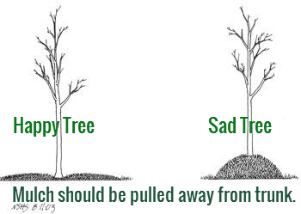

32. Pesticides/Herbicides
All pesticides and herbicides shall be selected to act on an identified pest and used to protect the plantings from infestations and/or serious damage. All submitted pesticides and spray schedules should conform to industry best standards. Labels shall conform to federal and state laws. Do not deliver pre-mixed pesticides to the work site.

33. Plants

a. KCDC desires that to the extent possible, plants have these attributes:

- Native
- Durable
- Perennials
- Low Maintenance

b. Plants expected to be purchased are listed in the proposal response section to get an idea of current costs. KCDC understands that actual costs may vary at the time of work initiation. KCDC and the supplier will arrive at a mutually satisfactory price schedule upon final determination of plants to be used.

c. A plant shall be dimensioned as it stands in its natural position.

d. Large plants cut back to sizes specified will be rejected.

e. Plants shall be sound, healthy and vigorous growing specimens.

f. Plants shall exhibit uniform growth and a form characteristic of their species.

g. Plants shall have normal, well-developed branches.

h. Plants shall be free from any infestations or defects, including but not limited to decay, disfiguring knots, frost and sunscald injuries, abrasions of the bark, girdled trunk or branches, head malformed from overcrowding, damage due to machinery operation, improper pruning and blasted buds.

i. All trees shall have straight trunks with a sturdy central leader. Clump forms may have more than one straight leader. Lateral branches shall arise near right angles forming U-shaped crotch. Trees with V-shaped crotches will be rejected. In the case of in-grade street trees, branching shall start at seven feet from the base of the trunk.

j. All trees shall have been properly pruned to ensure a strong, sturdy tree canopy.

k. All Trees shall have been properly planted from the root flair to guarantee healthy growth. If trees were planted improperly by employee shall replace immediately.

j. Foliage shall be free from chlorosis, yellowing blemishes or damaged parts.

k. Plants shall have vigorous fibrous root systems.

l. Container grown plants shall have been grown in the container long enough to develop new fibrous roots so that the root mass will retain its shape and hold together when removed from the container. All recently potted or root-bound plants will be rejected.

34. Plant Names/Types
KCDC has preapproved these plants for general usage at KCDC sites. Plants not on this list require advance approval by KCDC’s Housing Operations Directors (HODS) Jane Shrader or Kristie Toby.

Shrubs
- Forsythia, the native or cultivar
- American Beauty Berry
- Saint John’s Wart shrub
- Common Purple Lilac
- Buttonbush
- American Holly
- Butterfly Bush

Flowers
- Rudbeckia
- Purple Coneflower
- Wild Hydrangeas
- Wild Indigo/ Baptisia
- Butterfly milkweed
- Blackeyed Susans
- Coreopsis Verticillata/ Coreopsis mouse ears or lance leaf
- Daffodils and Tulips

35. Pruning
Shall be performed in accordance with industry best practices.

36. Seeds

a. All seed shall be clean, pure seed. Seed shall be free of varieties not specified and shall be free of noxious weed seed and any extraneous matter.

b. Seed shall be fresh material of the latest crop, mixed in the following proportions by weight which meets the following standards for pure live seed (P.L.S.) (purity x germination) content 8.

37. Water
Water may be available for the supplier's use at some sites.

The supplier shall provide hoses and equipment to transport water from the work site source to areas and specific locations where water is to be used. This shall be at the supplier's expense.

38. Submittal Instructions
Upload your information in the order indicated below but as one document:

Document Number | Title
Solicitation Document A | General Response Section
Solicitation Document B | Affidavits
Solicitation Document C | HUD Form 5369A
Solicitation Document D | Cost Proposal
Solicitation Document E | Business Capabilities and History
Solicitation Document F | References
Appendix 1 Insurance | Insurance Certification Page

Do not return this and the preceding pages to KCDC.

Solicitation Document A |  |  |  | General Information about the Supplier
Note: Complete all cells even if the answer if “Does not apply”
Sign Your Name to the Right of the Arrow
If completing this document in Adobe, an electronic signature is acceptable to KCDC.
Your signature indicates you read and agree to “KCDC’s General Instructions to Suppliers” (www.kcdc.org) and that you are authorized to bind the supplier or are submitting the response on behalf of and at the direction of the suppliers’ representative authorized to contractually bind the supplier. I represent that the supplier or its applicable representative(s) has reviewed the information contained in this Solicitation Package and that the information submitted is accurate.
Printed Name and Title
Legal Corporate Name
Street Address
City/State/Zip
Contact Person (Please Print Clearly)
Telephone Number
Cell Number
Supplier’s E-Mail Address (Please Print Clearly)
Addenda
Addenda are at www.kcdc.org. Click on “Procurement” and then on “Open Solicitations” to find addenda. Please check for addenda prior to submitting a proposal.
Acknowledge addenda have been issued by checking below as appropriate:
None ☐ | 1 ☐ |  |  |  | 2 ☐ |  | 3 ☐ |  | 4 ☐ |  | 5 ☐
Statistical Information (Check a box in each of the next four lines)
1. This business is at least 51% owned and operated by a woman |  |  |  |  |  |  |  |  |  |  | Yes ☐ No ☐
2. This business qualifies as a small business by the State of Tennessee  Total gross receipts of not more than $10,000,000 average over a three-year  period OR employs no more than 99 persons on a full-time basis |  |  |  |  |  |  |  |  |  |  | Yes ☐ No ☐
3. This business is at least 51% owned and operated by a veteran |  |  |  |  |  |  |  |  |  |  | Yes ☐ No ☐
4. This business is owned & operated by persons at least 51% of the following ethnic background:
Asian/Pacific  ☐ |  | Black  ☐ | Hasidic Jew  ☐ |  |  | Hispanic  ☐ |  | Native American ☐ |  | White  ☐ | Publicly Owned ☐
Prompt Payment Discount Statement
A ____% prompt payment discount applies when KCDC makes payment in ____ days of accurate invoicing.
Cooperative Procurement Statement
Subject to additional location/delivery charges, the supplier agrees to extend the offered costs to other governments if the government so desires. Yes ☐ No ☐

Solicitation Document B | Affidavits

Conflict of Interest
1. No commissioner or officer of KCDC or other person whose duty it is to vote for, let out,
overlook or in any manner superintend any of the work for KCDC has a direct interest in the award or the supplier providing goods or services.

2. No employee, officer or agent of the grantee or sub-grantee will participate in selection, or in the award or administration of an award supported by federal funds if a conflict of interest, real or apparent, would be involved. Such a conflict would arise when the employee, officer or agent, any member of his immediate family, his or her partner, or an organization, which employs, or is about to employ, any of the above, has a financial or other interest in the supplier selected for award.

3. The grantee's or sub-grantee's officers, employees or agents will neither solicit nor accept gratuities, favors or anything of monetary value from suppliers, potential suppliers, or parties to sub-agreements.

4. By submission of this form, the supplier is certifying that no conflicts of interest exist.

Drug Free Workplace Requirements
5. Private employers with five or more employees desiring to contract for construction services attest that they have a drug free workplace program in effect in accordance with TCA 50-9-112.

Eligibility
6. The supplier is eligible for employment on public contracts because no convictions or guilty pleas or pleas of nolo contender to violations of the Sherman Anti-Trust Act, mail fraud or state criminal violations with an award from the State of Tennessee or any political subdivision thereof have occurred.
General
7. Supplier fully understands the preparation and contents of the attached offer and of all pertinent circumstances respecting such offer.

8. Such offer is genuine and is not a sham offer.

Iran Divestment Act
9. Concerning the Iran Divestment Act (TCA 12-12-101 et seq.), by submission of this bid/quote/proposal, each supplier and each person signing on behalf of any supplier certifies, and in the case of a joint bid/quote/proposal, each party thereto certifies as to its own organization, under penalty of perjury, that to the best of its knowledge and belief that each supplier is not on the list created pursuant to § 12-12-106.

Accuracy of Electronic Copies
10. If the supplier provides electronic copies of the bid/proposal/quote to KCDC, the supplier certifies that the information provided on paper and in the electronic format is identical unless specifically noted otherwise.

General
11. Neither the said supplier nor any of its officers, partners, owners, agents, representatives, employees or parties interest, including this affiant, has in any way colluded conspired, connived or agreed, directly or indirectly, with any other responder, supplier, or person to submit a collusive or sham offer in connection with the award or agreement for which the attached offer has been submitted or to refrain from making an offer in connection with such award or agreement, or collusion or communication or conference with any other supplier, or, to fix any overhead, profit, or cost element of the offer price or the offer price of any other supplier, or to secure through any collusion, conspiracy, connivance, or unlawful agreement any advantage against KCDC or any person interested in the proposed award or agreement.

12. The price or prices quoted in the attached offer are fair, proper and not tainted by any collusion, conspiracy, connivance, or unlawful agreement on the part of the supplier or any of its agents, representatives, owners, employees, or parties in interest, including this affiant.

No Contact/No Advocacy Affidavit
13. After this solicitation is issued, any contact initiated by any supplier with any KCDC representative concerning this solicitation is strictly prohibited-except for communication with the Procurement Division. My signature signifies that no unauthorized contact occurred.

14. To ensure the integrity of the review and evaluation process, respondents to this solicitation nor any firm representing them, may not lobby or advocate to KCDC staff or Board members. My signature signifies that no unauthorized advocacy occurred.

Non-Boycott of Israel Affidavit
15. Concerning the Non-Boycott of Israel Act (TCA 12-4-1 et seq.), by submission of this bid/quote/proposal, each supplier and each person signing on behalf of any supplier certifies, and in the case of a joint bid/quote/proposal, each party thereto certifies as to its own organization, under penalty of perjury, that to the best of its knowledge and belief that each supplier is not boycotting Israel pursuant to § 12-4-1 and will not during the term of any award. Note: Applicable only to contracts of $250,000 or more and to suppliers with 10 or more employees.

Non-Discrimination Affidavit
16. Title VI of the Civil Rights Act of 1964 (42 U.S.C. § 2000d et seq.) “Nondiscrimination in Federally Assisted Programs” states “No person in the United States shall, on the grounds of race, color or national origin, be excluded from participation in, be denied the benefits of or be subjected to discrimination under any program or activity receiving federal financial assistance.”

17. Title VII of the Civil Rights Act of 1964 (42 U.S.C. § 2000d et seq.) prohibits employers from discriminating against employees based on sex, race, color, national origin and religion. It generally applies to employers with 15 or more employees, including federal, state and local governments. Title VII also applies to private and public colleges and universities, employment agencies and labor organizations.

The undersigned hereby acknowledges receipt of these affidavits and certifies that the submittal in response to this solicitation is in full compliance with the listed requirements. Failure to properly acknowledge issues concerning the above is grounds for bid rejection and may subject the signer to penalties as directed by the appropriate laws.

Signed by
Printed Name
Title

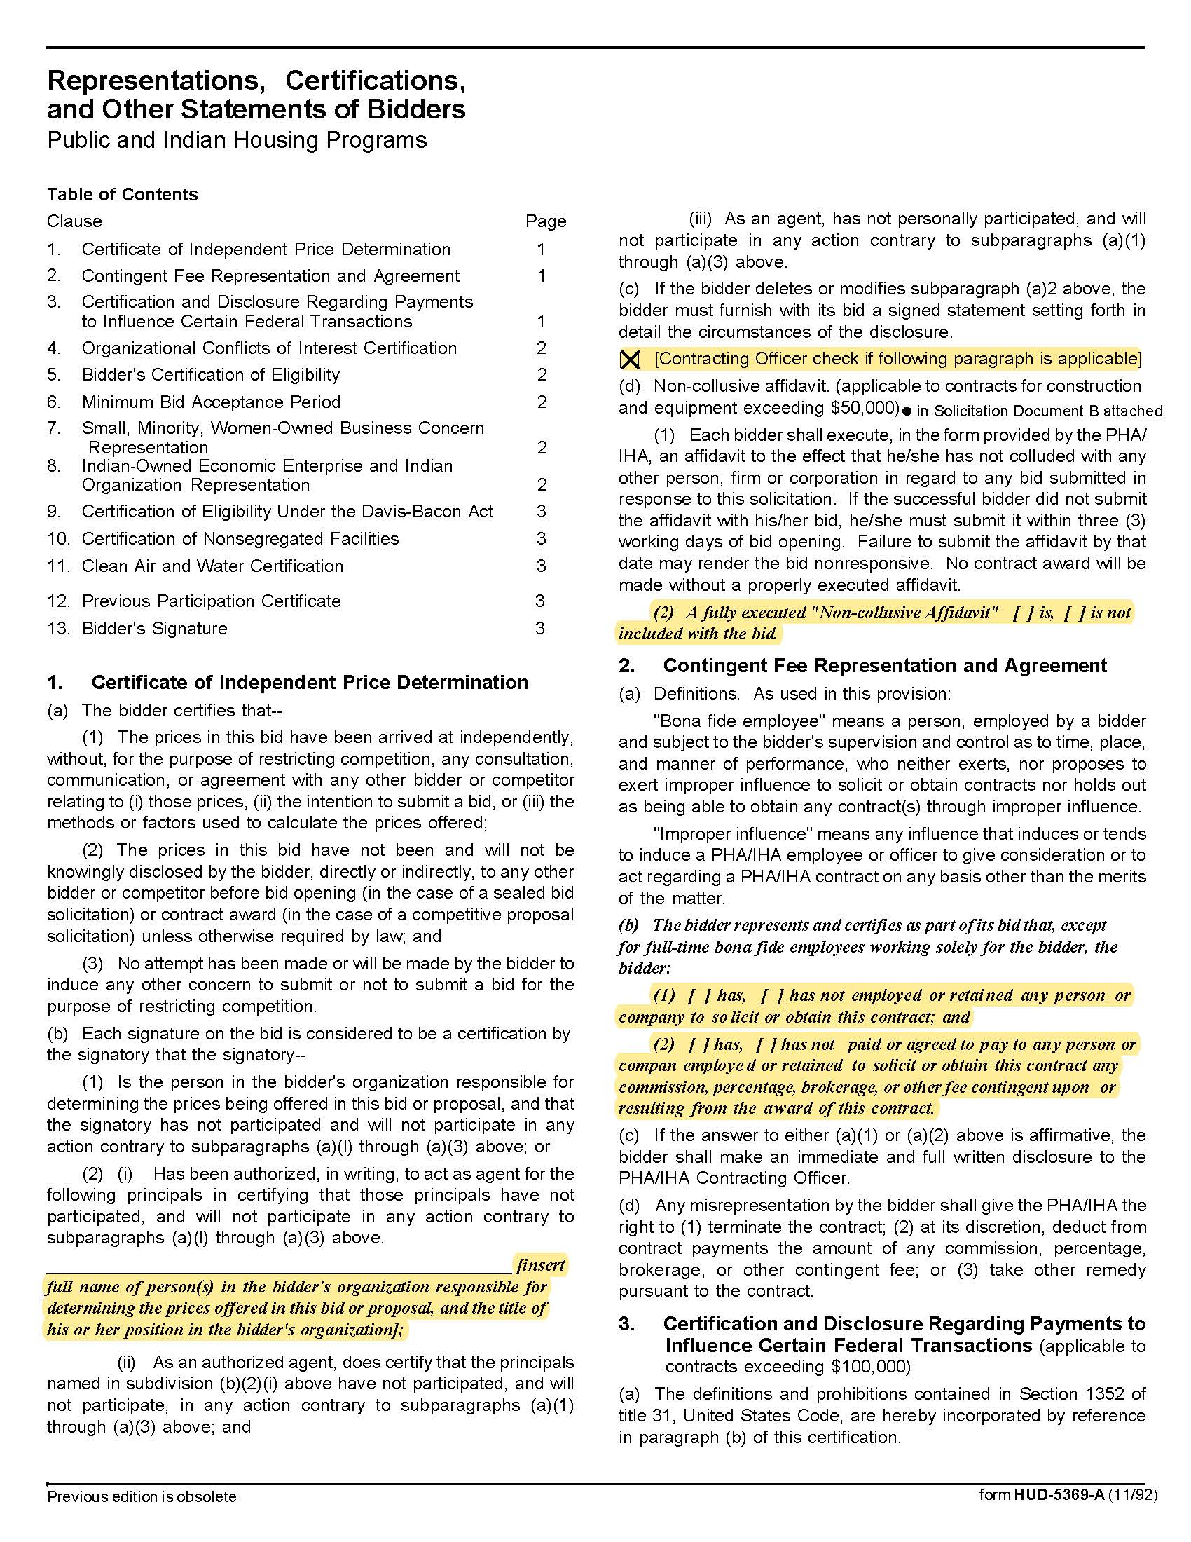
Solicitation Document C | HUD Form 5369A

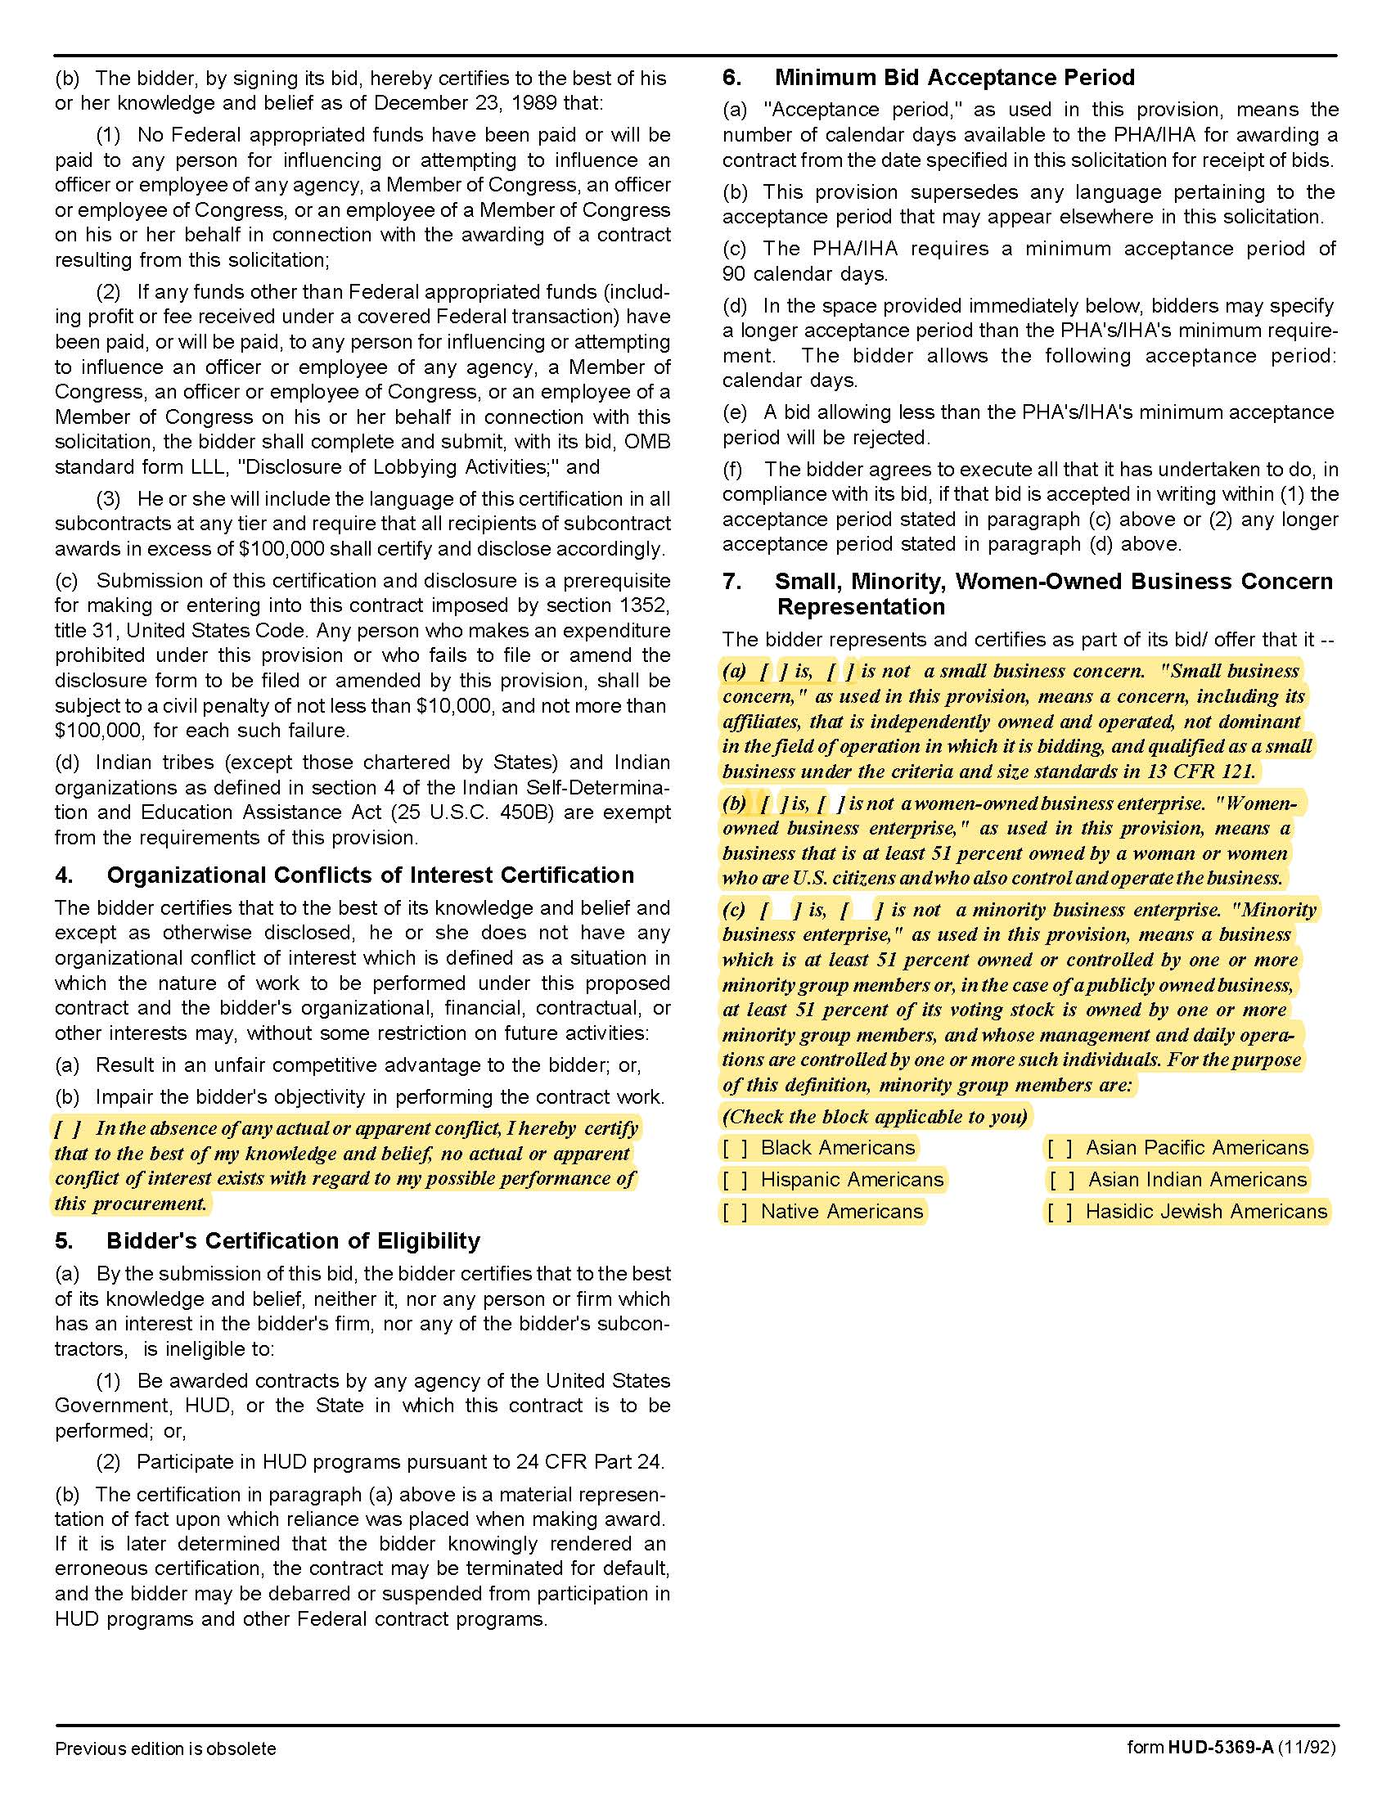

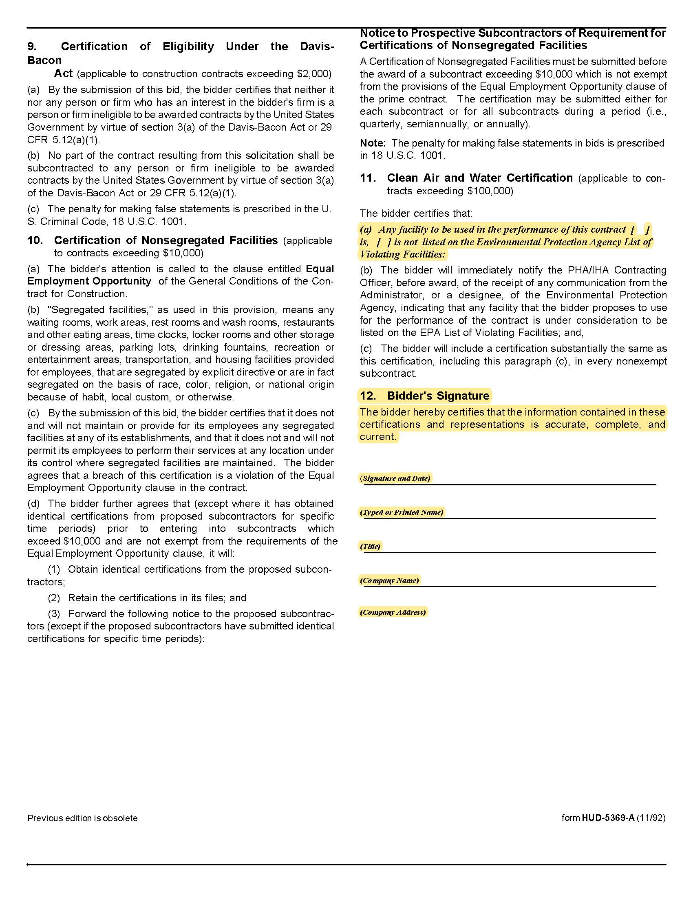

Solicitation Document D | Cost Proposal
Provide the following information for evaluation purposes but understand that actual work and materials may be different than indicated below and will be negotiated as needed. You may add items to the lists below.

Part One: Maintenance Agreement
Item | Cost per Year
Autumn Landing | $
Cagle Terrace | $
The Cottages at Clifton | $
First Creek | $
Five Points Properties | $
Guy B. Love Towers | $
Isabella Towers | $
Lonsdale Homes | $
Mechanicsville | $
Montgomery Village | $
Nature’s Cove | $
North Ridge Crossing | $
Northgate Terrace | $
Valley Oaks Apartments | $
The Verandas | $
The Vista at Summit Hill | $
Western Heights | $
Grand Total | $

Part Two: Mowing/Landscaping of 901 N. Broadway
Item | Cost | Unit of Measure
Monthly Fee | $ | Each
Fee for Leaf Pickup/Removal | $ | Each time
Other: | $ | Each
Other: | $ | Each

Part Three: Miscellaneous Items and Services (as needed)

Plants
Item | Cost | Unit of Measure
Azaleas, Autumn Embers™ 3-gallon container | $ | Each
Daylily, Golden Prize | $ | Each
King Alfred Daffodils | $ | Each
Leyland Cypress Cupressocyparis leylandii (5-gallon containers) | $ | Each
Forsythia, the native or cultivar | $ | Each
American Beauty Berry | $ | Each
Saint John’s Wart shrub | $ | Each
Common purple lilac | $ | Each
Butterfly Bush | $ | Each
Rudbeckia | $ | Each
Butterfly Milkweed | $ | Each
Blackeyed Susans | $ | Each
Bee Balm | $ | Each
Coreopsis | $ | Each
Maiden Fountain Grass 3-gallon containers | $ | Each
Mulch, Hardwood | $ | Cubic Yard
Mums - Various Colors (10” pots) add Native Perennials/ Trees / shrubs instead of list? Or should I put my list in? | $ | Each
Ornamental Cabbage | $ | Each
Pampas Grass, five-gallon containers. | $ | Each
Sod | $ | Per Square Yard
Top Soil | $ | Cubic Yard
Tulips | $ | Each

Trees
Item | Cost | Unit of Measure
Redbud, 4 foot | $ | Each
Redbud, 6 foot | $ | Each
Redbud, 8 foot | $ | Each
Redbud, 10 foot | $ | Each
Dogwood, White, 4 foot | $ | Each
Dogwood, White, 6 foot | $ | Each
Dogwood, White, 8 foot | $ | Each
Dogwood, White, 10 foot | $ | Each
Dogwood, Pink, 4 foot | $ | Each
Dogwood, Pink, 6 foot | $ | Each
Dogwood, Pink, 8 foot | $ | Each
Dogwood, Pink, 10 foot | $ | Each
Maple, Silver, 4 foot | $ | Each
Maple, Silver, 6 foot | $ | Each
Maple, Silver, 8 foot | $ | Each
Maple, Silver, 10 foot | $ | Each
Other: | $ | Each
Other: | $ | Each
Other: | $ | Each

Labor
Item | Cost | Unit of Measure
Aeration Services | $ | Square Foot
Bed Detail Services | $ | Hour
Herbicide or Pesticide Application | $ | Hour
Irrigation Installation/Repair | $ | Hour
Landscape Design | $ | Hour
Landscape Labor | $ | Hour
Plant/Mulch/Barrier Installation | $ | Hour
Shrub Trimming | $ | Hour
Snow/Ice Removal | $ | Hour
Spreading Top Soil or Mulch | $ | Hour
Other: | $ | Each
Other: | $ | Each

Parts and Supplies
Item | Cost | Unit of Measure
Herbicide | $ | Per gallon
Irrigation Parts | % | Over supplier cost
Landscape Fabric | $ | Square foot
Markup on Materials | % | Over supplier cost
Pesticide | $ | Per gallon
Other: | $ | Each
Other: | $ | Each

Solicitation Document E | Business Capabilities and History

The supplier will demonstrate their business history, capabilities and plan specific to KCDC by including these factors in their response to this section.

1. EXPERIENCE:
- Years in business and years in business under this name.
- Years performing this type of work.
- Total number of business clients.
- Value of work now under contract.
- Value of work in place last year.
- Percentage (%) of work usually self-performed (not sub-contracted).
- Has your firm failed to complete a contract?
- Has your firm been involved in bankruptcy or reorganization?
- Does your firm have pending judgment claims or suits against it?
- What company is used for pre-employment criminal background checks?

2. SAFETY:
- Have you had OSHA fines within the last three years?
- Have you had job-related fatalities within the last five years?
- If you answer YES to either of the above questions, you MUST provide details describing the circumstances surrounding each incident.

3. PERSONNEL, EQUIPMENT & MATERIALS:
- How many total employees does your company employ?
- How many full-time and how many part-time landscape employees?
- How many full-time and how many part-time Supervisors?
- Number of years of experience for the person(s) proposed to work for KCDC.
- Describe your company’s training program.
- Describe your company’s Drug Free Workplace policies including background checks.
- Provide information about landscaping related training.
- Provide information about OSHA safety training.
- Provide information about quality control programs you have in place.

4. Detail your firm’s past demonstrated ability to be innovative and creative. Provide examples of past products, demonstrated results and overall cost.

5. Indicate your utilization of technological advances in landscaping and the resulting benefits.

6. List the major equipment that your company owns.

7. Detail the various services that your firm provides.

8. Discuss your firm’s expertise.
Solicitation Document F | References

Part I Provide three references as similar as possible to this work. Suppliers may only list a firm as a reference once even if you have done multiple jobs for them.

- Name of the business serviced
- Contact person
- Contact person title
- Contact person’s telephone number
- Contact person’s email address
- Description of the service provided
- Contract began
- Contract ended
- Size of job

Part II Provide a list of all clients during the last three years as shown below.

Client Name/Contact Person | Still Providing Service
Appendix 1 | Insurance Requirements

INSURANCE

The Supplier shall maintain, at Supplier’s sole expense, on a primary and non‐contributory basis, at all times during the life of the contract insurance coverages, limits, and endorsements described herein. All insurance must be underwritten by insurers with an A.M. Best rating of A-: VI or better. Upon award, the Supplier shall provide Certificate(s) of Insurance and amendatory endorsements to KCDC evidencing said insurance coverages. See paragraph “e” for exact naming of certificate holder and additional insureds (Owner Entities).

The Supplier agrees the insurance requirements herein as well as KCDC’s review or acknowledgement, is not intended to and shall not in any manner limit or qualify the liabilities and obligations assumed by the Supplier under this contract. KCDC’s failure to require a certificate of insurance, acceptance of a non-conforming certificate, or allowing the Supplier to commence work shall not operate as a waiver of these minimum insurance requirements or the liabilities and obligations assumed by the Supplier under this contract.

a. Commercial General Liability Insurance: occurrence version general liability insurance including contractual liability with a minimum combined single limit of $1,000,000 per occurrence with $2,000,000 in the aggregate covering the following perils: bodily injury, personal injury, and broad form property damage including products/completed operations for one year after completion of the Project(s). Limits must apply separately to the work/location in this contract.

Such insurance shall contain or be endorsed to contain a provision that includes the Owner Entities (paragraph “e”) as additional insureds with respect to the Supplier’s ongoing and completed operations, providing coverage at least as broad as CG 20 10 07 04 and 20 37 07 04 endorsements. The coverage shall contain no special limitations on the scope of its protection afforded to the listed insureds.

b. Commercial Automobile Liability Insurance: in an amount not less than $1,000,000 (combined single limit) for all owned, hired, and non-owned vehicles utilized by Supplier in connection with the Project. Coverage is to include coverage for loading and unloading hazards.

Such insurance shall contain or be endorsed to contain a provision that includes the Owner Entities (paragraph “e”) as additional insureds.

c. Workers’ Compensation Insurance and Employers Liability Insurance: Workers’ Compensation Insurance with statutory limits as required by the State of Tennessee or other applicable laws.

d. Other Insurance Requirements:

- Upon award, Supplier shall furnish KCDC with original Certificate(s) of Insurance and
amendatory endorsements effecting coverage required by this section.

- Provide a waiver of subrogation for each required policy herein. When required by the
insurer, or should a policy condition not permit Supplier to enter into a pre‐loss agreement to waive subrogation without an endorsement, the policy should be endorsed with a Waiver of Transfer of Rights of Recovery Against Others, or its equivalent. This waiver of subrogation requirement shall not apply to any policy which includes a condition specifically prohibiting such an endorsement, or voids coverage should supplier enter into such an agreement on a pre‐loss basis.

- A minimum 30‐day cancellation notice for all insurances (by endorsement if necessary) is
required.

- Replace certificates, policies, and endorsements for any such insurance expiring prior to
completion of services.

- Maintain such insurance from the time services commence until services are completed or
through such extended discovery/reporting/tail period as required. Failure to maintain or renew coverage or to provide evidence of renewal may be treated by KCDC as a material breach of contract.

- Any deductibles and/or self‐insured retentions greater than $50,000 must be disclosed to
and approved by KCDC prior to the commencement of services. Use of large deductibles and/or self‐insured retentions will require proof of financial ability as determined by KCDC.

- All policies must be written on an occurrence basis with the exception of Errors and
Omissions Liability (E & O) / Professional Liability and Pollution Liability which may be claims made coverage.

8. Require all subcontractors to maintain during the term of the resulting contract commercial
general liability insurance, automobile liability insurance, and workers’ compensation/employers liability insurance (unless subcontractor’s employees are covered by contractor’s insurance) in the same manor and limits as specified for the Supplier.

e. Certificate Holder and Additional Insureds:

The Certificate Holder shall be:
KCDC
901 N Broadway
Knoxville, TN 37917
Additional Insureds:
Owner Entities are defined as those entities listed below and shall be provided all insurance coverages, limits, and endorsements included herein including additional insured status. Provided Supplier’s insurer(s) permits, the entities listed below can be identified collectively as “Owner Entities”:

KCDC, its officials, officers, employees, and volunteers
KHDC
Eastport Development, LP
Five Points 1 LP
Five Points 2 LP
Five Points 3 LP
Five Points 4 LP
Bell Street LP
Bell Street 2 LP
Bell Street 3 LP
Lonsdale, LP
North Ridge Crossing, LP
Vista at Summit Hill, LP
Montgomery Village Corporation
Cagle Terrace Corporation
Western Heights LP

(Note: Only one (1) certificate needs to be provided. Certificate must reflect KCDC as the Certificate Holder and specify all coverages and terms apply to all Owner Entities.)

f. Right to Revise or Reject: KCDC reserves the right to revise any insurance requirement, including but not limited to, limits, coverages, and endorsements based on changes in scope of work/specifications, insurance market conditions affecting the availability or affordability of coverage.

g. No Representation of Coverage Adequacy: The coverages, limits or endorsements required herein protect the primary interests of the Owner Entities, and the Supplier agrees in no way should these coverages, limits or endorsements required be relied upon when assessing the extent or determining appropriate types and limits of coverage to protect the Supplier against any loss exposures, whether as a result of the project or otherwise.

Certificate Holder | KCDC  901 N Broadway  Knoxville, TN 37917
Additional Insureds (Owner Entities)  (can be identified collectively as Owner Entities) | KCDC, its officials, officers, employees, and volunteers  Knoxville’s Housing Development Corporation (KHDC)  Eastport Development, LP  Five Points 1 LP  Five Points 2 LP  Five Points 3 LP  Five Points 4 LP  Bell Street LP  Bell Street 2 LP  Bell Street 3 LP  Lonsdale, LP  North Ridge Crossing, LP  Vista at Summit Hill, LP  Montgomery Village Corporation  Cagle Terrace Corporation  Western Heights LP
GL (Supplier & Subcontractors) | $1M / $2M (including contractual liability)
Auto (Supplier & Subcontractors) | $1M (owned, hired, & non-owned)
WC & Employers Liability (Supplier & Subcontractors) | Statutory limits
30-day cancellation (Supplier & Subcontractors) | Required– must indicate on COI
Primary non-contributory (Supplier & Subcontractors) | Required – must indicate on COI
Waiver of Subrogation (Supplier & Subcontractors) | Required – must indicate on COI

(Note: Only one certificate needs to be provided. Certificate must reflect KCDC as the Certificate Holder and specify all coverages and terms apply to all Owner Entities.)

Do not return this and the three preceding pages to KCDC.
Insurance Agent’s Statement and Certification:
I have reviewed these insurance requirements with the bidder/proposer named below and have told the bidder/proposer that the required coverage will be available and have advised the bidder/proposer of any additional costs that may be entailed with the coverages.

Insurance Agency 1 Name: ________________________________________________________

Authorizing Signature: ________________________________________________________

Insurance Agency 2 Name: ________________________________________________________

Authorizing Signature: ________________________________________________________

Insurance Agency 3 Name: ________________________________________________________

Authorizing Signature: ________________________________________________________

Bidder’s/Proposer’s Statement and Certification:
I certify that:

1. I have reviewed these requirements with my insurance agent(s).

2. If awarded the contract, I and my subcontractors (if any) will comply with the insurance requirements herein.

3. I/my insurance agency take no exceptions to the listed insurance requirements.

4. My subcontractors (if any) take no exceptions to the listed insurance requirements.

Bidder’s Name: ________________________________________________________

Authorizing Signature: ________________________________________________________

Return this page with your proposal

